Supporting Information
For
Risk in the quality of aquatic ecosystems exposed to pesticides in a natural protected area of influence in western Mexico.
Cruz-Esquivel Ángelª, Martínez-Rivera Luis Manuelª, Sandoval-Pinto Elena^{b}, Meza-Rodríguez Demetrioª, Peregrina-Lucano Alejandro Aaron^{c}
ª Department of Ecology and Natural Resources, South Coast University Center, University of Guadalajara, Autlan de Navarro, Jalisco, Mexico.
^{b} Department of Cellular and Molecular Biology, University Center for Agricultural Biological Sciences, University of Guadalajara, Guadalajara, Jalisco
^{c} Department of Pharmacobiology. University Center for Exact Sciences and Engineering, University of Guadalajara, Jalisco, Mexico

Table S1. Description of study sites
Sites | Altitude | Coordinates |  | Description | Foto
 |  | Latitude | Longitude
S1 | 910 | 19º51'25.7'' | 104º17'22.8'' | Tropical deciduous forest, canyon-type landscapes. | 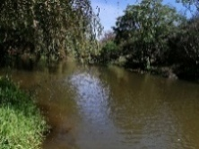
S2 | 870 | 19º47'28.1'' | 104º13'45.7'' | Peri-urban area, beginning of agricultural extensions. | 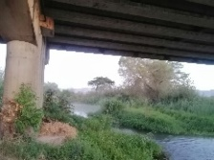
S3 | 866 | 19º45'27.6'' | 104º13'43.5'' | Valley area, sugar cane and corn crops. | 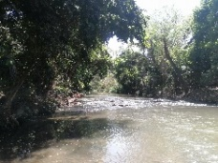
S4 | 866 | 19º45'41.3'' | 104º12'56.7'' | Wastewater discharge channel of the municipality of Autlan. | 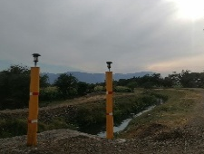
S5 | 860 | 19º44'3'' | 104º10'40.8'' | Valley area, sugar cane and corn crops. | 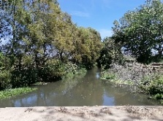
S6 | 860 | 19º44'41.7'' | 104º09'58.1'' | Wastewater discharge channel of the municipality of Grullo. | 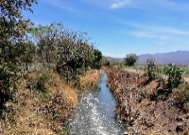
S7 | 858 | 19º42'40.6'' | 104º09'10.3'' | Valley area, sugar cane and corn crops. | 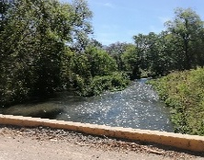
S8 | 848 | 19º41'27.6'' | 104º08'19.6' | Sierra de Manantlan Biosphere Reserve Area, tropical deciduous forest | 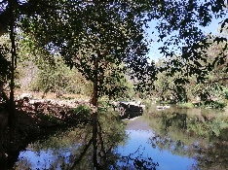
S9 | 848 | 19º41'24.9'' | 104º08'18' | Sierra de Manantlan Biosphere Reserve Area, tropical deciduous forest | 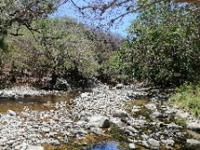
S10 | 810 | 19º39'57.7'' | 104º05'9.7' | Sierra de Manantlan Biosphere Reserve Area, relicts of horticultural crops. | 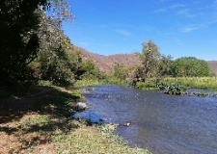
S11 | 692 | 19º36'2.9'' | 103º57'46.9' | Tropical deciduous forest, small relicts of agave plantations. | 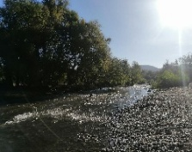
S12 | 701 | 19º36'41.7'' | 103º57'5' | Agave crops, influence of urban runoff. | 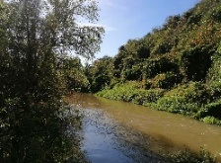
S13 | 680 | 19º35'58.6'' | 103º57'27.5' | Tropical deciduous forest, small relicts of agave plantations. | 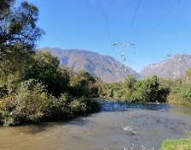

Chromatographic conditions:
For non-polar compounds: HPLC model 1200, Agilent Technologies brand, Zorbax Eclipse XDB C-18 chromatographic column, 2.1 x 5.0 mm, 3.5 micrometers. Mobile phase Water with 0.1% formic acid and 0.1% amino formate, Acetonitrile, gradient 60:40 to 0:100. Flow rate 0.5 mL/min, 3 minutes.
For polar compounds: HPLC model 1200, Agilent Technologies, Zorbax Eclipse XDB C-18 chromatographic column, 2.1 x 5.0 mm, 3.5 micrometers. Mobile phase 30:70 Water with 0.1% ammonium formate, 0.1% ammonium formate, acetonitrile. Flow rate 0.5 mL/min, 1 minute.

Table S2. Conditions for HPLC-MS/MS analysis
Non-polar pesticides
Name | Phase | Polarity | Ion Precursor | Ion Product
Acetochlor | Formic acid: Ammonium formate | Positive | 270.1 | 148.4
 |  |  |  | 224.2
Ametrine | Formic acid: Ammonium formate | Positive | 228.1 | 186
 |  |  |  | 96
Atrazine | Formic acid: Ammonium formate | Positive | 216 | 132
Carbendazim | Formic acid: Ammonium formate | Positive | 192.1 | 160
Carbofuran | Formic acid: Ammonium formate | Positive | 222 | 123
Diazinon | Formic acid: Ammonium formate | Positive | 305 | 153
Dimethoate | Formic acid: Ammonium formate | Positive | 230 | 171
Emamectin | Formic acid: Ammonium formate | Positive | 887.1 | 158.1
Imazalil | Formic acid: Ammonium formate | Positive | 297 | 159
L-Cyalothrin | Formic acid: Ammonium formate | Positive | 467.1 | 225.1
Malathion | Formic acid: Ammonium formate | Positive | 331 | 99
Meclizine | Formic acid: Ammonium formate | Positive | 391.2 | 201.1
Methomyl | Formic acid: Ammonium formate | Positive | 163.1 | 106
 |  |  |  | 65
 |  |  |  | 88.1
Metoxuron | Formic acid: Ammonium formate | Positive | 229.1 | 72.1
Molinate | Formic acid: Ammonium formate | Positive | 188.1 | 55.1
Parathion | Formic acid: Ammonium formate | Positive | 292 | 236
 |  |  |  | 264
Picloram | Formic acid: Ammonium formate | Positive | 240.9 | 194.9
 |  |  |  | 222.9
Pyraclostrobin | Formic acid: Ammonium formate | Positive | 388 | 163
Thiabendazole | Formic acid: Ammonium formate | Positive | 202 | 131
Polar Pesticides
2,4-D | Ammonium formate | Negative | 218.9 | 160.9
2,4-D | Ammonium formate | Negative | 220.9 | 162.9
Glufosinate | Ammonium formate | Negative | 179.9 | 136
 |  |  |  | 118.9
 |  |  |  | 94.9
Glifosate | Ammonium formate | Negative | 168.2 | 149.9
 |  |  |  | 81.1
 |  |  |  | 62.8

Table S3. Reference values on permissible thresholds for physicochemical variables
Parameters | Aquatic life* | Reference
Temperature (°C) | 8 a 31 | --
pH | 6.5-8.5 | U.S. EPA (2024)
DO (%) | 58.45 | CE-CCA (1989)
DO (ppm) | 5.5 | CE-CCA (1989)
µS/cm/C. E | 300-500 | U.S. EPA (2011)
TDS (ppm) | 500 | CCME (2007)
Turbidity (NTU) | 25 | CCME (2007)
NO3-N (mg/L) | 3 | CE-CCA (1989), CCME (2007)
PO4 (mg/L) | 0.11 | CE-CCA (1989)
FCOL (100ml) | 1000 | CE-CCA (1989)
L-cyhalothrin (ng/ml) | 0.23 | PPDB, 2009
Malathion (ng/ml) | 2 | PPDB, 2009
Methomyl (ng/ml) | 1.6 | PPDB, 2009

Table S4. Spatial distribution of physicochemical variables in the study sites.
Parameters |  | S1 | S2 | S3 | S4 | S5 | S6 | S7 | S8 | S9 | S10 | S11 | S12 | S13
Temperature (°C) | Mediana | 24.7 | 23.7 | 27.4 | 24.2 | 26.1 | 28 | 26 | 26.7 | 24.7 | 26.2 | 24.6 | 25.6 | 24.8
Temperature (°C) | Min-Max | 18.2-33 | 18.8-30.6 | 21.1-30.5 | 16.6-33.6 | 21.7-32.1 | 22.3-34 | 22.4-29.6 | 23-31.3 | 19.9-31 | 21.6-29.8 | 20.6-29 | 21.9-28.5 | 19.8-29.2
Temperature (°C) | DAM | 4.5 | 2.4 | 3.1 | 1.5 | 2.3 | 1.9 | 2.1 | 2.7 | 2.6 | 2.3 | 1.3 | 2 | 1.9
Temperature (°C) | Test Dunn* | a | a | a | a | a | a | a | a | a | a | a | a | a
pH | Mediana | 8.51 | 7.7 | 7.6 | 7.8 | 7.67 | 7.72 | 7.76 | 7.9 | 8.67 | 8.24 | 8.45 | 8.28 | 8.34
pH | Min-Max | 7.6-9.3 | 7.2-8.2 | 7.3-8.1 | 7.3-8.3 | 7.2-8 | 7.4-8.3 | 7.3-8 | 7.6-8.2 | 7.8-9.2 | 7.8-8.6 | 8-8.8 | 7.9-8.6 | 7.1-8.8
pH | DAM | 0.45 | 0.28 | 0.28 | 0.22 | 0.26 | 0.23 | 0.21 | 0.24 | 0.32 | 0.24 | 0.26 | 0.22 | 0.25
pH | Test Dunn | b | a | a | a | a | a | a | a | b | b | b | b | b
DO (%) | Mediana | 102.5 | 75.3 | 57.3 | 20.6 | 29.3 | 27.4 | 28.9 | 72.4 | 98.7 | 91.7 | 101.8 | 86.3 | 96.7
DO (%) | Min-Max | 52.1-198.6 | 39.1-88.9 | 6.1-93.6 | 0.3-87.1 | 15.6-78.6 | 4.5-175.4 | 13-68.1 | 38.8-91.9 | 72.3-124.5 | 38.5-130.4 | 27.3-118.9 | 28-122.4 | 54.2-116
DO (%) | DAM | 18.2 | 12.3 | 12.3 | 10.7 | 8.08 | 6.6 | 9 | 9.6 | 9.6 | 9.3 | 10.2 | 12.4 | 16.4
DO (%) | Test Dunn | d | bce | a | ab | a | a | a | bc | d | cde | d | cde | de
DO (ppm) | Mediana | 11.4 | 7.88 | 4.02 | 2.37 | 2.25 | 2.4 | 2.61 | 5.75 | 8.6 | 9.2 | 10.71 | 7.11 | 8
DO (ppm) | Min-Max | 3.45-16.2 | 2.9-11.7 | 0.81-12.5 | 0.02-6.6 | 1.09-7.46 | 0.55-18.9 | 0.97-5.19 | 2.73-11.6 | 5.66-15.8 | 3.08-13.9 | 5.5-16.5 | 0.2-16.7 | 4.11-16
DO (ppm) | DAM | 3.53 | 2.41 | 1.87 | 0.8 | 0.77 | 0.91 | 1.17 | 1.91 | 2.36 | 2.28 | 2.84 | 3.94 | 2.99
DO (ppm) | Test Dunn | d | bd | a | ac | a | a | a | bc | d | bd | d | bd | bd
µS/cm/C. E | Mediana | 217 | 412 | 661 | 716 | 685 | 1023 | 701 | 682 | 109 | 557 | 647 | 684 | 608
µS/cm/C. E | Min-Max | 37.5-455 | 38.2-496 | 42.7-831 | 44.2-1001 | 169.2-804 | 41.6-2000 | 44.8-827 | 42.8-804 | 35.3-190 | 41.5-740 | 42.9-870 | 85.2-1289 | 42.3-914
µS/cm/C. E | DAM | 54 | 63 | 76 | 143 | 58 | 565 | 35 | 42 | 45 | 106 | 147 | 171 | 96
µS/cm/C. E | Test Dunn | de | cde | ab | a | ab | b | ab | a | d | ace | a | ab | ac
TDS (ppm) | Mediana | 115 | 205 | 330 | 359 | 343 | 534 | 350 | 340 | 64 | 278 | 323 | 345 | 302
TDS (ppm) | Min-Max | 26.8-229 | 27-248 | 30.4-417 | 31.3-500 | 30.5-421 | 29.6-1000 | 31.1-413 | 30-401 | 25.2-699 | 29.5-370 | 30.4-435 | 60.1-644 | 23.8-457
TDS (ppm) | DAM | 33 | 33 | 37 | 70 | 28 | 279 | 19 | 23 | 19 | 56 | 74 | 85 | 68
TDS (ppm) | Test Dunn | d | cd | ab | a | a | b | ab | a | d | ac | a | ab | ac
Turbidity (NTU) | Mediana | 5.37 | 33 | 37.6 | 46.1 | 47.1 | 89.6 | 42 | 39.1 | 4.74 | 19.6 | 21.3 | 38.8 | 28.7
Turbidity (NTU) | Min-Max | 2.02-8 | 10.9-15 | 19-41 | 13.4-93 | 9.82-60 | 16.4-212 | 7.18-82 | 7.52-85 | 1.19-13 | 6.53-112 | 8.17-393 | 2.268-120 | 21-160
Turbidity (NTU) | DAM | 3.35 | 10.1 | 14.3 | 23 | 22.4 | 54.8 | 18.5 | 21 | 3.55 | 11.23 | 8.1 | 12.4 | 6.1
Turbidity (NTU) | Test Dunn | d | abc | abc | abc | abc | a | abc | abc | d | bc | b | ac | abc
NO3-N (mg/L) | Mediana | 2 | 3.4 | 3.3 | 4.4 | 3.2 | 3.8 | 3.2 | 4.1 | 1.65 | 4 | 3.4 | 2.5 | 3.3
NO3-N (mg/L) | Min-Max | 0.2-11.6 | 2.4-6.8 | 1.2-11.4 | 1.6-15.6 | 0.8-7.7 | 1.7-12.1 | 0.9-11.9 | 0.9-7.6 | 0.4-3.1 | 1.1-9.8 | 2.1-11.5 | 0.9-7.7 | 1.6-11.4
NO3-N (mg/L) | DAM | 0.9 | 0.7 | 0.7 | 2.1 | 0.8 | 1.8 | 1.4 | 1.2 | 0.6 | 1.3 | 0.7 | 1 | 1.1
NO3-N (mg/L) | Test Dunn | bc | a | a | a | ab | a | ab | a | c | a | a | ab | ab
PO4 (mg/L) | Mediana | 0.39 | 0.67 | 0.63 | 2.33 | 1.99 | 1.82 | 1.86 | 1.61 | 0.2 | 1.26 | 1.17 | 0.63 | 1.11
PO4 (mg/L) | Min-Max | 0.14-1.23 | 0.37-1.54 | 0.05-12 | 0.14-12 | 1.35-4.8 | 0.07-39 | 1.37-15 | 1.07-21 | 0.04-0.55 | 0.65-5.9 | 0.04-2.15 | 0.016-27 | 0.09-22
PO4 (mg/L) | DAM | 0.17 | 0.11 | 0.27 | 1.96 | 0.5 | 0.72 | 0.34 | 0.33 | 0.14 | 0.22 | 0.13 | 0.34 | 0.39
PO4 (mg/L) | Test Dunn | ef | cef | ab | b | b | ab | ab | abc | f | abe | acd | cde | abcd
F. Coliforms (100ml) | Mediana | 300 | 700 | 900 | 925000 | 500000 | 530000 | 59000 | 23350 | 150 | 1200 | 300 | 2200 | 1750
F. Coliforms (100ml) | Min-Max | 100-7100 | 200-26800 | 100-48x10⁴ | 10000-88x10⁵ | 6700-36x10⁵ | 12800-395x10⁴ | 1700-118x10⁴ | 100-10x10⁵ | 100-28000 | 100-45x10⁴ | 100-12400 | 100-5x10⁴ | 100-26000
F. Coliforms (100ml) | DAM | 100 | 400 | 700 | 849100 | 360000 | 370000 | 52300 | 17700 | 50 | 1100 | 200 | 1000 | 1250
F. Coliforms (100ml) | Test Dunn | d | cd | cd | a | a | a | ab | bc | d | cd | d | bc | cd
*Different letters indicate statistically significant differences

Table S5. Principal component analysis
 | Comp.1 | Comp.2
Habitat | 0.12437755 | 0.74679342
TEM | 0.09443582 | 0.10317857
pH | -0.29058755 | -0.27225737
DO | -0.47408819 | -0.17427917
OS | -0.46234351 | -0.18598328
EC | 0.38441755 | -0.38171436
TDS | 0.41797761 | -0.33490026
TUR | 0.27199461 | -0.1723505
NO3N | 0.23703723 | -0.07069621

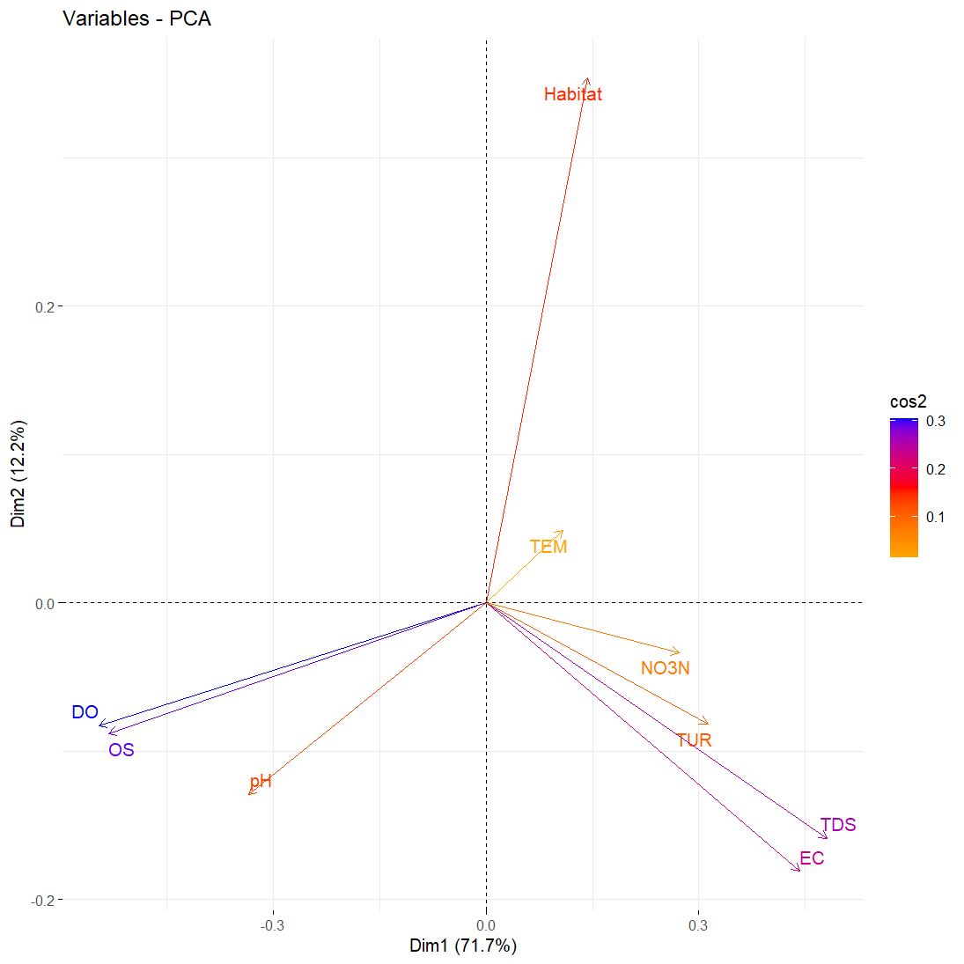
Fig S1. Principal component analysis of physicochemical variables.

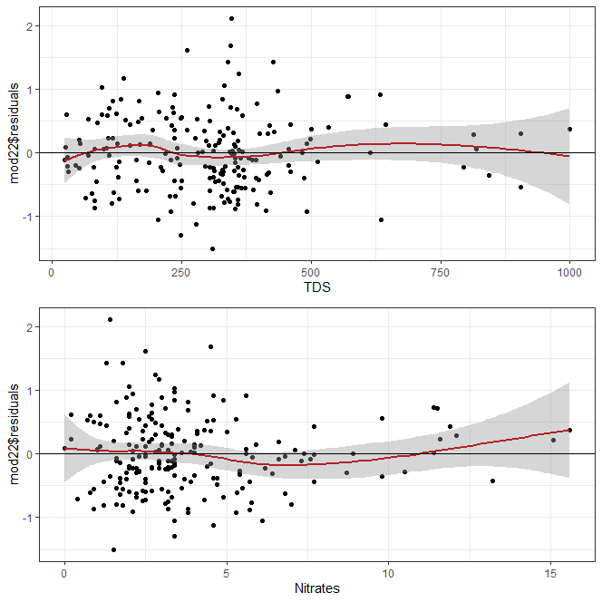
Fig S2. Linearity of predictors
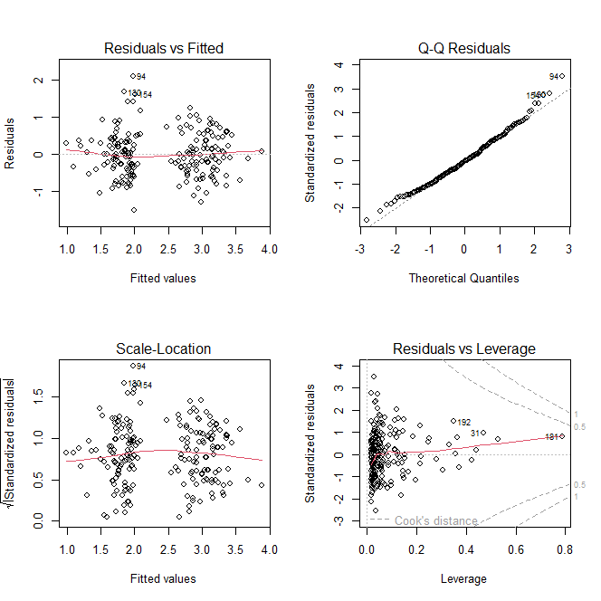
Fig S3. Verification of statistical assumptions
References
Canadian Council of Ministers of the Environment, (2017). Canadian water quality guidelines for the protection of aquatic life: CCME Water Quality Index, User’s Manual – 2017 Update. In: Canadian environmental quality guidelines, 1999, Canadian Council of Ministers of the Environment, Winnipeg. p 1-23
del Agua CEDC CE-CCA-001/89 (1989) ACUERDO por el que se establecen los Criterios Ecológicos de Calidad del Aguas CE-CCA-001/89. Diario Oficial de la Federación. SEGOB.
Footprint PPDB, (2009). Creating tools for pesticide risk assessment and management in Europe. The Pesticide 0, 2(4): 6. Retrieved April 10, 2024, from https://sitem.herts.ac.uk/aeru/ppdb/
U.S. EPA, (2024). National Recommended Water Quality Criteria - Aquatic Life Criteria. Retrieved March 25, 2024, from https://www.epa.gov/wqc/national-recommended-water-quality-criteria-aquatic-life-criteria-table
U.S. EPA, (2011). A Field-Based Aquatic Life Benchmark For Conductivity In Central Appalachian Streams (Final Report). U.S. Environmental Protection Agency, Washington, DC, EPA/600/R-10/023F, 2011.

