Supplemental figures

Figure 1A

Figure 1 B

Figure 2D-1
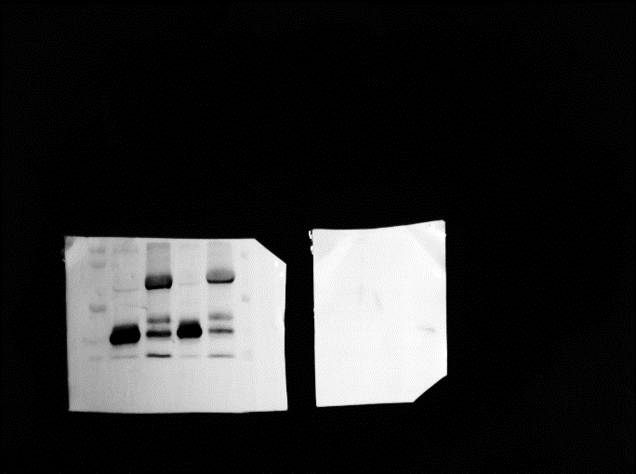

Figure 2D-2

Figure 2E-1

Figure 2E-2
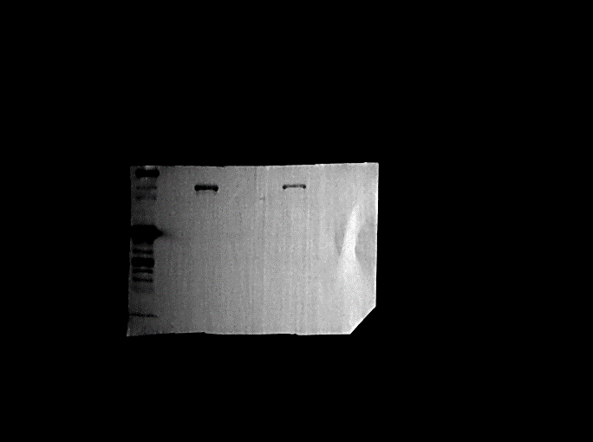

Figure 3A-1

Figure 3A-2

Figure 3A-3
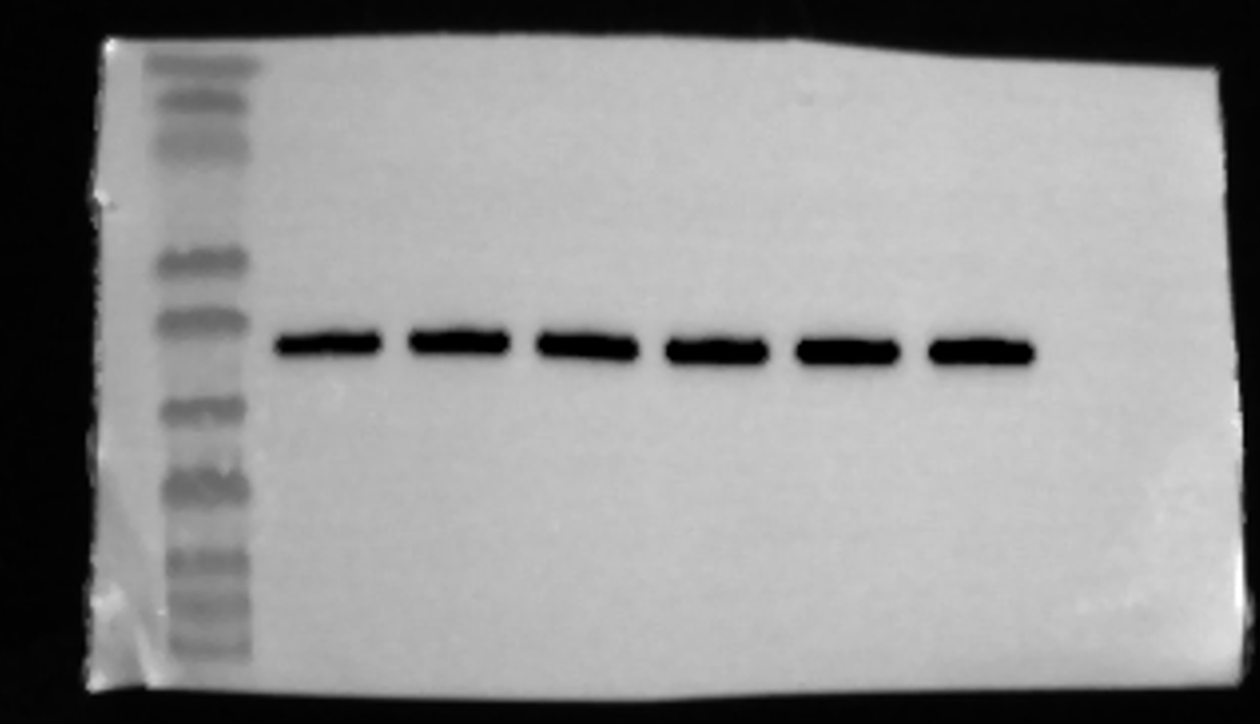

Figure 3B-1
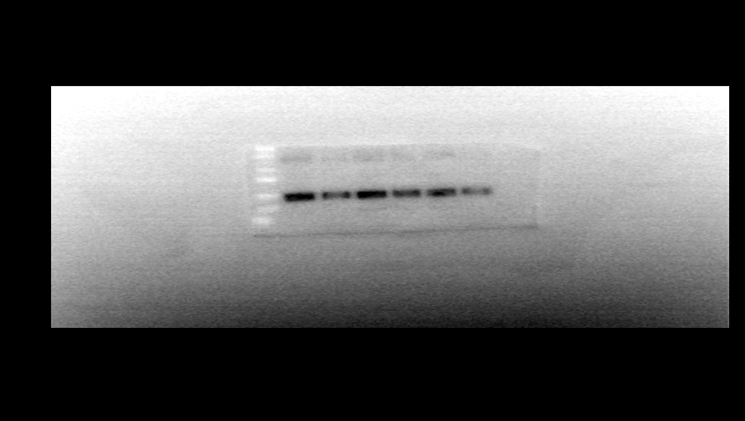

Figure 3B-2
Figure 3B-3
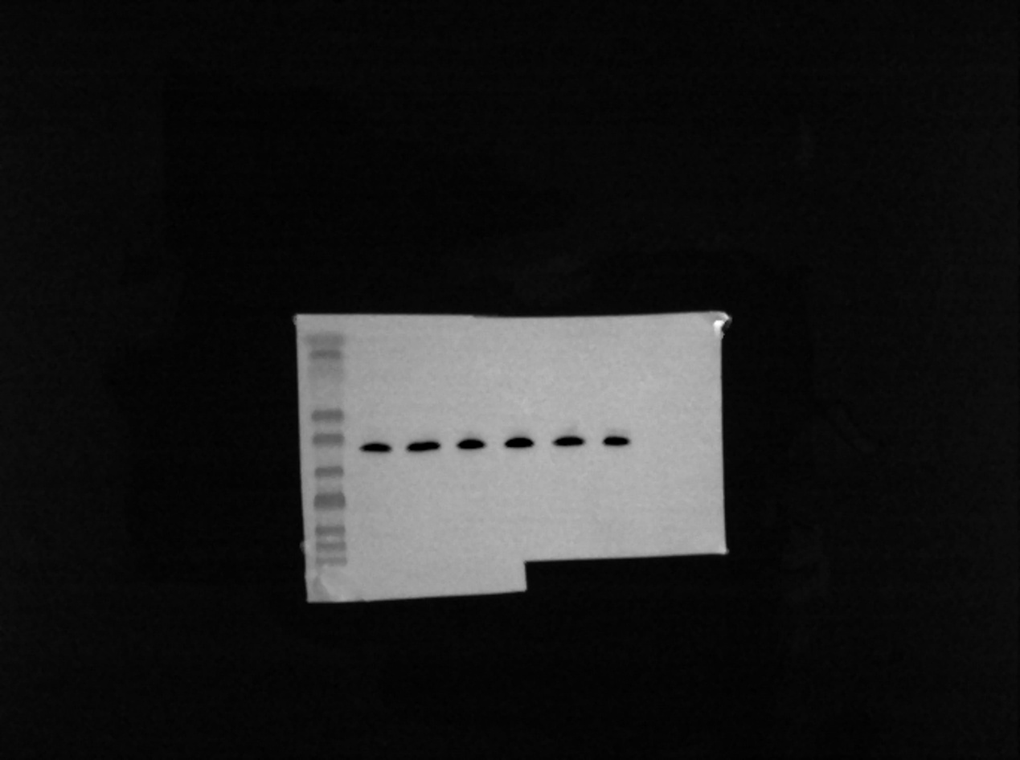

Figure 6A

Figure 6B

Figure 6C

Figure 7B-1
Figure 7B-2

Figure 7B-3

Figure 7C-1

Figure 7C-2

Figure 7C-3
