Supplemental materials

Figure S1. Prediction of secondary structure APV1-3′UTR and the interaction with eIF4E. RNAfold tool were used to predict the RNA secondary structure of APV1-3′UTR (A) and the energy and nucleotide conservancy of RNA secondary Structure (B). The red, green, and blue regions indicate key areas in the 3′UTR that may play important functional roles. The APV1-3′UTR-eIF4E binding model (C), and the key interacted sites (D) were predicted by the Alphafold Multimer module. Green represents eIF4E, and blue represents RNA.

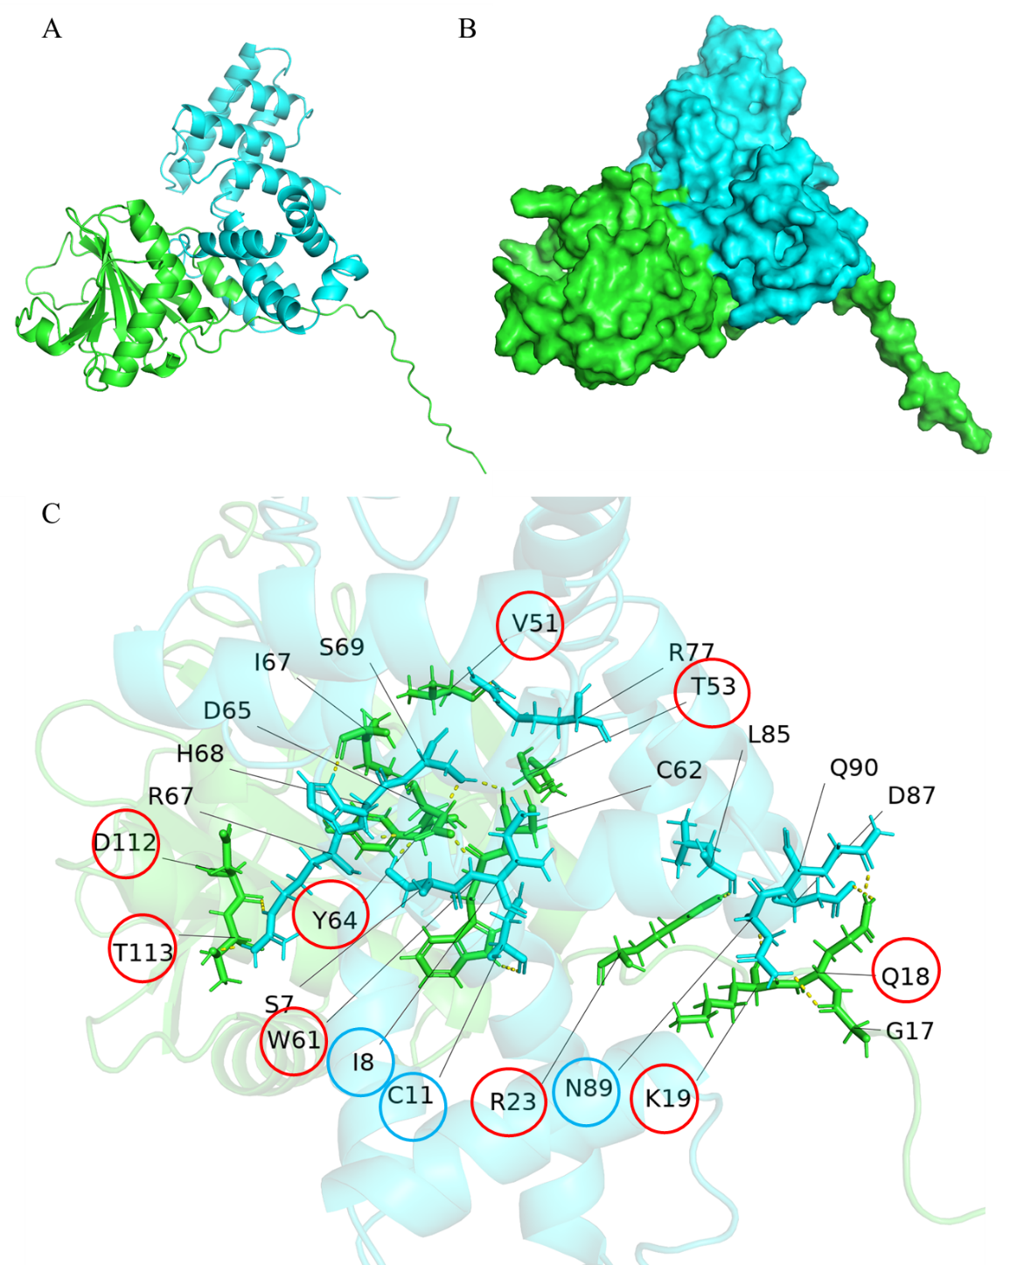
Figure S2. Three-dimensional prediction model of interaction between P25 and eIF4E. (A-B) The potential interaction mechanism between eIF4E and P25 proteins was predicted by the multimer module of Alphafold v2.3.2. All parameters were set to default, and the versions of the databases used included: Uniprot and Uniref90 as of March 1, 2023, and pdb_mmcif and pdb_seqres as of March 3, 2023. The databases were all default versions. Green represents eIF4E and blue represents P25. (C) The predicted multimeric structure was then visualized and analyzed using PyMOL v2.5.0, which identified potential hydrogen bonds and other key interaction sites between the two proteins.

Figure S3. Interaction between eIF4E and truncated P25. The truncated fragments were represented (A). Bimolecular fluorescence complementation (BiFC) assay demonstrating the interaction between the N-terminal fragments of YFP fused to the truncated P25 fragments 1-35aa (B), 36-215aa (C), 1-50aa (D) and 51-215aa (E), and eIF4E fused with C-terminal of YFP respectively. Leaves of N. benthamiana was harvested at 72 h post-infiltration (hpi). Bars, 50 μm.

Figure S4. Determination of the domains of interaction between eIF4E and P25. Yeast two-hybrid assay demonstrating the interaction between truncated P25 and eIF4E (A) and between the truncated eIF4E and P25 (B). pGBK-Lam+pGAD-T serves as a negative control, and pGBK-53+pGAD-T as a positive control. Samples were plated on quadruple drop-out (QDO) medium (SD/-Trp/-Leu/-His/-Ade) with X-α-Gal.

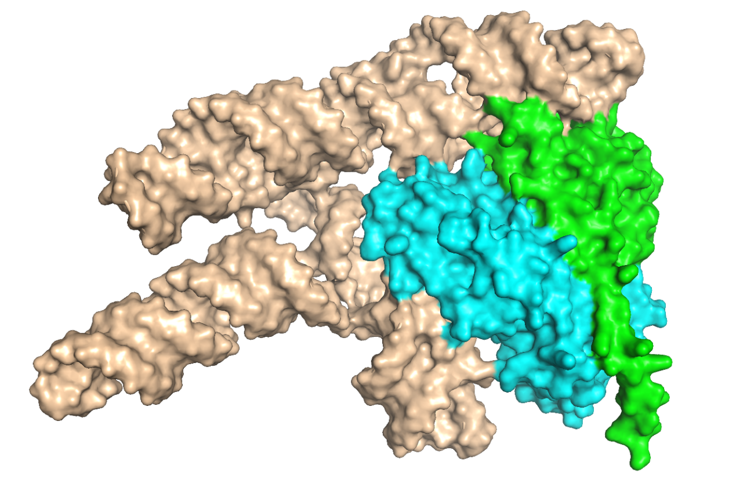
Figure S5. Predicted structural model of the ternary complex of APV1-3′-UTR, P25, and eIF4E. The potential interaction mechanism APV1-3’UTR, P25 and eIF4E was predicted by the multimer module of Alphafold 3. In the predicted structure, all parameters were set to default, and the versions of the databases used included: Uniprot and Uniref90 as of March 1, 2023, and pdb_mmcif and pdb_seqres as of March 3, 2023. The databases were all default versions. Green, blue and brown represent eIF4E, P25 and APV1-3′-UTR, respectively.

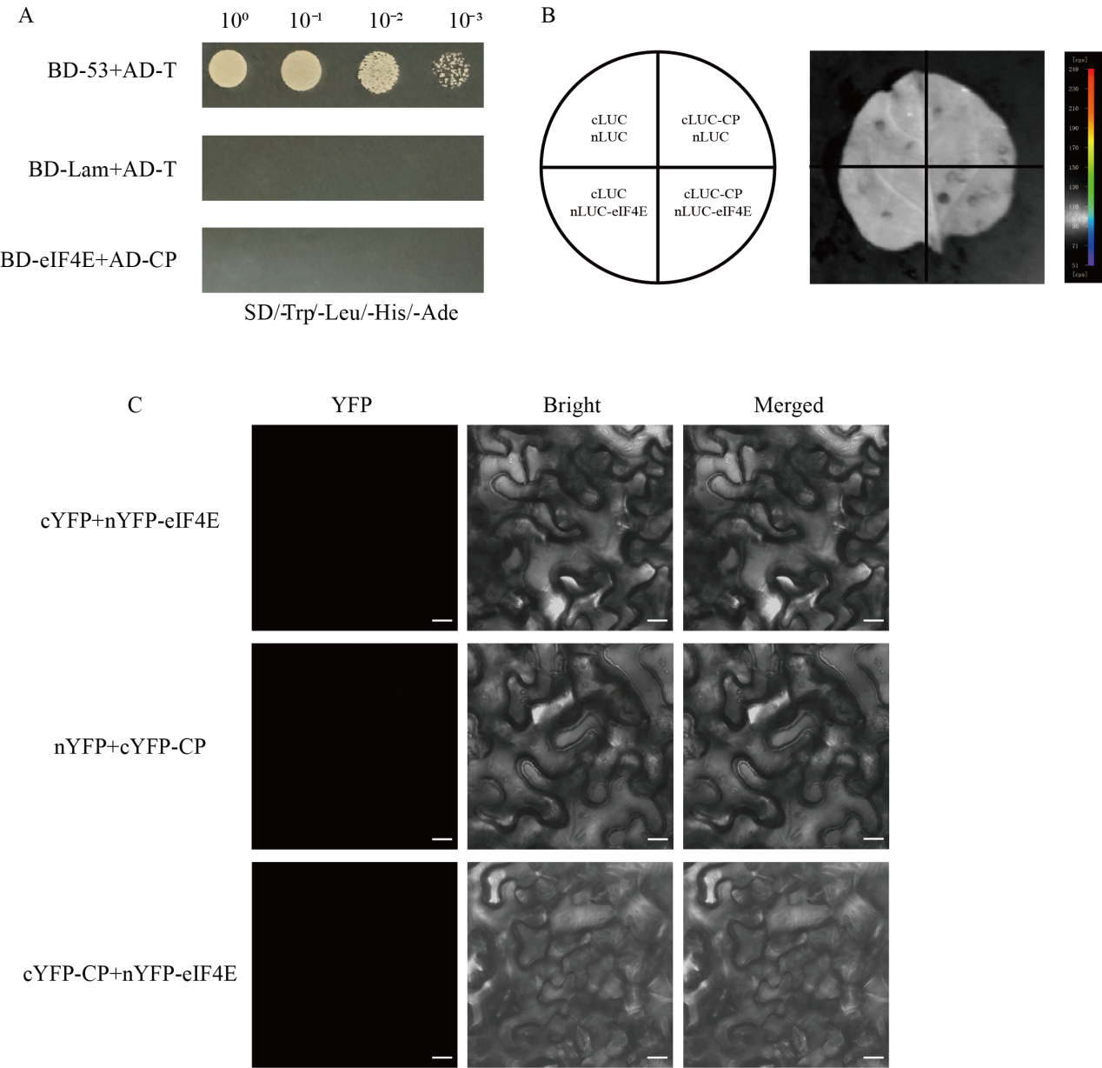
Figure S6. Determination of interaction between eIF4E and CP. (A) Yeast two-hybrid assay of the interaction between CP and eIF4E. pGBK-Lam+pGAD-T serves as a negative control, and pGBK-53+pGAD-T as a positive control. Samples were plated on quadruple drop-out (QDO) medium (SD/-Trp/-Leu/-His/-Ade). (B) Luciferase complementation assay (LCA) for the interaction between CP and eIF4E. Combinations of cLuc-CP and nLuc-eIF4E, cLuc-CP and EV-nLuc, nLuc-eIF4E and EV-cLuc, or EV-cLuc and EV-nLuc were infiltrated into a quarter section of N. benthamiana leaves. Luciferase activity was measured using the NightShade LB 985 In Vivo Plant Imaging System (Berthold Technologies, Germany) 72 hpi. (C) Bimolecular fluorescence complementation (BiFC) assay showing the interaction between CP and eIF4E. The vector was agroinfiltrated into N. benthamiana leaves, and fluorescence was observed using confocal microscopy 72 hours post-infiltration (hpi). Bars represent 50 μm.
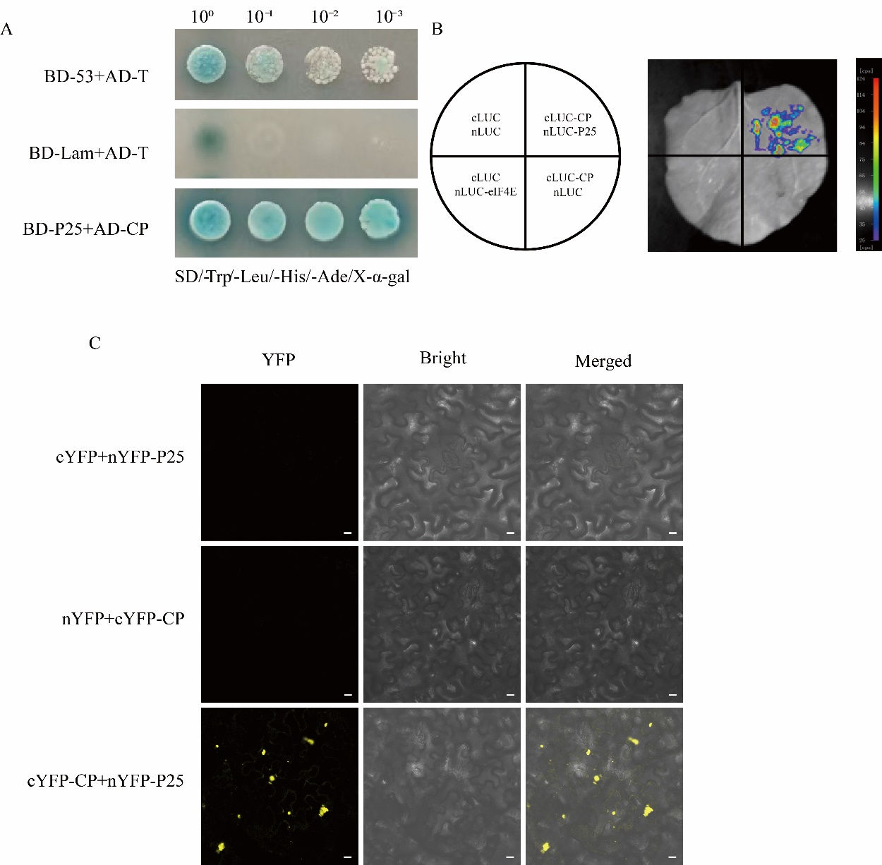

Figure S7. Determination of the interaction between CP with P25. (A) Yeast two-hybrid assay of the interaction between CP and P25. pGBK-Lam+pGAD-T and pGBK-53+pGAD-T serves as negative and positive control respectively. Samples were plated on quadruple drop-out (QDO) medium. (B) Luciferase complementation assay (LCA) for the interaction between CP and eIF4E. Combinations of cLuc-CP and nLuc- P25, cLuc-CP and EV-nLuc, nLuc-P25 and EV-cLuc, or EV-cLuc and EV-nLuc were infiltrated into a quarter section of N. benthamiana leaves and measured using the NightShade LB 985 In Vivo Plant Imaging System (Berthold Technologies, Germany) 72 hpi. (C) Bimolecular fluorescence complementation (BiFC) assay showing the interaction between CP and P25. The vector was agroinfiltrated into N. benthamiana leaves, and fluorescence was observed using confocal microscopy 72 hours post-infiltration (hpi). Bars represent 50 μm.

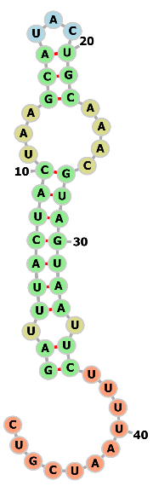
A
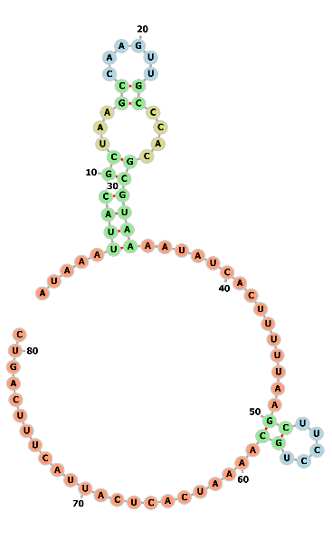
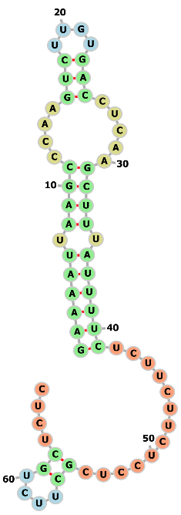
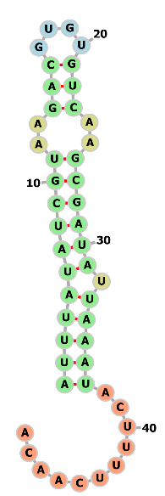
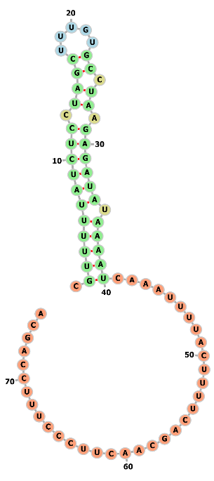

APV1
LChV-1
GLRaV-7
CoV-1
MdoVA

B
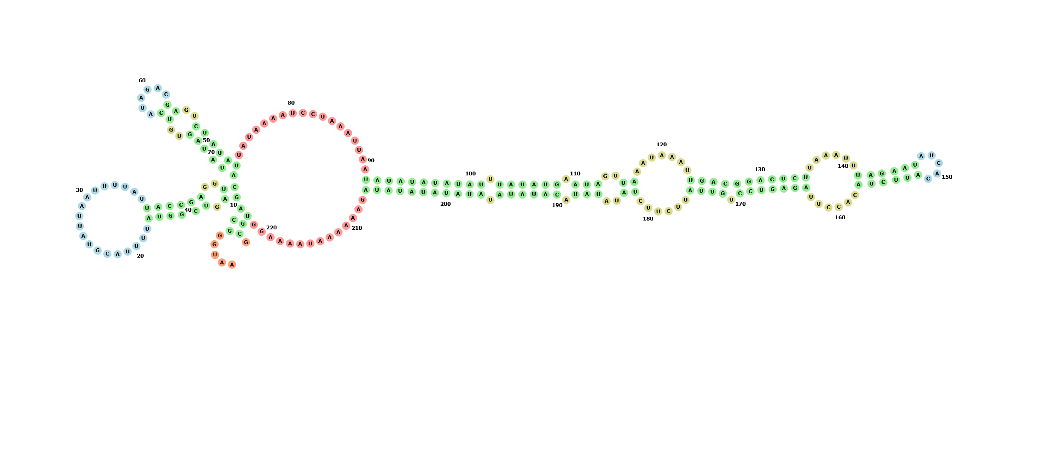
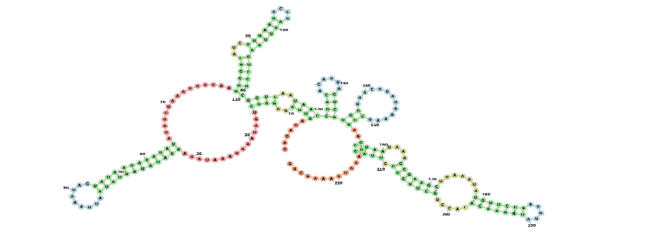
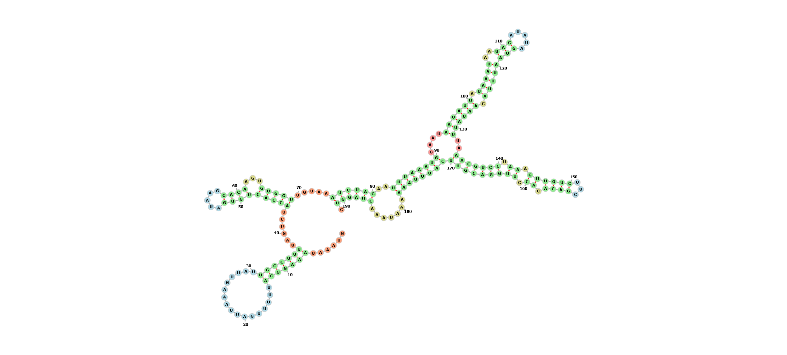
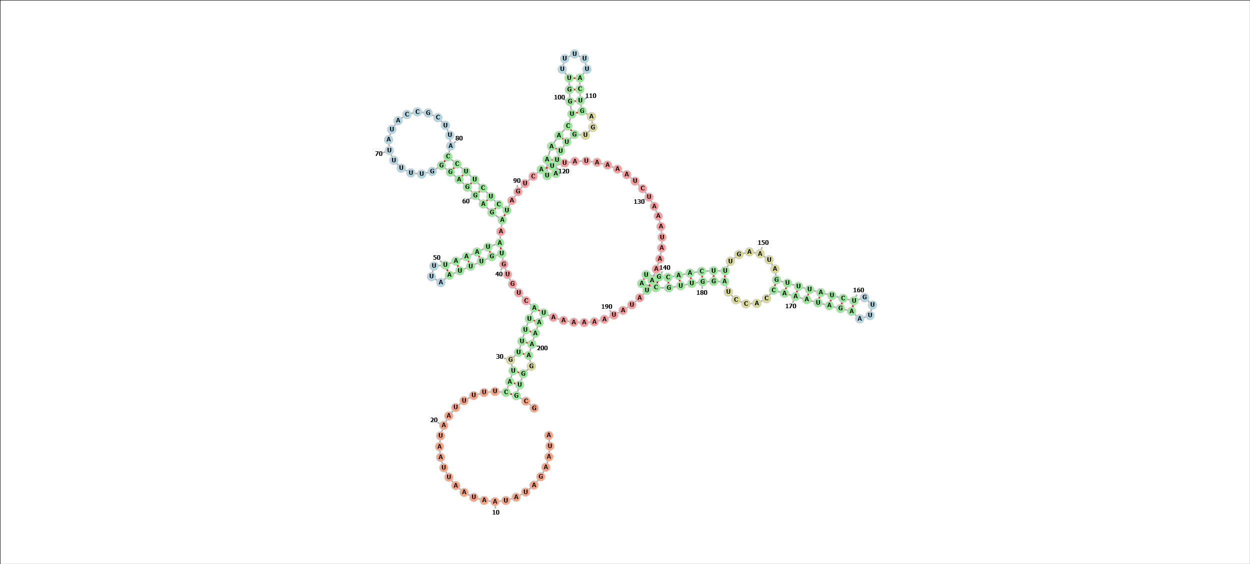
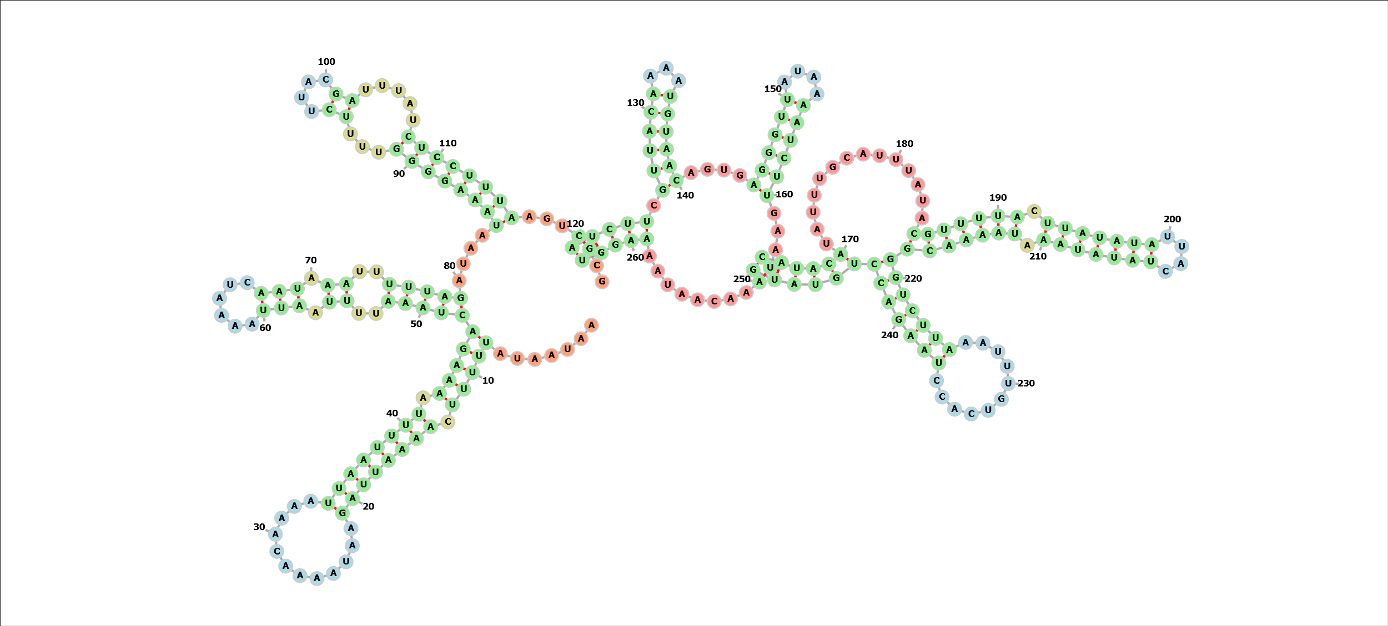
GLRaV-7
CoV-1
LChV-1
MdoVA
APV1

Figure S11. Comparison of the RNA secondary structures of the 5′-UTR and 3′-UTR of velarivirus. The RNA secondary structures of 5′-UTR (A) and 3′-UTR (B) of APV1, little cherry virus 1 (LChV-1), grapevine leafroll-associated virus 7 (GLRaV-7), cordyline virus 1 (CoV-1) and malus domestica virus A (MdoVA) were predicted by the Alphafold Multimer module.

Table S1. Interacted proteins identified by yeast two hybrid against cDNA library of Areca palm using pGBKT7-APV1-P25 as pray.
No. | Accession No. | Annotation | Species
1 | XM_010932528.2 | fructose-bisphosphate aldolase | Elaeis guineensis
2 | XM_010924018.3 | triosephosphate isomerase | Elaeis guineens
3 | XM_010944598.2 | calcineurin B-like protein 3 | Elaeis guineens
4 | XM_026803915.2 | chromatin remodeling protein EBS-like | Phoenix dactylifera
5 | XM_008796406.4 | CRIB domain-containing protein | Phoenix dactylifera
6 | XM_009367417.3 | serine/threonine-protein kinase PBL21 | Elaeis guineens
7 | JN003554.1 | auxin-repressed protein (ARP) | Elaeis guineensis
8 | XM_010935945.3 | eukaryotic translation initiation factor | Elaeis guineensis

Table S2. The elF4E isoforms in Areca catechu L.
Accession No. | Name | - thaliana  homologs | Annotation | Identities
Acat_4g005250 | elF4E.a | AT4G18040  AT4G18040  AT1G29550  AT1G29590 | elF4E  elF4E | 62%
Acat_10g015240 | eIF4E.b | AT4G18040  AT4G18040  AT1G29550  AT1G29590 | elF4E  elF4E | 41%
Acat_13g006880 | eIF4E.c | AT4G18040  AT4G18040  AT1G29550  AT1G29590 | elF4E | 51%
Acat_13g006940 | eIF4E.d | AT4G18040  AT4G18040  AT1G29550  AT1G29590 | elF4E | 50%
Acat_12g000940 | eIF4E | AT5G35620 | eIF4Eiso | 65%
Acat_11g004660 | eIF4EHP | AT5G18110 | cap-binding protein | 72%

Table S2. Primers and sequences used in this study.
Primers | Sequence (5’-3’)
eIF4E-GFP-F | GAGAACACGGGGGACGAGCTCATGGCGGCGGAAGT
eIF4E-GFP-R | GTCGACTCTAGAGGATCCCACATTATACCGACCGC
P25-RFP-F | GAGAACACGGGGGACGAGCTCATGGAGAAGATTCTCATCAG
P25-RFP-R | CATGTCGACTCTAGAGGATCCCTTGTCGTCGTCATCTTTATAG
P25-Flag-F | CGAGCTCGGTACCCGGGATCCATGGAGAAGATTCTCATCAG
P25-Flag-R | CATGGTCTTTGTAGTCGTCGACCTGCATATAATTGCACACG
eIF4E-AD- F | GTACCAGATTACGCTCATATGATGGCGGCGGAAGTTGAGGC
eIF4E-AD- R | CAGCTCGAGCTCGATGGATCCCACATTATACCGACCGCCCC
eIF4E-BD- F | CTCAGAGGAGGACCTGCATATGATGCTGGAACGGAAGTGGAC
eIF4E-BD- R | GGCCGCTGCAGGTCGACGGATCCCTTATCATTGCAGTCAATGATTTCCTTCC
P25-BD- F | GTACCAGATTACGCTCATATGATGGAAAAGATCTTGATTAGC
P25-BD- R | CAGCTCGAGCTCGATGGATCCTTATTGCATATAATTGCAAACG
CP-AD- F | GTACCAGATTACGCTCATATGATGGATAGACTTAACTTACTTAG
CP-AD- R | CAGCTCGAGCTCGATGGATCCTTACCGTCTAGTATTACCAACAATTTG
P25LQ-BD- F | CTGATCTCAGAGGAGGACCTGCAATGTTGTCTCCTGTATTATTAAG
P25LQ-BD- R | GCCGCTGCAGGTCGACGGATCCTTGCATATAATTGCAAACG
P25MQ-BD- F | CTGATCTCAGAGGAGGACCTGCAATGGAAAAGATCTTGATTAGC
P25MQ-BD- R | GCCGCTGCAGGTCGACGGATCCTTGTAAGTAATTATTATATAAAAAAC
P25GQ-BD- F | GATCTCAGAGGAGGACCTGCAATGGGTCAAGATGCGGTAG
P25GQ-BD- R | GCCGCTGCAGGTCGACGGATCCTTGCATATAATTGCAAACG
P25MY-BD- F | CTGATCTCAGAGGAGGACCTGCAATGGAAAAGATCTTGATTAG
P25MY-BD- R | GCTGCAGGTCGACGGATCCATAAAAATATCTTATTAAGTTAG
eIF4E-nYFP-F | CTCTCGAGCTTTCGCGAGCTCATGGCGGCGGAAGTTGAGGCG
eIF4E-nYFP-R | CGCCGGACGGGTACCGGATCCCACATTATACCGACCGCCCC
eIF4E-cYFP-F | CTCTCGAGCTTTCGCGAGCTCATGGCGGCGGAAGTTGAGG
eIF4E-cYFP-R | CGCCGGACGGGTACCGGATCCCACATTATACCGACCGCCC
P25-nYFP-F | CTCTCGAGCTTTCGCGAGCTCATGGAGAAGATTCTCATCAGC
P25-nYFP-R | GATGGATCTTCTAGAGGATCCCTGCATATAATTGCACACG
P25LQ- nYFP - F | CTCTCGAGCTTTCGCGAGCTCATGTTGTCTCCTGTATTATTAAGT
P25LQ- nYFP - R | GATGGATCTTCTAGAGGATCCTTGCATATAATTGCAAACGAA
P25MQ- nYFP - F | CTCTCGAGCTTTCGCGAGCTCATGGAAAAGATCTTGATTAGC
P25MQ- nYFP - R | GATGGATCTTCTAGAGGATCCTTGTAAGTAATTATTATATAA
P25GQ- nYFP - F | CTCTCGAGCTTTCGCGAGCTCATGGGTCAAGATGCGGTAGCCGCA
P25GQ- nYFP - R | GATGGATCTTCTAGAGGATCCTTGCATATAATTGCAAACGAA
P25MY- nYFP - F | CTCTCGAGCTTTCGCGAGCTCATGGAAAAGATCTTGATTAGC
P25MY- nYFP - R | GATGGATCTTCTAGAGGATCCATAAAAATATCTTATTAAGTTAGC
CP-nYFP-F | CTCTCGAGCTTTCGCGAGCTCATGGATAGACTTAACTTACTTAGAA
CP-nYFP-R | GATGGATCTTCTAGAGGATCCCCGTCTAGTATTACCAACAAT
eIF4E-nLUC- F | GACGAGCTCGGTACCCGGGATCCATGGCGGCGGAAGTTGAGG
eIF4E-nLUC- R | GGACGCGTACGAGATCTGGTCGACCACATTATACCGACCGCCCCTATTTG
P25-cLUC- F | CCCGGGGCGGTACCCGGGATCCAATGGAAAAGATCTTGATTAGCAT
P25-cLUC- R | AAAGCTCTGCAGGTCGACCTATTATTGCATATAATTGCAAACG
CP-cLUC- F | CCGGGGCGGTACCCGGGATCCAGACCGTTTGAACCTGCTC
CP-cLUC- R | CGAAAGCTCTGCAGGTCGACCTACCTGCGAGTATTACCCA
eIF4E-GST- F | CCAGGGGCCCCTGGGATCCATGGCGGCGGAAGTTGAG
eIF4E-GST- R | GCGGCCGCTCGAGTCGACCACATTATACCGACCGCCCC
P25-His- F | CGGTACCCTCGAGGGATCCATGGAAAAGATCTTGATTAGCAT
P25-His- R | CCTATCTAGACTGCAGGTCGACTTATTGCATATAATTGCAAAC
5'UTR-F | GATCGGTACCTAATACGACTCACTATAGGGGGATTTATATCGTAAGACGTGTGTCAAGCGA
5'UTR-R | CGTCGGTGACCATTGTTGAAAAGTATTTAATATCGCTTGACACACGTCTTACGATA
3'UTR-F | AGATCGCCGTGTAATTCTAGAAATGGGCAGAGTCGGTATTTTACG
3'UTR-R | CGCACCTTTTATTTTTTCTATA
Probe-5'UTR-F | TAATACGACTCACTATAGGGTGTTGAAAAGTATTTAATATC
Probe-5'UTR-R | ATTTATATCGTAAGACGTGTGTCAAG
Probe-3'UTR-F | TAATACGACTCACTATAGGGCGCACCTTTTATTTTTTCTATA
Probe-3'UTR-F | AATGGGCAGAGTCGGTATTTTAC
cLuc-P25-I8A-F | GCATATGATGGAAAAGATCTTGATTAGCGCGTTTGAAGCGGC
cLuc-P25- C11A-F | CGGGATCCAATGGAAAAGATCTTGATTAGCGCGTTTGAAGCGGC
cLuc-P25- I8A +C11A-F | GGGATCCAATGGAAAAGATCTTGATTAGCGCGTTTGAAGCGGCTT
His-P25-I8A+C11A-F | CGGATCCATGGAAAAGATCTTGATTAGCGCGTTTGAAGCGGC
qRT-PCR-Luc-F | ATATGGGCTCACTGAGACTAC
qRT-PCR-Luc-R | CGCTTCCGGATTGTTTACATAAC

