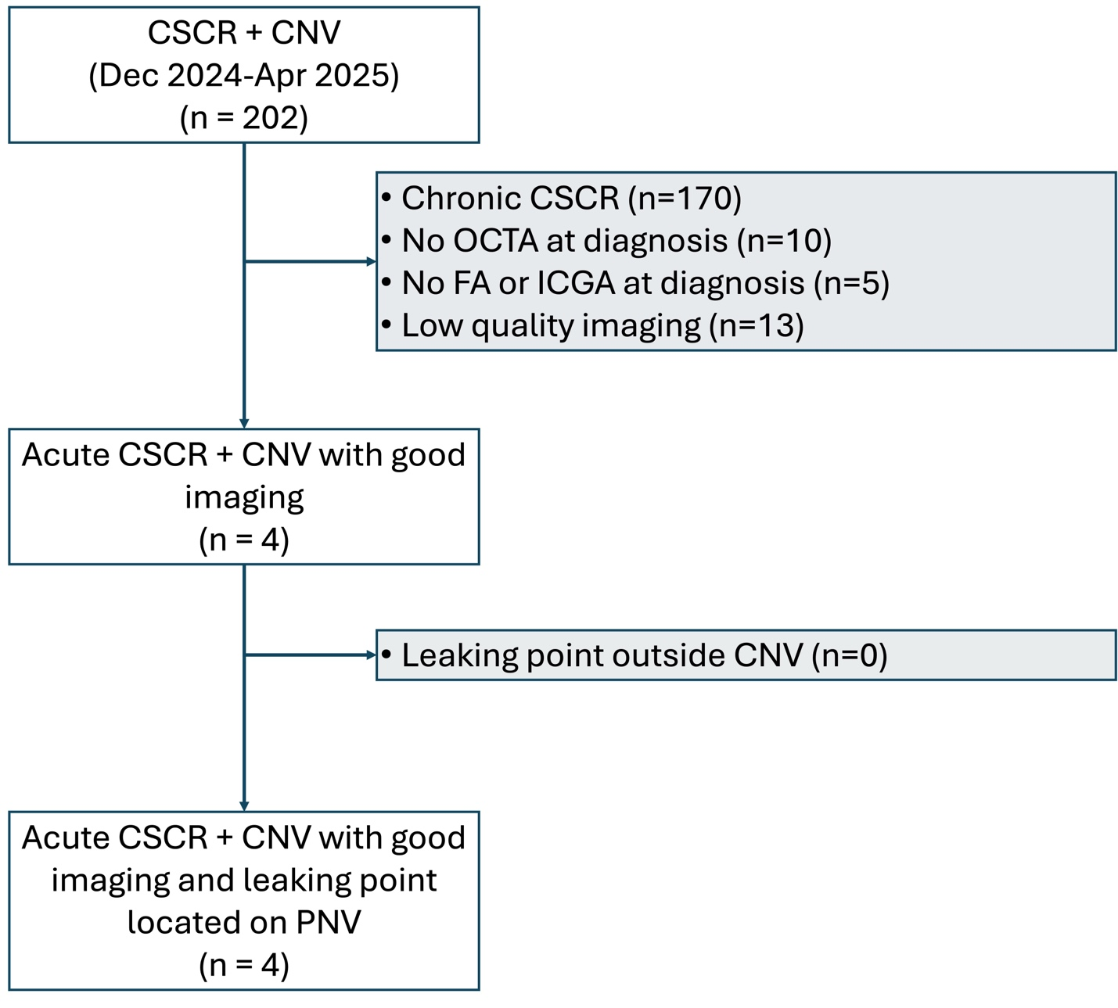
Supplementary Figure 1. Flowchart of patient selection with CSCR and CNV (Dec 2024–Apr 2025). After exclusions, 4 cases of acute CSCR with CNV and good imaging were retained, all showing a leaking point on PNV.

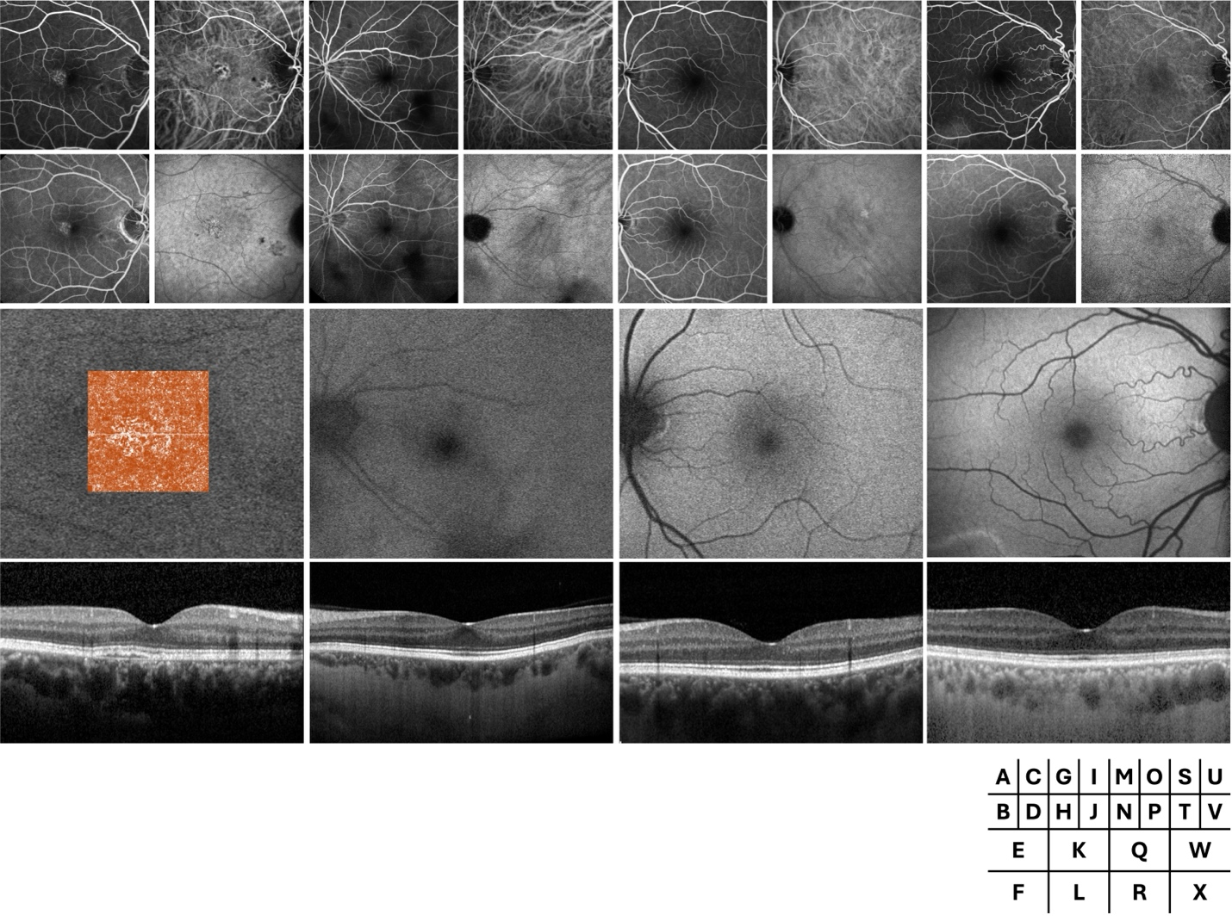
Supplementary Figure 2. Multimodal imaging of the contralateral eyes. For each patient (from left to right: patients 1 to 4), the following modalities are shown: early-phase fluorescein angiography (FA, top left), early-phase indocyanine green angiography (ICGA, top right), late-phase FA (middle left), late-phase ICGA (middle right), blue autofluorescence (BAF, center), and foveal optical coherence tomography (OCT, bottom). In Patient 1, a quiescent choroidal neovascularization (CNV) is visible, with optical coherence tomography angiography (OCTA) superimposed on the BAF image to better localize the lesion.

