Geopolitical risks in energy system models: hindcasting in 31 European countries

Authors: Aleksandr Gavrikov¹*, Xin Wen¹, Lucien Merrone¹, Evelina Trutnevyte¹

¹ Renewable Energy Systems group, Institute for Environmental Sciences (ISE), Section of Earth and Environmental Sciences, University of Geneva, Switzerland
* Corresponding author (Boulevard Carl Vogt 66, CH-1211 Geneva 4, Switzerland; +41 762397366; aleksandr.gavrikov@etu.unige.ch)

Supplementary Information

Contents of Supplementary Information
Figure S1 | Constructed geopolitical indices
Section S2 | Domestic fossil fuel resources of European countries
Figure S3 | Example of evolution of the total installed capacity and the diversification parameter (1/HHI) in the Basic and Diversification versions for two countries: Greece and Portugal.
Figure S4 | Model outputs’ accuracy for all versions (including combinations) and GPIs in absolute values of sMAPE and RMSLE.
Figure S5 | The relative differences of the accuracy indicators (sMAPE and RMSLE) of all created individual versions vs. Basic version for each of the GPI.
Figure S6 | Installed capacities for the United Kingdom in all individual model versions for different GPIs.
Figure S7 | Heatmap with accuracy indicators of all calculated individual model versions for all GPIs for the United Kingdom.
Figure S8 | For 30 countries (except the UK): a. Installed capacities in real-world transition, Basic version, and all other modelled versions for GPR without terrorism GPI. b. Heatmap with computed sMAPE and RSMLE indicators of the Basic version and deviations in all calculated model versions for all GPIs for each country.

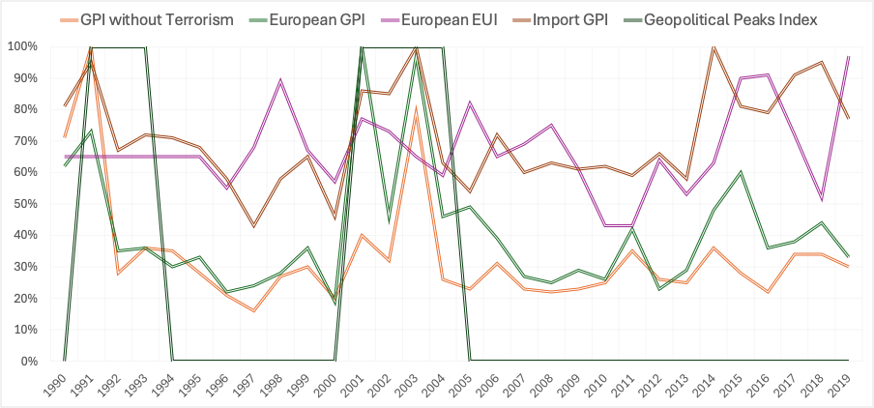
Figure S1. Profiles of constructed geopolitical indices (GPIs) over the period 1990-2019

Section S2. Domestic fossil fuel resources of European countries.
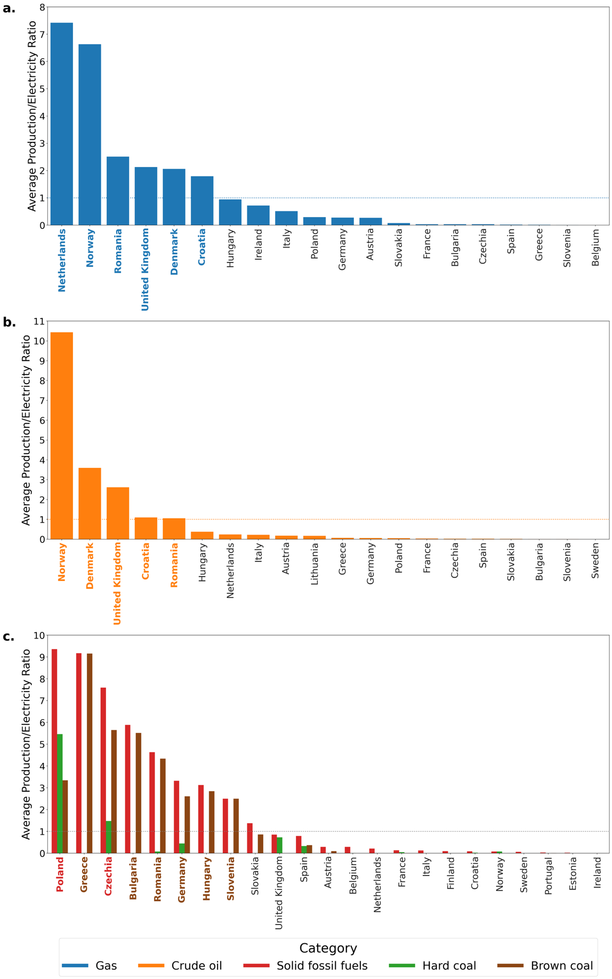
Figure S2. Information for the selection of countries to apply the two model versions focused on domestic resources. The figure shows the ratio of average yearly indigenous production of (a) gas, (b) oil, (c) coal production (in TJ) to yearly electricity generation (in TJ) by country over the period 1990-2019 (source: Eurostat). Countries with values higher than one are highlighted in colour.
As shown, for each type of fossil fuel, only a few countries produce them in significant amounts. Hence, we assume that they can potentially rely on increased electricity production from these sources during periods with elevated geopolitical risks. For the cases when the ratio of average energy production from the source to overall electricity production is greater than one, we consider this type of fossil fuel to be domestic for this country, in addition to all renewable sources mentioned in the main text. The table with countries and their domestic fossil fuels is Table S2.
Table S2 European countries and their domestic fossil fuels.
Fossil fuel | Countries with significant resources
Gas | Denmark, United Kingdom, Croatia, Netherlands, Norway, Romania
Oil | Denmark, United Kingdom, Croatia, Norway, Romania
Brown coal | Bulgaria, Czech Republic, Germany, Greece, Hungary, Poland, Romania, Slovenia
Hard coal | Czech Republic, Poland

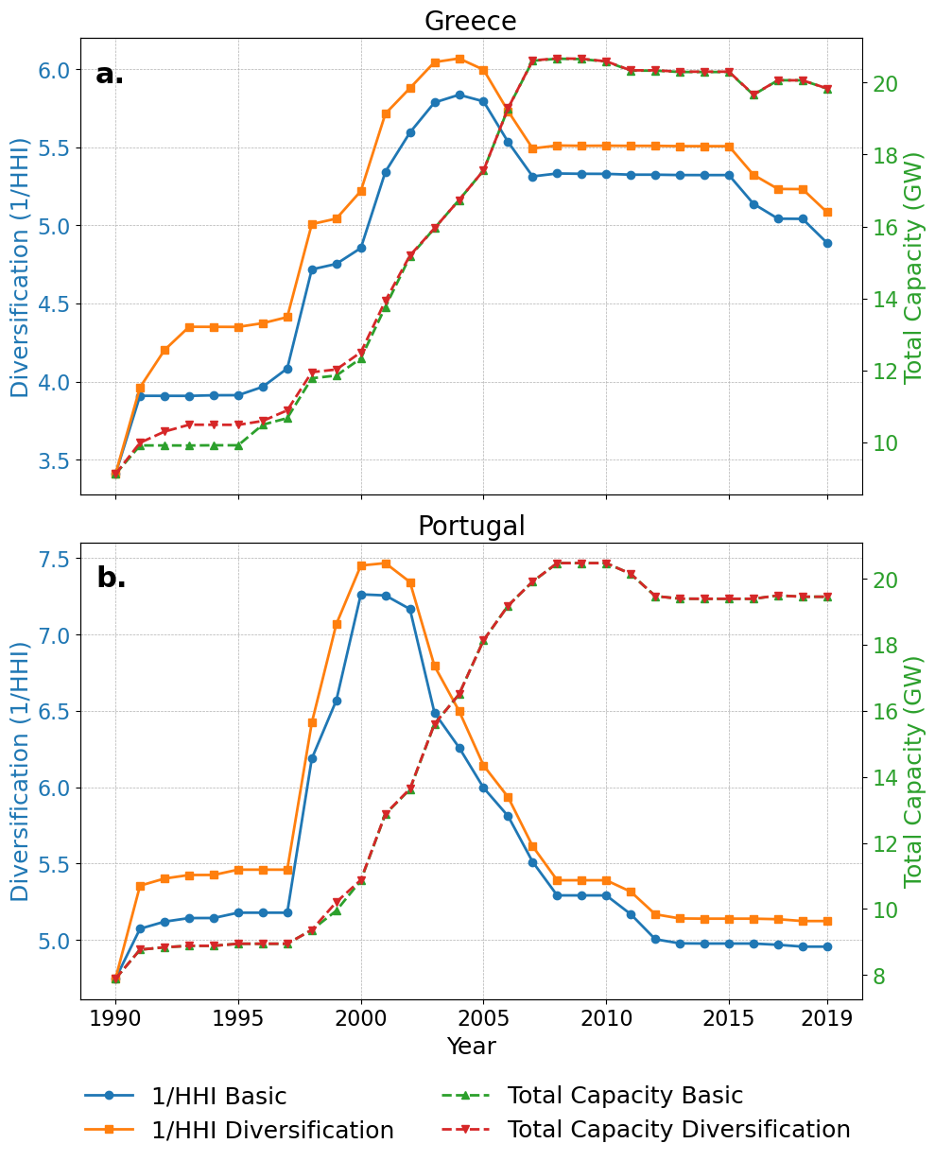
Figure S3. Evolution of the total installed capacity and the diversification parameter (1/HHI) in the Basic and Diversification versions for two countries: (a) Greece and (b) Portugal

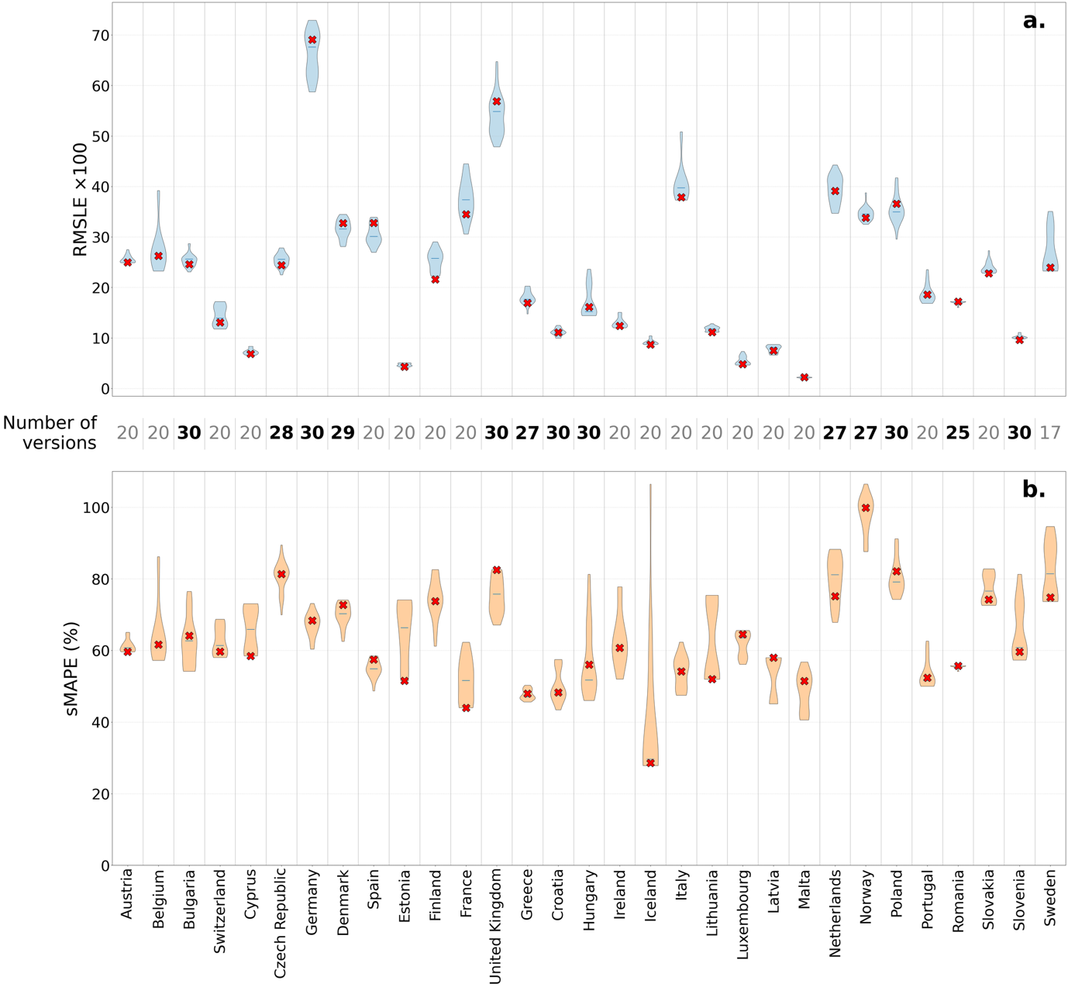
Figure S4. Accuracy of the modeled pathways quantified by absolute values of (a) RSMLE and (b) sMAPE for all different model versions for each of the five GPIs (in total 30 versions per country at maximum). Basic versions are shown with red crosses. Higher values mean lower accuracy. The total number of model versions that compute feasible solutions is shown between the plots; numbers for countries with domestic fossil fuels are written in bold.

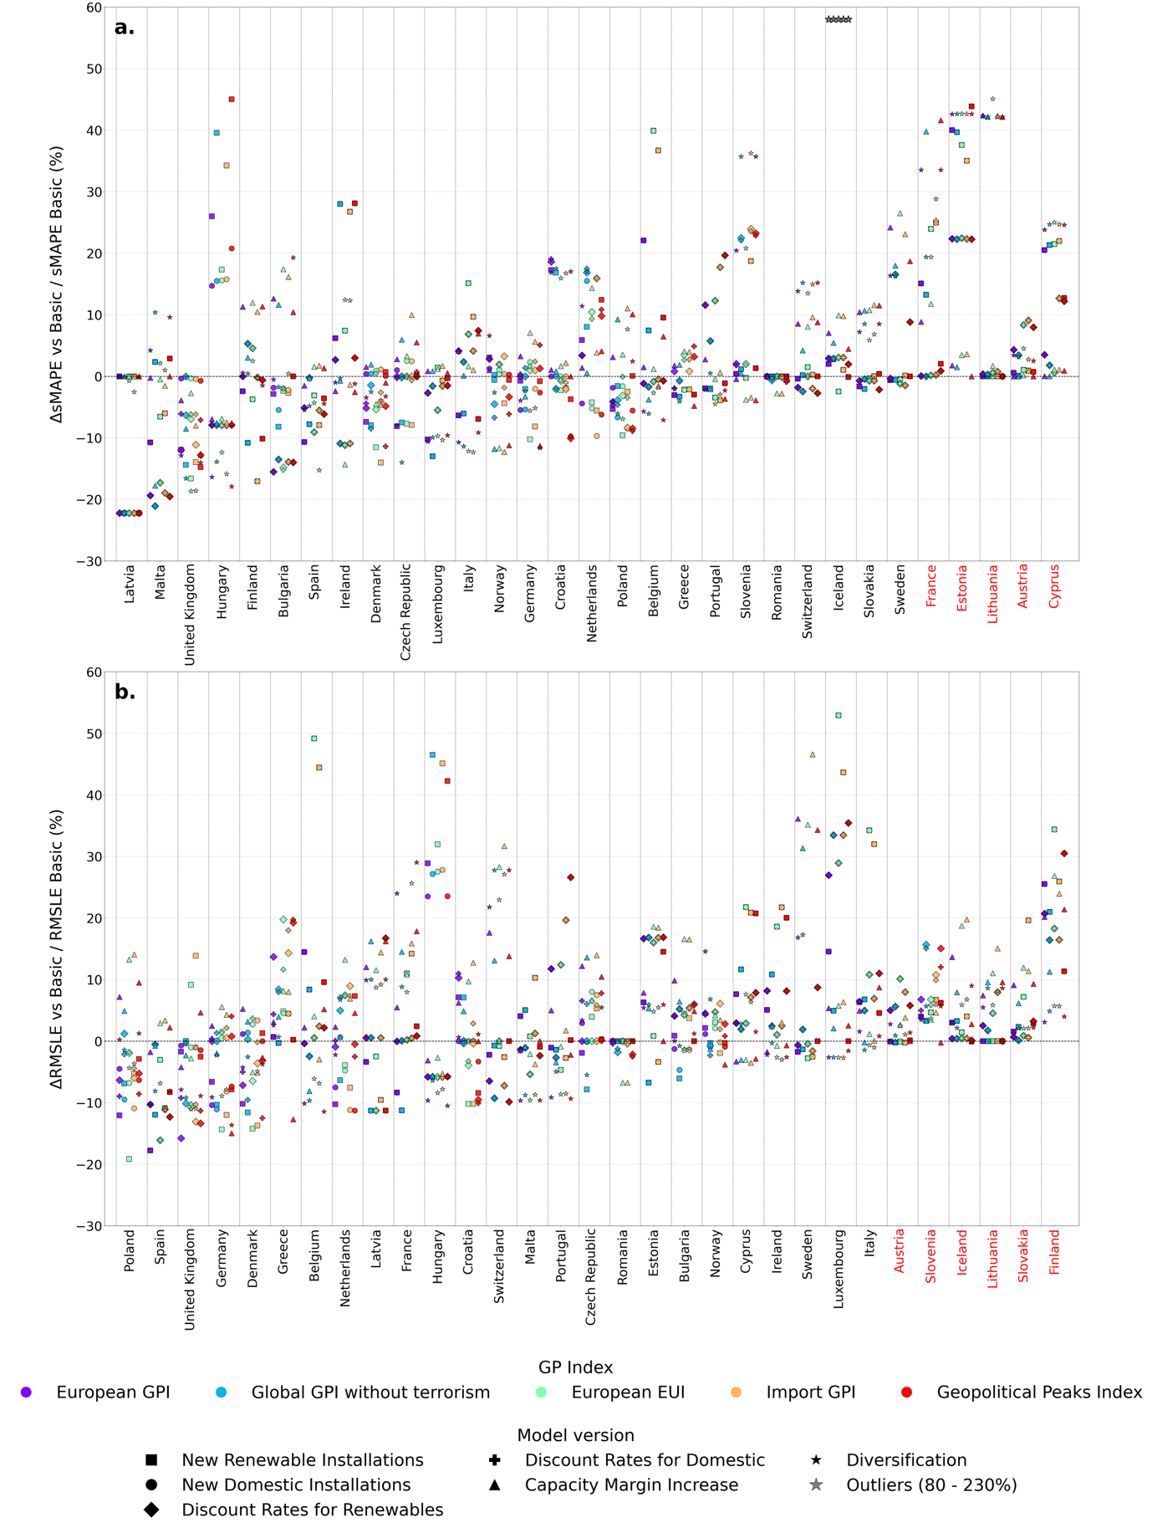
Figure S5. Scatter plots with calculated relative differences in (a) sMAPE and (b) RSMLE between the Basic and calculated model versions for each of the GPI across all countries. Countries are listed in order from highest to lowest RSMLE improvement of the best-performed version. Countries with no improvement of at least 1% in any version are coloured red.
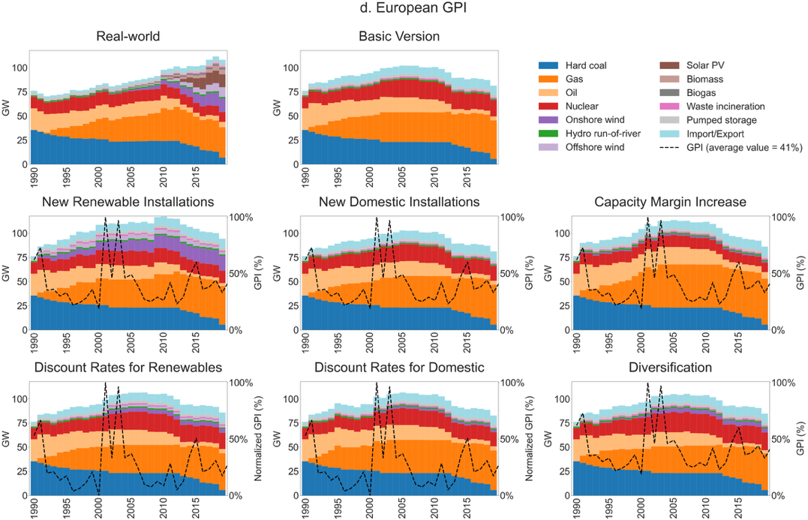
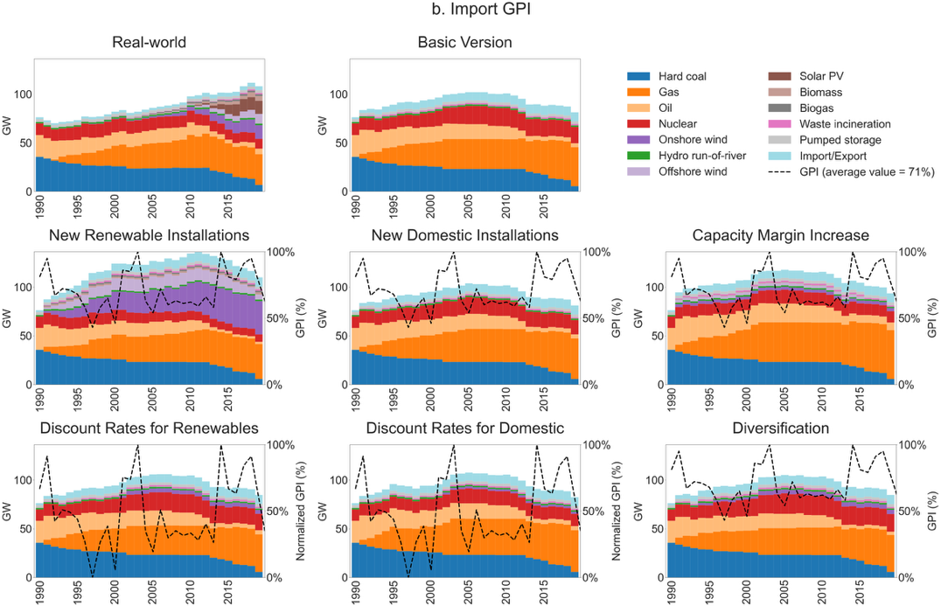
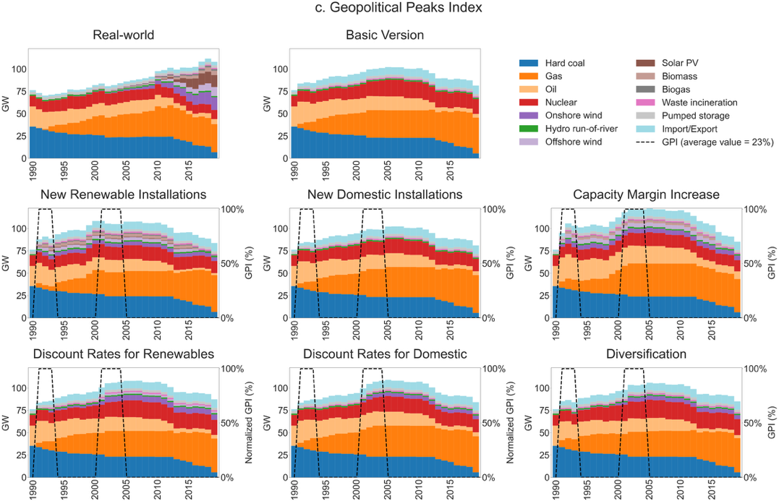
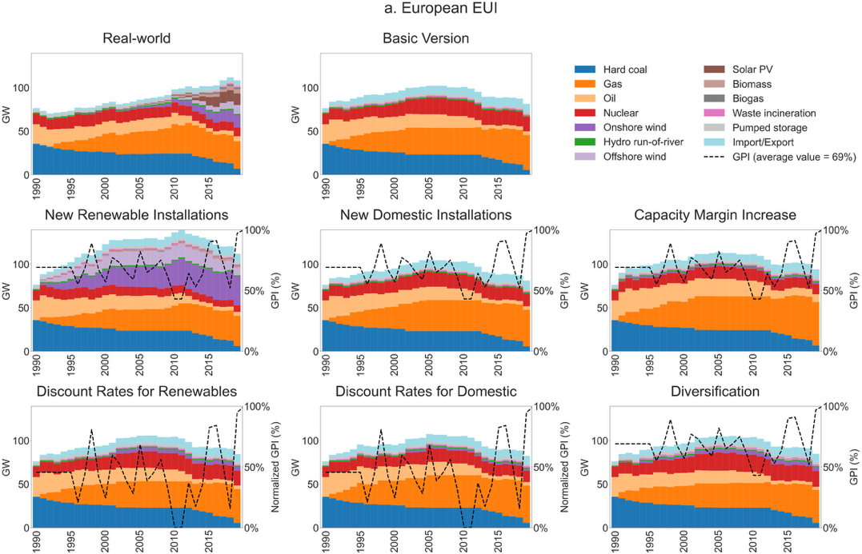
Figure S6. Installed capacities for the United Kingdom in all individual model versions for (a) European EUI, (b) Import GPI, (c) Geopolitical Peaks Index,
(d) European GPI. The GPR without terrorism GPI is presented in the main text (Figure 2)
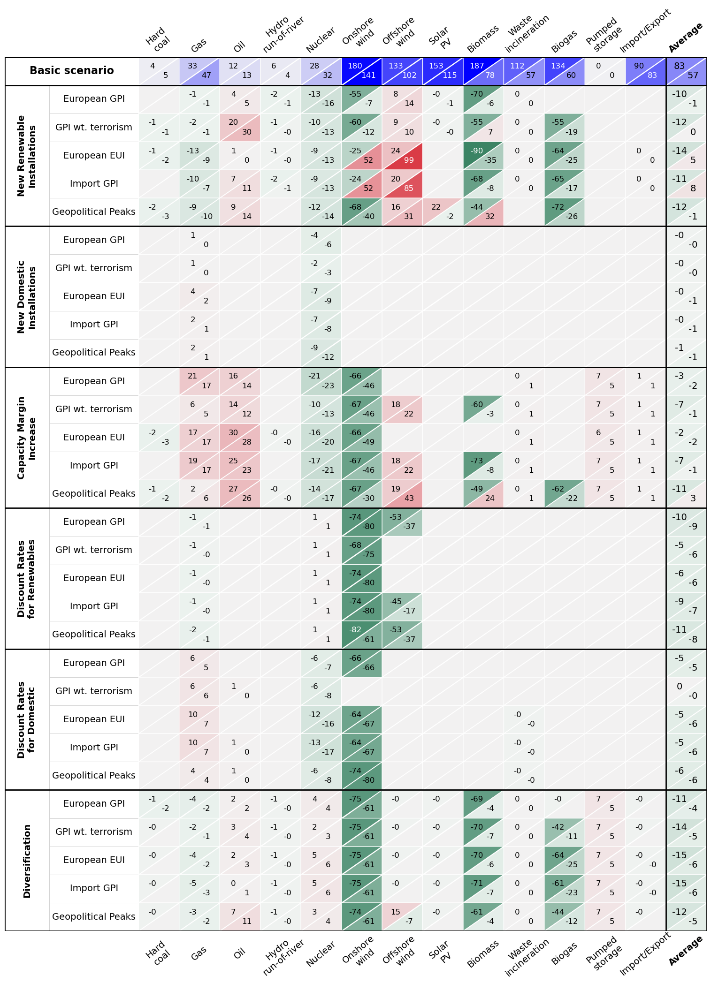
Figure S7. Heatmap with computed sMAPE (top-left) and RMSLE (bottom-right) indicators of the Basic version and deviations in all calculated individual model versions for all GPIs for the United Kingdom. All values ×100.
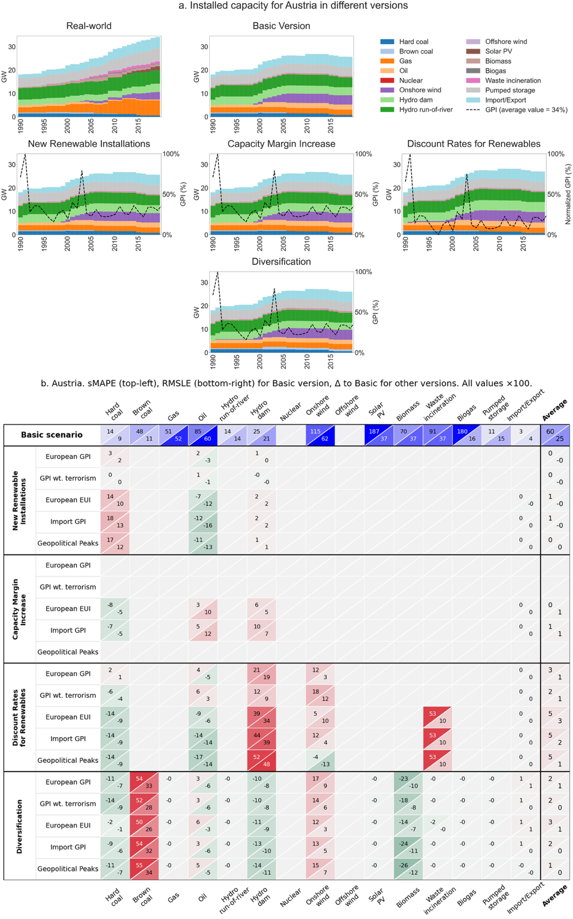
Fig. S8-1. Austria
Figures S8. For 30 countries (except the UK): (a) installed capacities in real-world transition in 1990-2019, Basic model version, and six different model versions, using Global GPI without terrorism as index, and (b) heatmap with computed sMAPE and RSMLE indicators of the Basic model version and error differences in all other model versions with all GPIs. For the Basic version, absolute values of indicators are shown; for all other versions, the differences with the Basic version as a ratio are shown. Higher values signify less accurate model outputs; hence more accurate outputs are colored green and less accurate colored red.
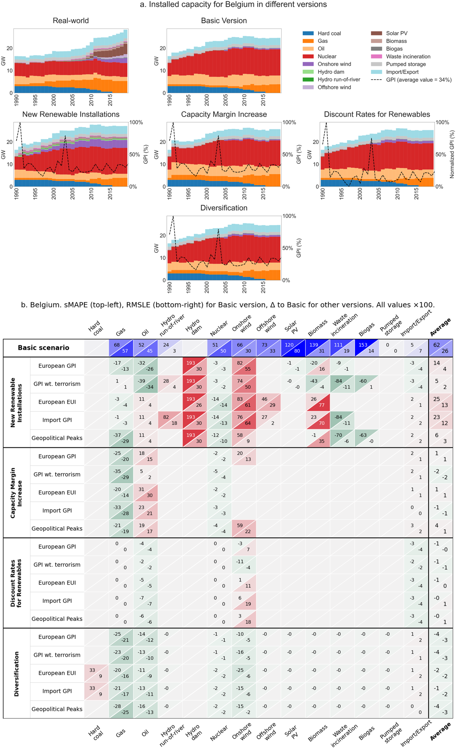
Fig. S8-2. Belgium
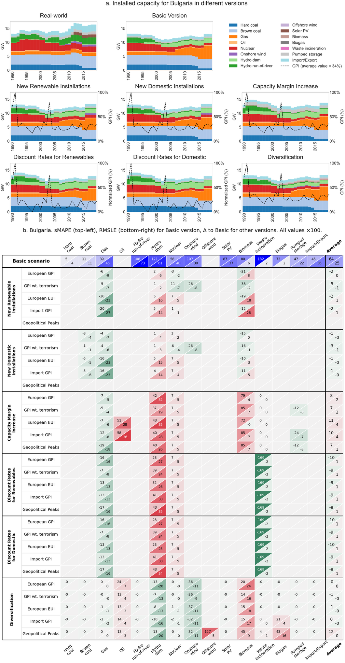
Fig. S8-3. Bulgaria
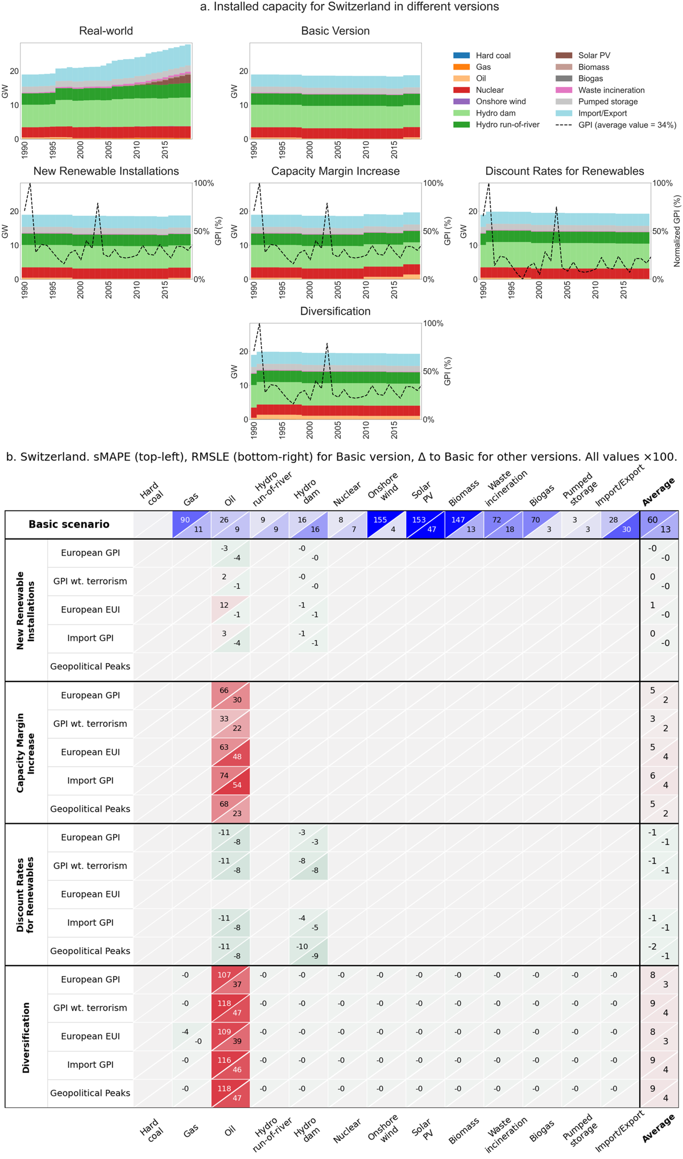
Fig. S8-4. Switzerland
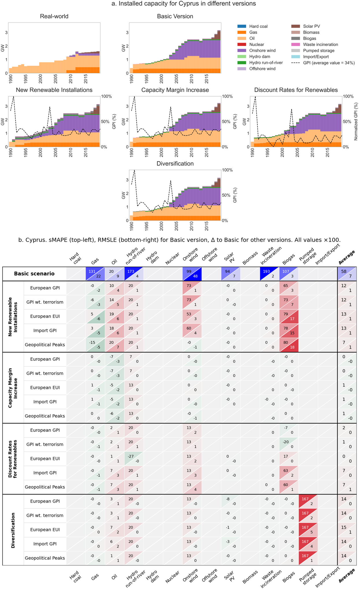
Fig. S8-5. Cyprus
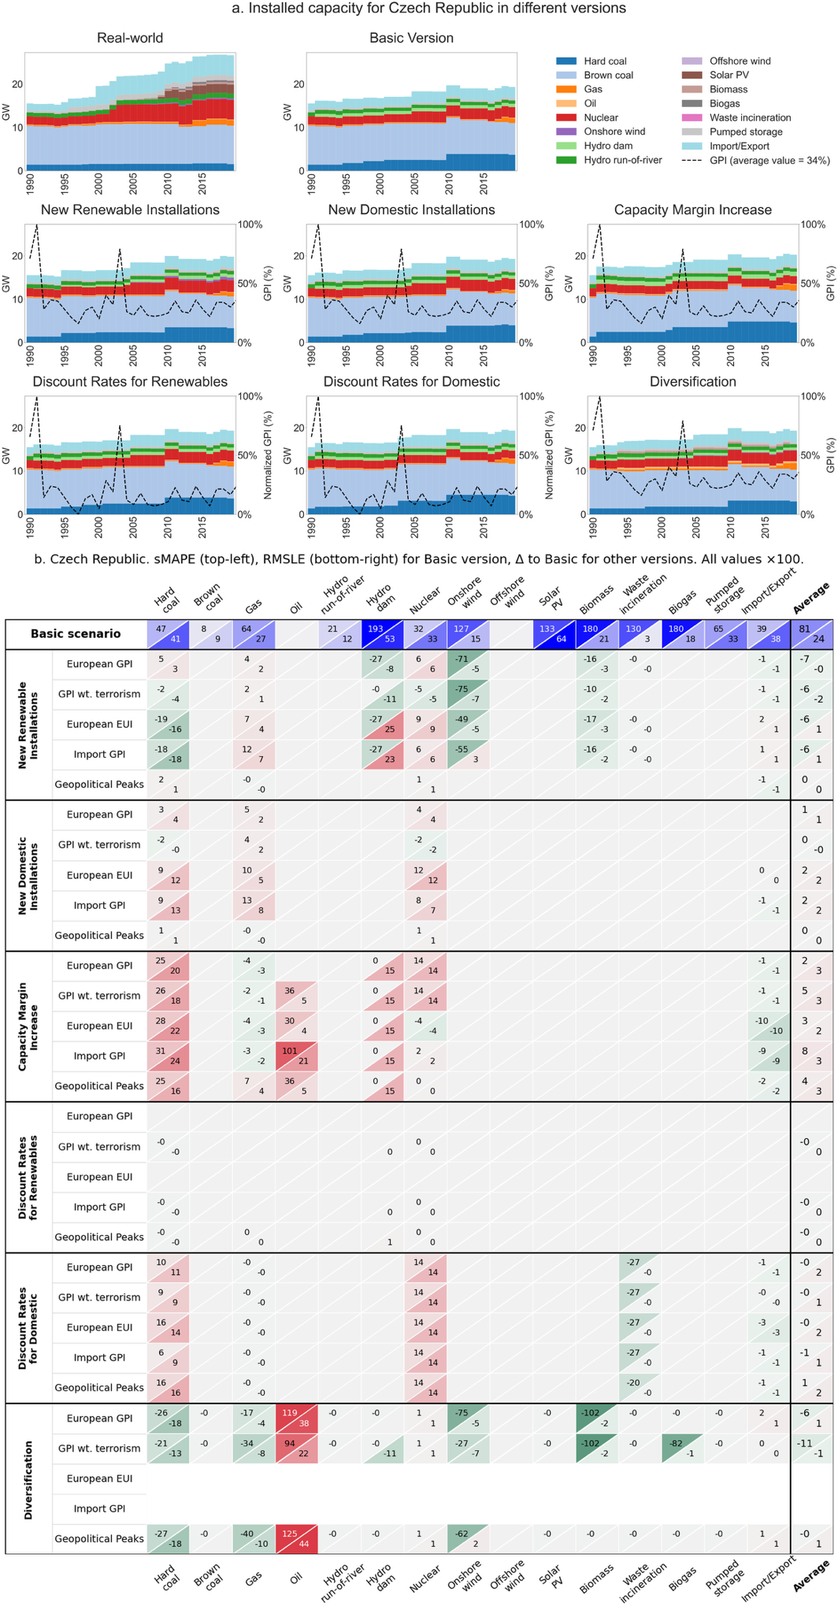
Fig. S8-6. Czech Republic
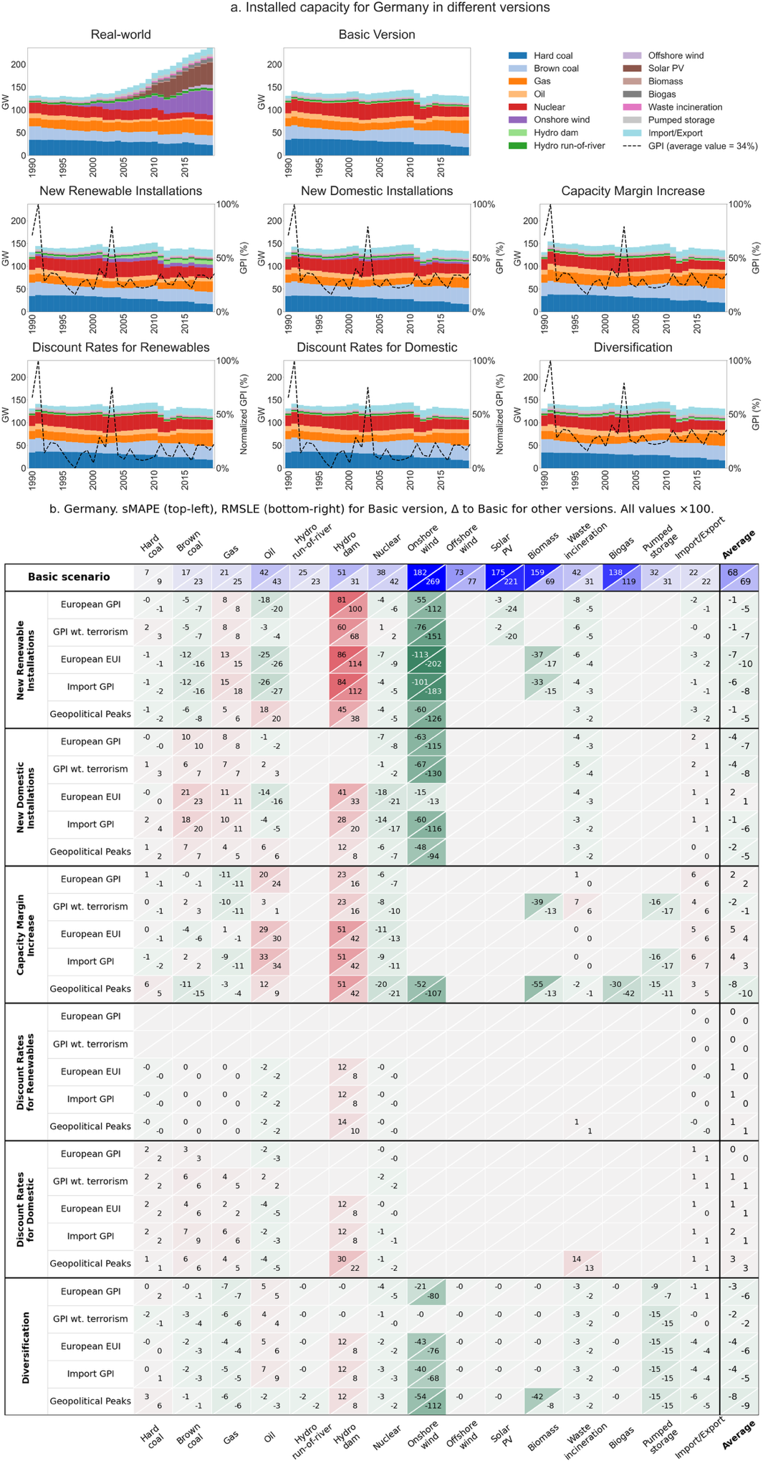
Fig. S8-7. Germany
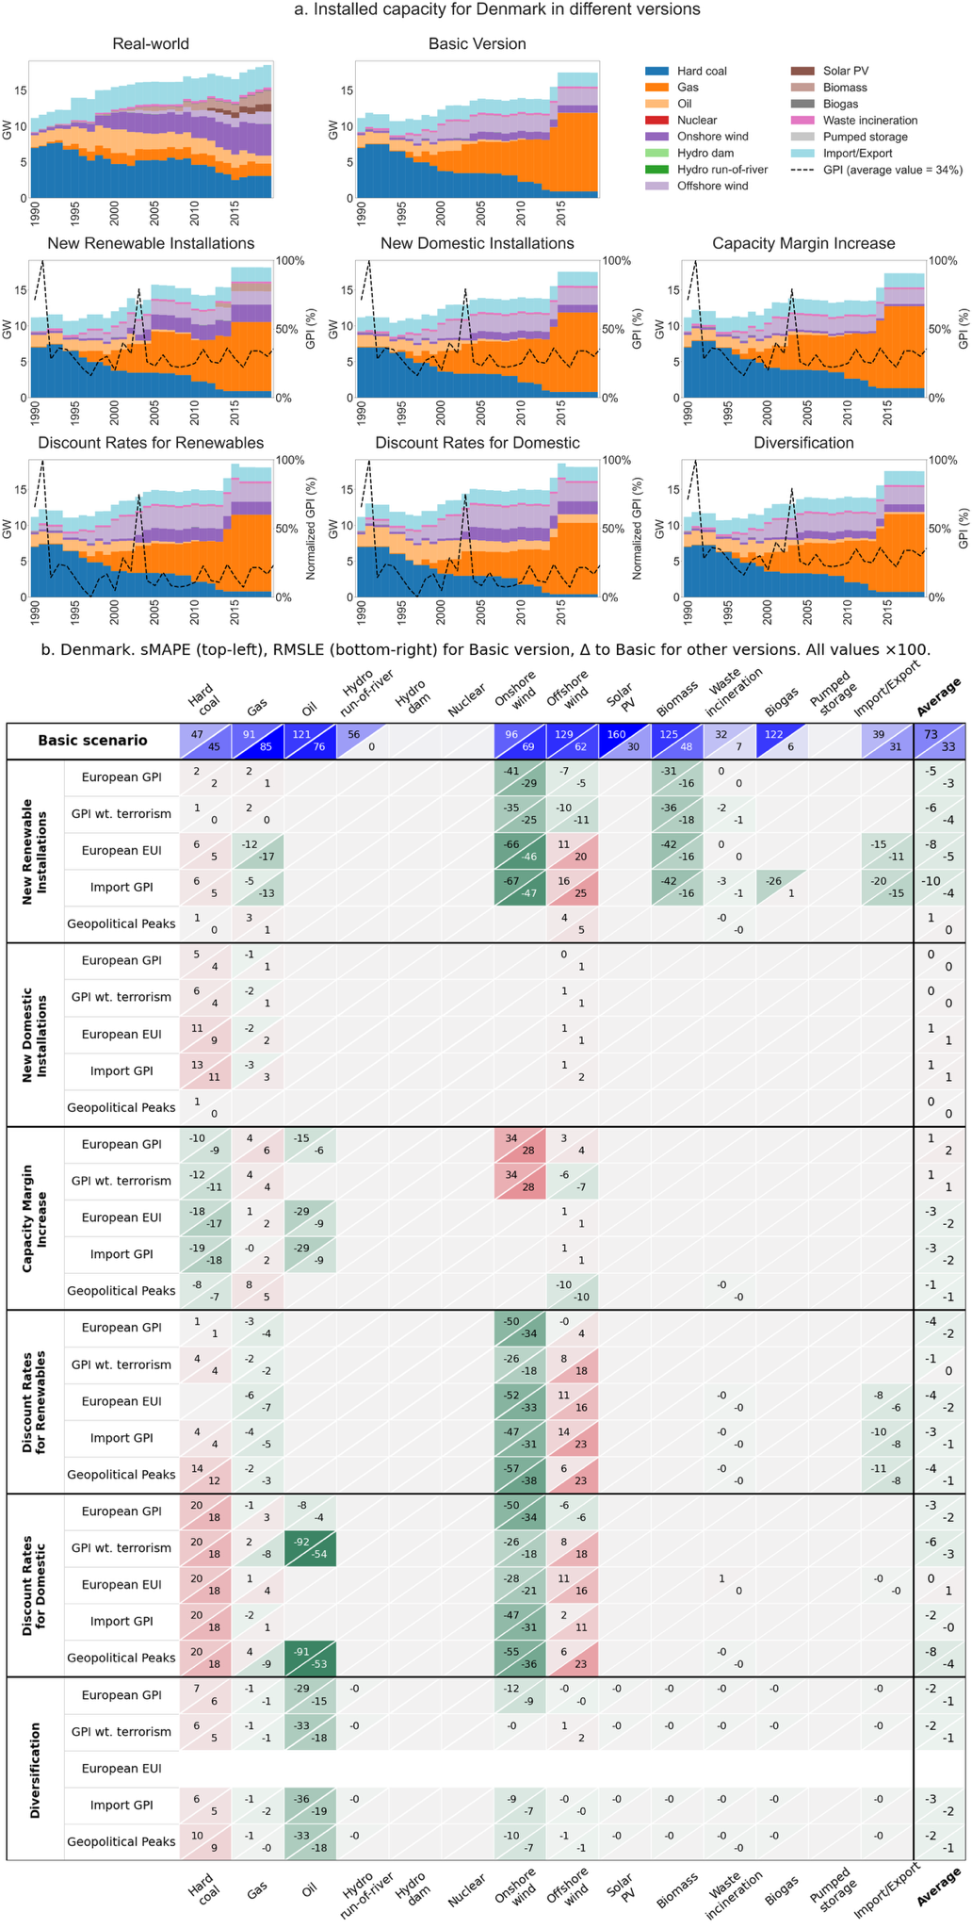
Fig. S8-8. Denmark
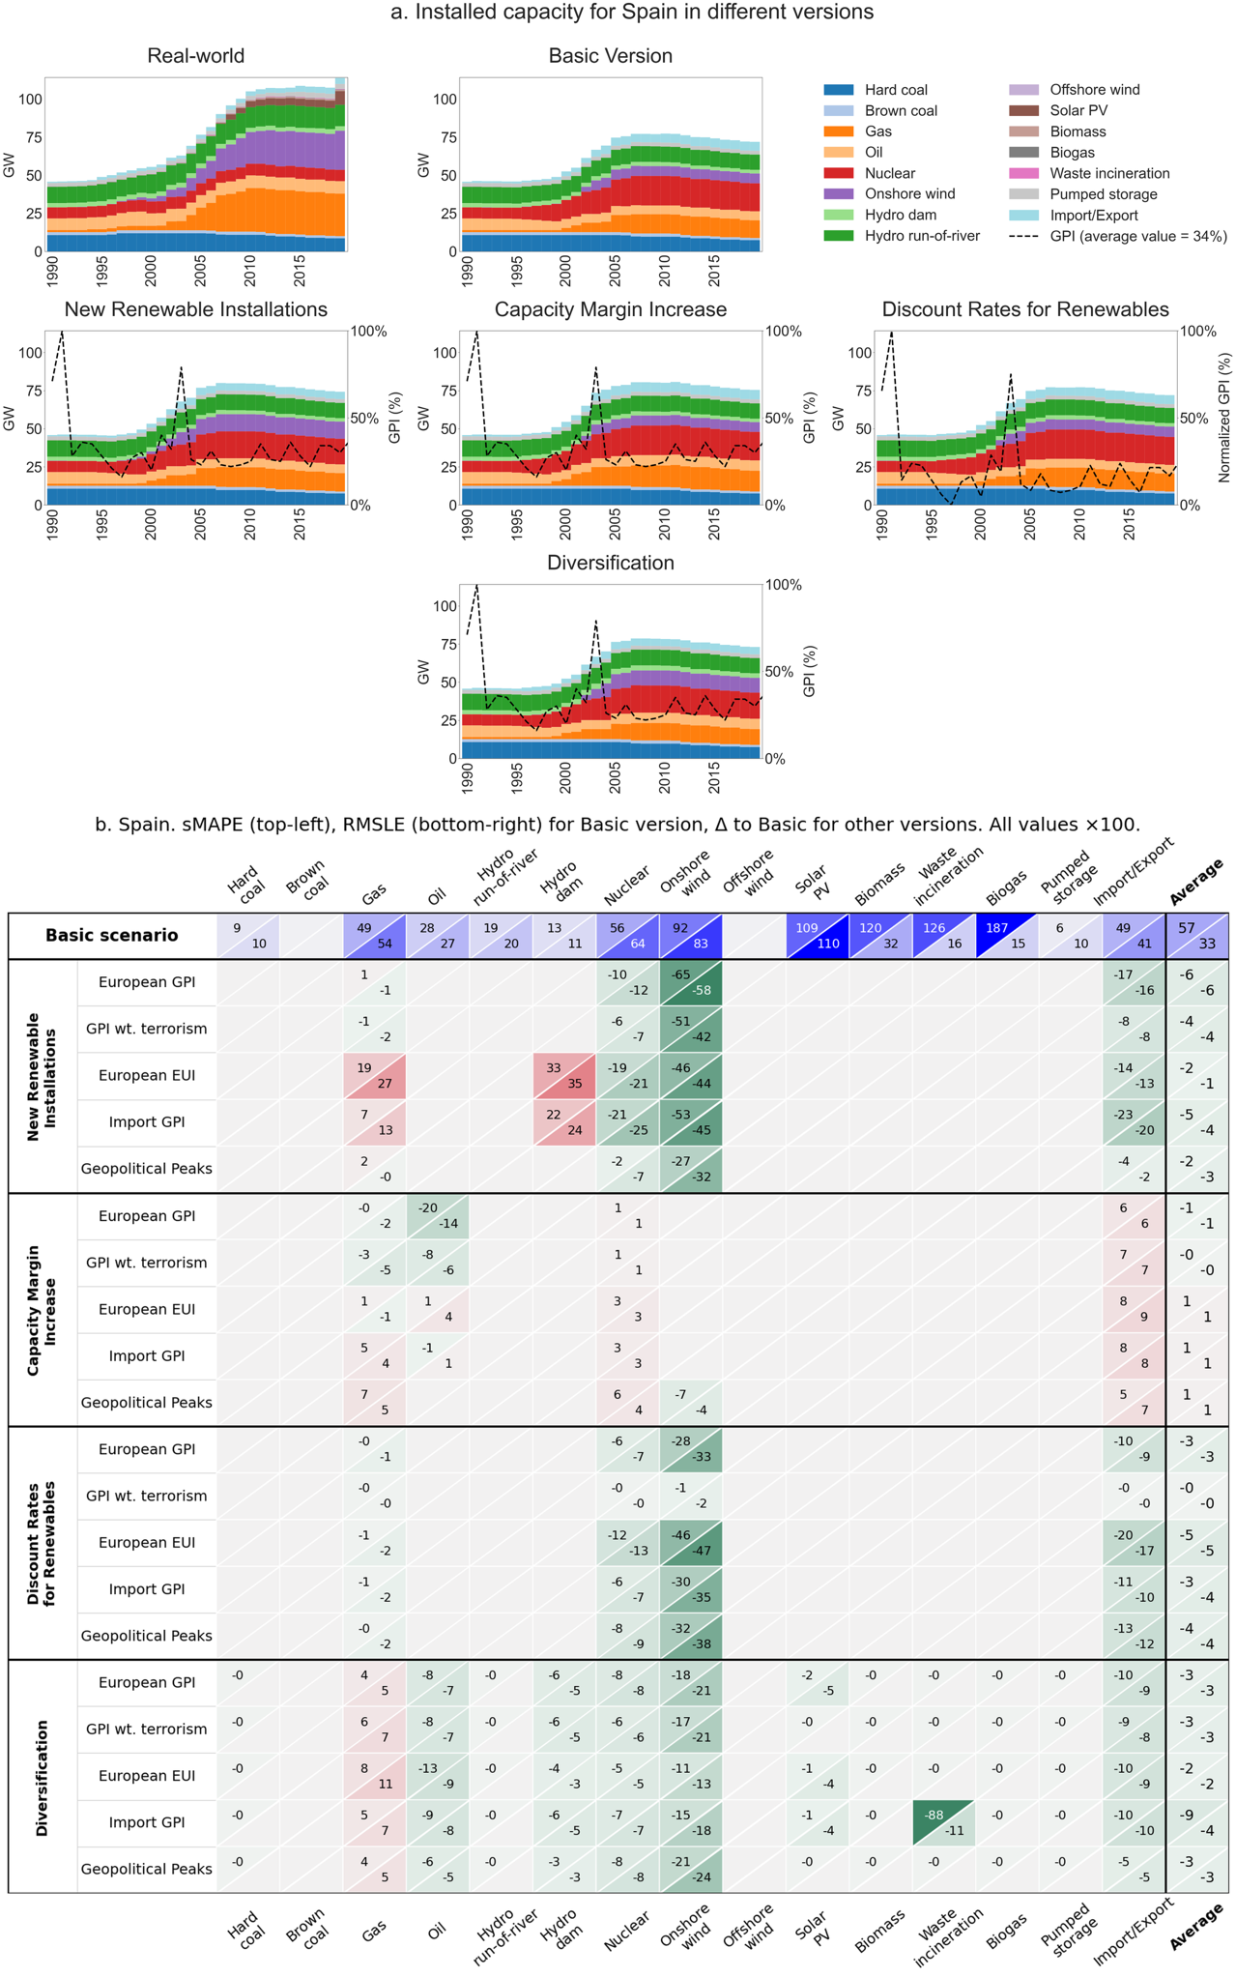
Fig. S8-9. Spain
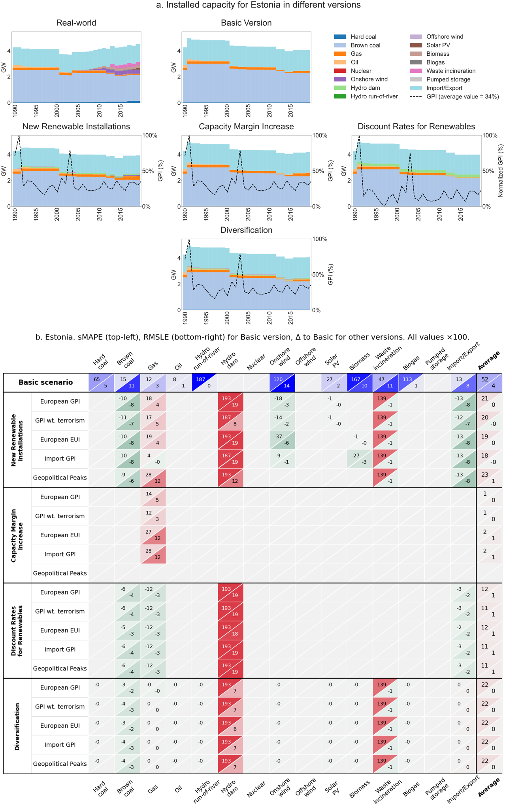
Fig. S8-10. Estonia
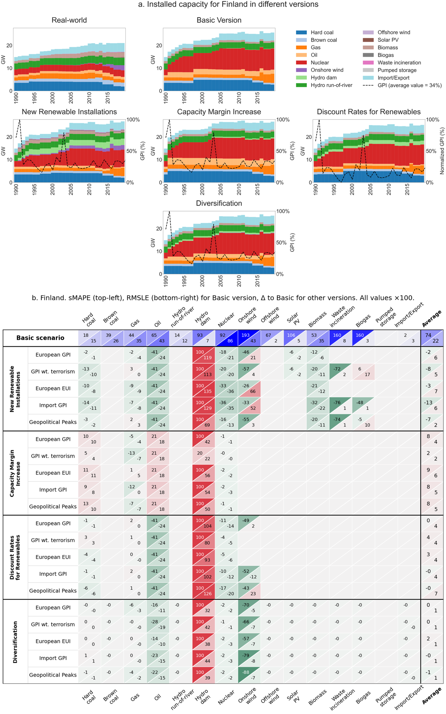
Fig. S8-11. Finland
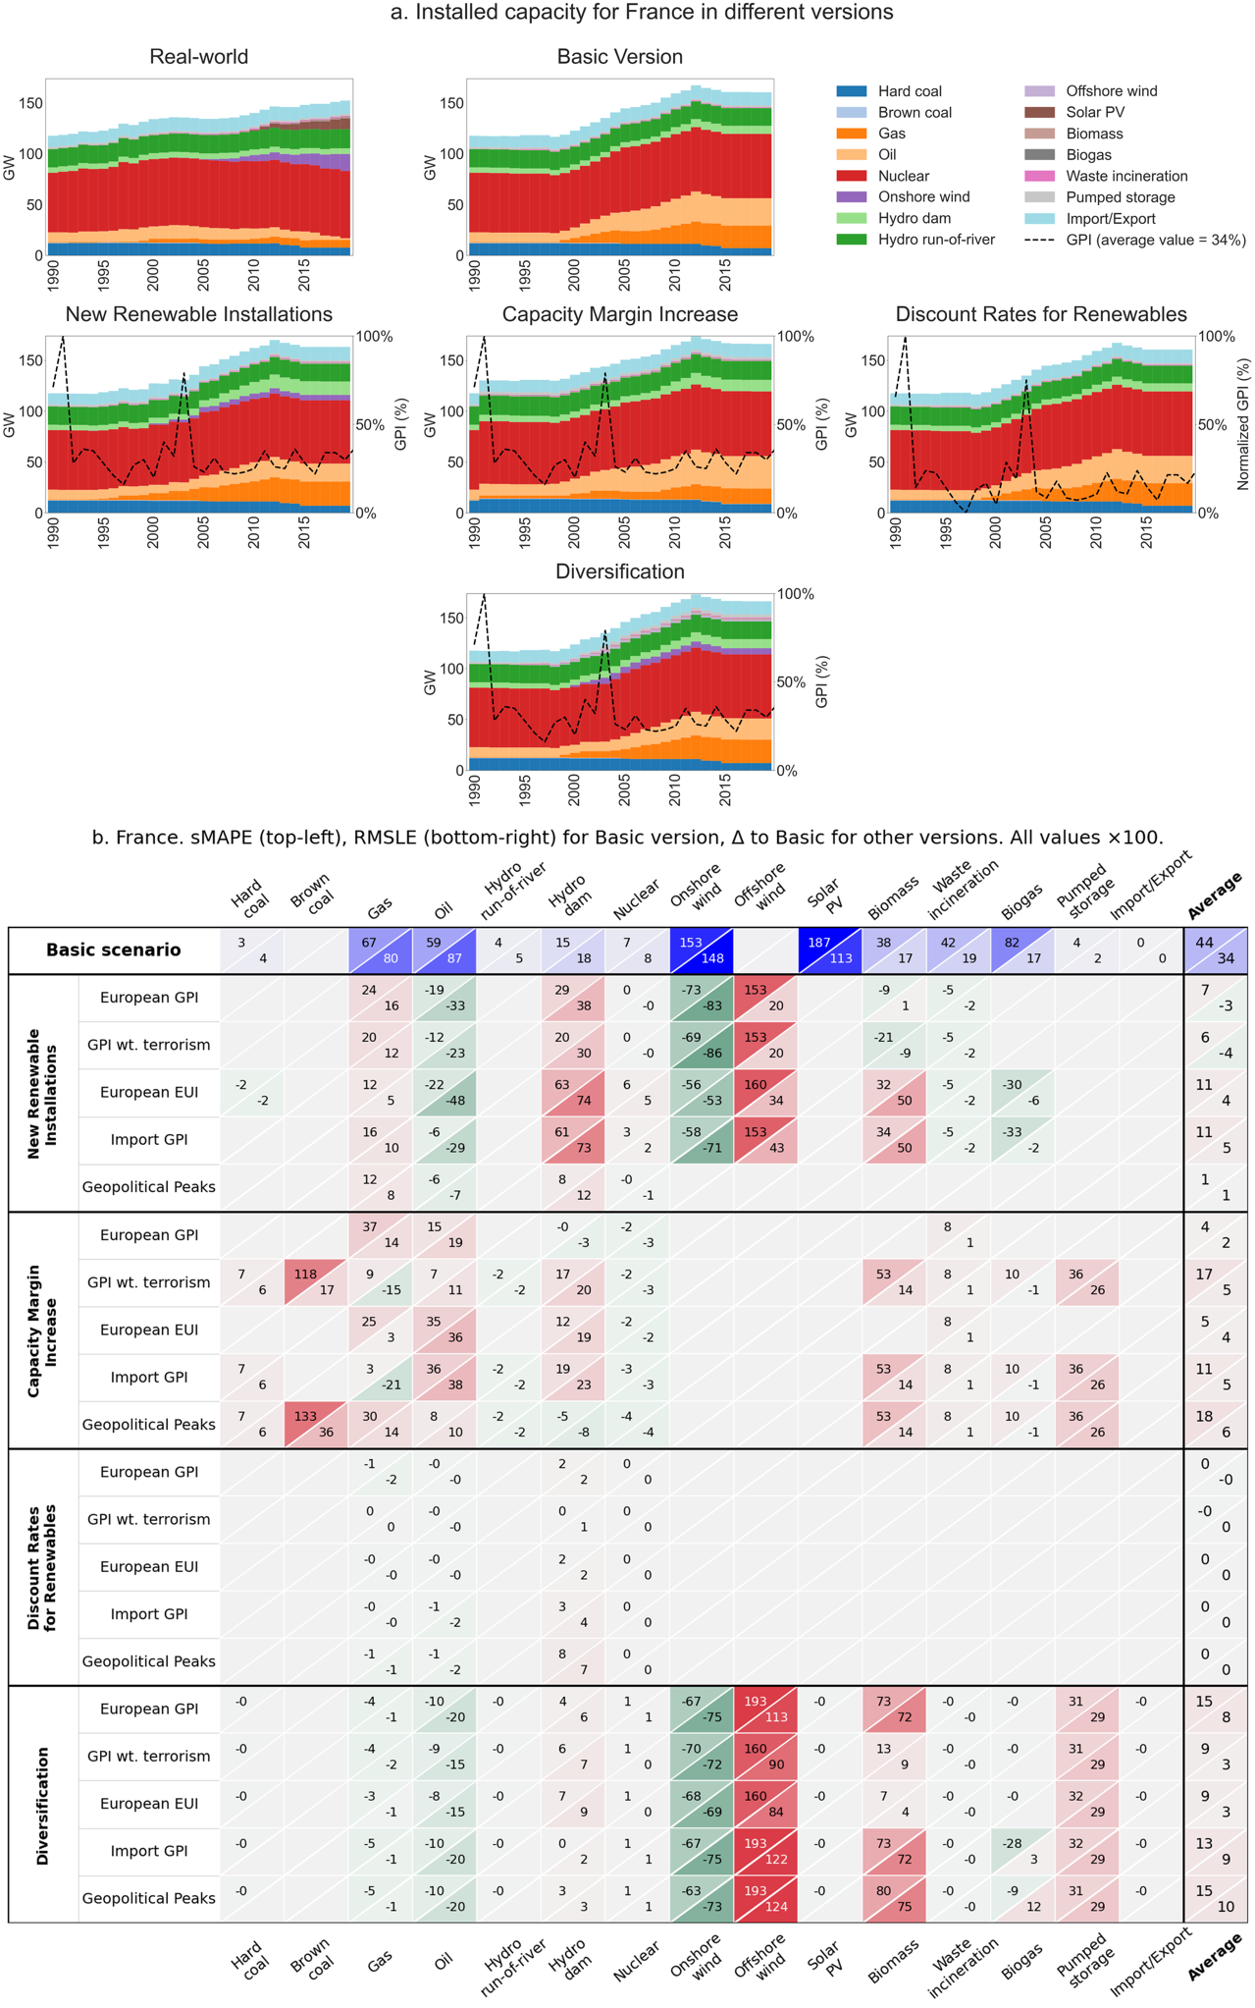
Fig. S8-12. France
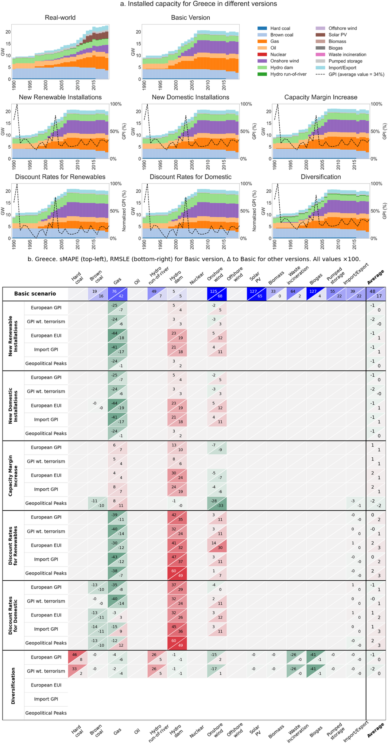
Fig. S8-13. Greece
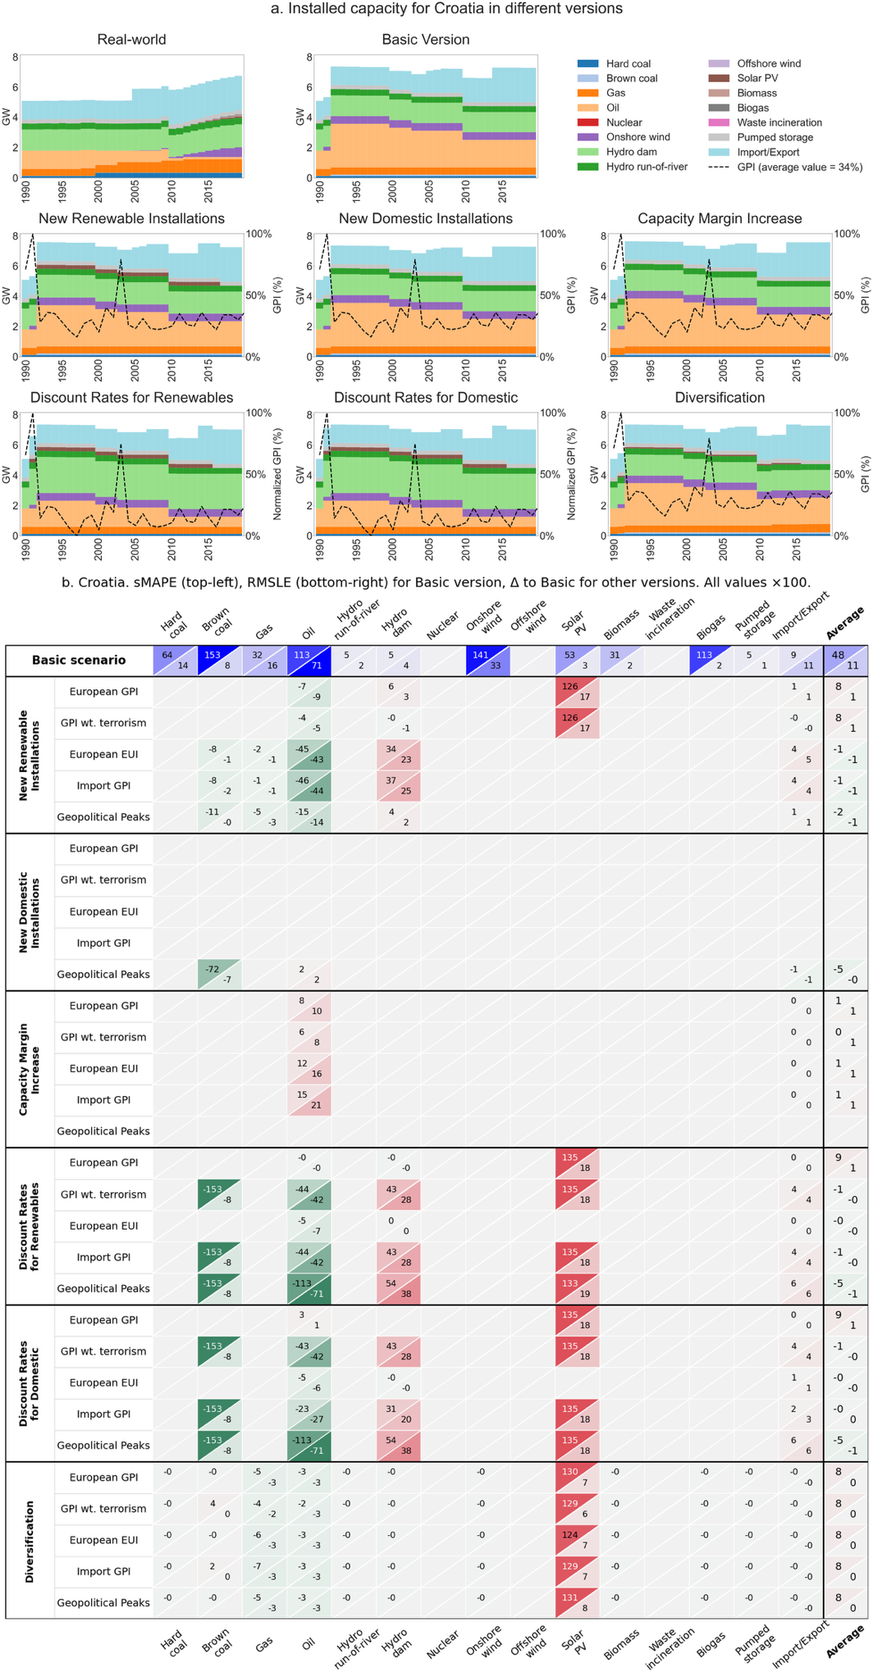
Fig. S8-14. Croatia
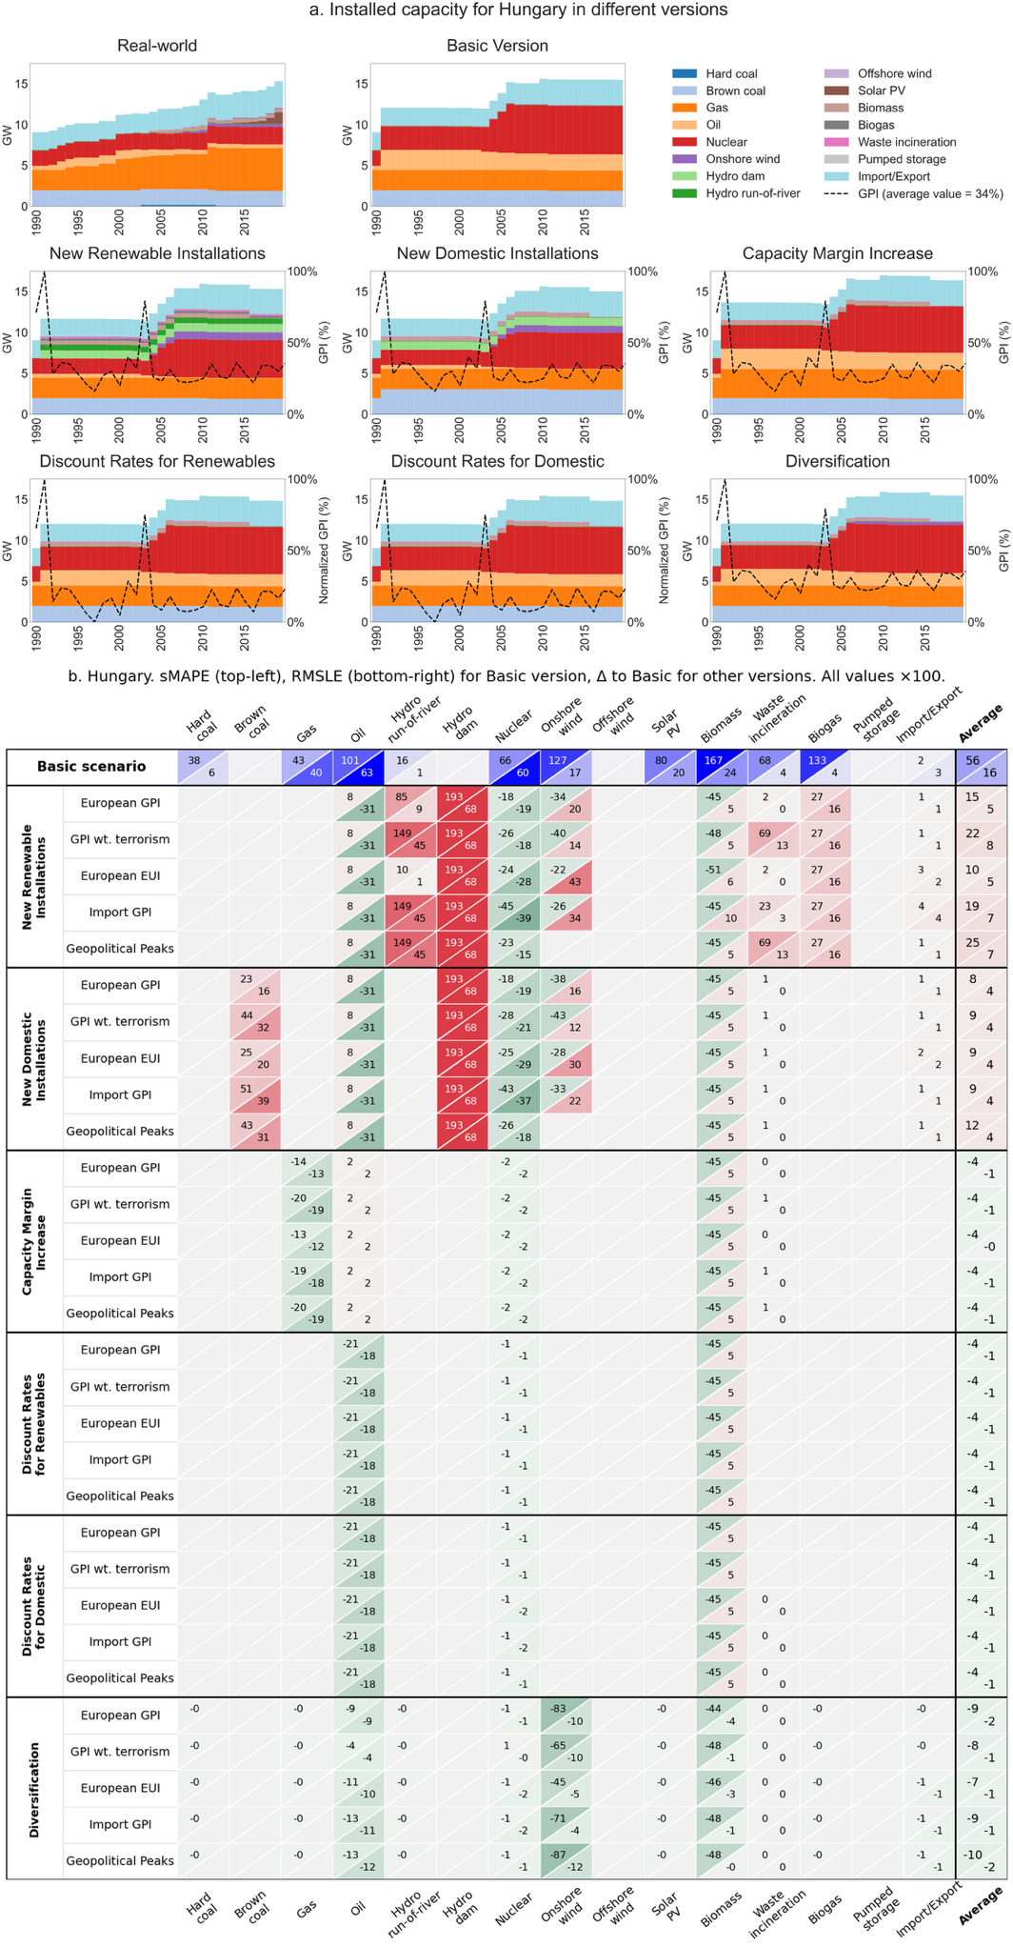
Fig. S8-15. Hungary
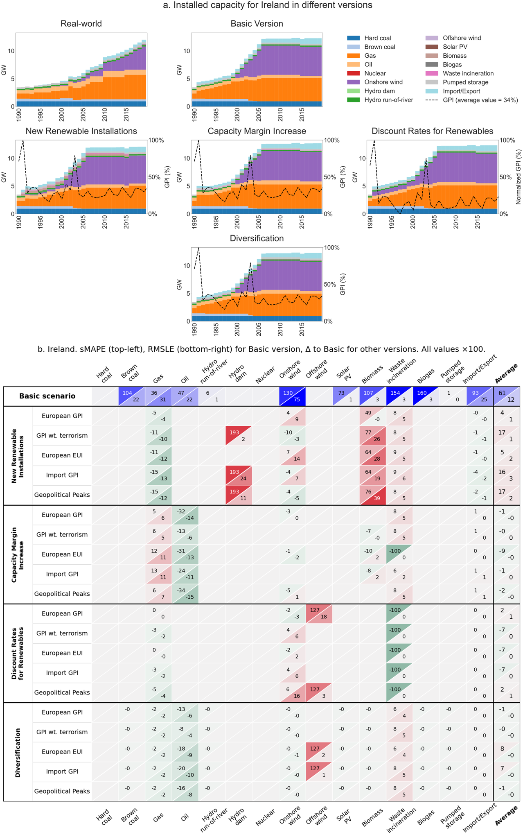
Fig. S8-16. Ireland
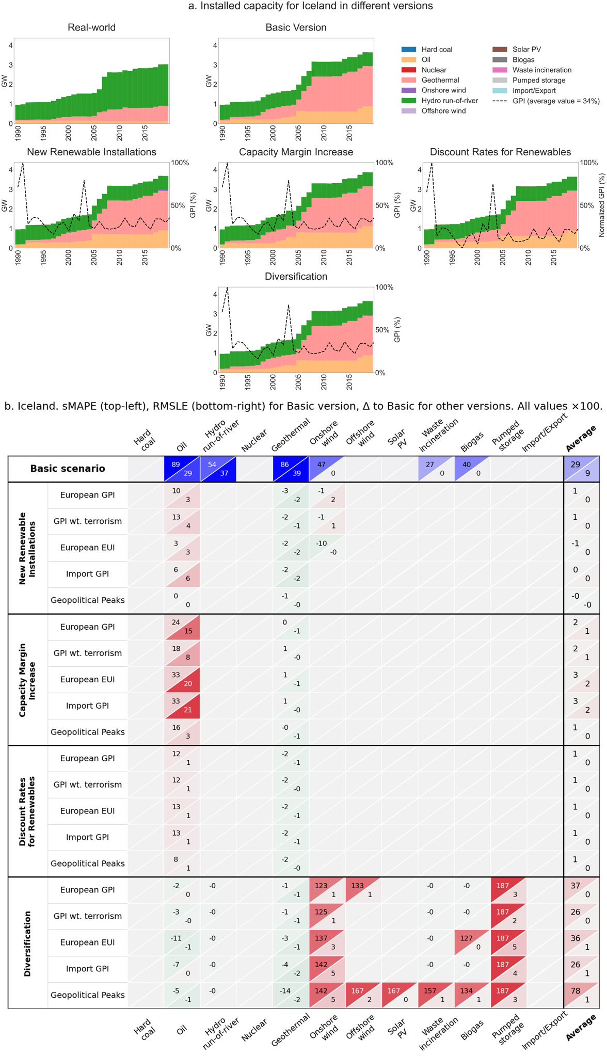
Fig. S8-17. Iceland
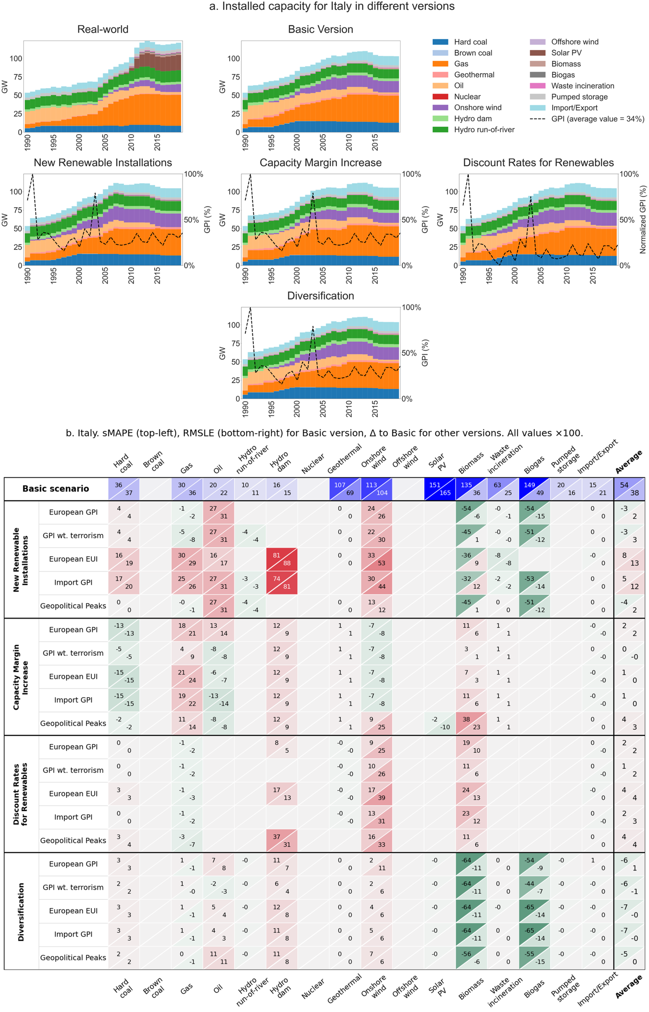
Fig. S8-18. Italy
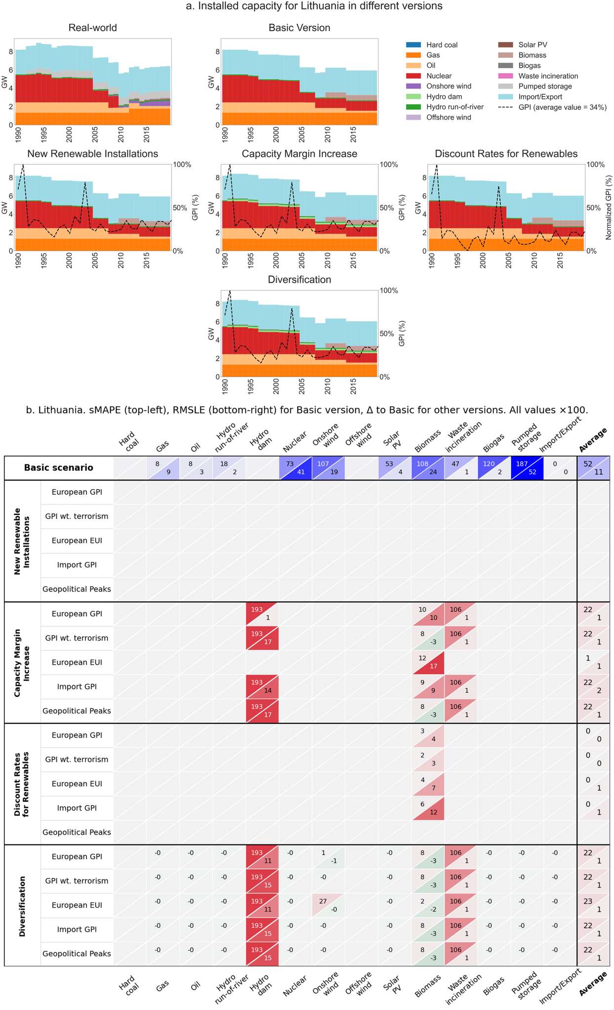
Fig. S8-19. Lithuania
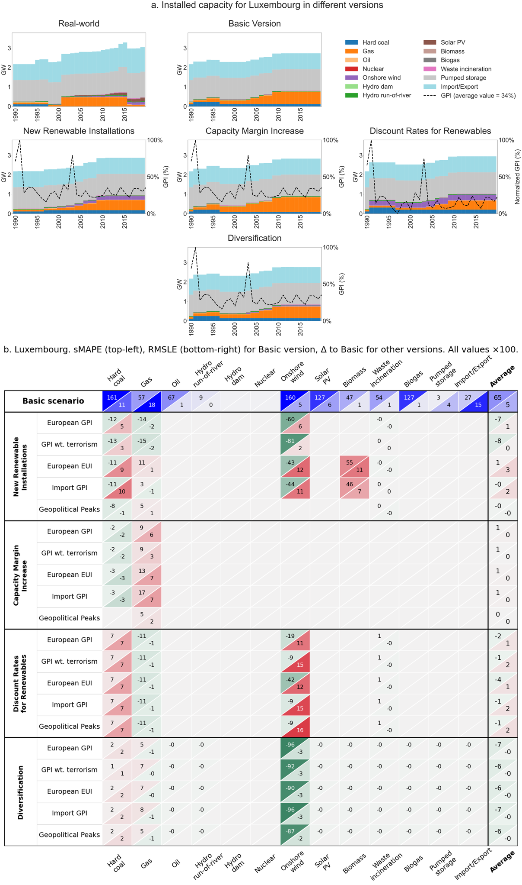
Fig. S8-20. Luxembourg
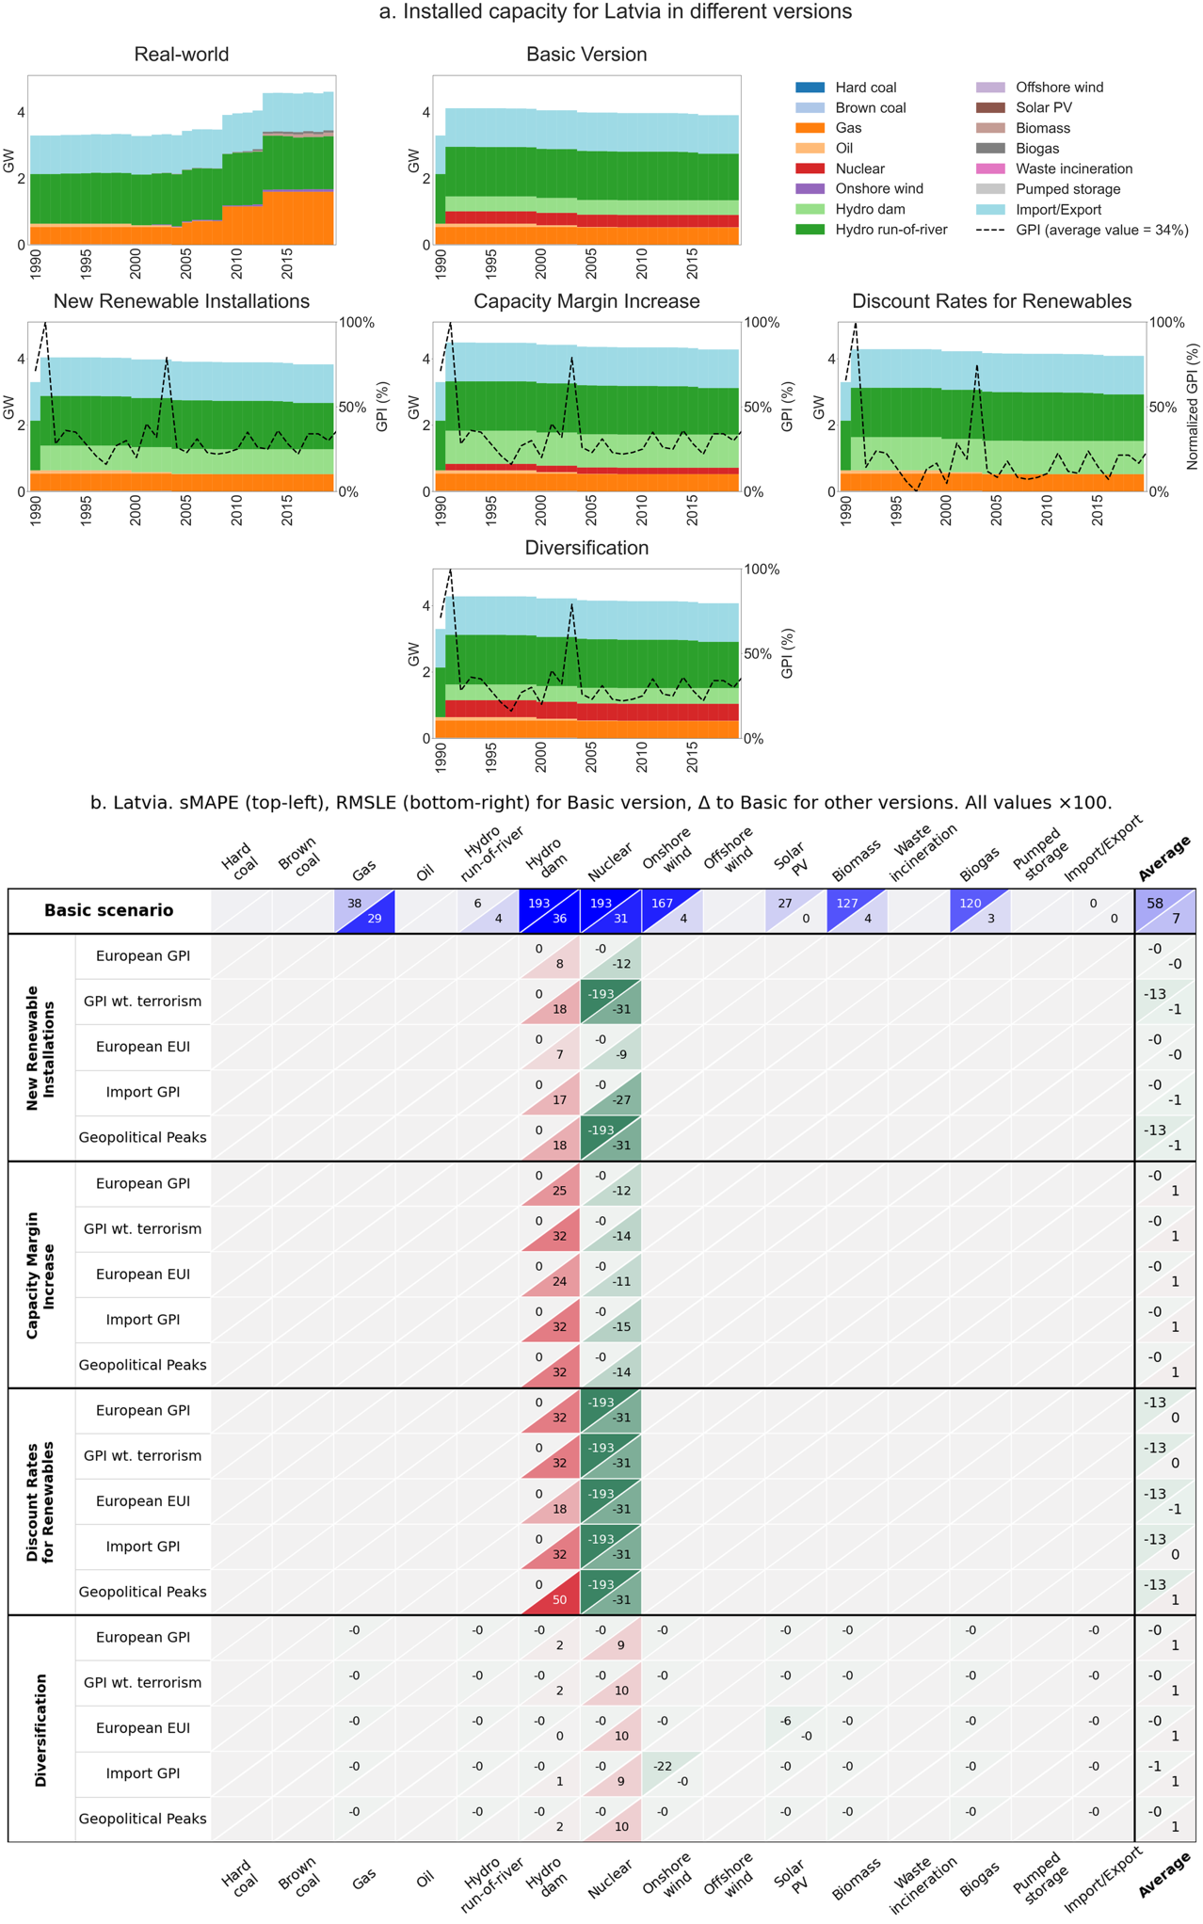
Fig. S8-21. Latvia
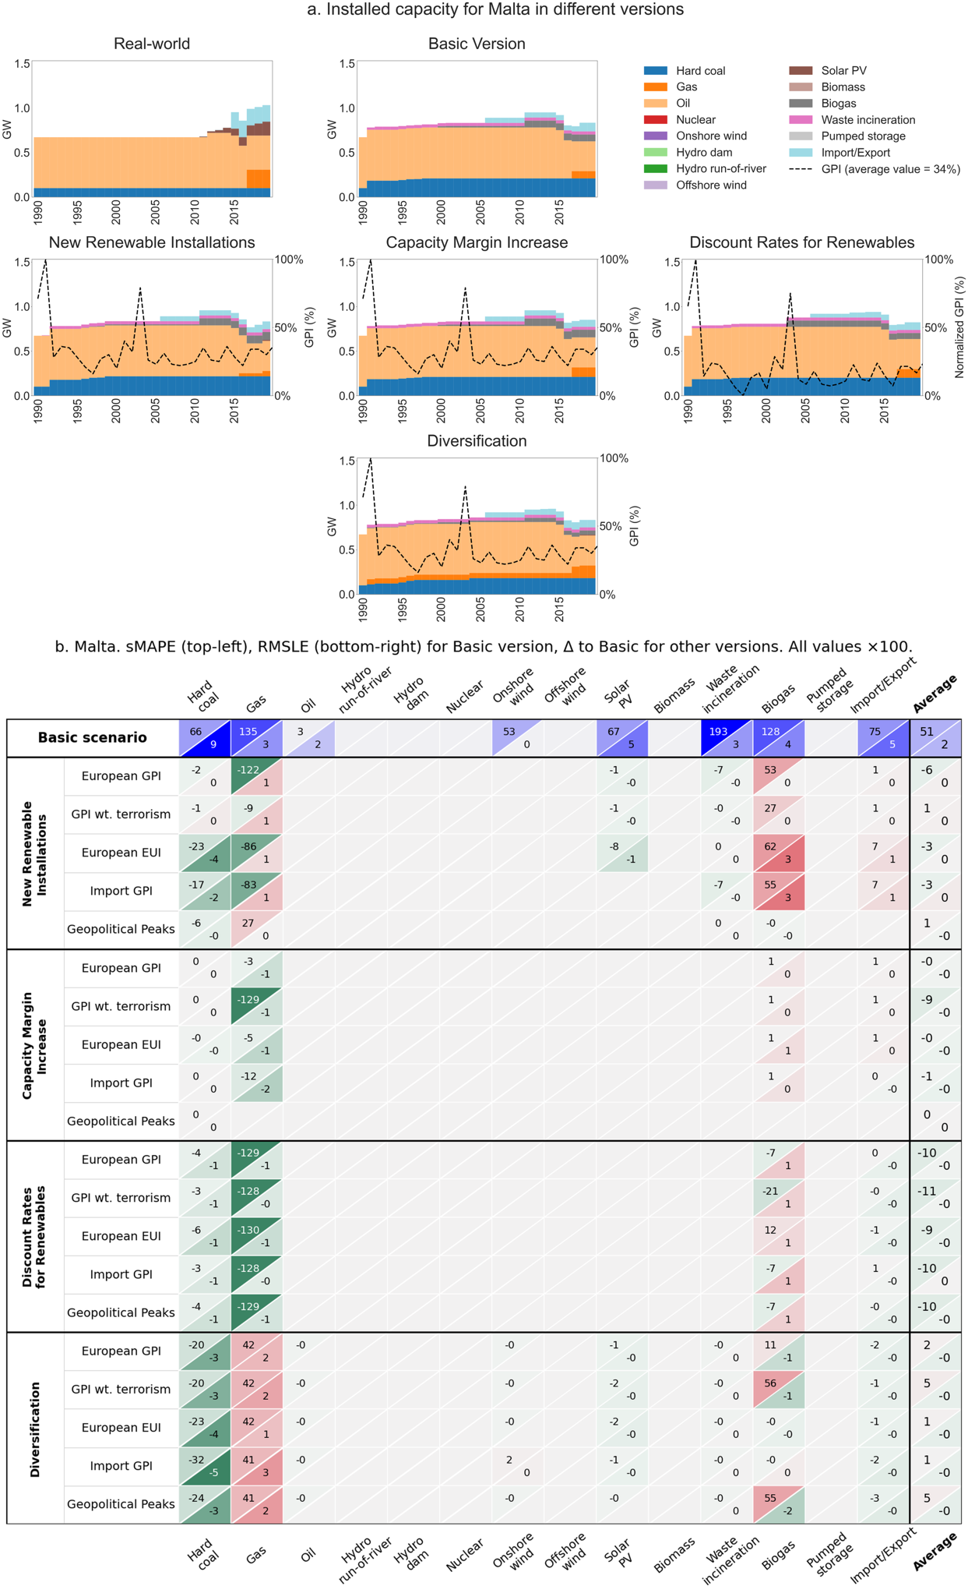
Fig. S8-22. Malta
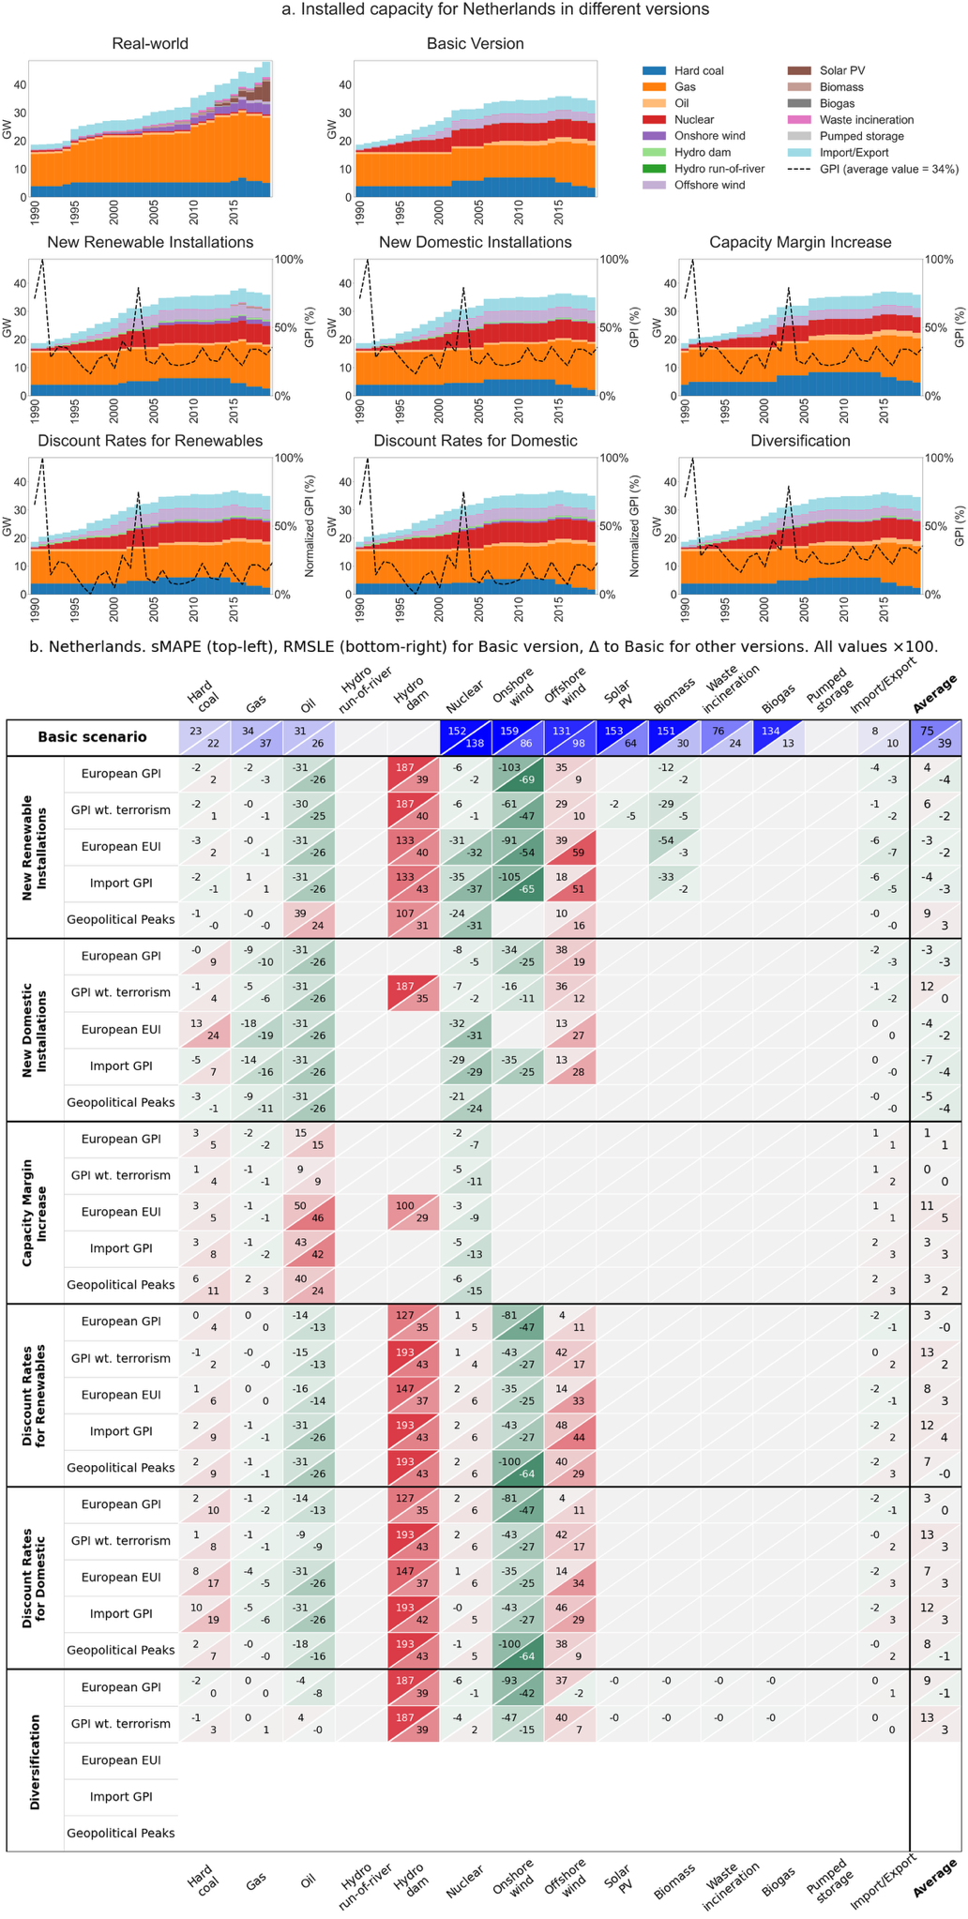
Fig. S8-23. Netherlands
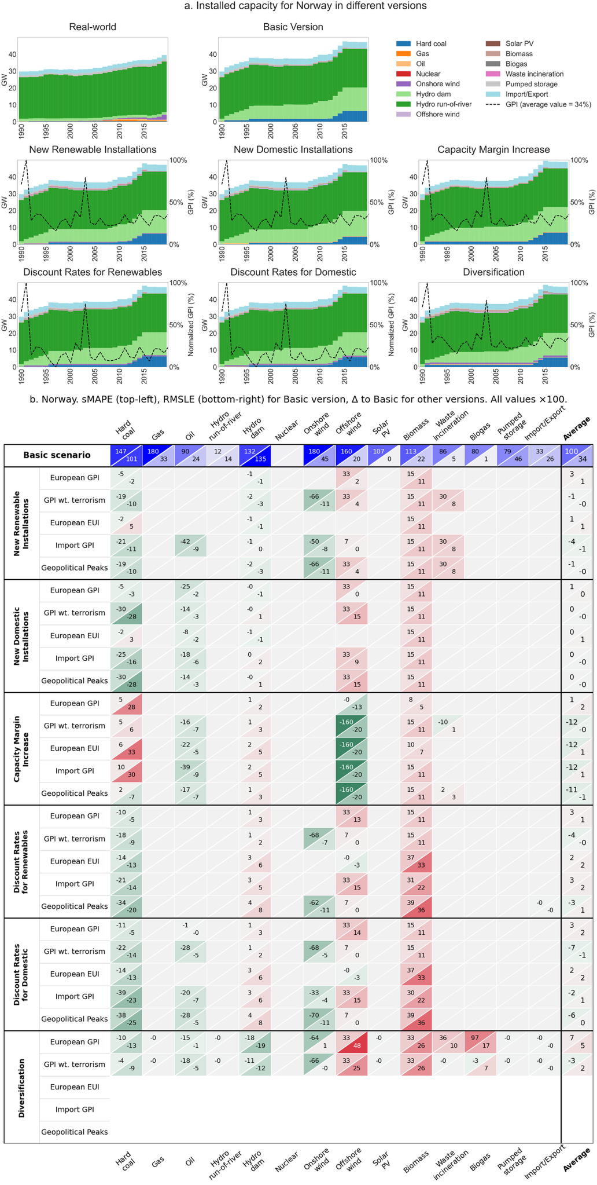
Fig. S8-24. Norway
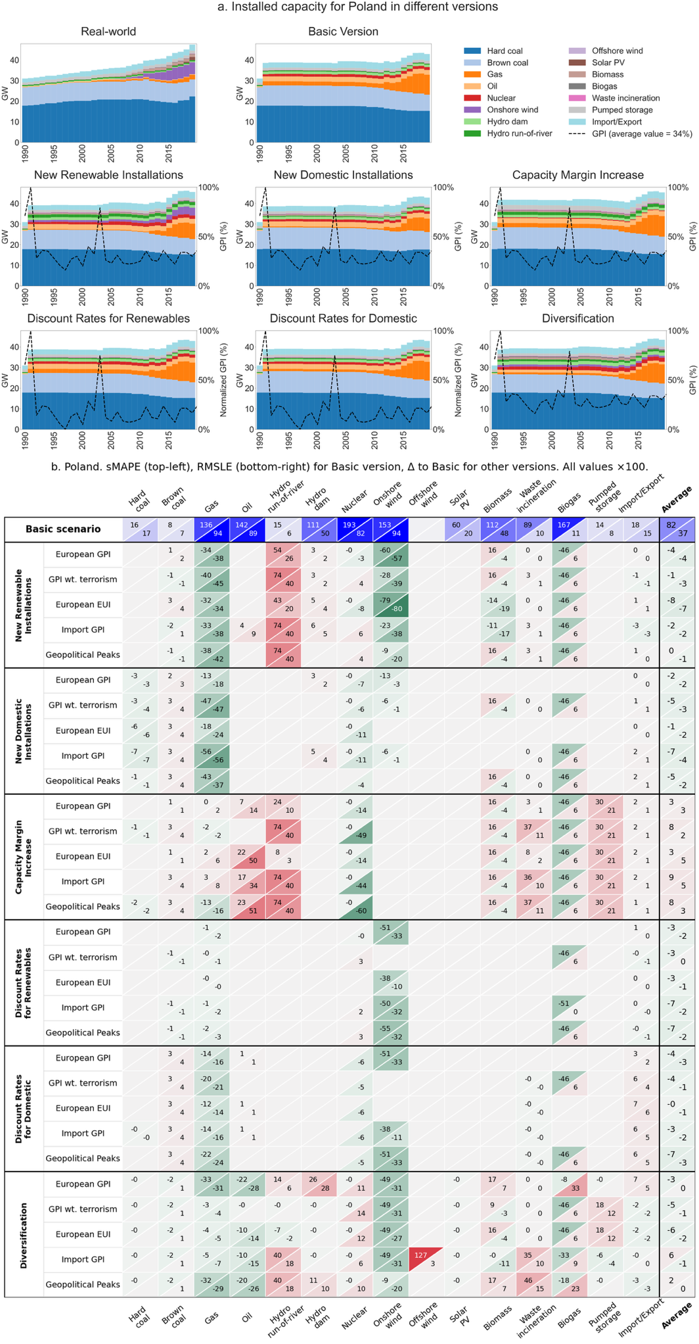
Fig. S8-25. Poland
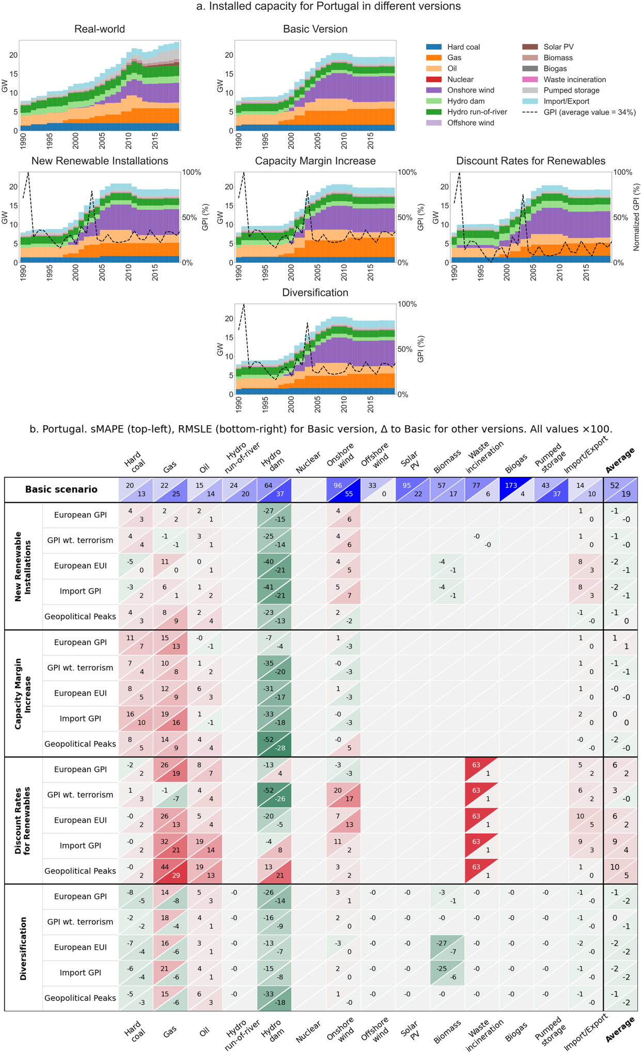
Fig. S8-26. Portugal
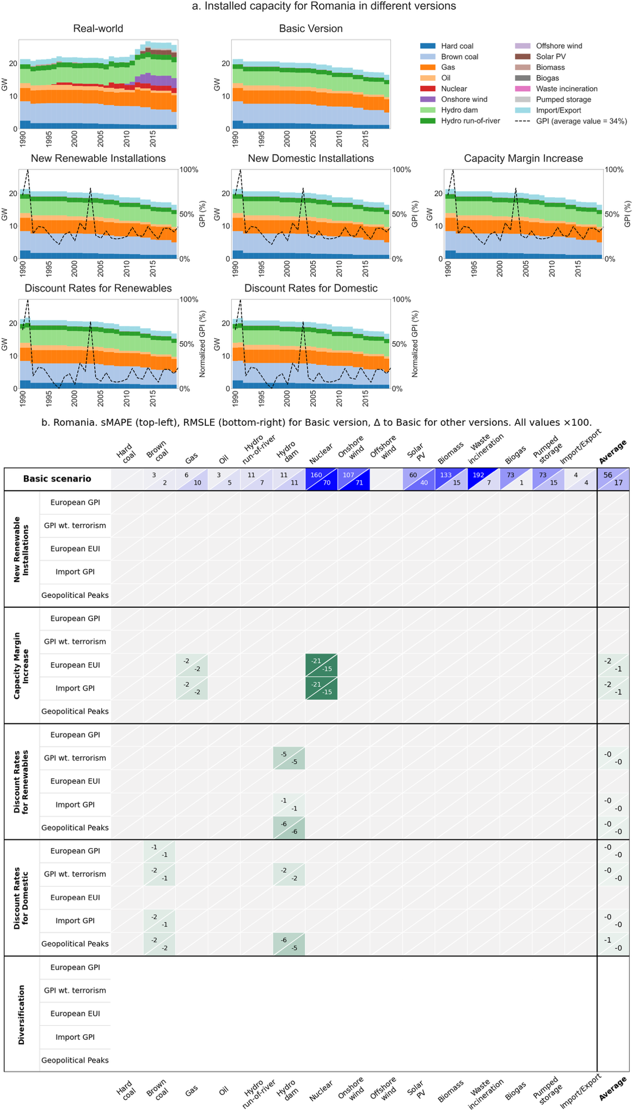
Fig. S8-27. Romania
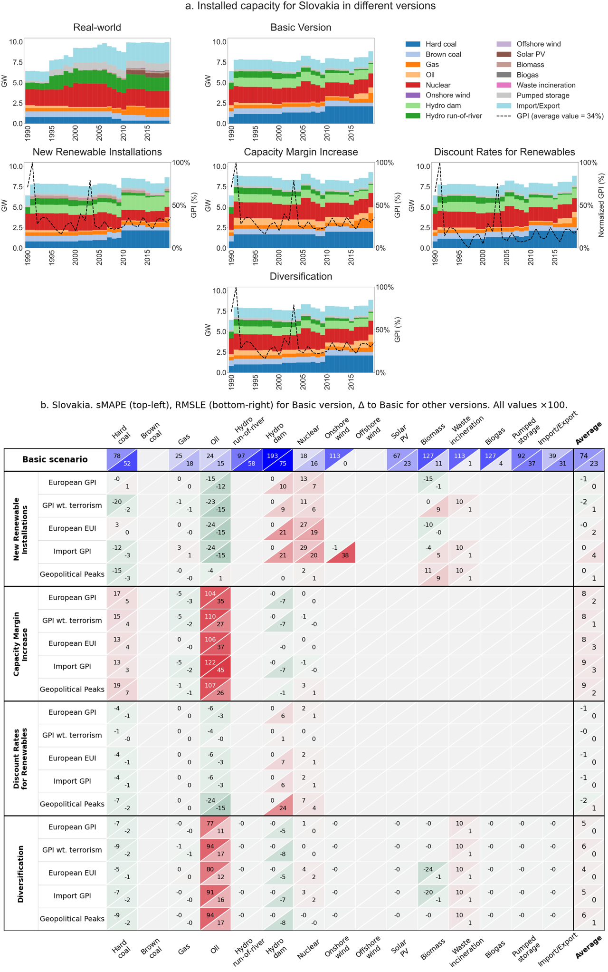
Fig. S8-28. Slovakia
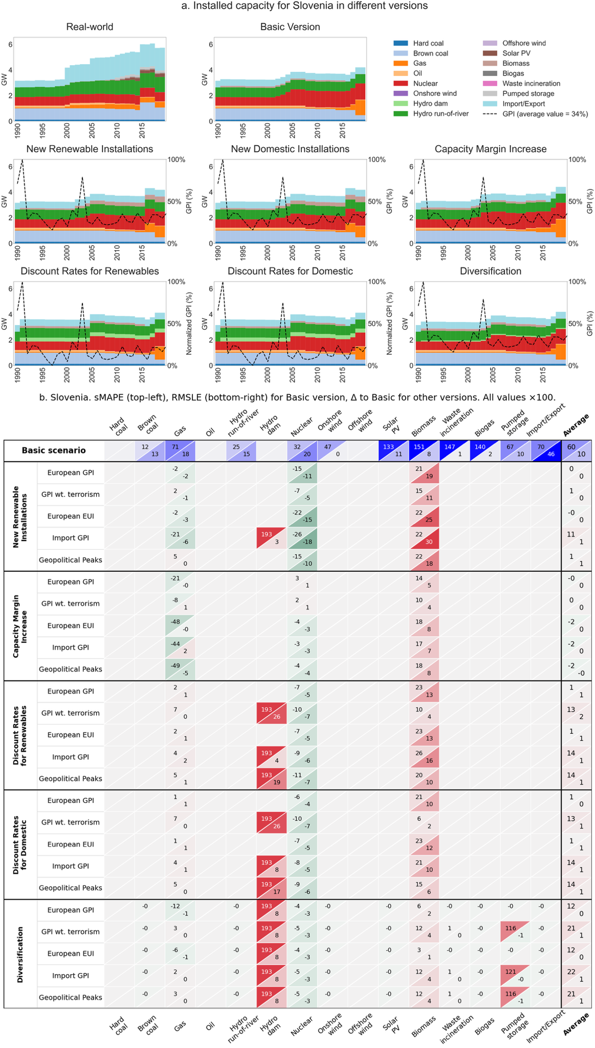
Fig. S8-29. Slovenia
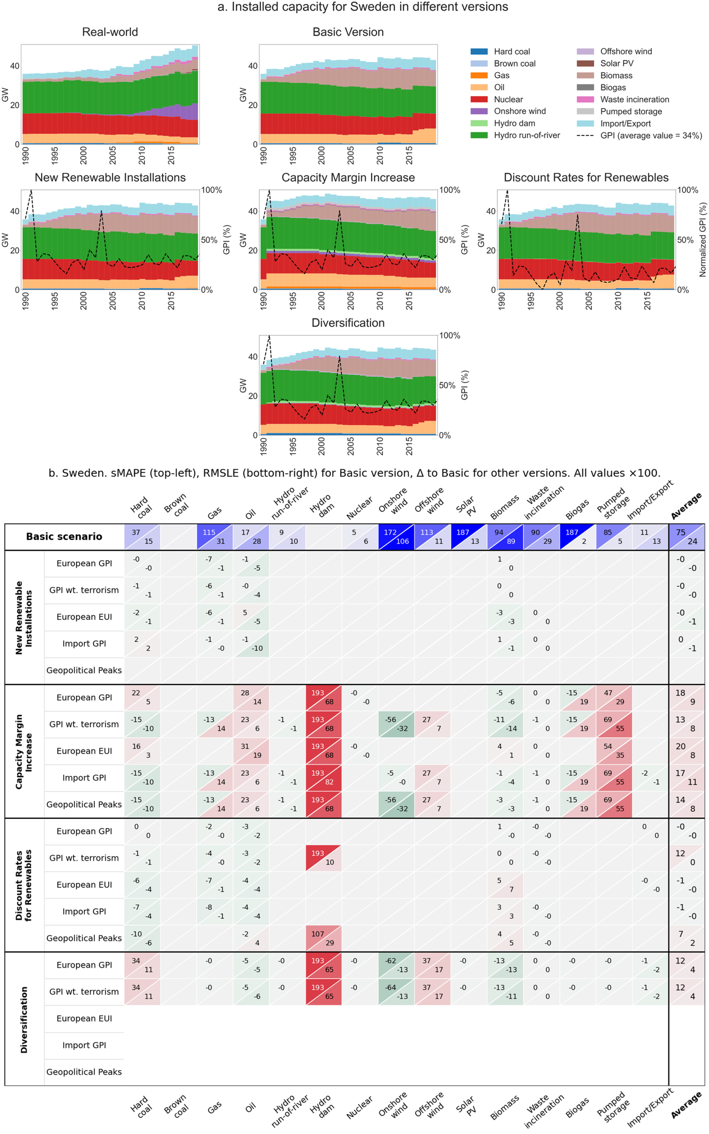
Fig. S8-30. Sweden

