Supplementary Information

Effects of distinct aerosols temporal implementations

The different narratives explored here allow us to understand the impact different levels of spatial detailing play in the aerosol implementation forcing. An exploratory set of experiments has focused on disentangling the effects temporal implementations of AOD have in global quantities. We report that temporal differences, i.e. aerosols implemented monthly or annually, contribute only minimally to the development of the surface air temperature (0.1 %), as the simulation annual plumes remains closely similar to the monthly plumes implementation over both the historical and future periods (Figure S1). This result could, evidently, be an artefact of the model not resolving seasonality appropriately. Nevertheless, in addition to this outcome, the fact that both land carbon and ocean heat uptake are known to show spatial dependency [1–4] corroborates our decision to have the discussions in the main text centred on different annual implementations of aerosols. This decision makes it possible to simplify the interpretation of results, focusing on the largest source of uncertainty.

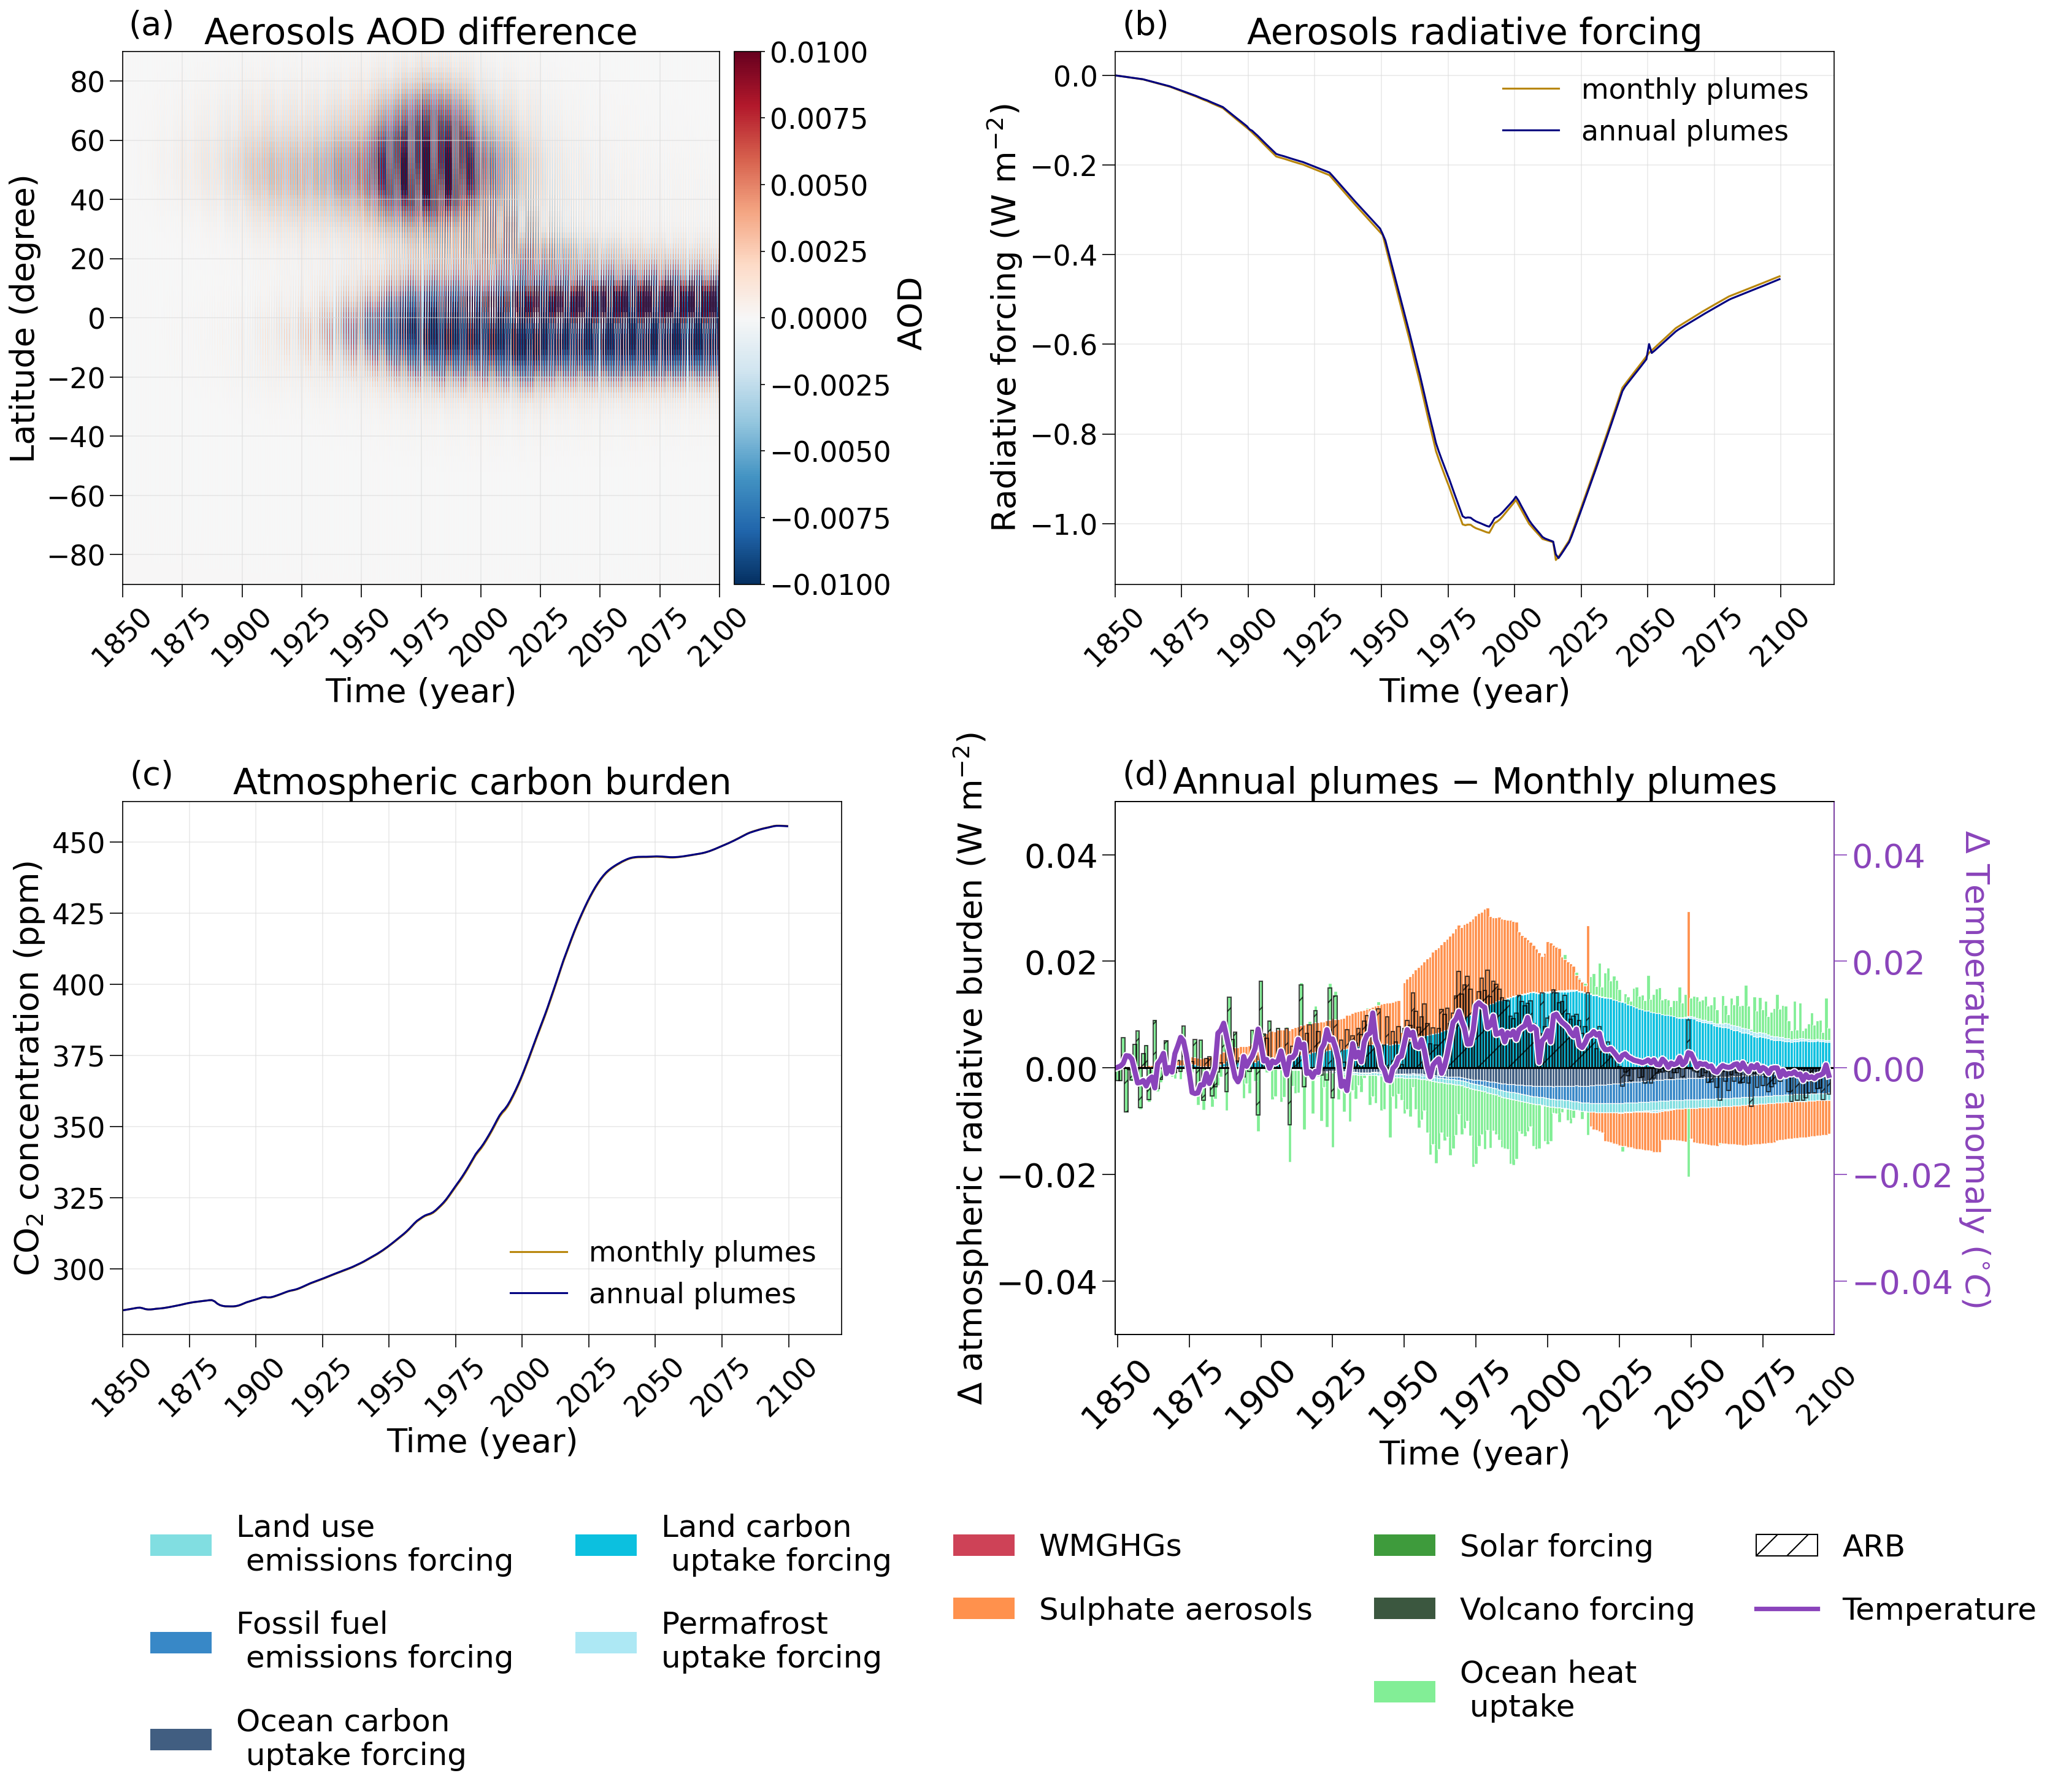
Figure S1. Comparison between the annual plumes and the monthly plumes experiment in terms of (a) Hovmöller diagram of the difference aerosol optical depth (AOD) input to
UVic ESCM version 2.10 (b) simulated annual global aerosols radiative forcing (W m⁻²) and (c) simulated atmospheric carbon burden (ppm), for the simulations monthly plumes (brown line) and annual plumes (blue line). (d) Stacked contributions to difference in atmospheric radiative burden (ARB) from all contributors (coloured bars—see legend) between monthly plumes and annual plumes from the start of the pre-industrial period in 1850 until the end of the 21st century. The black hatched bars in (d) indicate the net burden from the sum of the contributors considered (referring to left y axis), while the purple line represents the temperature variability (referring to right y axis).

Further experiments

The analysis presented here has focused on the comparable contribution of all forcing and responses to the remaining atmospheric burden controlling climate development. The changes in the individual contributors at each experiment and leading to the simulated difference in air temperature are detailed in Table S1. All experiments were aimed at reaching a 1.5°C surface air temperature anomaly to pre-industrial conditions. Through the distinct aerosol implementations, final stabilising temperatures were both higher and lower than that obtained in the default experiment. Similarly, land carbon uptake, ocean carbon uptake and ocean heat uptake, were simulated to be both higher and lower than in default depending on the aerosols’ implementation and associated carbon climate responses, in terms of their maximum anomaly, as well as the end of the century development.

Table S1. The first two lines show peak surface air temperature, land carbon uptake (LCU), ocean carbon uptake (OCU) and ocean heat uptake (OHU) relative to 1850-1900 for the default and no plumes experiments, as well as differences in values simulated between 2100 and 2020 for these experiments. Remaning lines show the same variables for the difference between all experiments analysed here and their respective baseline simulation (see the labels in the first column).
Experiments: | Max. global mean surface air temperature (GMSAT) relative to 1850-1900 (°C) | GMSAT difference between 2020 and 2100 (°C) | Max. land carbon uptake (LCU) anomaly relative to 1850-1900 (PgC yr⁻¹) | LCU difference between 2020 and 2100 (PgC yr⁻¹) | Max. ocean carbon uptake (OCU) anomaly relative to 1850-1900 (PgC yr⁻¹) | OCU difference between 2020 and 2100  (PgC yr⁻¹) | Max. ocean heat uptake (OHU) anomaly relative to 1850-1900 (W m⁻²) | OHU difference between 2020 and 2100  (W m⁻²)
Default | 1.6223 | 0.3495 | 347.5527 | 148.172 | 314.1616 | 160.2031 | 2.1099 | -0.5489
No plumes | 1.5500 | 0.2829 | 330.7935 | 148.9791 | 321.9731 | 161.814 | 2.0735 | -0.4804
No plumes - default | 0.09623 | -0.0537 | -18.5990 | -0.2943 | 7.8925 | 1.9715 | 0.0267 | 0.0952
only land - no plumes | -0.0915 | 0.023 | 32.3389 | -1.8367 | -12.8548 | -2.8962 | 0.0488 | -0.0354
only ocean- no plumes | 0.053 | -0.0192 | -9.5737 | 1.6284 | 3.8774 | 0.5085 | -0.0499 | 0.0226
NH - no plumes | -0.0471 | -0.011 | 9.1959 | 1.6921 | -2.7997 | -1.22 | -0.0404 | -0.0184
SH - no plumes | 0.0722 | -0.0317 | -9.7945 | 1.2599 | 3.4279 | 0.7069 | -0.0592 | 0.0243

No plumes vs. default

The highest surface air temperature differences between aerosol implementations were simulated in the years when aerosols’ radiative forcing was the strongest, an expected result as an overall larger aerosol burden in the atmosphere has a higher impact in the energy budget of the planet. For the specific case of the no plumes experiment, the correlation between the global radiative forcing of aerosols ($RF$) and the difference in simulated surface air temperature to the experiment default ($∆T$) can be obtained through $∆T= -0.0024- 0.0921*RF$ (Figure S2). The regression equation is expected to be distinct for the different spatial implementation experiments, but this finding could already prove useful for further informing and supporting, for example, the climate modelling community. As per design, these simulated differences in temperature are present even as aerosols radiative forcing is the same across experiments, and derive simply from the Earth system responses, strongest for stronger aerosols radiative forcing.

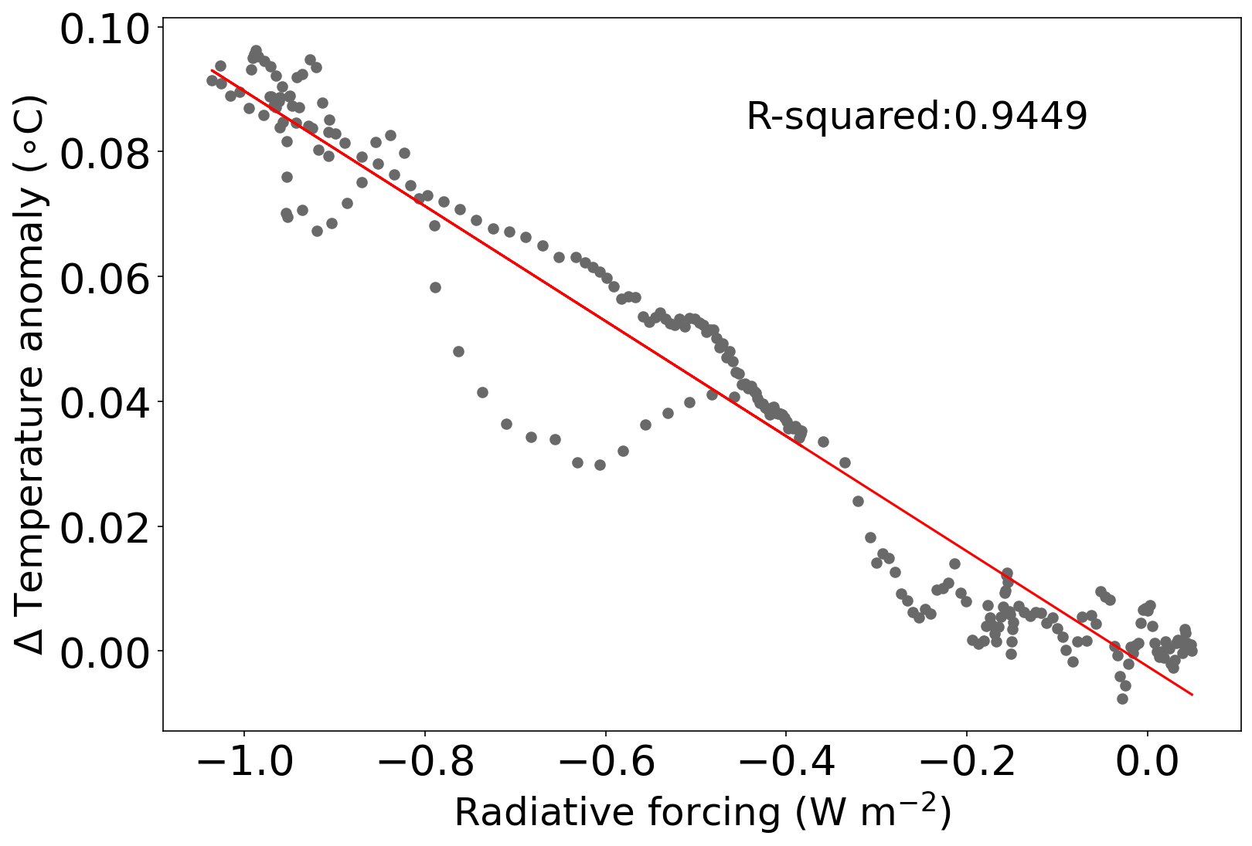
Figure S2. Linear regression (red line) between aerosols global radiative forcing (W m⁻²) and the temperature anomaly to pre-industrial conditions difference between the experiments no plumes and default (°C) (grey dots). The coefficient of determination (R-square) is also shown on the upper right corner.

As discussed in the main text, the no plumes experiment shows a lower land carbon uptake throughout most of the simulation in comparison to default. Higher temperatures in no plumes lead to higher soil respiration during the historical period and first decades of the 21st century (Figure S3 (a)). Due to warmer land temperatures over natural vegetation regions (Figure S4 (a)), as well as higher CO₂ burden in the atmosphere, there is also an increase in net primary production in comparison to the default experiment. Nevertheless, this effect is smaller than the response in soil respiration, which dominates over the primary production effect, causing a smaller land carbon uptake in this simulation. Most changes in vegetation carbon (Figure S4 (b)) are simulated in the high latitudes of the Northern Hemisphere, with a weak signal in the tropics (where important aerosol plumes are located and strengthening into the future), while the rest of the globe sees a decrease in carbon vegetation.
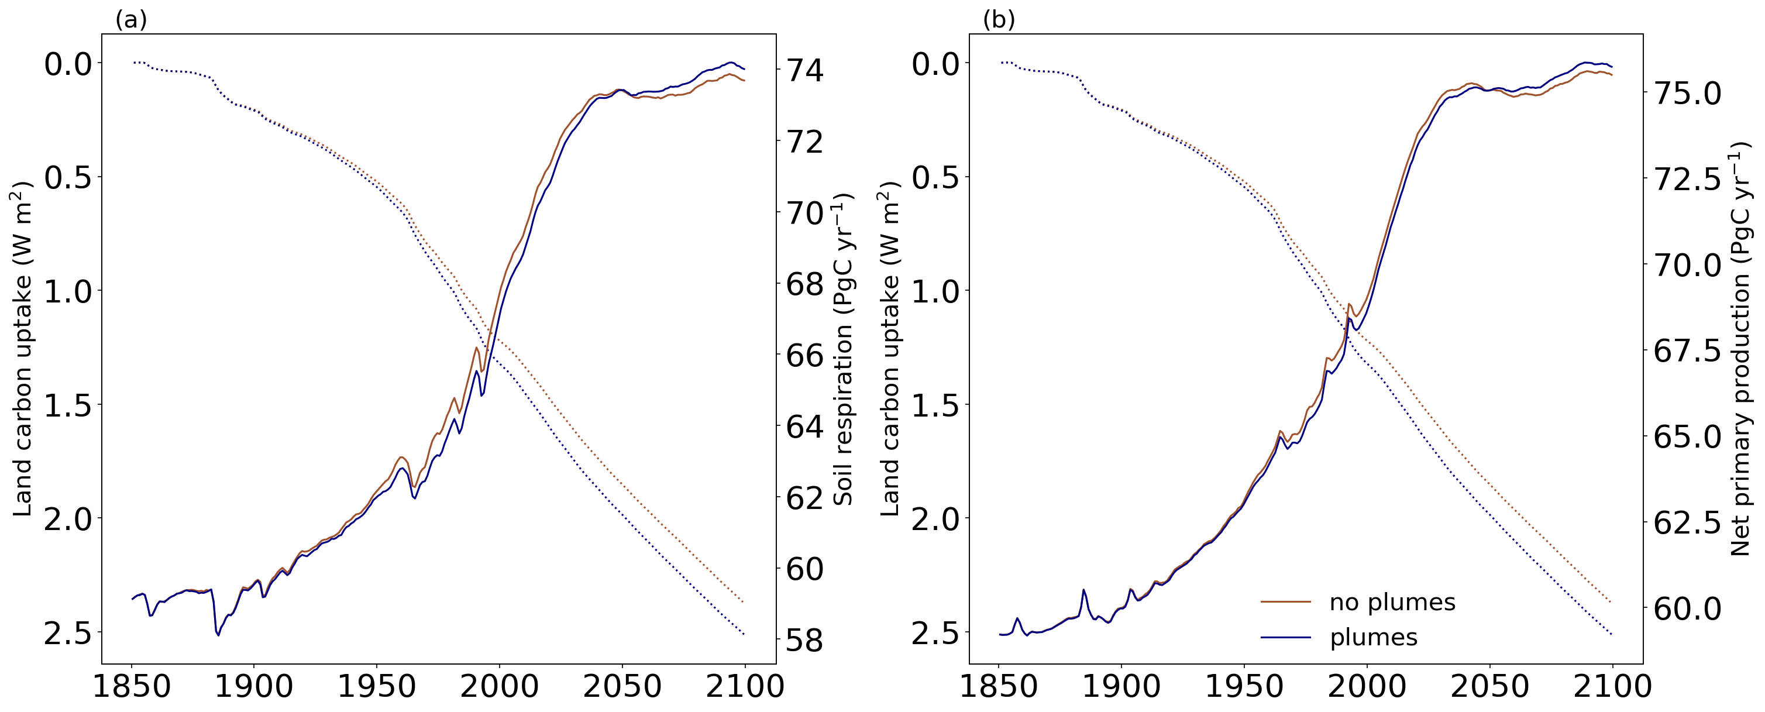
Figure S3. Land carbon uptake (W m⁻²) for the simulations no plumes (brown) and plumes (blue) in dashed lines referring to the left y axis. (a) Soil respiration and (b) net primary production in solid lines referring to the right y axis (PgC), from the start of the pre-industrial period in 1850 until the end of the 21st century. Please notice that the left y axis is inverted.

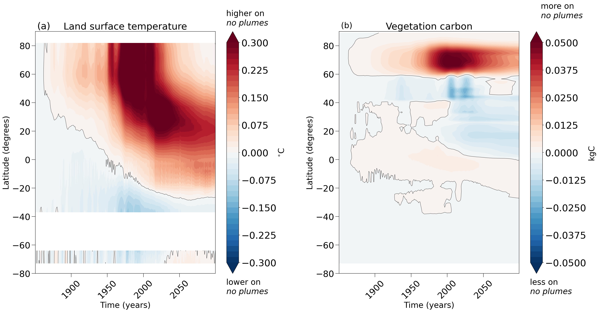
Figure S4. Time-latitude Hovmöller diagram of the difference in (a) land surface temperature (°C) and (b) vegetation carbon (kgC) between experiments no plumes and default from the start of the pre-industrial period in 1850 until the end of the 21st century. Values are given for a rolling latitude mean and positive values indicate higher fluxes on the no plumes experiment, while negative indicate lower fluxes.

Finally, ocean carbon uptake is simulated to overall increase throughout the experiment (Figure S5). This signal, nevertheless, is a mixture of increase in uptake over usual uptake areas, decrease of release in simulated release regions, and a change of release areas into uptakes areas. The final effect of these complicated signals is that of an overall increase in dissolved inorganic carbon in the ocean, mostly in Sub Antarctic regions, especially towards the end of the century.
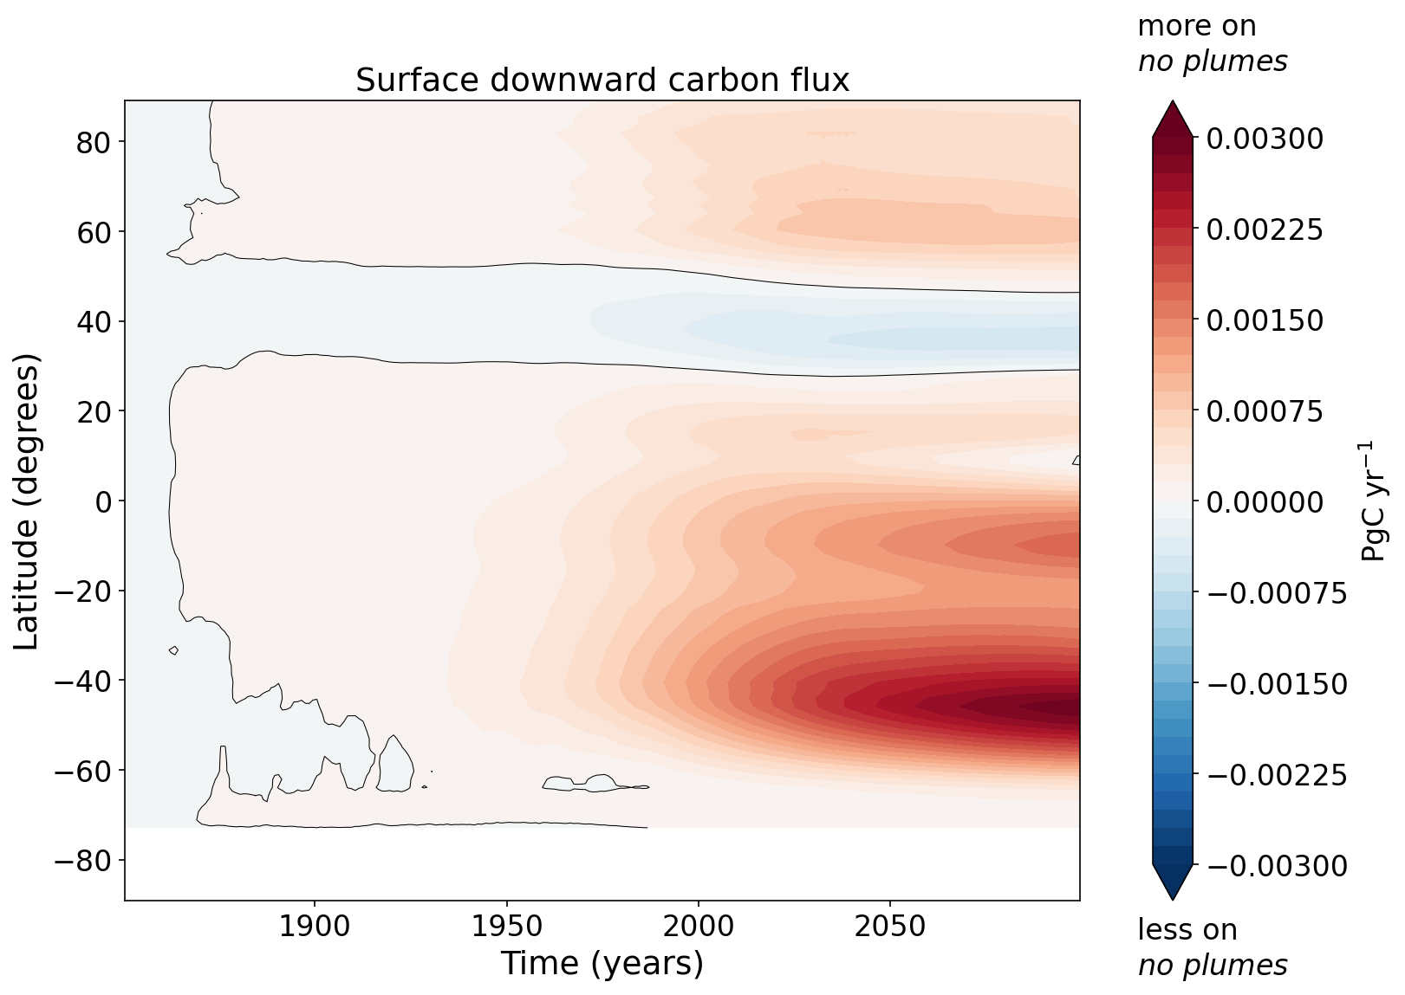
Figure S5. Time-latitude Hovmöller diagram of the difference in ocean surface downward carbon flux (PgC yr⁻¹) between experiments no plumes and default from the start of the pre-industrial period in 1850 until the end of the 21st century. Values are given for a rolling latitude mean and positive values indicate higher quantities on the no plumes experiment, while negative values indicate lower quantities.

No plumes only land and only ocean vs. no plumes

The simulation only land is an imperfect analogue to the default experiment, and similarly also shows lower carbon uptake by the land, especially driven by a decreased soil respiration (Figure S6 (a)). The main decrease in soil respiration comes from high latitudes and subtropical areas, while the increase in respiration is driven by the tropics in future scenarios. Additionally, the late historical period and future scenario are also characterized by slightly higher net primary production on the only land experiments (Figure S6 (b)), associated with tropical regions and the northern high latitudes towards the end of the simulation. Such responses are directly associated to the vegetation types encountered in these areas, with increased production by both broadleaf and needleleaf trees.
Differences between the simulation no plumes and only ocean are very small, both in terms of land carbon uptake (Figure S7 (a)) and soil respiration or net primary production (Figure S6 (c, d), respectively). As discussed in the main text, the similarity between these two simulations in terms of temperature and feedback developments corroborates the understanding that the latter is an imperfect analogue to the former. A similar opposite pattern to that simulated for only land, but with much smaller magnitude, is seen in terms of the heat responses for ocean uptake (compare Figure 4 with Figure S7 (b)). In fact, the temperature anomaly present in the only ocean simulations is quite smaller than the one simulated at only land (maximum temperature difference to no plumes of 0.05 °C, found over the historical period, reduced to 0.01 °C by the end of the century).

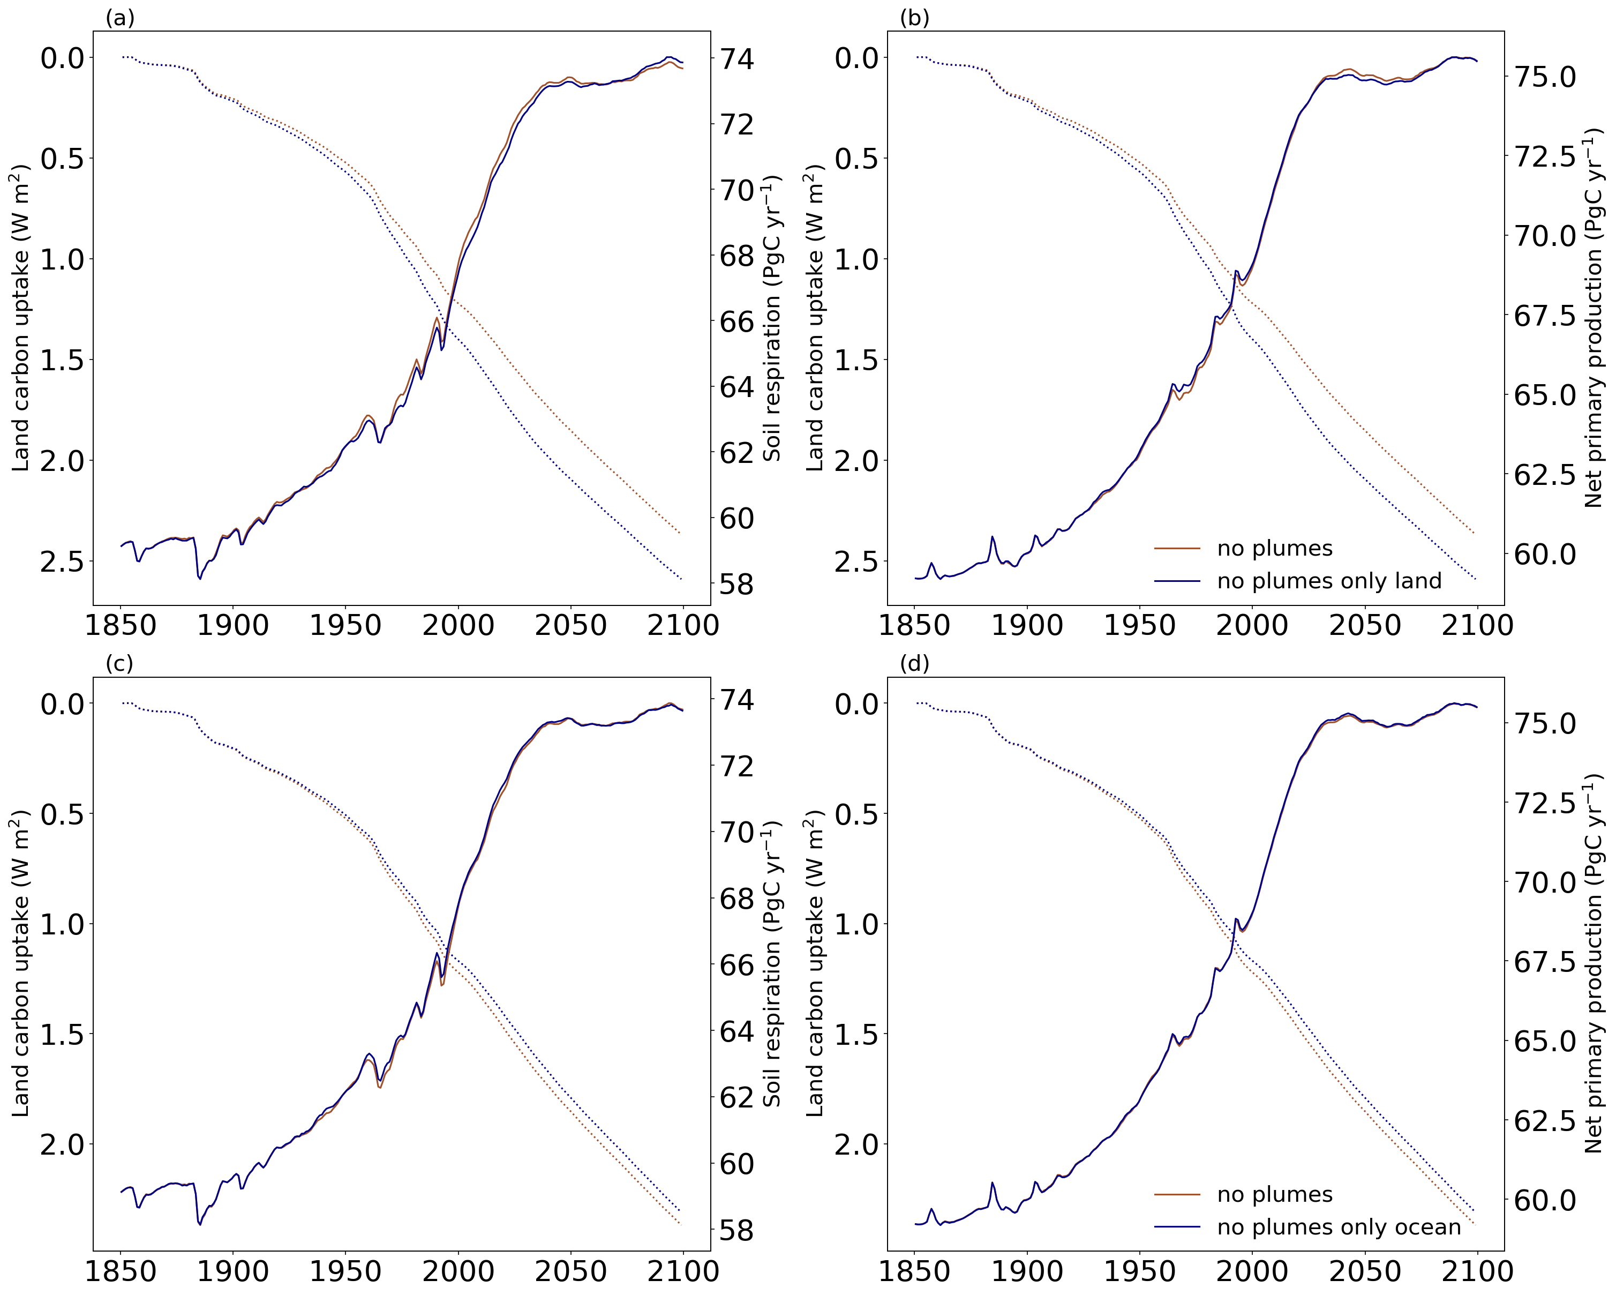

Figure S6. Land carbon uptake (W m⁻²) for the simulations no plumes (brown) and (a, b) no plumes only land (blue) and (c, d) no plumes only ocean (blue) in dashed lines referring to the left y axis. (a, c) Soil respiration and (b, d) net primary production in solid lines referring to the right y axis (PgC), from the start of the pre-industrial period in 1850 until the end of the 21st century. Please notice the left y axis is inverted.
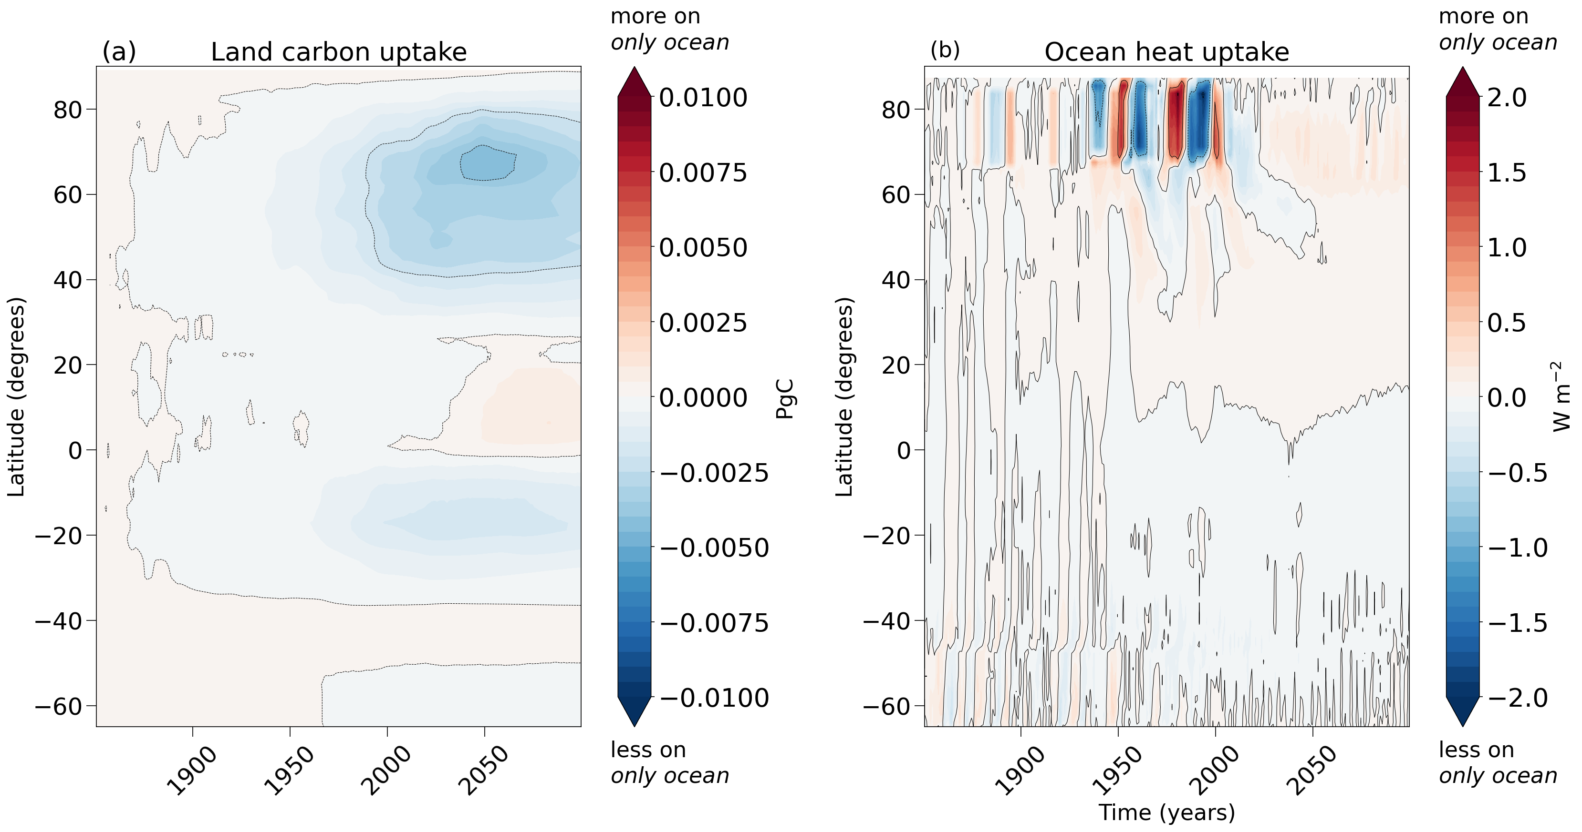
Figure S7. Time-latitude Hovmöller diagram of the difference in (a) land carbon uptake anomaly (PgC) and (b) ocean heat uptake anomaly (W m⁻²) between experiments no plumes only ocean and no plumes from the start of the pre-industrial period in 1850 until the end of the 21st century. Values are given for a rolling latitude mean and positive values indicate higher fluxes on the only ocean experiments, while negative values indicate lower fluxes.

No plumes Northern Hemisphere and Southern Hemisphere vs. no plumes

As previously mentioned, the close similarity between the experiments no plumes NH and no plumes can be observed in terms of the temperature development, but also of land carbon uptake processes (Figure S9 (a)). The former experiment has an overall small difference in, but larger carbon uptake, driven by (Figure S8 (a, b)) a slightly lower soil respiration rate throughout the simulation, while net primary production shows very close rates to what was observed in the no plumes experiment. Conversely, we see an inverse response patter for the no plumes SH experiment compared to no plumes, with a, still small difference in, lower land carbon uptake and consistently higher soil respiration (Figure S8 (c, d)). Similarly, the ocean heat uptake response of the no plumes NH experiment shows an opposing signal (Figure S9 (b)) but alike pattern to that simulated for only SH experiment, with even slightly stronger uptake signals for subpolar regions in the Northern Hemisphere.

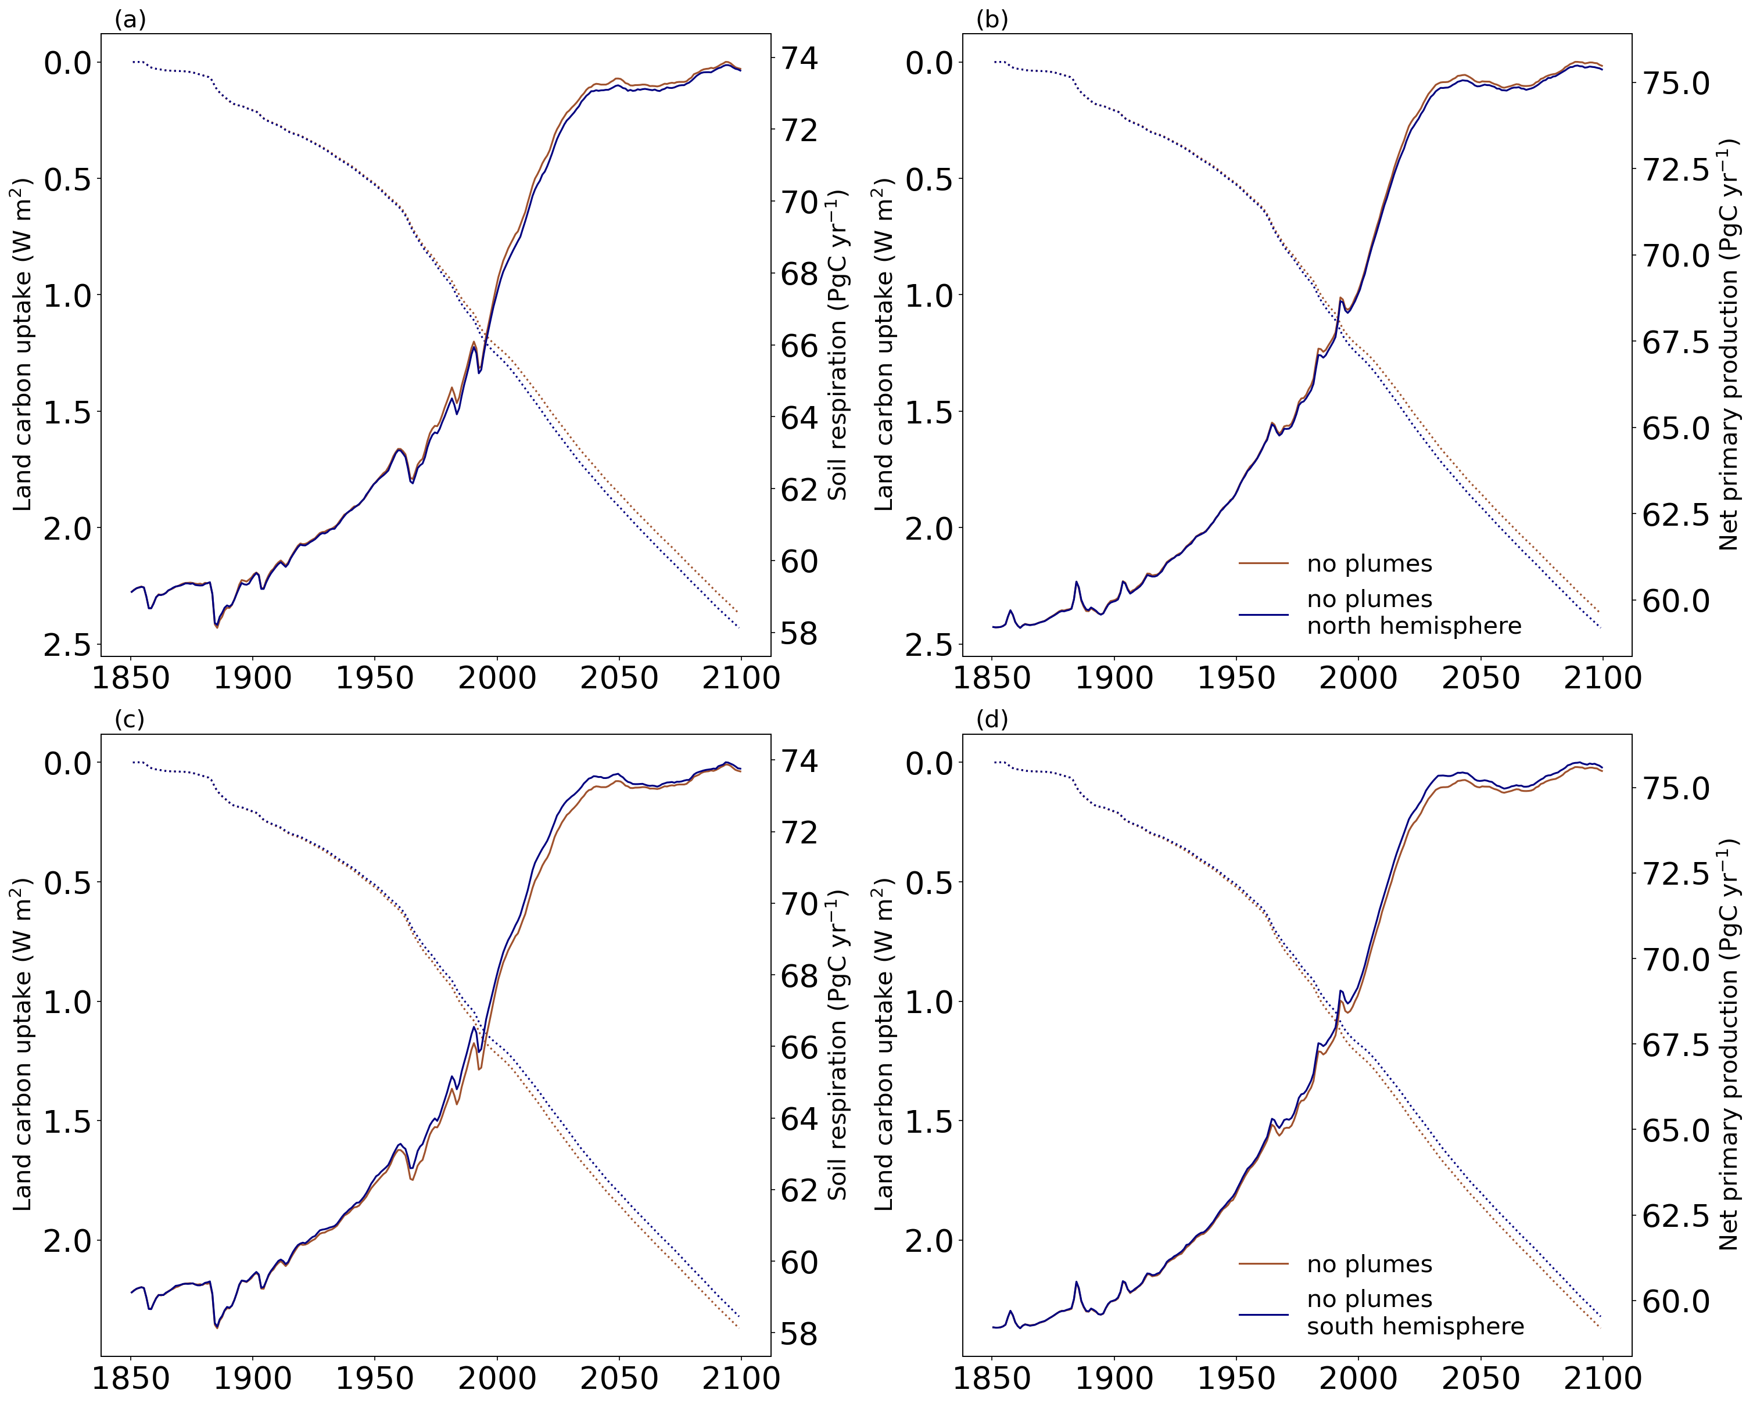
Figure S8. (a, b) Land carbon uptake (W m⁻²) for the simulations no plumes (brown) and no plumes Northern Hemisphere and (c, d) no plumes Southern Hemisphere (blue) in dashed lines referring to the left y axis. (a, c) Soil respiration and (b, d) net primary production in solid lines referring to the right y axis (PgC), from the start of the pre-industrial period in 1850 until the end of the 21st century. Please notice the right y axis is inverted.
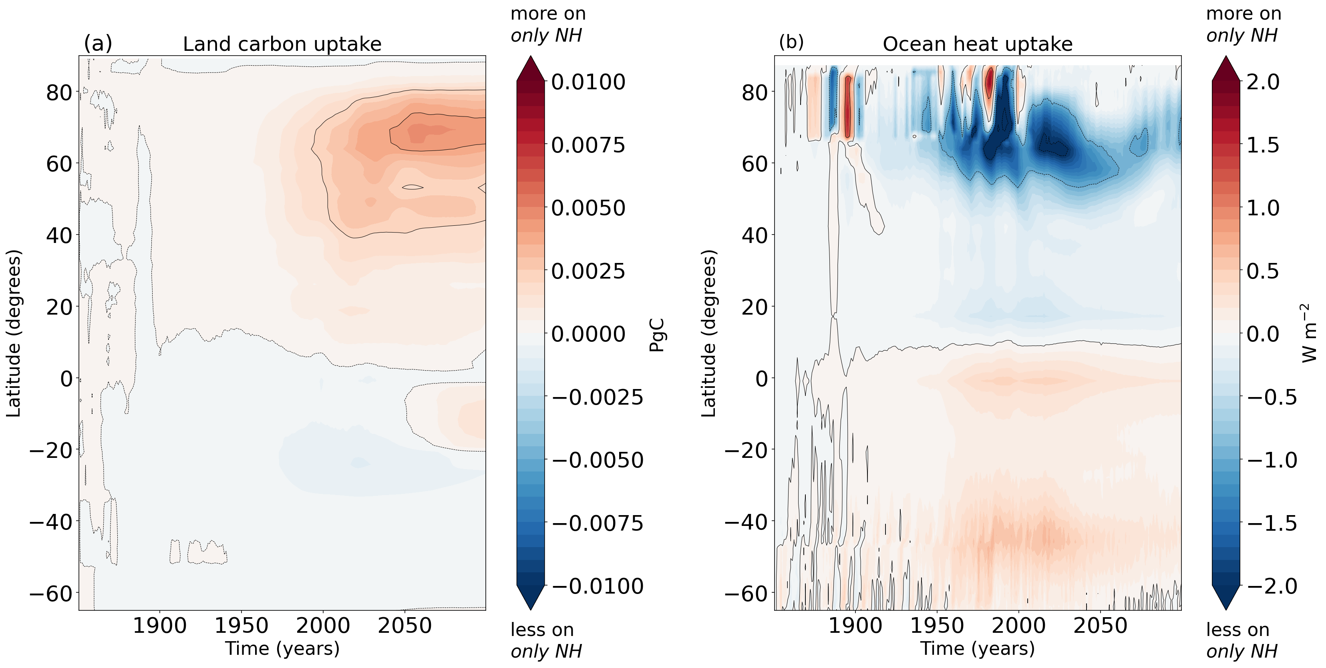
Figure S9. Hovmöller diagram of the difference in (a) land carbon uptake anomaly (PgC) and (b) ocean heat uptake anomaly (W m⁻²) between experiments no plumes only Northern Hemisphere and no plumes from the start of the pre-industrial period in 1850 until the end of the 21st century. Values are given for a rolling latitude mean and positive values indicate higher fluxes on the only experiments, while negative values indicate lower fluxes.

Further analysis on no plumes Southern Hemisphere experiment

The historical cumulative heat uptake by the Southern Ocean in the simulation with aerosols over the Southern Hemisphere, without any plumes, corresponds to only 39% of the model’s heat uptake, in contrast to the usual 56.6% in the default aerosol implementation with plumes and seasonality (Figure S10). On the other hand, northern oceans (at latitudes higher than 30°N) show a historical cumulative heat uptake in this experiment that is almost two times higher than what was simulated with the default UVic ESCM2.10 configuration (39.2% for the former in contrast to 22.9% for the latter). Additionally, the main ocean heat uptake areas responding in a simulation where aerosols are present only in the Southern Hemisphere are also found [5] to have strong response patterns in a simulation with only greenhouse gases and no aerosols forcing (Figure S11). The results obtained here agree with the hypothesis posed by [5], that the asymmetry in the uptake of heat and carbon by the Southern Ocean is due to the enhanced aerosols forcing over the northern oceans.

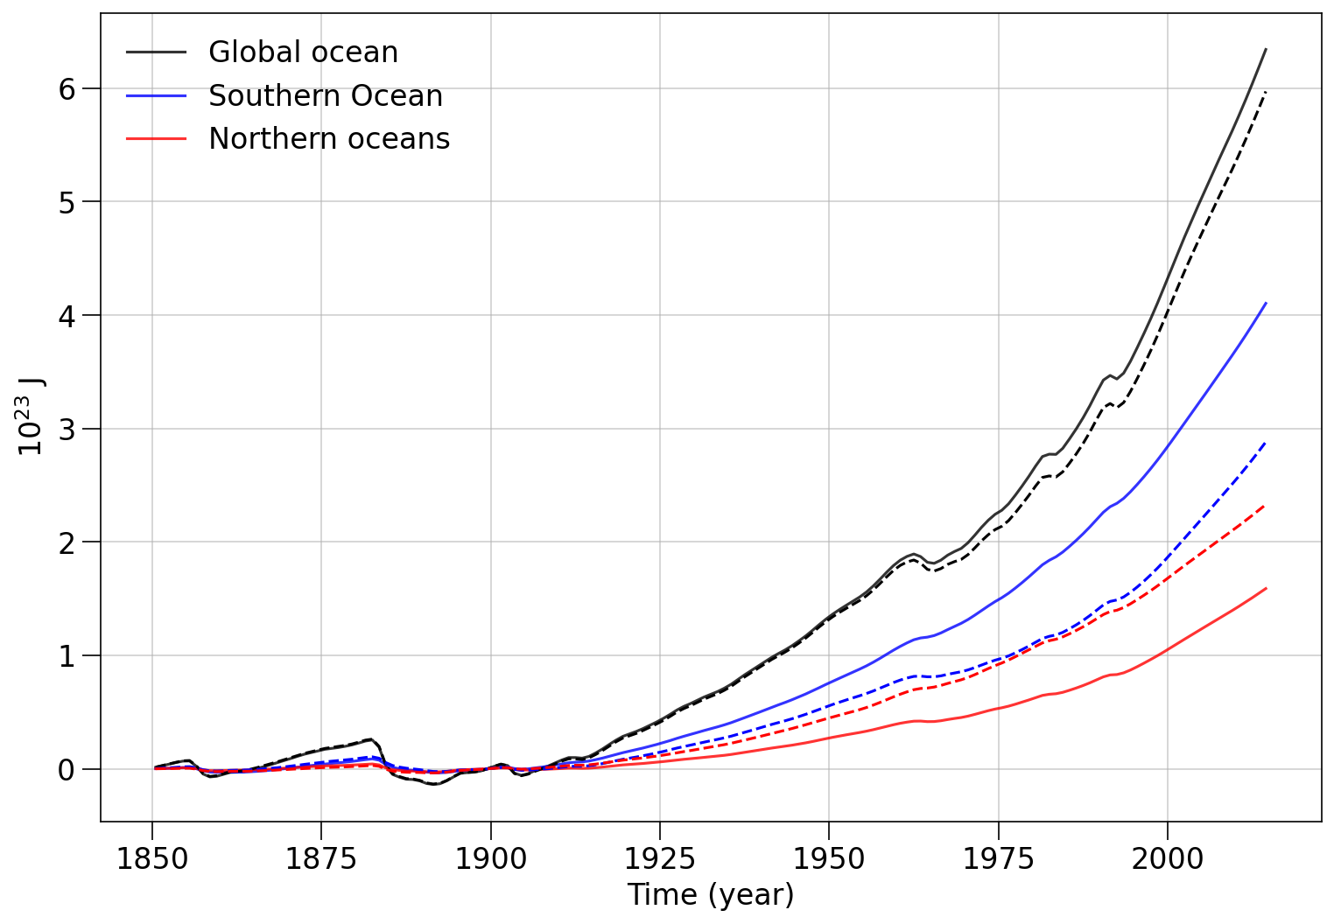
Figure S10. The global (black line), northern ocean (red line) and Southern Ocean (blue line) heat uptake anomalies over the historical period from 1850 to 2020 for the default monthly plumes implementation (solid lines) and the only Southern Hemisphere implementation (dashed lines), in similarity to Figure 1 in [5].
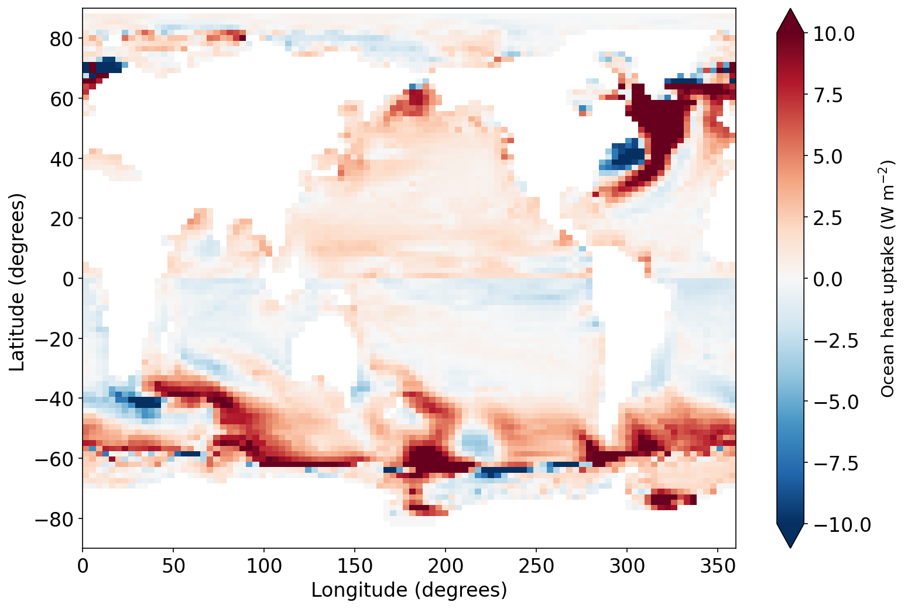
Figure S11. Temporal change in surface ocean heat uptake (W m⁻²) simulated under the experiment only Southern Hemisphere for a recent decade 2005-2015 relative to a pre-industrial era decade 1850-1860, in similarity to Figure 3 (b) third panel in [5].

References
[1] Roemmich D, Church J, Gilson J, Monselesan D, Sutton P and Wijffels S 2015 Unabated planetary warming and its ocean structure since 2006 Nature Climate Change 5 240–5
[2] Von Schuckmann K, Cheng L, Palmer M D, Hansen J, Tassone C, Aich V, Adusumilli S, Beltrami H, Boyer T, Cuesta-Valero F J, Desbruyères D, Domingues C, García-García A, Gentine P, Gilson J, Gorfer M, Haimberger L, Ishii M, Johnson G C, Killick R, King B A, Kirchengast G, Kolodziejczyk N, Lyman J, Marzeion B, Mayer M, Monier M, Monselesan D P, Purkey S, Roemmich D, Schweiger A, Seneviratne S I, Shepherd A, Slater D A, Steiner A K, Straneo F, Timmermans M-L and Wijffels S E 2020 Heat stored in the Earth system: where does the energy go? Earth Syst. Sci. Data 12 2013–41
[3] Huguenin M F, Holmes R M and England M H 2022 Drivers and distribution of global ocean heat uptake over the last half century Nature Communications 13 4921
[4] Friedlingstein P, Jones M W, Andrew R M, Bakker D C E, Hauck J, Landschützer P, Le Quéré C, Luijkx I T, Peters G P, Peters W, Pongratz J, Schwingshackl C, Sitch S, Canadell J G, Ciais P, Jackson R B, Alin S R, Anthoni P, Barbero L, Bates N R, Becker M, Bellouin N, Decharme B, Bopp L, Brasika I B M, Cadule P, Chamberlain M A, Chandra N, Chau T-T-T, Chevallier F, Chini L P, Cronin M, Dou X, Enyo K, Evans W, Falk S, Feely R A, Feng L, Ford D J, Gasser T, Ghattas J, Gkritzalis T, Grassi G, Gregor L, Gruber N, Gürses Ö, Harris I, Hefner M, Heinke J, Houghton R A, Hurtt G C, Iida Y, Ilyina T, Jacobson A R, Jain A, Jarníková T, Jersild A, Jiang F, Jin Z, Joos F, Kato E, Keeling R F, Kennedy D, Klein Goldewijk K, Knauer J, Korsbakken J I, Körtzinger A, Lan X, Lefèvre N, Li H, Liu J, Liu Z, Ma L, Marland G, Mayot N, McGuire P C, McKinley G A, Meyer G, Morgan E J, Munro D R, Nakaoka S-I, Niwa Y, Olsen A, Omar A M, Ono T, Paulsen M, Pierrot D, Pocock K, Poulter B, Powis C M, Rehder G, Resplandy L, Robertson E, Rödenbeck C, Rosan T M, Schwinger J, Séférian R, Smallman T L, et al 2023 Global Carbon Budget 2023 Earth System Science Data 15 5301–69
[5] Williams R G, Meijers A J S, Roussenov V M, Katavouta A, Ceppi P, Rosser J P and Salvi P 2024 Asymmetries in the Southern Ocean contribution to global heat and carbon uptake Nature Climate Change 14 823–31

