SUPPLEMENTARY FIGURES AND TABLES
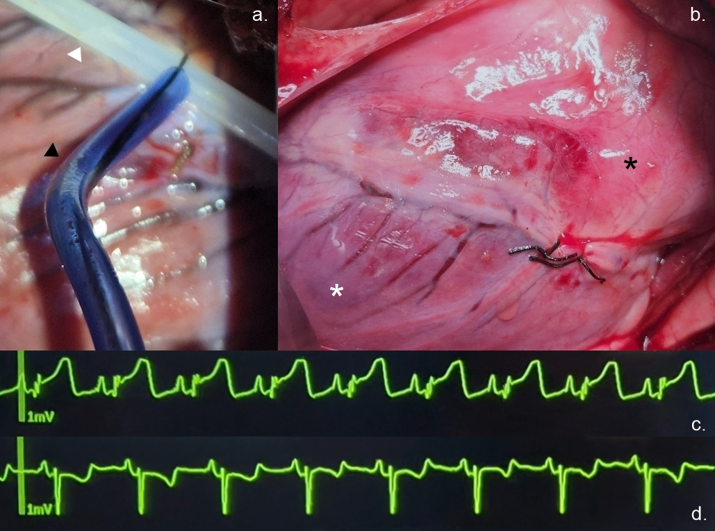
Supplementary Fig. 1 | Double-ligation technique for inducing ischemia-reperfusion injury in a porcine model.
(a) A white plastic piece (white arrowhead) is positioned between the coronary artery and a 2-0 braided silk suture to minimize direct trauma to the vessel during occlusion. The black silk suture is tightened using a blue silicone snare (black arrowhead), allowing for temporary occlusion of the coronary artery by compressing the vessel against the plastic surface. (b) After 120 minutes of ischemia, the plastic piece is removed to initiate reperfusion. The silk ligature is temporarily left in place in this image to mark the previous occlusion site, although it was subsequently removed as part of the ischemia-reperfusion protocol. The myocardium distal to the ligation site appears pale (white asterisk) in contrast to the adjacent unaffected myocardium (black asterisk), demonstrating effective regional ischemia following temporary coronary occlusion. Engorged coronary veins below the ligation site are also observed. (c) A representative ECG recording from lead II showing marked ST-segment elevation following coronary occlusion. (d) An ECG recording from a separate subject showing ST-segment depression as an alternative pattern of ischemic response to coronary occlusion.
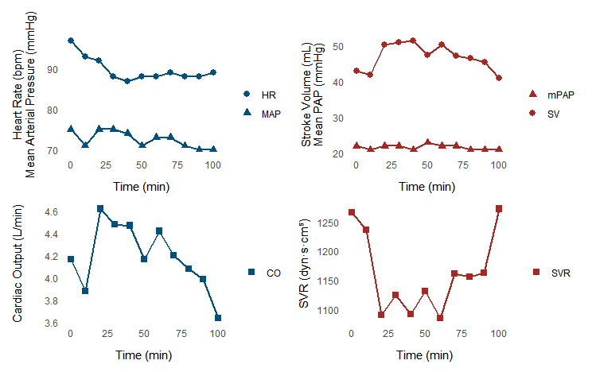
Supplementary Fig. 2 | Hemodynamic trends during continuous 70% SVC compression in Model 1 (n=1).
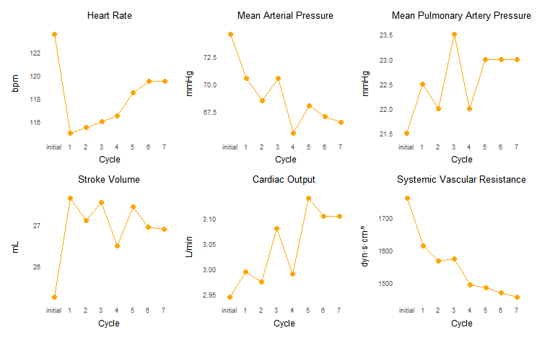
Supplementary Fig. 3 | Changes in hemodynamic parameters during the compression/release cycles in Model 2 and Model 3 with 100% compression of the SVC (n=2).

Model # | BW (kg) | Infarct Artery | POD # | Comp. % | C/R (min),  # of cycle | SV  (mL) | CO (L/min) | SVR  (dyn·s·cm⁻⁵) | LVEDV  (mL) | LVEDP  (mmHg)
1 | 50 | distal LAD | 9 | 70 | continuous,  100 min | 43.0 →  40.9 | 4.17 →  3.64 | 1266 →  1274 | 209.1 →  225.1 | 5.43 →  3.06
2 | 54 | proximal OM | 11 | 70 | 20/5,  7 | 32.9 →  38.2 | 3.13 →  3.40 | 1304 →  1176 | 54.3 →  55.1 | 2.48 →  2.61
3 | 68 | ramus intermedius | 21 | 70 | 20/5,  7 | 61.6 →  60.8 | 5.36 → 5.17 | 1104 →  866 | – | –
4 | 55 | proximal OM | 21 | 70 | 20/5,  7 | 42.9 →  49.8 | 4.20 →  4.28 | 1124 →  990 | 141.9 →  127.2 | 2.05 →  2.66
5 | 51 | proximal OM | 8 | 70 | 20/5,  7 | 33.8 →  36.4 | 3.04 →  3.13 | 1315 →  1303 | 166.9 →  145.4 | 5.44 →  4.75
6 | 57 | proximal OM | 42 | 85 | 20/5,  7 | 40.5 →  50.2 | 3.48 →  4.97 | 1631 →  1014 | 100.6 →  79.9 | 5.66 →  7.19
7 | 54 | distal LAD | 8 | 85 | 20/5,  7 | 43.5 →  48.2 | 4.22 →  5.30 | 1365 →  905 | 117.4 →  71.23 | 10.66 →  9.41
8 | 55 | proximal OM | 12 | 85 | 20/5,  7 | 36.4 →  44.8 | 3.90 →  4.79 | 1394 →  1085 | 145.5 →  139.0 | 8.21 →  8.03
9 | 61 | proximal OM | 22 | 85 | 20/5,  7 | 33.9 →  41.2 | 3.73 →  4.45 | 1394 →  1096 | 207.2 →  212.3 | 3.55 →  3.18
10 | 52 | proximal OM | 10 | 100 | 20/5,  7 | 30.1 →  31.2 | 2.65 →  2.93 | 1720 →  1446 | 127.8 →  159.4 | 2.00 →  1.93
11 | 63 | proximal OM | 20 | 100 | 20/5,  7 | 20.4 →  22.6 | 3.24 →  3.28 | 1802 →  1463 | – | –
Supplementary Table 1. Individual model characteristics and representative hemodynamic parameters measured before and after the SVC compression protocol. Hemodynamic values are presented as pre-compression → post-compression (prior to device application and after the completion of the 7th compression cycle). Arrows (→) indicate the direction of change from pre-compression to post-compression. Missing values (indicated by ‘–’) reflect instances where reliable conductance catheter measurements could not be obtained due to technical limitations during data acquisition.
BW, body weight; POD, postoperative day; Comp., compression; C/R, compression/release; SV, stroke volume; CO, cardiac output; SVR, systemic vascular resistance; LVEDV, left ventricular end-diastolic volume; LVEDP, left ventricular end-diastolic pressure; LAD, left anterior descending; OM, obtuse marginal.
Parameter | Post-Experiment (n=8) | Reference Range
pH | 7.49 ± 0.05 | 7.35–7.45
PaCO₂ (mmHg) | 39.0 ± 3.6 | 35–45
PaO₂ (mmHg) | 300.8 ± 88.6 | 80–100
HCO₃⁻ (mEq/L) | 29.7 ± 1.7 | 22–26
SpO₂ (%) | 99.9 ± 0.4 | 95–100
Hb (g/dL) | 9.3 ± 0.5 | 12.1–15.1
Hct (%) | 27.9 ± 1.8 | 35–47
Na (mmol/L) | 137.3 ± 3.2 | 135–145
K (mmol/L) | 4.4 ± 0.5 | 3.5–5.0
Cl (mmol/L) | 105.0 ± 2.9 | 98–106
iCa (mmol/L) | 1.26 ± 0.15 | 1.12–1.32
iMg (mmol/L) | 0.48 ± 0.12 | 0.45–0.60
Lactate (mmol/L) | 1.3 ± 0.6 | 0.5–2.2
BUN (mg/dL) | 6.2 ± 1.3 | 7–20
Cr (mg/dL) | 0.86 ± 0.32 | 0.5–1.1
Supplementary Table 2. Arterial blood gas values measured after completion of the SVC cyclic compression.

