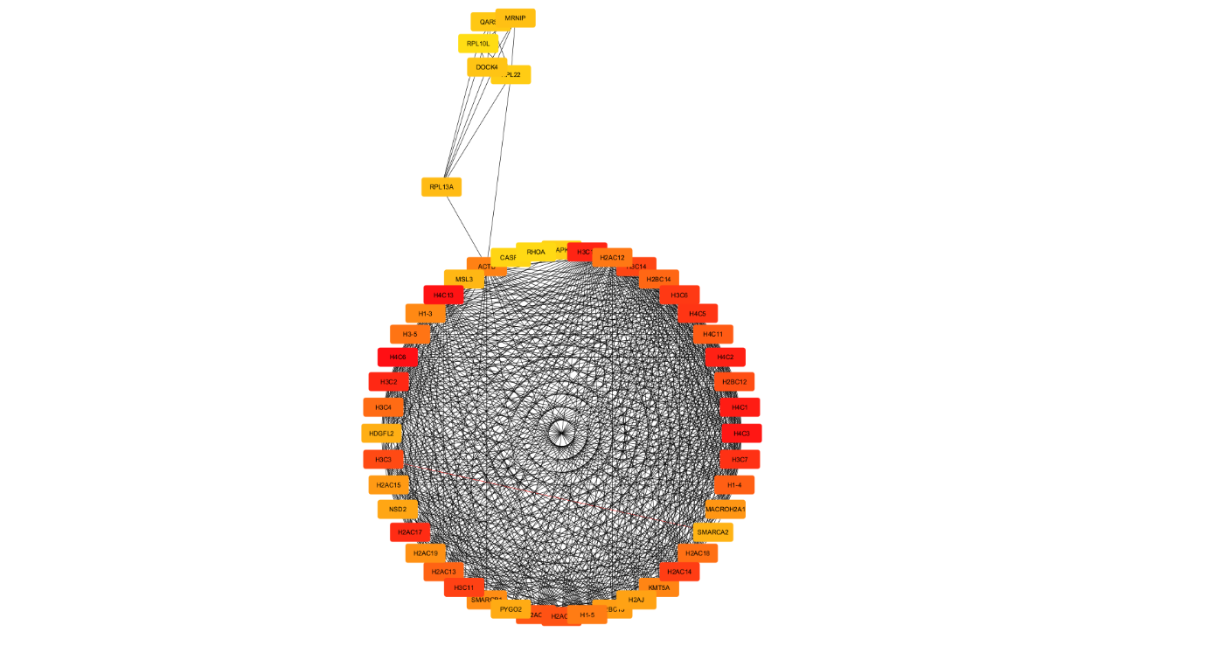
Supplementary Figure S1: cytoscape_network.tiff - PPI Network Visualized in Cytoscape with Prefuse Force-Directed Layout, Showing Community Clusters and High-Degree Nodes.

