Supplementary material_1. Double-layered pie chart of perioperative outcomes between the difficult and non-difficult groups in laparoscopic pancreaticoduodenectomy (LPD)
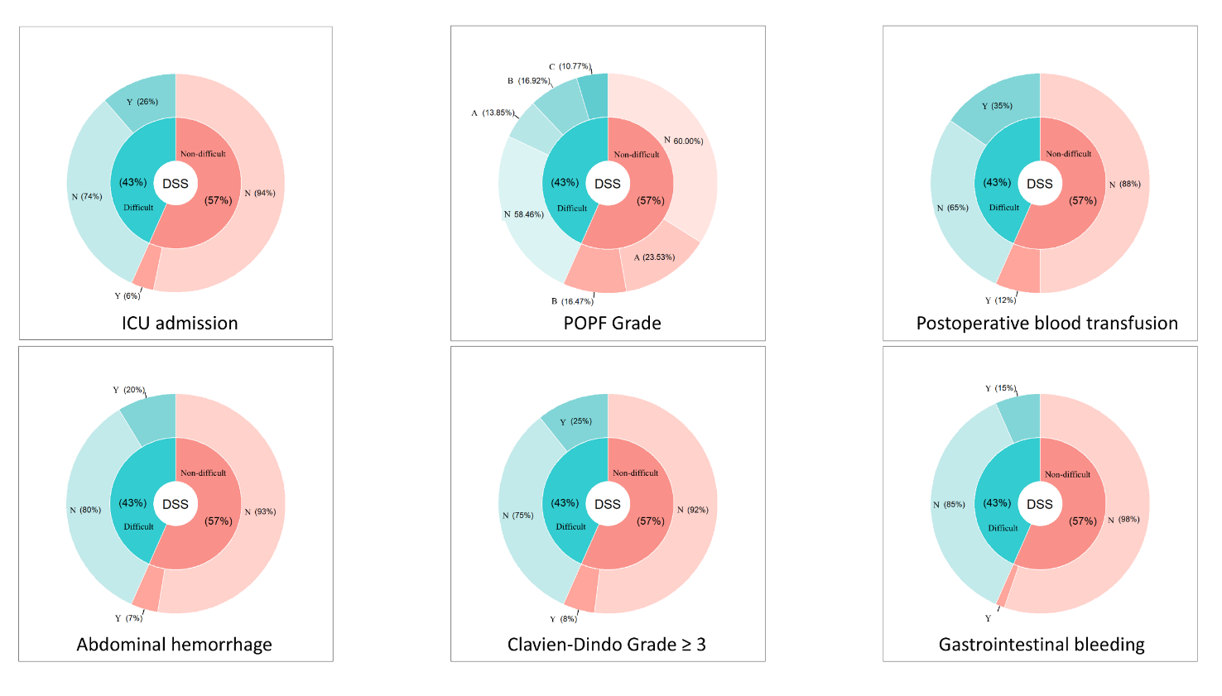
Supplementary material_2. Process of radiological feature selection
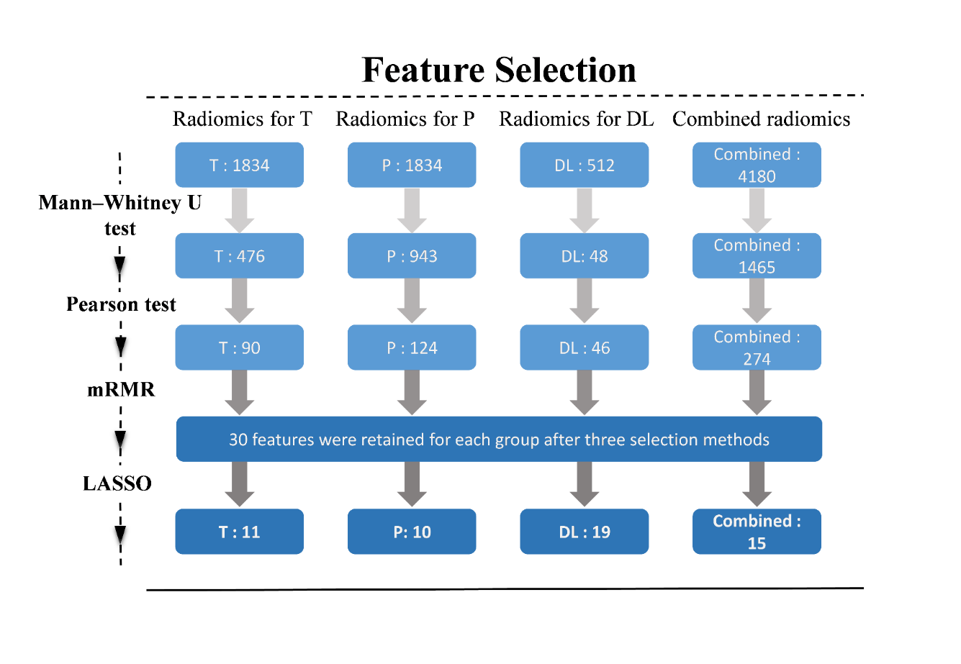
Supplementary material_3. Distribution of feature weights in different models
