Bee responses to landscape composition on coupled and decoupled multiscale approaches
Lázaro da Silva Carneiro, Milton Cezar Ribeiro, Willian Moura de Aguiar, Camila de Fatima Priante, Wilson Frantine-Silva, Maria Cristina Gaglianone

Supplementary Material

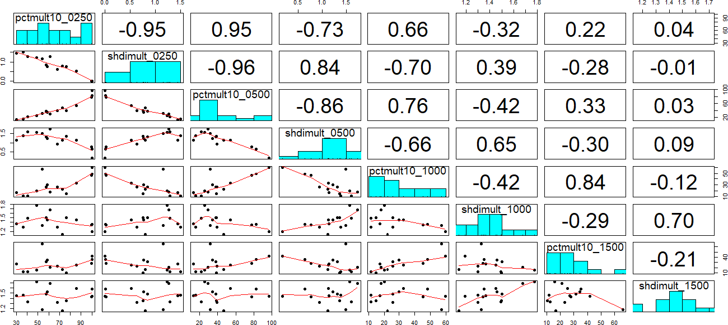
Figure S1. Scatter plot and correlation matrix between forest cover (pct) and landscape heterogeneity (shdi) quantified at coupled local scales (i.e. nested) in 15 landscapes from southeast Brazil. The above right matrix represents the Pearson's correlation (r) between each landscape metric pairwise. The diagonal matrix is the frequency histogram of landscape metrics. The lower left matrix represents the fit of the correlation between forest cover and heterogeneity at each spatial scale.

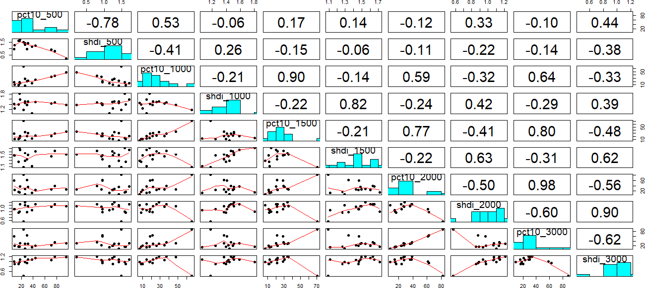
Figure S2. Scatter plot and correlation matrix between forest cover (pct) and landscape heterogeneity (shdi) quantified at decoupled regional scales in 15 landscapes in southeast Brazil. The above right matrix represents the Pearson's correlation (r) between each landscape metric pairwise. The diagonal matrix is the frequency histogram of landscape metrics. The lower left matrix represents the fit of the correlation between forest cover and heterogeneity at each spatial scale.

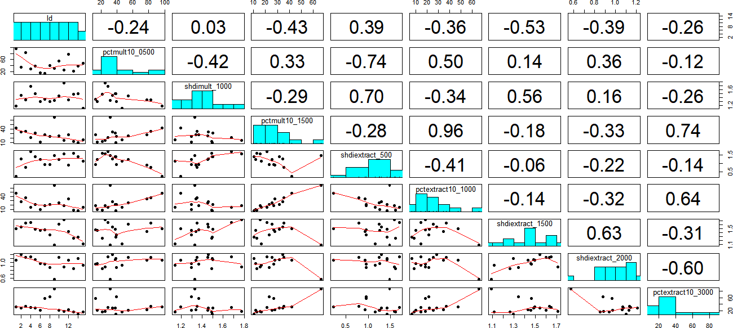Figure S3. Scatter plot and correlation matrix between forest cover (pct) and landscape heterogeneity (shdi) quantified at coupled local (mult), and decoupled regional (extract) scales in 15 landscapes in southeast Brazil. The above right matrix represents the Pearson's correlation (r) between each landscape metric pairwise. The diagonal matrix is the frequency histogram of landscape metrics. The lower left matrix represents the fit of the correlation between forest cover and heterogeneity at each spatial scale.

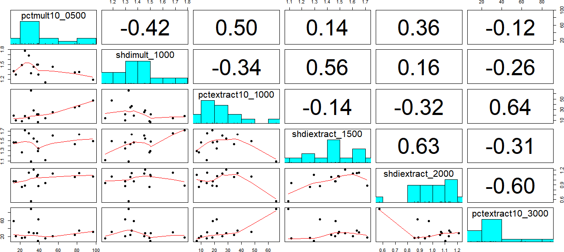
Figure S4. Scatter plot and final correlation matrix between forest cover (pct) and landscape heterogeneity (shdi) quantified at coupled local (mult), and decoupled regional (extract) scales in 15 landscapes in southeast Brazil. The above right matrix represents the Pearson's correlation (r) between each landscape metric pairwise. The diagonal matrix is the frequency histogram of landscape metrics. The lower left matrix represents the fit of the correlation between forest cover and heterogeneity at each spatial scale.

Table S1. Coefficient of determination (R²) of Linear Models (LMs) between response variables (richness, residual richness, total abundance, residual total abundance (log10), total abundance (log10), residual total abundance (log10)), and the landscape attributes in coupled local scales and decoupled regional scales, besides altitude. The choice of the response variable for the analysis is shown in table (X). We selected LMs with R² > 0.1 for analysis with Generalized Linear Models - GLMs.
Local Coupled Scales | Richness | Res. Richness | Total Abundance | Res. Total Abundance | Total Abundance (log10) | Res. Total Abundance (log10)
Forest 500 m | R²= 0.194 | R²= 0.195 | R²= 0.087 | R²=0.135 | R²=0.140 | R²=0.441
Heterogeneity 1000 m | R²= 0.062 | R²= 0.034 | R²= 0.062 | R²=0.394 | R²=0.001 | R²=0.268
Regional Decoupled Scales
Forest 1000 m | R²= 0.032 | R²= 0.144 | R²= 0.080 | R²=0.055 | R²=0.085 | R²=0.244
Heterogeneity 1500 m | R²= 0.278 | R²= 0.253 | R²= 0.076 | R²= 0.33 | R²=0.007 | R²=0.011
Heterogeneity 2000 m | R²= 0.294 | R²= 0.165 | R²= 0.129 | R²= 0.000 | R²=0. 339 | R²=0.069
Forest 3000 m | R²= 0.131 | R²= 0.007 | R²= 0.381 | R²=0.009 | R²=0.723 | R²=0.004
Altitude | R²= 0.089 | -------- | R²= 0.535 | --------- | R²=0.767
Decision | X |  |  |  |  | X

Table S2. Coefficient of determination (R²) of Linear Models (LMs) between response variables (Common Species Abundance, Residual Common Species Abundance, Common Species Abundance (log10), Residual Common Species Abundance (log10), Intermediate Species Abundance, Residual Intermediate Species Abundance, Intermediate Species Abundance (log10), Residual Species Abundance (log10)), and the landscape attributes in coupled local scales and decoupled regional scales, besides altitude. The choice of the response variable for the analysis is shown in table (X). We selected LMs with R² > 0.1 for analysis with Generalized Linear Models - GLMs.
Local Coupled Scales | Ab. Common Species | Res. Ab. Common Species | Ab. Common Species (log10) | Res. Ab. Common Species (log10) | Ab. Intermediate Species | Res. Ab. Intermediate Species | Ab. Inter. Species (log10) | Res. Ab. Inter. Species (log10)
Forest 500 m | R²= 0.077 | R²= 0.115 | R²=0.117 | R²=0.348 | R²= 0.261 | R²= 0.259 | R²=0.265 | R²=0.271
Heterogeneity 1000 m | R²= 0.06 | R²= 0.372 | R²=0.000 | R²=0.207 | R²= 0.084 | R²= 0.123 | R²=0.044 | R²=0.089
Regional Decoupled Scales
Forest 1000 m | R²= 0.083 | R²= 0.047 | R²= 0.076 | R²=0.265 | R²= 0.016 | R²= 0.071 | R²=0.010 | R²=0.090
Heterogeneity 1500 m | R²=0.083 | R²= 0.343 | R²=0.010 | R²=0.005 | R²= 0.050 | R²= 0.038 | R²=0.023 | R²=0.012
Heterogeneity 2000 m | R²= 0.121 | R²= 0.001 | R²=0.331 | R²=0.062 | R²= 0.080 | R²= 0.030 | R²=0.059 | R²=0.008
Forest 3000 m | R²= 0.364 | R²= 0.011 | R²=0.699 | R²=0.001 | R²= 0.149 | R²= 0.035 | R²=0.213 | R²=0.034
Altitude | R²= 0.524 | ------ | R²=0.760 |  | R²= 0.046 | ------ | R²=0.092
Decision |  |  |  | X |  |  | X

Table S3. Coefficient of determination (R²) of Linear Models (LMs) between response variables (Rare Species Abundance, Residual Rare Species Abundance, Rare Species Abundance (log10), Residual Rare Species Abundance (log10)), and the landscape attributes in coupled local scales and decoupled regional scales, besides altitude. The choice of the response variable for the analysis is shown in table (X). We selected LMs with R² > 0.1 for analysis with Generalized Linear Models - GLMs.
Local Coupled Scales | Ab. Rare Species | Res. Ab. Rare Species | Ab. Rare Species (log10) | Res. Ab. Rare Species (log10)
Forest 500 m | R²= 0.006 | R²= 0.021 | R²=0.002 | R²=0.011
Heterogeneity 1000 m | R²= 0.345 | R²= 0.303 | R²=0.315 | R²=0.272
Regional Decoupled Scales
Forest 1000 m | R²= 0.113 | R²= 0.000 | R²=0.106 | R²=0.002
Heterogeneity 1500 m | R²= 0.113 | R²= 0.091 | R²=0.130 | R²=0.111
Heterogeneity 2000 m | R²= 0.145 | R²= 0.007 | R²=0.193 | R²=0.024
Forest 3000 m | R²= 0.237 | R²= 0.007 | R²=0.247 | R²=0.008
Altitude | R²= 0.355 | ----- | R²=0.370
Decision |  |  | X

Table S4. Models used to explain the parameters of the Euglossini bee communities (richness, residual total abundance (log10), residual common species abundance (log10), intermediate species abundance (log10), rare species abundance (log10)) from forest cover (%) (FOR) and landscape heterogeneity (HET) quantified in coupled local (L) and decoupled regional (R) scales. The plausible models (ΔAICc < 2.0 and wi > 0.1) are in bold. The degrees of freedom of the models are represented by "df'', and the model weight by “wi”.
Response Variables | Models | ΔAICc | df | wi
Richness | ~NULL | 0 | 1 | 0.260124074596419
Richness | ~HET_R2000 | 0.97750462705266 | 2 | 0.159557827862236
Richness | ~HET_R1500 | 1.12446560086921 | 2 | 0.148253838073301
Richness | ~FOR_L500 | 1.65431383654114 | 2 | 0.113749857934489
Richness | ~FOR_R3000 | 1.9379566043501 | 2 | 0.0987094241836496
Richness | ~FOR_L500+HET_R1500 | 3.58615993900856 | 3 | 0.0432968012293618
Richness | ~FOR_R500 + HET_R2000 | 3.80744942938171 | 3 | 0.0387617529784634
Richness | ~HET_R1500+ HET_R2000 | 3.8291259659969 | 3 | 0.0383439111308851
Richness | ~HET_R1500+ FOR_R3000 | 4.00794216076583 | 3 | 0.0350644447431606
Richness | ~HET_R2000+FOR_R3000 | 4.12662403206188 | 3 | 0.0330442215423268
Richness | ~FOR_L500+FOR_R3000 | 4.2482976284068 | 3 | 0.0310938457257086
Res. Total Abundance (log10)  Res. Total Abundance (log10) | ~FOR_L500 | 0 | 3 | 0.497448874133865
Res. Total Abundance (log10)  Res. Total Abundance (log10) | ~FOR_L500 +HET_L1000 | 1.81577759140239 | 4 | 0.200658406075494
Res. Total Abundance (log10)  Res. Total Abundance (log10) | ~FOR_L500 +FOR_R1000 | 2.87415407291613 | 4 | 0.118204449643294
Res. Total Abundance (log10)  Res. Total Abundance (log10) | ~HET_L1000 | 4.038275552644 | 3 | 0.0660462338351558
Res. Total Abundance (log10)  Res. Total Abundance (log10) | ~FOR_R1000 | 4.5339598701635 | 3 | 0.0515479710429161
Res. Total Abundance (log10)  Res. Total Abundance (log10) | ~FOR_R1000 +HET_L1000 | 5.29998653225737 | 4 | 0.035145603058274
Res. Total Abundance (log10)  Res. Total Abundance (log10) | ~NULL | 5.55433894819493 | 2 | 0.030948462211001
Res. Ab. Common Species (log10) | ~FOR_L500 | 0 | 3 | 0.385830773148392
Res. Ab. Common Species (log10) | ~FOR_R1000 | 1.79350899564909 | 3 | 0.157377025683082
Res. Ab. Common Species (log10) | ~FOR_L500+ FOR_R1000 | 2.27603779401834 | 4 | 0.123640722990556
Res. Ab. Common Species (log10) | ~FOR_L500+ HET_L1000 | 2.56410325966395 | 4 | 0.1070554829132
Res. Ab. Common Species (log10) | ~HET_L1000 | 2.9435167693908 | 3 | 0.0885564743819792
Res. Ab. Common Species (log10) | ~NULL | 3.24344861361973 | 2 | 0.0762238613684145
Res. Ab. Common Species (log10) | ~HET_L1000 + FOR_R1000 | 3.67872718895727 | 4 | 0.061315659514377
Intermediate Species Abundance (log10) | ~FOR_L500 | 0 | 3 | 3.294.479.649
Intermediate Species Abundance (log10) | ~FOR_L500+ FOR_R3000 | 9.141.177.966 | 4 | 3.147.291.822
Intermediate Species Abundance (log10) | ~FOR_R3000 | 1.037.378.258 | 3 | 1.961.205.048
Intermediate Species Abundance (log10) | ~NULL | 1.448.213.323 | 2 | 1.597.023.481
Ab. Rare Species (log10)  Ab. Rare Species (log10) | ~HET_L1000 | 0 | 3 | 0.217121859512405
Ab. Rare Species (log10)  Ab. Rare Species (log10) | ~HET_L1000+ FOR_R3000 | 0.551290960109494 | 4 | 0.164813293792825
Ab. Rare Species (log10)  Ab. Rare Species (log10) | ~HET_L1000 + HET_R2000 | 0.758289147203154 | 4 | 0.14860832994853
Ab. Rare Species (log10)  Ab. Rare Species (log10) | ~FOR_R3000 | 1.42286153619689 | 3 | 0.106594081803197
Ab. Rare Species (log10)  Ab. Rare Species (log10) | ~HET_R2000 | 2.4703918767515 | 3 | 0.0631342127890495
Ab. Rare Species (log10)  Ab. Rare Species (log10) | ~NULL | 2.50515799010957 | 2 | 0.062046230812151
Ab. Rare Species (log10)  Ab. Rare Species (log10) | ~HET_L1000+ FOR_R1000 | 3.35506025224422 | 4 | 0.0405659333516042
Ab. Rare Species (log10)  Ab. Rare Species (log10) | ~HET_R1500 | 3.5863903272602 | 3 | 0.03613506042248
Ab. Rare Species (log10)  Ab. Rare Species (log10) | ~HET_L1000 + HET_R1500 | 3.75307940209481 | 4 | 0.0332454880266696
Ab. Rare Species (log10)  Ab. Rare Species (log10) | ~HET_L1000 | 3.99898982266529 | 3 | 0.0293990937536196
Ab. Rare Species (log10)  Ab. Rare Species (log10) | ~HET_R1500+ FOR_R3000 | 4.24368757572568 | 4 | 0.0260134827945591
Ab. Rare Species (log10)  Ab. Rare Species (log10) | ~HET_R2000 + FOR_R3000 | 4.59629067248403 | 4 | 0.0218087970816829
Ab. Rare Species (log10)  Ab. Rare Species (log10) | ~FOR_R1000 +FOR_R3000 | 5.23950364808253 | 4 | 0.0158110163821983
Ab. Rare Species (log10)  Ab. Rare Species (log10) | ~FOR_R1000 +HET_R2000 | 5.56536196386739 | 4 | 0.0134338518468632
Ab. Rare Species (log10)  Ab. Rare Species (log10) | ~FOR_R1000 +HET_R1500 | 5.99595418610739 | 4 | 0.0108317503390529
Ab. Rare Species (log10)  Ab. Rare Species (log10) | ~HET_R1500 +HET_R2000 | 6.07010401740851 | 4 | 0.0104375173431121

