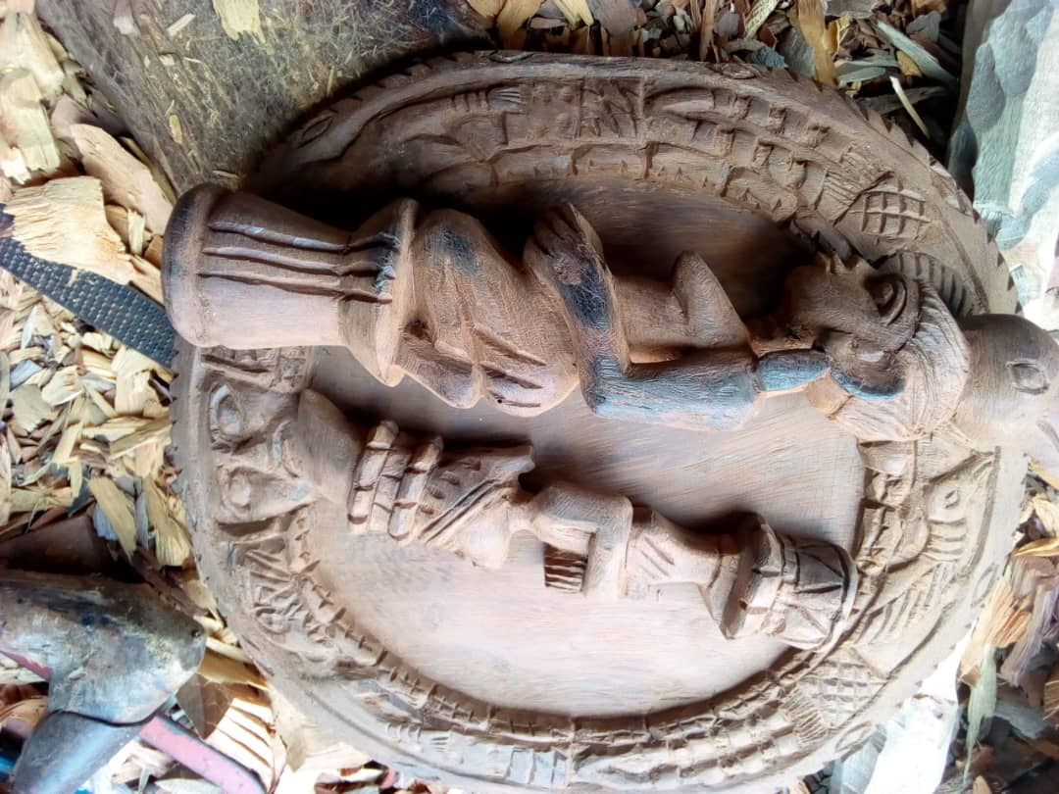
Photo 1. Small ornamental art made with wood of Chlorophora excelsa

