SUPPLEMENTARY MATERIALS

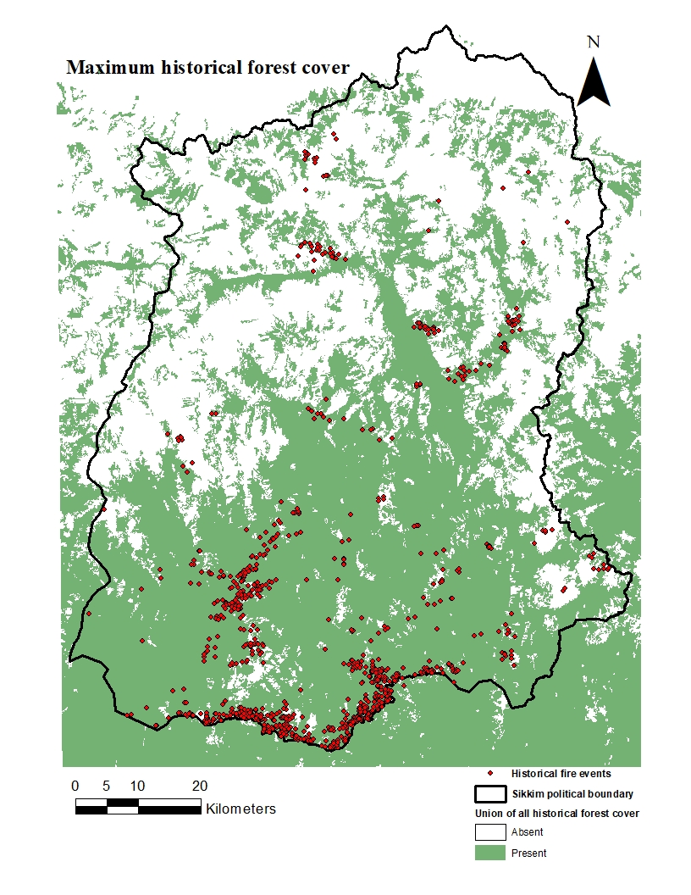
Supplement Figure 1: Fire events confined within historical forest cover were considered as wildfires.

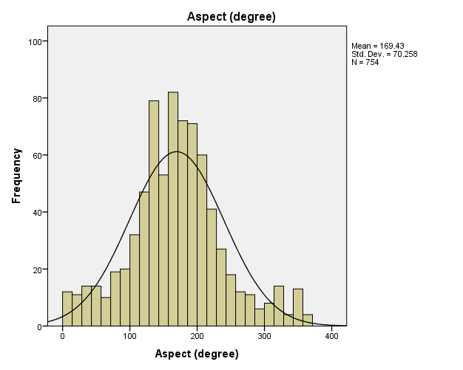
Supplement Figure 2: Histogram of wildfire events over environmental features (a) Aspect (Cont.)
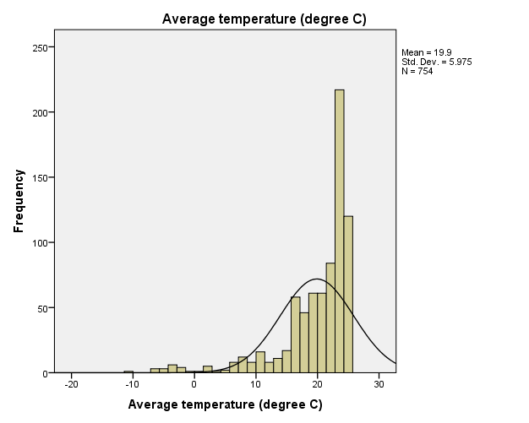

Supplement Figure 2: (b) Average temperature (Cont.)
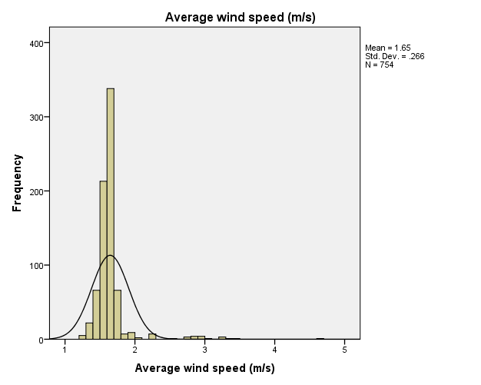
Supplement Figure 2: (c) Average wind speed (Cont.)
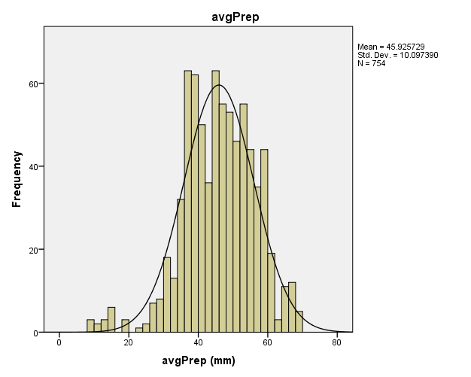

Supplement Figure 2: (d): Average precipitation (Cont.)

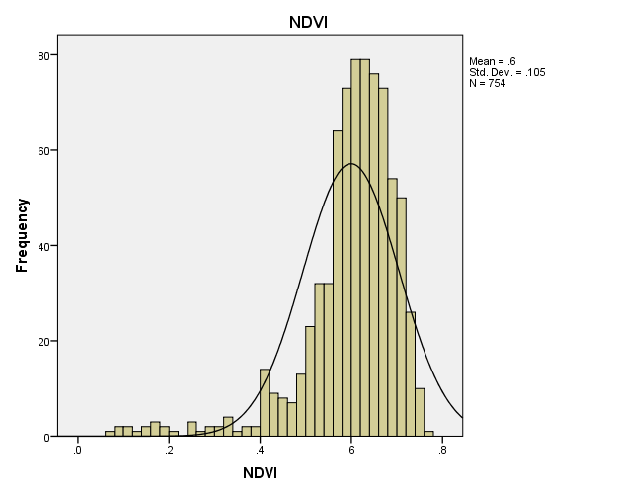
Supplement Figure 2: (e) NDVI (Cont.)
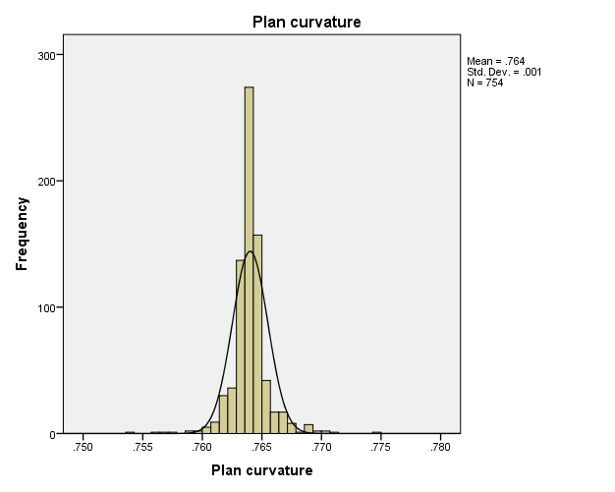
Supplement Figure 2: (f) Plan curvature (Cont.)
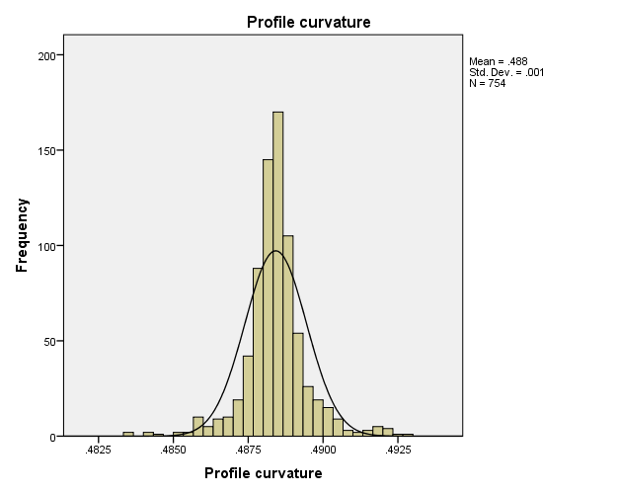
Supplement Figure 2: (g) Profile curvature (Cont.)

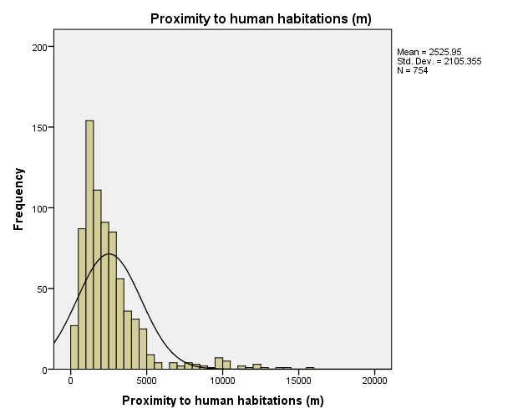
Supplement Figure 2: (h) Proximity to settlements (Cont.)
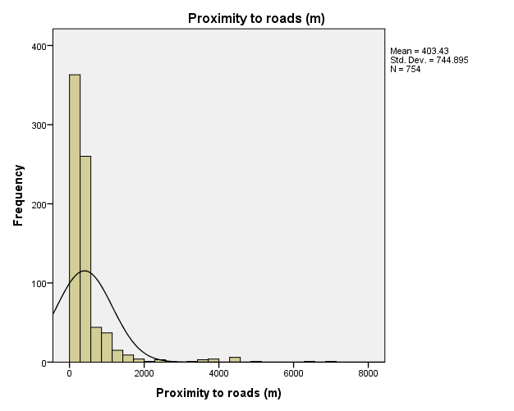
Supplement Figure 2: (i) Proximity to roadways (Cont.)

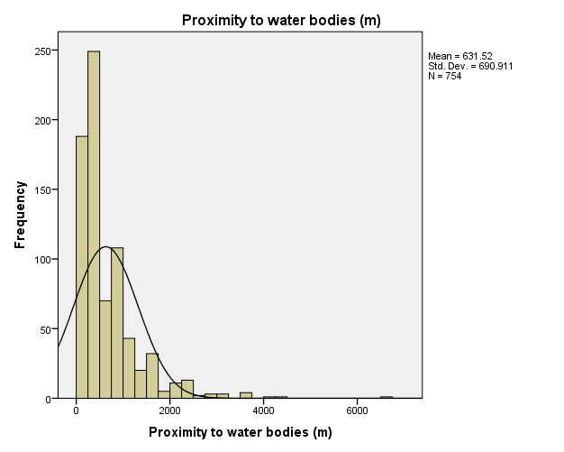
Supplement Figure 2: (j) Proximity to water bodies (Cont.)
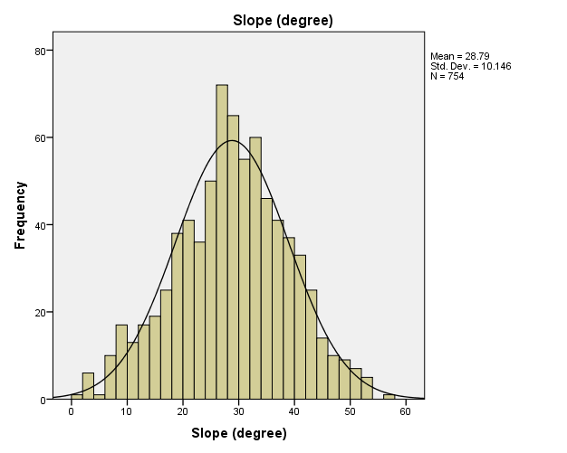
Supplement Figure 2: (k) Slope (Cont.)
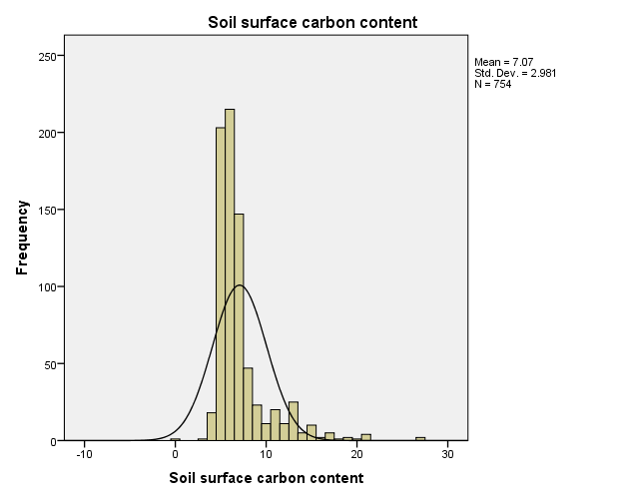

Supplement Figure 2: (l) Soil carbon content (× 5g/kg of soil) (Cont.)

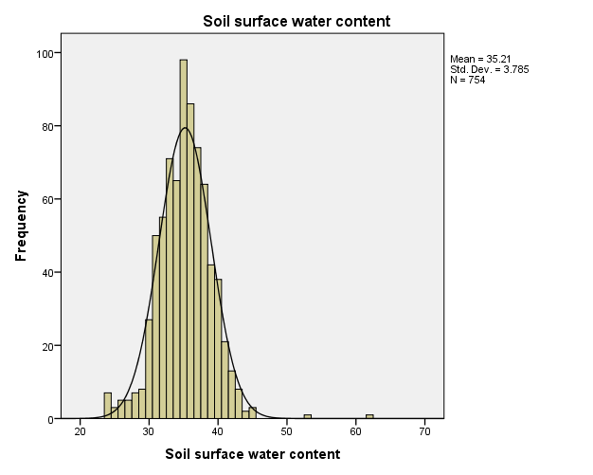
Supplement Figure 2: (m) Soil water content (volumetric %) (Cont.)
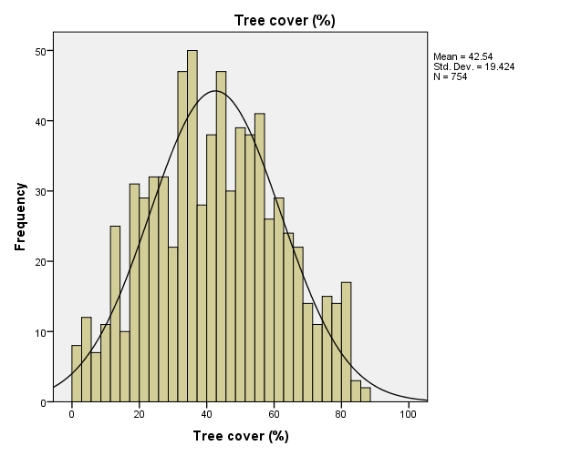
Supplement Figure 2: (n) Tree cover (Cont.)
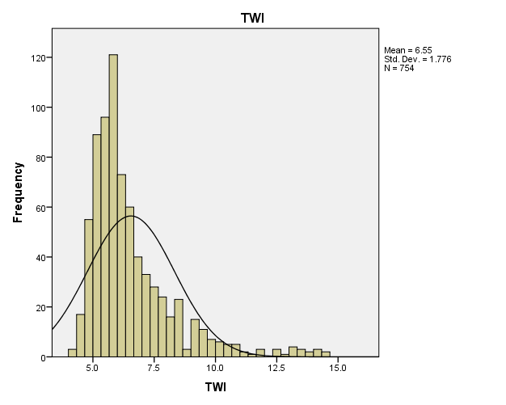
Supplement Figure 2: (Cont.) (o) TWI.

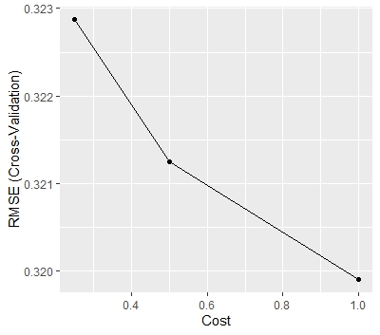
Supplement Figure 3: Performance in terms of RMSE of (a) SVM (Cont.)
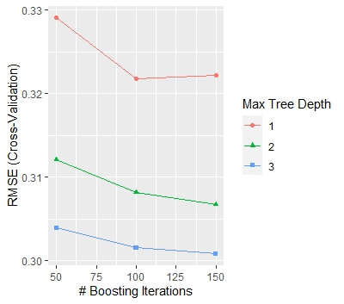
Figure 3: (b) GBM (Cont.)
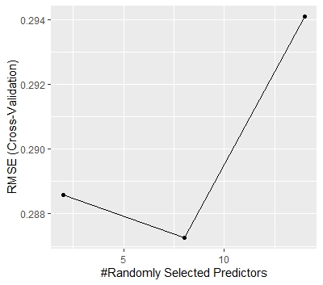
Figure 3: (Cont.) (c) RF.

