Supplementary information

Explainable Artificial Intelligence Reveals Spatially Divergent Effects of Global Change on Mammals
Lei Song^{1*}, Amy E. Frazier², Peter Kedron², Diogo S. A. Araujo³, Diyang Cui², Brian J. Enquist^{4,5}, César Hinojo-Hinojo⁶, Joana Madeira Krieger⁷, Brian S. Maitner⁸, Cory Merow⁹, Gabriel M. Moulatlet⁴, Efthymios I. Nikolopoulos³, and Patrick R. Roehrdanz⁷
¹Department of Geography, Rutgers University, Piscataway, NJ 08854, USA.
²Department of Geography, University of California, Santa Barbara, CA 93117, USA.
³Department of Civil and Environmental Engineering, Rutgers University, Piscataway, NJ 08854, USA.
⁴Department of Ecology and Evolutionary Biology, University of Arizona, Tucson, AZ 85721, USA.
⁵The Santa Fe Institute, Santa Fe, NM 87501, USA.
⁶Departamento de Investigaciones Científicas y Tecnologicas (DICTUS), Universidad de Sonora, Hermosillo, Sonora, Mexico
⁷Moore Center for Science and Solutions, Conservation International, Arlington, VA, USA.
⁸Department of Integrative Biology, University of South Florida, St. Petersburg, FL 33701, USA.
⁹Department of Ecology and Evolutionary Biology and Eversource Energy Center, University of Connecticut, Storrs, CT, USA.
*Corresponding author: lei.song@rutgers.edu

Extended Methods

Text S1. Metadata filtering for species occurrence records
Step 1: Data retrieval from GBIF
We downloaded mammal species occurrence records with geographic coordinates from the Global Biodiversity Information Facility (GBIF). During data retrieval, we applied the following initial filters:
- Set hasCoordinate = TRUE (to retain only georeferenced records).
- Set hasGeospatialIssue = FALSE (to exclude records flagged with geospatial issues by GBIF).
These criteria automatically excluded records with the following issues:
- Zero coordinates: Records with coordinates exactly at (0,0).
- Country-coordinate mismatch: Records whose coordinates fall outside the specified country's boundaries.
- Invalid coordinates: Records for which GBIF could not interpret the provided coordinates.
- Out-of-range coordinates: Records with latitude values not within -90 to 90, or longitude values outside -180 to 180.
Additionally, we retained only species presence records by setting:
- occurrenceStatus = PRESENT (thus removing any absence records).
- Excluding occurrences derived from fossil or living specimens by removing records with:
  - basisOfRecord = FOSSIL_SPECIMEN
  - basisOfRecord = LIVING_SPECIMEN
Step 2: Post-retrieval quality control
After downloading data from GBIF, we applied further quality-control filters to enhance data reliability:
- Temporal filtering: Removed records collected before the year 1945 (based on the year attribute).
- Spatial uncertainty filtering: Excluded records with high spatial uncertainty (coordinatePrecision ≥ 0.01 and coordinateUncertaintyInMeters ≥ 100,000 m). Also removed records containing known default or placeholder values for coordinateUncertaintyInMeters (specifically values of 301, 3036, 999, and 9999), as these typically indicate large uncertainties exceeding the stated value.
- Duplicate record removal: Eliminated exact duplicate records to avoid redundancy, using the cc_dupl function from the R package CoordinateCleaner.
- Removal of records at zero latitude or longitude: Filtered out records located precisely along the equator (decimalLatitude = 0) or prime meridian (decimalLongitude = 0).
- Removal of records where absolute longitude equaled absolute latitude.
- Institutional and administrative bias removal: Removed records located within 100 meters of country centroids, capital cities, known biodiversity institutions, and GBIF headquarters, using the clean_coordinates function from the R package CoordinateCleaner.
The numbers of records and species remaining after each step are summarized in Table S1. And all the records are shared with the manuscript.

Text S2. Natal dispersal distance
Schloss et al. (2012) modeled single-natal dispersal distances for 493 species using positive allometric relationships between median dispersal distance (D, km) and body mass (M, kg), with separate equations for carnivores (Eq. 1) and for herbivores and omnivores combined (Eq. 2):
$$D_{carn}=3.45×M^{0.89}$$ | (1)
$$D_{Herb, Omn}=1.45×M^{0.54}$$ | (2)

Text S3. Shapley value and SHapley Additive exPlanations (SHAP)
SHapley Additive exPlanations (SHAP)¹ has been developed to explain individual predictions using Shapley values in machine learning modeling. For a given $f(x)$ for a single input $x$, the SHAP method explains the prediction as the sum of the contributions from each feature value¹:
$$g\left(x^{'}\right)=∅_{0}+\sum_{i=1}^{M}{∅_{i}x_{i}^{'}}$$ | (3)
where $g$ is the explanation model. $x^{'}$ is the simplified $x$ that maps to the original $x$ by function $x=h_{x}(x^{'})$. $M$ is the number of input features. $∅_{0}$ is the constant value when all inputs are missing, and $∅_{i}∈R$ is the feature attribution for feature $i$. Shapley values are the unique solution to Eq.1, satisfying three key properties: local accuracy, missingness, and consistency¹:
$$∅_{i}=\sum_{Q⊆S\backslash \{i\}}{\frac{\left|Q\right|!\left(\left|S\right|-\left|Q\right|-1\right)!}{\left|S\right|!}}[f_{Q∪\left\{i\right\}}\left(x_{Q∪\left\{i\right\}}\right)-f_{Q}(x_{Q})]$$ | (4)
where $S$ is the set of all features in the model. $Q$ is a subset of $S$. $f_{Q∪\left\{i\right\}}$ is a model trained with feature $i$ present and $f_{Q}$ is a model trained with feature $i$ withheld. Thus, $f_{Q∪\left\{i\right\}}\left(x_{Q∪\left\{i\right\}}\right)-f_{Q}(x_{Q})$represents the effects of including feature $i$ on the model. Because the effect of withholding a feature relies on other features, $∅_{i}$ calculates the weighted average of $f_{Q∪\left\{i\right\}}\left(x_{Q∪\left\{i\right\}}\right)-f_{Q}(x_{Q})$of all possible subsets $Q⊆S\backslash \{i\}$.
However, computing exact Shapley values is computationally infeasible because it requires predictions for every possible combination of variables both with and without the focal feature, but the number of possible coalitions grows exponentially with the number of variables. To address this challenge, several methods and tools have been developed to approximate Shapley values, including the R package kernelshap (https://github.com/ModelOriented/kernelshap), fastshap², shapr³ and Python library shap (https://github.com/shap/shap). We used the fastshap² package to estimate Shapley values, as it efficiently implements a Monte Carlo sampling approach that ensures accurate and consistent computation. Within this process, we optimized the key parameter, the number of Monte Carlo repetitions, for all species distribution models. To achieve this, we first calculated Shapley values for the training dataset using 10,000 repetitions as the reference. Then, we sequentially computed Shapley values with 100, 1,000, 2,000, 4,000, and 7,000 repetitions, assessing their correlation with the reference values at each step. If the correlation improvement was less than 0.001, we stopped and selected that repetition number. We found that 1,000 repetitions were sufficient for most models in our study (Figure S2).

Supplementary Figures and Tables
Table S1. Summary of filtering steps applied to GBIF occurrence records and resulting numbers of records and mammal species retained.
Filter |  | No. of records | No. of species
GBIF query |  | 25,830,904 | 5,069
Metadata filtering | Year >= 1945 | 25,347,822 | 5,007
Metadata filtering | Spatial uncertainty filtering | 25,086,696 | 4,996
Metadata filtering | Remove duplicate records | 8,596,557 | 4,996
Metadata filtering | Remove records at zero latitude or longitude | 8,596,517 | 4,996
Metadata filtering | Remove records with latitude and longitude | 8,596,148 | 4,996
Metadata filtering | Remove institutional and administrative bias | 8,580,937 | 4,996
Metadata filtering | Remove species with insufficient data (<4 records) | 8,579,557 | 4,216
AOH filtering |  | 5,587,649 | 3,954
Remove species with insufficient data (<15 records) |  | 5,579,234* | 2,480*
* These numbers will further decrease during environmental sampling (see section species distribution modeling in the main text).
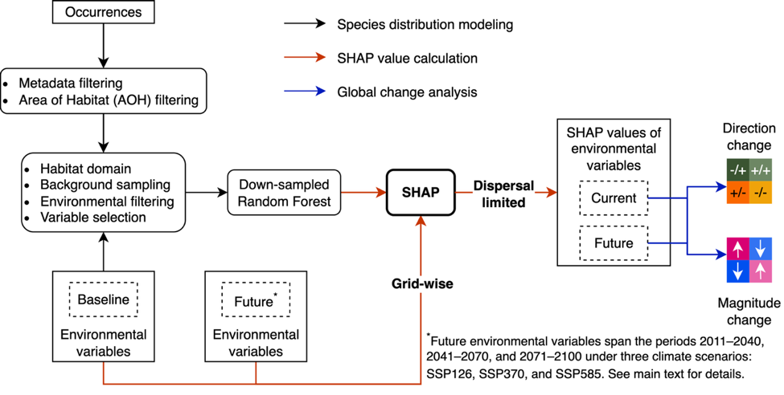
Figure S1. Conceptual workflow of the global change impact analysis. Black arrows indicate species distribution modeling (SDM). The red arrows indicate model explanation, and blue arrows indicate global change impact analysis. SHAP (SHapley Additive exPlanations) is the method to use Shapley values to interpret models.
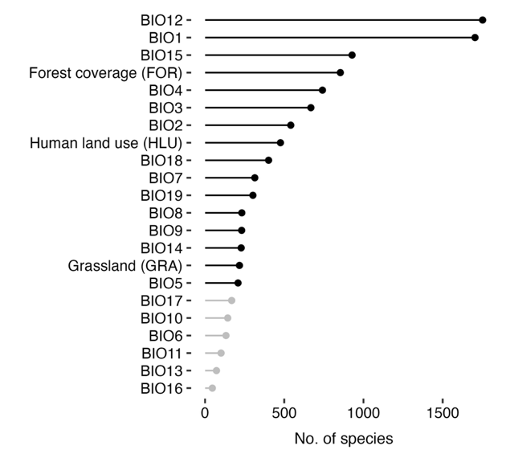
Figure S2. Selected environmental variables and the number of species for which each variable was included in distribution modeling. Environmental variables are BIO1 (Annual Mean Temperature), BIO2 (Mean Diurnal Range, mean of monthly [max temperature − min temperature]), BIO3 (Isothermality, BIO2/BIO7 × 100), BIO4 (Temperature Seasonality, standard deviation × 100), BIO5 (Max Temperature of Warmest Month), BIO6 (Min Temperature of Coldest Month), BIO7 (Temperature Annual Range, BIO5 − BIO6), BIO8 (Mean Temperature of Wettest Quarter), BIO9 (Mean Temperature of Driest Quarter), BIO10 (Mean Temperature of Warmest Quarter), BIO11 (Mean Temperature of Coldest Quarter), BIO12 (Annual Precipitation), BIO13 (Precipitation of Wettest Month), BIO14 (Precipitation of Driest Month), BIO15 (Precipitation Seasonality, coefficient of variation), BIO16 (Precipitation of Wettest Quarter), BIO17 (Precipitation of Driest Quarter), BIO18 (Precipitation of Warmest Quarter), and BIO19 (Precipitation of Coldest Quarter), FOR (forest coverage), HLU (human land use), and GRA (grassland coverage). Greyed-out variables were selected in fewer than 10% of species distribution models and were therefore excluded from the analysis.
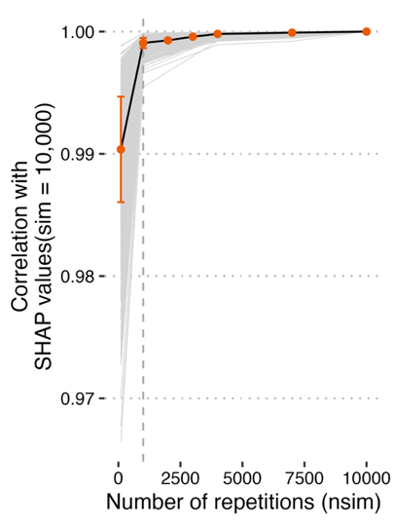
Figure S3. Pearson correlation between SHAP values computed with different numbers of repetitions and those computed with 10,000 repetitions. The dashed line represents nsim = 1,000.
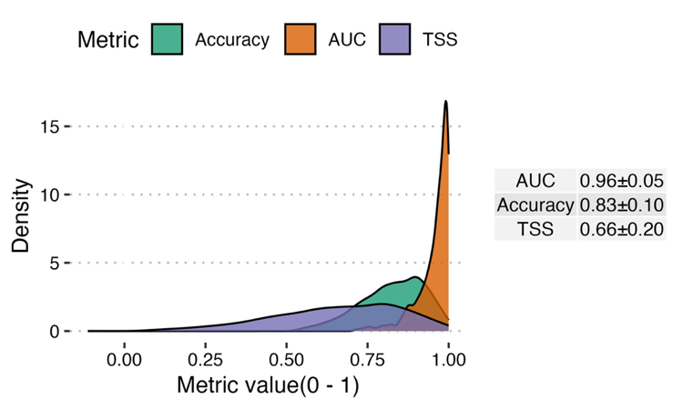
Figure S4. Evaluation of species distribution models (SDMs) used in the global change analysis. AUC is the area under the Receiver Operating Characteristic (ROC) curve. TSS is True Skill Statistics.

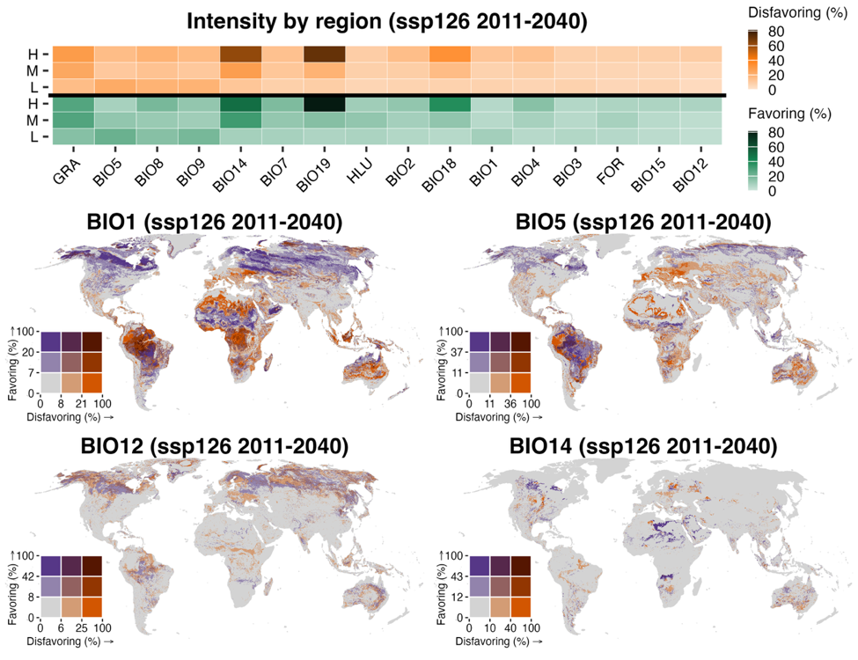
Figure S5. Spatial intensity of projected turnovers of environmental variables for mammal species under SSP126 for the early-century period (2011–2040). Intensity of turnovers is calculated as the percentage of species in each grid cell (~10 km²) projected to experience the corresponding turnovers. For each environmental variable, we only consider species that both inhabit a given grid cell and include that variable in their distribution models for the calculations. Disfavoring turnover refers to a shift from favorable to unfavorable conditions (positive to negative SHAP values), while favoring turnover indicates the reverse. The top bar plot is the median intensity of turnovers (favoring and disfavoring) by latitudinal band: low (L, 30°S–30°N), middle (M, 30°–60°N/S), and high (H, 60°–90°N/S). The bottom maps are bivariate maps showing intensity of disfavoring and favoring turnover of all variables. Environmental variables are BIO1 (Annual Mean Temperature), BIO2 (Mean Diurnal Range, mean of monthly [max temperature − min temperature]), BIO3 (Isothermality, BIO2/BIO7 × 100), BIO4 (Temperature Seasonality, standard deviation × 100), BIO5 (Max Temperature of Warmest Month), BIO7 (Temperature Annual Range, BIO5 − BIO6), BIO8 (Mean Temperature of Wettest Quarter), BIO9 (Mean Temperature of Driest Quarter), BIO12 (Annual Precipitation), BIO14 (Precipitation of Driest Month), BIO15 (Precipitation Seasonality, coefficient of variation), BIO18 (Precipitation of Warmest Quarter), and BIO19 (Precipitation of Coldest Quarter)^{4,5}, FOR (forest coverage), HLU (human land use), and GRA (grassland coverage). Breakpoints for intensity of turnovers are determined using the Fisher–Jenks algorithm, as implemented in the R package classInt. (Figure continued on next page)
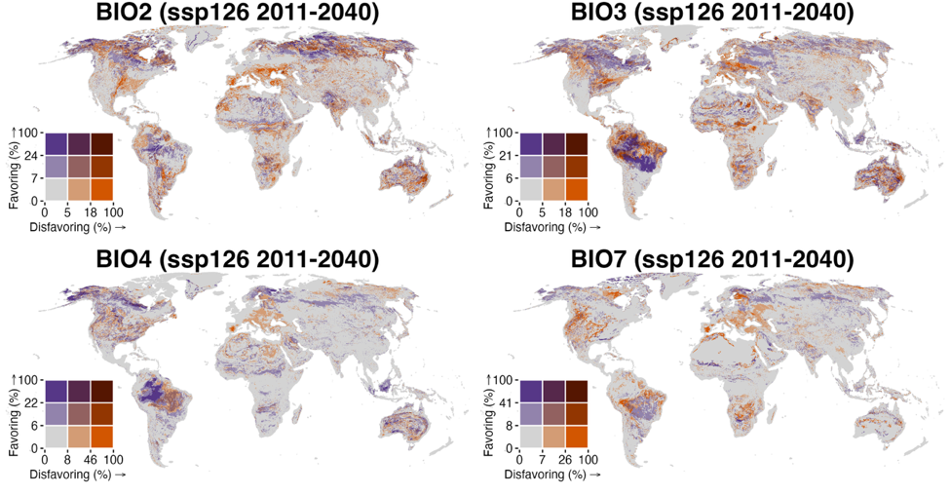
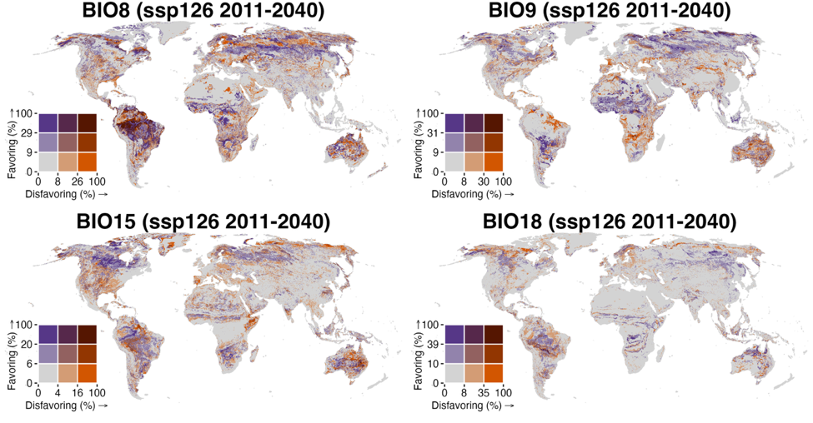

Figure S5 (continued).
See caption on previous page.
(Figure continued on next page)
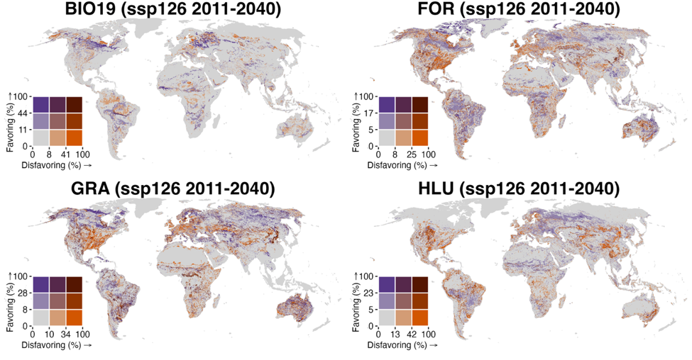
Figure S5 (continued).
See caption on page 8.
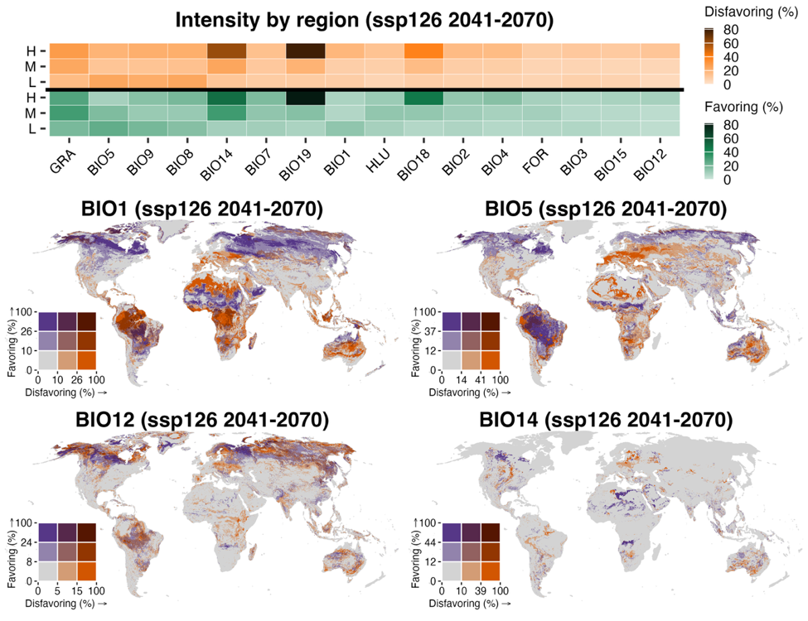
Figure S6. Spatial intensity of projected turnovers of environmental variables for mammal species under SSP126 for the mid-century period (2041–2070). Intensity of turnovers is calculated as the percentage of species in each grid cell (~10 km²) projected to experience the corresponding turnovers. For each environmental variable, we only consider species that both inhabit a given grid cell and include that variable in their distribution models for the calculations. Disfavoring turnover refers to a shift from favorable to unfavorable conditions (positive to negative SHAP values), while favoring turnover indicates the reverse. The top bar plot is the median intensity of turnovers (favoring and disfavoring) by latitudinal band: low (L, 30°S–30°N), middle (M, 30°–60°N/S), and high (H, 60°–90°N/S). The bottom maps are bivariate maps showing intensity of disfavoring and favoring turnover of all variables. Environmental variables are BIO1 (Annual Mean Temperature), BIO2 (Mean Diurnal Range, mean of monthly [max temperature − min temperature]), BIO3 (Isothermality, BIO2/BIO7 × 100), BIO4 (Temperature Seasonality, standard deviation × 100), BIO5 (Max Temperature of Warmest Month), BIO7 (Temperature Annual Range, BIO5 − BIO6), BIO8 (Mean Temperature of Wettest Quarter), BIO9 (Mean Temperature of Driest Quarter), BIO12 (Annual Precipitation), BIO14 (Precipitation of Driest Month), BIO15 (Precipitation Seasonality, coefficient of variation), BIO18 (Precipitation of Warmest Quarter), and BIO19 (Precipitation of Coldest Quarter)^{4,5}, FOR (forest coverage), HLU (human land use), and GRA (grassland coverage). Breakpoints for intensity of turnovers are determined using the Fisher–Jenks algorithm, as implemented in the R package classInt. (Figure continued on next page)
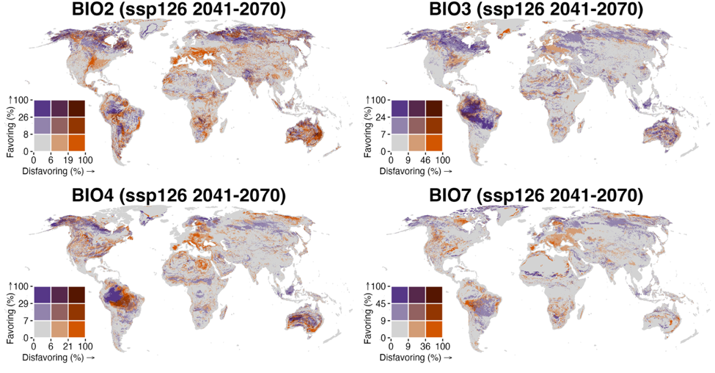
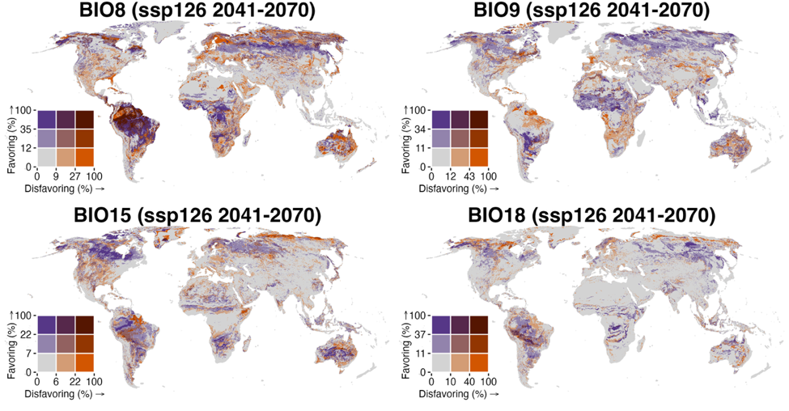
Figure S6 (continued).
See caption on previous page.
(Figure continued on next page)
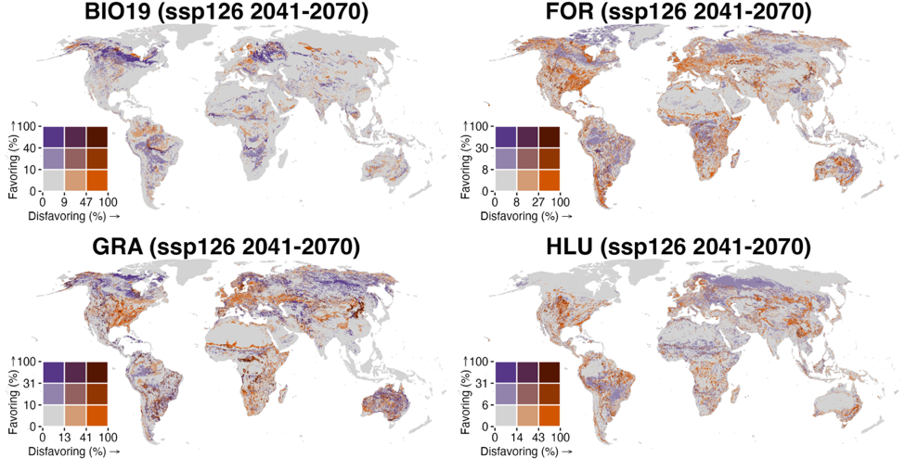
Figure S6 (continued).
See caption on page 11.
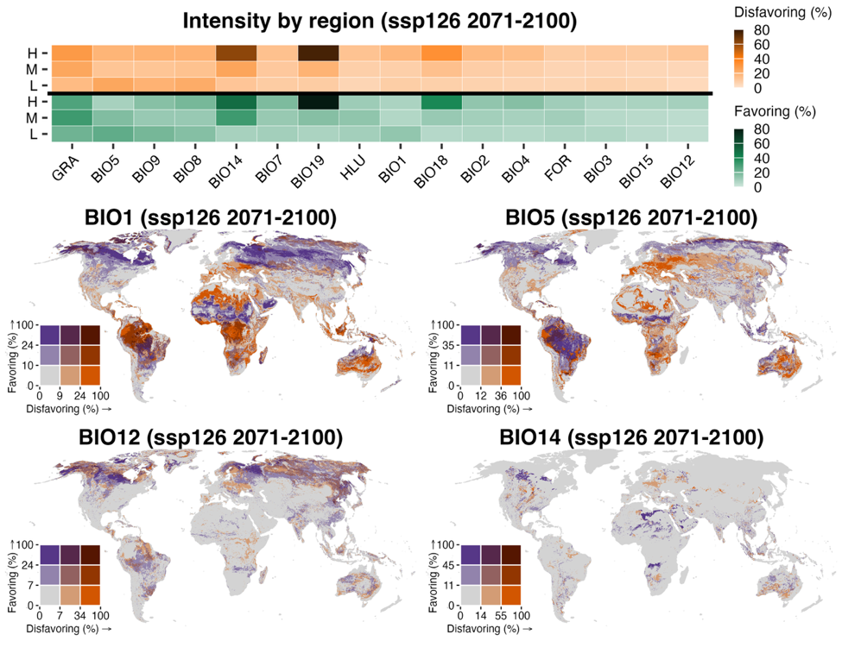
Figure S7. Spatial intensity of projected turnovers of environmental variables for mammal species under SSP126 for the late-century period (2071–2100). Intensity of turnovers is calculated as the percentage of species in each grid cell (~10 km²) projected to experience the corresponding turnovers. For each environmental variable, we only consider species that both inhabit a given grid cell and include that variable in their distribution models for the calculations. Disfavoring turnover refers to a shift from favorable to unfavorable conditions (positive to negative SHAP values), while favoring turnover indicates the reverse. The top bar plot is the median intensity of turnovers (favoring and disfavoring) by latitudinal band: low (L, 30°S–30°N), middle (M, 30°–60°N/S), and high (H, 60°–90°N/S). The bottom maps are bivariate maps showing intensity of disfavoring and favoring turnover of all variables. Environmental variables are BIO1 (Annual Mean Temperature), BIO2 (Mean Diurnal Range, mean of monthly [max temperature − min temperature]), BIO3 (Isothermality, BIO2/BIO7 × 100), BIO4 (Temperature Seasonality, standard deviation × 100), BIO5 (Max Temperature of Warmest Month), BIO7 (Temperature Annual Range, BIO5 − BIO6), BIO8 (Mean Temperature of Wettest Quarter), BIO9 (Mean Temperature of Driest Quarter), BIO12 (Annual Precipitation), BIO14 (Precipitation of Driest Month), BIO15 (Precipitation Seasonality, coefficient of variation), BIO18 (Precipitation of Warmest Quarter), and BIO19 (Precipitation of Coldest Quarter)^{4,5}, FOR (forest coverage), HLU (human land use), and GRA (grassland coverage). Breakpoints for intensity of turnovers are determined using the Fisher–Jenks algorithm, as implemented in the R package classInt. (Figure continued on next page)
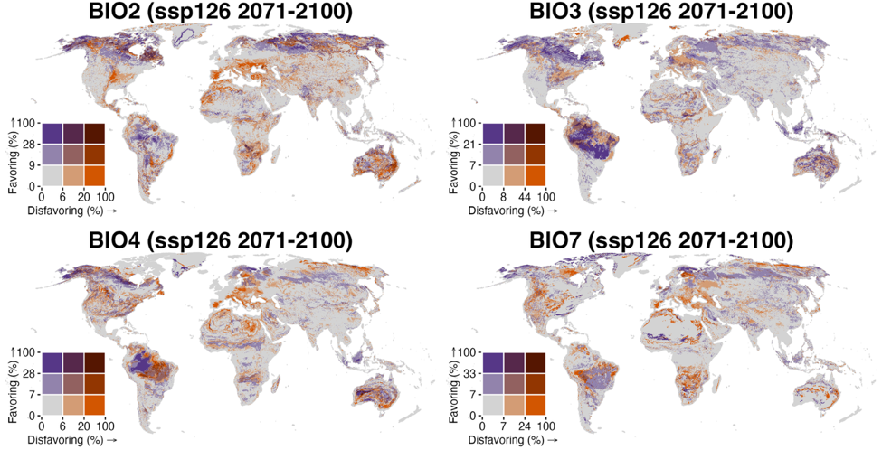
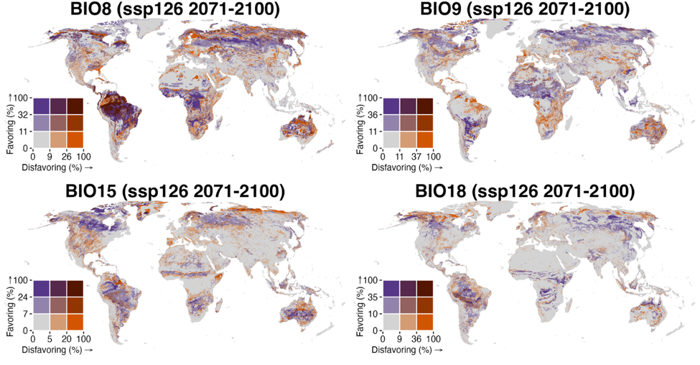
Figure S7 (continued).
See caption on previous page.
(Figure continued on next page)
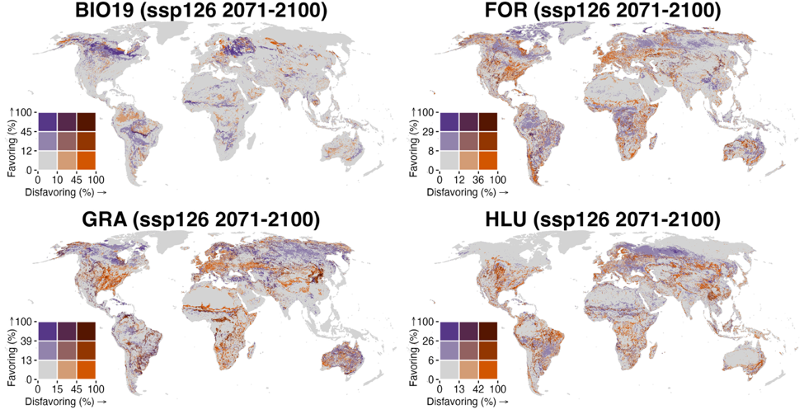
Figure S7 (continued).
See caption on page 14.
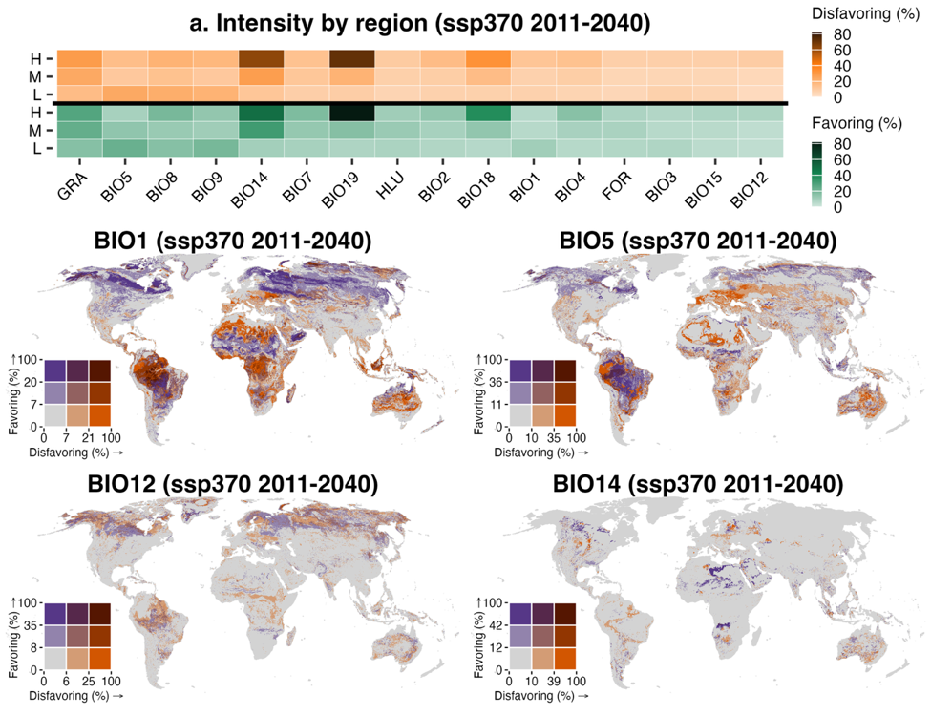
Figure S8. Spatial intensity of projected turnovers of environmental variables for mammal species under SSP370 for the early-century period (2011–2040). Intensity of turnovers is calculated as the percentage of species in each grid cell (~10 km²) projected to experience the corresponding turnovers. For each environmental variable, we only consider species that both inhabit a given grid cell and include that variable in their distribution models for the calculations. Disfavoring turnover refers to a shift from favorable to unfavorable conditions (positive to negative SHAP values), while favoring turnover indicates the reverse. The top bar plot is the median intensity of turnovers (favoring and disfavoring) by latitudinal band: low (L, 30°S–30°N), middle (M, 30°–60°N/S), and high (H, 60°–90°N/S). The bottom maps are bivariate maps showing intensity of disfavoring and favoring turnover of all variables. Environmental variables are BIO1 (Annual Mean Temperature), BIO2 (Mean Diurnal Range, mean of monthly [max temperature − min temperature]), BIO3 (Isothermality, BIO2/BIO7 × 100), BIO4 (Temperature Seasonality, standard deviation × 100), BIO5 (Max Temperature of Warmest Month), BIO7 (Temperature Annual Range, BIO5 − BIO6), BIO8 (Mean Temperature of Wettest Quarter), BIO9 (Mean Temperature of Driest Quarter), BIO12 (Annual Precipitation), BIO14 (Precipitation of Driest Month), BIO15 (Precipitation Seasonality, coefficient of variation), BIO18 (Precipitation of Warmest Quarter), and BIO19 (Precipitation of Coldest Quarter)^{4,5}, FOR (forest coverage), HLU (human land use), and GRA (grassland coverage). Breakpoints for intensity of turnovers are determined using the Fisher–Jenks algorithm, as implemented in the R package classInt. (Figure continued on next page)
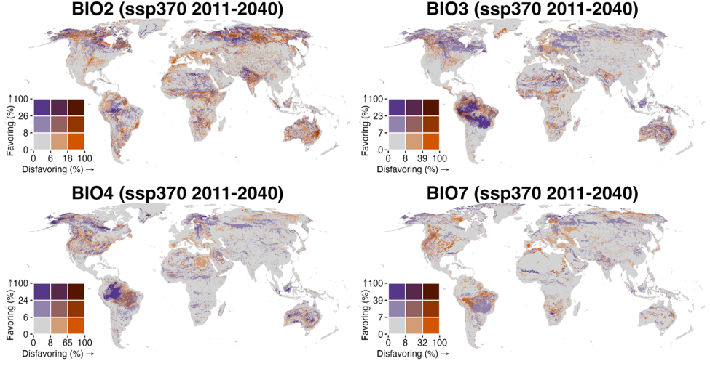
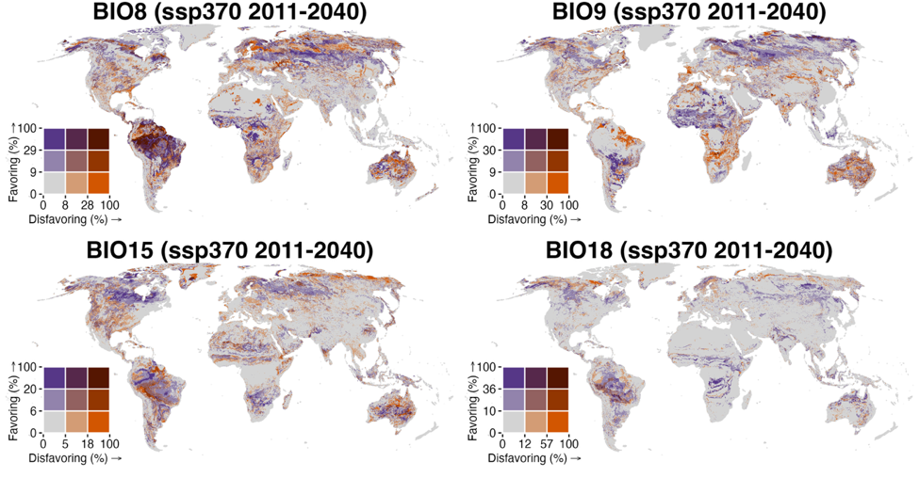
Figure S8 (continued).
See caption on previous page.
(Figure continued on next page)
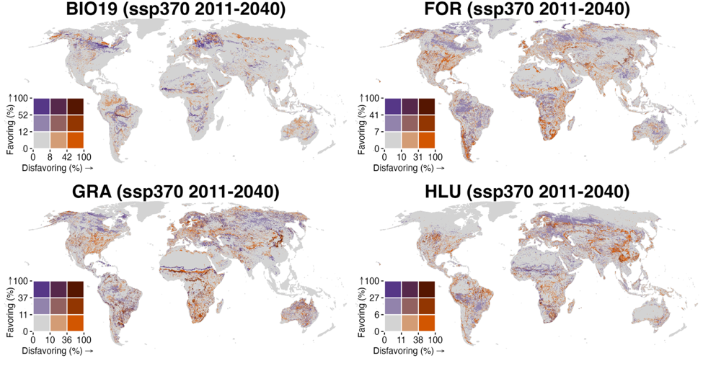
Figure S8 (continued).
See caption on page 17.
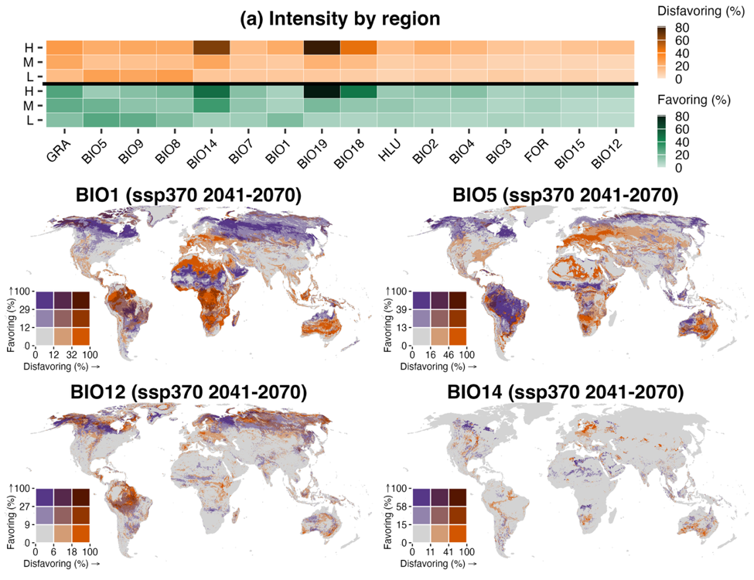
Figure S9. Spatial intensity of projected turnovers of environmental variables for mammal species under SSP370 for the mid-century period (2041–2070). Intensity of turnovers is calculated as the percentage of species in each grid cell (~10 km²) projected to experience the corresponding turnovers. For each environmental variable, we only consider species that both inhabit a given grid cell and include that variable in their distribution models for the calculations. Disfavoring turnover refers to a shift from favorable to unfavorable conditions (positive to negative SHAP values), while favoring turnover indicates the reverse. The top bar plot is the median intensity of turnovers (favoring and disfavoring) by latitudinal band: low (L, 30°S–30°N), middle (M, 30°–60°N/S), and high (H, 60°–90°N/S). The bottom maps are bivariate maps showing intensity of disfavoring and favoring turnover of all variables. Environmental variables are BIO1 (Annual Mean Temperature), BIO2 (Mean Diurnal Range, mean of monthly [max temperature − min temperature]), BIO3 (Isothermality, BIO2/BIO7 × 100), BIO4 (Temperature Seasonality, standard deviation × 100), BIO5 (Max Temperature of Warmest Month), BIO7 (Temperature Annual Range, BIO5 − BIO6), BIO8 (Mean Temperature of Wettest Quarter), BIO9 (Mean Temperature of Driest Quarter), BIO12 (Annual Precipitation), BIO14 (Precipitation of Driest Month), BIO15 (Precipitation Seasonality, coefficient of variation), BIO18 (Precipitation of Warmest Quarter), and BIO19 (Precipitation of Coldest Quarter)^{4,5}, FOR (forest coverage), HLU (human land use), and GRA (grassland coverage). Breakpoints for intensity of turnovers are determined using the Fisher–Jenks algorithm, as implemented in the R package classInt. (Figure continued on next page)
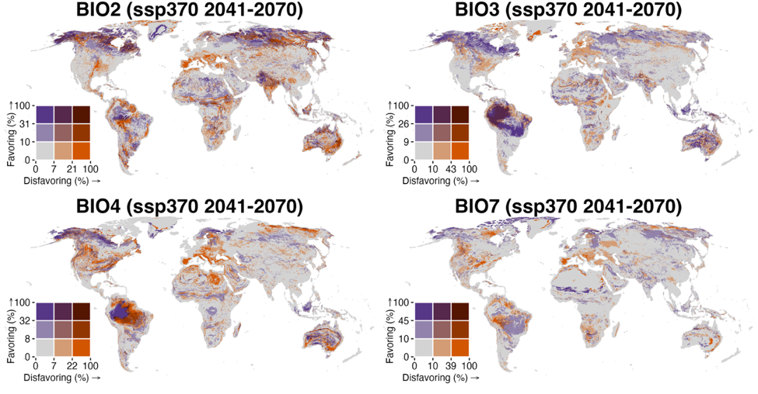
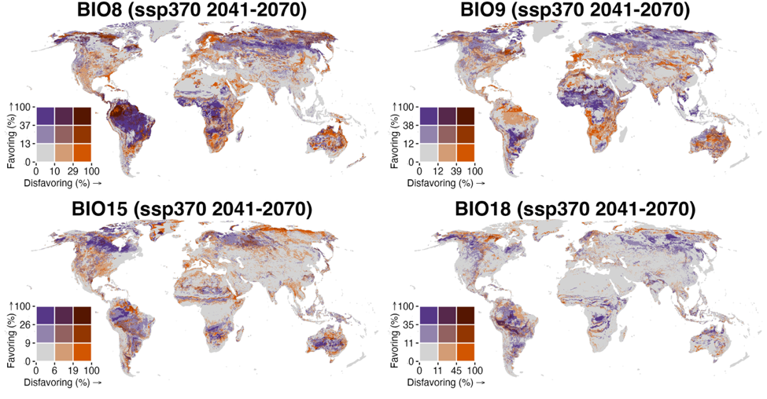
Figure S9 (continued).
See caption on previous page.
(Figure continued on next page)
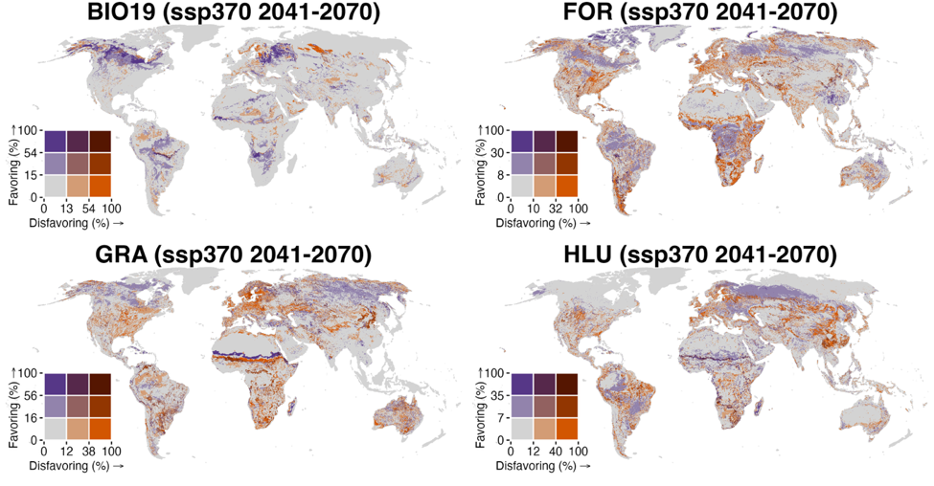
Figure S9 (continued).
See caption on page 20.
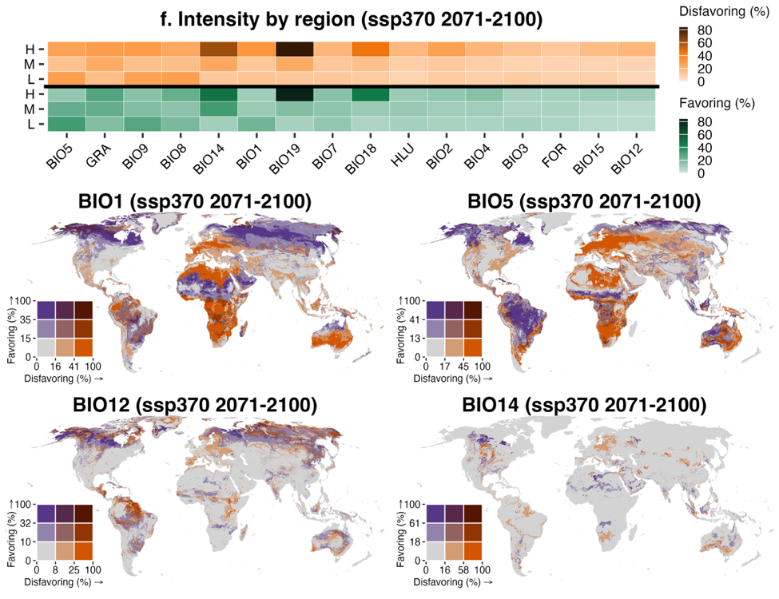
Figure S10. Spatial intensity of projected turnovers of environmental variables for mammal species under SSP370 for the late-century period (2071–2100). Intensity of turnovers is calculated as the percentage of species in each grid cell (~10 km²) projected to experience the corresponding turnovers. For each environmental variable, we only consider species that both inhabit a given grid cell and include that variable in their distribution models for the calculations. Disfavoring turnover refers to a shift from favorable to unfavorable conditions (positive to negative SHAP values), while favoring turnover indicates the reverse. The top bar plot is the median intensity of turnovers (favoring and disfavoring) by latitudinal band: low (L, 30°S–30°N), middle (M, 30°–60°N/S), and high (H, 60°–90°N/S). The bottom maps are bivariate maps showing intensity of disfavoring and favoring turnover of all variables. Environmental variables are BIO1 (Annual Mean Temperature), BIO2 (Mean Diurnal Range, mean of monthly [max temperature − min temperature]), BIO3 (Isothermality, BIO2/BIO7 × 100), BIO4 (Temperature Seasonality, standard deviation × 100), BIO5 (Max Temperature of Warmest Month), BIO7 (Temperature Annual Range, BIO5 − BIO6), BIO8 (Mean Temperature of Wettest Quarter), BIO9 (Mean Temperature of Driest Quarter), BIO12 (Annual Precipitation), BIO14 (Precipitation of Driest Month), BIO15 (Precipitation Seasonality, coefficient of variation), BIO18 (Precipitation of Warmest Quarter), and BIO19 (Precipitation of Coldest Quarter)^{4,5}, FOR (forest coverage), HLU (human land use), and GRA (grassland coverage). Breakpoints for intensity of turnovers are determined using the Fisher–Jenks algorithm, as implemented in the R package classInt. (Figure continued on next page)
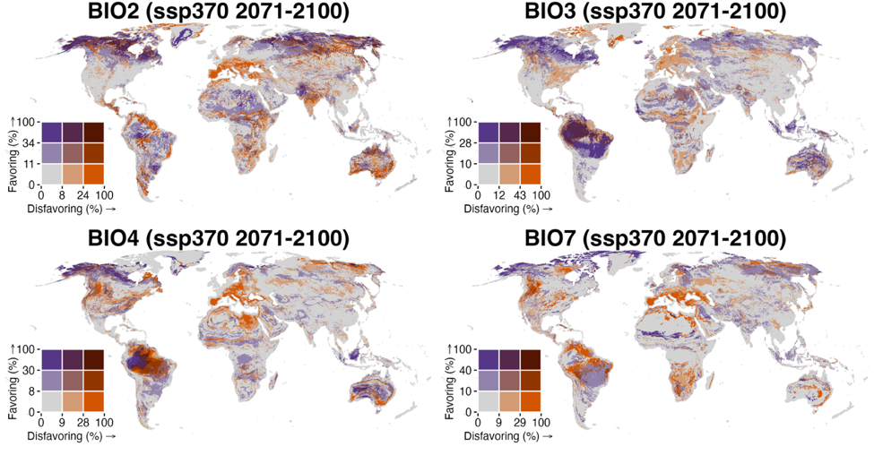
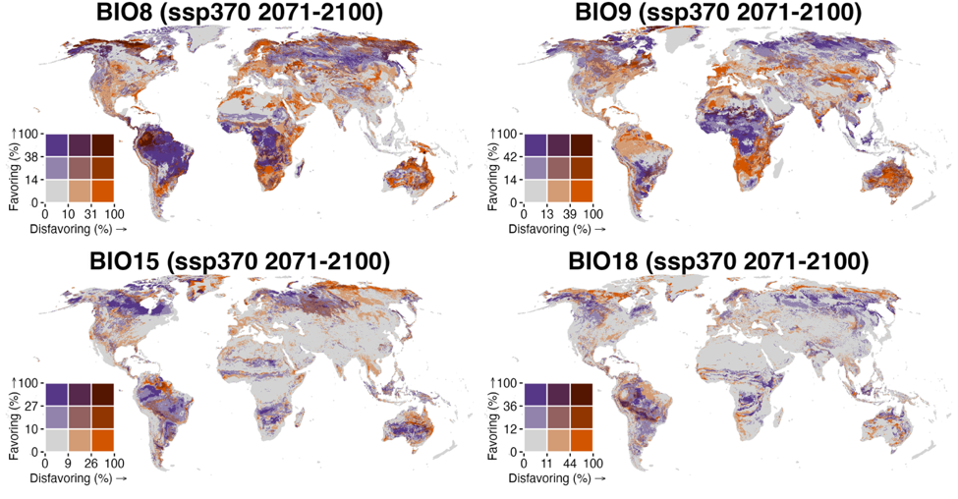
Figure S10 (continued).
See caption on previous page.
(Figure continued on next page)
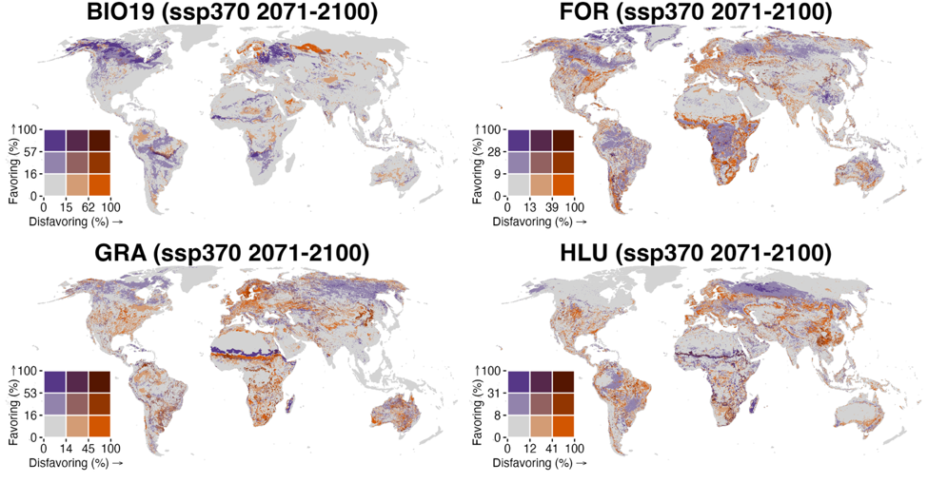
Figure S10 (continued).
See caption on page 23.
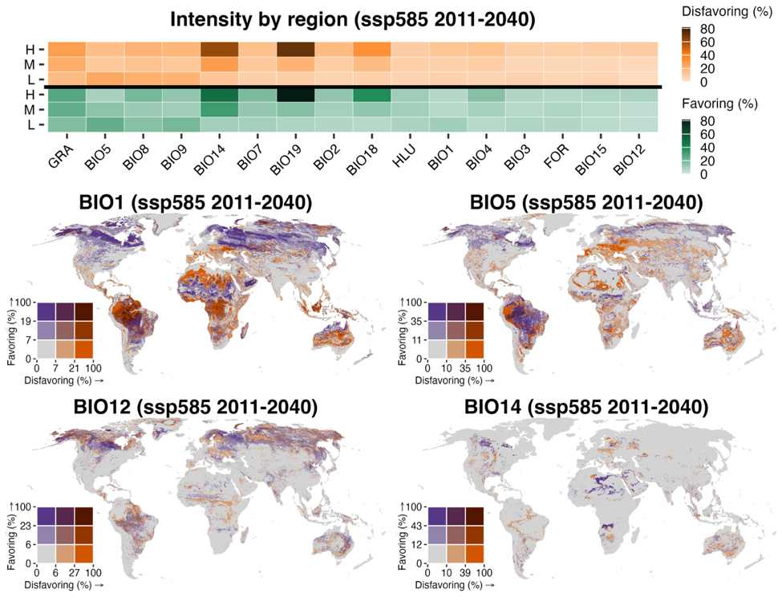
Figure S11. Spatial intensity of projected turnovers of environmental variables for mammal species under SSP585 for the early-century period (2011–2040). Intensity of turnovers is calculated as the percentage of species in each grid cell (~10 km²) projected to experience the corresponding turnovers. For each environmental variable, we only consider species that both inhabit a given grid cell and include that variable in their distribution models for the calculations. Disfavoring turnover refers to a shift from favorable to unfavorable conditions (positive to negative SHAP values), while favoring turnover indicates the reverse. The top bar plot is the median intensity of turnovers (favoring and disfavoring) by latitudinal band: low (L, 30°S–30°N), middle (M, 30°–60°N/S), and high (H, 60°–90°N/S). The bottom maps are bivariate maps showing intensity of disfavoring and favoring turnover of all variables. Environmental variables are BIO1 (Annual Mean Temperature), BIO2 (Mean Diurnal Range, mean of monthly [max temperature − min temperature]), BIO3 (Isothermality, BIO2/BIO7 × 100), BIO4 (Temperature Seasonality, standard deviation × 100), BIO5 (Max Temperature of Warmest Month), BIO7 (Temperature Annual Range, BIO5 − BIO6), BIO8 (Mean Temperature of Wettest Quarter), BIO9 (Mean Temperature of Driest Quarter), BIO12 (Annual Precipitation), BIO14 (Precipitation of Driest Month), BIO15 (Precipitation Seasonality, coefficient of variation), BIO18 (Precipitation of Warmest Quarter), and BIO19 (Precipitation of Coldest Quarter)^{4,5}, FOR (forest coverage), HLU (human land use), and GRA (grassland coverage). Breakpoints for intensity of turnovers are determined using the Fisher–Jenks algorithm, as implemented in the R package classInt. (Figure continued on next page)
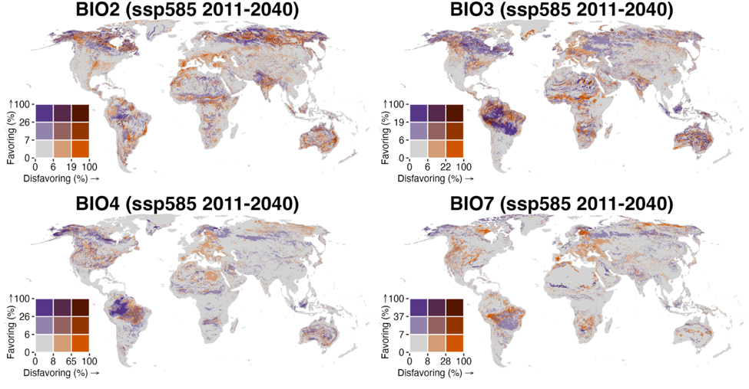
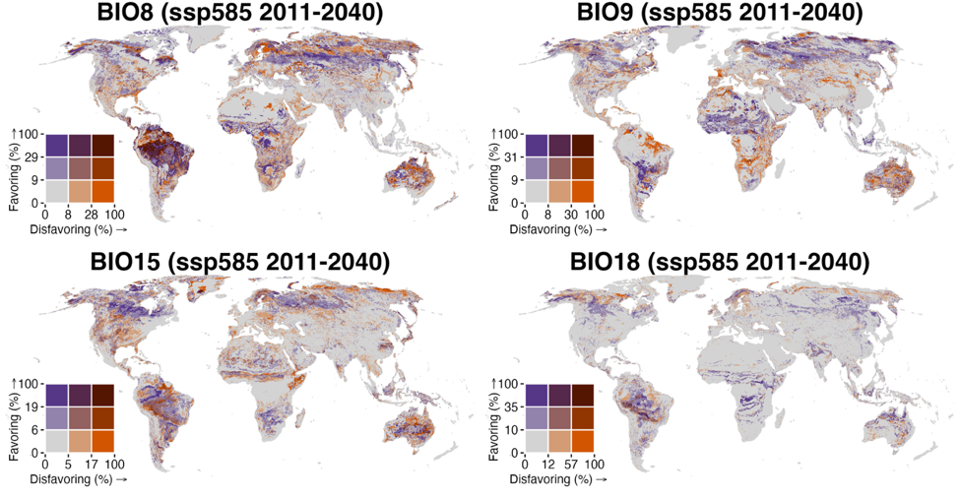
Figure S11 (continued).
See caption on previous page.
(Figure continued on next page)
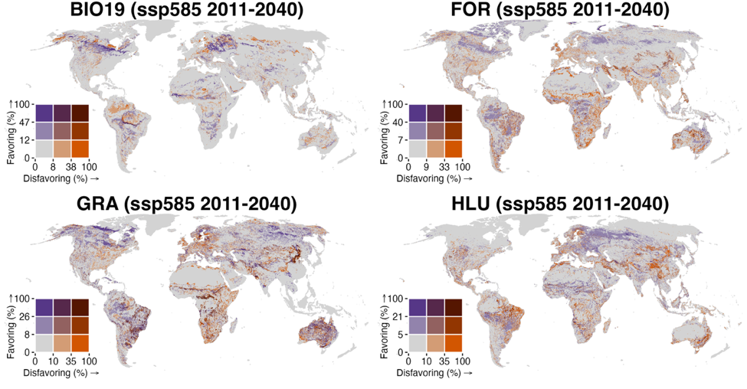
Figure S11 (continued).
See caption on page 26.
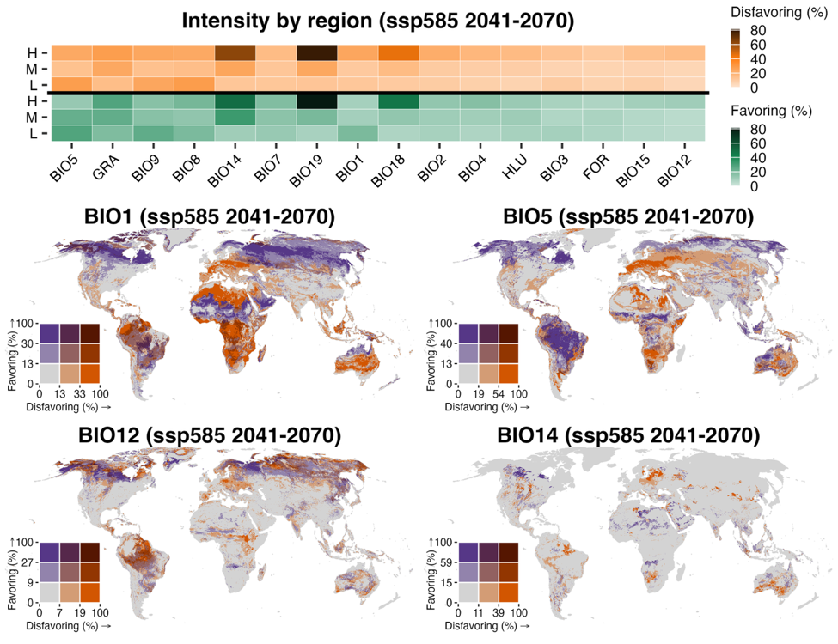
Figure S12. Spatial intensity of projected turnovers of environmental variables for mammal species under SSP585 for the mid-century period (2041–2070). Intensity of turnovers is calculated as the percentage of species in each grid cell (~10 km²) projected to experience the corresponding turnovers. For each environmental variable, we only consider species that both inhabit a given grid cell and include that variable in their distribution models for the calculations. Disfavoring turnover refers to a shift from favorable to unfavorable conditions (positive to negative SHAP values), while favoring turnover indicates the reverse. The top bar plot is the median intensity of turnovers (favoring and disfavoring) by latitudinal band: low (L, 30°S–30°N), middle (M, 30°–60°N/S), and high (H, 60°–90°N/S). The bottom maps are bivariate maps showing intensity of disfavoring and favoring turnover of all variables. Environmental variables are BIO1 (Annual Mean Temperature), BIO2 (Mean Diurnal Range, mean of monthly [max temperature − min temperature]), BIO3 (Isothermality, BIO2/BIO7 × 100), BIO4 (Temperature Seasonality, standard deviation × 100), BIO5 (Max Temperature of Warmest Month), BIO7 (Temperature Annual Range, BIO5 − BIO6), BIO8 (Mean Temperature of Wettest Quarter), BIO9 (Mean Temperature of Driest Quarter), BIO12 (Annual Precipitation), BIO14 (Precipitation of Driest Month), BIO15 (Precipitation Seasonality, coefficient of variation), BIO18 (Precipitation of Warmest Quarter), and BIO19 (Precipitation of Coldest Quarter)^{4,5}, FOR (forest coverage), HLU (human land use), and GRA (grassland coverage). Breakpoints for intensity of turnovers are determined using the Fisher–Jenks algorithm, as implemented in the R package classInt. (Figure continued on next page)
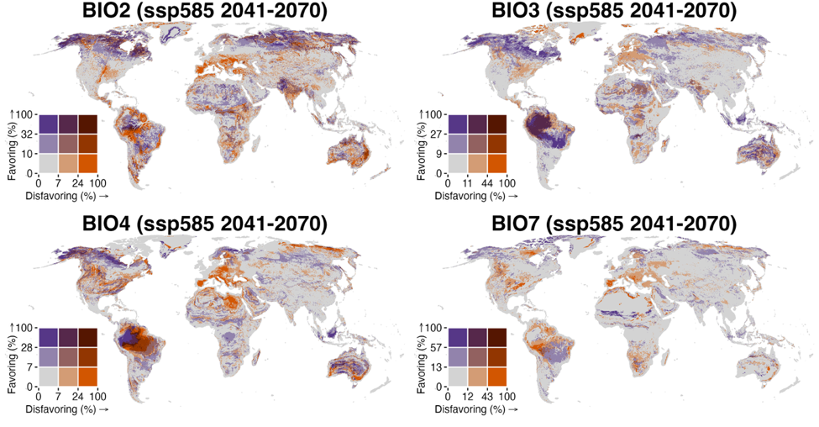
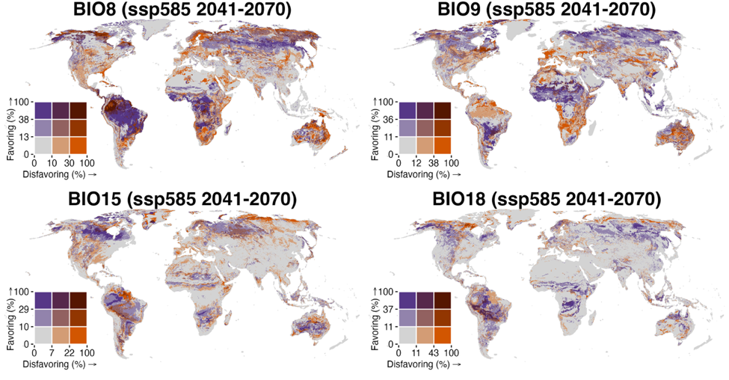
Figure S12 (continued).
See caption on previous page.
(Figure continued on next page)
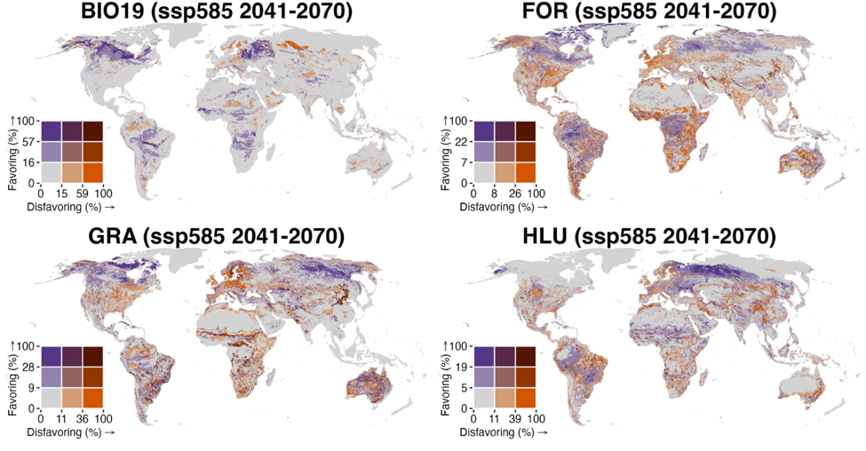
Figure S12 (continued).
See caption on page 29.
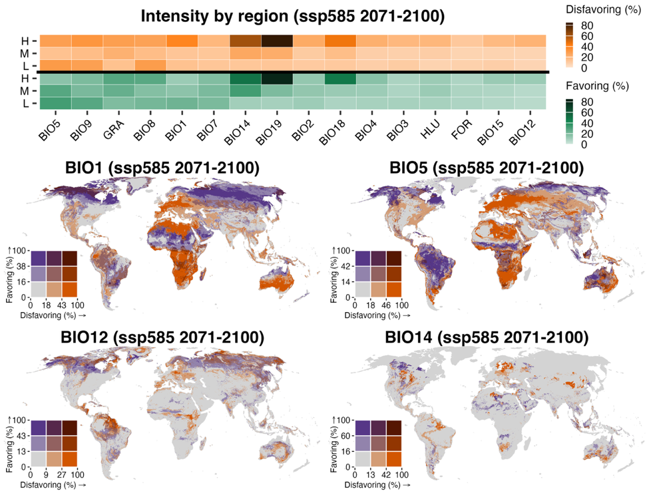
Figure S13. Spatial intensity of projected turnovers of environmental variables for mammal species under SSP585 for the late-century period (2071–2100). Intensity of turnovers is calculated as the percentage of species in each grid cell (~10 km²) projected to experience the corresponding turnovers. For each environmental variable, we only consider species that both inhabit a given grid cell and include that variable in their distribution models for the calculations. Disfavoring turnover refers to a shift from favorable to unfavorable conditions (positive to negative SHAP values), while favoring turnover indicates the reverse. The top bar plot is the median intensity of turnovers (favoring and disfavoring) by latitudinal band: low (L, 30°S–30°N), middle (M, 30°–60°N/S), and high (H, 60°–90°N/S). The bottom maps are bivariate maps showing intensity of disfavoring and favoring turnover of all variables. Environmental variables are BIO1 (Annual Mean Temperature), BIO2 (Mean Diurnal Range, mean of monthly [max temperature − min temperature]), BIO3 (Isothermality, BIO2/BIO7 × 100), BIO4 (Temperature Seasonality, standard deviation × 100), BIO5 (Max Temperature of Warmest Month), BIO7 (Temperature Annual Range, BIO5 − BIO6), BIO8 (Mean Temperature of Wettest Quarter), BIO9 (Mean Temperature of Driest Quarter), BIO12 (Annual Precipitation), BIO14 (Precipitation of Driest Month), BIO15 (Precipitation Seasonality, coefficient of variation), BIO18 (Precipitation of Warmest Quarter), and BIO19 (Precipitation of Coldest Quarter)^{4,5}, FOR (forest coverage), HLU (human land use), and GRA (grassland coverage). Breakpoints for intensity of turnovers are determined using the Fisher–Jenks algorithm, as implemented in the R package classInt. (Figure continued on next page)
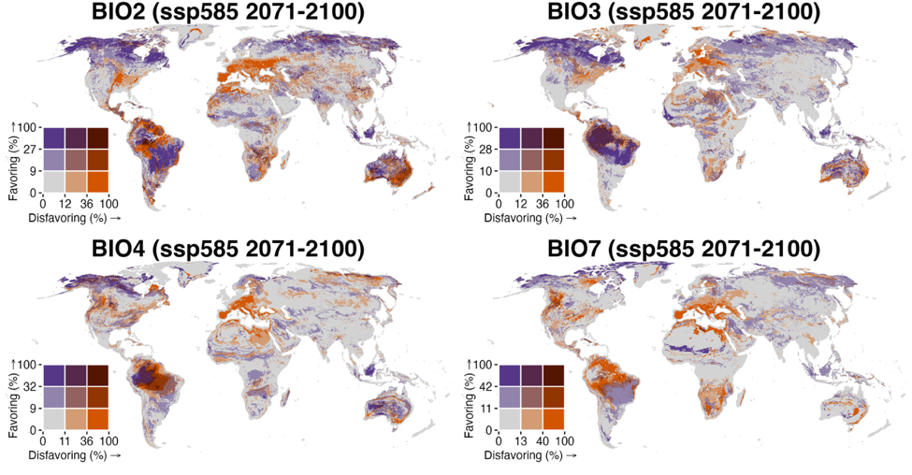
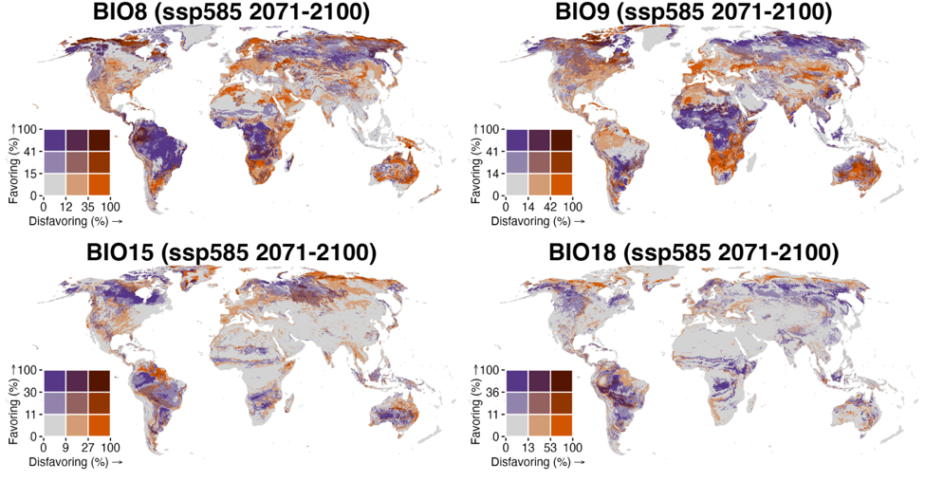
Figure S13 (continued).
See caption on previous page.
(Figure continued on next page)
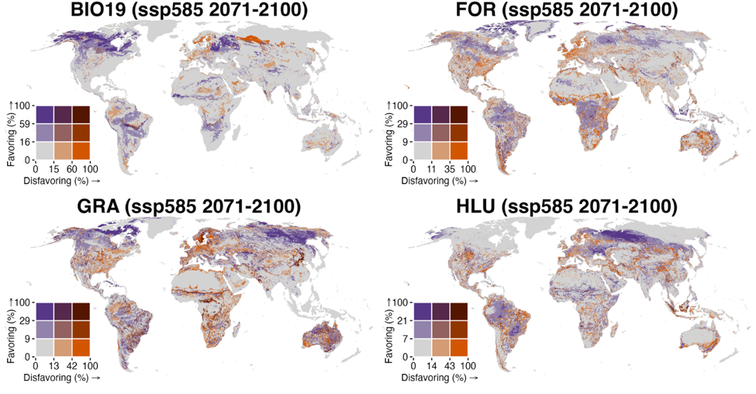
Figure S13 (continued).
See caption on page 32.

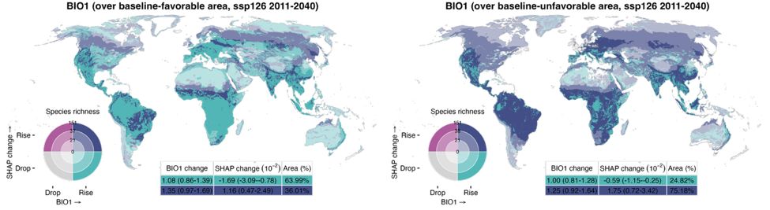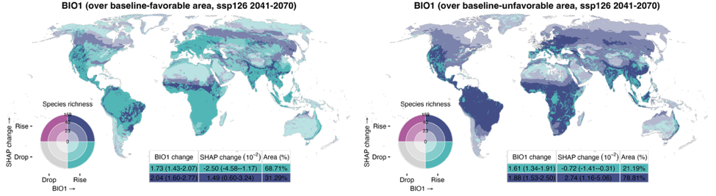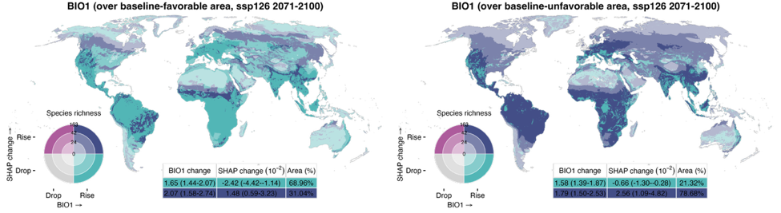
Figure S14. Spatial relationships between environmental changes and magnitude shifts in the relative contribution of annual mean temperature (BIO1) under SSP126, SSP370, and SSP585 across three future periods (2011–2040, 2041–2070, and 2071–2100). Changes in BIO1 and SHAP-based favorability shifts are categorized as “drop” or “rise” depending on whether values decrease or increase, respectively; areas with no change are masked. Favorability shifts are defined as the difference in SHAP values between the baseline period (1981–2010) and each future period, and averaged across all relevant species that inhabit a given grid cell and include that variable in their distribution model. In all panels, rising SHAP values (magenta and purple) indicate increasing favorability for species, and declining values (gray and teal) indicate reduced favorability. The inset table presents area-weighted medians and interquartile ranges (25th–75th percentile) for each combination zone. Species richness is categorized as low, medium, or high based on the 33rd and 66th percentiles and is symbolized by the darkening hue of the four colors on the bivariate map. (Figure continued on next page)
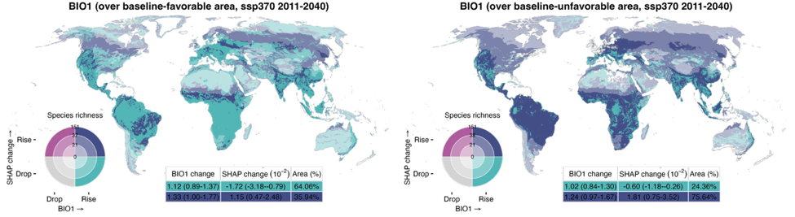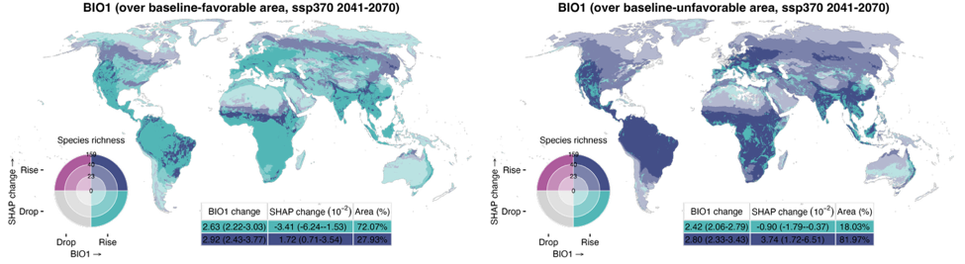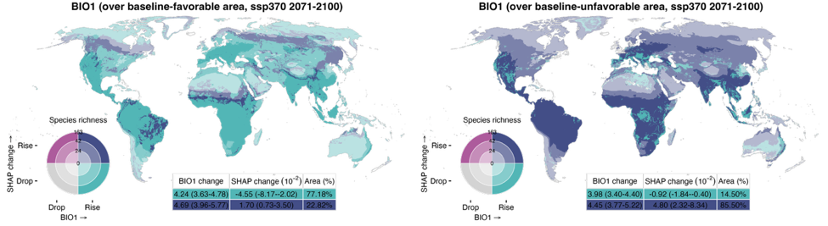
Figure S14 (continued).
See caption on previous page.
(Figure continued on next page)
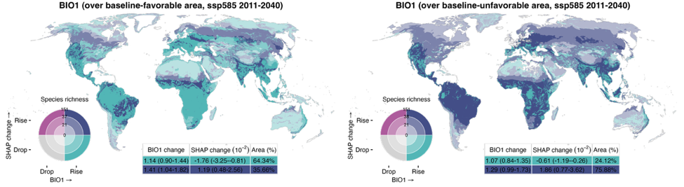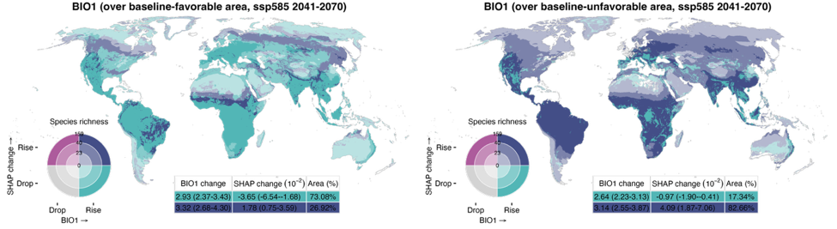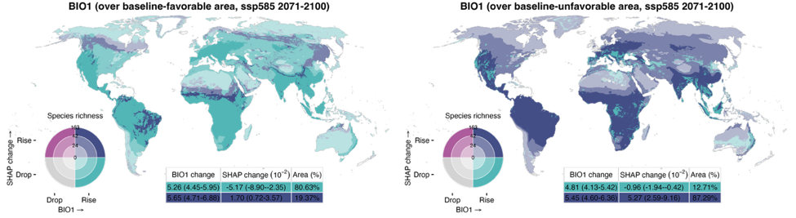
Figure S14 (continued).
See caption on page 35.
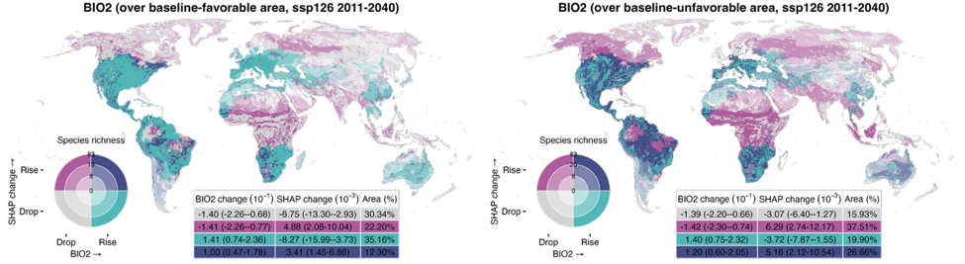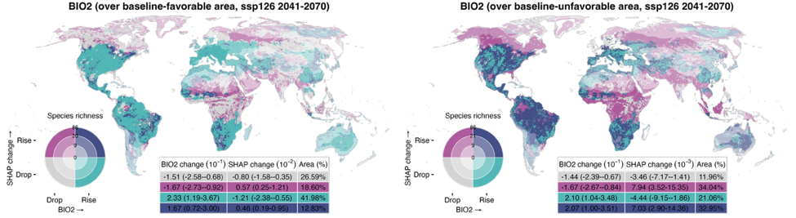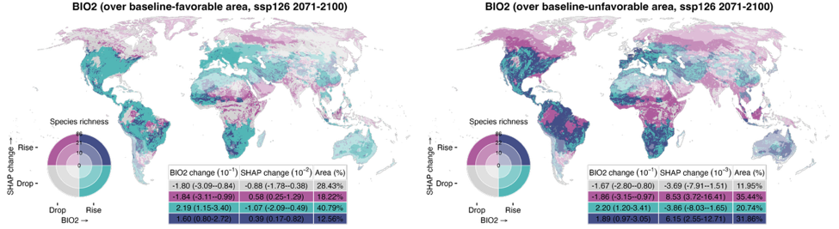
Figure S15. Spatial relationships between environmental changes and magnitude shifts in the relative contribution of mean diurnal range (BIO2) under SSP126, SSP370, and SSP585 across three future periods (2011–2040, 2041–2070, and 2071–2100). Changes in BIO2 and SHAP-based favorability shifts are categorized as “drop” or “rise” depending on whether values decrease or increase, respectively; areas with no change are masked. Favorability shifts are defined as the difference in SHAP values between the baseline period (1981–2010) and each future period, and averaged across all relevant species that inhabit a given grid cell and include that variable in their distribution model. In all panels, rising SHAP values (magenta and purple) indicate increasing favorability for species, and declining values (gray and teal) indicate reduced favorability. The inset table presents area-weighted medians and interquartile ranges (25th–75th percentile) for each combination zone. Species richness is categorized as low, medium, or high based on the 33rd and 66th percentiles and is symbolized by the darkening hue of the four colors on the bivariate map. (Figure continued on next page)
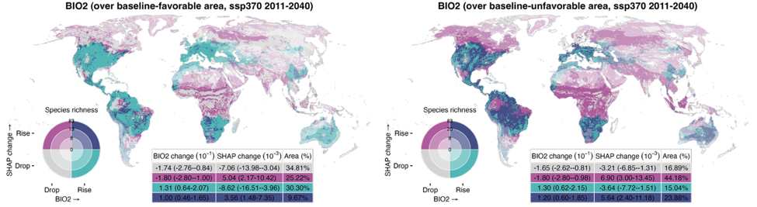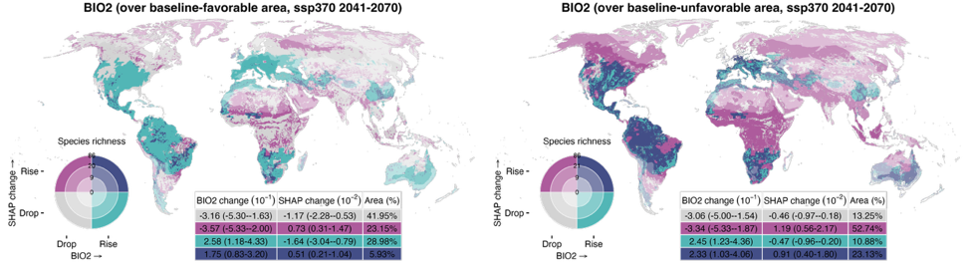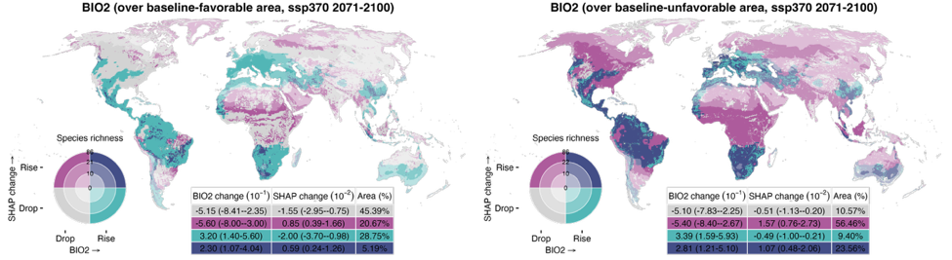
Figure S15 (continued).
See caption on previous page.
(Figure continued on next page)
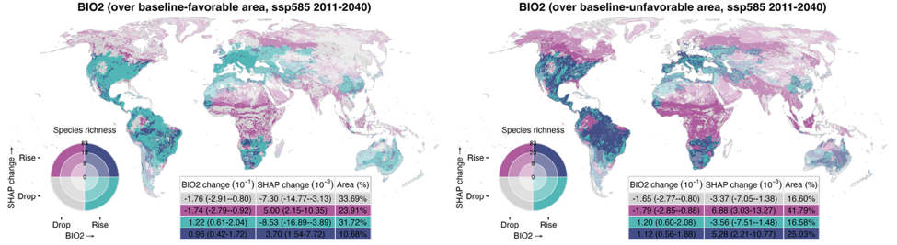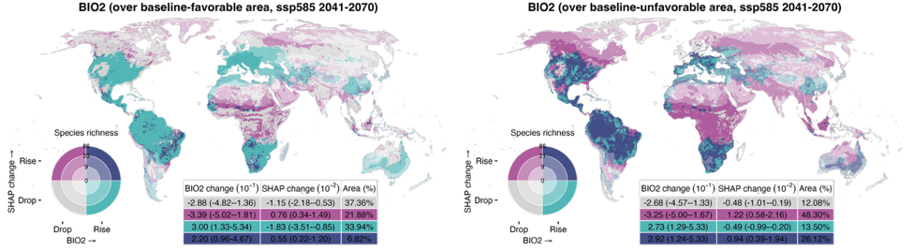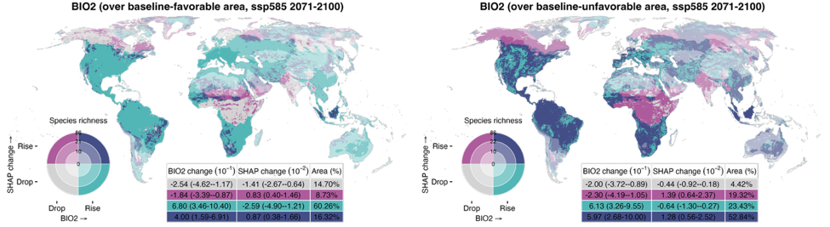
Figure S15 (continued).
See caption on page 38.
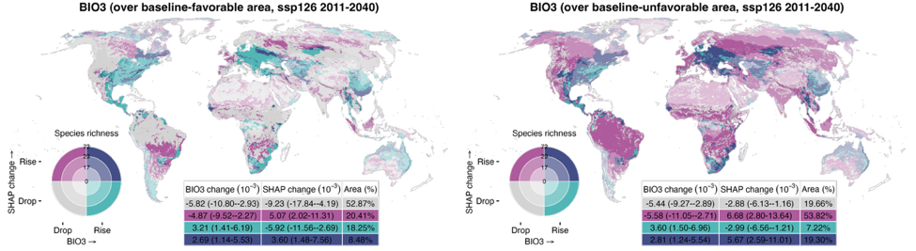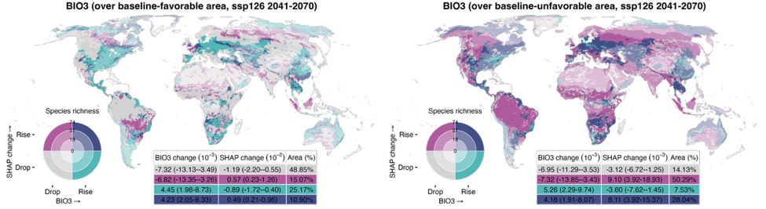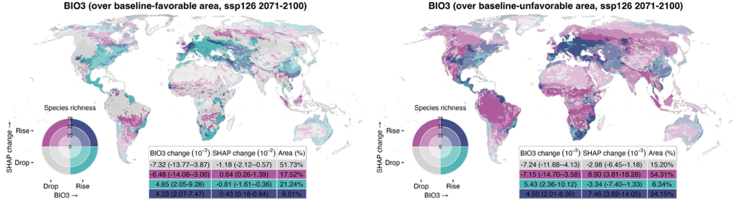
Figure S16. Spatial relationships between environmental changes and magnitude shifts in the relative contribution of isothermality (BIO3) under SSP126, SSP370, and SSP585 across three future periods (2011–2040, 2041–2070, and 2071–2100). Changes in BIO3 and SHAP-based favorability shifts are categorized as “drop” or “rise” depending on whether values decrease or increase, respectively; areas with no change are masked. Favorability shifts are defined as the difference in SHAP values between the baseline period (1981–2010) and each future period, and averaged across all relevant species that inhabit a given grid cell and include that variable in their distribution model. In all panels, rising SHAP values (magenta and purple) indicate increasing favorability for species, and declining values (gray and teal) indicate reduced favorability. The inset table presents area-weighted medians and interquartile ranges (25th–75th percentile) for each combination zone. Species richness is categorized as low, medium, or high based on the 33rd and 66th percentiles and is symbolized by the darkening hue of the four colors on the bivariate map. (Figure continued on next page)
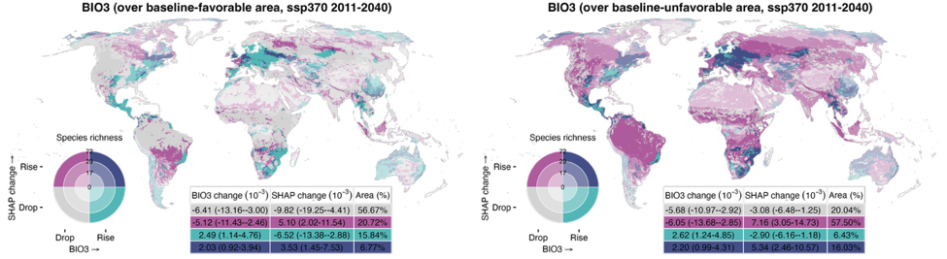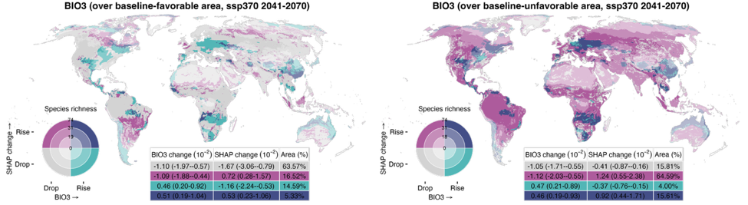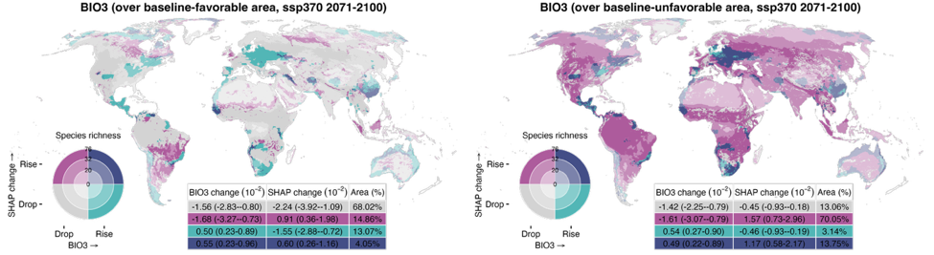
Figure S16 (continued).
See caption on previous page.
(Figure continued on next page)
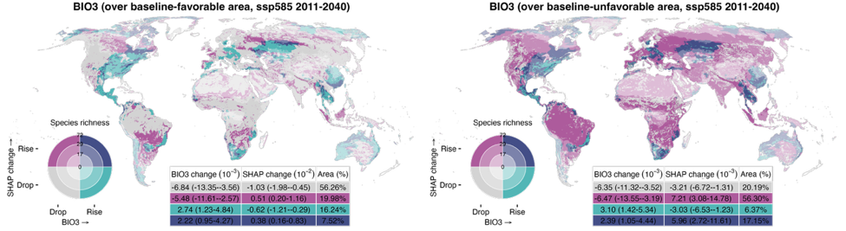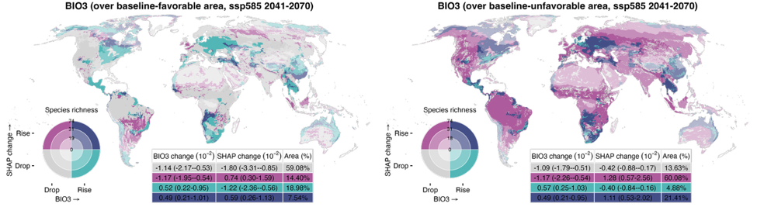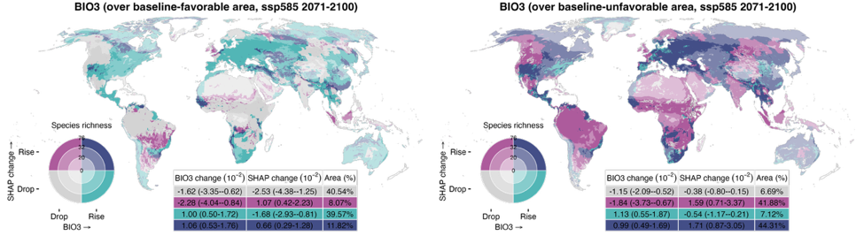
Figure S16 (continued).
See caption on page 41.
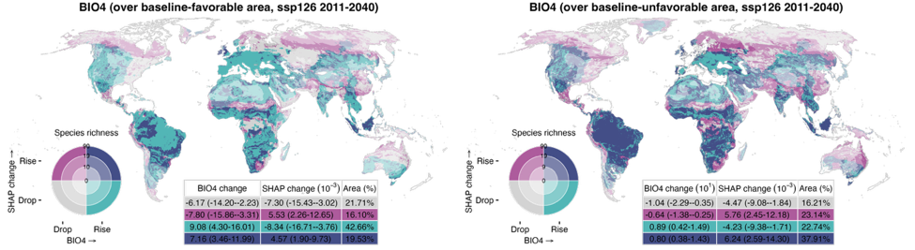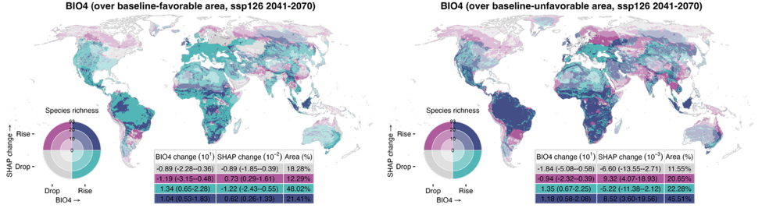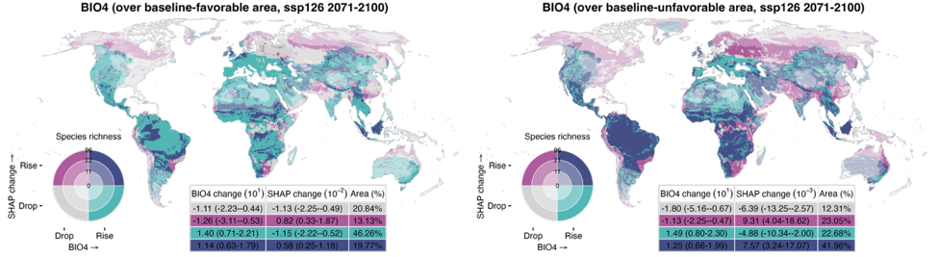
Figure S17. Spatial relationships between environmental changes and magnitude shifts in the relative contribution of temperature seasonality (BIO4) under SSP126, SSP370, and SSP585 across three future periods (2011–2040, 2041–2070, and 2071–2100). Changes in BIO4 and SHAP-based favorability shifts are categorized as “drop” or “rise” depending on whether values decrease or increase, respectively; areas with no change are masked. Favorability shifts are defined as the difference in SHAP values between the baseline period (1981–2010) and each future period, and averaged across all relevant species that inhabit a given grid cell and include that variable in their distribution model. In all panels, rising SHAP values (magenta and purple) indicate increasing favorability for species, and declining values (gray and teal) indicate reduced favorability. The inset table presents area-weighted medians and interquartile ranges (25th–75th percentile) for each combination zone. Species richness is categorized as low, medium, or high based on the 33rd and 66th percentiles and is symbolized by the darkening hue of the four colors on the bivariate map. (Figure continued on next page)
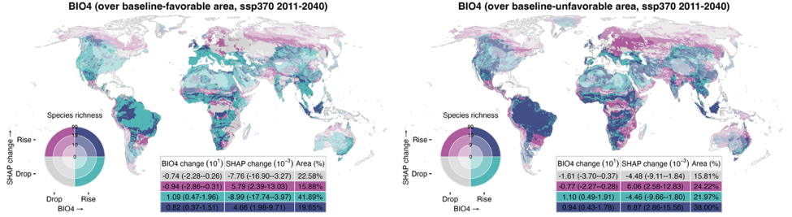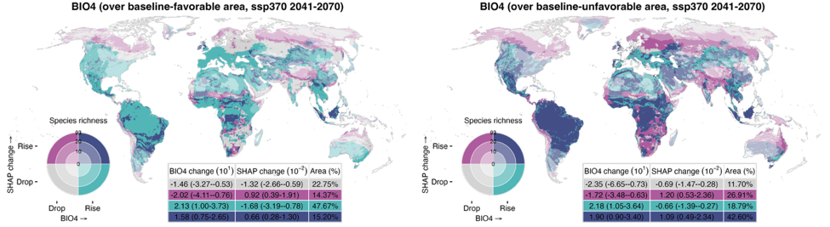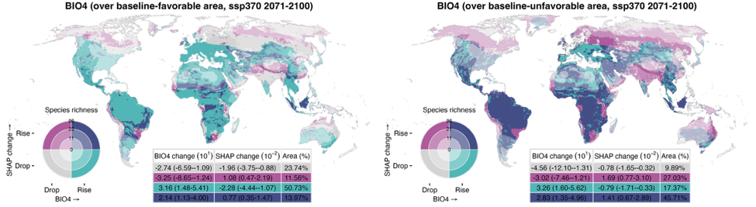
Figure S17 (continued).
See caption on previous page.
(Figure continued on next page)
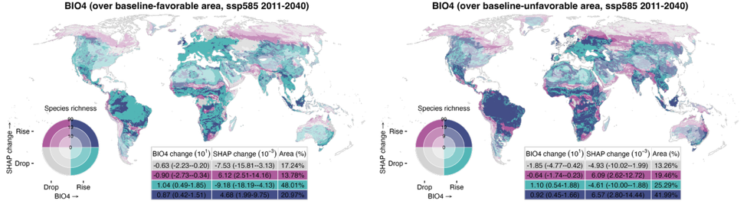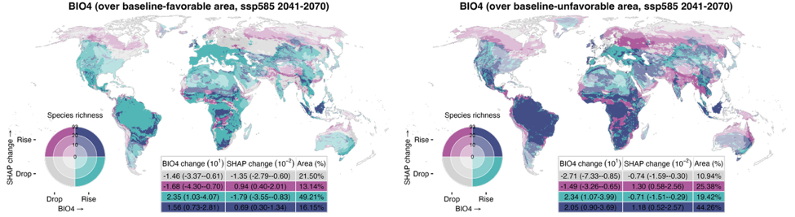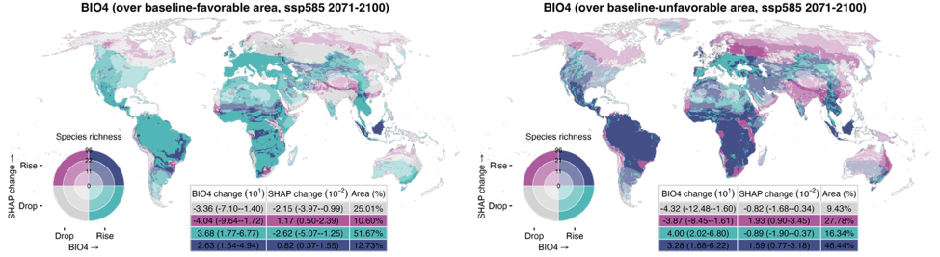
Figure S17 (continued).
See caption on page 44.
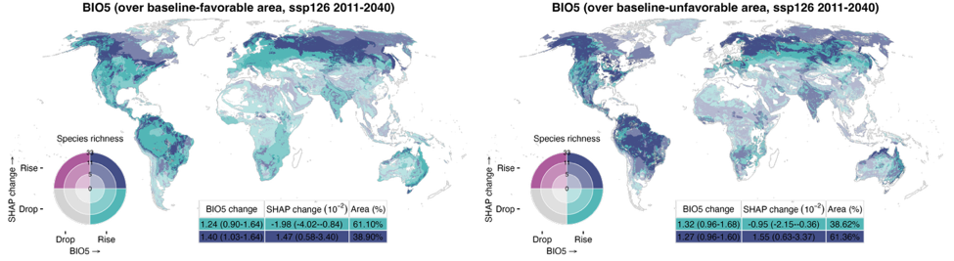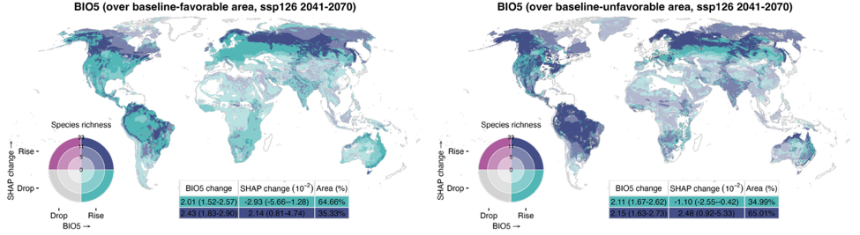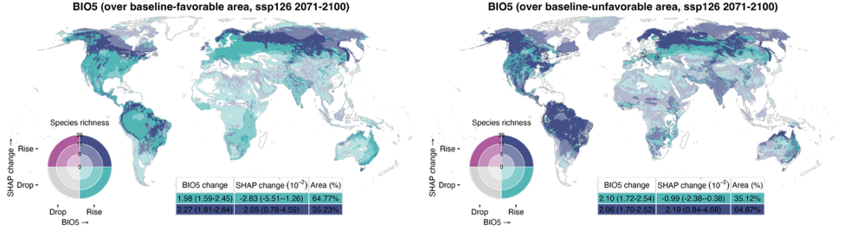
Figure S18. Spatial relationships between environmental changes and magnitude shifts in the relative contribution of max temperature of warmest month (BIO5) under SSP126, SSP370, and SSP585 across three future periods (2011–2040, 2041–2070, and 2071–2100). Changes in BIO5 and SHAP-based favorability shifts are categorized as “drop” or “rise” depending on whether values decrease or increase, respectively; areas with no change are masked. Favorability shifts are defined as the difference in SHAP values between the baseline period (1981–2010) and each future period, and averaged across all relevant species that inhabit a given grid cell and include that variable in their distribution model. In all panels, rising SHAP values (magenta and purple) indicate increasing favorability for species, and declining values (gray and teal) indicate reduced favorability. The inset table presents area-weighted medians and interquartile ranges (25th–75th percentile) for each combination zone. Species richness is categorized as low, medium, or high based on the 33rd and 66th percentiles and is symbolized by the darkening hue of the four colors on the bivariate map. (Figure continued on next page)
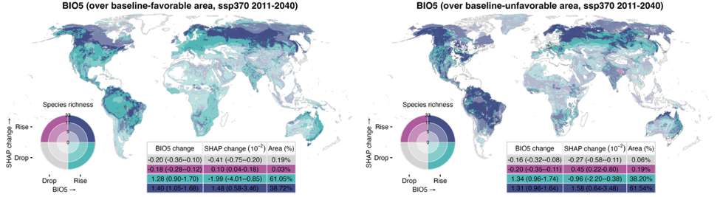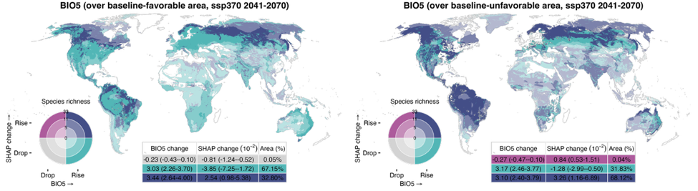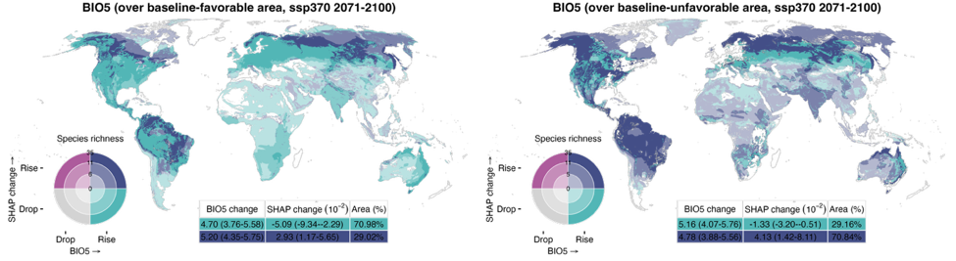
Figure S18 (continued).
See caption on previous page.
(Figure continued on next page)
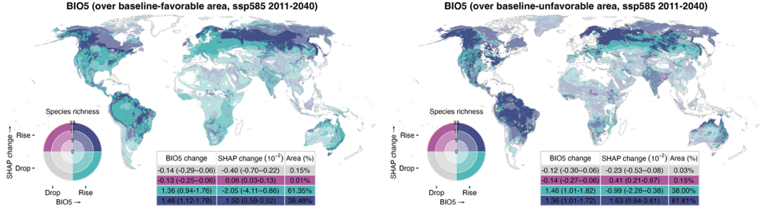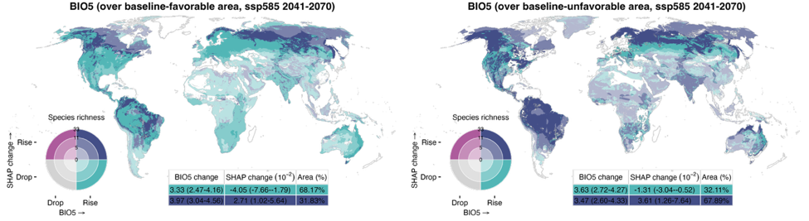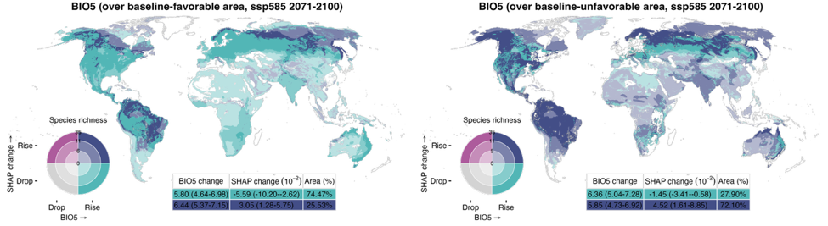
Figure S18 (continued).
See caption on page 47.
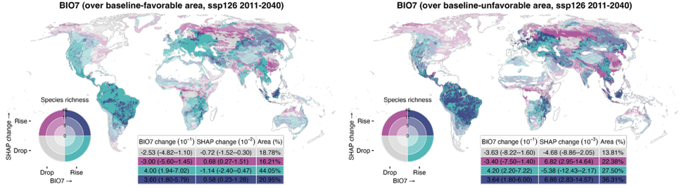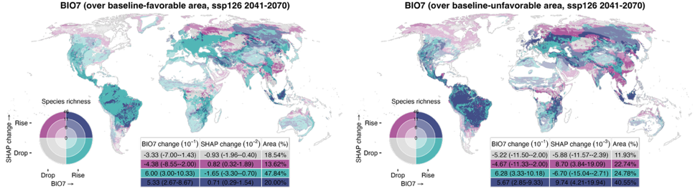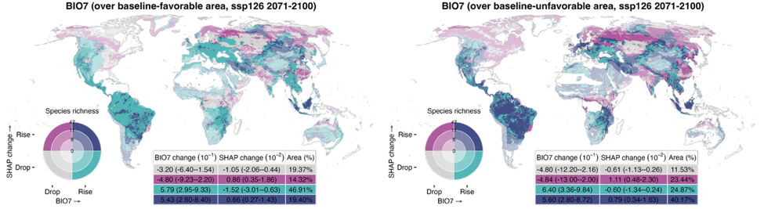
Figure S19. Spatial relationships between environmental changes and magnitude shifts in the relative contribution of temperature annual range (BIO7) under SSP126, SSP370, and SSP585 across three future periods (2011–2040, 2041–2070, and 2071–2100). Changes in BIO7 and SHAP-based favorability shifts are categorized as “drop” or “rise” depending on whether values decrease or increase, respectively; areas with no change are masked. Favorability shifts are defined as the difference in SHAP values between the baseline period (1981–2010) and each future period, and averaged across all relevant species that inhabit a given grid cell and include that variable in their distribution model. In all panels, rising SHAP values (magenta and purple) indicate increasing favorability for species, and declining values (gray and teal) indicate reduced favorability. The inset table presents area-weighted medians and interquartile ranges (25th–75th percentile) for each combination zone. Species richness is categorized as low, medium, or high based on the 33rd and 66th percentiles and is symbolized by the darkening hue of the four colors on the bivariate map. (Figure continued on next page)
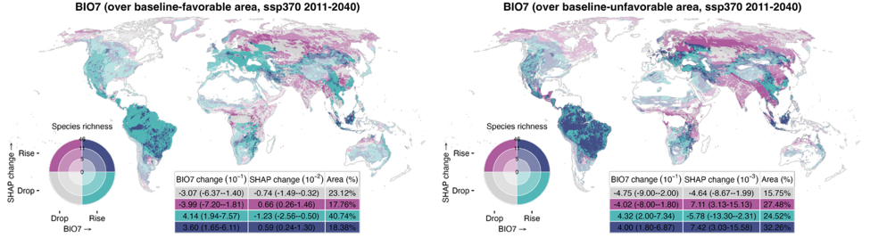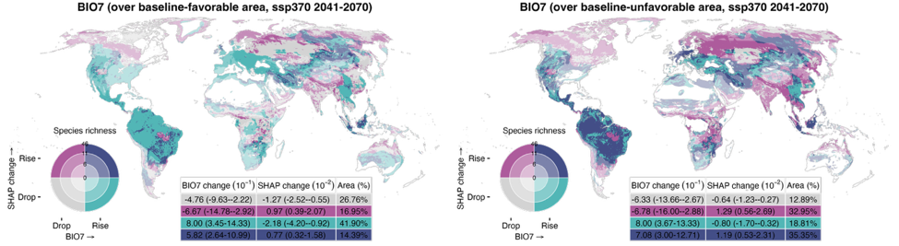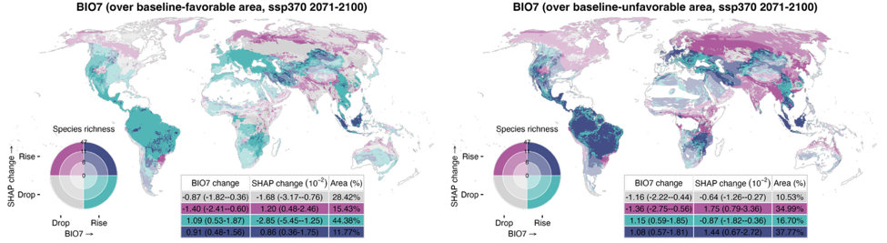
Figure S19 (continued).
See caption on previous page.
(Figure continued on next page)
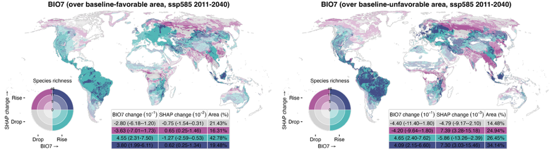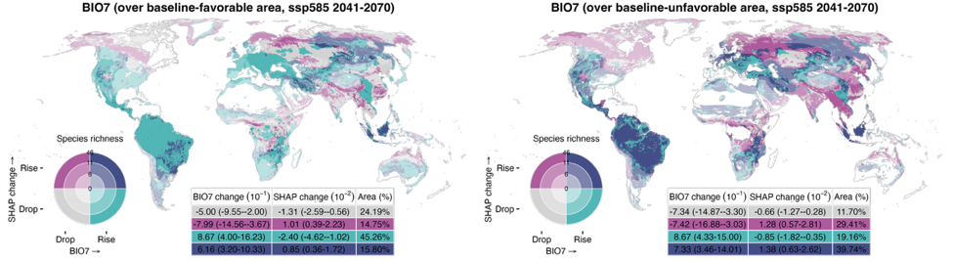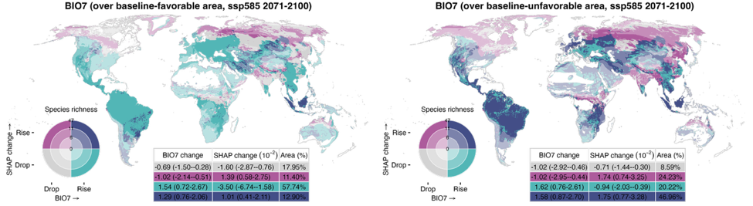
Figure S19 (continued).
See caption on page 50.
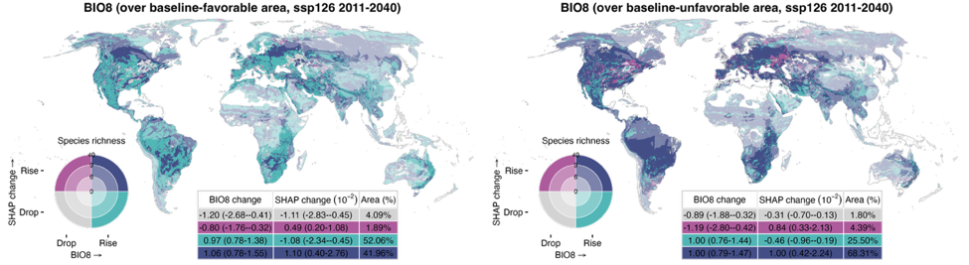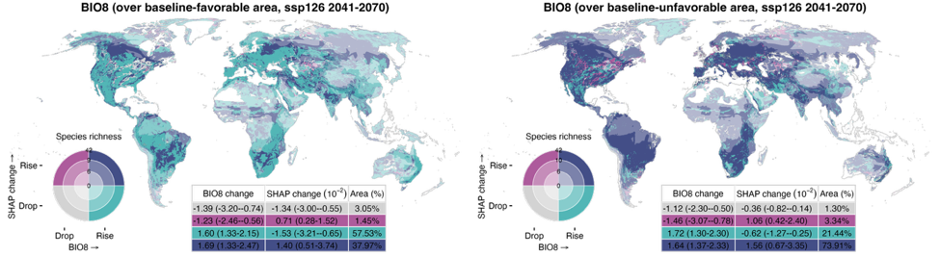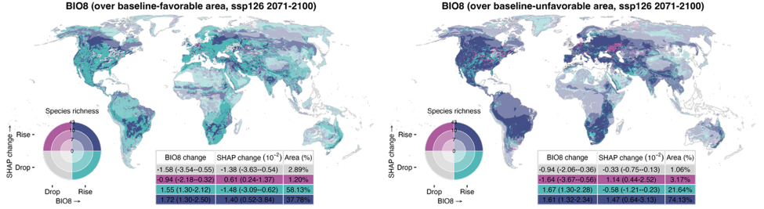
Figure S20. Spatial relationships between environmental changes and magnitude shifts in the relative contribution of mean temperature of wettest quarter (BIO8) under SSP126, SSP370, and SSP585 across three future periods (2011–2040, 2041–2070, and 2071–2100). Changes in BIO8 and SHAP-based favorability shifts are categorized as “drop” or “rise” depending on whether values decrease or increase, respectively; areas with no change are masked. Favorability shifts are defined as the difference in SHAP values between the baseline period (1981–2010) and each future period, and averaged across all relevant species that inhabit a given grid cell and include that variable in their distribution model. In all panels, rising SHAP values (magenta and purple) indicate increasing favorability for species, and declining values (gray and teal) indicate reduced favorability. The inset table presents area-weighted medians and interquartile ranges (25th–75th percentile) for each combination zone. Species richness is categorized as low, medium, or high based on the 33rd and 66th percentiles and is symbolized by the darkening hue of the four colors on the bivariate map. (Figure continued on next page)
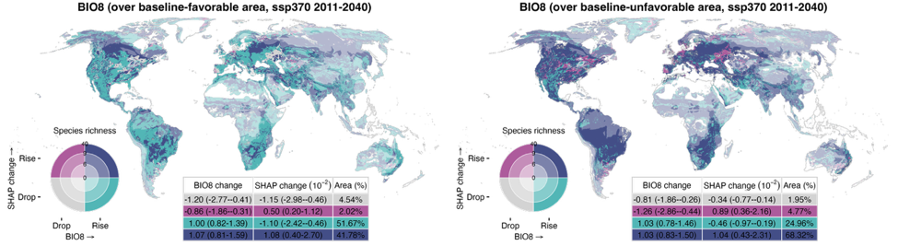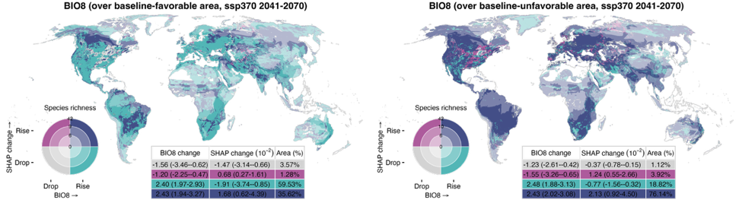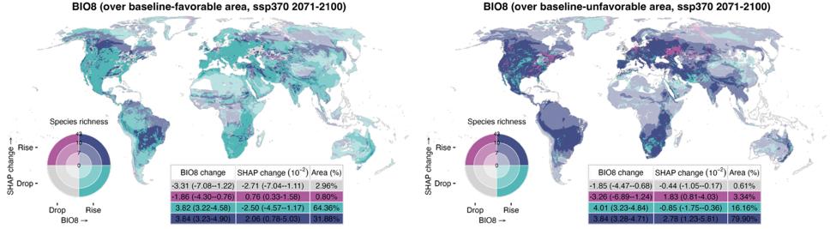
Figure S20 (continued).
See caption on previous page.
(Figure continued on next page)
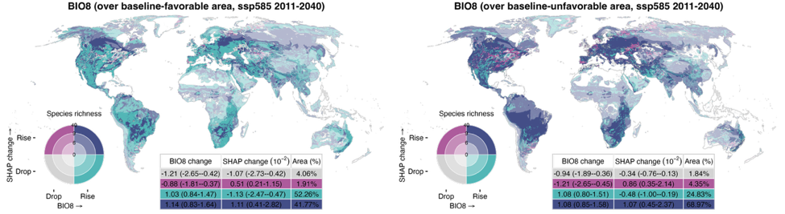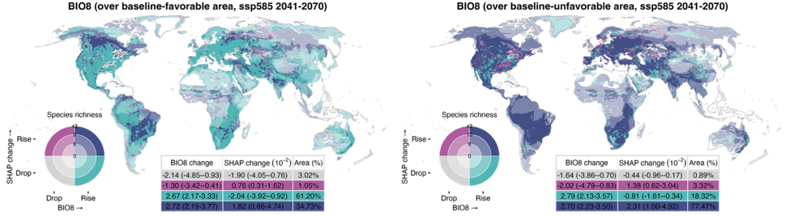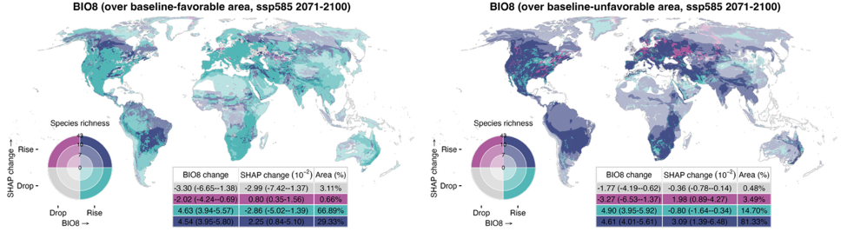
Figure S20 (continued).
See caption on page 53.
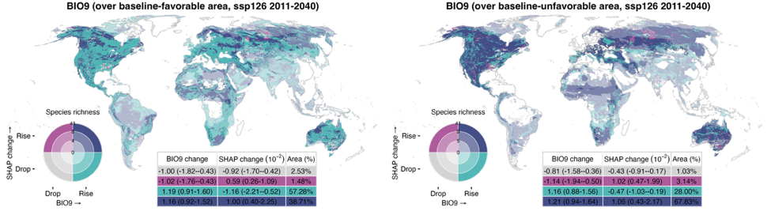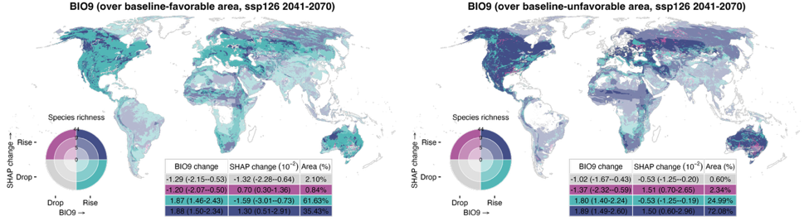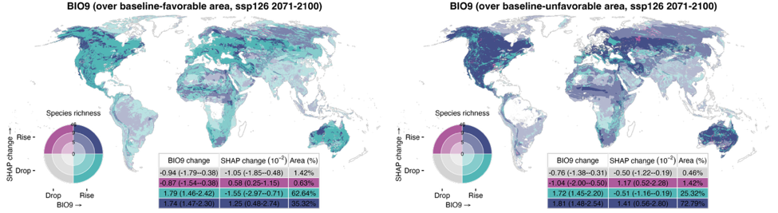
Figure S21. Spatial relationships between environmental changes and magnitude shifts in the relative contribution of mean temperature of driest quarter (BIO9) under SSP126, SSP370, and SSP585 across three future periods (2011–2040, 2041–2070, and 2071–2100). Changes in BIO9 and SHAP-based favorability shifts are categorized as “drop” or “rise” depending on whether values decrease or increase, respectively; areas with no change are masked. Favorability shifts are defined as the difference in SHAP values between the baseline period (1981–2010) and each future period, and averaged across all relevant species that inhabit a given grid cell and include that variable in their distribution model. In all panels, rising SHAP values (magenta and purple) indicate increasing favorability for species, and declining values (gray and teal) indicate reduced favorability. The inset table presents area-weighted medians and interquartile ranges (25th–75th percentile) for each combination zone. Species richness is categorized as low, medium, or high based on the 33rd and 66th percentiles and is symbolized by the darkening hue of the four colors on the bivariate map. (Figure continued on next page)
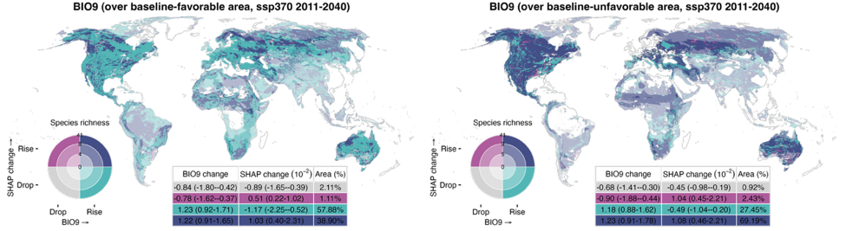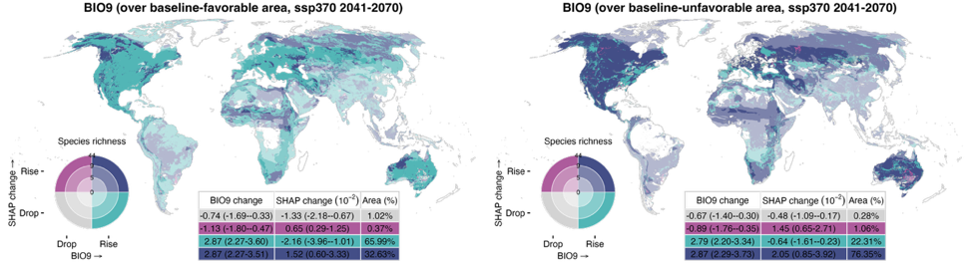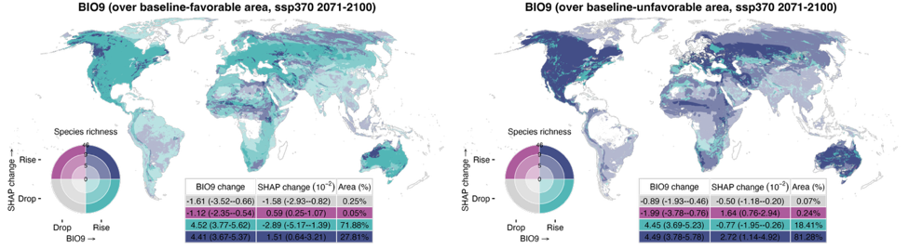
Figure S21 (continued).
See caption on previous page.
(Figure continued on next page)
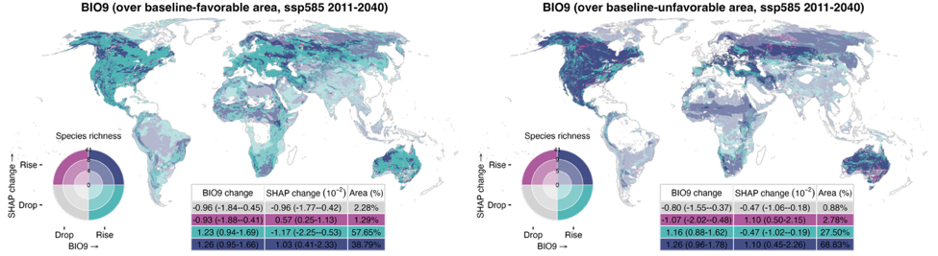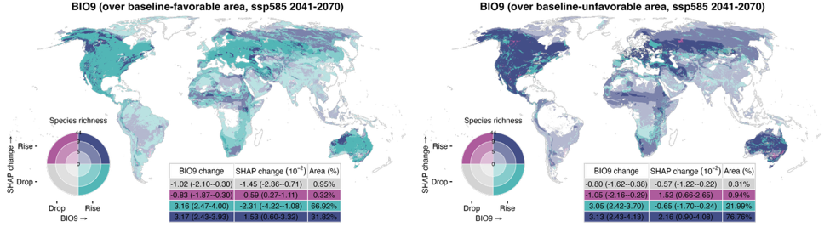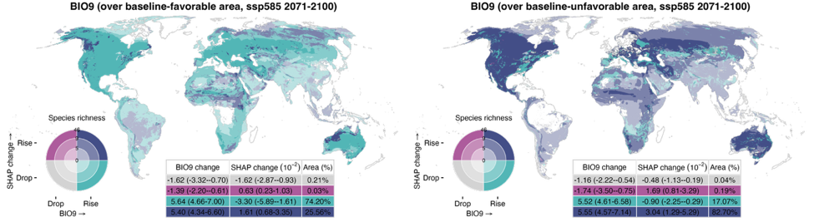
Figure S21 (continued).
See caption on page 56.
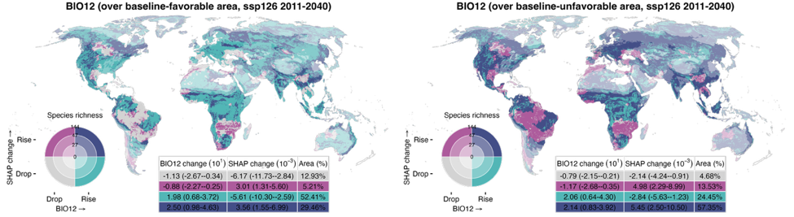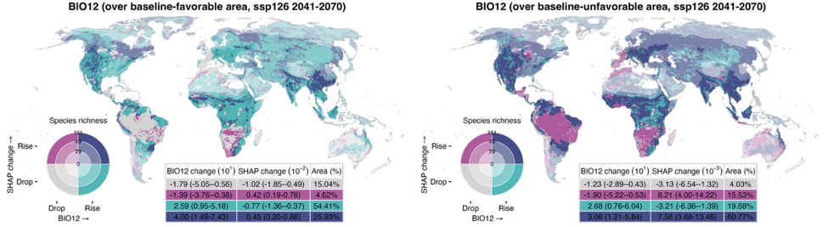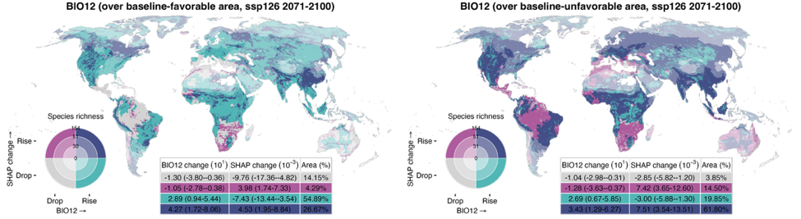
Figure S22. Spatial relationships between environmental changes and magnitude shifts in the relative contribution of annual precipitation (BIO12) under SSP126, SSP370, and SSP585 across three future periods (2011–2040, 2041–2070, and 2071–2100). Changes in BIO12 and SHAP-based favorability shifts are categorized as “drop” or “rise” depending on whether values decrease or increase, respectively; areas with no change are masked. Favorability shifts are defined as the difference in SHAP values between the baseline period (1981–2010) and each future period, and averaged across all relevant species that inhabit a given grid cell and include that variable in their distribution model. In all panels, rising SHAP values (magenta and purple) indicate increasing favorability for species, and declining values (gray and teal) indicate reduced favorability. The inset table presents area-weighted medians and interquartile ranges (25th–75th percentile) for each combination zone. Species richness is categorized as low, medium, or high based on the 33rd and 66th percentiles and is symbolized by the darkening hue of the four colors on the bivariate map. (Figure continued on next page)
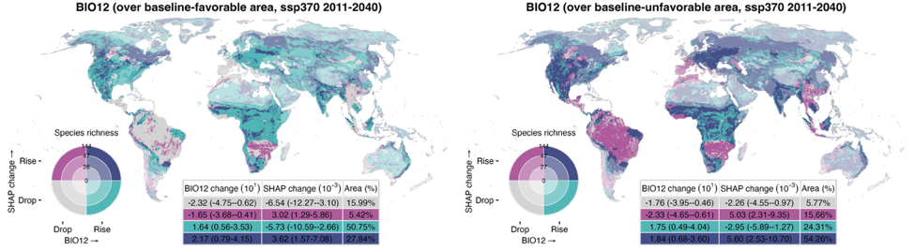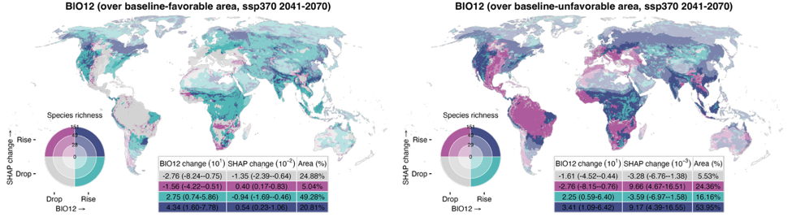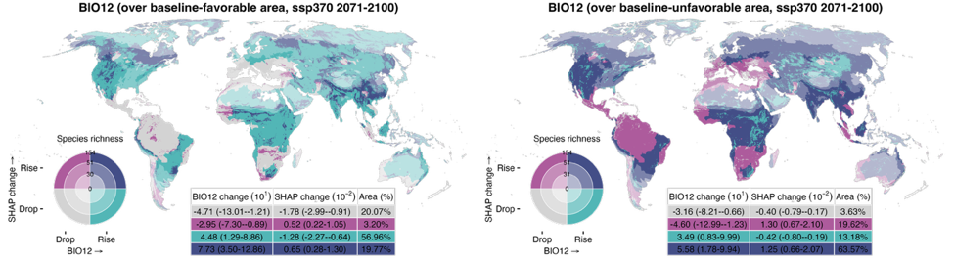
Figure S22 (continued).
See caption on previous page.
(Figure continued on next page)
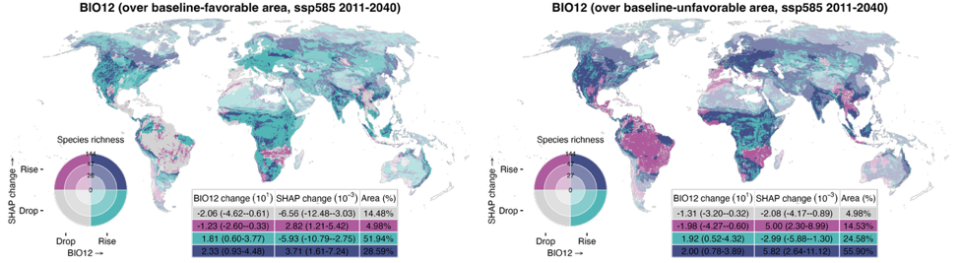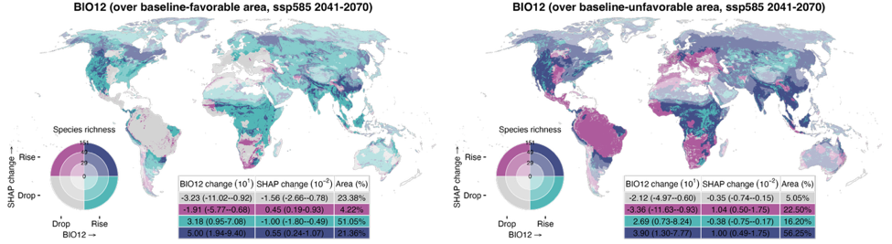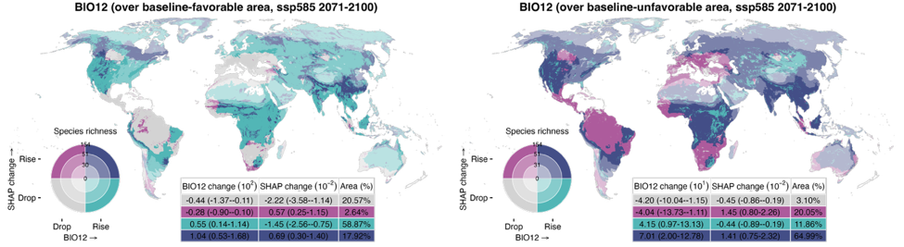
Figure S22 (continued).
See caption on page 59.
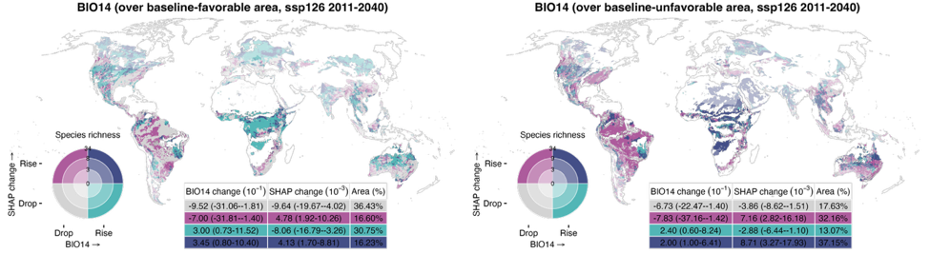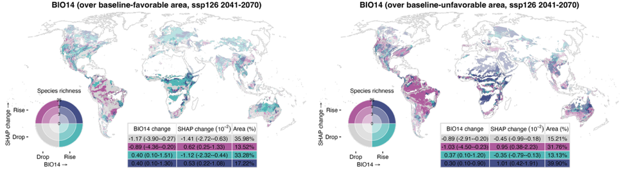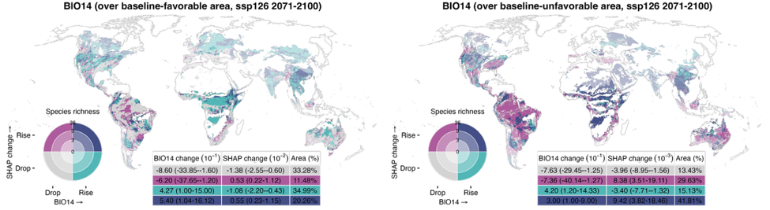
Figure S23. Spatial relationships between environmental changes and magnitude shifts in the relative contribution of precipitation of driest month (BIO14) under SSP126, SSP370, and SSP585 across three future periods (2011–2040, 2041–2070, and 2071–2100). Changes in BIO14 and SHAP-based favorability shifts are categorized as “drop” or “rise” depending on whether values decrease or increase, respectively; areas with no change are masked. Favorability shifts are defined as the difference in SHAP values between the baseline period (1981–2010) and each future period, and averaged across all relevant species that inhabit a given grid cell and include that variable in their distribution model. In all panels, rising SHAP values (magenta and purple) indicate increasing favorability for species, and declining values (gray and teal) indicate reduced favorability. The inset table presents area-weighted medians and interquartile ranges (25th–75th percentile) for each combination zone. Species richness is categorized as low, medium, or high based on the 33rd and 66th percentiles and is symbolized by the darkening hue of the four colors on the bivariate map. (Figure continued on next page)
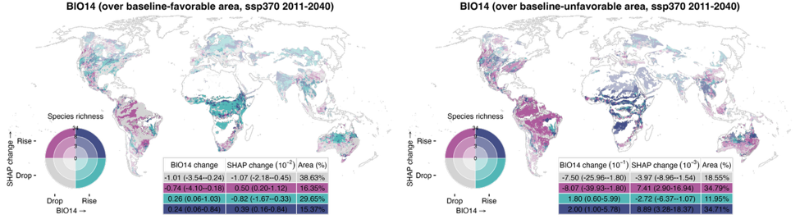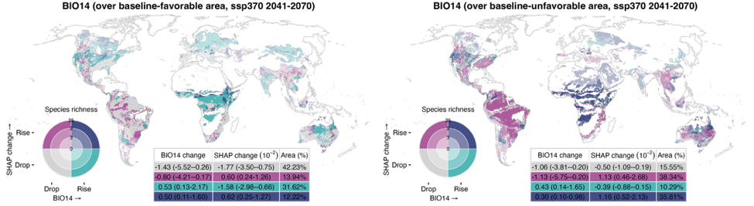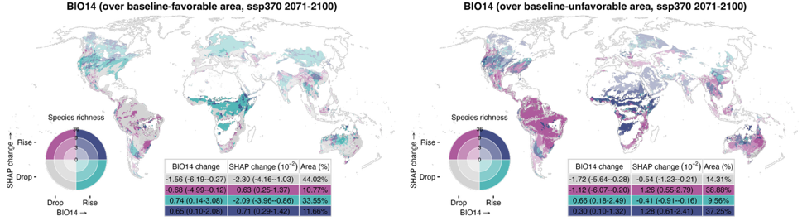
Figure S23 (continued).
See caption on previous page.
(Figure continued on next page)
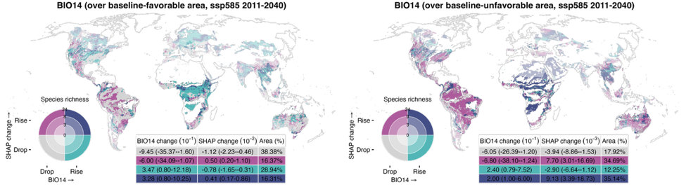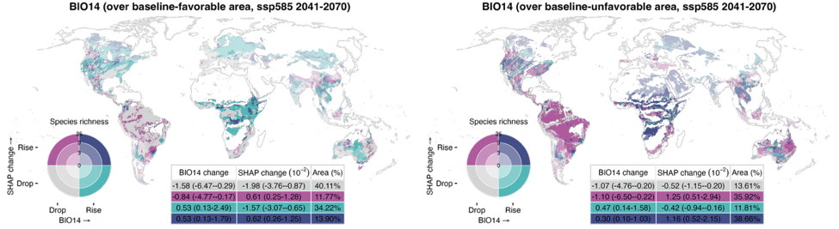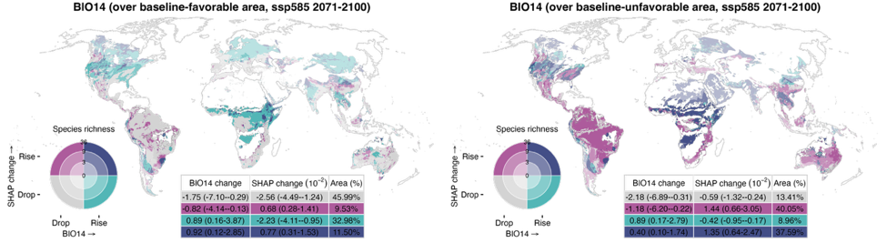
Figure S23 (continued).
See caption on page 62.
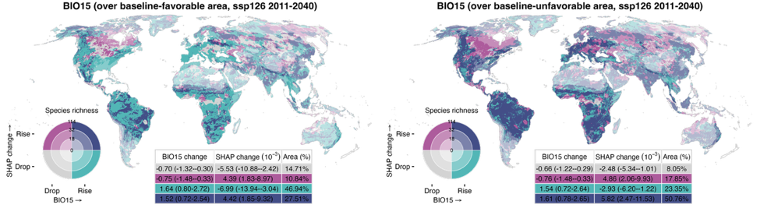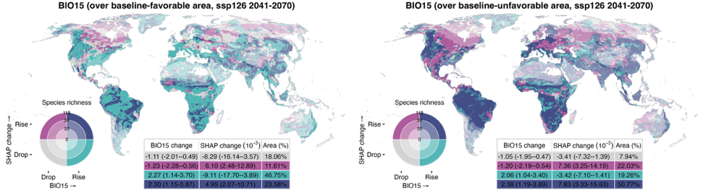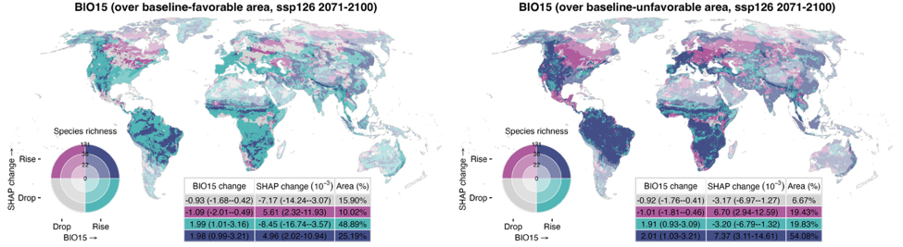
Figure S24. Spatial relationships between environmental changes and magnitude shifts in the relative contribution of precipitation seasonality (BIO15) under SSP126, SSP370, and SSP585 across three future periods (2011–2040, 2041–2070, and 2071–2100). Changes in BIO15 and SHAP-based favorability shifts are categorized as “drop” or “rise” depending on whether values decrease or increase, respectively; areas with no change are masked. Favorability shifts are defined as the difference in SHAP values between the baseline period (1981–2010) and each future period, and averaged across all relevant species that inhabit a given grid cell and include that variable in their distribution model. In all panels, rising SHAP values (magenta and purple) indicate increasing favorability for species, and declining values (gray and teal) indicate reduced favorability. The inset table presents area-weighted medians and interquartile ranges (25th–75th percentile) for each combination zone. Species richness is categorized as low, medium, or high based on the 33rd and 66th percentiles and is symbolized by the darkening hue of the four colors on the bivariate map. (Figure continued on next page)
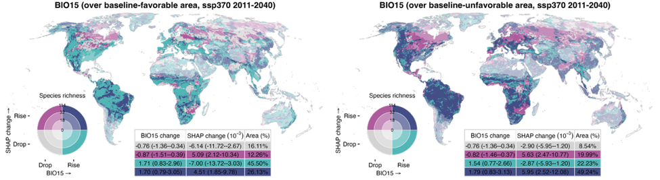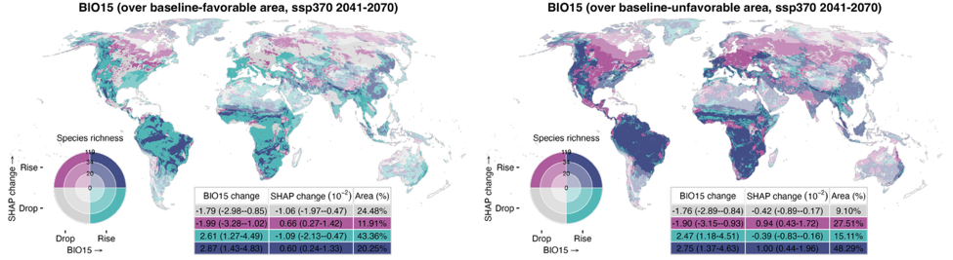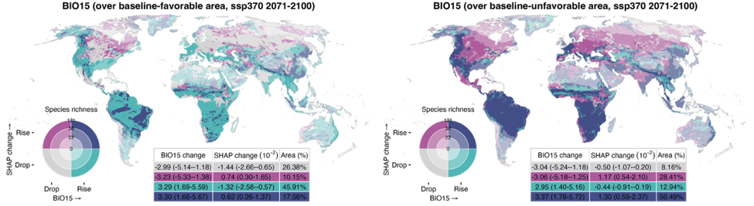
Figure S24 (continued).
See caption on previous page.
(Figure continued on next page)
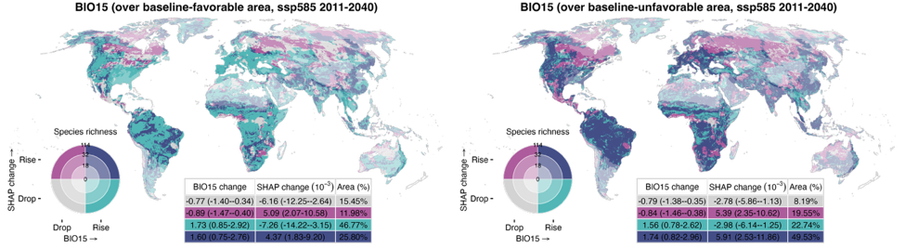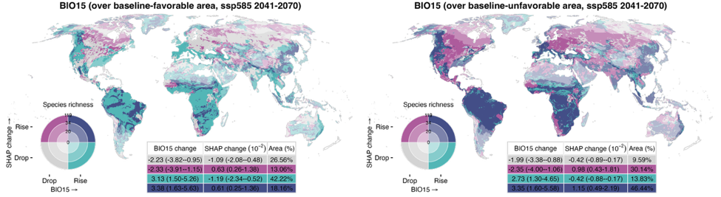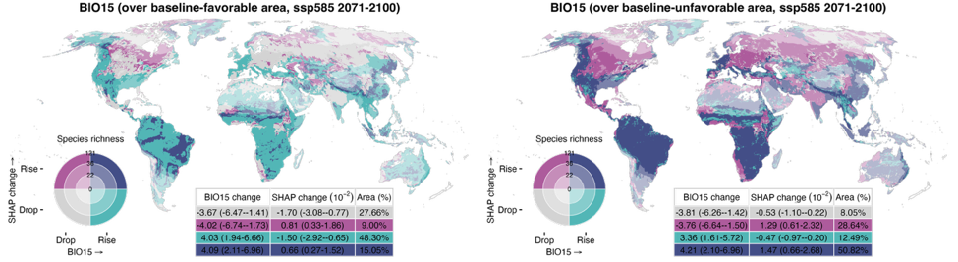
Figure S24 (continued).
See caption on page 65.
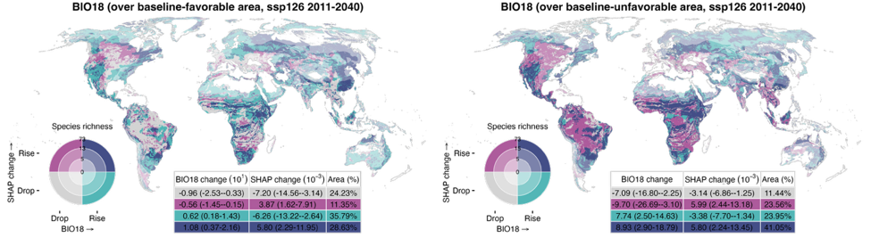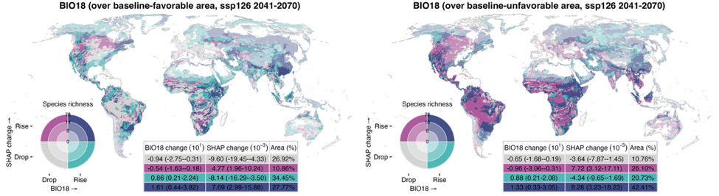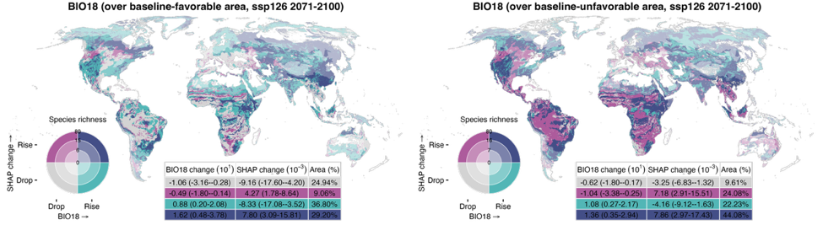
Figure S25. Spatial relationships between environmental changes and magnitude shifts in the relative contribution of precipitation of warmest quarter (BIO18) under SSP126, SSP370, and SSP585 across three future periods (2011–2040, 2041–2070, and 2071–2100). Changes in BIO18 and SHAP-based favorability shifts are categorized as “drop” or “rise” depending on whether values decrease or increase, respectively; areas with no change are masked. Favorability shifts are defined as the difference in SHAP values between the baseline period (1981–2010) and each future period, and averaged across all relevant species that inhabit a given grid cell and include that variable in their distribution model. In all panels, rising SHAP values (magenta and purple) indicate increasing favorability for species, and declining values (gray and teal) indicate reduced favorability. The inset table presents area-weighted medians and interquartile ranges (25th–75th percentile) for each combination zone. Species richness is categorized as low, medium, or high based on the 33rd and 66th percentiles and is symbolized by the darkening hue of the four colors on the bivariate map. (Figure continued on next page)
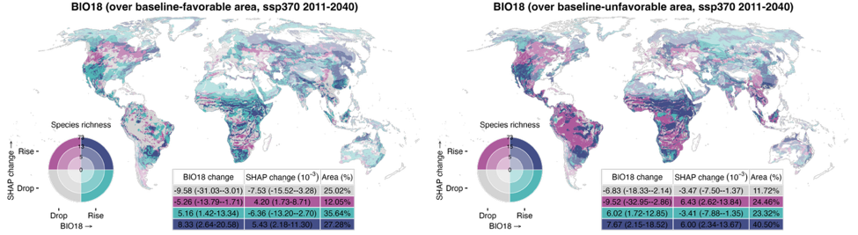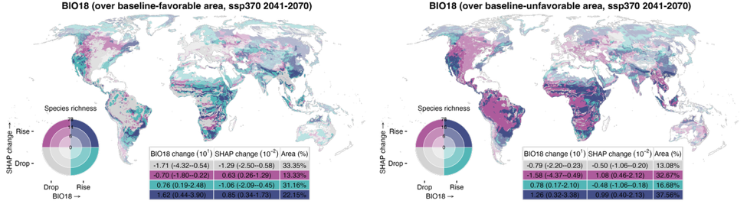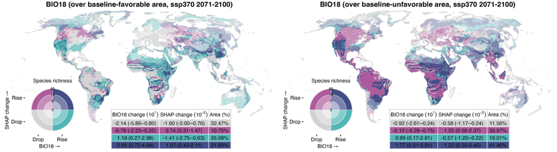
Figure S25 (continued).
See caption on previous page.
(Figure continued on next page)
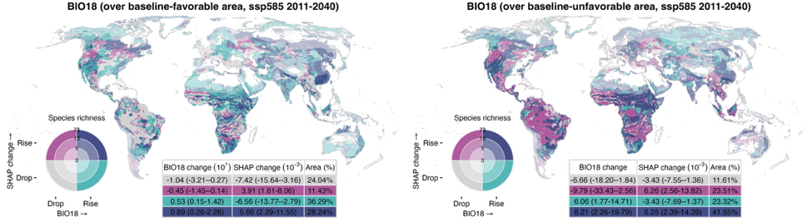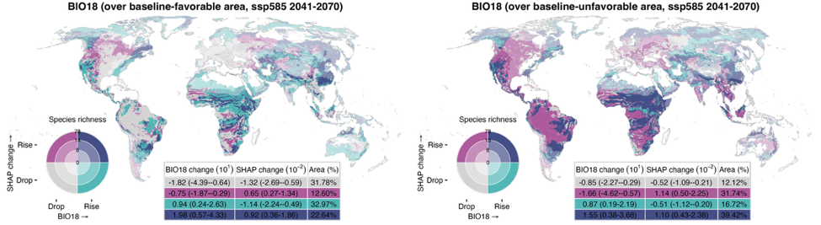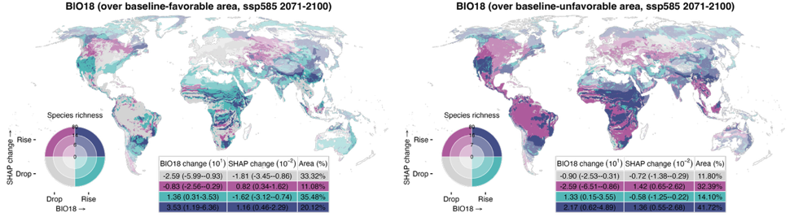
Figure S25 (continued).
See caption on page 68.
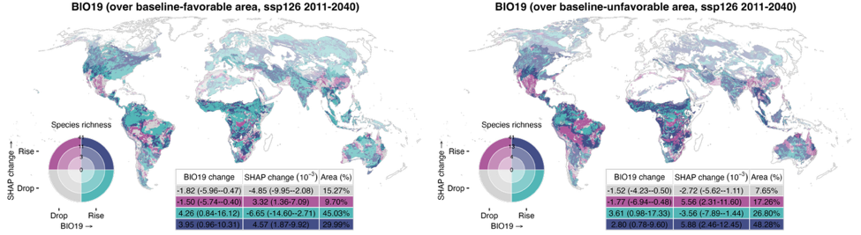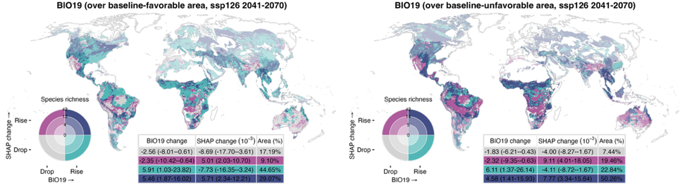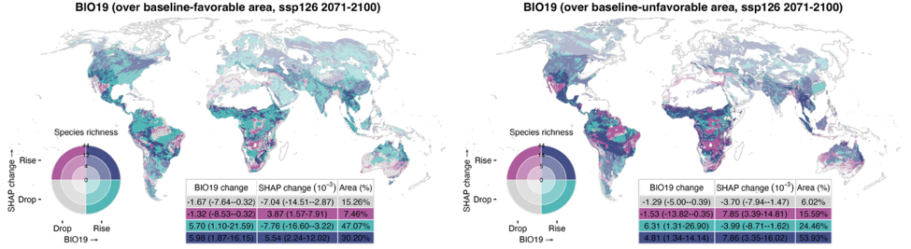
Figure S26. Spatial relationships between environmental changes and magnitude shifts in the relative contribution of precipitation of coldest quarter (BIO19) under SSP126, SSP370, and SSP585 across three future periods (2011–2040, 2041–2070, and 2071–2100). Changes in BIO19 and SHAP-based favorability shifts are categorized as “drop” or “rise” depending on whether values decrease or increase, respectively; areas with no change are masked. Favorability shifts are defined as the difference in SHAP values between the baseline period (1981–2010) and each future period, and averaged across all relevant species that inhabit a given grid cell and include that variable in their distribution model. In all panels, rising SHAP values (magenta and purple) indicate increasing favorability for species, and declining values (gray and teal) indicate reduced favorability. The inset table presents area-weighted medians and interquartile ranges (25th–75th percentile) for each combination zone. Species richness is categorized as low, medium, or high based on the 33rd and 66th percentiles and is symbolized by the darkening hue of the four colors on the bivariate map. (Figure continued on next page)
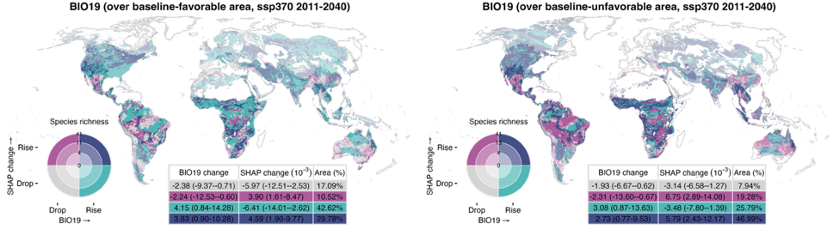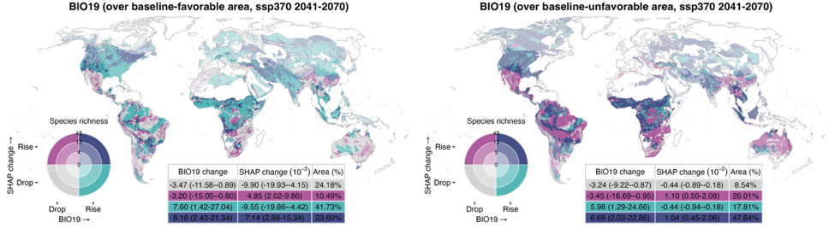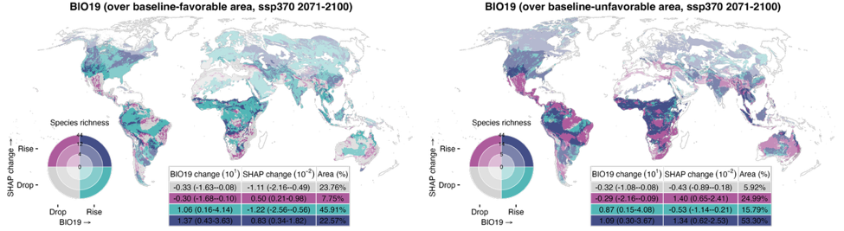
Figure S26 (continued).
See caption on previous page.
(Figure continued on next page)
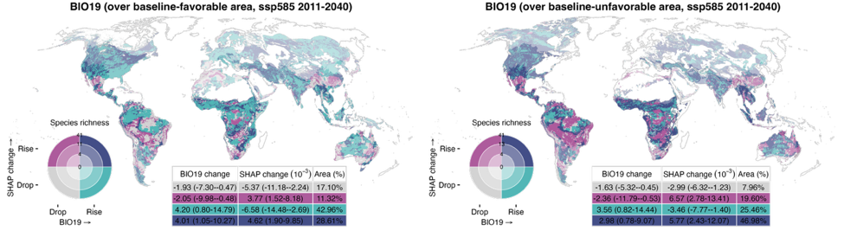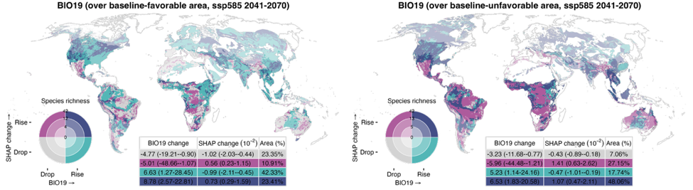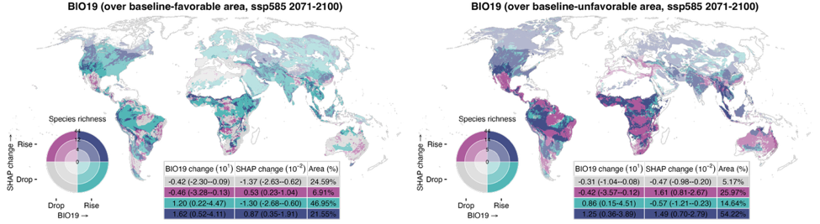
Figure S26 (continued).
See caption on page 71.
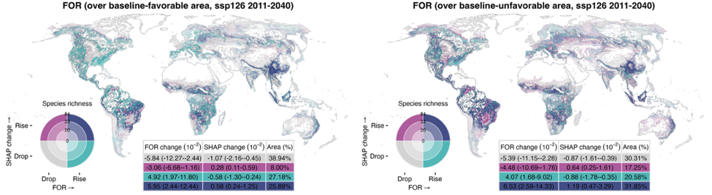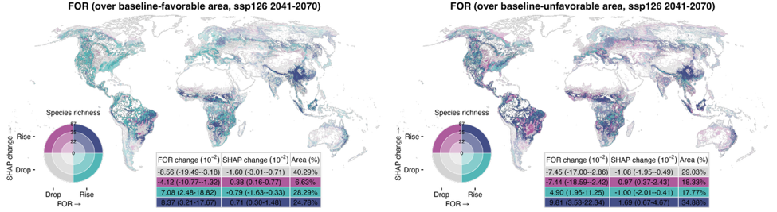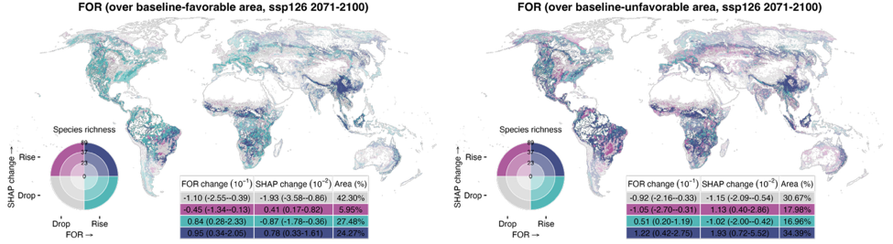
Figure S27. Spatial relationships between environmental changes and magnitude shifts in the relative contribution of forest coverage (FOR) under SSP126, SSP370, and SSP585 across three future periods (2011–2040, 2041–2070, and 2071–2100). Changes in FOR and SHAP-based favorability shifts are categorized as “drop” or “rise” depending on whether values decrease or increase, respectively; areas with no change are masked. Favorability shifts are defined as the difference in SHAP values between the baseline period (1981–2010) and each future period, and averaged across all relevant species that inhabit a given grid cell and include that variable in their distribution model. In all panels, rising SHAP values (magenta and purple) indicate increasing favorability for species, and declining values (gray and teal) indicate reduced favorability. The inset table presents area-weighted medians and interquartile ranges (25th–75th percentile) for each combination zone. Species richness is categorized as low, medium, or high based on the 33rd and 66th percentiles and is symbolized by the darkening hue of the four colors on the bivariate map. (Figure continued on next page)
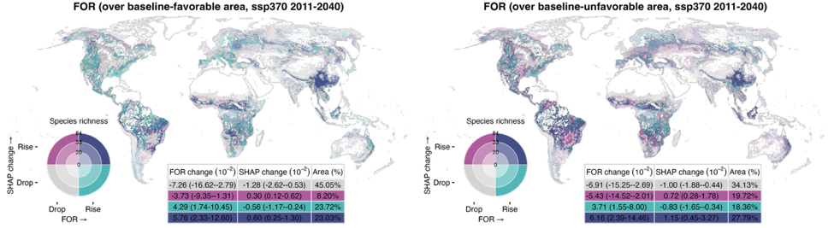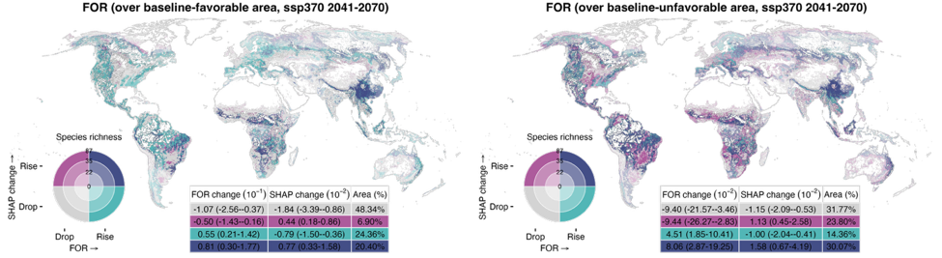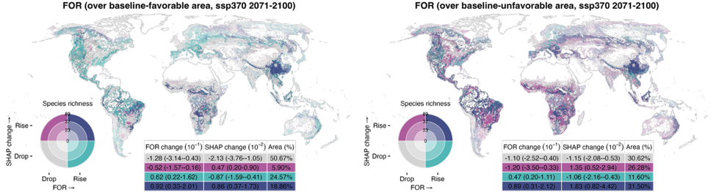
Figure S27 (continued).
See caption on previous page.
(Figure continued on next page)
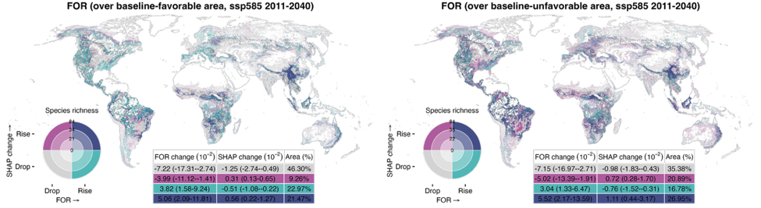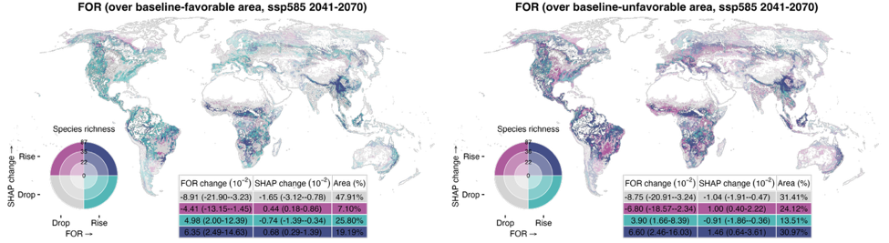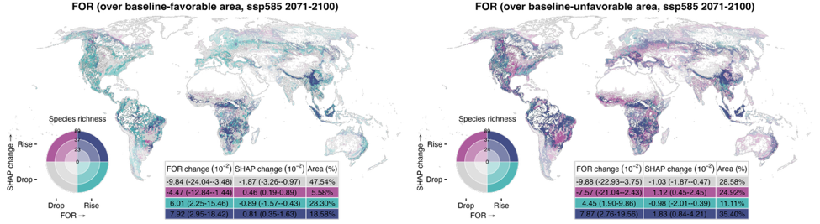
Figure S27 (continued).
See caption on page 74.
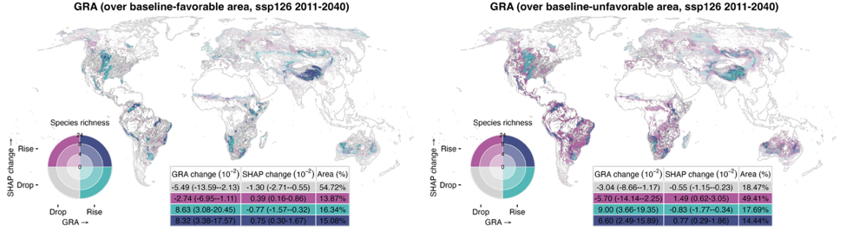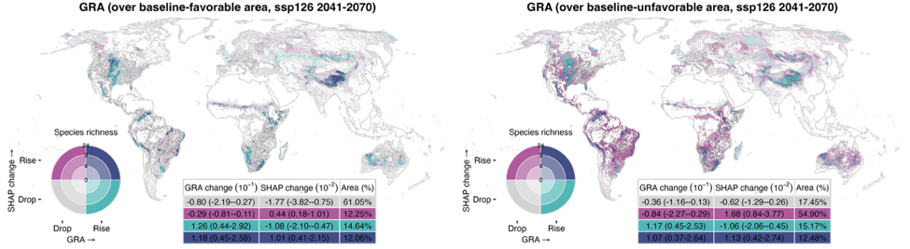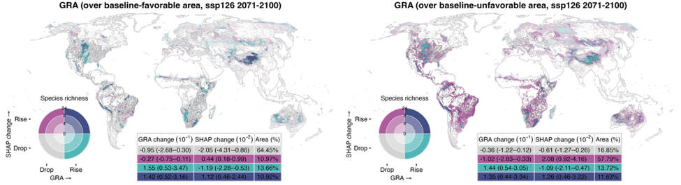
Figure S28. Spatial relationships between environmental changes and magnitude shifts in the relative contribution of grassland coverage (GRA) under SSP126, SSP370, and SSP585 across three future periods (2011–2040, 2041–2070, and 2071–2100). Changes in GRA and SHAP-based favorability shifts are categorized as “drop” or “rise” depending on whether values decrease or increase, respectively; areas with no change are masked. Favorability shifts are defined as the difference in SHAP values between the baseline period (1981–2010) and each future period, and averaged across all relevant species that inhabit a given grid cell and include that variable in their distribution model. In all panels, rising SHAP values (magenta and purple) indicate increasing favorability for species, and declining values (gray and teal) indicate reduced favorability. The inset table presents area-weighted medians and interquartile ranges (25th–75th percentile) for each combination zone. Species richness is categorized as low, medium, or high based on the 33rd and 66th percentiles and is symbolized by the darkening hue of the four colors on the bivariate map. (Figure continued on next page)
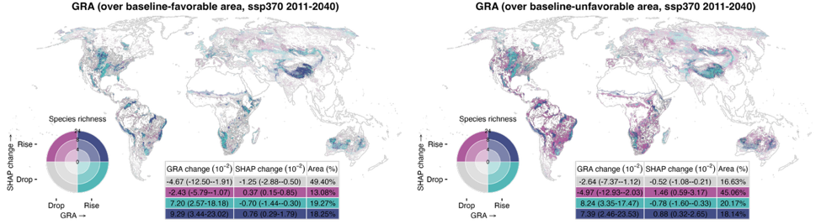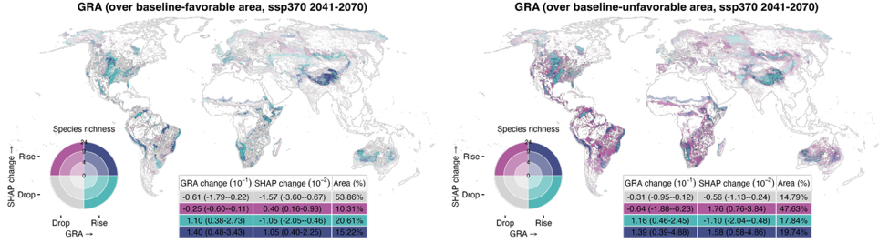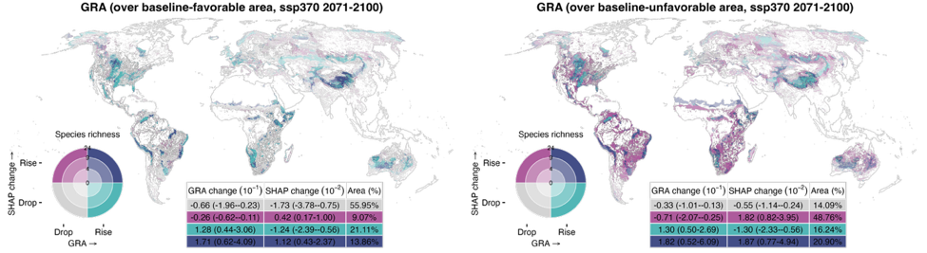
Figure S28 (continued).
See caption on previous page.
(Figure continued on next page)
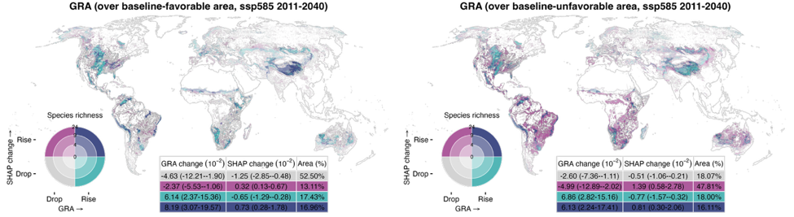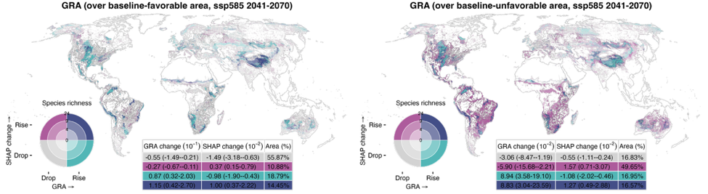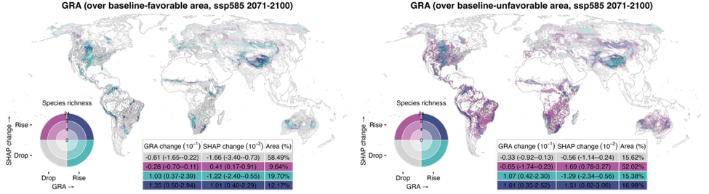
Figure S28 (continued).
See caption on page 77.
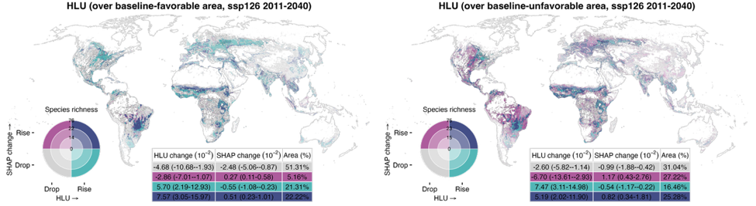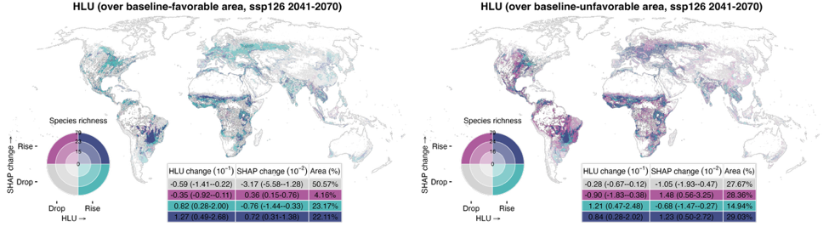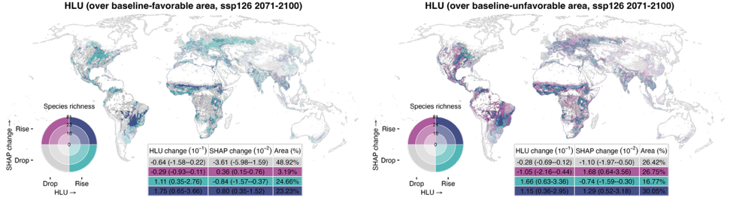
Figure S29. Spatial relationships between environmental changes and magnitude shifts in the relative contribution of human land use (HLU) under SSP126, SSP370, and SSP585 across three future periods (2011–2040, 2041–2070, and 2071–2100). Changes in HLU and SHAP-based favorability shifts are categorized as “drop” or “rise” depending on whether values decrease or increase, respectively; areas with no change are masked. Favorability shifts are defined as the difference in SHAP values between the baseline period (1981–2010) and each future period, and averaged across all relevant species that inhabit a given grid cell and include that variable in their distribution model. In all panels, rising SHAP values (magenta and purple) indicate increasing favorability for species, and declining values (gray and teal) indicate reduced favorability. The inset table presents area-weighted medians and interquartile ranges (25th–75th percentile) for each combination zone. Species richness is categorized as low, medium, or high based on the 33rd and 66th percentiles and is symbolized by the darkening hue of the four colors on the bivariate map. (Figure continued on next page)
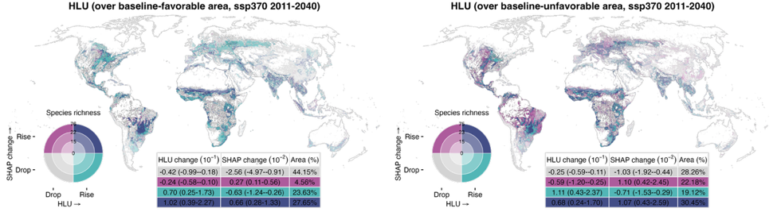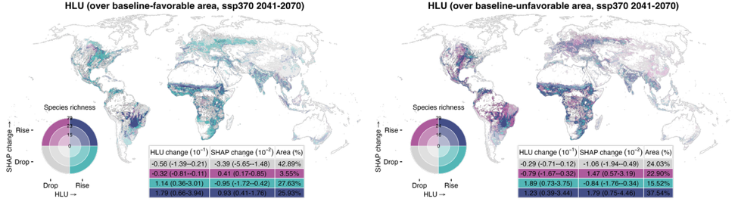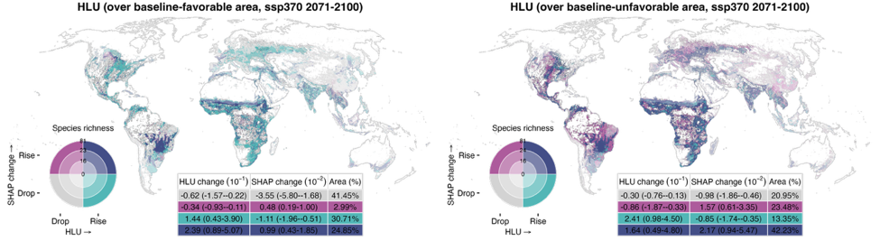
Figure S29 (continued).
See caption on previous page.
(Figure continued on next page)
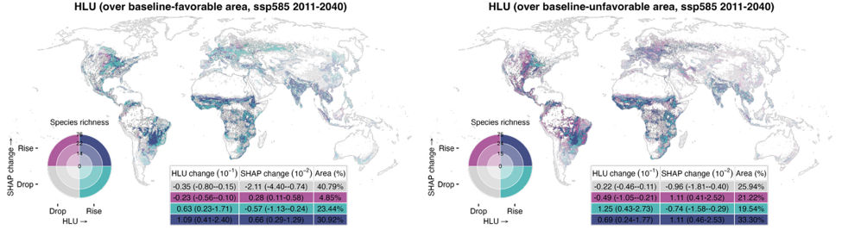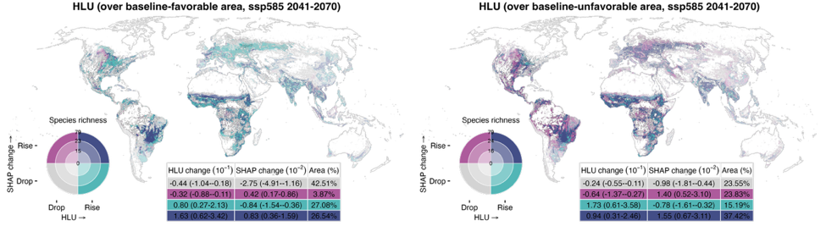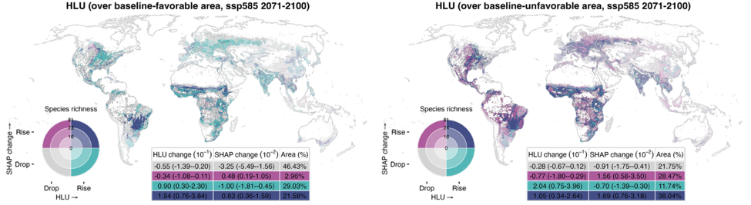
Figure S29 (continued).
See caption on page 80.

References
1. Lundberg, S. M. & Lee, S.-I. A unified approach to interpreting model predictions. in Proceedings of the 31st international conference on neural information processing systems 4768–4777 (2017).
2. Greenwell, B. Fastshap: Fast Approximate Shapley Values. (2021).
3. Sellereite, N. & Jullum, M. shapr: An R-package for explaining machine learning models with dependence-aware Shapley values. J. Open Source Softw. 5, 2027 (2019).
4. Brun, P., Zimmermann, N. E., Hari, C., Pellissier, L. & Karger, D. N. CHELSA-BIOCLIM+ A novel set of global climate-related predictors at kilometre-resolution. (2022) doi:http://dx.doi.org/10.16904/envidat.332.
5. Booth, T. H., Nix, H. A., Busby, J. R. & Hutchinson, M. F. bioclim : the first species distribution modelling package, its early applications and relevance to most current MaxEnt studies. Divers. Distrib. 20, 1–9 (2014).

