Extended Data Table 1 | Projected turnover-affected areas of environmental variables for endangered mammal species under the SSP370 scenario (2041–2070). Environmental variables are BIO1 (Annual Mean Temperature), BIO2 (Mean Diurnal Range, mean of monthly [max temperature − min temperature]), BIO3 (Isothermality, BIO2/BIO7 × 100), BIO4 (Temperature Seasonality, standard deviation × 100), BIO5 (Max Temperature of Warmest Month), BIO6 (Min Temperature of Coldest Month), BIO7 (Temperature Annual Range, BIO5 − BIO6), BIO8 (Mean Temperature of Wettest Quarter), BIO9 (Mean Temperature of Driest Quarter), BIO10 (Mean Temperature of Warmest Quarter), BIO11 (Mean Temperature of Coldest Quarter), BIO12 (Annual Precipitation), BIO13 (Precipitation of Wettest Month), BIO14 (Precipitation of Driest Month), BIO15 (Precipitation Seasonality, coefficient of variation), BIO16 (Precipitation of Wettest Quarter), BIO17 (Precipitation of Driest Quarter), BIO18 (Precipitation of Warmest Quarter), and BIO19 (Precipitation of Coldest Quarter), FOR (forest coverage), HLU (human land use), and GRA (grassland coverage). Species are categorized based on IUCN Red List status: EN (endangered), VU (vulnerable), and CR (critically endangered).
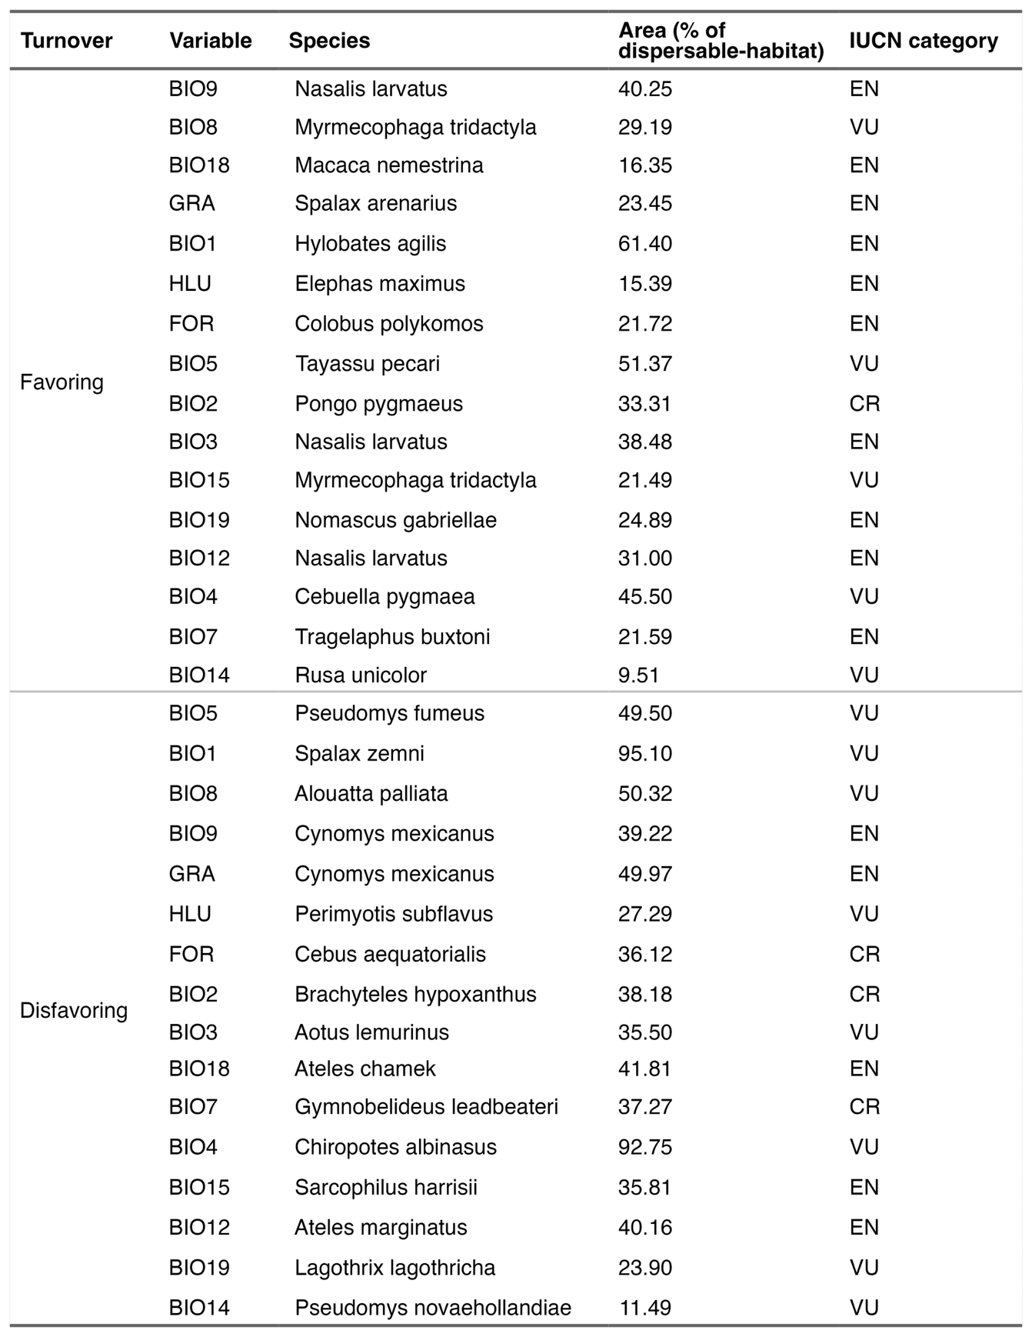

Extended Data Table 2 | Projected favorability shifts of environmental variables for endangered mammal species under the SSP370 scenario (2041–2070). Favorability shifts represent median grid-wise changes in SHAP values, separately computed for areas favorable (positive SHAP) and unfavorable (negative SHAP) during the baseline period (1981–2010). Q1 and Q3 indicate the first and third quantiles, respectively. Environmental variables are BIO1 (Annual Mean Temperature), BIO2 (Mean Diurnal Range, mean of monthly [max temperature − min temperature]), BIO3 (Isothermality, BIO2/BIO7 × 100), BIO4 (Temperature Seasonality, standard deviation × 100), BIO5 (Max Temperature of Warmest Month), BIO6 (Min Temperature of Coldest Month), BIO7 (Temperature Annual Range, BIO5 − BIO6), BIO8 (Mean Temperature of Wettest Quarter), BIO9 (Mean Temperature of Driest Quarter), BIO10 (Mean Temperature of Warmest Quarter), BIO11 (Mean Temperature of Coldest Quarter), BIO12 (Annual Precipitation), BIO13 (Precipitation of Wettest Month), BIO14 (Precipitation of Driest Month), BIO15 (Precipitation Seasonality, coefficient of variation), BIO16 (Precipitation of Wettest Quarter), BIO17 (Precipitation of Driest Quarter), BIO18 (Precipitation of Warmest Quarter), and BIO19 (Precipitation of Coldest Quarter), FOR (forest coverage), HLU (human land use), and GRA (grassland coverage). Species are categorized based on IUCN Red List status: EN (endangered), VU (vulnerable), and CR (critically endangered).
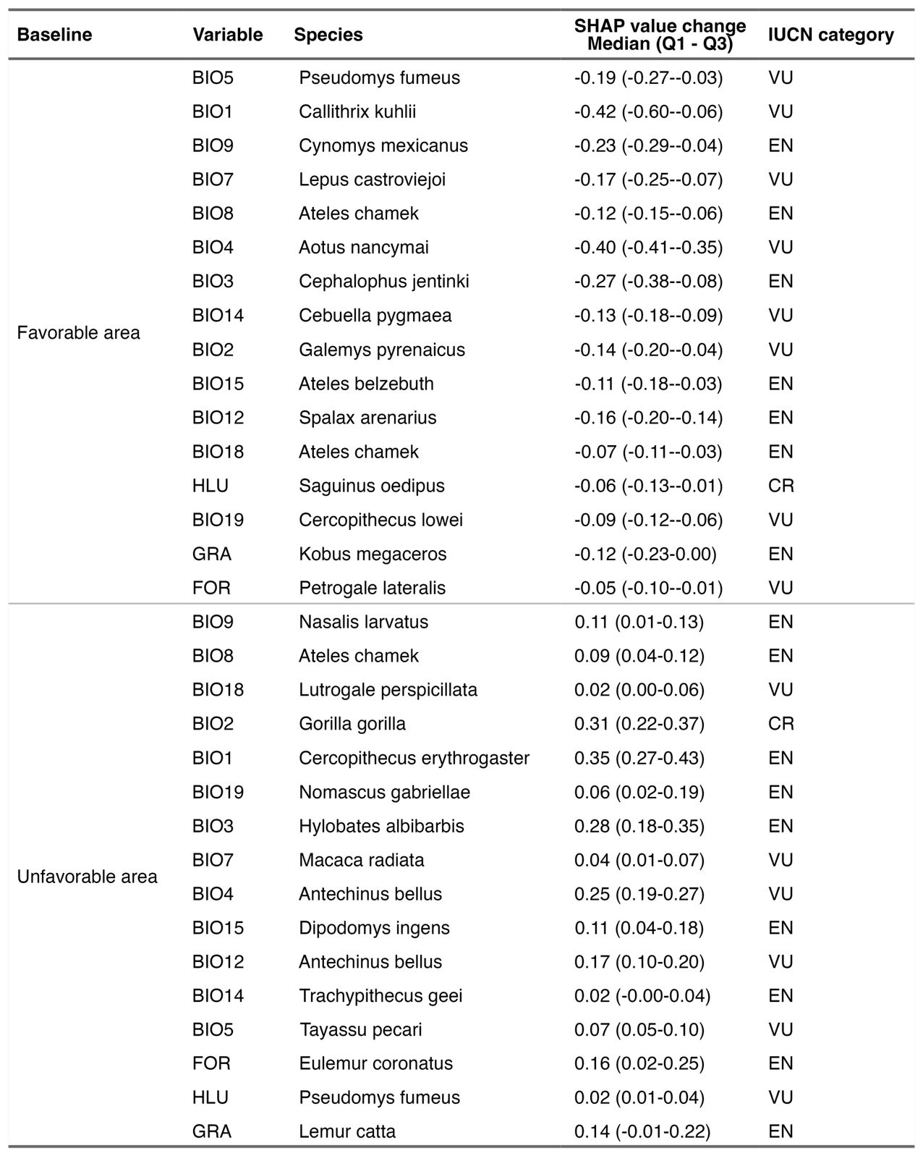

Extended Data Table 3 | Global extent and local intensity of projected turnovers of environmental variable groups for mammal species under SSP370 for the mid-century period (2041–2070). Global area is calculated as percentage of total terrestrial area (excluding Antarctica) projected to experience turnovers in the relative contributions of each environmental variable group. Local intensity is calculated as median percentage of species projected to experience turnovers (local intensity) in each grid cell (~10 km²) across the terrestrial surface (excluding Antarctica).
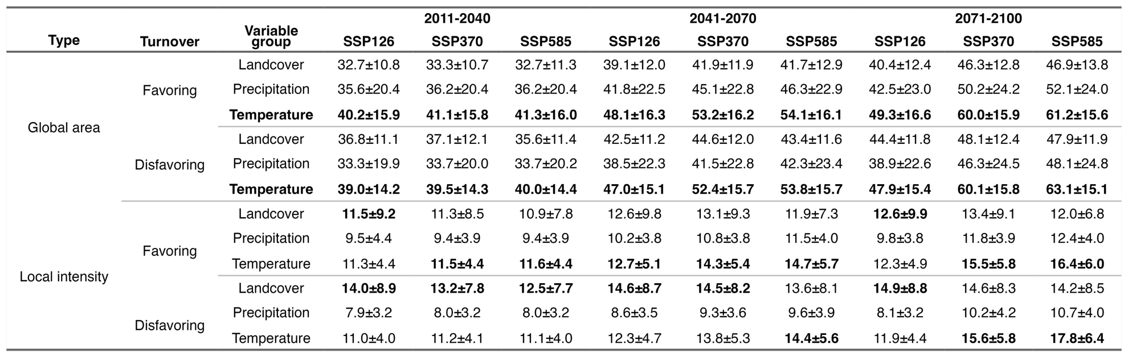
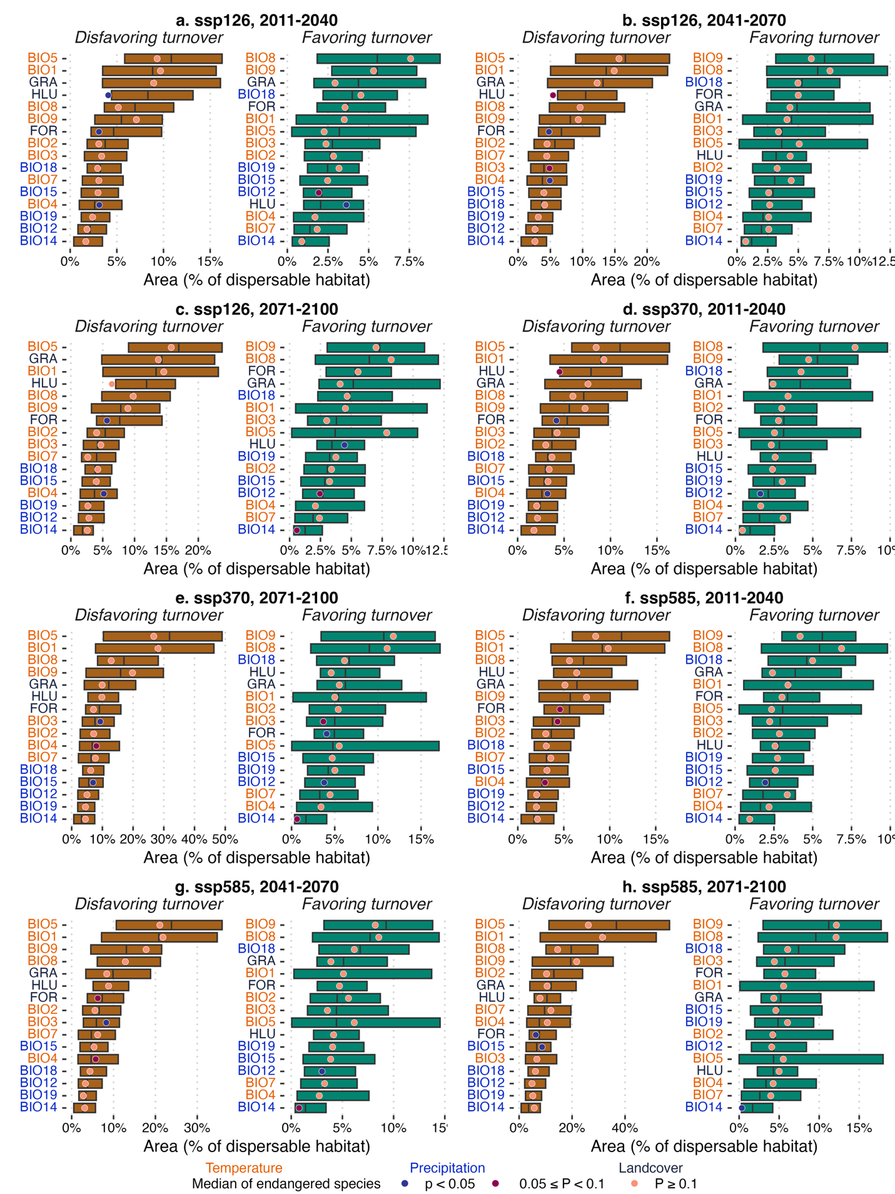
Extended Data Fig. 1 | Projected turnover-affected areas of environmental variables at species-level. (a–h) Distribution of turnover-affected area (%) for 16 environmental variables, comparing all mammals with endangered species under SSP126, SSP370, and SSP585 across three future time periods: 2011–2040, 2041–2070, and 2071–2100. Analyses were conducted within each species' accessible habitat, defined as habitat range plus potential dispersal distance. Turnovers represent directional changes in favorability of individual environmental variables: Disfavoring turnover (when an area changes from favorable to unfavorable) and favoring turnover (when an area changes from unfavorable to favorable), based on changes in SHAP values (Fig. 1). Turnover-affected areas are quantified as percentages (%) of each species' accessible habitat. Environmental variables are BIO1 (Annual Mean Temperature), BIO2 (Mean Diurnal Range, mean of monthly [max temperature − min temperature]), BIO3 (Isothermality, BIO2/BIO7 × 100), BIO4 (Temperature Seasonality, standard deviation × 100), BIO5 (Max Temperature of Warmest Month), BIO6 (Min Temperature of Coldest Month), BIO7 (Temperature Annual Range, BIO5 − BIO6), BIO8 (Mean Temperature of Wettest Quarter), BIO9 (Mean Temperature of Driest Quarter), BIO10 (Mean Temperature of Warmest Quarter), BIO11 (Mean Temperature of Coldest Quarter), BIO12 (Annual Precipitation), BIO13 (Precipitation of Wettest Month), BIO14 (Precipitation of Driest Month), BIO15 (Precipitation Seasonality, coefficient of variation), BIO16 (Precipitation of Wettest Quarter), BIO17 (Precipitation of Driest Quarter), BIO18 (Precipitation of Warmest Quarter), and BIO19 (Precipitation of Coldest Quarter), FOR (forest coverage), HLU (human land use), and GRA (grassland coverage). Differences between all mammals and endangered species were examined using two-sided Mann–Whitney U tests.
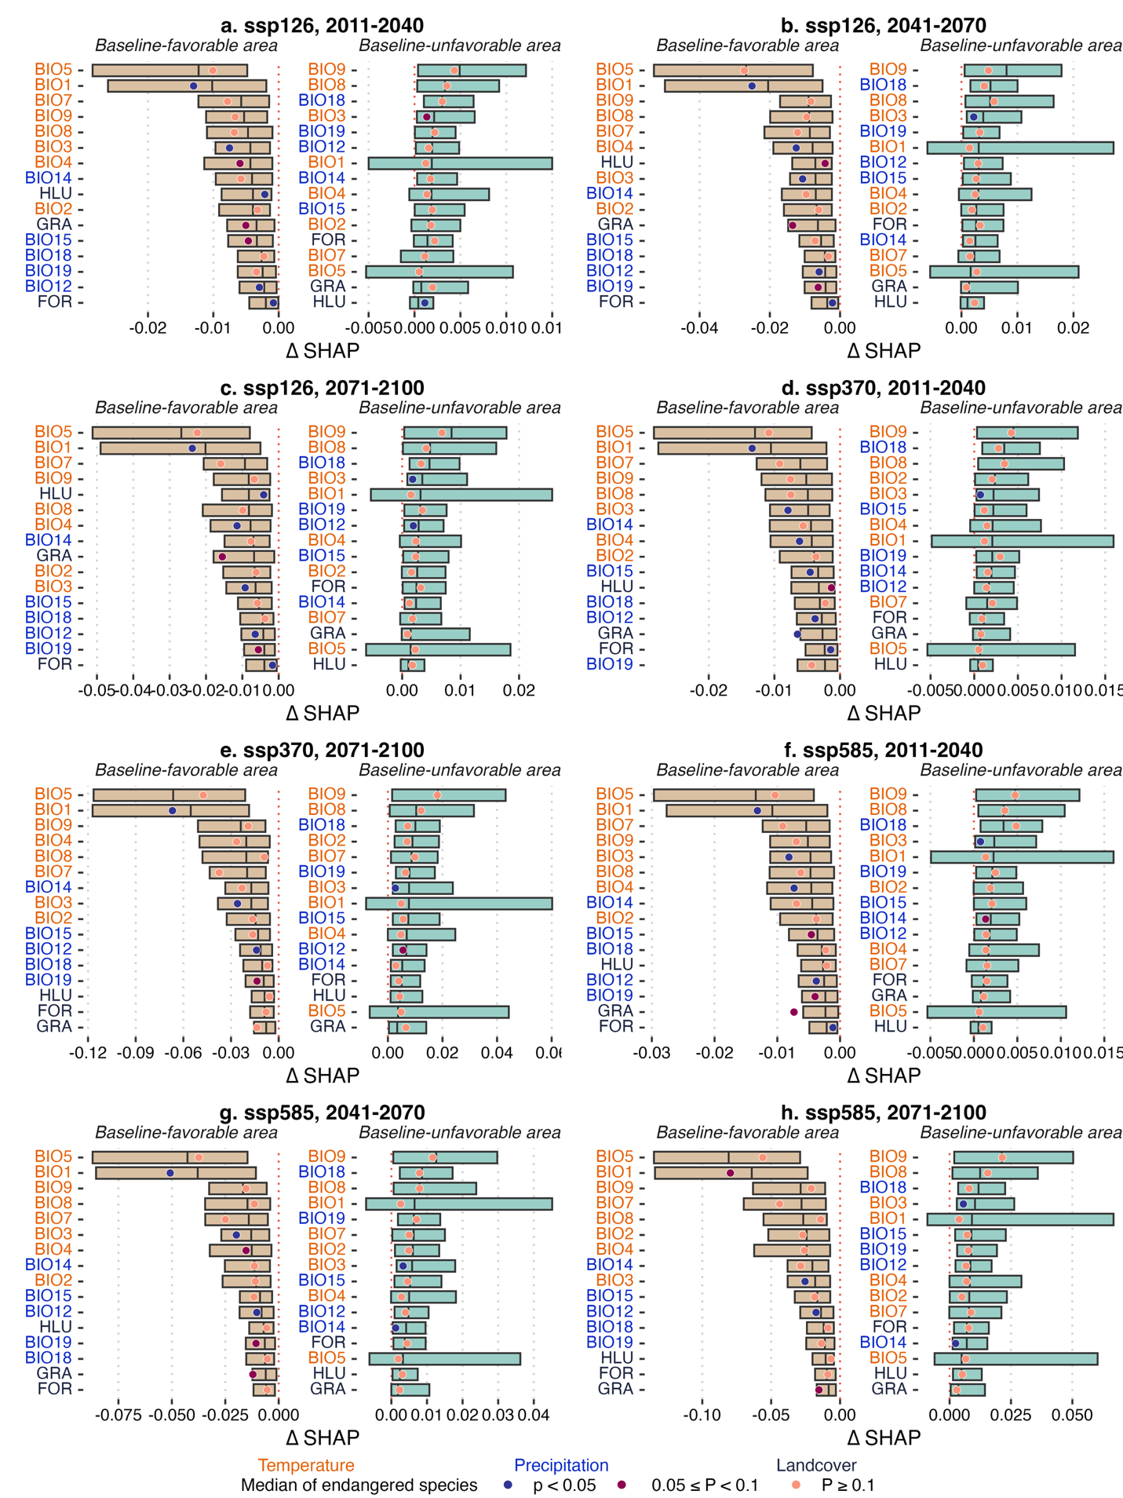

Extended Data Fig. 2 | Projected favorability shifts of environmental variables at species-level. (a–h) Distribution of favorability shifts (∆SHAP) for 16 environmental variables, comparing all mammals with endangered species under SSP126, SSP370, and SSP585 across three future time periods: 2011–2040, 2041–2070, and 2071–2100. Analyses were conducted within each species' accessible habitat, defined as habitat range plus potential dispersal distance. Favorability shifts (∆SHAP, a measure of the change in how much a variable contributes to species suitability) represent median grid-wise changes in SHAP values, separately computed for areas favorable (SHAP ≥0) and unfavorable (SHAP <0) during the baseline period (1981–2010). Environmental variables are BIO1 (Annual Mean Temperature), BIO2 (Mean Diurnal Range, mean of monthly [max temperature − min temperature]), BIO3 (Isothermality, BIO2/BIO7 × 100), BIO4 (Temperature Seasonality, standard deviation × 100), BIO5 (Max Temperature of Warmest Month), BIO6 (Min Temperature of Coldest Month), BIO7 (Temperature Annual Range, BIO5 − BIO6), BIO8 (Mean Temperature of Wettest Quarter), BIO9 (Mean Temperature of Driest Quarter), BIO10 (Mean Temperature of Warmest Quarter), BIO11 (Mean Temperature of Coldest Quarter), BIO12 (Annual Precipitation), BIO13 (Precipitation of Wettest Month), BIO14 (Precipitation of Driest Month), BIO15 (Precipitation Seasonality, coefficient of variation), BIO16 (Precipitation of Wettest Quarter), BIO17 (Precipitation of Driest Quarter), BIO18 (Precipitation of Warmest Quarter), and BIO19 (Precipitation of Coldest Quarter), FOR (forest coverage), HLU (human land use), and GRA (grassland coverage). Differences between all mammals and endangered species were examined using two-sided Mann–Whitney U tests.
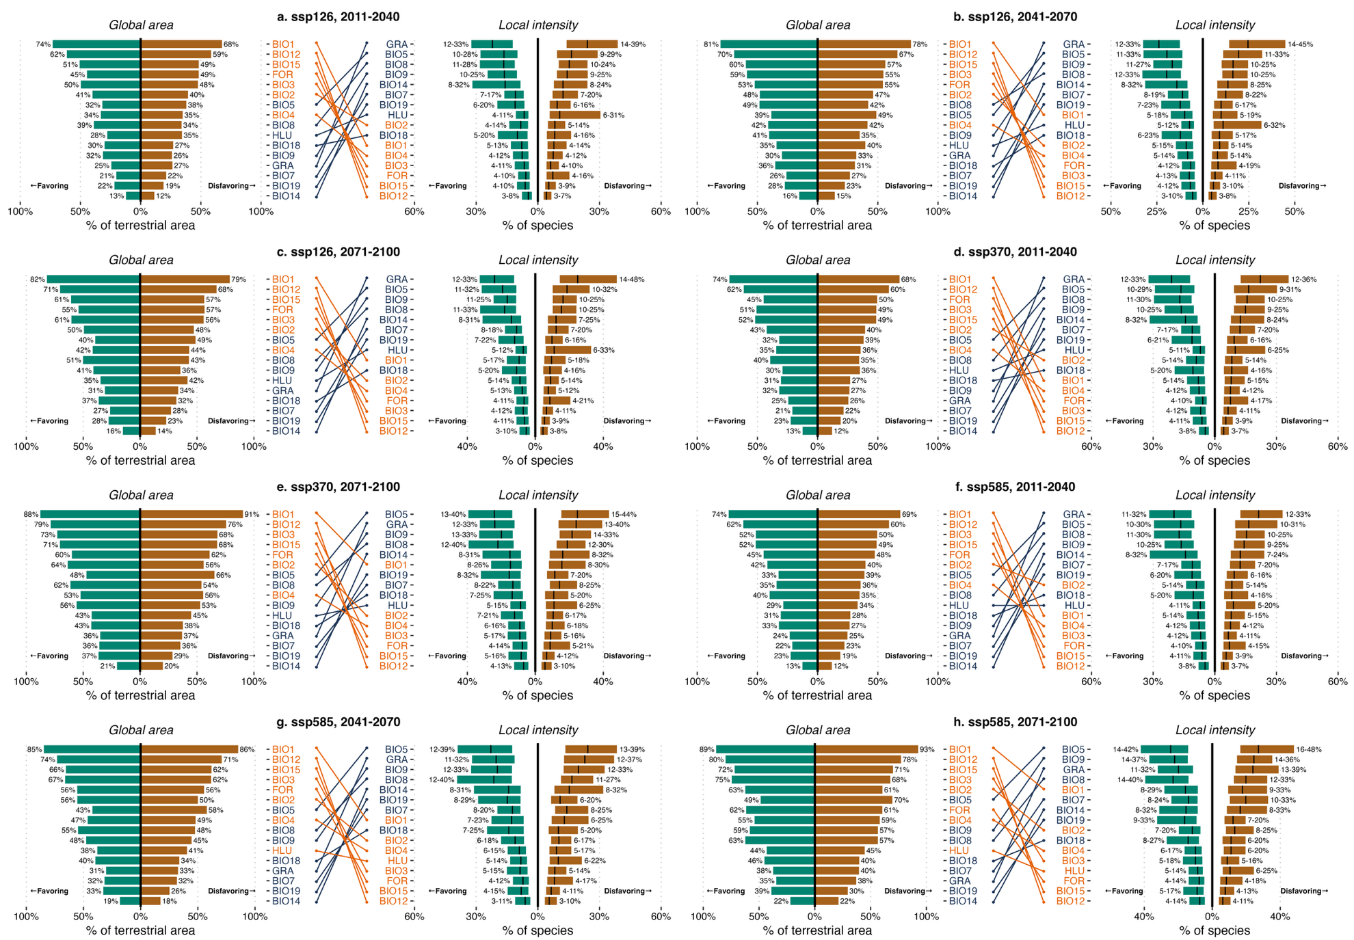
Extended Data Fig. 3 | Global area and local intensity (% of species) of projected turnovers of environmental variables for mammal species. (a–h) Projected spatial area and local intensity of favoring and disfavoring turnovers for all 16 environmental variables under SSP126, SSP370, and SSP585 across three future periods: 2011–2040, 2041–2070, and 2071–2100. Left panels show the percentage of total terrestrial area (excluding Antarctica) where at least one species experiences a turnover in a given variable. Right panels show the percentage of species experiencing turnovers in each grid cell (~10 km²), summarized as interquartile ranges (25th–75th percentile) across the terrestrial surface (excluding Antarctica). For each environmental variable, we only consider species that both inhabit a given grid cell and include that variable in their distribution model for the calculations. Disfavoring turnover refers to a shift from favorable to unfavorable conditions (positive to negative SHAP values), while favoring turnover indicates the reverse. Variables highlighted in bright orange are projected to have broader but locally less intense turnovers, while those highlighted in navy blue show narrower but more locally intense turnovers. The color coding shows a clear reversal in the important drivers when comparing global area to local species impacts. Environmental variables are BIO1 (Annual Mean Temperature), BIO2 (Mean Diurnal Range, mean of monthly [max temperature − min temperature]), BIO3 (Isothermality, BIO2/BIO7 × 100), BIO4 (Temperature Seasonality, standard deviation × 100), BIO5 (Max Temperature of Warmest Month), BIO6 (Min Temperature of Coldest Month), BIO7 (Temperature Annual Range, BIO5 − BIO6), BIO8 (Mean Temperature of Wettest Quarter), BIO9 (Mean Temperature of Driest Quarter), BIO10 (Mean Temperature of Warmest Quarter), BIO11 (Mean Temperature of Coldest Quarter), BIO12 (Annual Precipitation), BIO13 (Precipitation of Wettest Month), BIO14 (Precipitation of Driest Month), BIO15 (Precipitation Seasonality, coefficient of variation), BIO16 (Precipitation of Wettest Quarter), BIO17 (Precipitation of Driest Quarter), BIO18 (Precipitation of Warmest Quarter), and BIO19 (Precipitation of Coldest Quarter), FOR (forest coverage), HLU (human land use), and GRA (grassland coverage).

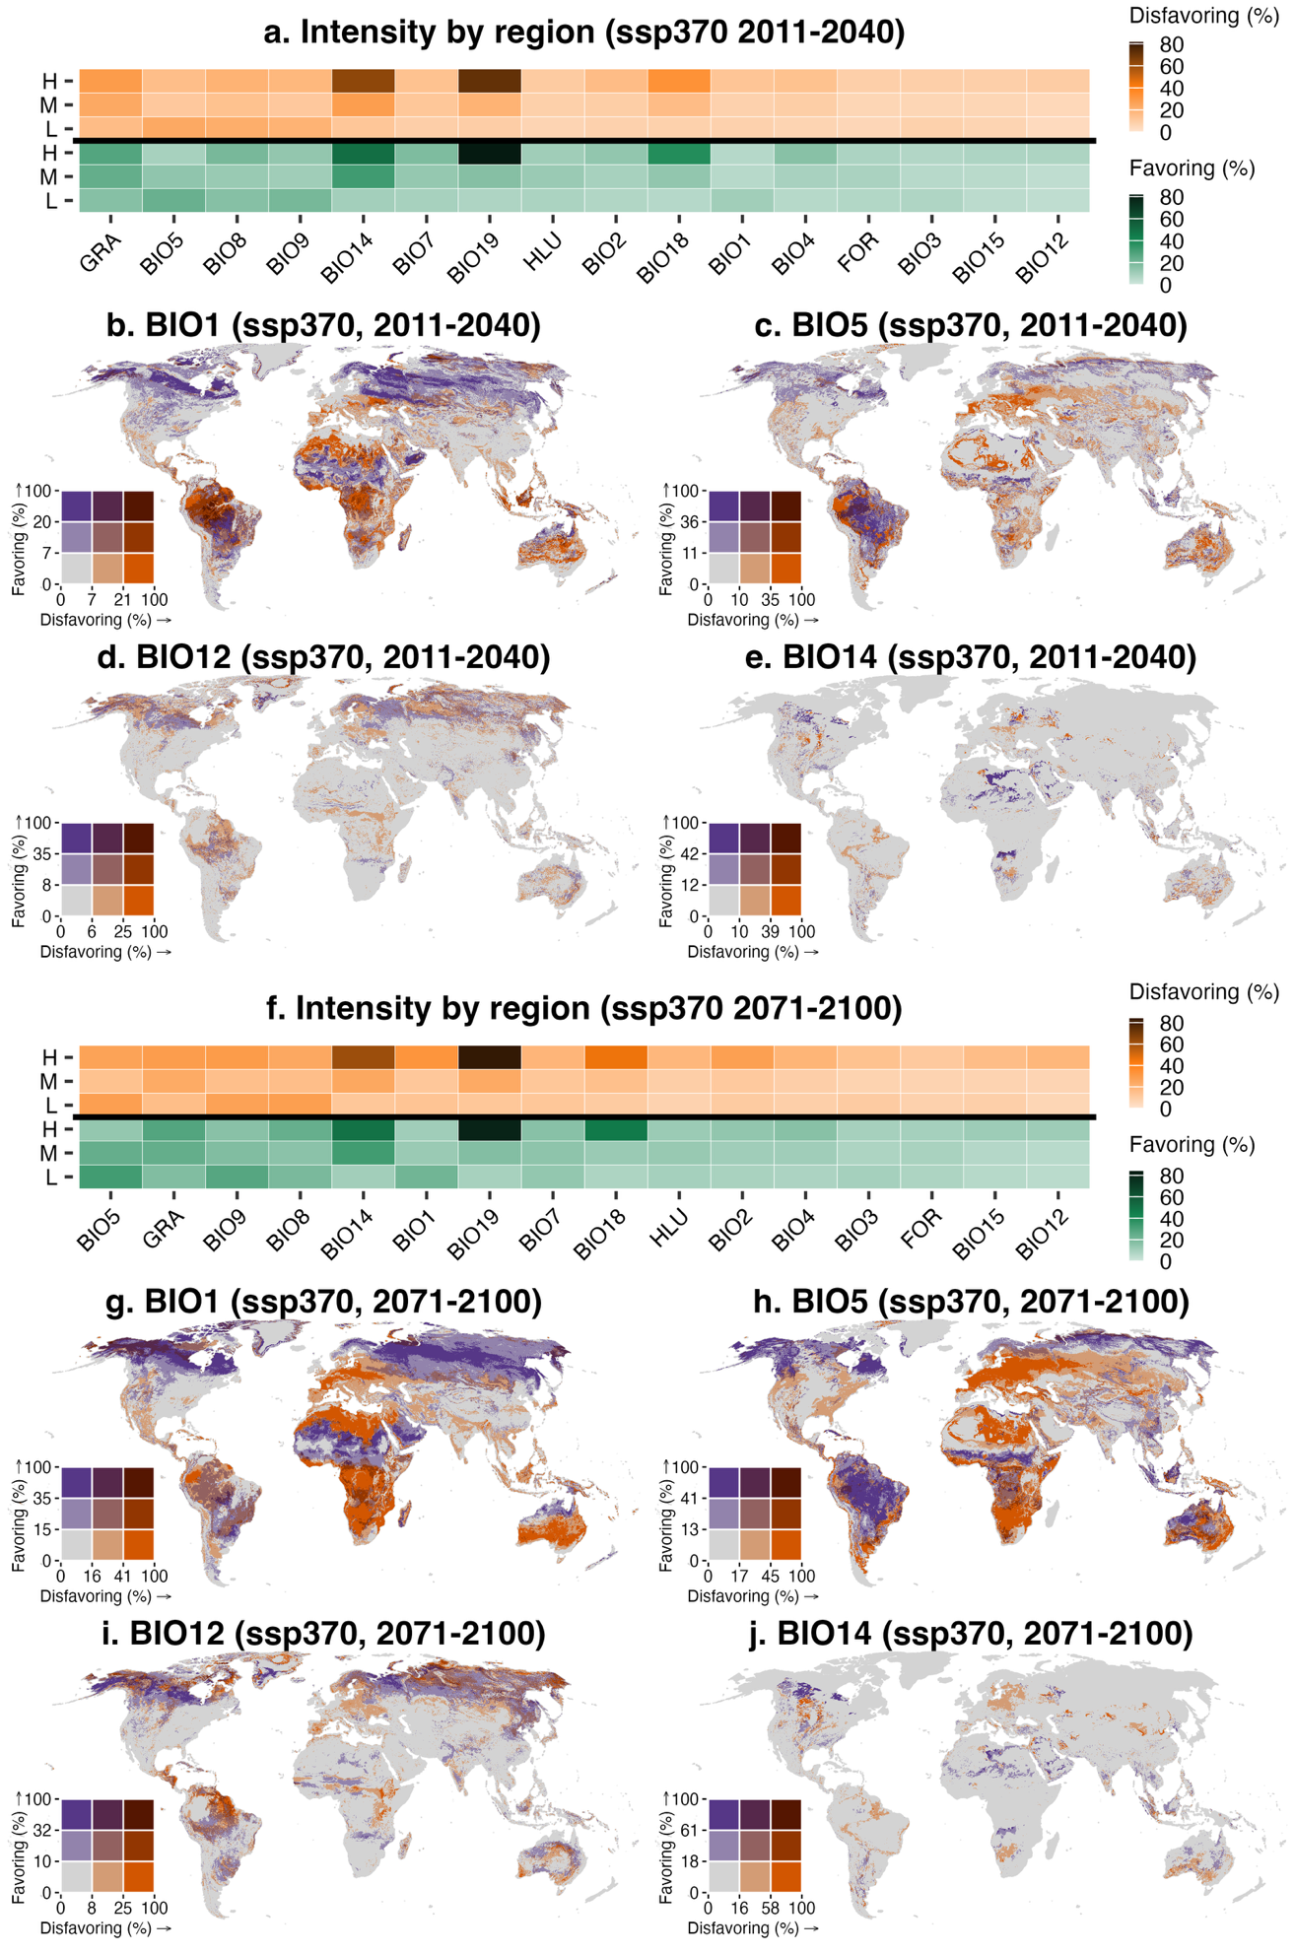
Extended Data Fig. 4 | Spatial intensity of projected turnovers of environmental variables for mammal species under SSP470. Intensity of turnovers is calculated as the percentage of species in each grid cell (~10 km²) projected to experience the corresponding turnovers. For each environmental variable, we only consider species that both inhabit a given grid cell and include that variable in their distribution models for the calculations. Disfavoring turnover refers to a shift from favorable to unfavorable conditions (positive to negative SHAP values), while favoring turnover indicates the reverse. (a, f) Median intensity of turnovers (favoring and disfavoring) by latitudinal band: low (L, 30°S–30°N), middle (M, 30°–60°N/S), and high (H, 60°–90°N/S) for 2041–2070, and 2071–2100. (b-e) Bivariate maps showing intensity of disfavoring and favoring turnovers for annual mean temperature (BIO1), max temperature of warmest month (BIO5), annual precipitation (BIO12) and precipitation of driest month (BIO14) for 2011-2040, respectively. (g-j) Bivariate maps showing intensity of disfavoring and favoring turnovers for annual mean temperature (BIO1), max temperature of warmest month (BIO5), annual precipitation (BIO12) and precipitation of driest month (BIO14) for 2071-2100, respectively. Breakpoints for intensity of turnovers are determined using the Fisher–Jenks algorithm, as implemented in the R package classInt. Environmental variables are BIO1 (Annual Mean Temperature), BIO2 (Mean Diurnal Range, mean of monthly [max temperature − min temperature]), BIO3 (Isothermality, BIO2/BIO7 × 100), BIO4 (Temperature Seasonality, standard deviation × 100), BIO5 (Max Temperature of Warmest Month), BIO6 (Min Temperature of Coldest Month), BIO7 (Temperature Annual Range, BIO5 − BIO6), BIO8 (Mean Temperature of Wettest Quarter), BIO9 (Mean Temperature of Driest Quarter), BIO10 (Mean Temperature of Warmest Quarter), BIO11 (Mean Temperature of Coldest Quarter), BIO12 (Annual Precipitation), BIO13 (Precipitation of Wettest Month), BIO14 (Precipitation of Driest Month), BIO15 (Precipitation Seasonality, coefficient of variation), BIO16 (Precipitation of Wettest Quarter), BIO17 (Precipitation of Driest Quarter), BIO18 (Precipitation of Warmest Quarter), and BIO19 (Precipitation of Coldest Quarter), FOR (forest coverage), HLU (human land use), and GRA (grassland coverage).
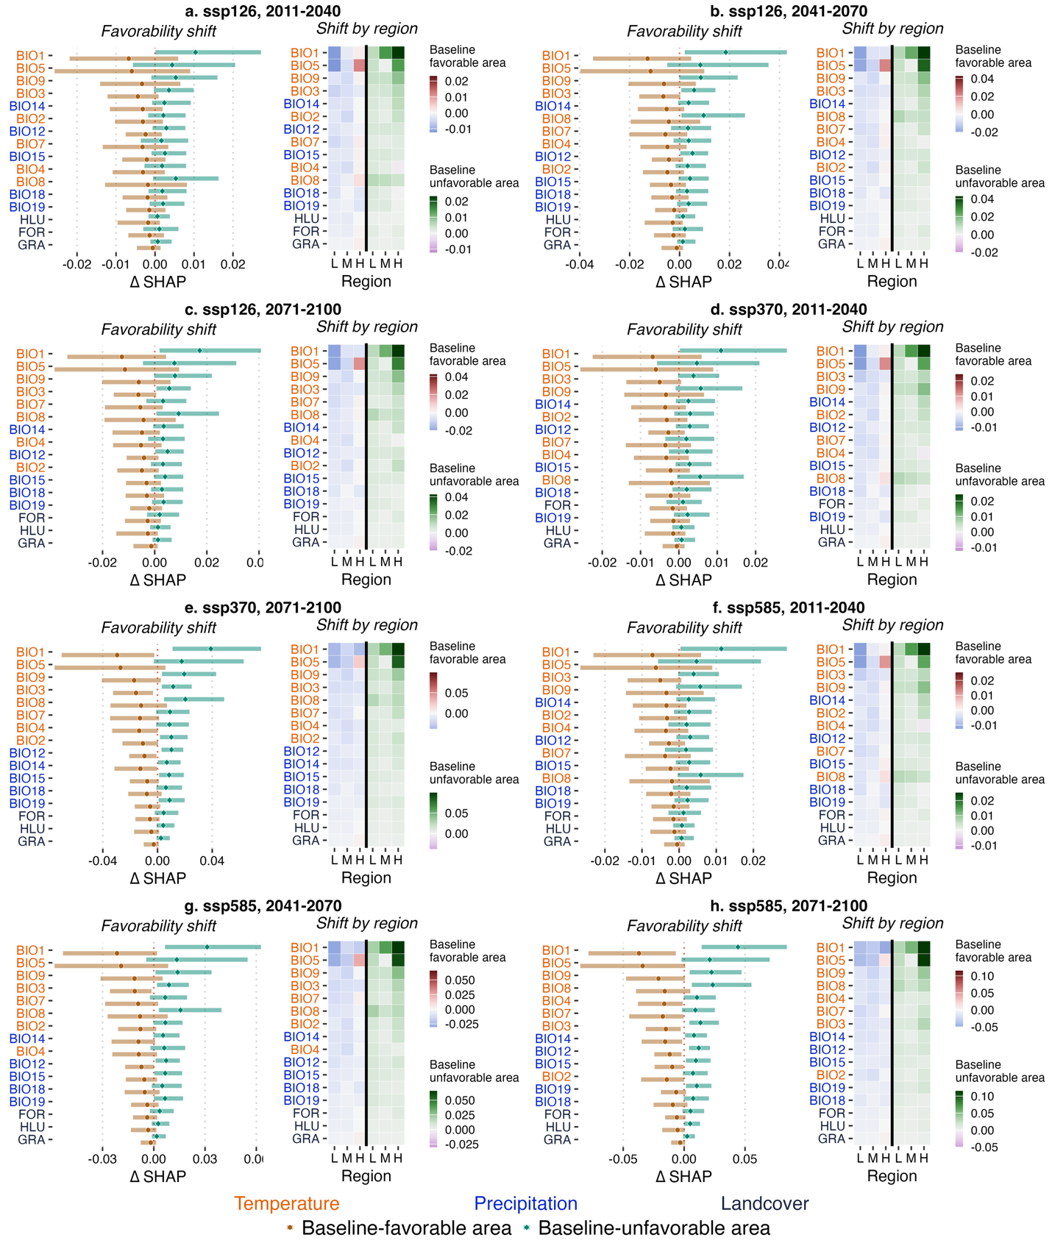
Extended Data Fig. 5 | Favorability shifts in the relative contributions of environmental variables for mammal species. (a-h) Grid-wise species-average favorability shifts (∆SHAP) and corresponding regional median grid-wise favorability shifts (∆SHAP) over baseline-favorable and baseline-unfavorable areas for all 16 environmental variables under SSP126, SSP370, and SSP585 across three future time periods: 2011–2040, 2041–2070, and 2071–2100. Left panels show the distribution of grid-wise ∆SHAP values, with shaded areas around median lines indicating the interquartile range (25th–75th percentile). A negative favorability shift suggests that a variable becomes less favorable or more unfavorable to species, while a positive shift suggests increasing favorability or decreasing unfavorability. Right panels summarize regional medians by latitudinal band: low (L, 30°S–30°N), middle (M, 30°–60°N/S), and high (H, 60°–90°N/S). Environmental variables are BIO1 (Annual Mean Temperature), BIO2 (Mean Diurnal Range, mean of monthly [max temperature − min temperature]), BIO3 (Isothermality, BIO2/BIO7 × 100), BIO4 (Temperature Seasonality, standard deviation × 100), BIO5 (Max Temperature of Warmest Month), BIO6 (Min Temperature of Coldest Month), BIO7 (Temperature Annual Range, BIO5 − BIO6), BIO8 (Mean Temperature of Wettest Quarter), BIO9 (Mean Temperature of Driest Quarter), BIO10 (Mean Temperature of Warmest Quarter), BIO11 (Mean Temperature of Coldest Quarter), BIO12 (Annual Precipitation), BIO13 (Precipitation of Wettest Month), BIO14 (Precipitation of Driest Month), BIO15 (Precipitation Seasonality, coefficient of variation), BIO16 (Precipitation of Wettest Quarter), BIO17 (Precipitation of Driest Quarter), BIO18 (Precipitation of Warmest Quarter), and BIO19 (Precipitation of Coldest Quarter), FOR (forest coverage), HLU (human land use), and GRA (grassland coverage).
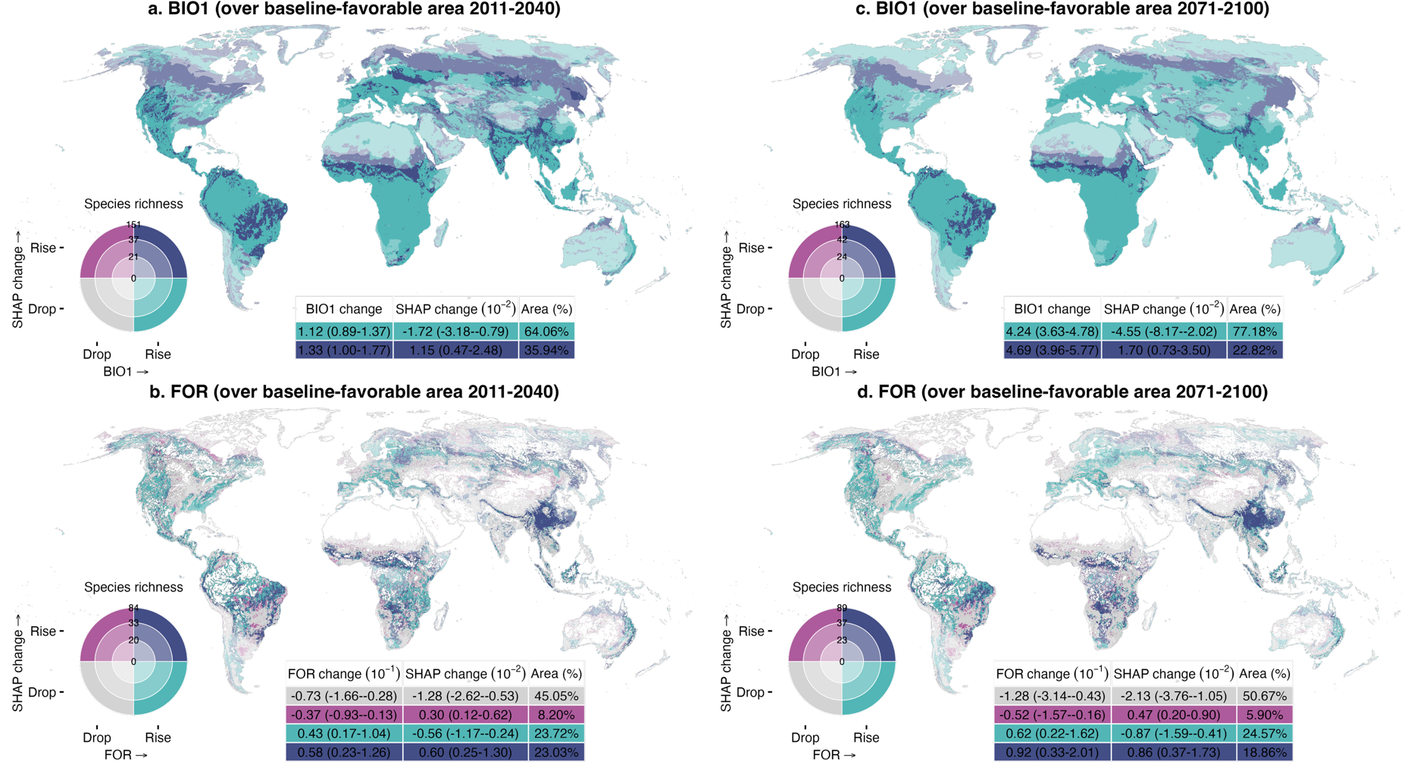
Extended Data Fig. 6 | Spatial relationships between environmental changes and favorability shifts in variable contributions under SSP370. Changes in environmental variables and SHAP-based favorability shifts are categorized as “drop” or “rise” depending on whether values decrease or increase, respectively; areas with no change are masked. Favorability shifts are defined as the difference in SHAP values between the baseline period (1981–2010) and future time periods, and average across all relevant species. (a, c) Bivariate maps showing changes in annual mean temperature (BIO1) and favorability shifts over baseline-favorable areas (i.e., grid cells where BIO1 had a positive SHAP value at baseline) in 2011–2040 and 2071–2100. (b, d) Same as (a, c), but for forest cover (FOR). In all panels, rising SHAP values indicate increasing favorability for species, and declining values indicate reduced favorability. The inset table presents area-weighted medians and interquartile ranges (25th–75th percentile) for each combination zone. Species richness is categorized as low, medium, or high based on the 33rd and 66th percentiles and is symbolized through darkening hue of the four colors of the bivariate map.

