Supplementary Materials

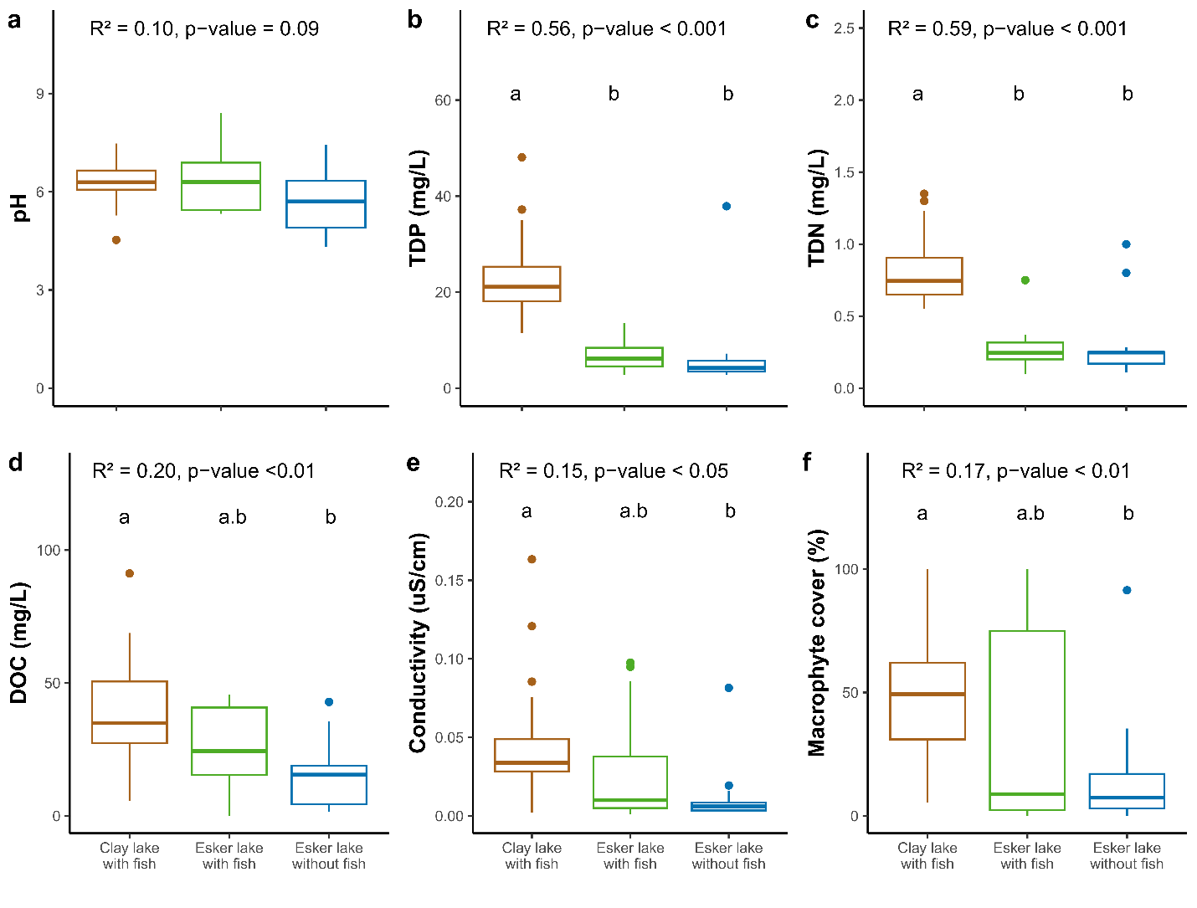
a
a
a
Specific conductivity (mS/cm)
TDP (µg/L)
Figure S1 Physicochemistry and macrophyte cover in the studied lakes. TDP = total dissolved phosphorus, TDN = total dissolved nitrogen and DOC = dissolved organic carbon. Significant differences between lake categories are indicated by different letters (Tukey tests).
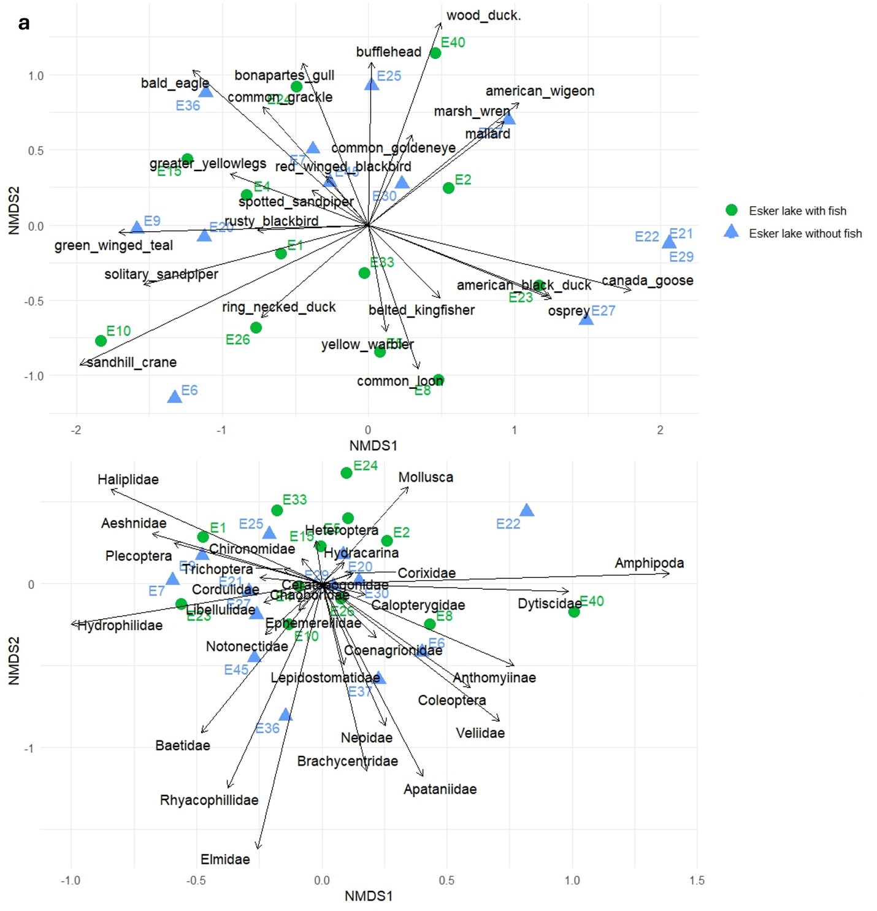

Figure S2 Waterbird and macroinvertebrate community composition in esker lakes with and without fish.

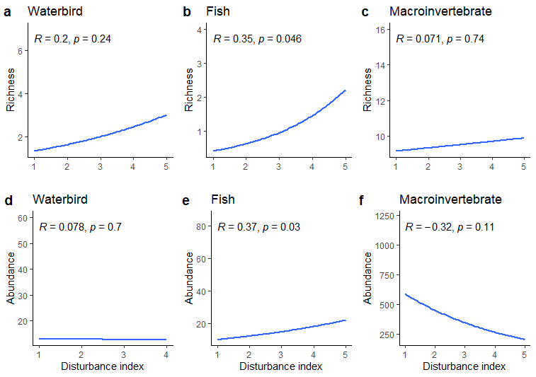
Figure S3: Generalized linear models explaining relation between abundance of waterbird, fish and macroinvertebrates with the disturbance index

