Supplementary information

Design and evaluation of octopromycin-derived peptides as multifunctional antimicrobial agents against multidrug-resistant pathogens

Byambasuren Ganbaatar ^{1,5}, Sukumar Dinesh Kumar ^{2,5}, Eun Young Kim ^{2,1}, Naveen Kumar Radhakrishnan ³, Sungtae Yang ^{4,}* Song Yub Shin ^{2,}*, and Chul Won Lee ^{1,}*

¹ Department of Chemistry, Chonnam National University, Gwangju 61186, Republic of Korea
² Department of Cellular & Molecular Medicine, School of Medicine, Chosun University, Gwangju 61452, Republic of Korea
³ Graduate School of Biomedical Science, Chosun University, Gwangju 61452, Republic of Korea
⁴ Department of Microbiology, School of Medicine and Institute of Well-Aging Medicare & CSU GLAMP Project Group, Chosun University, Gwangju 61452, Republic of Korea

⁵ These authors contributed equally to this work.
* Corresponding authors:
E-mail address: styang@chosun.ac.kr (S. Yang), syshin@chosun.ac.kr (S.Y. Shin), cwlee@jnu.ac.kr (C.W. Lee)
Supplementary Figures

Fig. S1. ESI/MS spectra of OPM38, OPM23, OPM23-a1, OPM23-a2, OPM23-a3 and OPM23-a4---------------------------------------------------------------------------------------------------------S3
Fig. S2. ESI/MS spectra of OPM23-a5, OPM23-a6, OPM23-a7 and OPM23-a7-d, OPM23-a8 and OPM23-a8-d---------------------------------------------------------------------------------------S4
Fig. S3. Analytical RP-HPLC profiles of OPM23 and its analogs-------------------------------S5
Fig. S4. Concentration-dependent hemolysis against sheep red blood cells (sRBCs) of OPM23 and its analogs------------------------------------------------------------------------------------------S6
Fig. S5. Circular dichroism (CD) spectra of the peptides were obtained under three different conditions-----------------------------------------------------------------------------------------------S7
Fig. S6. RP-HPLC analysis of OPM23, OPM23-a7, OPM23-a8, OPM23-a7-d and OPM23-a8-d after incubation with chymotrypsin for 0, 2, 4, 6, 18h and 24h---------------------------------S8
Fig. S7. RP-HPLC analysis of OPM23, OPM23-a7, OPM23-a8, OPM23-a7-d and OPM23-a8-d after incubation with trypsin for 0, 2, 4, 6, 18h and 24h-----------------------------------------S9
Fig. S8. RP-HPLC analysis of OPM23, OPM23-a7, OPM23-a8, OPM23-a7-d and OPM23-a8-d after incubation with 25% human serum for 0, 6, 12, 24, 36, and 60 h------------------------S10
Fig. S9. Cell viability of HCT116 (a), RAW 264.7 (b), and HEK 293.7 cells (c) of the peptides in the presence of the peptides------------------------------------------------------------------------S11

Table S1: Antibiofilm activity of the selected peptides against MDRPA 2095 biofilm-----S12

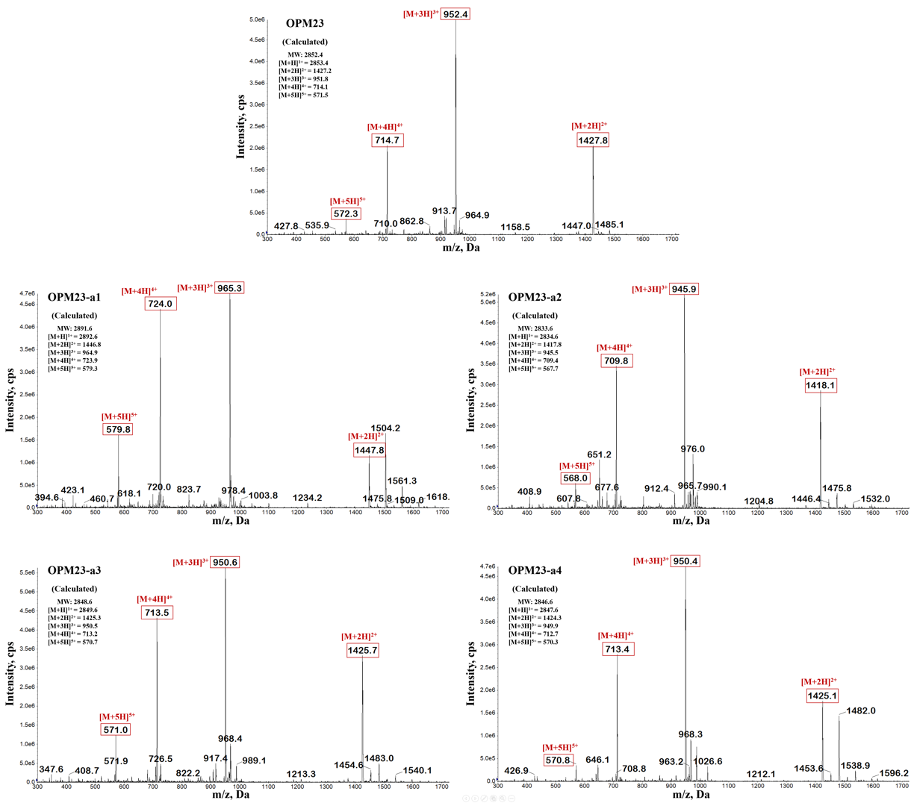

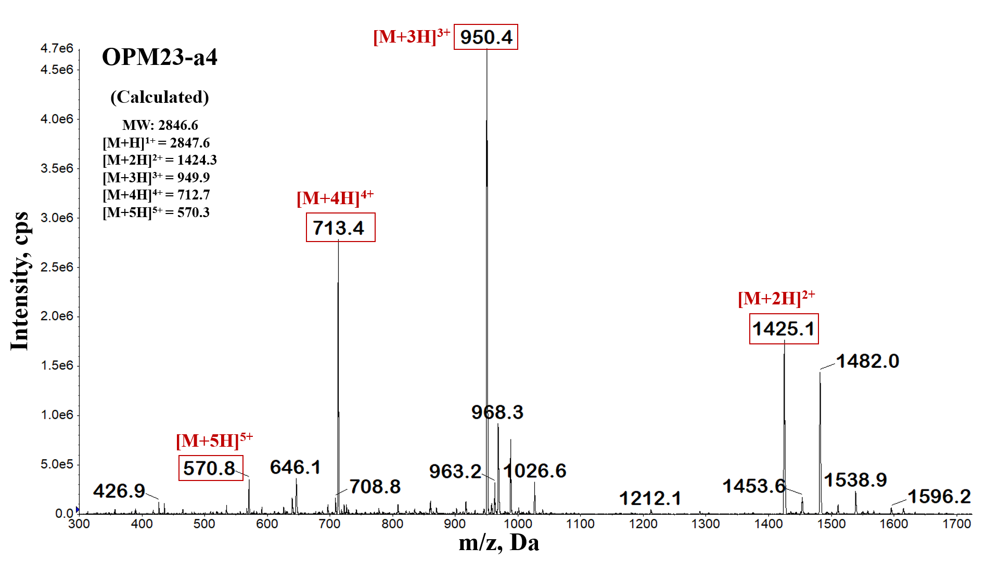
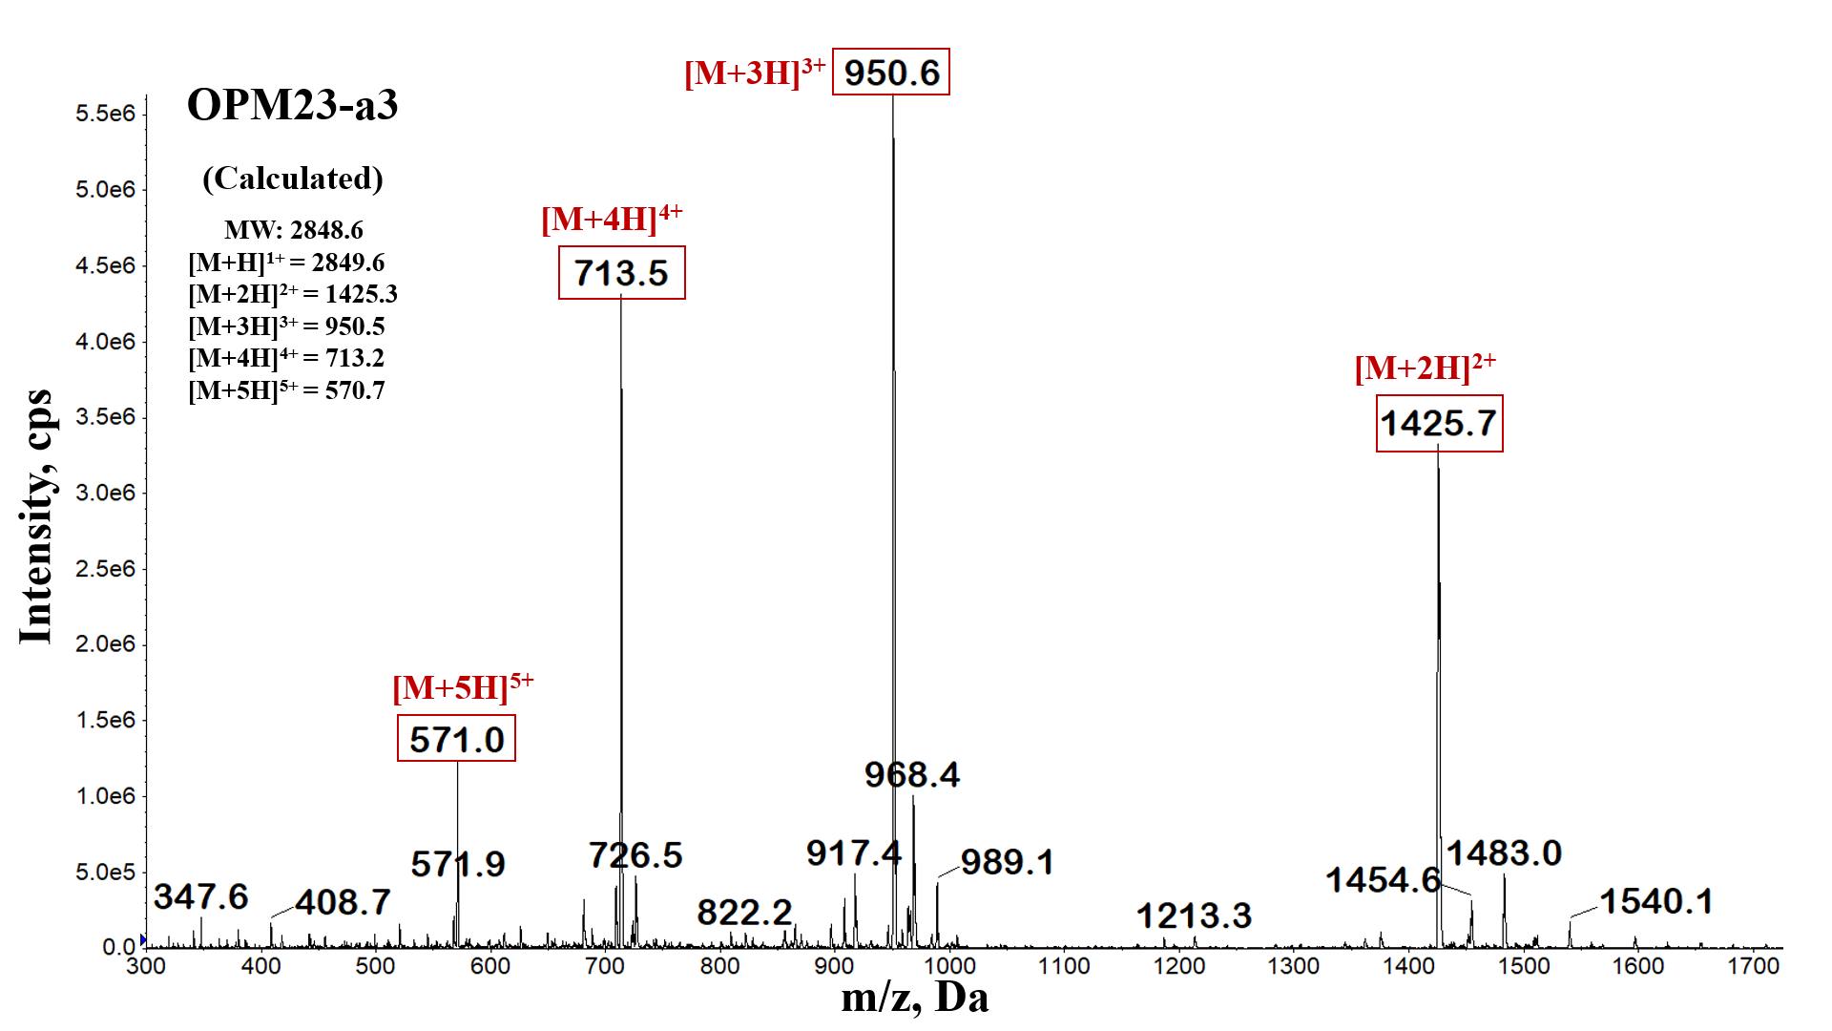
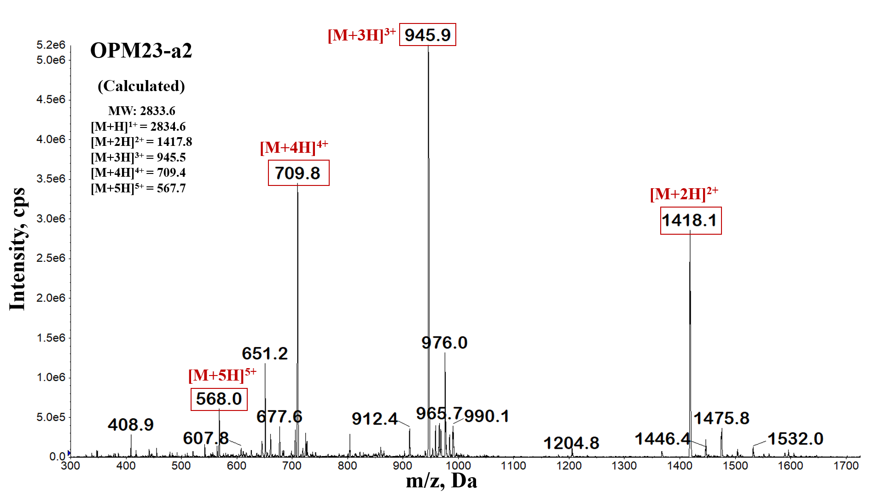
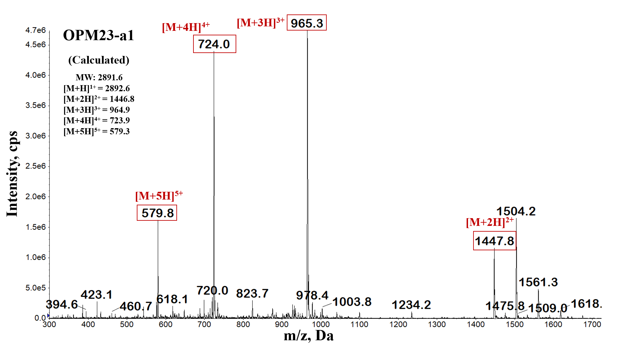
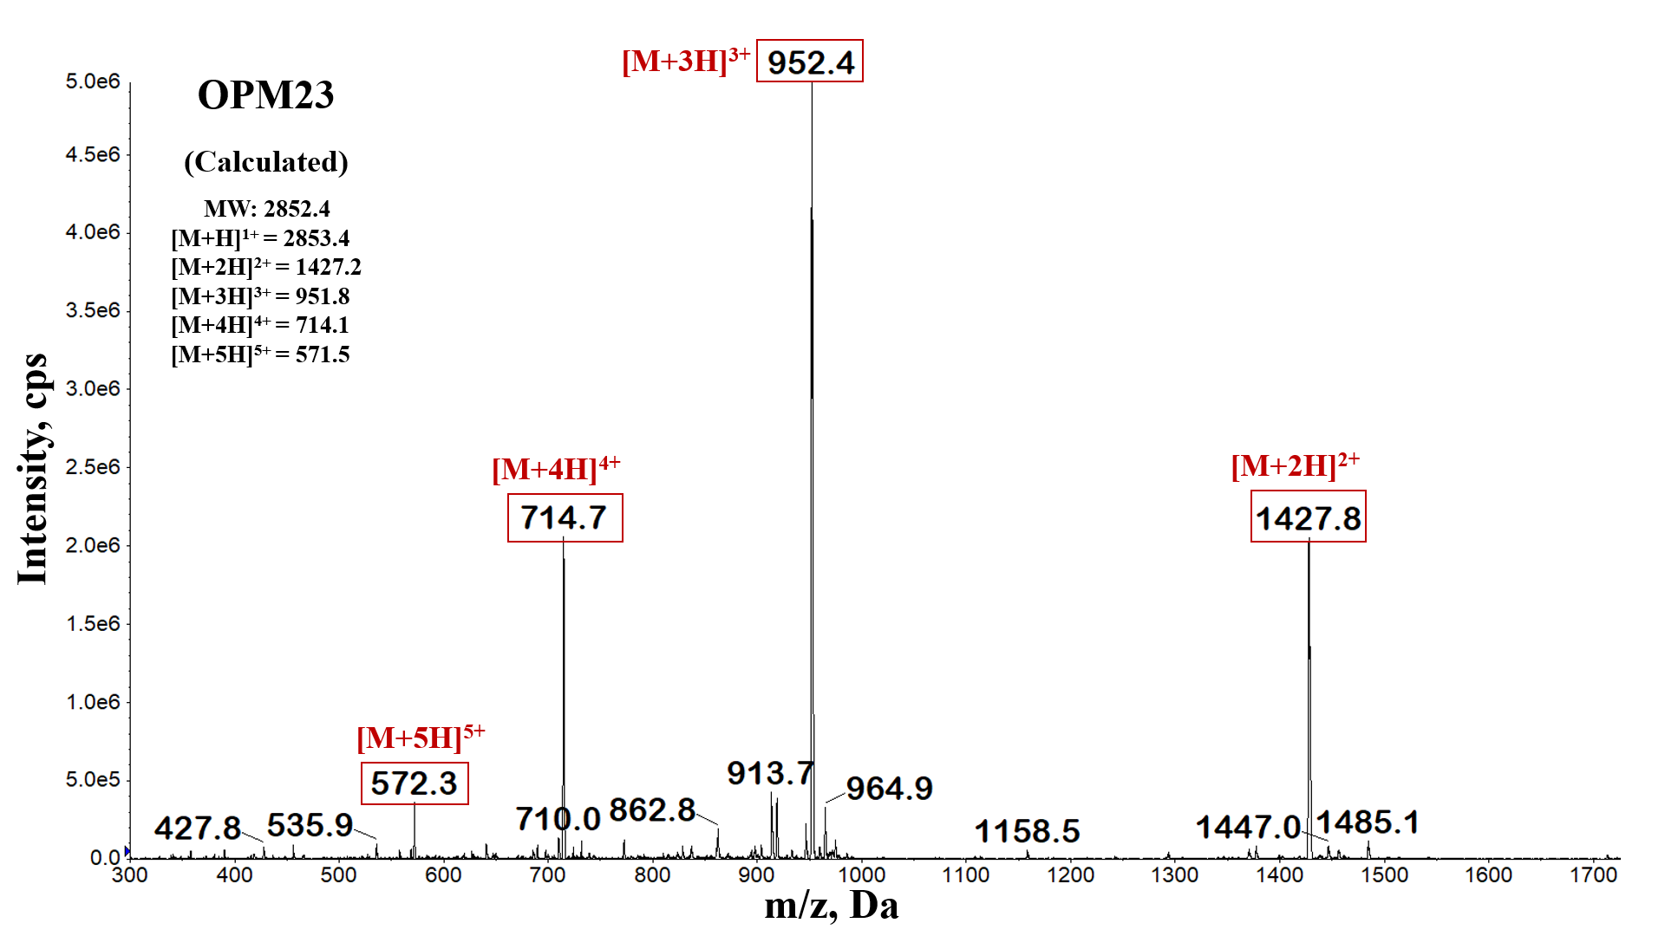
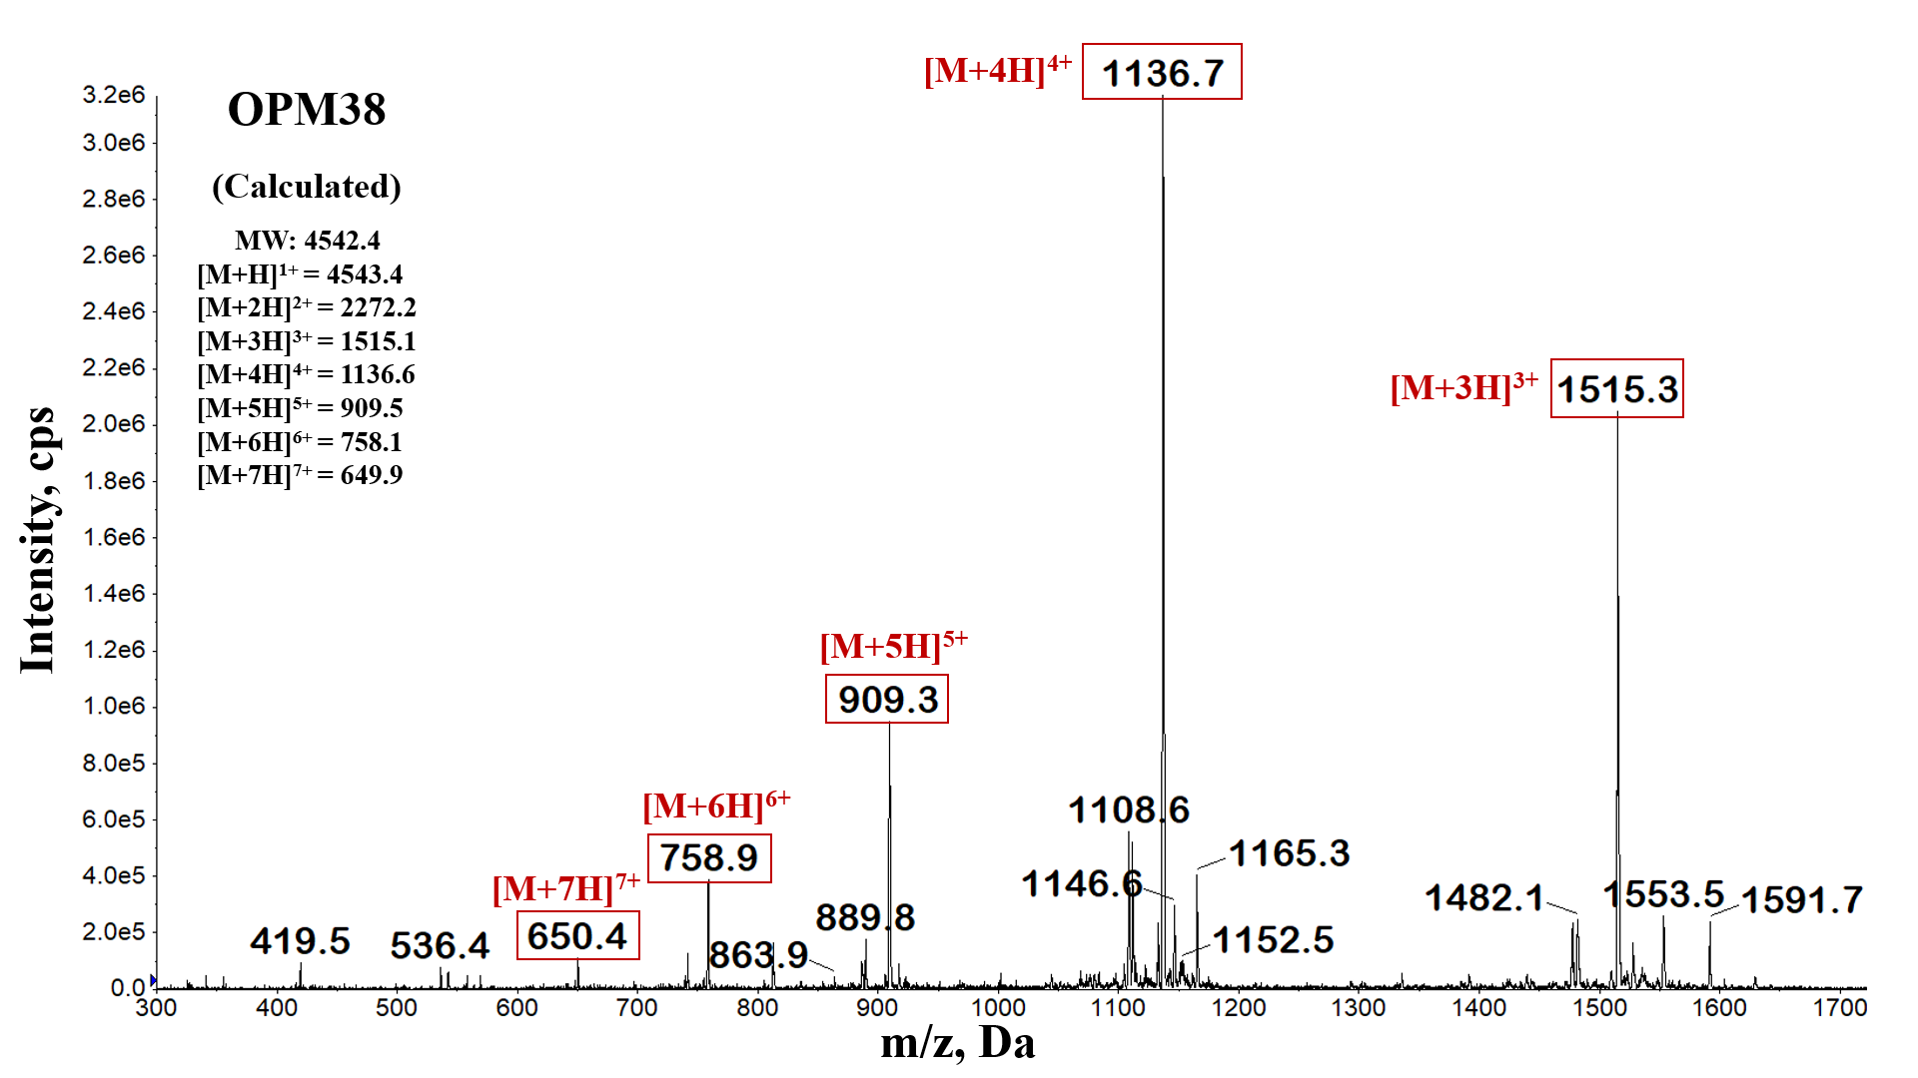
Figure S1. ESI/MS spectra of OPM38, OPM23, OPM23-a1, OPM23-a2, OPM23-a3 and OPM23-a4.

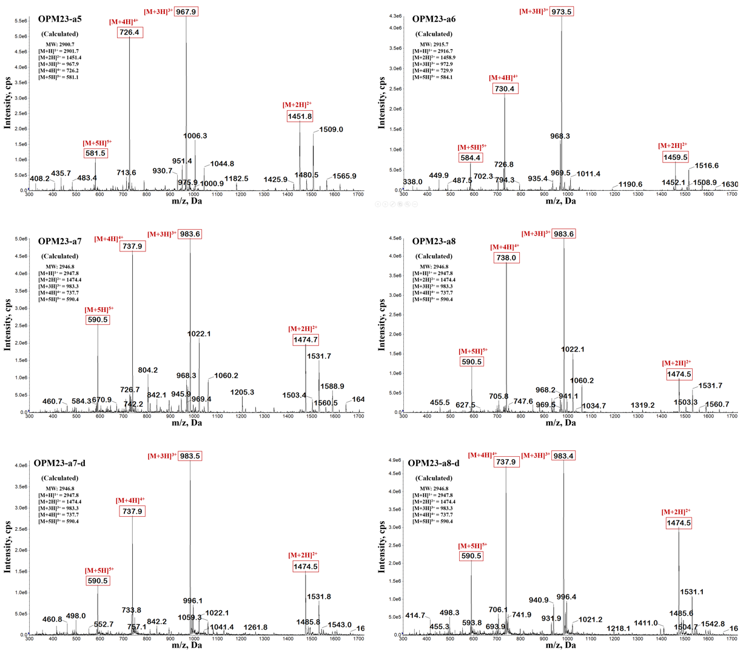

Figure S2. ESI/MS spectra of OPM23-a5, OPM23-a6, OPM23-a7 and OPM23-a7-d, OPM23-a8 and OPM23-a8-d.

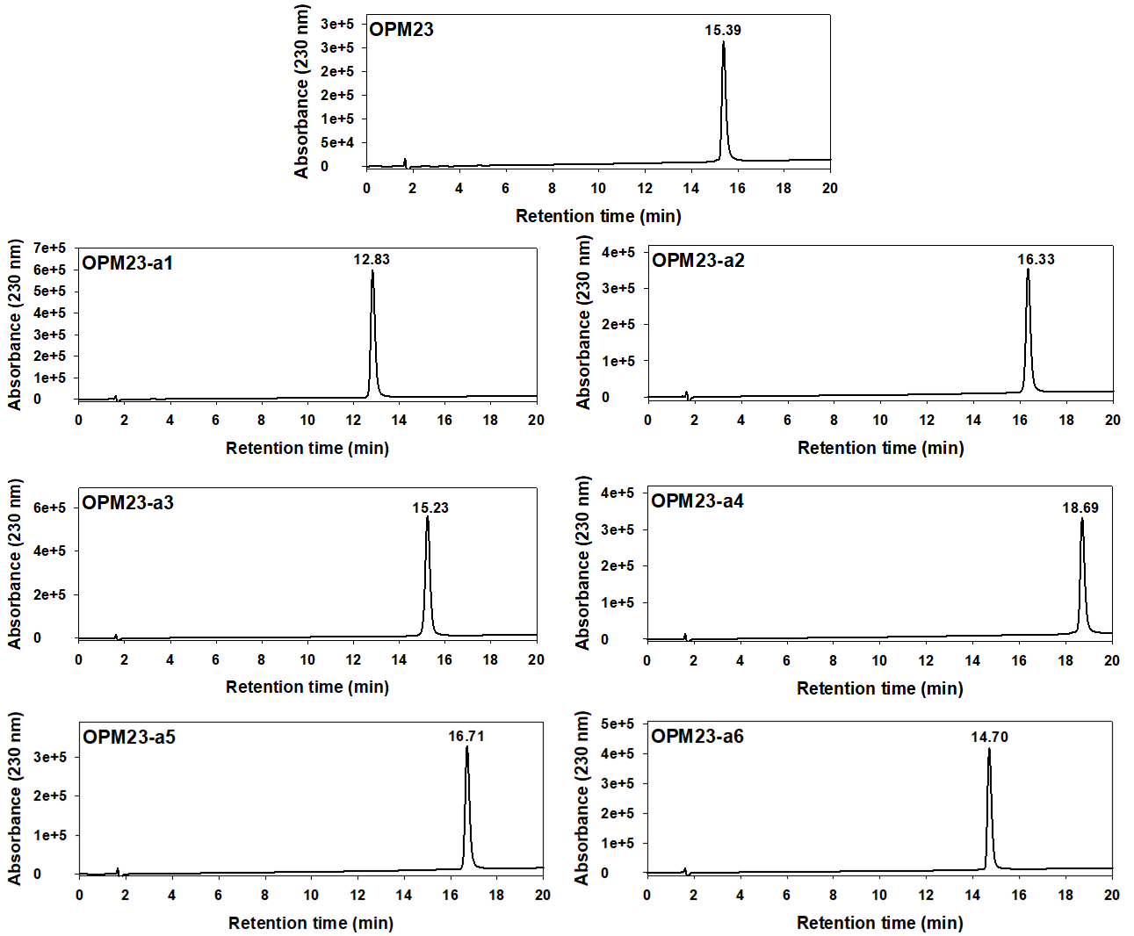
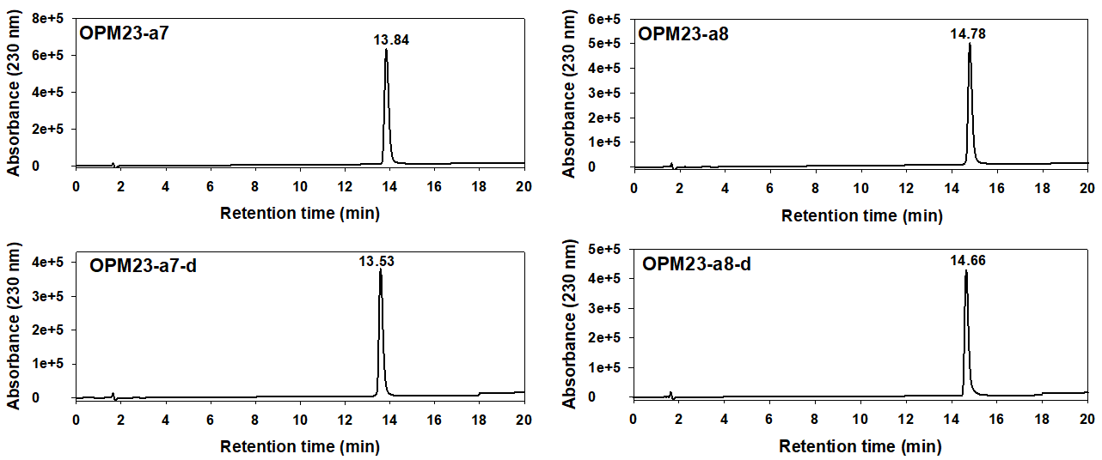
Figure S3. Analytical RP-HPLC profiles of OPM23 and its analogs. Peptides were eluted for 20 min with a flow rate of 0.2 mL/min by analytical RP-HPLC on a X-Bridge C18 column (dimensions: 2.1 mm × 100 mm, 3.5µm) using a gradient of buffer B (0.05% TFA in CH₃CN) in buffer A (0.05 % TFA in H₂O).

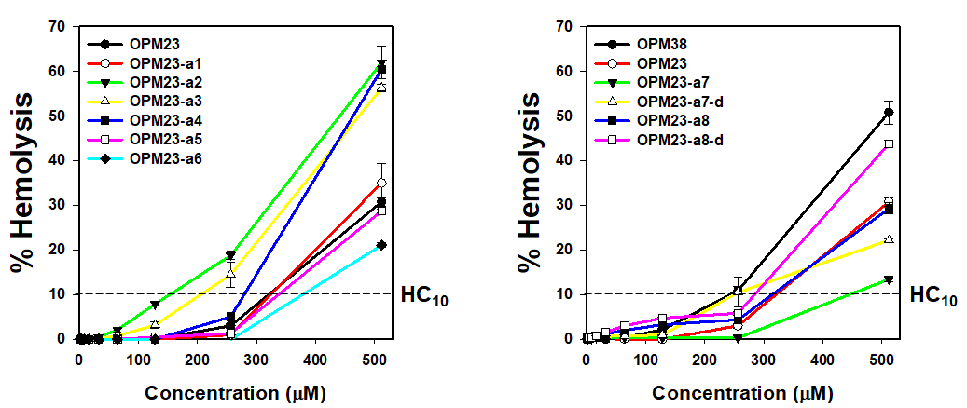
Figure S4. Concentration-dependent hemolysis against sheep red blood cells (sRBCs) of OPM23 and its analogs.

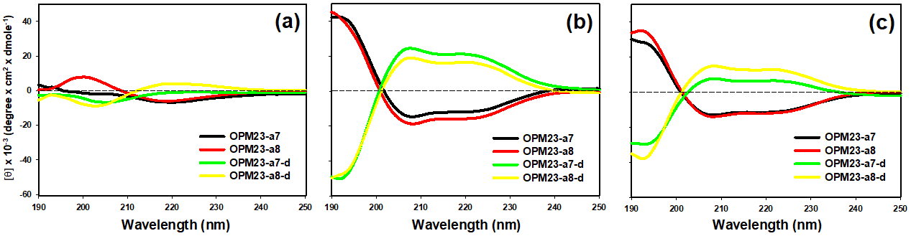
Figure S5. Circular dichroism (CD) spectra of the peptides were obtained under three different conditions: 10 mM sodium phosphate buffer (a), 50% trifluoroethanol (TFE) (b), and 30 mM sodium dodecyl sulfate (SDS) (c). The wavelength-dependent mean residue ellipticity was recorded and plotted, with each spectrum representing the averaged data from three separate measurements.

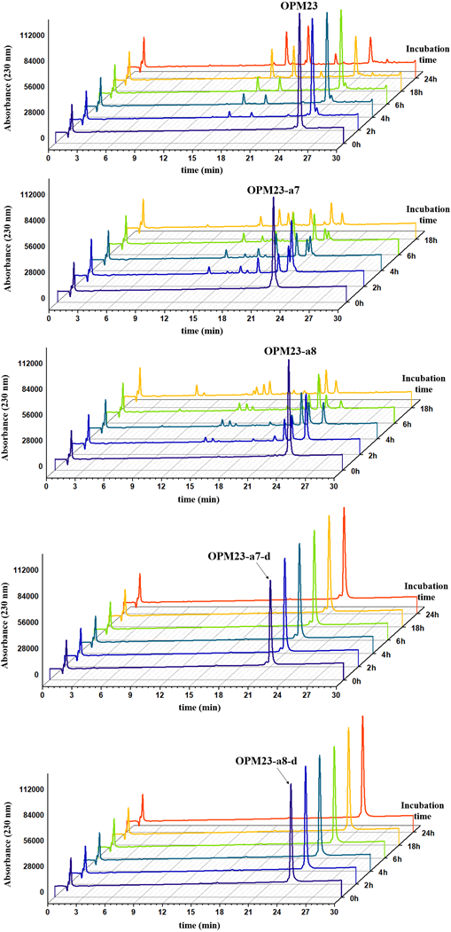

Figure S6. RP-HPLC analysis of OPM23, OPM23-a7, OPM23-a8, OPM23-a7-d and OPM23-a8-d after incubation with chymotrypsin for 0, 2, 4, 6, 18h and 24h.

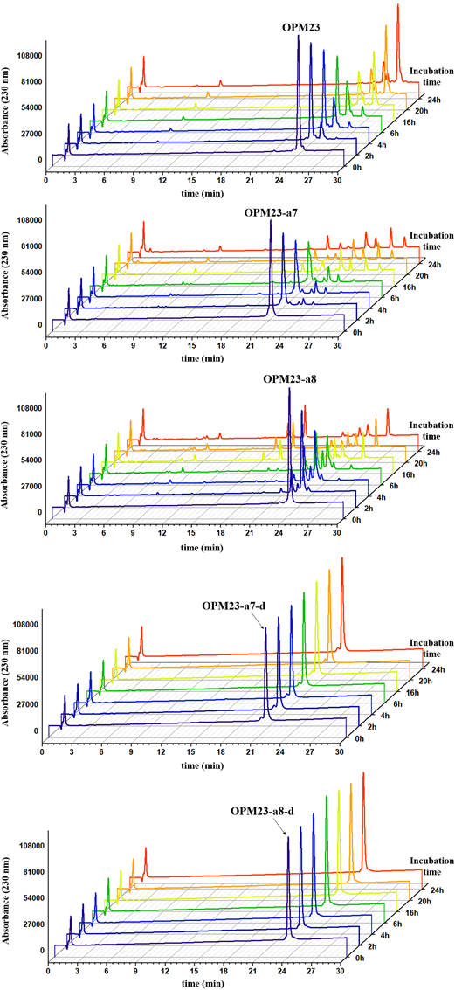

Figure S7. RP-HPLC analysis of OPM23, OPM23-a7, OPM23-a8, OPM23-a7-d and OPM23-a8-d after incubation with trypsin for 0, 2, 4, 6, 18h and 24h.

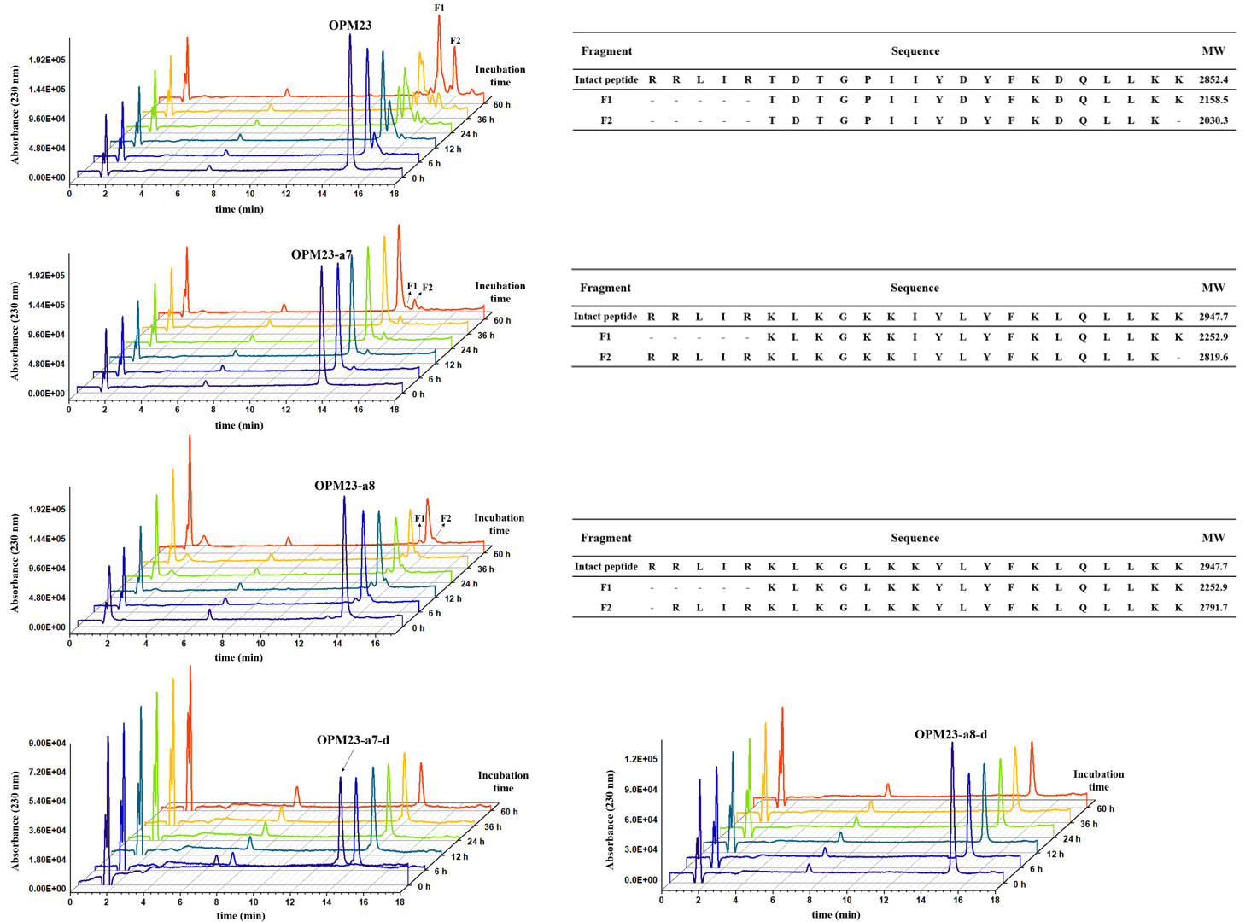

Figure S8. RP-HPLC analysis of OPM23, OPM23-a7, OPM23-a8, OPM23-a7-d and OPM23-a8-d after incubation with 25% human serum for 0, 6, 12, 24, 36, and 60 h.

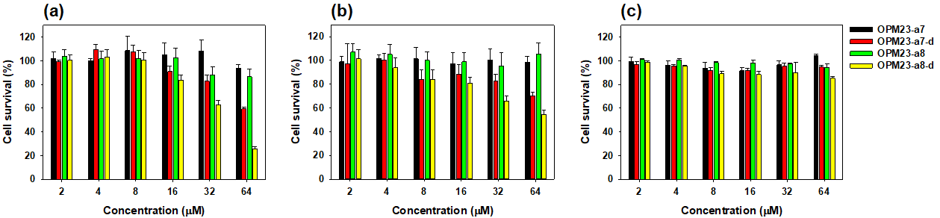

Figure S9. Cell viability of HCT116 (a), RAW 264.7 (b), and HEK 293.7 cells (c) in the presence of the peptides.

Table S1. Antibiofilm activity of the selected peptides against MDRPA 2095 biofilms.
Peptides | MBIC₅₀ (μM) / MBIC₉₀ (μM) | MBEC₅₀ (μM) / MBEC₉₀ (μM)
OPM23-a7 | 8 / 32 | 16 / >64
OPM23-a7-d | 4 / 16 | 16 / 32
OPM23-a8 | 4 / 32 | 16 / >64
OPM23-a8-d | 4 / 16 | 16 / 32
LL-37 | 32 / >64 | 64 / >64
MBIC: minimum biofilm inhibition concentration; MBEC: minimum biofilm eradication concentration

