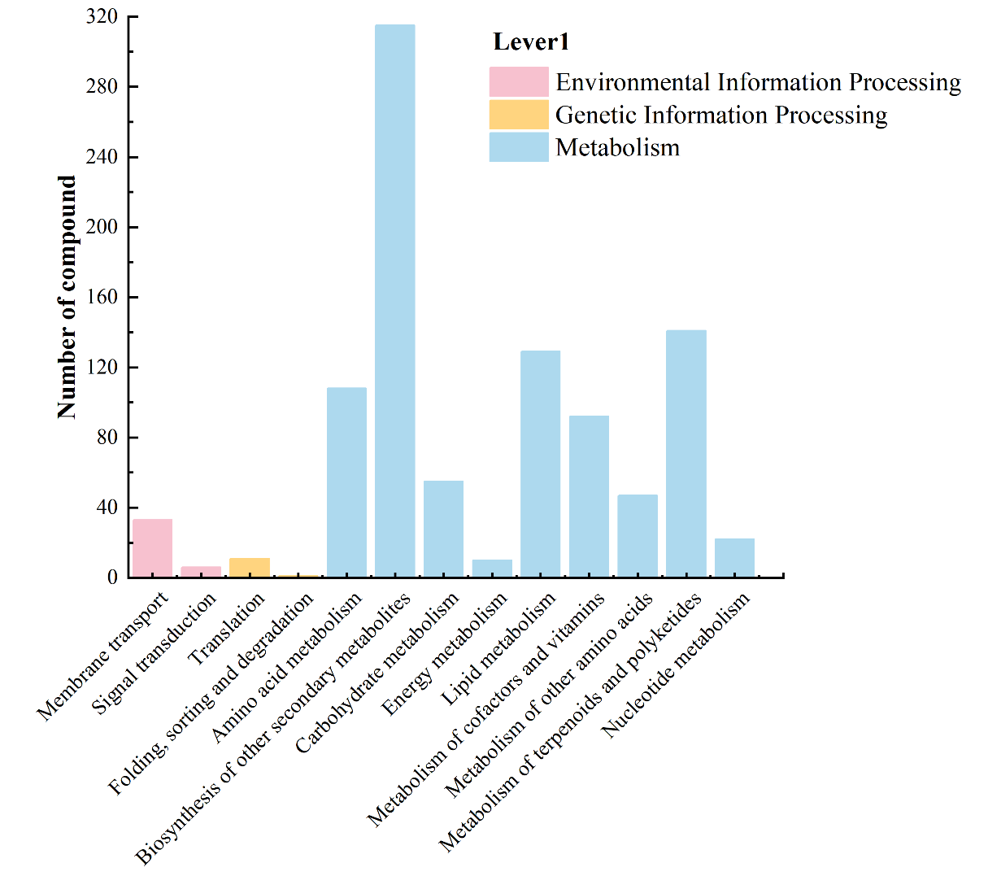 Fig. S1 Classification of KEGG annotations for differential metabolites

