Solventless, ambient-pressure production of bio-based lactones over earth-abundant, mixed metal oxide catalysts for circular polyesters
Daniyal Kiani,^{1,2,‡} Gloria Rosetto,^{1,‡} Faysal Ibrahim,³ Ozge Deniz Bozkurt,⁴ Ajinkya Pal,⁵ Elisabeth V. Roijen,⁶ Jason S. DesVeaux,⁵ Simon R. Bare,^{4,9,}* Ive Hermans,^{3,7,8,9,}* Gregg T. Beckham^{1,2,9,10,}*
- Renewable Resources and Enabling Sciences Center, National Renewable Energy Laboratory, Golden, CO, 80401, USA
- BOTTLE Consortium, Golden, CO, 80401, USA
- Department of Chemistry, University of Wisconsin–Madison, Madison, WI, 53706, USA
- SSRL, SLAC National Accelerator Laboratory, Menlo Park, CA 94025, United States
- Catalytic Carbon Transformation and Scale-up Center, National Renewable Energy Laboratory, Golden CO 80401, USA
- Strategic Energy Analysis Center, National Renewable Energy Laboratory, Golden, Colorado 80401, United States
- Department of Chemical and Biological Engineering, University of Wisconsin–Madison, Madison, WI, 53706, USA
- Wisconsin Energy Institute, University of Wisconsin–Madison, Madison, WI, 53726, USA
⁹ Senior author
¹⁰ Lead contact
‡ equal contribution
*Correspondence: srbare@slac.stanford.edu, hermans@chem.wisc.edu, gregg.beckham@nrel.gov

Contents
Experimental supplement 2
TEA/LCA supplement 9
Data tables for Figure 3 18
Data tables for Figure6 20
References 22

Experimental supplement

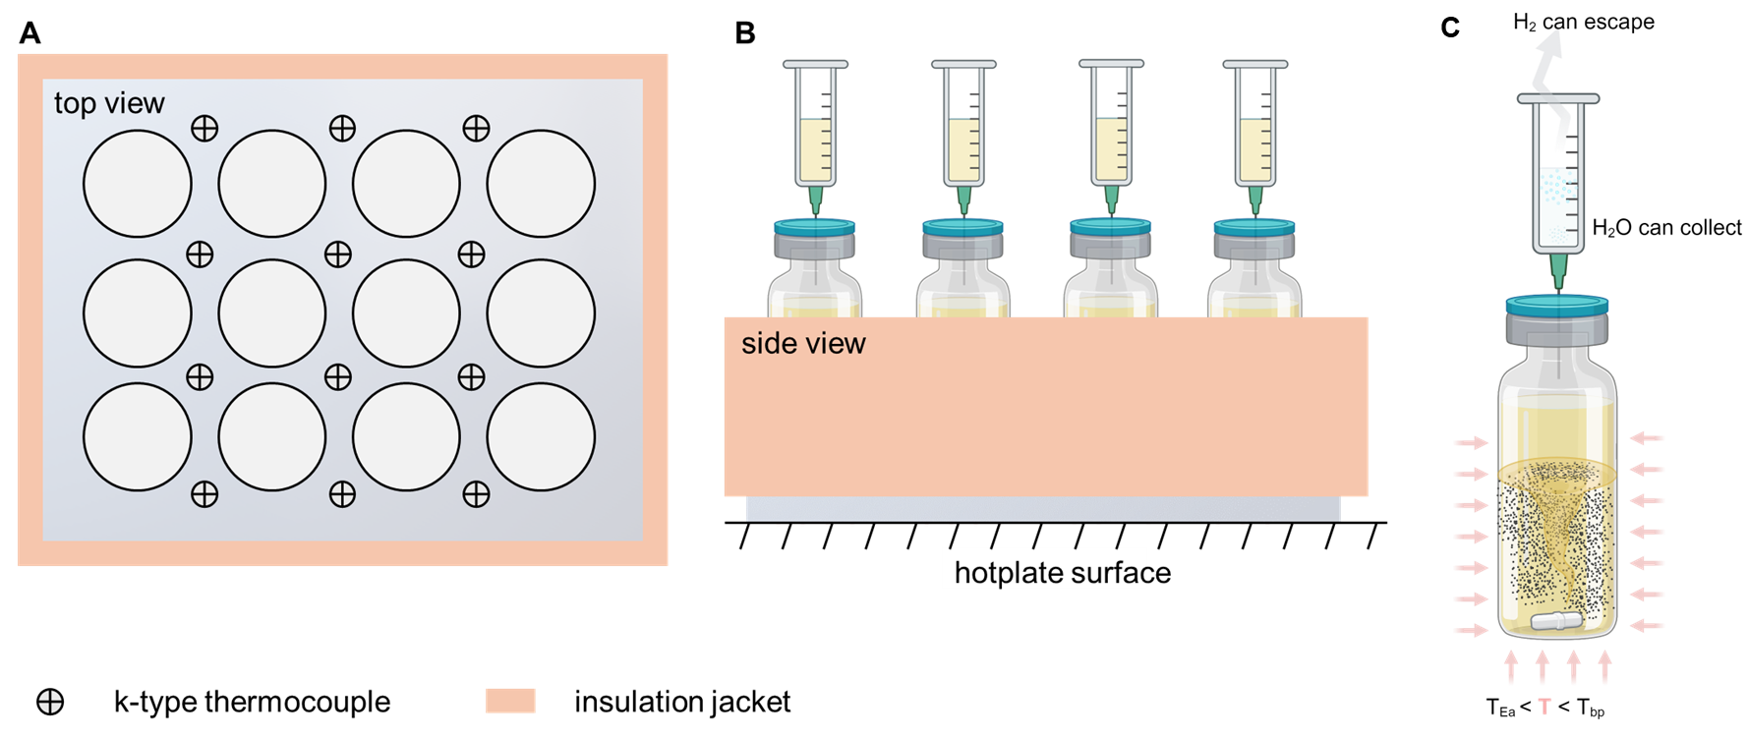
D
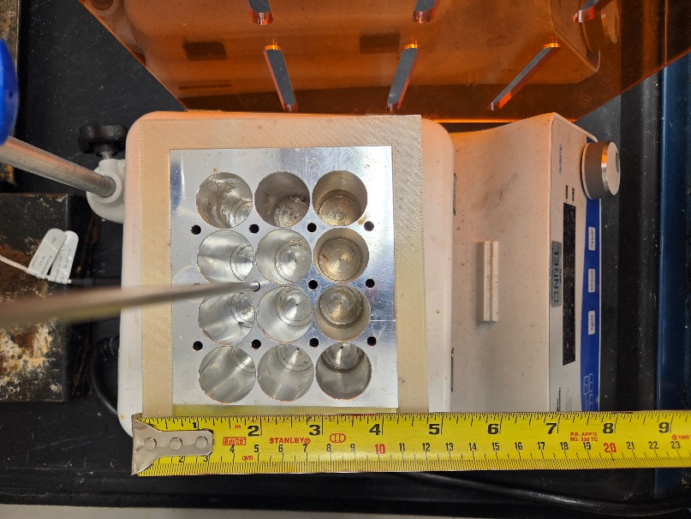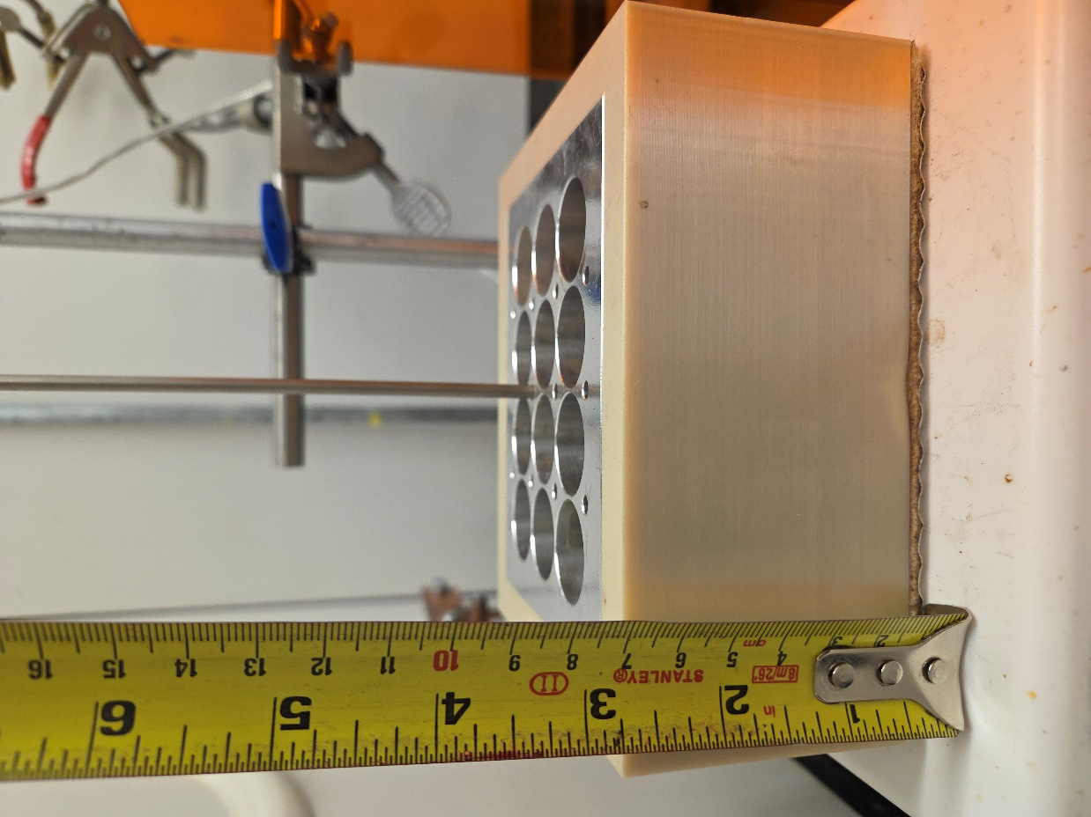
Figure S1. (A-D) A custom, home-built reactor setup allowed for screening 12 catalysts simultaneously via probe reaction of 1,4-butanediol to γ-butyrolactone in semi-batch mode. Each vial is 20 mL, 23 x 75 mm (Agilent 5183-4474), sealed with a crimp top cap with PTFE lining and septa (Biotage 352298). In a typical trial, ~2 g of 1,4-butanediol was pipetted into each vial, to which 0.10 g of catalyst, and a stir bar was added, giving a diol/catalyst ratio of ~20, stirred at 500 RPM. The vials are housed in a thick-walled aluminum block to ensure isothermal operation and heat retention over prolonged reaction times. Additionally, the aluminum block was further insulated by a 3D-printed polyetherimide thermoplastic jacket (ULTEM™ 9085 resin from Stratasys) to ensure isothermal operation. A 3 ml plastic syringe, with the plunger removed, fitted with a narrow bore needle (0.5 x 25 mm) is fixed to each vial through the crimp top septum to allow for the escape of volatile vapors or gases that are expected to form during reaction. The narrow-bore needle is intentionally used to leverage Venturi effect to promote condensation of the vapor in the syringe and retain mass-balance > 90% in all tests.

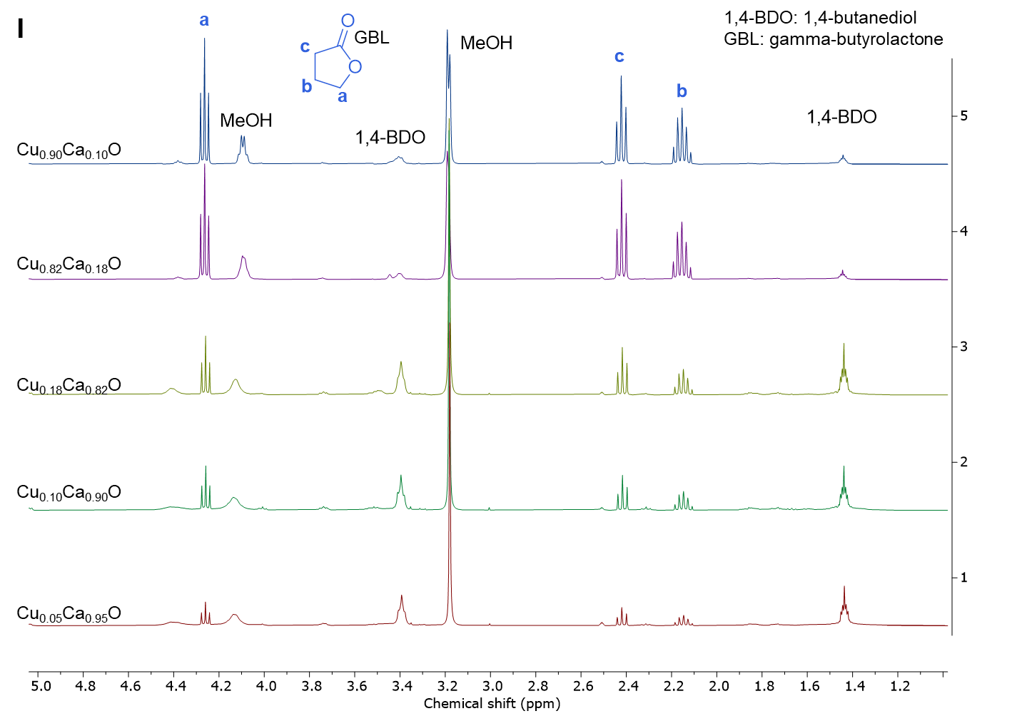
Figure S2. (A-H) NMR of various lactones produced via oxidative dehydrocyclization of corresponding diols (I) Stacked NMR spectra of filtrates from dehydrocyclization of 1,4-BDO to GBL as a function of copper content in Cu_{(X)}Ca_{(1-x)}O MMO catalysts under identical catalysts. NMR spectra shown here are used to estimate GBL yields, summarized in Figure 2B in the main text. The NMR quantifications were independently verified via GC-MS analysis as well (not shown for brevity).
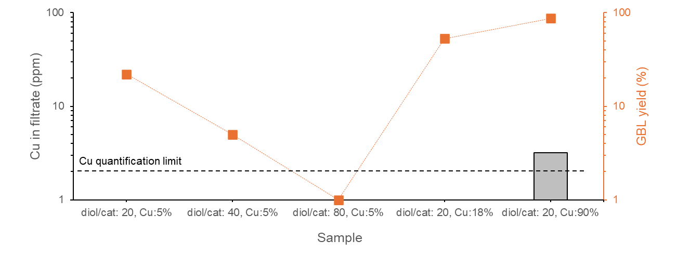
Figure S3. ICP-OES quantification of copper in filtrates from a wide range of reaction conditions spanning Cu:5%-90%, GBL yields: 5-87%, reaction temperatures: 180-200 °C, t: 24 h. Minor Cu-leaching is only evident at extremely high Cu-contents e.g. in Cu_{0.90}Ca_{0.10}O MMO catalyst and leaching is observed for low-Cu catalysts e.g. Cu_{0.05}Ca_{0.95}O and Cu_{0.18}Ca_{0.82}O MMO catalysts, which are the focus of this study. Ca²⁺ leaching from the catalytically irrelevant domains like Ca(OH)₂, CaO is dependent on Cu/Ca ratio where higher Cu leads to lower population of residual Ca(OH)₂ and CaO domains; < 2ppm for Cu_{0.90}Ca_{0.10}O, 67 ppm for Cu_{0.18}Ca_{0.82}O, 120-700 ppm for Cu_{0.05}Ca_{0.95}O. We note that dissolved Ca²⁺ is easily recoverable via CO₂ bubbling, and catalytically inert as runs with Ca(OH)₂ or CaO or physical mixtures of CuO+Ca(OH)₂ runs yield no lactone.
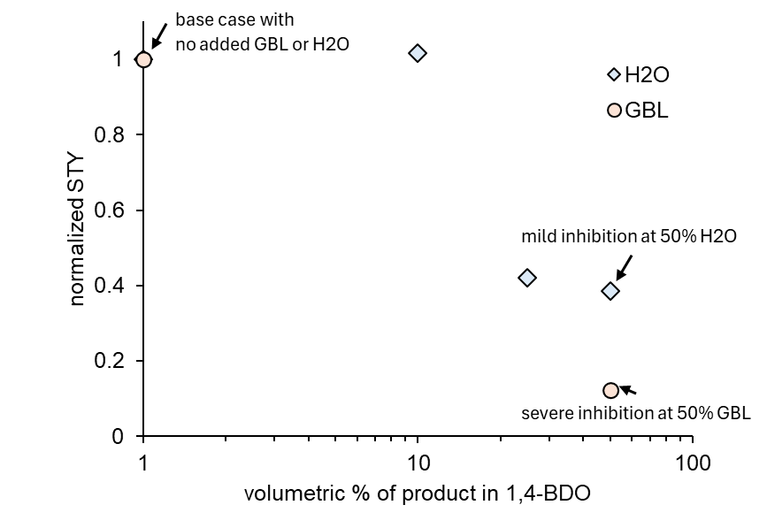
Figure S4. Effects of H₂O and GBL pre-spiking demonstrating product-based inhibition at high reaction extents.
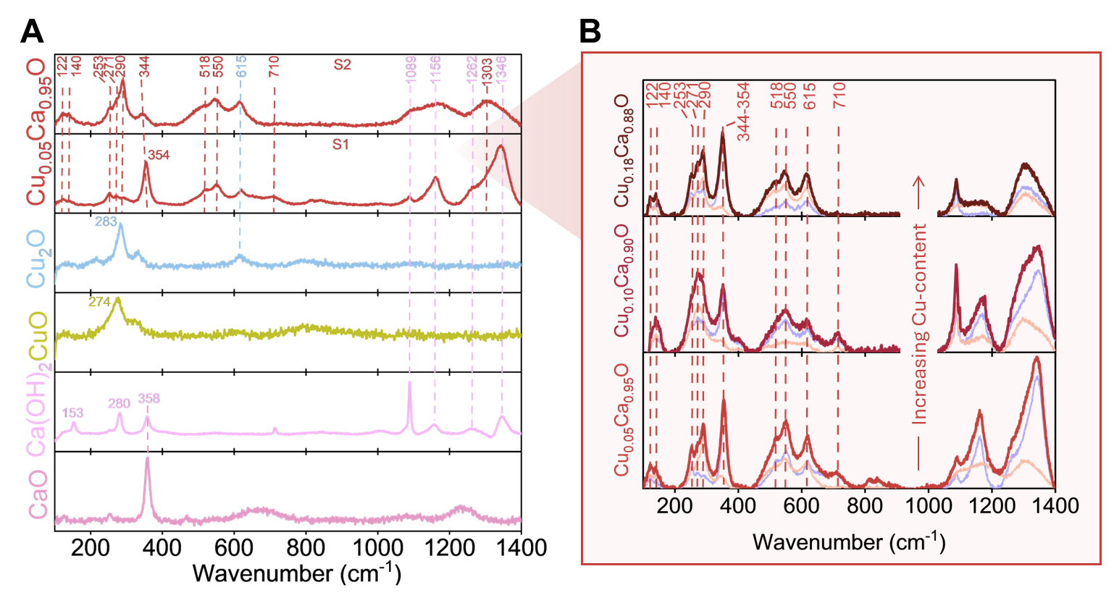
Figure S5. Extended Raman analysis of (A) reference bulk compounds and representative Cu_{(x)}Ca_{(1-x)}O MMO catalyst. S1 and S2 represent two different spots in the catalyst. Multiple different spots were analyzed with Raman to ensure a representative average is captured. (B) Raman of Cu_{(x)}Ca_{(1-x)}O MMO catalysts as a function of Cu-content. Red spectral envelopes show the linear combination of the two spectra from different areas shown in orange and purple. While the relative intensity ratio of the bands may differ in different areas due to heterogeneities in the sample, all bands are observed in every spot analyzed. Carbonate bands are present between 1000-1400 cm⁻¹and not marked in panel B.

Figure S6. (A) In situ DRIFTS spectra collected at 120 °C after dehydration under inert flow at 500 °C, evincing the total consumption of surface and bulk hydroxyl peaks (3639 and 3710 cm⁻¹) upon addition of just 5% (mass basis) copper to the Ca(OH)₂ matrix. (B) Lactone formation on the catalyst surface tracked via time-resolved DRIFTS at 150 °C during reduction half-cycle.
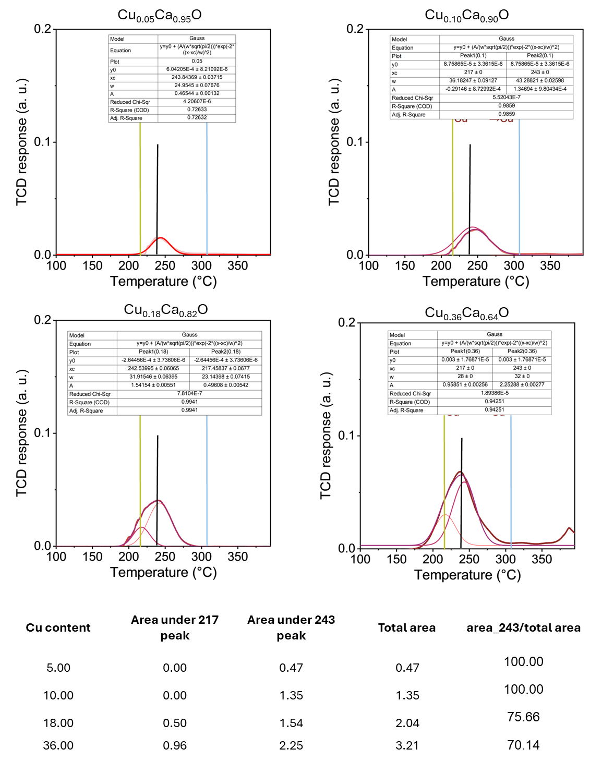
Figure S7. H₂-TPR deconvolution of 217 and 243 °C reduction peaks corresponding to bulk-like CuO and Cu_{(x)}Ca_{(1-x)}O MMO domains. Gaussiam peak centers were constrained for deconvolution analysis.

TEA/LCA supplement
To evaluate the economic viability and environmental implications of our proposed process, we conducted detailed process modeling and techno-economic analysis (TEA). We model a facility with an annual feed capacity of 65kt of bio-derived 1,4-butanediol (1,4-BDO), consistent with the planned capacity of Qore’s commercial-scale plant.¹ Qore, a joint venture between Cargill and HELM, utilizes Genomatica’s GENO BDO® fermentation technology for the sustainable production of 1,4-BDO.²

Figure S8. Detailed process flow diagram for 1,4-BDO conversion to GBL comprising the multiple batch reactor in parallel and storage tanks to process a continuous feed stream of 1,4 BDO (65 ktpa).
The process model assumes that the plant receives a continuous feed of bio-derived 1,4-BDO from an upstream production facility. Prior to entering the reactor, the 1,4-BDO feed is preheated to 185 °C and introduced into a batch-operated bubble column reactor together with a catalyst, maintaining a 1,4-BDO-to-catalyst mass ratio of 20 to mimic experimental work. The reaction proceeds in the liquid phase at ambient pressure and a temperature of 195 °C, achieving complete conversion of 1,4-BDO to γ-butyrolactone (GBL) within 24 hours. Including reactor turnaround and catalyst recovery, the total cycle time is 35 hours.
Table S1. Stream properties of the process model for 1,4 butanediol conversion to gamma butyrolactone.
 | Stream number
 | Units | S1 | S2 | S3 | S4 | S5 | S6 | S7 | S8 | S9
Temperature | C | 35.0 | 35.5 | 35.0 | 35.2 | 125.0 | 185.0 | 195.0 | 195.0 | 195.0
Pressure | atm | 1.0 | 2.2 | 1.0 | 2.2 | 1.5 | 1.0 | 1.0 | 1.5 | 1.0
Mass Flows | kg/hr | 8,256.9 | 8,256.9 | 8,256.9 | 8,256.9 | 8,257 | 8,257 | 8,289 | 8,289 | 7,875.7
Water | kg/hr | 12.4 | 12.4 | 12.4 | 12.4 | 12.4 | 12.4 | 0 | 0 | 0
1,4 Butanediol | kg/hr | 8,244.5 | 8,244.5 | 8,244.5 | 8,244.5 | 8,244.5 | 8,244.5 | 0 | 0 | 0
GBL | kg/hr | 0 | 0 | 0 | 0 | 0 | 0 | 7,875.7 | 7,875.7 | 7,875.7
Catalyst | kg/hr | 0 | 0 | 0 | 0 | 0 | 0 | 412.8 | 412.8 | 0.0
Nitrogen | kg/hr | 0 | 0 | 0 | 0 | 0 | 0 | 0 | 0 | 0
Oxygen | kg/hr | 0 | 0 | 0 | 0 | 0 | 0 | 0 | 0 | 0
Carbon dioxide | kg/hr | 0 | 0 | 0 | 0 | 0 | 0 | 0 | 0 | 0
Argon | kg/hr | 0 | 0 | 0 | 0 | 0 | 0 | 0 | 0 | 0
 | Stream number
 |  | S10 | S11 | S12 | S13 | Air | Catalyst | Vent | Catalyst Recycle
Temperature | C | 195.0 | 42.2 | 35.0 | 79.0 | 35.0 | 35.0 | 105.0 | 195.0
Pressure | atm | 1.5 | 1.0 | 1.0 | 1.5 | 1.0 | 1.0 | 1.0 | 1.0
Mass Flows | kg/hr | 7,875.7 | 7,875.7 | 13,789.8 | 13,789.8 | 20110.1 | 412.8 | 20644.5 | 412.8
Water | kg/hr | 0 | 0 | 0 | 0 | 0 | 0 | 4809.3 | 0
1,4 Butanediol | kg/hr | 0 | 0 | 0 | 0 | 0 | 0 | 0 | 0
GBL | kg/hr | 7,875.7 | 7,875.7 | 0 | 0 | 0 | 0 | 0 | 0
Catalyst | kg/hr | 0.0 | 0.0 | 0 | 0 | 0 | 412.8 | 0.0 | 412.8
Nitrogen | kg/hr | 0 | 0 | 10413.5 | 10413.5 | 15186.3 | 0 | 15186.3 | 0
Oxygen | kg/hr | 0 | 0 | 3190.1 | 3190.1 | 4652.2 | 0 | 377.2 | 0
Carbon dioxide | kg/hr | 0 | 0 | 8.6 | 8.6 | 12.6 | 0 | 12.6 | 0
Argon | kg/hr | 0 | 0 | 177.6 | 177.6 | 259 | 0 | 259 | 0

The conversion of 1,4-BDO to GBL is exothermic; therefore, cooling water is circulated to maintain a stable reactor temperature of 195 °C. Compressed air is sparged into the reactor at a flow rate of 0.62 VVM to provide the oxygen for the reaction. The reactor is assumed to operate under well-mixed conditions. Water, formed as a byproduct during the reaction, is continuously removed via evaporation and carried out of the reactor along with the exhaust air, preventing its accumulation in the liquid phase. Although 1,4-BDO and water do not form an azeotrope, their binary mixture exhibits a positive deviation from Raoult’s law. Specifically, 6.5 mol% water reduces the boiling point of the mixture to 184.7 °C—below the operating temperature—thus water removal during the reaction is essential.³ The gas stream comprising undissolved air, water and entrained liquid reactant and product (1,4 BDO and GBL), is cooled to 105 C. The gas stream, consisting of water and undissolved air is vented and the condensed liquid is recycled to the reactor. Upon completion of the reaction, the catalyst is recovered via a combination of settling and filtration. The product stream, primarily composed of GBL, is utilized to partially preheat the incoming feed before being cooled and directed to storage.
Figure S9. Reactor scheduling for 1,4 butanediol conversion to gamma-butyrolactone in the batch process.
Table S2. Process parameters for 1,4 BDO conversion to GBL.
Parameters | Value
Plant size (1,4 BDO), ktpa | 65
Feed (1,4 BDO) purity, wt% | 99.85
Reactor pressure, atm | 1
Reactor temperature, C | 195
Catalyst | Cu_{0.05}Ca_{0.95}O
1,4 BDO/Catalyst ratio | 20
Reaction rate, mol_{diol}/min.g_{Cu} | 0.00336
Air flow rate, VVM | 0.62
No of reactors (R ) | 4
Feed time (T_{F}) , hr | 3
Reaction time (T_{r}), hr | 24
Discharge time (T_{dis}), hr | 3
Down time (T_{d}), hr | 5
Cycle time (T_{c}) , hr | 35
1,4 BDO flow rate In (S) ,m³/h | 13.5
Reactor volume, m³ | 150
Reactor L/D ratio | 3
Reactor feed Liquid volume (V_{F}),m³ | 117.8
Reactor feed In (V_{F}/T_{F}) ,m³/h | 39.3
Hold tank volume required (R(V_{F} -T_{F}S)) ,m³ | 309.7
Hold tank volume actual, m³ | 387.2
Reactor product Liquid volume (V_{P}), m³ | 106.5
Reactor discharge out (V_{P}/T_{dis}) ,m³/h | 35.5
Storage tank volume required (RV_{P}),m³ | 426.2
Storage tank volume actual,m³ | 532.7

Continuous feeding of bio-derived 1,4-BDO and its batch conversion require reactor scheduling and intermediate storage to maintain semi-continuous operation. Reactor and storage sizes, as well as feed (39.3 m³/h) and discharge (35.51 m³/h) rates, are determined by the fixed reaction and cycle times (Figure S5, Table S2). The evolution of liquid properties (viscosity, density, oxygen solubility, and OTR) with conversion was modeled in Aspen Plus. As the reaction proceeds, increased liquid density reduces the reactor volume (Figure S6). Oxygen solubility is critical for ensuring complete conversion of 1,4-BDO to GBL within 24 h. Assuming a constant reaction rate, OTR (g/L·h) was calculated, showing an increase with conversion due to liquid volume reduction, despite a constant oxygen flow rate. The required gas–liquid mass transfer coefficient (kLa) was then estimated as a function of dissolved oxygen concentration.
Liquid entrainment in bubble column reactors is governed by both thermodynamic factors (e.g., surface tension, vapor–liquid equilibrium behavior, temperature, and pressure) and physical factors (e.g., turbulence, bubble breakup, and droplet transport dynamics). The contribution of thermodynamic factors to liquid entrainment was estimated using Aspen Plus. Based on the known reactor volume, reactor L/D ratio, and air flow rate, the superficial gas velocity was calculated as 0.097 m/s. This value (0.05 m/s < u < 0.1 m/s) places the system in the churn-turbulent flow regime, wherein approximately 1 wt% of the liquid is assumed to be entrained physical factors.⁴
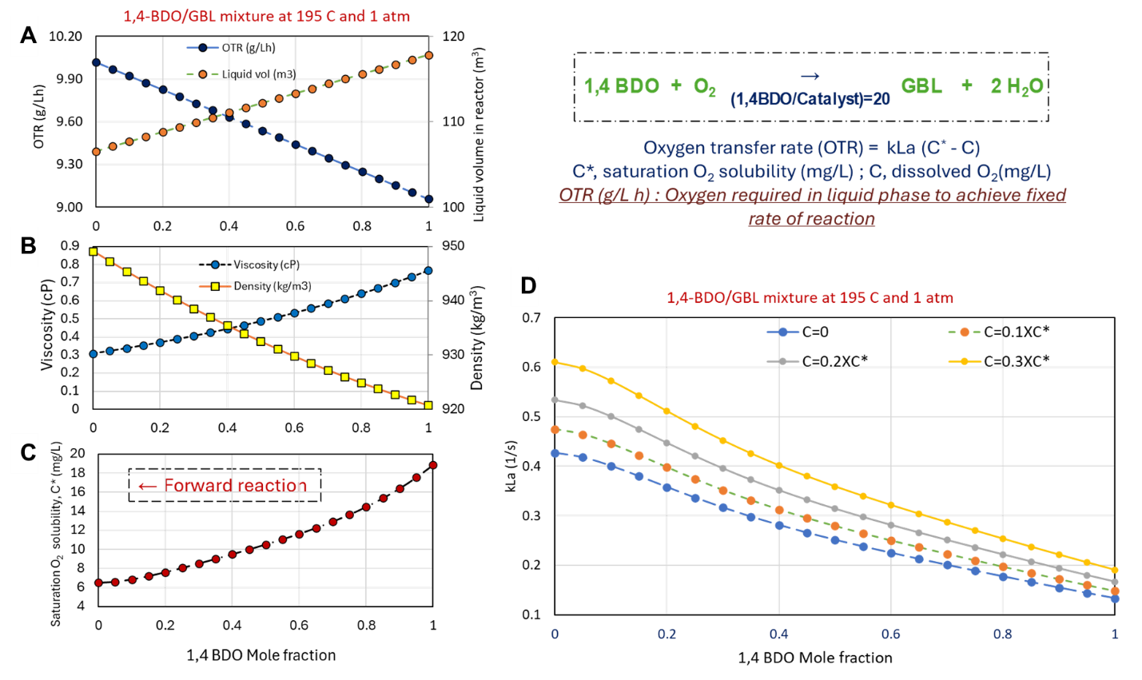
Figure S10. Fluid properties with change in composition of the reactor content. (A) OTR and liquid volume in the reactor (B) viscosity and density (C) saturation oxygen solubility, and (D) required kLa. Figure S10a illustrates the schematic of air sparging, highlighting key steps: oxygen dissolution into the liquid phase, subsequent oxygen consumption for the conversion of 1,4-BDO to GBL, and the concurrent evaporation of water with undissolved air. Due to the small bubble size and high heat transfer coefficients characteristic of bubble columns, the gas phase temperature rapidly equilibrates with the surface liquid temperature; thus, the gas stream temperature is assumed to be 195 °C. Figures S10b-c present the composition of 1,4-BDO, GBL, and water in the gas phase at 195 °C and 105 °C. At 50% conversion, 8.7 mol% of 1,4-BDO and 16.89 mol% of GBL are present in the gas phase at 195 °C. Upon cooling to 105 °C, the condensed liquid is recycled to the reactor, and the gas phase retains less than 0.03 mol% of 1,4-BDO and GBL. Most of the water is vented with the undissolved air, ensuring that reactant and product losses due to liquid entrainment are negligible.
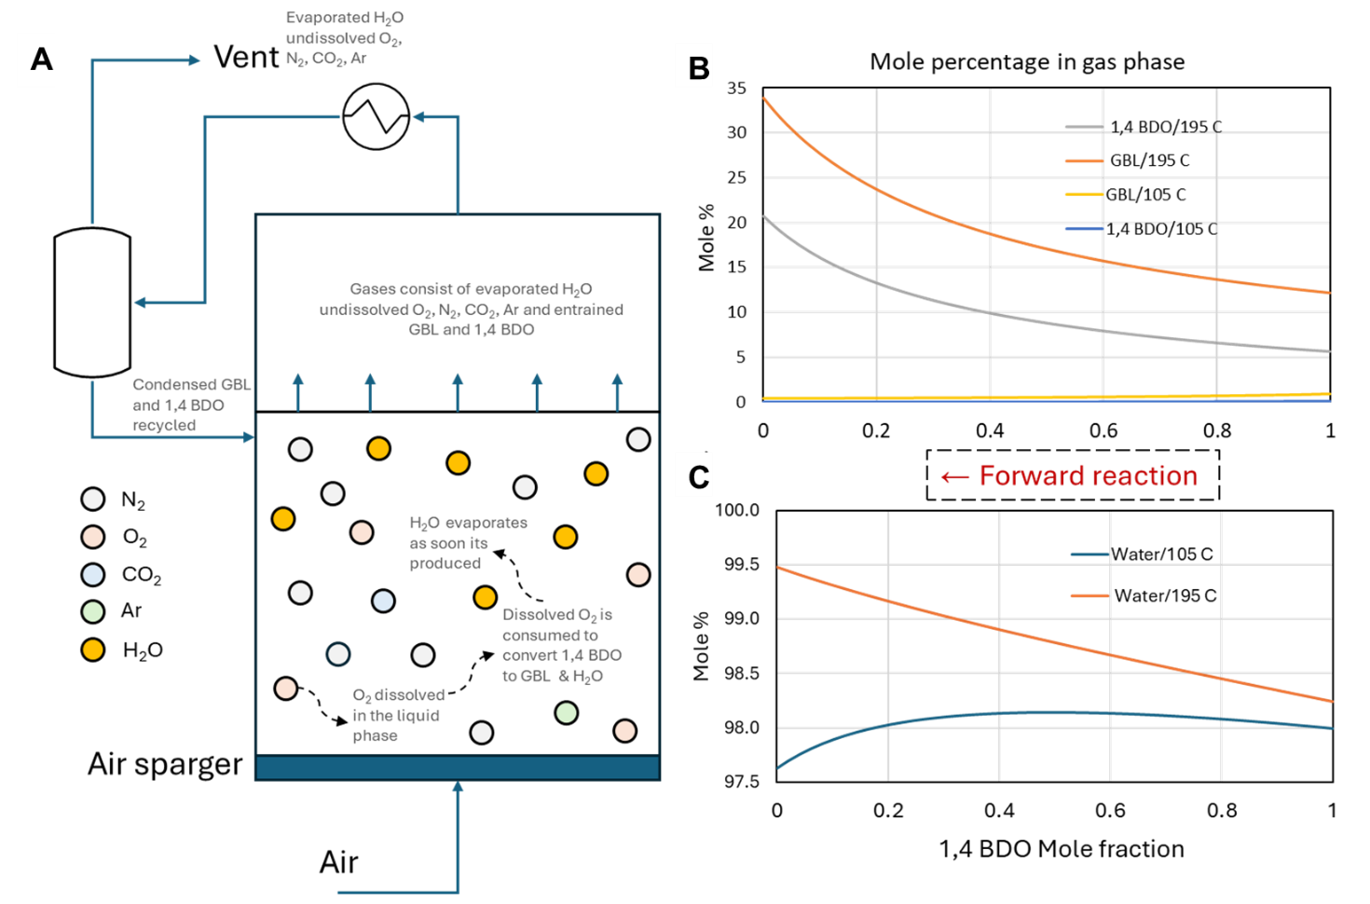
Figure S11. (A) Schematic of batch reactor for 1,4 BDO conversion to GBL, producing water as a side product in the presence of catalyst. Air is sparged to provide oxygen for the reaction. Oxygen dissolves while air and water leave the reactor. Mole fraction of (B) 1,4 BDO and GBL in the gas-phase, and (C) water in the gas phase at 195 °C and 105 °C.
The minimum selling price (MSP) of GBL was estimated to be $2.89/kg, with the cost primarily driven by feedstock ($2.55/kg) and capital expenses ($0.22/kg). The feedstock cost is based on the price of bio-derived 1,4-BDO, estimated at $2.43/kg, as reported in a techno-economic analysis of a single-step bioconversion process developed by Genomatica. In this process, sugars are biologically converted to 1,4-BDO, followed by downstream purification steps including filtration to remove spent cells, proteins, and other macromolecules. Subsequent cation and anion exchange treatments, along with vacuum evaporation, are employed to eliminate water and volatile organics, yielding a high-purity product (99.99 wt% 1,4-BDO).⁵ The study reported an MSP of $1.82/kg for 1,4-BDO, based on economic conditions in 2016. For consistency with our analysis, this value was adjusted to reflect 2022 cost conditions using the chemical price index. Figure S8 presents the time series plot of 1,4 BDO and GBL prices.
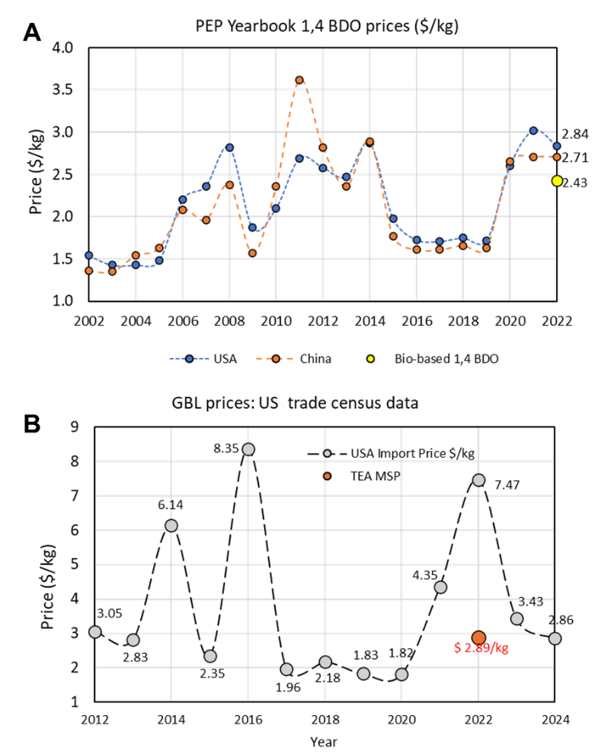
Figure S12. Historic market prices of (A) 1,4 BDO and (B) GBL over the last decade.

Table S3. Financial assumptions used in the TEA, based on n^{th} plant design
Cost Year Basis: 2022
Additional ISBL direct costs
Warehouse | % of ISBL | 4%
Site development | % of ISBL | 9%
Additional piping | % of ISBL | 4.5%
Additional indirect costs
Prorateable expenses | % of TDC | 10%
Field expenses | % of TDC | 10%
Office & construction fee | % of TDC | 20%
Project contingency | % of TDC | 10%
Other costs (Start-up, permits, etc.) | % of TDC | 10%
Land requirement | Acres | 20
Land cost | $/acre | 14000
Equity | % of FCI | 40%
Loan interest |  | 8%
Loan Term, years |  | 10
Working capital | % of FCI | 12%
Internal rate of return (IRR) |  | 12%
Income tax rate |  | 21%
Plant depreciation period | Years | 7
Catalyst replacement frequency | Years | 1
Plant capacity factor | % | 90
Plant life | Years | 30
Construction period | Years | 3
% Spent in Year -2 | % of FCI | 8%
% Spent in Year -1 | % of FCI | 60%
% Spent in Year 0 | % of FCI | 32%
Start-up Time | Years | 0.5
Production in year 1 | % of Normal Capacity | 50%
Variable costs | % of Normal | 75%
Fixed cost | % of Normal | 100%

Table S4. Life cycle inventory data for GBL production from bio-based 1,4 BDO
Output | Quantity | Units
GBL from bio-based BDO | 1 | kg
Input
1,4-butanediol from glucose | 1.0484 | kg
cooling water | 164.4 | kg
market group for electricity, medium voltage | 0.03973 | kWh
market for heat, from steam, in chemical industry | 0.317 | MJ
Emissions to air
oxygen | 0.0487 | kg
water | 0.000613 | m³
nitrogen | 1.9282 | kg
argon-40 | 0.0329 | kg

Table S5. Life cycle inventory data for bio-based 1,4 BDO production
Output | Quantity | Units
bio-based BDO | 1 | kg
Input
water, decarbonised | 27.5 | kg
ammonia, anhydrous, liquid | 0.0247 | kg
ammonium sulfate | 0.03225 | kg
magnesium sulfate | 0.03225 | kg
potassium sulfate | 0.03225 | kg
cooling water | 0.00814 | kg
market group for electricity, medium voltage | 0.5544 | kWh
market for heat, from steam, in chemical industry | 5.69 | MJ
glucose | 2 | kg

Table S6. Life cycle inventory for the sensitivity analysis for GBL production.
Output | VM 1 | VM 1.5 | Units
GBL from bio-based BDO | 1 | 1 | kg
Input
1,4-butanediol from glucose | 1.0484 | 1.0484 | kg
cooling water | 163.281 | 162.06 | kg
market group for electricity, medium voltage | 0.059 | 0.084 | kWh
market for heat, from steam, in chemical industry | 0.317 | 0.317 | MJ
Emissions to air
Oxygen | 0.4153 | 0.8736 | kg
Water | 0.000613 | 0.000613 | m³
Nitrogen | 3.125 | 4.621 | kg
Argon-40 | 0.0533 | 0.0788 | kg

Table S7. LCA results for sensitivity analysis of bio-based GBL production
Impact Category | Unit (per kg polymer) | base case (VVM 0.7) | VVM 1 | VVM 1.5
global warming potential | kg CO₂ eq | 4.706 | 4.715 | 4.727
acidification | kg SO₂ eq | 0.02 | 0.02 | 0.02
ecotoxicity | kg 1,4-DCB eq | 28.43 | 28.44 | 28.45
energy resources: non-renewable, fossil | kg oil eq | 1.17 | 1.17 | 1.18
eutrophication | kg N eq | 0.00387 | 0.00387 | 0.00388
human toxicity | kg 1,4-DCB eq | 5.54 | 5.54 | 5.55
ionising radiation | kg Co-60 eq | 0.26 | 0.26 | 0.27
land use | m²*a crop-eq | 1.00 | 1.00 | 1.00
material resources use | kg Cu eq | 21.99 | 21.99 | 21.99
ozone depletion | kg CFC-11 eq | 1.67E-05 | 1.67E-05 | 1.67E-05
particulate matter formation | kg PM_{2.5} eq | 0.008 | 0.008 | 0.008
photochemical oxidant formation | kg NO_{x} eq | 0.02 | 0.02 | 0.02
water use | m³ | 0.26 | 0.26 | 0.26

Data tables for Figure 3

Figure 3A.
open system/semi-batch | Lactone yield (%) | Lactone yield (%) | Lactone yield (%)
 | diol/cat ratio (g/g) | diol/cat ratio (g/g) | diol/cat ratio (g/g)
Cu(%) | 20 | 40 | 80
1 | 0 | 0 | 0
5 | 21.57424 | 4.784689 | 0
10 | 44.54343 | 9.276438 | 0
18 | 52.70694 | 32.3 | 5.733945
closed system/batch | Lactone yield (%) | Lactone yield (%) | Lactone yield (%)
 | diol/cat ratio (g/g) | diol/cat ratio (g/g) | diol/cat ratio (g/g)
Cu(%) | 20 | 40 | 80
1 | 0 | 0 | 0
5 | 9.041591 | 2.894356 | 0
10 | 10.10101 | 4.063389 | 0
18 | 32.73322 | 4.208754 | 5.733945
diol/cat ratio (g/g) | 20 | 40 | 80
catalyst (g) | 0.1 | 0.05 | 0.025
diol (g) | 2 | 2 | 2

Figure 3B-C.
 |  |  | Rate | Rate per mass | Site time yield
Cu moles in 0.1g catalyst | Cu loading % | avg lactone yield % (n=3 to 20) | moles/min | moles/min/g | moles per min per mole Cu
0 | 0 | 0 | 0 | 0 | 0
1.57366E-05 | 1 | 0.05 | 0 | 0 | 0
7.86832E-05 | 5 | 21.57424158 | 3.26359E-06 | 3.26359E-05 | 0.041477569
0.000157366 | 10 | 44.54342984 | 6.72359E-06 | 6.72359E-05 | 0.037725737
0.000283259 | 18 | 52.70694087 | 7.96255E-06 | 7.96255E-05 | 0.028110441
0.000566519 | 36 | 68.74881875 | 1.038E-05 | 0.0001038 | 0.01832246
0.000786832 | 50 | 72.88938276 | 1.10146E-05 | 0.000110146 | 0.01399868
0.001290404 | 82 | 87.92395349 | 1.3281E-05 | 0.00013281 | 0.010292114
0.001416297 | 90 | 87.29554964 | 1.31903E-05 | 0.000131903 | 0.00931325
0.001573663 | 100 | 0 | 0 | 0 | 0

Figure 3D.
rxn time (min) | lactone yield (%) | STY (mol per min per Cu)
60 | 4.2 | 0.054
120 | 8.249795861 | 0.052800689
240 | 15.27507606 | 0.046630261
1440 | 52.70694087 | 0.028110441

Figure 3E.
Cu (%) | STY (mol per min per Cu) | rate (mol/min/g) | Ln(Cu) | Lnrate | LnSTY
5 | 0.104500431 | 8.22242E-05 | 1.609437912 | -9.406060411 | -2.258564084
10 | 0.057607735 | 9.97207E-05 | 2.302585093 | -9.213137402 | -2.854098436
18 | 0.052800689 | 0.000149563 | 2.890371758 | -8.807793513 | -2.941231032

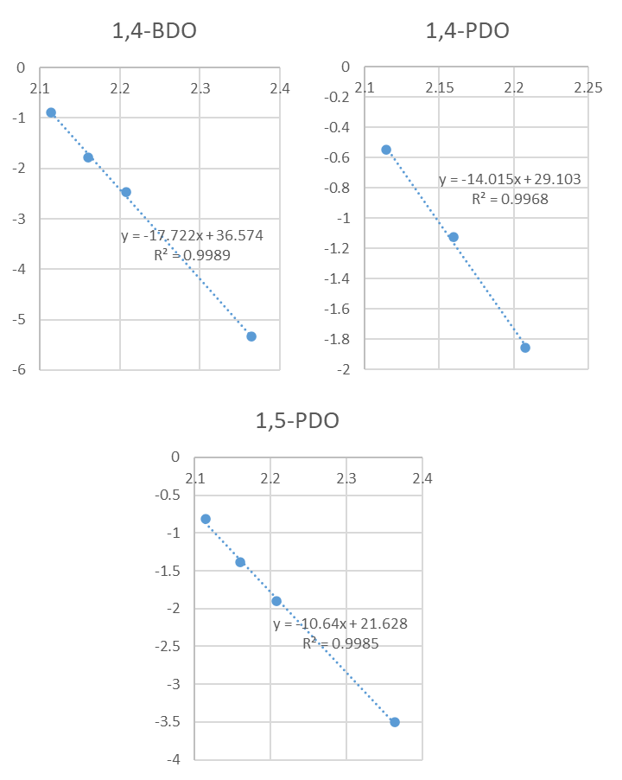
Figure 3F.
 | STY | STY | STY
T (K) | 1,4 BDO | 1,5 BDO | 14PDO
423 | 0.004801 | 0.030066
453 | 0.084491 | 0.149865 | 0.156263
463 | 0.169 | 0.249775 | 0.325028
473 | 0.413594 | 0.443316 | 0.577549
1/T | LnSTY | LnSTY | LnSTY
2.364066 | -5.33901 | -3.50438 | #NUM!
2.207506 | -2.47111 | -1.89802 | -1.85621
2.159827 | -1.77786 | -1.38719 | -1.12385
2.114165 | -0.88287 | -0.81347 | -0.54896
 |  | Ea
 | 1,5PDO | 88.5
 | 1,4BDO | 147.3
 | 1,4PDO | 116.5

Data tables for Figure 6
Figure 6B.
Total (MM $) | 15.21 | Percentage
Reactors | 11.98 | 78.74
Tanks | 1.82 | 11.99
Pumps | 0.30 | 1.94
Blower | 0.77 | 5.09
Heat exchangers | 0.34 | 2.24

Figure 6C and 6D.
Total (MM $) | 165.067 | Percentage
Feedstock | 158.187 | 95.832
Electricity | 0.247 | 0.149
Cooling water | 0.820 | 0.497
Fixed operating cost | 5.813 | 3.522

Figure 6E.
Minimum Selling Price Cost Breakdown (cents/kg )
Capital charge | Feedstock | Fixed cost | Others | Total
22.27 | 254.78 | 9.36 | 2.36 | 288.77

Figure 6F.
Process step | GWP (kg CO₂e/kg)
Feedstock (1,4 BDO production) | 4.7
Electricity | 4.45
Cooling water and steam | 3.68

Figure 6G.
Impact category | Bio-based GBL | Fossil-based GBL | Normalized std dev. (bio-based) | Normalized std dev. (fossil-based)
Acidification | 1 | 0.8453386 | 0.7000988 | 0.5523911
Ecotoxicity | 1 | 0.7110495 | 3.8150615 | 2.3159787
Eutrophication, freshwater | 0.9077939 | 1 | 0.9632462 | 1.2741952
Eutrophication, marine | 1 | 0.0589193 | 0.3783889 | 0.0268301
Ionizing radiation | 0.6077296 | 1 | 1.9432234 | 3.5169251
Fossil resources use | 0.5990695 | 1 | 0.1093661 | 0.3983273
Human toxicity | 1 | 0.8494915 | 135.12537 | 7.5727859
Land use | 1 | 0.1303123 | 0.409698 | 0.0757478
Mineral resources use | 1 | 0.0024098 | 0.0984661 | 0.0039354
Ozone depletion | 1 | 0.089612 | 0.2824368 | 0.0451165
Particulates formation | 0.9422752 | 1 | 0.5860988 | 0.5965177
Water use | 0.9216401 | 1 | 0.2245677 | 0.3451459
Photo-oxidant formation | 0.9155515 | 1 | 0.1687679 | 0.2940952
Climate change | 0.8499488 | 1 | 0.1425053 | 0.3517111

Figure 6K.
Scenario | Bio-based GBL (kg CO₂e/kg) | Fossil-based GBL (kg CO₂e/kg)
Base case | 4.7 | 5.5
Renewable electricity | 4.45 | 5.038
Renewable heat | 3.68 | 3.12
Mixed sugars | 1.55 | N/A

References
(1) Cargill and HELM partner to build $300M commercial-scale, renewable BDO facility, first in the US, to meet growing customer demand. https://www.cargill.com/2021/cargill-and-helm-partner-to-build-$300m-facility (accessed 2025-04-07).
(2) QIRA - Company. https://www.myqira.com/qira-company (accessed 2025-04-07).
(3) Seo, W.-W.; Yim, J.-H.; Kang, J. W.; Lim, J. S. Isobaric Vapor–Liquid Equilibrium Data of Binary Mixtures of [Water + 2,3-Butanediol] and [Water + 1,4-Butanediol] at 40, 50, 60, 66.7, 80, and 101 KPa. Korean J. Chem. Eng. 2024, 41 (5), 1457–1466.
(4) Ouallal, M.; Leyer, S.; Gupta, S. A correlation for pool entrainment phenomenon. Nucl. Eng. Des 2021, 383, 111386.
(5) Satam, C. C.; Daub, M.; Realff, M. J. Techno-economic analysis of 1,4-butanediol production by a single-step bioconversion process. Biofuel. Bioprod. Biorefin. 2019, 13 (5), 1261–1273.

