Table 1. Field description of the Nowshera Reef Facies
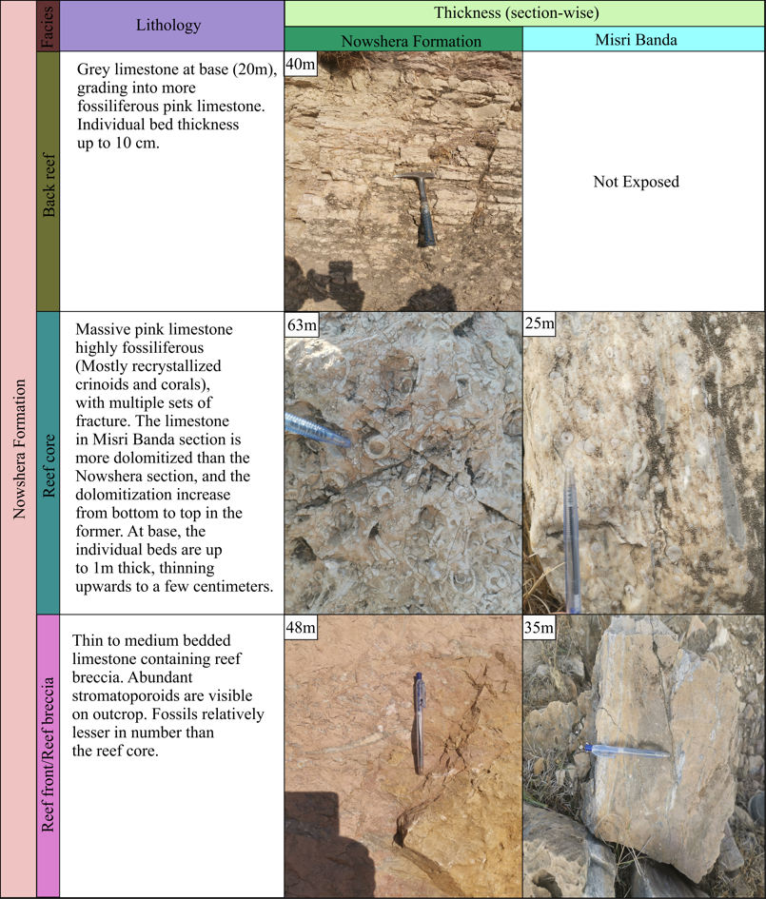

Table 2. Different outcrop feature of the Ghundai Sar Formation