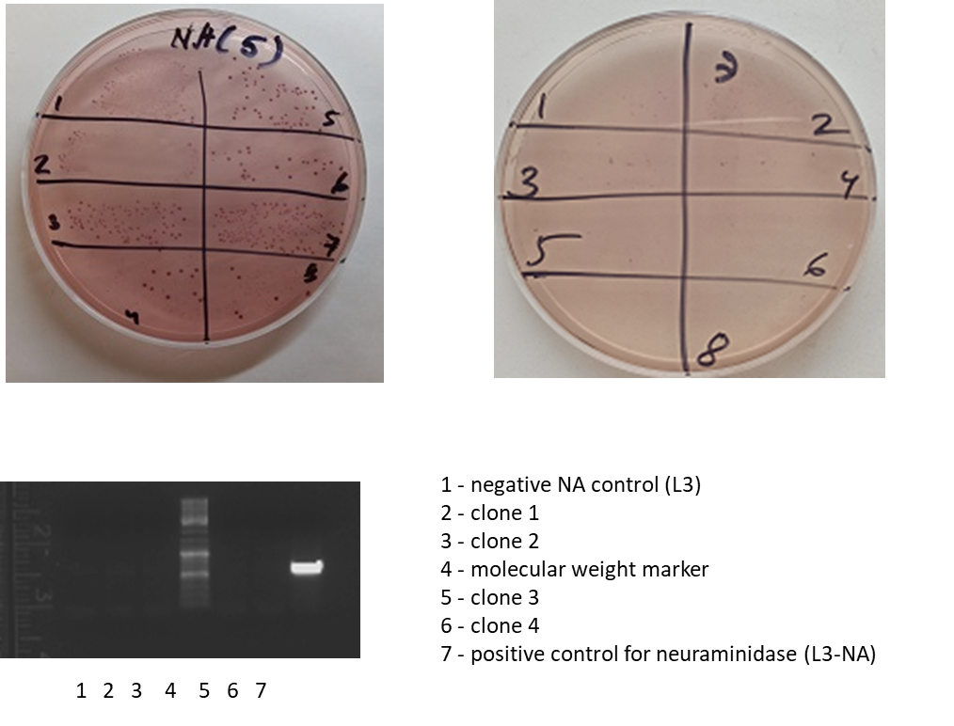
Supplementary data 2. Bacterial persistence in the intestines of L3-NA immunized animals. Enterococcal (azide) agar inhibits the growth of gram-negative bacteria and does not prevent the development of Enterococcus. On enterococcal agar, their colonies are pink. Erythromycin in agar inhibits the growth of normal mouse enterococcal flora and does not prevent the development of L3-NA. Thus, the presence of L3-NA in the feces of mice can be judged by the development of pink colonies on a selective medium.

