C
D
B
A

(A) Positive control animals administered 7,12-dimethylbenz[a]anthracene (DMBA) at 2 mg/kg body weight; and treatment groups receiving Sunset Yellow at doses of (B) 200 mg/kg, (C) 400 mg/kg, and (D) 600 mg/kg body weight, respectively.

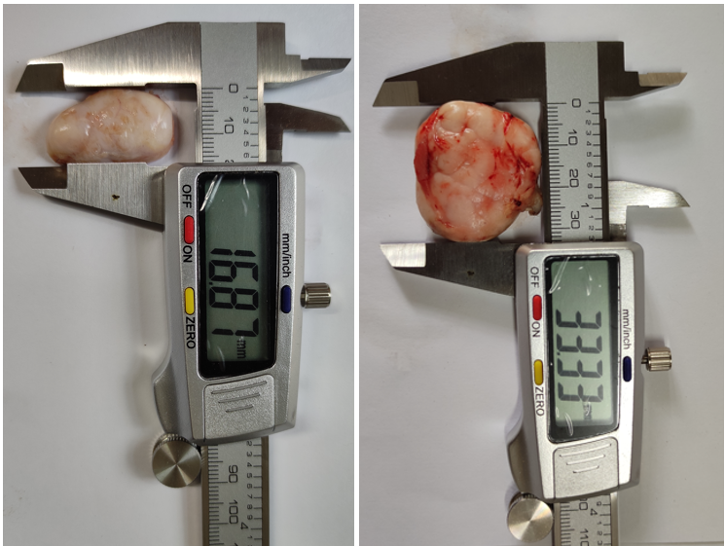
B
A

Treatment groups receiving Sunset Yellow at doses of (A) 200, 400, and 600 mg/kg body weight, respectively. (B) Positive control animals administered 7,12-dimethylbenz[a]anthracene (DMBA) at 2 mg/kg body weight;

