Discovery of Cold tolerance genes and Favorable Alleles in Kam Sweet Rice Across Various Growth Stages
Fig S1. Genome-wide selective signals (CLR score) of subgroups. (A–E) CC, EC, SC, SW, and GZ (Cold tolerant genes in red font).

Fig S2. Selective sweeps gene CTB4a. (A) CLR score and π-value (genetic diversity) plot for CTB4a. (E) Box plot showing cold tolerance grade at the seedling stage for different haplotypes of CTB4a. (F) Box plot showing survival rate at the bud stage for different haplotypes of CTB4a. (G) Frequency changes of CTB4a haplotypes in KSR, CC, EC, SC, SW, and GZ subpopulations.

Fig S3. Plot of differentially expressed genes. (A) Volcano plot of control group VS. cold stress group in Gouhuanggang. (B) Volcano plot of control group VS. cold stress group in Heigu. (C) Venn diagram of all up regulated differentially expressed genes in Gouhuanggang and Heigu. (D) Venn diagram of all down regulated differentially expressed genes in Gouhuanggang and Heigu.

Fig S4. Co-expression network of different treatments in cold-tolerant accession Gouhuanggang and cold-sensitive accession Heigu. (A) Soft threshold determination of gene co-expression network. (B) Hierarchical cluster tree showing co-expression modules identified by WGCNA. Each branch of the gene clustering tree corresponds to one module. (C) Correlation heat map of gene co-expression network module and different treatments. Each cell contains the corresponding correlation and P value.

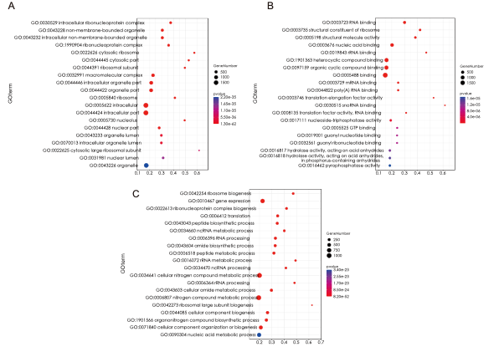
Fig S5. Gene GO annotation in blue module and t magenta module.

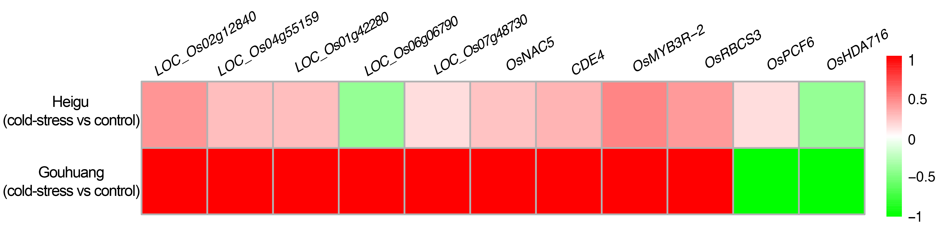Fig S6. The heatmap of scaled expression scores of hub genes associated with cold tolerance.
Fig S7. Localization of the candidate gene OsGRS7 on chromosome 7. (A) Partial Manhattan plot (upper panel) and linkage disequilibrium heatmap (lower panel) surrounding the peak on chromosome 7. (B) Gene structure and polymorphisms identified in OsGRS7. (C‒D) Violin plots showing germination energy and germination rate at the germination stage for different haplotypes of OsGRS7. (E) Violin plots showing survival rate at the bud stage for different haplotypes of OsGRS7. (F) Frequency distribution of haplotypes Hap1 and Hap2 across different subpopulations.

Fig S8. Localization of the candidate gene OsBSR6 on chromosome 6. (A) Partial Manhattan plot (upper panel) and linkage disequilibrium heatmap (lower panel) surrounding the peak on chromosome 6. (B) Gene structure and polymorphisms identified in OsBSR6. (C‒D) Violin plots showing survival rate at the bud stage and cold tolerance grade at the seedling stage for different haplotypes of OsBSR6. (F) Frequency distribution of haplotypes Hap1 and Hap2 across different subpopulations.

