In situ study of surface species and structure over Oxide-Derived Copper Catalysts for Electrochemical CO₂ Reduction

Chunjun Chen,^{1, 2} Xupeng Yan, ^{1, 2} Yahui Wu, ^{1, 2} Shoujie Liu,³ Xiaofu Sun, ^{1, 2} Qinggong Zhu, ¹ Rongjuan Feng,¹ Tianbin Wu, ¹ Qingli Qian,¹ Huizhen Liu,¹ Lirong Zheng,⁶ Jing Zhang,⁶ and Bxing Han^{1, 2, 4, 5}*

1. Beijing National Laboratory for Molecular Sciences, Key Laboratory of Colloid and Interface and Thermodynamics, Institute of Chemistry, Chinese Academy of Sciences, Beijing 100190, China.
2. School of Chemistry and Chemical Engineering, University of Chinese Academy of Sciences, Beijing 100049, China.
3. Chemistry and Chemical Engineering of Guangdong Laboratory, Shantou 515063, China.
4. Physical Science Laboratory, Huairou National Comprehensive Science Center, No. 5 Yanqi East Second Street, Beijing 101400, China.
5. Shanghai Key Laboratory of Green Chemistry and Chemical Processes, School of Chemistry and Molecular Engineering, East China Normal University, Shanghai 200062, China.
6. Institute of High Energy Physics, Chinese Academy of Sciences, Beijing 100049, China.

Experimental Section
Synthetic procedures for Cu(OH)₂: The Cu(OH)₂ nanorods were prepared by a literature method.^{[S1]} Typically, 1 g of Cu(NO₃)₂ was dissolved in 100 mL distilled water. Then, 30 mL NH₃·H₂O (0.15 M) solution was added to the Cu(NO₃)₂ solution under constant stirring at room temperature. A blue precipitate of Cu(OH)₂ was produced when 10 mL of NaOH (1 M) solution (≈2 mL min⁻¹) was dropwise added to the above solution to adjust the pH value to 9-10. After 30 min, the blue Cu(OH)₂ precipitate was centrifuged and washed several times with H₂O to obtain a solid product, which was dried by freeze-drying for 24 h.
Preparation of electrodes. To construct the cathode electrode, a catalyst slurry that contained 5 mg of obtained catalysts, 1 mL of methanol and 20 µL of Nafion ionomer solution (5 wt% in H₂O) was first mixed and sonicated for 30 min. Then, the catalyst slurry (0.2 mL) was slowly drop cast onto a PTFE membrane (Fuel Cell Store) under vacuum to achieve a catalyst loading of ~1.0 mg cm⁻². Ni foam was used as anode electrode.
EIS study. The EIS measurement was carried out in 1 M KOH solution at an open circuit potential (OCP) with an amplitude of 5 mV of 10⁻² to 10⁶ Hz.
Double-layer capacitance (C_{dl}) measurements. The electrochemical active surface area is proportional to C_{dl} value. C_{dl} was determined by measuring the capacitive current associated with double-layer charging from the scan-rate dependence of cyclic voltammogram (CV). The CV ranged from 0 V to -0.1 V vs. RHE. The C_{dl} was estimated by plotting the Δj (j_{a}-j_{c}) at -0.05 V vs. RHE against the scan rates, in which the j_{a} and j_{c} are the anodic and cathodic current density, respectively. The scan rates were 20, 30, 50, 80, 100 and 120 mV s⁻¹.
Product analysis. The gaseous product of electrochemical experiments was collected using a gas bag and analyzed by gas chromatography (GC, HP 4890D), which was equipped with TCD detectors using argon as the carrier gas. The liquid product was analyzed by ¹H NMR (Bruker Avance III 400 HD spectrometer) in deuteroxide.
Calculations of Faradaic efficiencies of gaseous and liquid products.
liquid products:
After electrolysis, a certain amount of internal standard solution was added to the electrolyte as the internal standard. Because the concentration of internal standard was known, the moles of liquid products can be calculated from integral areas and calibration curves. To accurately integerate the products in NMR analysis, two standards located in different regions were used in NMR analysis. The sodium 2, 2-dimethyl-2-silapentane-5-sulfonate (DSS) was the reference for n-propanol, ethanol and acetic acid, and the phenol was the reference for formate. 400 μL catholyte after the reaction was mixed with 100 μL 6 mM DSS solution, 100 μL 200 mM phenol and 200 μL D₂O, and then analyzed by 1H NMR (Bruker Avance III 400 HD spectrometer).
The Faradaic efficiency of liquid product is:
$$\text{FE}\text{=}\frac{\text{moles of product}}{\text{Q / nF}}×100\%$$
(Q: electric quantity (C); F：Faradaic constant (96485 C/mol); n: the number of electrons required to generate the product)
Gaseous products:
From the GC peak areas and calibration curves for the TCD detector, we can obtain the V % of gaseous products . Since the flow rate of the CO₂ was constant, the moles of gaseous products can be calculated. The Faradaic efficiency of gaseous product is:
$$\text{FE}\text{=}\frac{\text{moles of product}}{\text{Q / nF}}×100\%$$
(Q: electric quantity (C); F：Faradaic constant (96485 C/mol); n: the number of electrons required to generate the product)
Computational Method
DFT calculations were performed by using the Vienna ab-initio simulation package (VASP). ^{[S2-S3]} The generalized gradient approximation in the Perdew-Burke-Ernzerhof form was used to describe the exchange and correlation energy. For Cu(100) and Cu(111), a periodic four-layer model was used, with the two lower layers fixed and two upper layers relaxed, and a p(3× 3) super cell was chosen. The cutoff energy of plane-wave basis set was 400 eV. As for geometric optimization, the atomic positions were optimized until the forces were less than 0.02 eV/Å and 3× 3 × 1 Monkhorst-Pack sampled k-points were used in all slabs system. To avoid interactions between neighbour slabs caused by the periodic boundary conditions, the vacuum spacing perpendicular to the surface was 15.0 Å. The transitional state (TS) was located using the climbing image Nudged Elastic Band method.

Supplementary Figures

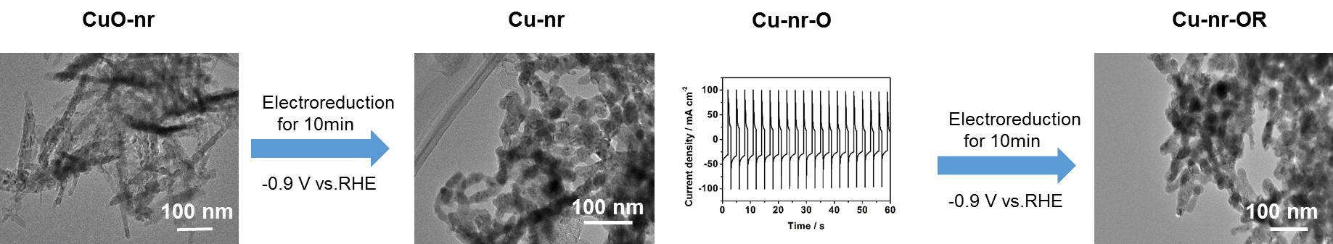
Figure S1. The schematic illustration for the formation of Cu-nr-OR.

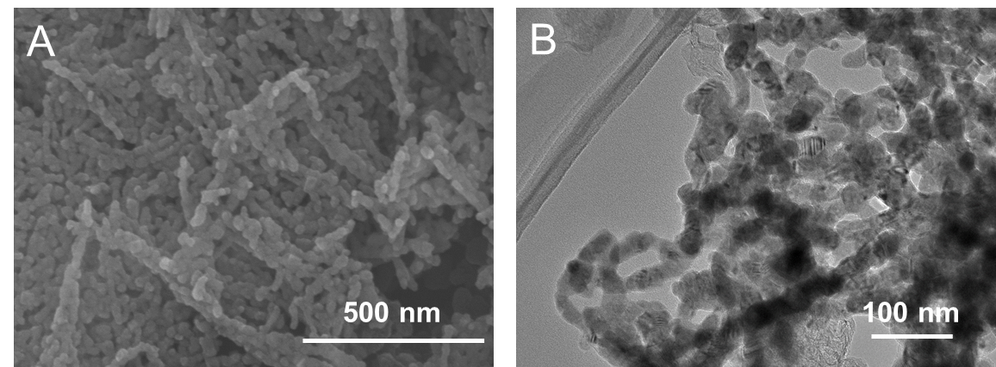
Figure S2. (A) The SEM images of the Cu-nr; (B) The TEM image of the Cu-nr.

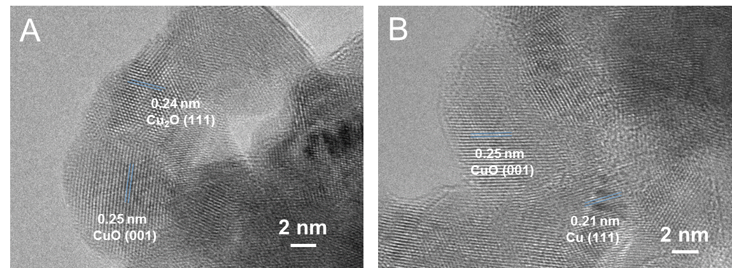
Figure S3. The HR-TEM images of the Cu-nr-OR.

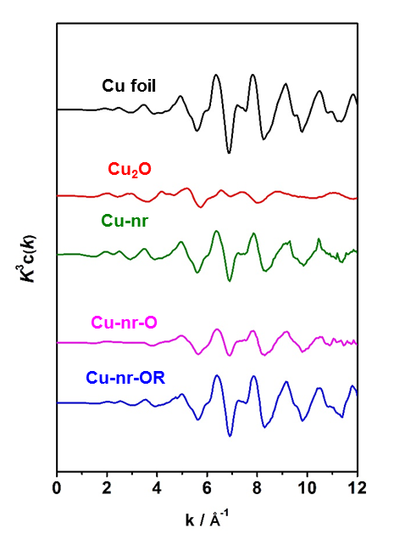
Figure S4. Cu K-edge extended XAFS oscillation function k³w(k) for various catalysts.

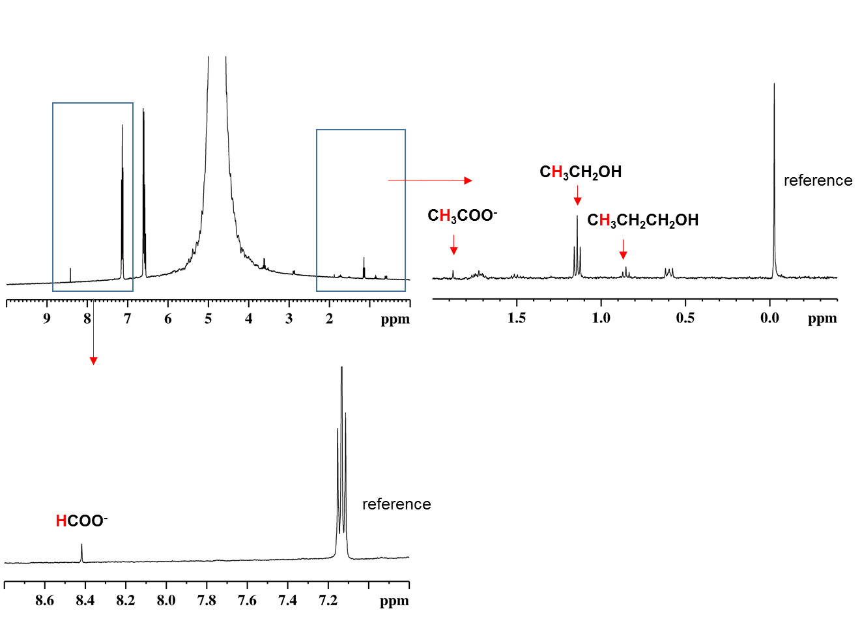
Figure S5. A typical ¹H NMR spectrum of liquid products after electrolysis over the Cu-nr-OR.

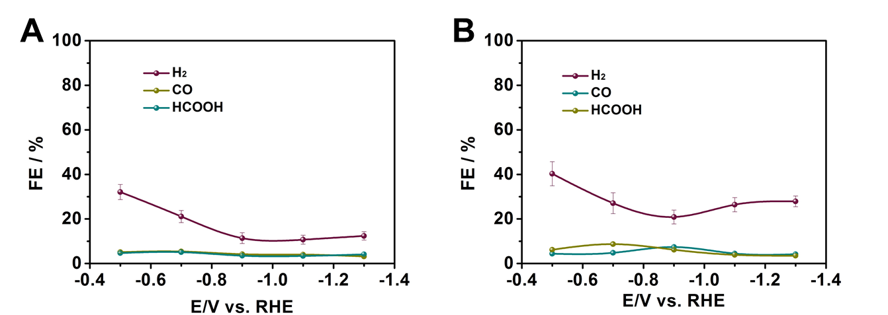

Figure S6. The distribution of C1 and H₂ products for: Cu-nr-OR (A) and Cu-nr (B).

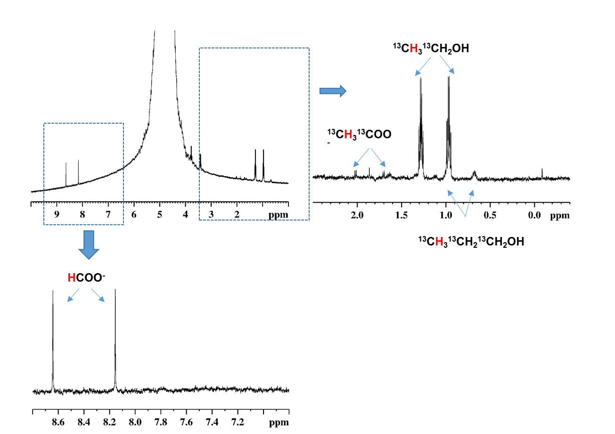
Figure S7. ¹H NMR spectra of the liquid products using ¹³CO₂ as gas source.

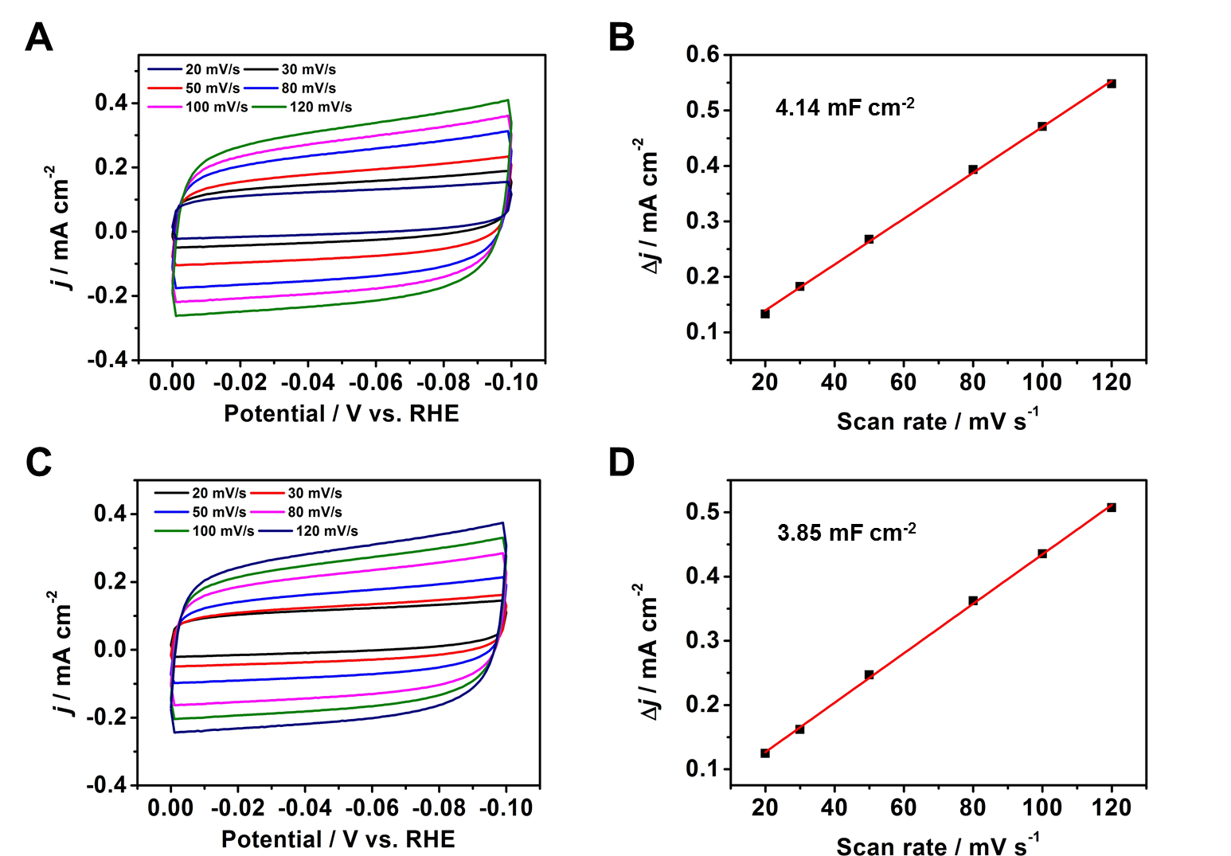
Figure S8. (A) The cyclic voltammetry at different scan rates over Cu-nr; (B) The charging current density differences plotted against the scan rates over Cu-nr; (C) The cyclic voltammetry at different scan rates over Cu-nr-OR; (D) The charging current density differences plotted against the scan rates of Cu-nr-OR.

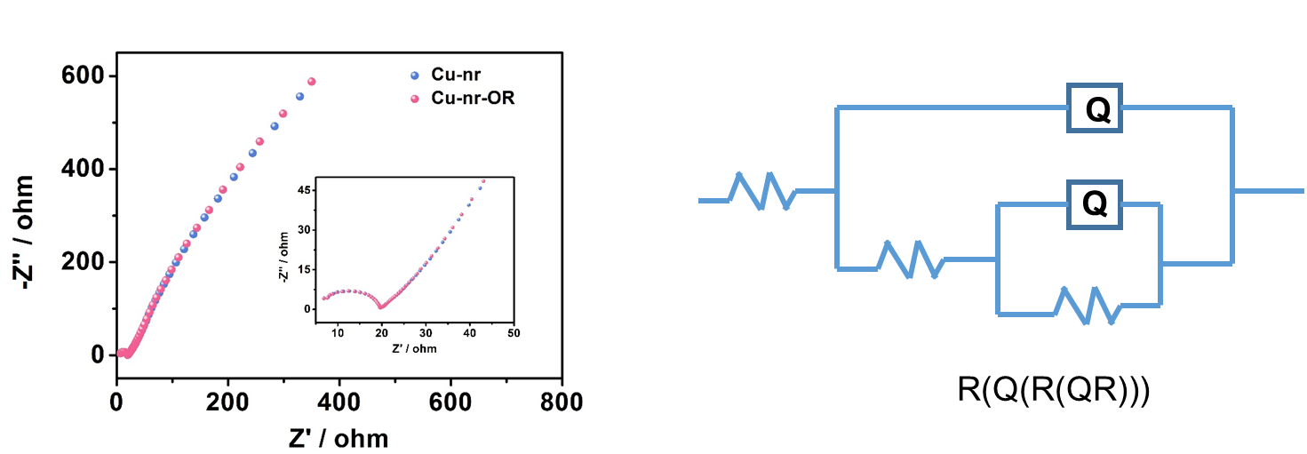
Figure S9. Nyquist plots for different electrodes in CO₂-saturated 1 M KOH electrolyte.

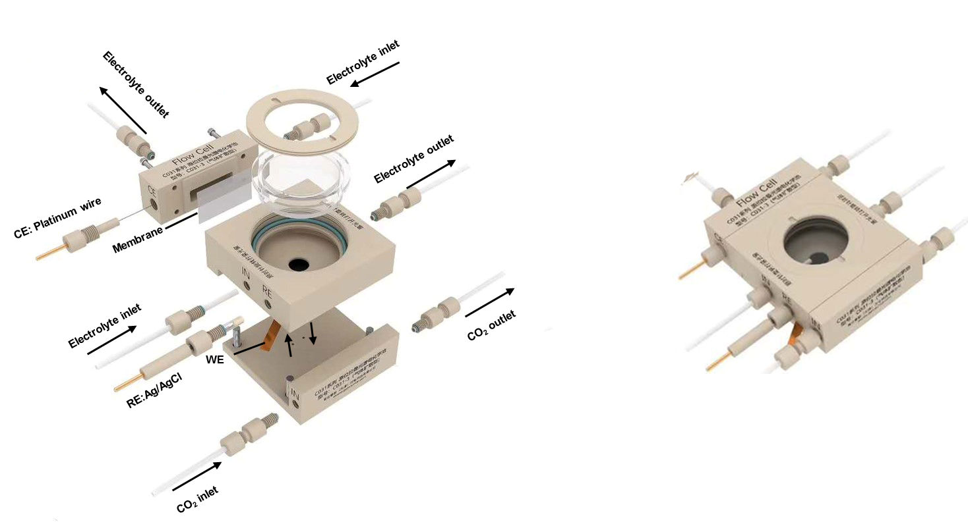
Figure S10. In situ electrochemical spectral cell for SERS test.

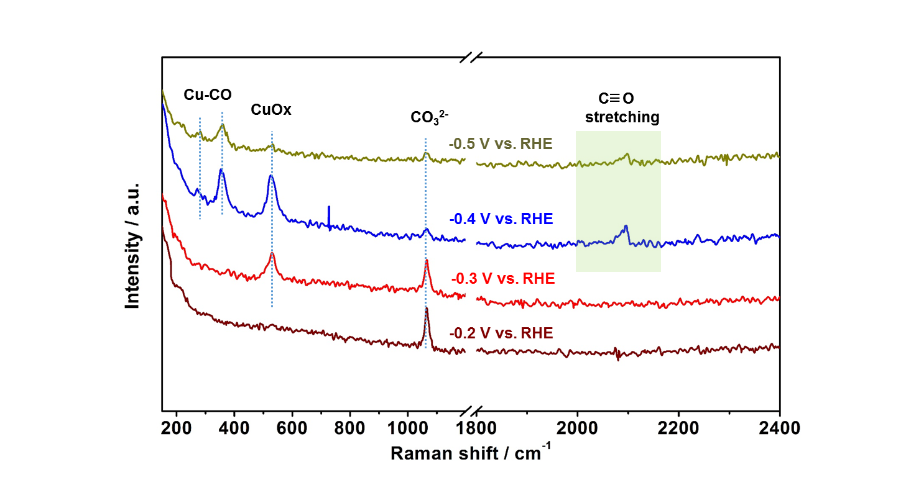
Figure S11. The in-situ SERS for Cu-nr at different potentials during CO₂RR.

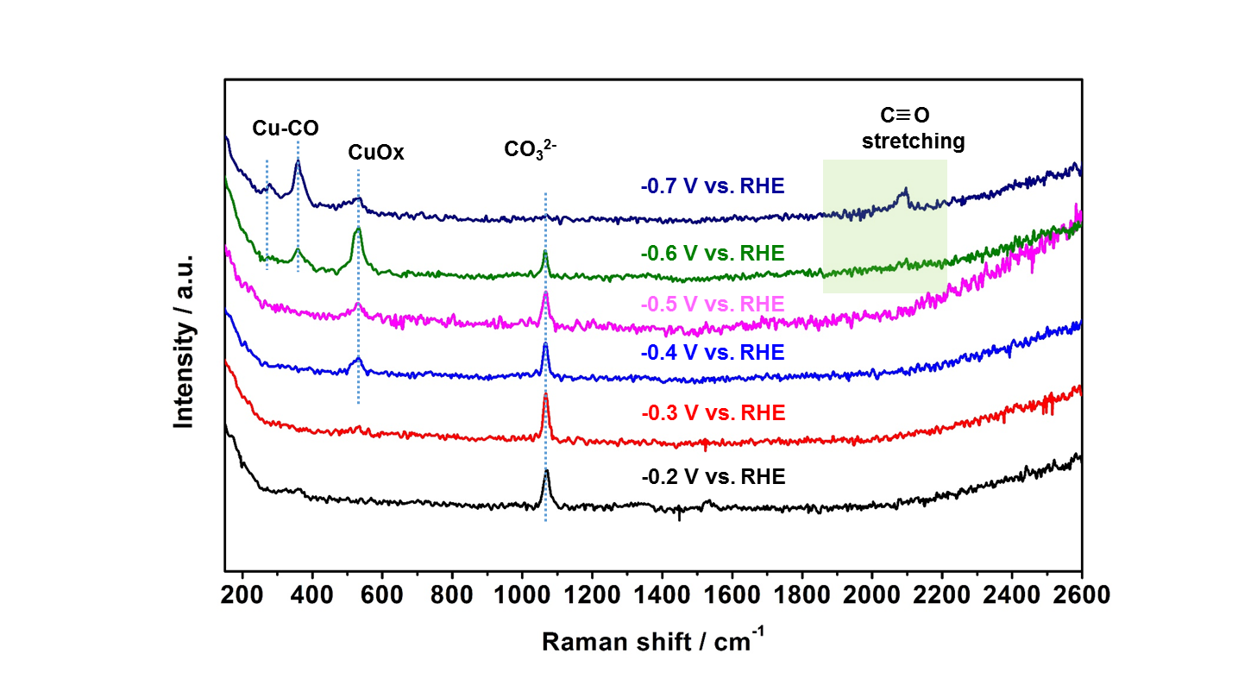
Figure S12. The in-situ SERS for Cu-nr with D₂O as electrolyte at different potentials during CO₂RR.

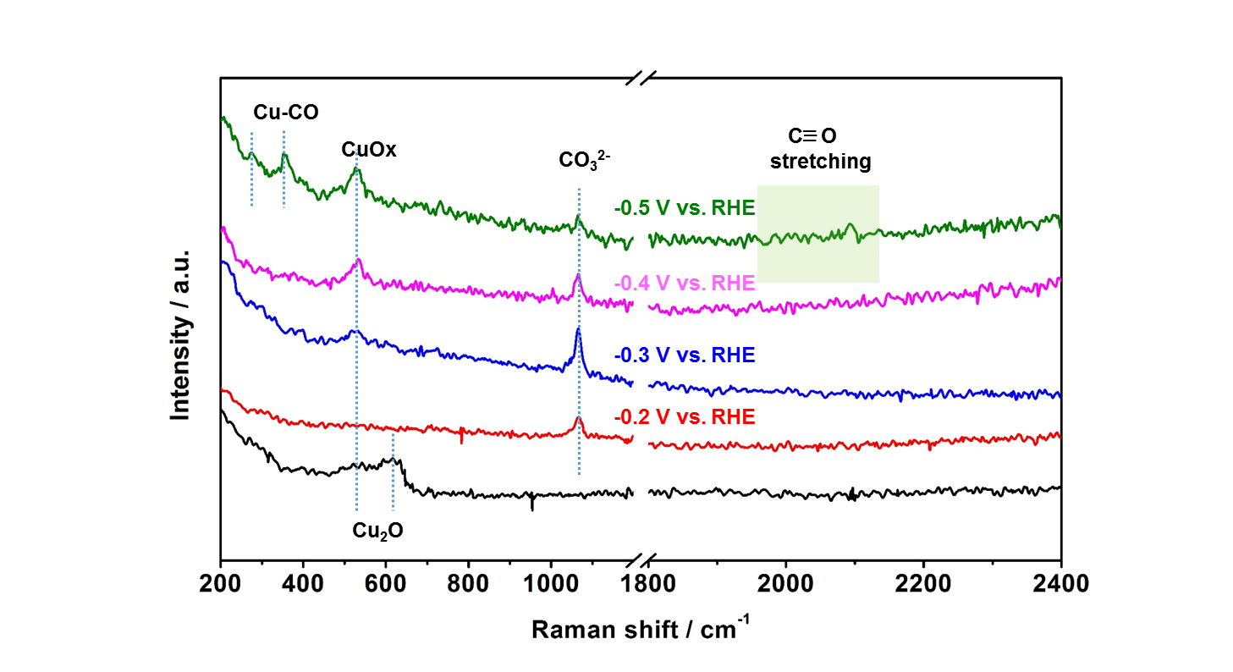
Figure S13. The in-situ SERS for Cu-nr-OR with H₂¹⁸O as electrolyte at different potentials during CO₂RR.

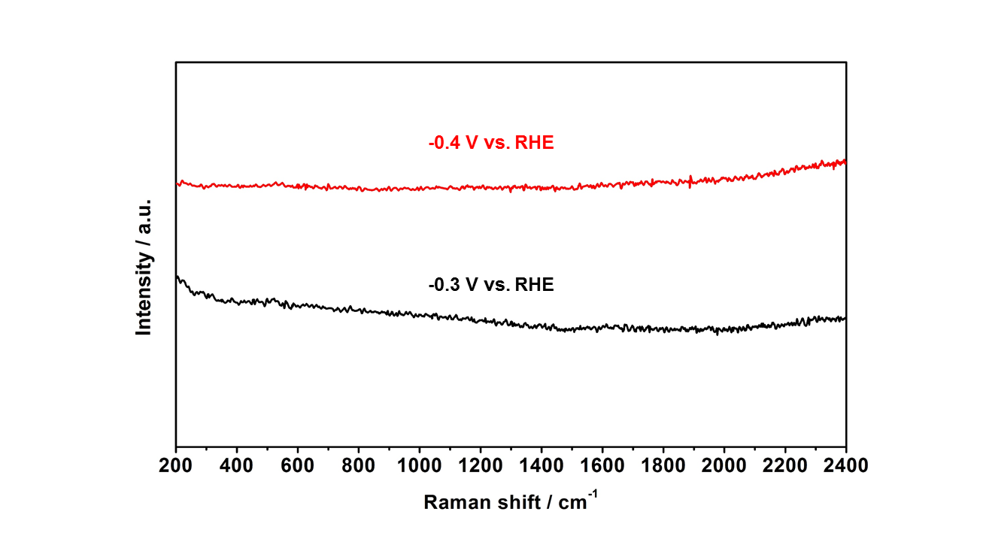
Figure S14. The in-situ SERS for Cu-nr-OR at different potentials in N₂ atmosphere.

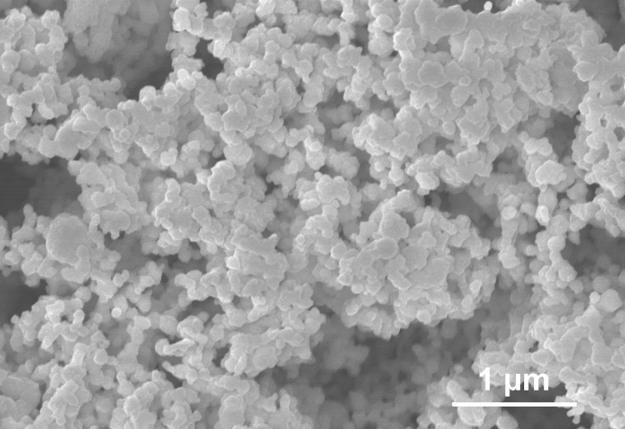
Figure S15. The SEM images of commercial Cu nanoparticles.

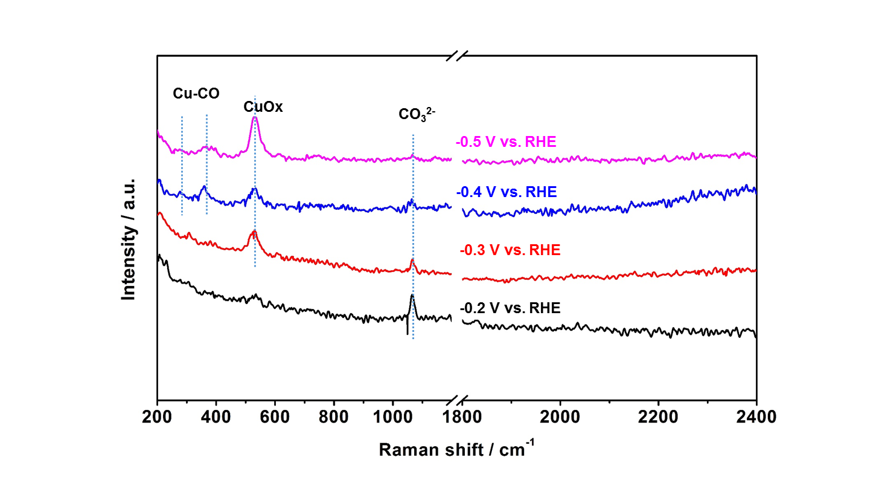
Figure S16. The in-situ SERS for commercial Cu nanoparticles at different potentials during CO₂RR.

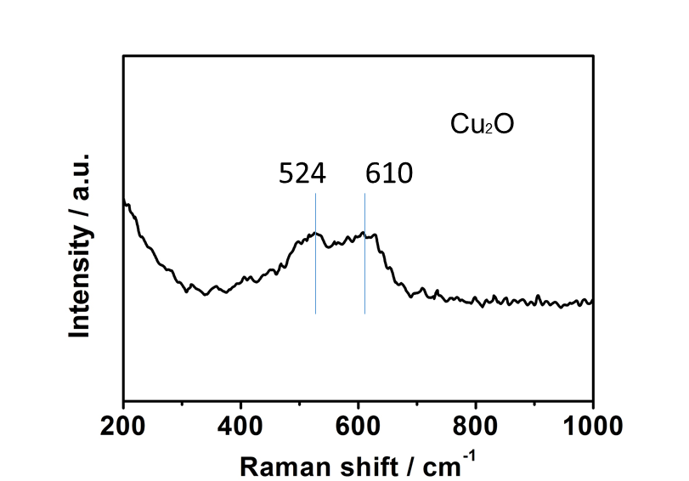
Figure S17. The in-situ SERS for Cu-nr-OR with H₂O as electrolyte after the potential was removed.

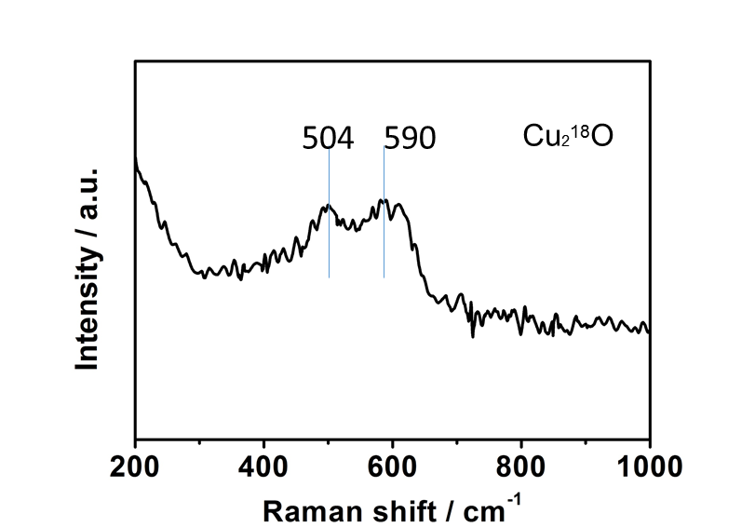
Figure S18. The in-situ SERS for Cu-nr-OR with H₂¹⁸O as electrolyte after the potential was removed.

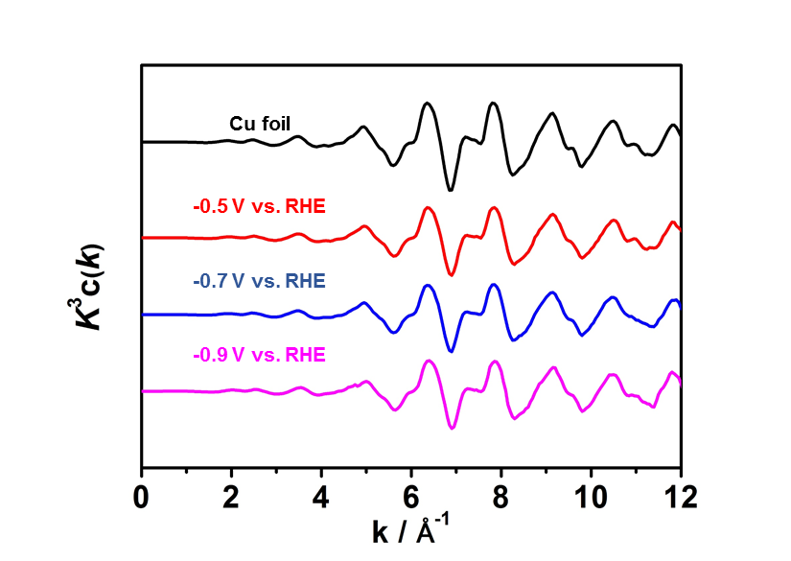
Figure S19. Cu K-edge extended XAFS oscillation function k³w(k) for Cu-nr-OR at different potentials

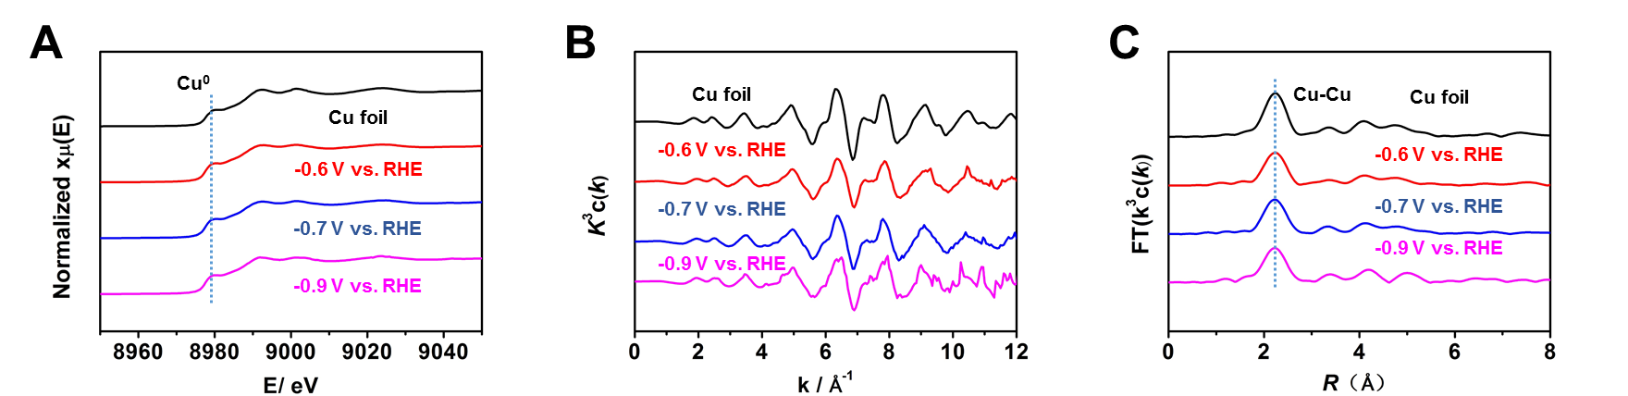
Figure S20. (A) XANES spectra at the Cu K-edge for Cu-nr at different potentials. (B) Cu K-edge extended XAFS oscillation function k³w(k) for Cu-nr at different potentials. (C) The corresponding Fourier transforms FT(k³w(k)) for Cu-nr at different potentials.

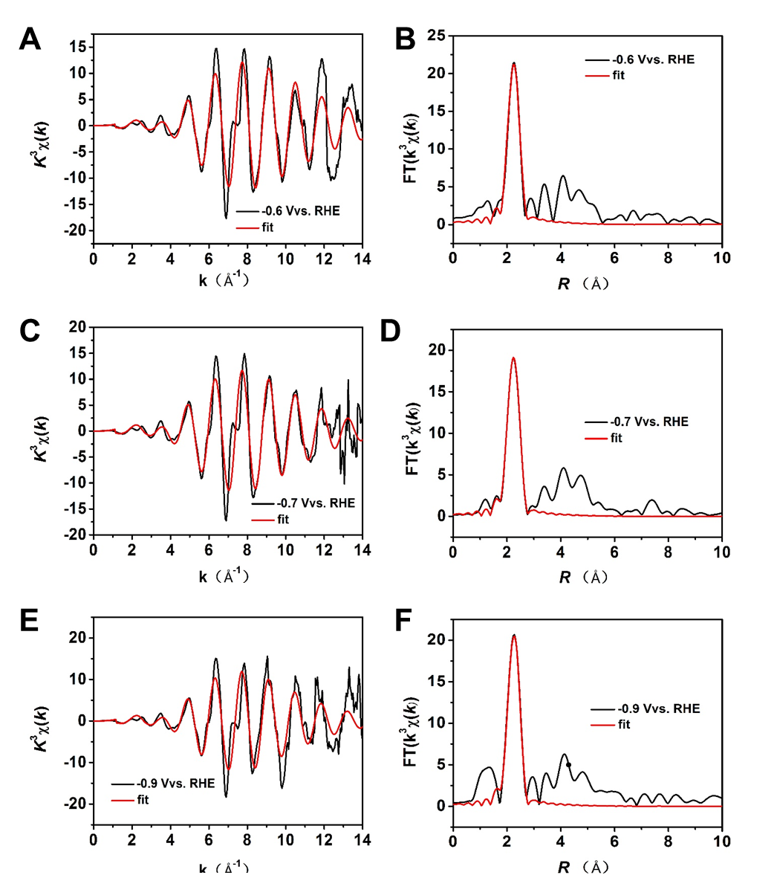
Figure S21. The EXAFS data fitting results of Cu-nr at different potentials.

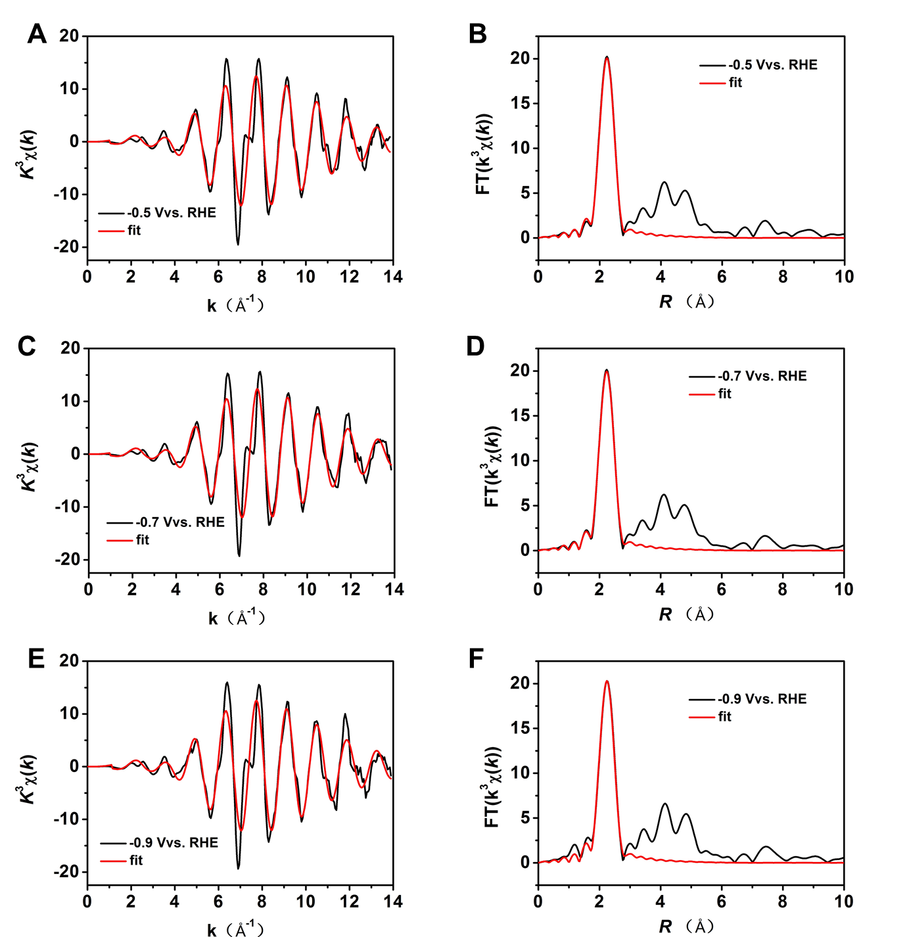
Figure S22. The EXAFS data fitting results of Cu-nr-OR at different potentials.

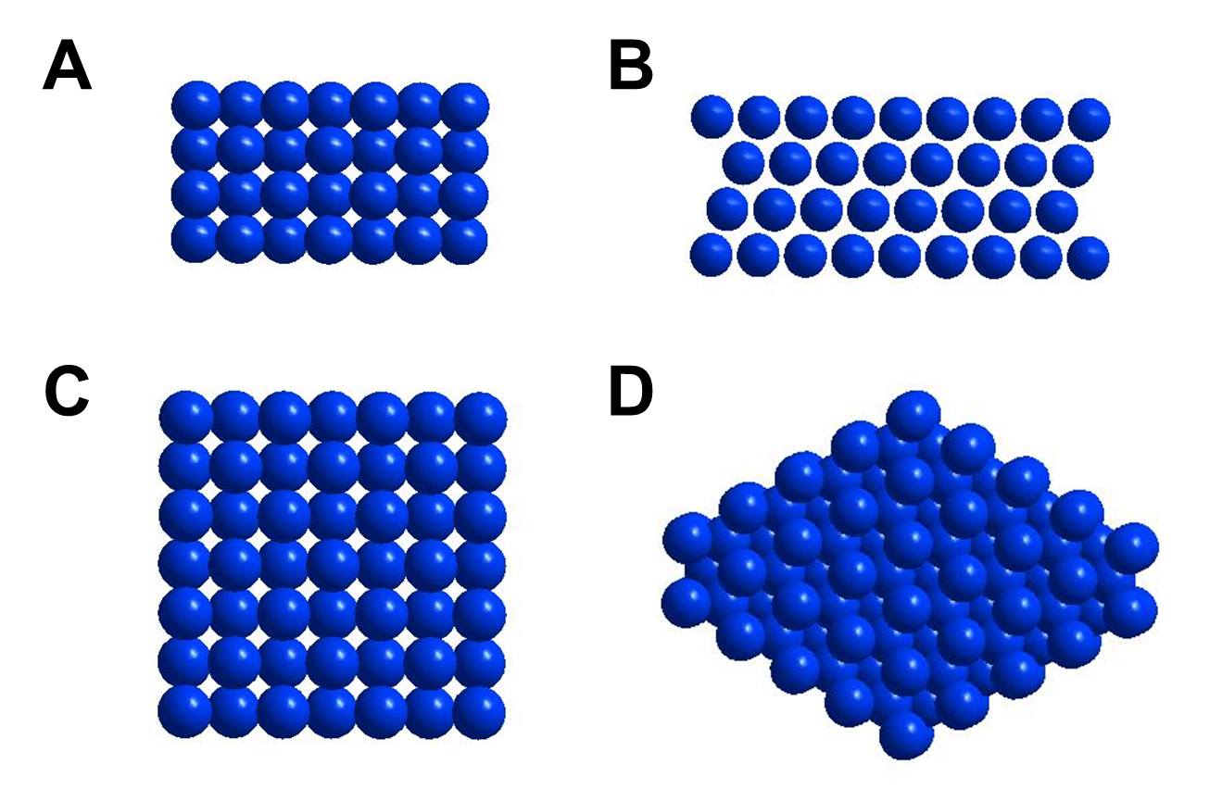
Figure S23. (A) Side view and (C) top view of the Cu (100). (B) Side view and (D) top view of the Cu (111).

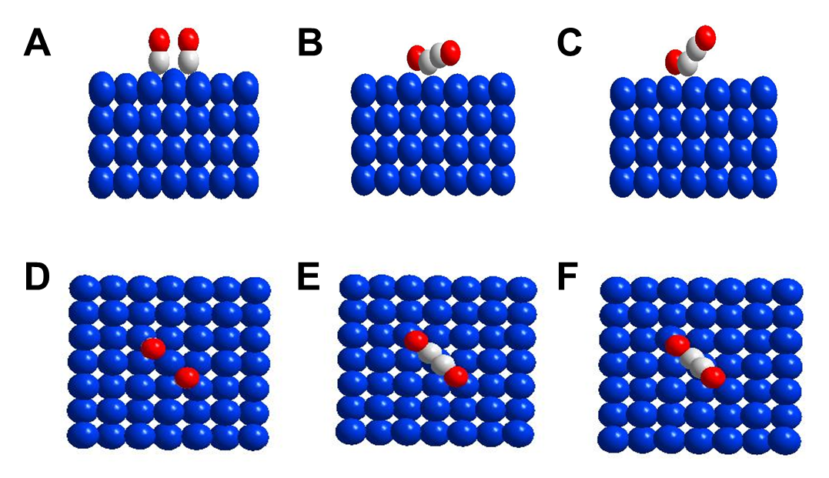
Figure S24. (A) Side view and (D) top view of 2CO* on the Cu (100). (B) Side view and (E) top view of transition states on the Cu (100). (C) Side view and (F) top view of OCCO* on the Cu (100). The atoms in blue, gray and red represent Cu, C, and O, respectively.

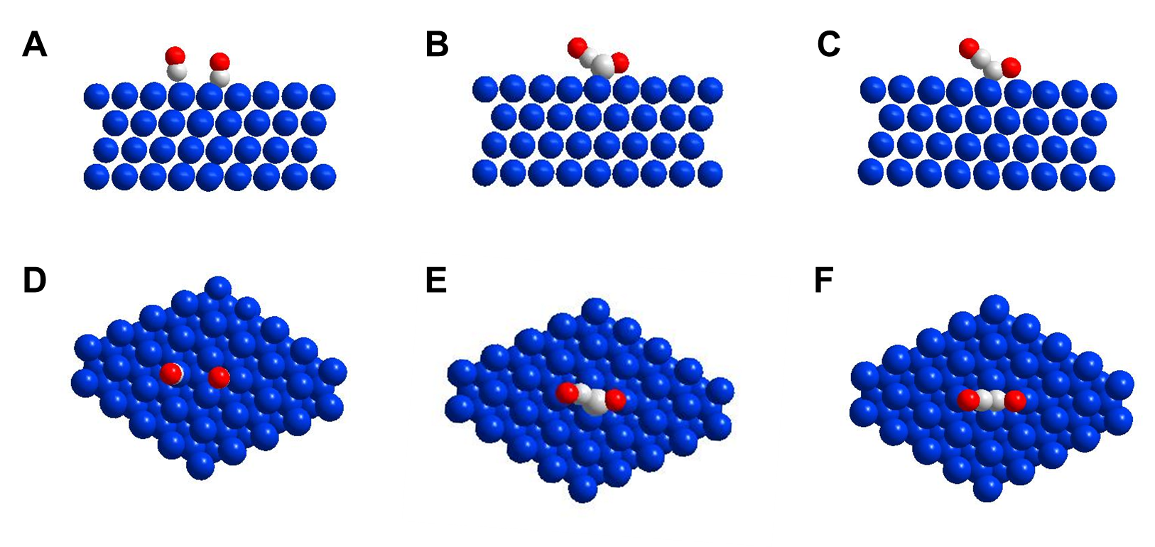
Figure S25. (A) Side view and (D) top view of 2CO* on the Cu (111). (B) Side view and (E) top view of transition states on the Cu (111). (C) Side view and (F) top view of OCCO* on the Cu (111). The atoms in blue, gray and red represent Cu, C, and O, respectively.

Supplementary Tables

Table S1. Comparision of C2+ products in CO₂RR on various Cu-based catalysts.

Samples | E vs. RHE | FE_{C2+} (%) | J (mA cm⁻²) | references
Cu-nr-OR | -0.9 | 83.8 | 341.5 | This work
Cu-nr | -0.9 | 64.6 | 271.2 | This work
Ce(OH)x/Cu | -0.7 | 80.3 | 297 | S4
FeTPP[Cl]/Cu | -0.82 | 85 | 302.4 | S5
Cu-CO₂ | -0.71 | 90 | 577 | S6
CuAg wire | -0.7 | 85 | 300 | S7
NGQ/Cu-nr | -0.9 | 80.4 | 282.1 | S8
Cu-chloride | -0.68 | 84 | 400 | S9
Nanoporous Cu | -0.67 | 62 | 653 | S1

Table S2. Structural parameters of Cu-nr and Cu-nr-OR at different potentials extracted from the EXAFS fitting.
Sample |  | Potential V vs.RHE | Scattering pair | CN | R(Å) | σ ²(10⁻³Å²) | ΔE₀(eV)
 | Cu-nr | -0.6 | Cu-Cu | 9.8.0±0.8 | 2.55±0.02 | 5.4±0.8 | 3.4±0.3
 | Cu-nr | -0.7 | Cu-Cu | 9.8±0.9 | 2.55±0.02 | 5.8±0.6 | 3.4±0.8
 | Cu-nr | -0.9 | Cu-Cu | 9.8±0.7 | 2.55±0.02 | 6.2±0.7 | 3.4±0.7
 | Cu-nr-OR | -0.5 | Cu-Cu | 9.5±0.6 | 2.56±0.02 | 5.1±0.6 | 3.2±0.6
 | Cu-nr-OR | -0.7 | Cu-Cu | 9.5±0.8 | 2.56±0.02 | 5.1±0.6 | 3.2±0.8
 | Cu-nr-OR | -0.9 | Cu-Cu | 9.5±0.7 | 2.56±0.02 | 5.1±0.7 | 3.2±0.7

S₀² is the amplitude reduction factor S₀²=0.85; CN is the coordination number; R is interatomic distance (the bond length between central atoms and surrounding coordination atoms); σ² is Debye-Waller factor (a measure of thermal and static disorder in absorber-scatterer distances); ΔE₀ is edge-energy shift (the difference between the zero kinetic energy value of the sample and that of the theoretical model). R factor is used to value the goodness of the fitting.

Table S3. The proportion of different crystal faces on Cu-nr and Cu-nr-OR.

 | Cu (100) / % | Cu (110) / % | Cu (111) / %
Cu-nr | 29 | 26 | 44
Cu-nr-OR | 32 | 28 | 39

Table S4. Activation energies (Ea) and enthalpy changes (ΔH) of CO dimerization on Cu (100) and Cu (111).

 | Ea (eV) | ΔH (eV)
Cu (100) | 1.43 | -0.15
Cu (111) | 1.54 | -0.03

References
S1 Lv, J. J. et al., A Highly Porous Copper Electrocatalyst for Carbon Dioxide Reduction. Adv. Mater. 30, e1803111 (2018).
S2 Kresse, G. & Furthmüller, J. Efficient iterative schemes for ab initio total-energy calculations using a plane-wave basis set. Phys. Rev. B 54, 11169-11186 (1996).
S3 Kresse, G. & Hafner, J. Ab initio. Phys. Rev. B 49, 14251-14269 (1994).
S4 Luo, M. et al., Hydroxide promotes carbon dioxide electroreduction to ethanol on copper via tuning of adsorbed hydrogen. Nat. Commun. 10, 5814 (2019).
S5 Li, F. et al., Cooperative CO₂-to-ethanol conversion via enriched intermediates at molecule-metal catalyst interfaces. Nat. Catal. 3, 75-82. (2020).
S6 Wang, Y. et al., Catalyst synthesis under CO₂ electroreduction favours faceting and promotes renewable fuels electrosynthesis. Nat. Catal. 3, 98-106 (2020).
S7 Hoang, T. T. H. et al., Nanoporous Copper-Silver Alloys by Additive-Controlled Electrodeposition for the Selective Electroreduction of CO₂ to Ethylene and Ethanol. J. Am. Chem. Soc. 140, 5791-5797 (2018).
S8 Chen, C. et al., Highly Efficient Electroreduction of CO₂ to C2+ Alcohols on Heterogeneous Dual Active Sites. Angew. Chem. Int. Ed. doi.org/10.1002/anie.202006847.
S9 Kibria, M. G. et al., A Surface Reconstruction Route to High Productivity and Selectivity in CO₂ Electroreduction toward C2+ Hydrocarbons. Adv. Mater. e1804867 (2018).

