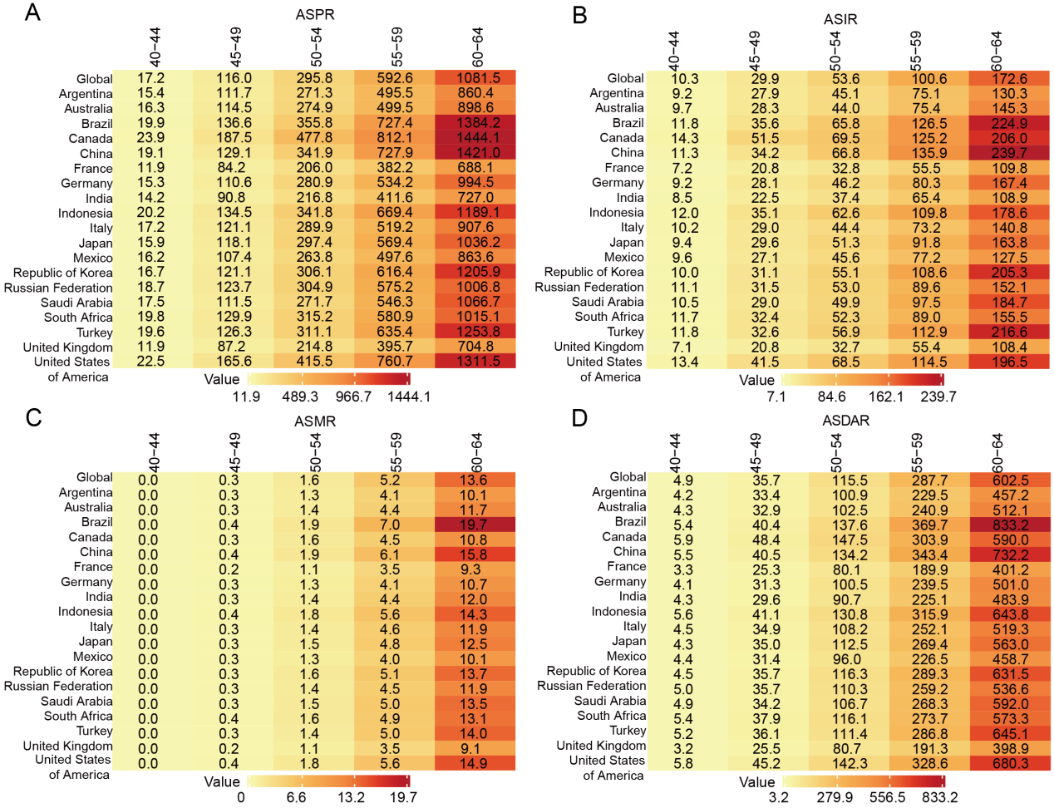
Fig. S1 The burden of early-onset Alzheimer 's disease and other dementia (EOAD) in different age groups in G20 countries and globally (2021). (A) ASPR; (B) ASIR; (C) ASMR; (D) ASDAR. The heat map color gradient is used to show the degree of burden, from light yellow (lower burden) to deep red (higher burden). ASPR: Age-standardized prevalence rate; ASIR: Age-standardized incidence rate; ASMR: Age-standardized mortality rate; ASDAR: Age-standardized disability-adjusted life year rares

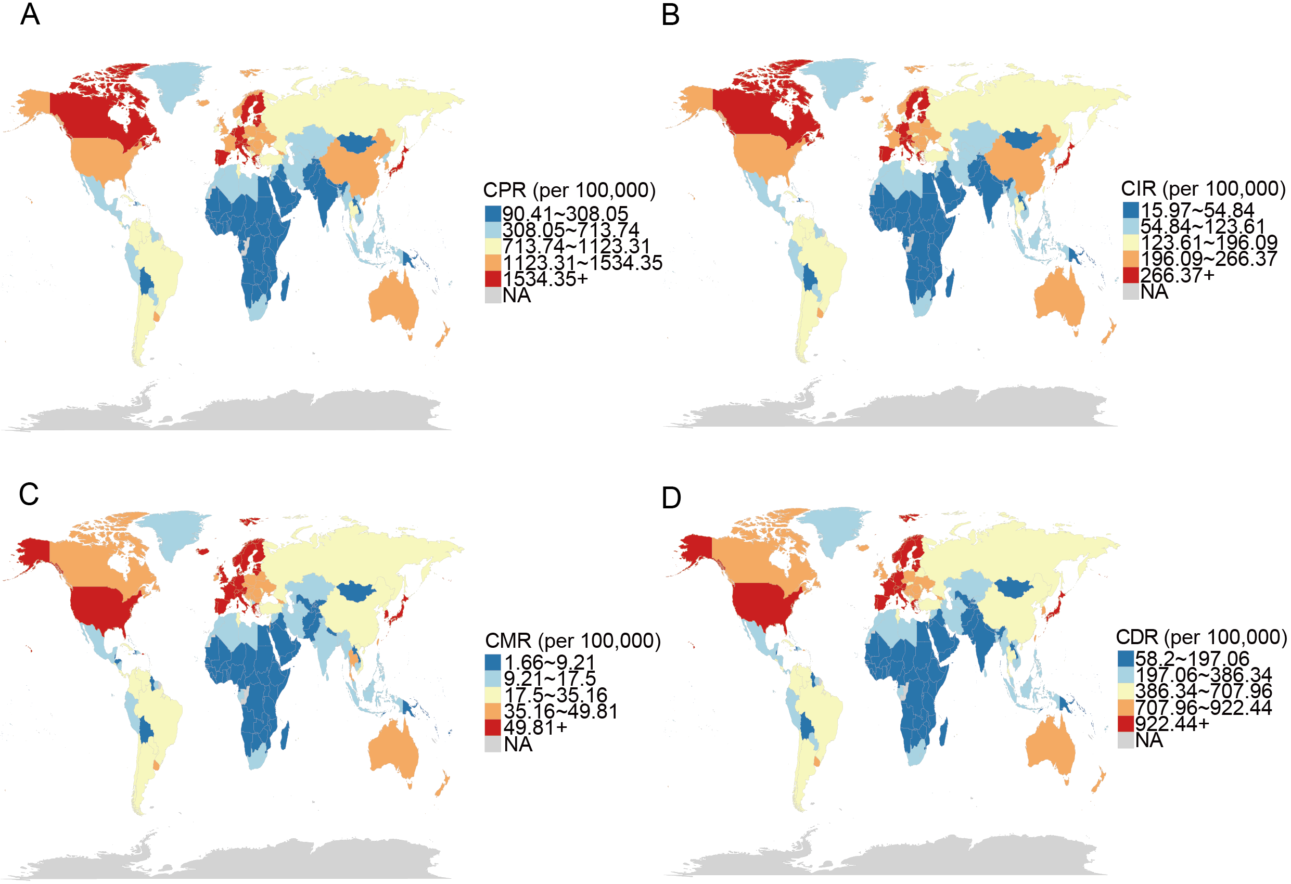
Fig.S2 Geographical distribution of the global burden of EOAD in 2021. (A) CPR; (B) CIR; (C) CMR; (D) CDR, per 100,000 population. The map presents the burden intensity of different regions with a color gradient, from light blue (low burden) to deep red (high burden). CPR: Crude Prevalence Rate; CIR: Crude incidence rate; CMR: Crude Mortality Rate; CDR: Crude DALYs Rate
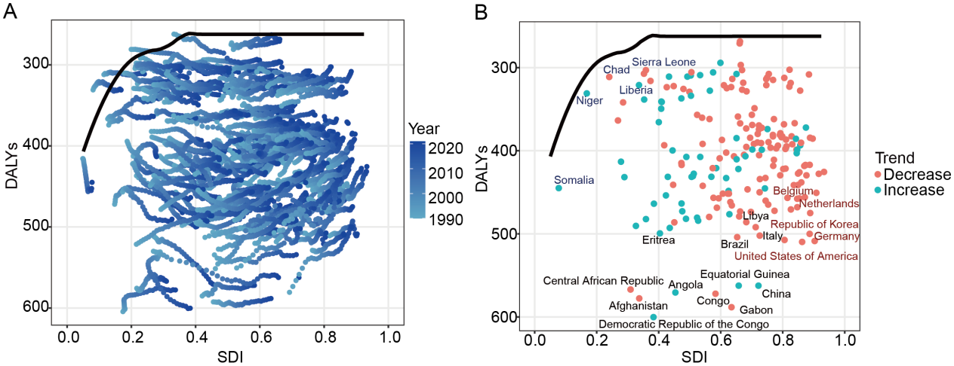
Fig. S3 Frontier analysis (1990-2021) between SDI and DALYs caused by EOAD in 40-64 years old. (A) The trajectories of DALYs and SDI in different countries from 1990 to 2021. Each point represents a population DALYs (per 100,000 people) for a certain year in a country. The color of the point from light to dark represents the year from early to late (light blue represents 1990, dark blue represents 2020), and the point is connected into a line to represent the trajectory of a country. The black solid line represents the global expected DALYs benchmark level predicted by SDI. (B) The distribution map of DALYs and SDI in each country in 2021. The red dot indicates countries with a downward trend in DALYs from 1990 to 2021, and the blue-green dot indicates countries with rising DALYs. Country name labeling is used to highlight different types of performance: black fonts identify countries with high DALYs values, red fonts indicate countries with high SDI but still at a high level of DALYs, and blue fonts represent countries with low SDI and light DALYs burden.

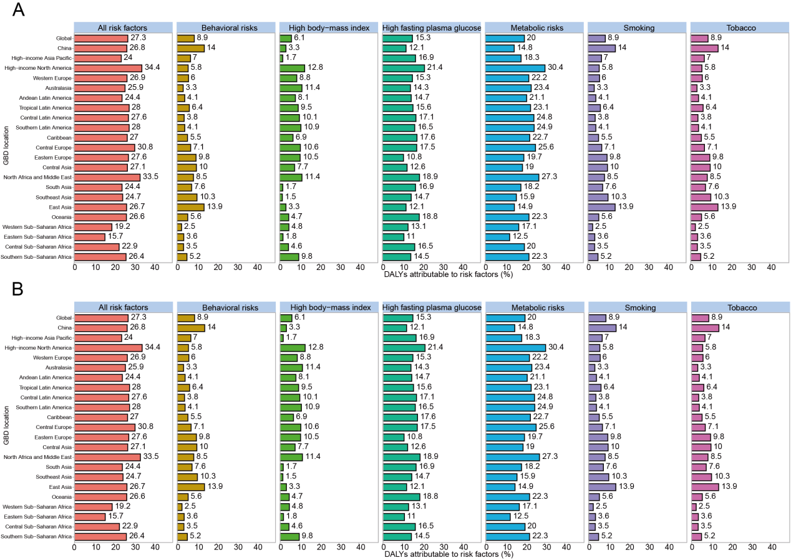
Fig.S4 Percentage of DALYs attributable to various risk factors for EOAD in different GBD regions in 2021. (A) Attribution burden of risk factors in male population. (B) Attribution burden of risk factors in female population.

Supplementary Table S1 Changes in the prevalence, morbidity, incidence, and DALYs and age-standardized rate of early-onset Alzheimer 's disease and other dementia in 19 member countries of the G20 (the 20th member country is the EU) from 1990 to 2021.
Measure | Location | Number_1990 | Rate_1990 | Number_2021 | Rate_2021 | PC | AAPC_UI
Prevalence | Global | 21799761 (19067087, 24837693) | 672.22 (588.73, 763.95) | 56856688 (49382064, 64977512) | 694.01 (602.88, 794.08) | 3.20% | 0% (-0.02%, 0.03%)
Prevalence | Argentina | 182119 (156924, 207945) | 624.58 (540.01, 715.42) | 347969 (301069, 398592) | 592.53 (512.44, 676.59) | -5.10% | -0.18% (-0.2%, -0.16%)
Prevalence | Australia | 132333 (114608, 150477) | 702.82 (607.11, 797.96) | 300594 (262040, 338693) | 589.93 (513.23, 663.34) | -16.10% | -0.6% (-0.64%, -0.56%)
Prevalence | Brazil | 526396 (455692, 602287) | 759.73 (661.49, 864.32) | 1825795 (1586088, 2075169) | 761.45 (661.47, 869.62) | 0.20% | -0.05% (-0.09%, 0%)
Prevalence | Canada | 285210 (250854, 320424) | 885.63 (781.67, 993.27) | 631350 (556981, 707709) | 792.31 (701.61, 888.19) | -10.50% | -0.55% (-0.64%, -0.45%)
Prevalence | China | 4024536 (3446398, 4623086) | 703.14 (608.36, 809.51) | 16990827 (14488494, 19672741) | 900.82 (770.92, 1043.22) | 28.10% | 0.44% (0.35%, 0.53%)
Prevalence | France | 511500 (451626, 568213) | 553.5 (491.88, 615.65) | 924607 (807081, 1045108) | 525.22 (458.8, 593.27) | -5.10% | -0.2% (-0.23%, -0.16%)
Prevalence | Germany | 1093577 (962012, 1237640) | 809.57 (715.41, 909.95) | 1995249 (1724732, 2268186) | 820.5 (713.82, 930.77) | 1.40% | 0.06% (0.03%, 0.08%)
Prevalence | India | 1350128 (1162809, 1543953) | 440.05 (382.11, 503.9) | 4169684 (3591612, 4772663) | 436.13 (376.02, 501.15) | -0.90% | -0.16% (-0.21%, -0.12%)
Prevalence | Indonesia | 460740 (396354, 528840) | 678.72 (587.97, 777.61) | 1109364 (953356, 1273166) | 662.13 (571.11, 761.15) | -2.40% | -0.08% (-0.1%, -0.05%)
Prevalence | Italy | 633483 (535315, 736346) | 692.96 (589.47, 798.14) | 1427946 (1213976, 1647057) | 759.15 (652.54, 869.83) | 9.60% | 0.13% (-0.01%, 0.27%)
Prevalence | Japan | 1023227 (885710, 1169176) | 649.68 (564.43, 739.33) | 3367358 (2893951, 3872084) | 674.1 (584.78, 770.24) | 3.80% | 0.3% (0.24%, 0.36%)
Prevalence | Mexico | 200517 (172127, 230327) | 585.32 (506.17, 669.22) | 608490 (526098, 699600) | 534.2 (460.41, 612.87) | -8.70% | -0.2% (-0.24%, -0.16%)
Prevalence | Republic of Korea | 149622 (129867, 168608) | 751.01 (651.71, 856.59) | 697045 (609566, 789739) | 739.81 (647.7, 836.31) | -1.50% | 0.01% (-0.05%, 0.06%)
Prevalence | Russian Federation | 1044398 (900321, 1202421) | 669.98 (580.01, 769.14) | 1605863 (1392755, 1846536) | 661.42 (573.18, 758.61) | -1.30% | -0.08% (-0.13%, -0.03%)
Prevalence | Saudi Arabia | 30755 (26362, 35091) | 747.42 (639.76, 857.11) | 71832 (61576, 82118) | 701.74 (600.97, 807.91) | -6.10% | -0.2% (-0.22%, -0.19%)
Prevalence | South Africa | 109918 (94755, 125478) | 646.32 (559.39, 738.74) | 224953 (193264, 257575) | 609.51 (526.77, 695.77) | -5.70% | -0.16% (-0.17%, -0.15%)
Prevalence | Turkey | 235493 (203402, 268352) | 873.29 (753.94, 992.75) | 688425 (595237, 787216) | 819.36 (706.2, 936.59) | -6.20% | -0.25% (-0.27%, -0.23%)
Prevalence | United Kingdom | 607852 (521255, 696576) | 625.6 (539.95, 712.3) | 906467 (778218, 1036141) | 591.08 (508.13, 674.77) | -5.50% | -0.13% (-0.18%, -0.09%)
Prevalence | United States of America | 2736354 (2365020, 3137757) | 809.27 (700.87, 926.57) | 4876579 (4231620, 5601213) | 773.07 (670.26, 887.66) | -4.50% | -0.17% (-0.19%, -0.16%)
Incidence | Global | 3834526 (3367544, 4358428) | 116.97 (102.77, 132.32) | 9837056 (8620519, 11163700) | 119.76 (104.96, 135.89) | 2.40% | -0.02% (-0.04%, 0%)
Incidence | Argentina | 32950 (28371, 37756) | 112.19 (97.11, 128.39) | 62825 (54326, 72188) | 106.73 (92.2, 122.29) | -4.90% | -0.17% (-0.18%, -0.15%)
Incidence | Australia | 23451 (20535, 26658) | 122.93 (107.54, 138.36) | 52191 (45954, 58772) | 102.66 (90.27, 115.36) | -16.50% | -0.62% (-0.67%, -0.58%)
Incidence | Brazil | 90515 (79222, 102650) | 129.35 (113.26, 146.89) | 305421 (269292, 345696) | 127.08 (112.01, 144.66) | -1.80% | -0.11% (-0.15%, -0.07%)
Incidence | Canada | 48603 (43425, 54209) | 149.59 (134.39, 165.87) | 105264 (93819, 117160) | 132.4 (118.02, 147.29) | -11.50% | -0.55% (-0.61%, -0.48%)
Incidence | China | 703178 (601506, 808633) | 121.11 (105.5, 137.99) | 2914112 (2504728, 3350743) | 151.47 (131.22, 173.34) | 25.10% | 0.41% (0.33%, 0.49%)
Incidence | France | 91990 (82415, 101758) | 99.39 (89.46, 109.62) | 163141 (143062, 184345) | 93.63 (82.25, 105.56) | -5.80% | -0.22% (-0.26%, -0.19%)
Incidence | Germany | 200149 (178695, 222831) | 145.12 (130.54, 161.52) | 339825 (299328, 382749) | 142.13 (124.57, 159.72) | -2.10% | -0.1% (-0.13%, -0.07%)
Incidence | India | 241550 (209565, 274946) | 79.45 (68.69, 90.82) | 749490 (648646, 856823) | 78.92 (68.29, 90.58) | -0.70% | -0.16% (-0.21%, -0.11%)
Incidence | Indonesia | 78840 (68676, 89397) | 115.97 (101.07, 132) | 189722 (164142, 216604) | 113.31 (98.38, 129.52) | -2.30% | -0.07% (-0.09%, -0.05%)
Incidence | Italy | 106541 (89872, 123112) | 116.29 (98.96, 133.09) | 248809 (215069, 285482) | 134.76 (116.74, 153.65) | 15.90% | 0.28% (0.09%, 0.47%)
Incidence | Japan | 184306 (160124, 210886) | 115.81 (101.01, 131.94) | 576270 (503457, 662794) | 117.23 (102.05, 133.68) | 1.20% | 0.2% (0.15%, 0.26%)
Incidence | Mexico | 36269 (31428, 41673) | 106.03 (91.84, 120.63) | 110467 (96168, 125494) | 97.19 (84.27, 111.26) | -8.30% | -0.19% (-0.23%, -0.15%)
Incidence | Republic of Korea | 26566 (23162, 30284) | 127.7 (112.52, 145.12) | 117489 (102910, 133127) | 124.63 (109.44, 140.89) | -2.40% | 0.01% (-0.04%, 0.06%)
Incidence | Russian Federation | 183438 (158327, 212154) | 117.07 (102.29, 133.67) | 279806 (243531, 319869) | 115.89 (101.23, 131.98) | -1% | -0.07% (-0.12%, -0.03%)
Incidence | Saudi Arabia | 5403 (4676, 6166) | 127.34 (111.13, 146.35) | 13064 (11315, 14779) | 120.44 (104.42, 138.45) | -5.40% | -0.19% (-0.2%, -0.17%)
Incidence | South Africa | 19443 (16975, 21983) | 114.18 (99.52, 130.09) | 39715 (34529, 45264) | 107.78 (93.63, 122.59) | -5.60% | -0.16% (-0.17%, -0.14%)
Incidence | Turkey | 40370 (35493, 45675) | 147.22 (129.54, 166.99) | 117991 (102838, 133396) | 139.1 (120.57, 158.16) | -5.50% | -0.22% (-0.24%, -0.2%)
Incidence | United Kingdom | 112869 (97201, 130280) | 114.58 (99.74, 130.77) | 164947 (142721, 190062) | 107.93 (93.37, 123.89) | -5.80% | -0.17% (-0.2%, -0.13%)
Incidence | United States of America | 471556 (410796, 540646) | 138.61 (120.85, 157.59) | 822911 (718803, 935112) | 131.29 (113.93, 149.6) | -5.30% | -0.19% (-0.2%, -0.17%)
Mortality | Global | 663294 (163580, 1764991) | 25.04 (6.29, 66.28) | 1952677 (512981, 4984737) | 25.16 (6.68, 64.25) | 0.50% | -0.02% (-0.03%, -0.01%)
Mortality | Argentina | 5215 (1290, 14323) | 20.88 (5.2, 56.06) | 12020 (3078, 31562) | 20.21 (5.17, 53.04) | -3.20% | -0.06% (-0.07%, -0.04%)
Mortality | Australia | 4101 (1001, 10983) | 24.2 (6.03, 63.96) | 12846 (3361, 32378) | 22.89 (5.93, 57.75) | -5.40% | -0.16% (-0.18%, -0.14%)
Mortality | Brazil | 15457 (3832, 40591) | 28.16 (7.35, 73.41) | 63898 (16794, 161436) | 27.29 (7.15, 69.06) | -3.10% | -0.07% (-0.09%, -0.06%)
Mortality | Canada | 6682 (1705, 17577) | 22.03 (5.7, 57.72) | 18653 (4957, 47198) | 21.15 (5.57, 54) | -4% | -0.16% (-0.18%, -0.13%)
Mortality | China | 119809 (28349, 322103) | 31.39 (7.6, 83.63) | 491774 (124968, 1330182) | 30.82 (7.88, 82.43) | -1.80% | -0.19% (-0.23%, -0.15%)
Mortality | France | 20499 (5118, 54435) | 22.98 (5.79, 60.15) | 46573 (12129, 116347) | 21.69 (5.61, 54.3) | -5.60% | -0.18% (-0.2%, -0.16%)
Mortality | Germany | 37435 (9417, 94968) | 29.5 (7.52, 73.8) | 78577 (21416, 186714) | 29.25 (7.91, 69.29) | -0.80% | -0.07% (-0.12%, -0.02%)
Mortality | India | 30324 (6852, 88796) | 13.35 (3.01, 38.49) | 133287 (31384, 367633) | 16.98 (4.05, 46.35) | 27.20% | 0.89% (0.82%, 0.95%)
Mortality | Indonesia | 8976 (2114, 25126) | 17.55 (4.1, 47.58) | 26277 (6326, 72878) | 22.97 (5.62, 63.06) | 30.90% | 0.77% (0.68%, 0.87%)
Mortality | Italy | 25599 (6506, 67615) | 31.5 (8.08, 81.26) | 64759 (17891, 156721) | 29.75 (8.1, 72.88) | -5.60% | -0.09% (-0.13%, -0.05%)
Mortality | Japan | 36973 (9425, 96174) | 27.18 (7.14, 69.33) | 172807 (50406, 398754) | 26.33 (7.39, 62.16) | -3.10% | -0.07% (-0.1%, -0.04%)
Mortality | Mexico | 4203 (1005, 11878) | 15.1 (3.65, 41.69) | 15548 (3646, 43852) | 14.8 (3.49, 41.39) | -2% | -0.07% (-0.09%, -0.06%)
Mortality | Republic of Korea | 4925 (1232, 12867) | 35.68 (9.05, 90) | 25859 (6917, 62627) | 29.02 (7.87, 69.71) | -18.70% | -0.53% (-0.6%, -0.46%)
Mortality | Russian Federation | 26902 (6595, 75553) | 21.62 (5.27, 59.64) | 50932 (12579, 141824) | 21.05 (5.19, 58.31) | -2.60% | -0.09% (-0.1%, -0.08%)
Mortality | Saudi Arabia | 934 (223, 2463) | 28.48 (6.96, 74.02) | 1696 (409, 4714) | 25.85 (6.36, 71.39) | -9.20% | -0.36% (-0.39%, -0.33%)
Mortality | South Africa | 3120 (759, 8446) | 21.16 (5.19, 57.34) | 6666 (1615, 18627) | 22.58 (5.4, 61.8) | 6.70% | 0.18% (0.09%, 0.26%)
Mortality | Turkey | 6866 (1707, 18082) | 30.08 (7.54, 79.27) | 20001 (5054, 52548) | 26.16 (6.61, 69.03) | -13% | -0.45% (-0.59%, -0.32%)
Mortality | United Kingdom | 21688 (5405, 58197) | 23.69 (5.96, 62.48) | 37559 (9844, 94974) | 22.61 (5.88, 57.62) | -4.60% | -0.09% (-0.13%, -0.05%)
Mortality | United States of America | 99957 (25910, 258206) | 29.64 (7.72, 76.08) | 198045 (53297, 494055) | 29.17 (7.74, 73.52) | -1.60% | -0.08% (-0.09%, -0.06%)
DALYs | Global | 13572308 (6439341, 29586865) | 445.75 (206.08, 958.03) | 36332687 (17237624, 76873276) | 450.98 (212.69, 950.16) | 1.20% | -0.02% (-0.03%, 0%)
DALYs | Argentina | 105932 (52094, 225365) | 382.45 (185.41, 805.4) | 217920 (103875, 455816) | 369.59 (176.33, 772.22) | -3.40% | -0.09% (-0.1%, -0.07%)
DALYs | Australia | 79881 (38809, 167478) | 439.01 (211.17, 915.75) | 210791 (97742, 437602) | 398.66 (187.36, 824.12) | -9.20% | -0.32% (-0.33%, -0.31%)
DALYs | Brazil | 332564 (155594, 736269) | 511.96 (234.64, 1114.18) | 1201684 (564832, 2563994) | 503.99 (236.06, 1073.53) | -1.60% | -0.06% (-0.07%, -0.05%)
DALYs | Canada | 142377 (73455, 282907) | 450.78 (230.93, 891.1) | 345631 (172913, 685499) | 417.19 (213, 829.97) | -7.50% | -0.35% (-0.4%, -0.3%)
DALYs | China | 2702484 (1239177, 6085395) | 534.47 (236.2, 1190.6) | 10072478 (4947154, 22219154) | 562.39 (271.16, 1238.81) | 5.20% | -0.02% (-0.07%, 0.02%)
DALYs | France | 352243 (162106, 767033) | 388.02 (176.76, 835.11) | 699416 (319077, 1483216) | 366.86 (171.08, 763.86) | -5.50% | -0.18% (-0.2%, -0.17%)
DALYs | Germany | 674607 (328264, 1415808) | 510.92 (245.56, 1063.38) | 1288751 (625382, 2595514) | 508.64 (250.83, 1028.42) | -0.40% | -0.05% (-0.09%, -0.01%)
DALYs | India | 760230 (352482, 1776414) | 262.07 (122.6, 600.9) | 2787339 (1236932, 6211031) | 305.73 (135.42, 676.67) | 16.70% | 0.52% (0.48%, 0.56%)
DALYs | Indonesia | 232715 (116393, 493915) | 365.07 (178.21, 779.12) | 633905 (302564, 1387130) | 422 (194.37, 933.56) | 15.60% | 0.41% (0.35%, 0.48%)
DALYs | Italy | 450863 (205649, 977093) | 516.62 (233.92, 1110.05) | 1008203 (479893, 2046522) | 507.4 (243.87, 1036.59) | -1.80% | -0.03% (-0.06%, 0%)
DALYs | Japan | 688560 (323202, 1492468) | 460.57 (214.58, 985.33) | 2539294 (1209735, 5046913) | 456 (221.79, 920.17) | -1% | 0.03% (0.01%, 0.06%)
DALYs | Mexico | 100577 (50171, 215759) | 309.4 (150.68, 660.7) | 331079 (163369, 717517) | 296.84 (144.66, 642.67) | -4.10% | -0.11% (-0.12%, -0.1%)
DALYs | Republic of Korea | 101642 (47102, 222693) | 580.65 (260.79, 1256.03) | 461797 (218816, 928411) | 500.05 (234.92, 1004.38) | -13.90% | -0.36% (-0.41%, -0.31%)
DALYs | Russian Federation | 589959 (286543, 1293549) | 406.03 (192.39, 878.44) | 971902 (459547, 2086551) | 397.87 (188.83, 852.89) | -2% | -0.08% (-0.1%, -0.06%)
DALYs | Saudi Arabia | 19124 (8991, 40204) | 501.05 (232.4, 1064.97) | 40839 (19150, 87867) | 456.71 (208.96, 1019.77) | -8.80% | -0.33% (-0.35%, -0.31%)
DALYs | South Africa | 64719 (31062, 139266) | 396.83 (186.63, 850.32) | 140199 (65093, 313929) | 406.65 (185.95, 901.85) | 2.50% | 0.07% (0.01%, 0.13%)
DALYs | Turkey | 141131 (68914, 297639) | 551.48 (267.29, 1158.43) | 401906 (196644, 841832) | 491.99 (236.53, 1031.11) | -10.80% | -0.4% (-0.47%, -0.32%)
DALYs | United Kingdom | 388789 (183323, 833867) | 409.43 (191.44, 870.23) | 615410 (288559, 1286176) | 390.4 (183.98, 817.67) | -4.60% | -0.1% (-0.13%, -0.08%)
DALYs | United States of America | 1789056 (842342, 3821142) | 528.79 (248.85, 1122.13) | 3318643 (1550259, 6957871) | 509.74 (240.09, 1068.07) | -3.60% | -0.15% (-0.16%, -0.13%)

Supplementary Table S2 The age-standardized predictive value and its 95 % UI of the main epidemiological indicators of early-onset Alzheimer 's disease and other dementia in China from 2022 to 2041 were disaggregated by gender.
Measure | Sex | Year | Forecast_Value | Lower_95 | Upper_95
Prevalence | Male | 2022 | 762.8534004 | 747.0112955 | 778.6955054
Prevalence | Male | 2023 | 768.8467221 | 738.3175868 | 799.3758573
Prevalence | Male | 2024 | 774.8400437 | 734.6768278 | 815.0032596
Prevalence | Male | 2025 | 780.8333653 | 732.9361866 | 828.730544
Prevalence | Male | 2026 | 786.8266869 | 732.2813339 | 841.37204
Prevalence | Male | 2027 | 792.8200086 | 732.3530643 | 853.2869528
Prevalence | Male | 2028 | 798.8133302 | 732.9550948 | 864.6715655
Prevalence | Male | 2029 | 804.8066518 | 733.9662468 | 875.6470568
Prevalence | Male | 2030 | 810.7999734 | 735.3054784 | 886.2944685
Prevalence | Male | 2031 | 816.7932951 | 736.915422 | 896.6711681
Prevalence | Male | 2032 | 822.7866167 | 738.753704 | 906.8195294
Prevalence | Male | 2033 | 828.7799383 | 740.7879715 | 916.7719051
Prevalence | Male | 2034 | 834.7732599 | 742.9928588 | 926.5536611
Prevalence | Male | 2035 | 840.7665816 | 745.3480412 | 936.1851219
Prevalence | Male | 2036 | 846.7599032 | 747.8369349 | 945.6828715
Prevalence | Male | 2037 | 852.7532248 | 750.4457985 | 955.0606511
Prevalence | Male | 2038 | 858.7465464 | 753.1630947 | 964.3299982
Prevalence | Male | 2039 | 864.7398681 | 755.9790245 | 973.5007116
Prevalence | Male | 2040 | 870.7331897 | 758.8851816 | 982.5811978
Prevalence | Male | 2041 | 876.7265113 | 761.8742901 | 991.5787325
Prevalence | Female | 2022 | 1076.297533 | 1046.667362 | 1105.927703
Prevalence | Female | 2023 | 1110.509652 | 1055.259482 | 1165.759821
Prevalence | Female | 2024 | 1134.980476 | 1056.03501 | 1213.925942
Prevalence | Female | 2025 | 1153.861412 | 1053.487283 | 1254.235541
Prevalence | Female | 2026 | 1169.53468 | 1049.842672 | 1289.226689
Prevalence | Female | 2027 | 1183.367279 | 1046.176913 | 1320.557645
Prevalence | Female | 2028 | 1196.143638 | 1042.979701 | 1349.307576
Prevalence | Female | 2029 | 1208.313892 | 1040.444175 | 1376.183609
Prevalence | Female | 2030 | 1220.136341 | 1038.616963 | 1401.655718
Prevalence | Female | 2031 | 1231.759208 | 1037.47597 | 1426.042446
Prevalence | Female | 2032 | 1243.267548 | 1036.970261 | 1449.564835
Prevalence | Female | 2033 | 1254.710168 | 1037.04 | 1472.380337
Prevalence | Female | 2034 | 1266.115077 | 1037.625951 | 1494.604203
Prevalence | Female | 2035 | 1277.498345 | 1038.673574 | 1516.323116
Prevalence | Female | 2036 | 1288.869195 | 1040.134414 | 1537.603976
Prevalence | Female | 2037 | 1300.232919 | 1041.96619 | 1558.499648
Prevalence | Female | 2038 | 1311.592554 | 1044.132305 | 1579.052803
Prevalence | Female | 2039 | 1322.949843 | 1046.601163 | 1599.298522
Prevalence | Female | 2040 | 1334.305785 | 1049.345456 | 1619.266113
Prevalence | Female | 2041 | 1345.660954 | 1052.341517 | 1638.980391
Incidence | Male | 2022 | 131.6984705 | 129.1284359 | 134.2685051
Incidence | Male | 2023 | 132.6988242 | 127.7176537 | 137.6799947
Incidence | Male | 2024 | 133.6991778 | 127.1402876 | 140.2580681
Incidence | Male | 2025 | 134.6995315 | 126.8748256 | 142.5242374
Incidence | Male | 2026 | 135.6998852 | 126.7873656 | 144.6124047
Incidence | Male | 2027 | 136.7002388 | 126.8189441 | 146.5815336
Incidence | Male | 2028 | 137.7005925 | 126.9373696 | 148.4638154
Incidence | Male | 2029 | 138.7009462 | 127.1227792 | 150.2791131
Incidence | Male | 2030 | 139.7012998 | 127.3618942 | 152.0407054
Incidence | Male | 2031 | 140.7016535 | 127.6453174 | 153.7579896
Incidence | Male | 2032 | 141.7020072 | 127.9661091 | 155.4379052
Incidence | Male | 2033 | 142.7023608 | 128.3189719 | 157.0857497
Incidence | Male | 2034 | 143.7027145 | 128.6997529 | 158.7056761
Incidence | Male | 2035 | 144.7030682 | 129.1051247 | 160.3010116
Incidence | Male | 2036 | 145.7034218 | 129.532373 | 161.8744707
Incidence | Male | 2037 | 146.7037755 | 129.9792485 | 163.4283024
Incidence | Male | 2038 | 147.7041291 | 130.4438631 | 164.9643952
Incidence | Male | 2039 | 148.7044828 | 130.9246131 | 166.4843525
Incidence | Male | 2040 | 149.7048365 | 131.420123 | 167.98955
Incidence | Male | 2041 | 150.7051901 | 131.9292021 | 169.4811782
Incidence | Female | 2022 | 179.2734152 | 174.9404098 | 183.6064206
Incidence | Female | 2023 | 184.2720756 | 176.1974289 | 192.3467223
Incidence | Female | 2024 | 187.8600777 | 176.3277969 | 199.3923584
Incidence | Female | 2025 | 190.6404983 | 175.9832217 | 205.2977748
Incidence | Female | 2026 | 192.9585902 | 175.4853055 | 210.4318748
Incidence | Female | 2027 | 195.0120056 | 174.9886309 | 215.0353804
Incidence | Female | 2028 | 196.9138977 | 174.5630174 | 219.2647779
Incidence | Female | 2029 | 198.7290447 | 174.2355709 | 223.2225185
Incidence | Female | 2030 | 200.4945316 | 174.0124082 | 226.9766549
Incidence | Female | 2031 | 202.2315886 | 173.8898774 | 230.5732998
Incidence | Female | 2032 | 203.9523701 | 173.860287 | 234.0444532
Incidence | Female | 2033 | 205.6638339 | 173.9147529 | 237.412915
Incidence | Female | 2034 | 207.3699637 | 174.0445442 | 240.6953831
Incidence | Female | 2035 | 209.0730396 | 174.2416559 | 243.9044233
Incidence | Female | 2036 | 210.7743674 | 174.4989947 | 247.0497401
Incidence | Female | 2037 | 212.4746943 | 174.8103815 | 250.1390071
Incidence | Female | 2038 | 214.1744483 | 175.1704749 | 253.1784217
Incidence | Female | 2039 | 215.8738742 | 175.5746668 | 256.1730817
Incidence | Female | 2040 | 217.5731124 | 176.0189775 | 259.1272474
Incidence | Female | 2041 | 219.2722431 | 176.4999585 | 262.0445277
Mortality | Male | 2022 | 25.60641502 | 25.12292926 | 26.08990077
Mortality | Male | 2023 | 25.39402703 | 24.79680118 | 25.99125288
Mortality | Male | 2024 | 25.24001382 | 24.59092565 | 25.88910199
Mortality | Male | 2025 | 25.1283311 | 24.45356876 | 25.80309344
Mortality | Male | 2026 | 25.04734435 | 24.35946575 | 25.73522295
Mortality | Male | 2027 | 24.98861678 | 24.29394043 | 25.68329313
Mortality | Male | 2028 | 24.94603047 | 24.24780612 | 25.64425482
Mortality | Male | 2029 | 24.915149 | 24.21506617 | 25.61523182
Mortality | Male | 2030 | 24.89275529 | 24.19169717 | 25.5938134
Mortality | Male | 2031 | 24.87651648 | 24.17494606 | 25.5780869
Mortality | Male | 2032 | 24.86474091 | 24.16290125 | 25.56658057
Mortality | Male | 2033 | 24.85620185 | 24.15422065 | 25.55818305
Mortality | Male | 2034 | 24.85000975 | 24.14795413 | 25.55206536
Mortality | Male | 2035 | 24.84551954 | 24.1434248 | 25.54761428
Mortality | Male | 2036 | 24.84226347 | 24.14014815 | 25.54437879
Mortality | Male | 2037 | 24.83990233 | 24.13777619 | 25.54202846
Mortality | Male | 2038 | 24.83819014 | 24.13605832 | 25.54032197
Mortality | Male | 2039 | 24.83694855 | 24.13481374 | 25.53908337
Mortality | Male | 2040 | 24.83604822 | 24.13391183 | 25.5381846
Mortality | Male | 2041 | 24.83539533 | 24.13325812 | 25.53753255
Mortality | Female | 2022 | 33.79941248 | 33.24222503 | 34.35659993
Mortality | Female | 2023 | 33.79941248 | 33.01143043 | 34.58739453
Mortality | Female | 2024 | 33.79941248 | 32.83433551 | 34.76448945
Mortality | Female | 2025 | 33.79941248 | 32.68503758 | 34.91378738
Mortality | Female | 2026 | 33.79941248 | 32.55350347 | 35.04532149
Mortality | Female | 2027 | 33.79941248 | 32.43458754 | 35.16423742
Mortality | Female | 2028 | 33.79941248 | 32.32523306 | 35.2735919
Mortality | Female | 2029 | 33.79941248 | 32.22344839 | 35.37537657
Mortality | Female | 2030 | 33.79941248 | 32.12785013 | 35.47097483
Mortality | Female | 2031 | 33.79941248 | 32.03743106 | 35.5613939
Mortality | Female | 2032 | 33.79941248 | 31.95143077 | 35.64739419
Mortality | Female | 2033 | 33.79941248 | 31.86925854 | 35.72956642
Mortality | Female | 2034 | 33.79941248 | 31.79044456 | 35.8083804
Mortality | Female | 2035 | 33.79941248 | 31.71460795 | 35.88421701
Mortality | Female | 2036 | 33.79941248 | 31.64143477 | 35.95739019
Mortality | Female | 2037 | 33.79941248 | 31.57066268 | 36.02816228
Mortality | Female | 2038 | 33.79941248 | 31.50206978 | 36.09675518
Mortality | Female | 2039 | 33.79941248 | 31.43546634 | 36.16335862
Mortality | Female | 2040 | 33.79941248 | 31.3706887 | 36.22813626
Mortality | Female | 2041 | 33.79941248 | 31.30759446 | 36.2912305

