SUPPLEMENTARY INFORMATION

A multi-level spillover risk assessment for chikungunya virus in China: insights from the 2025 Foshan outbreak

Table S1. Street-level gravity spillover proportions (rank) in Foshan 2
Table S2. CHIKV spillover cases by district in Foshan, 2025 4
Table S3. Normalized gravity values for each city–street ID 6
Table S4. Provincial reported spillover cases 11
Fig. S1. Temporal gaussian distribution of imported cases 12
Fig. S2. Model structure and assumptions 13
Table S5. Model compartments: symbols, descriptions 15
Table S6. Model parameters and values 16
Table S7. Parameter descriptions, distributions, and values for the Index P 17
Table S8. National four-tier transmission-risk classification and historical outbreak weights 18
Fig. S3-S33 Provincial Index P maps 22
Reference 53

Table S1. Street-level gravity spillover proportions (rank) in Foshan
Table S1. Street-level gravity spillover proportions (rank) in Foshan
target_Chinese | target | gravity spillover proportion
石湾镇街道 | shiwan | 0.329295851
祖庙街道 | zumiao | 0.214795825
桂城街道 | guicheng | 0.093699768
张槎街道 | zhangcha | 0.075817072
陈村镇 | chen | 0.049808419
大沥镇 | dali | 0.039169249
伦教街道 | lunjiao | 0.036164717
大良街道 | daliang | 0.034432711
龙江镇 | longjiang | 0.027691407
容桂街道 | ronggui | 0.025247646
勒流街道 | leiliu | 0.023953597
南庄镇 | nanzhuang | 0.019174736
狮山镇 | shishan | 0.009161293
九江镇 | jiujiang | 0.004214469
西樵镇 | xiqiao | 0.003386235
杏坛镇 | xingtan | 0.002860074
荷城街道 | hecheng | 0.002756228
里水镇 | lishui | 0.002512671
均安镇 | junan | 0.001667932
西南街道 | xinan | 0.001567906
丹灶镇 | danzao | 0.001436318
云东海街道 | yundonghai | 0.000450047
乐平镇 | leping | 0.00034207
白坭镇 | baini | 0.000245037
大塘镇 | datang | 4.22E-05
杨和镇 | yanghe | 3.80E-05
明城镇 | mingcheng | 2.78E-05
芦苞镇 | lubao | 2.76E-05
更合镇 | genghe | 8.86E-06
南山镇 | nanshan | 4.25E-06

Table S2. CHIKV spillover cases by district in Foshan, 2025
Table S2. CHIKV spillover cases by district in Foshan, 2025
Date | Shunde District | Chancheng District | Nanhai District | Sanshui District | Gaoming District | Cumulative Cases | Main Sources
2025/7/8 | 1 imported case | 0 | 0 | 0 | 0 | 1 | [1]
2025/7/15 | 478 cases, mainly in Lecong, Beijiao, Chencun streets | 0 | 0 | 0 | 0 | 478 | [1]
2025/7/19 | 1,790 cases, mainly in Lecong, Beijiao, Chencun streets | 49 cases, mainly in Shiwanzhen, Zumiao, Zhangcha subdistricts | 34 cases, mainly in Guicheng subdistrict | Not reported | Not reported | 1,873 | [2]
2025/7/20 | 2,158 cases, mainly in Lecong, Beijiao, Chencun streets | 69 cases, mainly in Shiwanzhen, Zumiao, Zhangcha subdistricts | 58 cases, mainly in Guicheng subdistrict | 0 | 0 | 2,285 | [3]
2025/7/21 | 2,471 cases, mainly in Lecong, Beijiao, Chencun streets | 100 cases, mainly in Shiwanzhen, Zumiao, Zhangcha subdistricts | 84 cases, mainly in Guicheng subdistrict | 3 cases, mainly in Xinan subdistrict, Datang street | 0 | 2,658 | [2], [4]
2025/7/22 | 2,934 cases, mainly in Lecong, Beijiao, Chencun streets | 147 cases, mainly in Shiwanzhen, Zumiao, Zhangcha subdistricts | 107 cases, mainly in Guicheng subdistrict | 5 cases, mainly in Xinan subdistrict and Yundonghai subdistrict | 1 case in Hecheng subdistrict | 3,194 | [5]
2025/7/23 | 3,317 cases, mainly in Lecong, Beijiao, Chencun streets | 178 cases, mainly in Shiwanzhen, Zumiao, Zhangcha subdistricts | 141 cases, mainly in Guicheng subdistrict | 6 cases, mainly in Xinan subdistrict and Yundonghai subdistrict | 3 cases in Hecheng subdistrict | 3,645 | [6], [7]
2025/7/24 | 3,627 | 210 | 169 | 8 | 3 | 4,014 | —
From July 8, 2025, Shunde District reported 1 imported case, with no cases in other districts【1】. By July 15, all 478 cases were concentrated in Shunde, mainly in Lecong, Beijiao, and Chencun streets【1】. On July 19, Shunde (1,790 cases) remained the main affected district, with cases concentrated in Lecong, Beijiao, and Chencun; Chancheng (49 cases) mainly in Shiwanzhen, Zumiao, and Zhangcha subdistricts; Nanhai (34 cases) mainly in Guicheng subdistrict; Sanshui and Gaoming had no reported cases【2】. On July 20, the distribution pattern was similar: Shunde (2,158) mainly in Lecong, Beijiao, and Chencun; Chancheng (69) in Shiwanzhen, Zumiao, Zhangcha; Nanhai (58) in Guicheng; Sanshui and Gaoming reported no cases【3】. By July 21, Shunde (2,471) still led, concentrated in Lecong, Beijiao, and Chencun; Chancheng (100) in Shiwanzhen, Zumiao, Zhangcha; Nanhai (84) in Guicheng; Sanshui (3) in Xinan and Datang; Gaoming had no cases【2】【4】. On July 22, Shunde (2,934) remained highest, mainly in Lecong, Beijiao, and Chencun; Chancheng (147) in Shiwanzhen, Zumiao, Zhangcha; Nanhai (107) in Guicheng; Sanshui (5) in Xinan and Yundonghai; Gaoming (1) in Hecheng【5】. On July 23, the situation persisted: Shunde (3,317) in Lecong, Beijiao, and Chencun; Chancheng (178) in Shiwanzhen, Zumiao, Zhangcha; Nanhai (141) in Guicheng; Sanshui (6) in Xinan and Yundonghai; Gaoming (3) in Hecheng【6】【7】. By July 24, Shunde, Chancheng, and Nanhai remained the primary affected areas; Sanshui had small numbers in Xinan and Yundonghai; Gaoming possibly recorded zero cases.

Table S3. Normalized gravity values for each city–street ID
Table S3. Normalized gravity values for each city–street ID
Rank | City-street ID | Normalized gravity ratio | Rank | City-street ID | Normalized gravity ratio
1 | fs-shiwan | 0.064133297 | 105 | gz-qianjin | 0.002785333
2 | fs-zumiao | 0.038151638 | 106 | gz-jingtai | 0.002622983
3 | gz-longjin | 0.02633717 | 107 | gz-helong | 0.002512408
4 | gz-fengyuan | 0.024217742 | 108 | fs-jiujiang | 0.002460166
5 | fs-chencun | 0.023972161 | 109 | gz-dalong | 0.002361041
6 | gz-hualin | 0.020439596 | 110 | jm-beijie | 0.002331222
7 | fs-zhangcha | 0.019456004 | 111 | gz-shamian | 0.00229342
8 | gz-jinhua | 0.018373502 | 112 | gz-nancun | 0.002215415
9 | gz-changgang | 0.017553706 | 113 | jm-jiaobei | 0.002162908
10 | gz-sushe | 0.017110457 | 114 | gz-yuangang | 0.002146481
11 | gz-shayuan | 0.016939388 | 115 | gz-qiaonan | 0.002122053
12 | gz-caihong | 0.016611629 | 116 | gz-wushan | 0.002033763
13 | gz-dadong | 0.016239737 | 117 | gz-huazhou | 0.001965275
14 | fs-guicheng | 0.015954043 | 118 | gz-shijing | 0.001750463
15 | gz-jiangnanzhong | 0.015755783 | 119 | gz-huangpu | 0.001726167
16 | fs-lunjiao | 0.015304545 | 120 | gz-yongping | 0.001615101
17 | gz-guangta | 0.014771198 | 121 | gz-liuhua | 0.001566151
18 | gz-longfeng | 0.01442546 | 122 | gz-shiji | 0.001551745
19 | gz-zhuguang | 0.013573351 | 123 | fs-xingtan | 0.001472322
20 | gz-duobao | 0.012473217 | 124 | gz-xiaoguwei | 0.001378832
21 | gz-haichuang | 0.012082724 | 125 | fs-xiqiao | 0.001356778
22 | gz-lingnan | 0.011898787 | 126 | gz-guanzhou | 0.001344012
23 | gz-ruibao | 0.011564646 | 127 | jm-shaping | 0.001336266
24 | gz-meihuacun | 0.011553365 | 128 | gz-changxing | 0.001301013
25 | gz-fengyang | 0.010633786 | 129 | fs-shishan | 0.001206808
26 | gz-baihedong | 0.010313675 | 130 | gz-baiyunhu | 0.001143881
27 | gz-binjiang | 0.010307128 | 131 | zs-nantou | 0.001123568
28 | gz-jianshe | 0.00993149 | 132 | gz-xintang | 0.001046964
29 | gz-nanshitou | 0.00975377 | 133 | gz-longdong | 0.001027682
30 | gz-nanyuan | 0.009714752 | 134 | fs-junan | 0.001024225
31 | gz-zhanqian | 0.009441317 | 135 | gz-huangcun | 0.001009222
32 | gz-datang | 0.009392298 | 136 | gz-wenchong | 0.000942378
33 | gz-shiqiao | 0.009280435 | 137 | gz-yuzhu | 0.000942253
34 | gz-renmin | 0.009257943 | 138 | zs-xiaolan | 0.000917245
35 | fs-longjiang | 0.009091851 | 139 | gz-junhe | 0.000900364
36 | gz-nanhuaxi | 0.009068642 | 140 | gz-pazhou | 0.000843109
37 | gz-xingang | 0.00873051 | 141 | jm-huanshi | 0.000839861
38 | gz-beijing | 0.008567514 | 142 | fs-danzao | 0.000762225
39 | gz-liurong | 0.008416144 | 143 | fs-lishui | 0.000761056
40 | gz-tongde | 0.008386354 | 144 | gz-tonghe | 0.000724786
41 | gz-nonglin | 0.008196184 | 145 | fs-gaomingjianyu* | 0.000723976
42 | fs-leiliu | 0.008153371 | 146 | fs-foshanjianyu* | 0.000723976
43 | gz-xicun | 0.007966082 | 147 | gz-xinhua | 0.000676074
44 | gz-shipai | 0.007652669 | 148 | gz-nangang | 0.000651462
45 | gz-jianghai | 0.007581556 | 149 | gz-shimen | 0.000640361
46 | gz-chongkou | 0.007446865 | 150 | zs-dongfeng | 0.000597222
47 | gz-huale | 0.007440498 | 151 | gz-xinzao | 0.00057238
48 | gz-chajiao | 0.007287165 | 152 | zs-gu | 0.000562911
49 | gz-dashi | 0.007214485 | 153 | gz-hongshan | 0.000547624
50 | gz-dongjiao | 0.007114481 | 154 | gz-suidong | 0.000518169
51 | gz-huadi | 0.007057526 | 155 | gz-lilian | 0.000513833
52 | gz-changhua | 0.007048227 | 156 | fs-hecheng | 0.000509016
53 | fs-nanzhuang | 0.006862204 | 157 | gz-zhangzhou | 0.000498833
54 | fs-daliang | 0.006615382 | 158 | gz-dasha | 0.000483342
55 | gz-chigang | 0.006612014 | 159 | jm-baisha | 0.000466284
56 | gz-shahe | 0.006488113 | 160 | gz-fenghuang | 0.000460602
57 | gz-dongshan | 0.006384706 | 161 | gz-lanhe | 0.00042119
58 | fs-dali | 0.006211385 | 162 | gz-yunpu | 0.000371866
59 | gz-shiweitang | 0.00611425 | 163 | fs-xinan | 0.000370631
60 | gz-tangjing | 0.005913251 | 164 | fs-yundonghai | 0.000351903
61 | jm-jiangnan | 0.005892925 | 165 | zs-dongsheng | 0.000348551
62 | gz-huanghuagang | 0.005768797 | 166 | jm-hetang | 0.000337056
63 | gz-zhongcun | 0.005677139 | 167 | jm-waihai | 0.000334918
64 | gz-kuangquan | 0.005424972 | 168 | zs-huangpu | 0.000320834
65 | gz-tianhenan | 0.005076937 | 169 | gz-dongyong | 0.00031716
66 | gz-jiahe | 0.005016657 | 170 | fs-baini | 0.000306134
67 | gz-tangxia | 0.005016056 | 171 | fs-shengdierjiedulaojiaosuo* | 0.00028977
68 | gz-hongqiao | 0.00499072 | 172 | fs-guangzhoujunqusanshuinongchang* | 0.00028977
69 | gz-chebei | 0.004683061 | 173 | fs-shengsanshuilaojiaosuo* | 0.00028977
70 | gz-zhuji | 0.004606071 | 174 | fs-shengnvzilaojiaosuo* | 0.00028977
71 | gz-luopu | 0.004605164 | 175 | gz-xiagang | 0.000286876
72 | fs-lecong | 0.004577088 | 176 | gz-xinya | 0.000279747
73 | fs-beijiao | 0.004577088 | 177 | jm-chaolian | 0.000260881
74 | fs-ronggui | 0.004391516 | 178 | zs-fusha | 0.000239562
75 | gz-nanzhou | 0.00423633 | 179 | zs-henglan | 0.000204589
76 | gz-xinshi | 0.004195235 | 180 | gz-xiuquan | 0.000200331
77 | gz-xinghua | 0.004131358 | 181 | gz-dagang | 0.000196965
78 | gz-shatou | 0.004124938 | 182 | fs-duichuanchachang* | 0.000195558
79 | gz-zhongnan | 0.004066143 | 183 | gz-jianggao | 0.000193626
80 | gz-xintang | 0.004055845 | 184 | gz-renhe | 0.000190307
81 | gz-yuancun | 0.003894782 | 185 | gz-lianhe | 0.000187259
82 | gz-qiaozhong | 0.003853518 | 186 | gz-nansha | 0.000186998
83 | gz-hailong | 0.003761027 | 187 | jm-tangxia | 0.000173686
84 | gz-jinsha | 0.003719346 | 188 | gz-shilou | 0.000172141
85 | gz-dongsha | 0.00370767 | 189 | gz-hualong | 0.000171297
86 | gz-linhe | 0.003694959 | 190 | zs-sanjiao | 0.000170572
87 | gz-tianyuan | 0.003643101 | 191 | zs-gangkou | 0.000149266
88 | gz-yuncheng | 0.003539058 | 192 | fs-leping | 0.000146777
89 | gz-songzhou | 0.003410906 | 193 | gz-huangge | 0.000134227
90 | gz-dengfeng | 0.00327107 | 194 | jm-duruan | 0.000124444
91 | gz-baiyun | 0.00326023 | 195 | jm-gulao | 0.000109926
92 | gz-xiancun | 0.003092814 | 196 | gz-zhongluotan | 8.38E-05
93 | jm-jiaotou | 0.003072725 | 197 | gz-luogang | 8.24E-05
94 | jm-didong | 0.003072725 | 198 | jm-taoyuan | 7.71E-05
95 | jm-canghou | 0.003072725 | 199 | gz-hengli | 7.25E-05
96 | gz-donghuan | 0.003031018 | 200 | jm-yayao | 6.76E-05
97 | gz-huangshi | 0.002967717 | 201 | gz-zhujiang | 6.51E-05
98 | gz-sanyuanli | 0.002966397 | 202 | gz-taihe | 6.25E-05
99 | gz-jingxi | 0.002965802 | 203 | zs-minzhong | 5.68E-05
100 | gz-shadong | 0.002873246 | 204 | gz-tanbu | 4.35E-05
101 | jm-baisha | 0.002858965 | 205 | fs-yanghe | 4.08E-05
102 | gz-shibi | 0.002844029 | 206 | fs-mingcheng | 3.69E-05
103 | gz-shawan | 0.002817655 | 207 | jm-longkou | 3.12E-05
104 | gz-liede | 0.002800436 | 208 | jm-hecheng | 1.62E-05
* Partially derived from spatial interpolation due to missing population data.

Table S4. Provincial reported spillover cases
Table S4. Provincial reported spillover cases
city name | spillover reported cases | proportion
Guangzhou | 22 | 37.93%
Zhongshan | 18 | 31.03%
Dongguan | 3 | 5.17%
Zhuhai | 3 | 5.17%
Heyuan | 3 | 5.17%
Jiangmen | 2 | 3.45%
Yangjiang | 2 | 3.45%
Zhaoqing | 2 | 3.45%
Qingyuan | 1 | 1.72%
Shenzhen | 1 | 1.72%
Zhnajiang | 1 | 1.72%
Other | 12 | 17.10%
Total | 70 | 100.00%
Percentages in the third column use all reported spillover cases as denominator (n = 70).

Fig. S1. Temporal gaussian distribution of imported cases
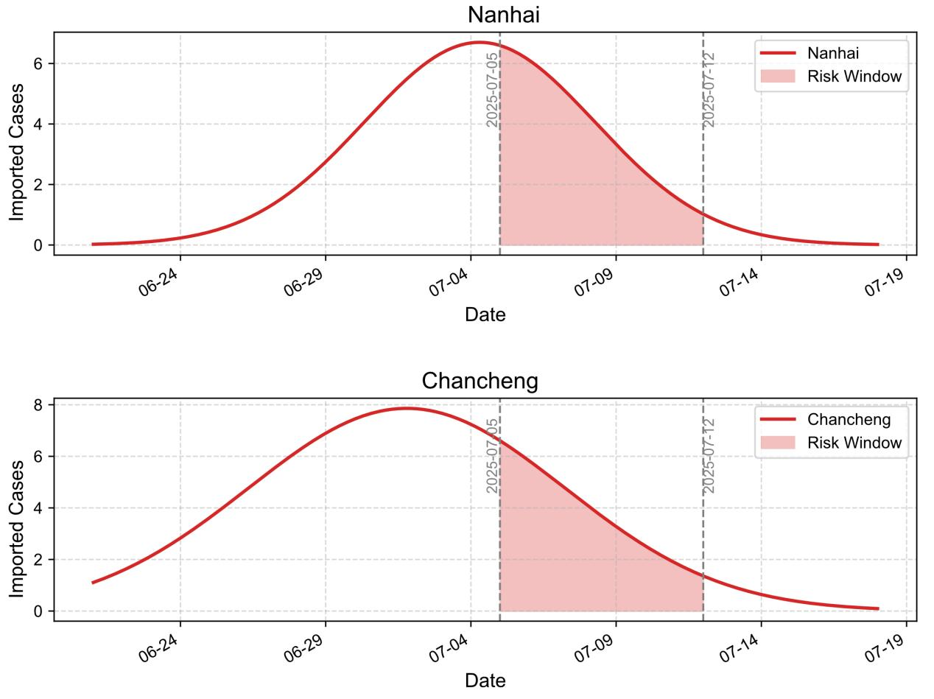
Fig S1. Temporal Gaussian distribution of imported cases
(Chancheng district at ~7.6 days after outbreak onset ($\text{μ }\text{= 7.62, }\text{σ} \text{=} \text{4.45, amplitude = 4.88}$) and for Nanhai district at ~9.5 days ($\text{μ}\text{ = 9.47, }\text{σ} \text{=} \text{1.17, amplitude = 3.92}$), $\text{μ}$: the timing of the peak, i.e., when imported infections reached their maximum after outbreak onset. $\text{σ}$: the spread or duration of the importation wave. A larger σ indicates a longer and more prolonged inflow, while a smaller σ reflects a shorter and more concentrated period of importation. $\text{A}\text{mplitude}$: the intensity or magnitude of the peak, reflecting the maximum level of imported infections at that time.

Fig. S2. Model structure and assumptions
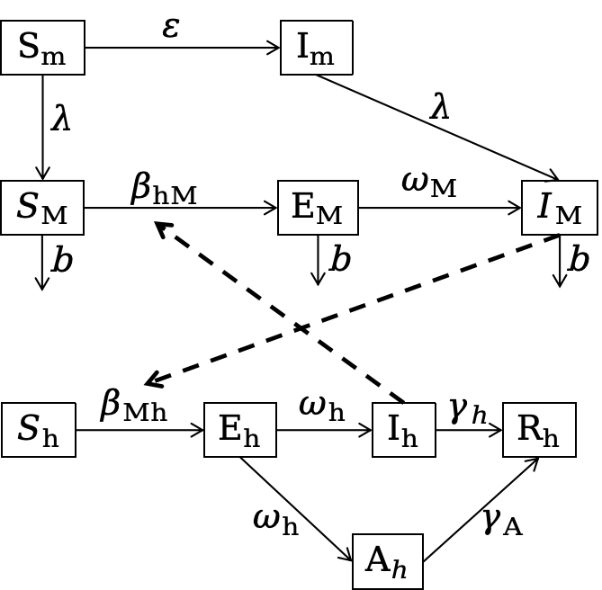
Fig S2. Model structure

The model is based on the following assumptions:
- Human population compartments: The human population is divided into five compartments: susceptible (${\text{S}}_{\text{h}}$), exposed (${\text{E}}_{\text{h}}$), sysptomatic infected (${\text{I}}_{\text{h}}$), asymptomatic Infected (${\text{A}}_{\text{h}}$), recovered (${\text{R}}_{\text{h}}$). A susceptible individual bitten by an infectious adult mosquito has a certain probability of becoming infected and subsequently enters the exposed state (${\text{E}}_{\text{h}}$), representing the latent stage of infection. Exposed individuals progress to either symptomatic infect (${\text{I}}_{\text{h}}$) asymptomatic infected (${\text{A}}_{\text{h}}$) according to a fixed proprotion q, which denotes the probability of asymptomatic infection. Both ${\text{I}}_{\text{h}}$ and ${\text{A}}_{\text{h}}$eventually recover and move into the recovered class (${\text{R}}_{\text{h}}$), where they are assumed to acquire long-lasting immunity. Over the time horizon of the model, the total human population size is assumed constant, with demographic processes such as births and natural deaths neglected.
- Mosquito population compartments: The mosquito life cycle is divided into larval and adult stages, denoted by the subscripts m and M,respectively. The larval stage includes susceptible larvae (${\text{S}}_{\text{m}}$), and infected larvae (${\text{I}}_{\text{m}}$), while the adult stage consists of susceptible mosquitoes (${\text{S}}_{\text{M}}$), exposed mosquitoes (${\text{E}}_{\text{M}}$), and infected mosquitoes (${\text{I}}_{\text{M}}$). Larvae deveplop into adult mosquitoes through emergence, occuring at a constant rate $\text{λ}$. infected larvae (${\text{I}}_{\text{m}}$) emerge as infected adults (${\text{I}}_{\text{M}}$), while susceptible larvaes emerge as susceptible adults (${\text{S}}_{\text{M}}$).
- Transmission and disease progression: Transmission between humans and mosquitoes occurs via bites, under the assumption of homogeneous mixing, where all individuals face the same risk of being bitten. When an infectious mosquito bites a susceptible human, there is a probability that the human becomes infected and enters the exposed class (${\text{E}}_{\text{h}}$). Both symptomatic and asymptomatic human infections (${\text{I}}_{\text{h}}$, ${\text{A}}_{\text{h}}$) can infect susceptible mosquitoes, causing them to move into the exposed class (${\text{E}}_{\text{M}}$), which later progresses to the infectious stage (${\text{I}}_{\text{M}}$). Humans in ${\text{E}}_{\text{h}}$ progress to either ${\text{I}}_{\text{h}}$ or ${\text{A}}_{\text{h}}$ infections, while msoquitoes in ${\text{E}}_{\text{M}}$ progress to infected mosquitoes (${\text{I}}_{\text{M}}$) and remain infectious for life.
- Population dynamics and vertical transmission: The human population is considered demographically stable during the epidemic phase, while mosquito populations undergo natural birth, emergence, and death processes. Vertical transmission is included: infectious adult mosquitoes (${\text{I}}_{\text{M}}$) can lay eggs that hatch into infected larvae (${\text{I}}_{\text{m}}$), with the probability of transovarial transmission denoted by $\text{ε}$. Once infected, mosquitoes remain infectious until death, whereas humans who recover are assumed immune and cannot be reinfected within the model period. In contrast, human infectious individuals (${\text{I}}_{\text{h}}$, ${\text{A}}_{\text{h}}$) eventually recover and lose infectiousness, moving into the recovered (${\text{R}}_{\text{h}}$) where they are assumed to acquire immunity.

Table S5. Model compartments: symbols, descriptions
Table S5. Model compartments: symbols, descriptions
Symbol | Description
$${\text{S}}_{\text{m}}$$ | Susceptible larvaes
$${\text{I}}_{\text{m}}$$ | Infected larvaes
$${\text{S}}_{\text{M}}$$ | Susceptible adult mosquitoes
$${\text{E}}_{\text{M}}$$ | Exposed adult mosquitoes
$${\text{I}}_{\text{M}}$$ | Symptomatic Infected mosquitoes
$${\text{S}}_{\text{h}}$$ | Susceptible humans
$${\text{E}}_{\text{h}}$$ | Exposed humans
$${\text{I}}_{\text{h}}$$ | Symptomatic Infected humans
$${\text{A}}_{\text{h}}$$ | Asymptomatic Infected humans
$${\text{R}}_{\text{h}}$$ | Recovered humans

Table S6. Model parameters and values
Table S6. Model parameters and values
Parameter | Description | Unit | Value | Range | Source
$$\text{a}$$ | Birth rate of Aedes mosquitoes |  | 0.071 | 0.02-0.25 | (1, 2)
$$\text{ε}$$ | Proportion of infected adult females that transmit the pathogen to their offspring via eggs |  | 0.1 | 0.014-0.174 | (3)
$$\text{λ}$$ | The average maturation rate from immature stages (larvae/pupae) to adults |  | 0.1176 | 0.09434 -0.12195 | (4)
$$\text{c}$$ | Seasonality coefficient for Aedes population dynamics | 1 |  | - | Model fitting
$$\text{b}$$ | Natural mortality rate of adult mosquitoes |  | 0.0714 | ≥0 | (1, 2)
$${\text{β}}_{\text{h}\text{M}}$$ | Transmission rate from humans to mosquitoes |  |  | ≥0 | Model fitting
$${\text{β}}_{\text{Mh}}$$ | Transmission rate from mosquitoes to humans |  |  | ≥0
$${\text{ω}}_{\text{M}}$$ | Mosquito incubation rate |  | 0.1 | 0.0833-0.1250 | (5)
$${\text{ω}}_{\text{h}}$$ | Human incubation rate |  | 0.1429 | 0.0833-0.5 | (6)
$$\text{q}$$ | Proportion of asymptomatic human infections |  | 0.14 | 0-1 | (7)
$${\text{γ}}_{\text{I}}$$ | Recovery rate of symptomatic humans |  | 0.143 | 0.0714-.0333 | (5)
$${\text{γ}}_{\text{A}}$$ | Recovery rate of asymptomatic humans |  | 0.143 | 0.0714-.0333 | (1, 2)

Table S7. Parameter descriptions, distributions, and values for the Index P
Table S7. Parameter descriptions, distributions, and values for the Index P
Symbol | Description | Distribution | Mean, SD | Units | Sources
$${\text{a}}_{\text{(u)}}^{\text{v}}$$ | Adult Aedes biting rate | normal | 0.25, 0.01 |  | (8, 9)
$$\text{1/}{\text{μ}}_{\text{(u,t)}}^{\text{v}}$$ | Adult Aedes lifespan | normal | 10, 2.55 |  | (10, 11)
$${\text{1/γ}}_{\text{(t)}}^{\text{v}}$$ | Extrinsic Aedes-DENV incubation period | lognormal | 1228, 1825 (∞,15 °C) |  | (12)
$${\text{1/γ}}_{\text{(t)}}^{\text{v}}$$ | Extrinsic Aedes-DENV incubation period | lognormal | 232, 181 [15 °C, 17.5 °C) |  | (12)
$${\text{1/γ}}_{\text{(t)}}^{\text{v}}$$ | Extrinsic Aedes-DENV incubation period | lognormal | 72.4, 32.6 [17.5 °C, 20 °C) |  | (12)
$${\text{1/γ}}_{\text{(t)}}^{\text{v}}$$ | Extrinsic Aedes-DENV incubation period | lognormal | 28.9, 7.64 [20 °C, 22.5 °C) |  | (12)
$${\text{1/γ}}_{\text{(t)}}^{\text{v}}$$ | Extrinsic Aedes-DENV incubation period | lognormal | 14.7, 2.66 [22.5 °C, 25 °C) |  | (12)
$${\text{1/γ}}_{\text{(t)}}^{\text{v}}$$ | Extrinsic Aedes-DENV incubation period | lognormal | 8.68, 1.31 [25 °C, 27.5 °C) |  | (12)
$${\text{1/γ}}_{\text{(t)}}^{\text{v}}$$ | Extrinsic Aedes-DENV incubation period | lognormal | 5.76, 0.87 [27.5 °C, 30 °C) |  | (12)
$${\text{1/γ}}_{\text{(t)}}^{\text{v}}$$ | Extrinsic Aedes-DENV incubation period | lognormal | 4.14, 0.63 [30 °C, 32.5 °C) |  | (12)
$${\text{1/γ}}_{\text{(t)}}^{\text{v}}$$ | Extrinsic Aedes-DENV incubation period | lognormal | 3.19, 0.48 [32.5 °C, ∞) |  | (12)
$${\text{1/γ}}^{\text{h}}$$ | Intrinsic human-DENV incubation period | lognormal | 5.94, 1.80 |  | (12)
$${\text{1/σ}}^{\text{h}}$$ | Human-DENV infectious period | normal | 4, 0.51 |  | (13-15)
$$\text{1/}{\text{μ}}^{\text{h}}$$ | Human lifespan | normal | 70, 3 |  | -
$${\text{ϕ}}_{\text{(t)}}^{\text{v→h}}$$ | Transmission probability per mosquito bite (Aedes-to-human) | none | N/A | N/A | N/A
$${\text{ϕ}}_{\text{(t)}}^{\text{h→v}}$$ | Transmission probability per mosquito bite (human-to-Aedes) | none | N/A | N/A | N/A

Table S8. National four-tier transmission-risk classification and historical outbreak weights
Table S8. National four-tier transmission-risk classification and historical outbreak weights
Province | Tier | Historical magnitude (cases) | Historical share (%) | Final historical weight (%) | Allocation rule
Guangdong | I | 68,070 | 57.74 | 57.74 | Direct (harmonized historical magnitude)
Yunnan | I | 30,785 | 26.11 | 26.11 | Direct
Fujian | I | 3,742 | 3.17 | 3.17 | Direct
Zhejiang | I | 3,260 | 2.77 | 2.77 | Direct
Guangxi | I | 3,136 | 2.66 | 2.66 | Direct
Hainan | I | — | — | 0.0789 | No harmonized historical record (captured by other modules)
Shanghai | II | — | — | 0.4545 | Tier II (5% / 11)
Jiangsu | II | — | — | 0.4545 | Tier II
Anhui | II | — | — | 0.4545 | Tier II
Jiangxi | II | — | — | 0.4545 | Tier II
Shandong | II | — | — | 0.4545 | Tier II
Henan | II | — | — | 0.4545 | Tier II
Hubei | II | — | — | 0.4545 | Tier II
Hunan | II | — | — | 0.4545 | Tier II
Chongqing | II | — | — | 0.4545 | Tier II
Sichuan | II | — | — | 0.4545 | Tier II
Guizhou | II | — | — | 0.4545 | Tier II
Beijing | III | — | — | 0.25 | Tier III (2% / 8)
Tianjin | III | — | — | 0.25 | Tier III
Hebei | III | — | — | 0.25 | Tier III
Shanxi | III | — | — | 0.25 | Tier III
Liaoning | III | — | — | 0.25 | Tier III
Tibet (Xizang) | III | — | — | 0.25 | Tier III
Shaanxi | III | — | — | 0.25 | Tier III
Gansu | III | — | — | 0.25 | Tier III
Inner Mongolia | IV | — | — | 0.0786 | Tier IV residual (0.55% / 7)
Jilin | IV | — | — | 0.0786 | Tier IV residual
Heilongjiang | IV | — | — | 0.0786 | Tier IV residual
Qinghai | IV | — | — | 0.0786 | Tier IV residual
Ningxia | IV | — | — | 0.0786 | Tier IV residual
Xinjiang | IV | — | — | 0.0786 | Tier IV residual

Fig. S3-S33 Provincial Index P maps
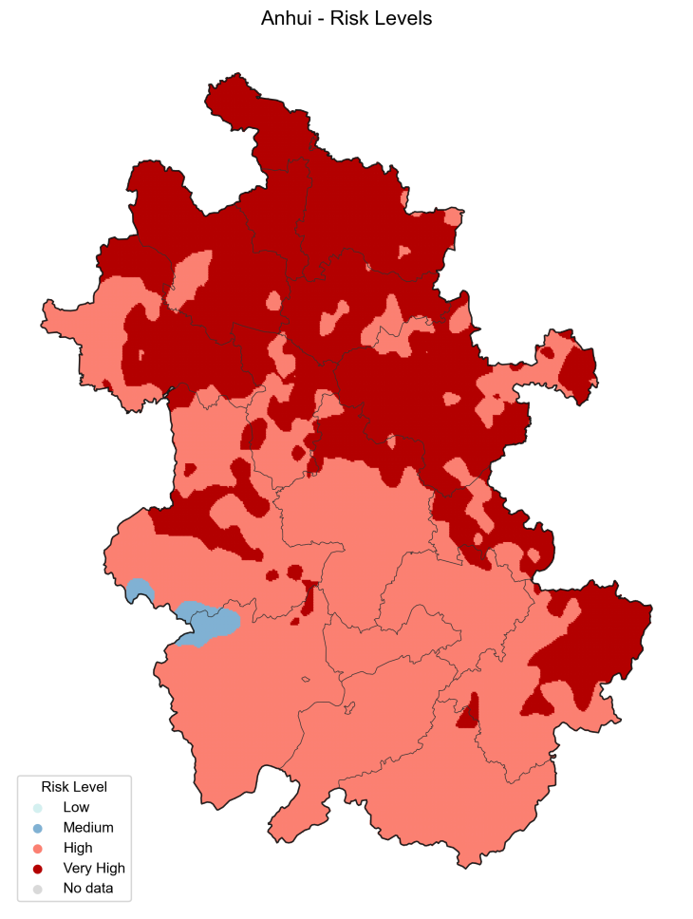
Figure S3 Anhui

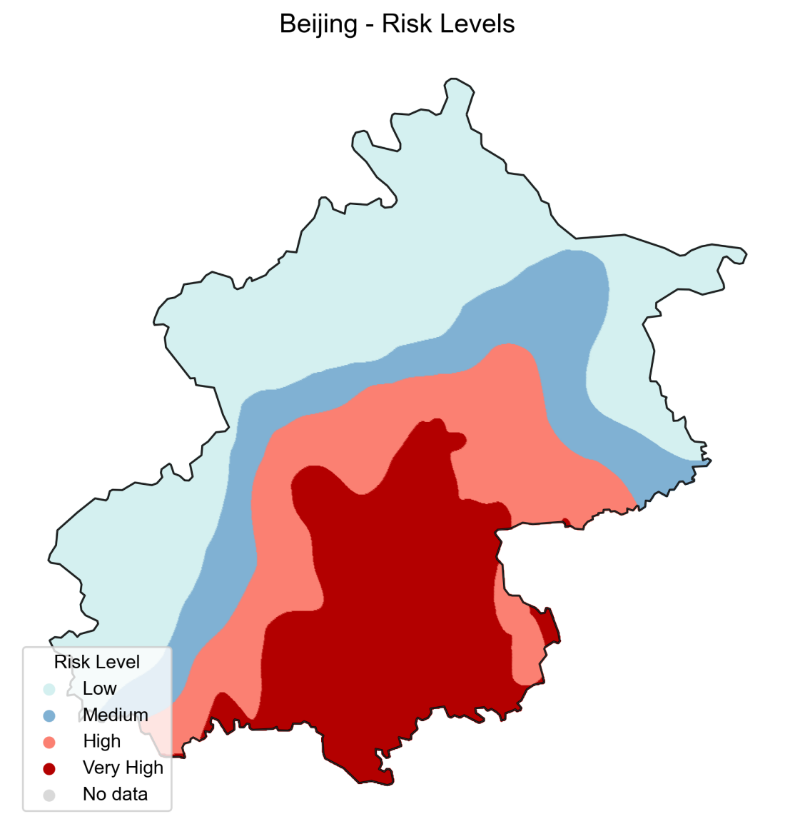
Figure S4. Beijing
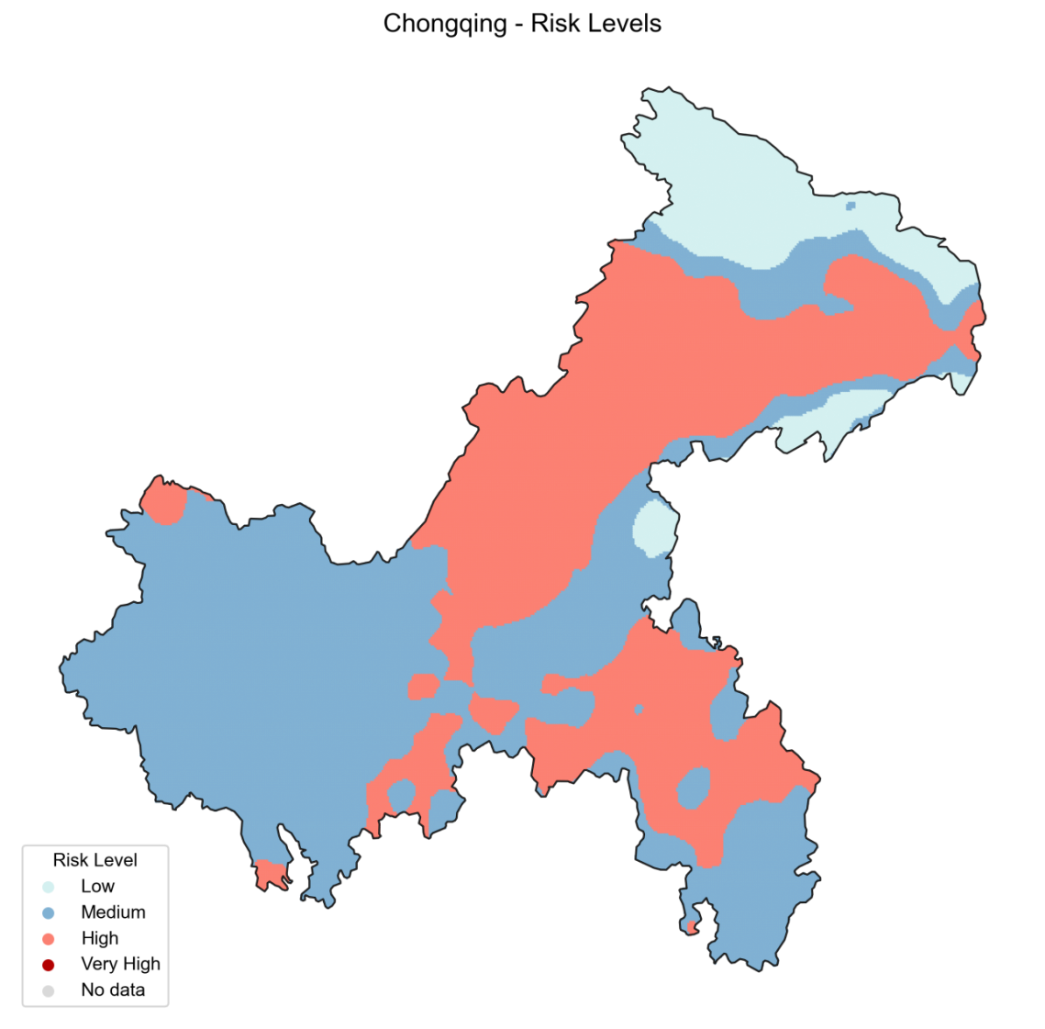
Figure S5. Chongqing

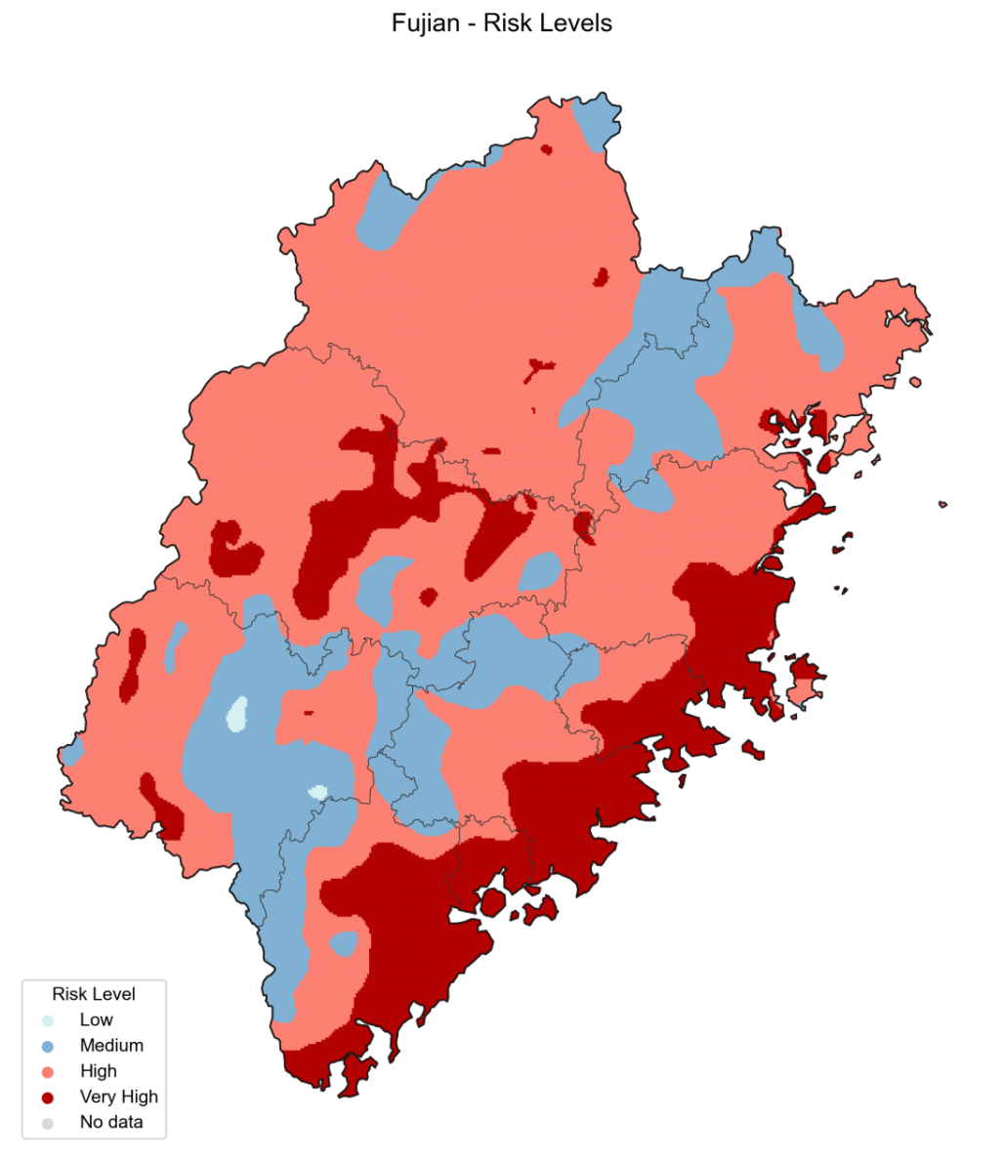
Figure S6. Fujian
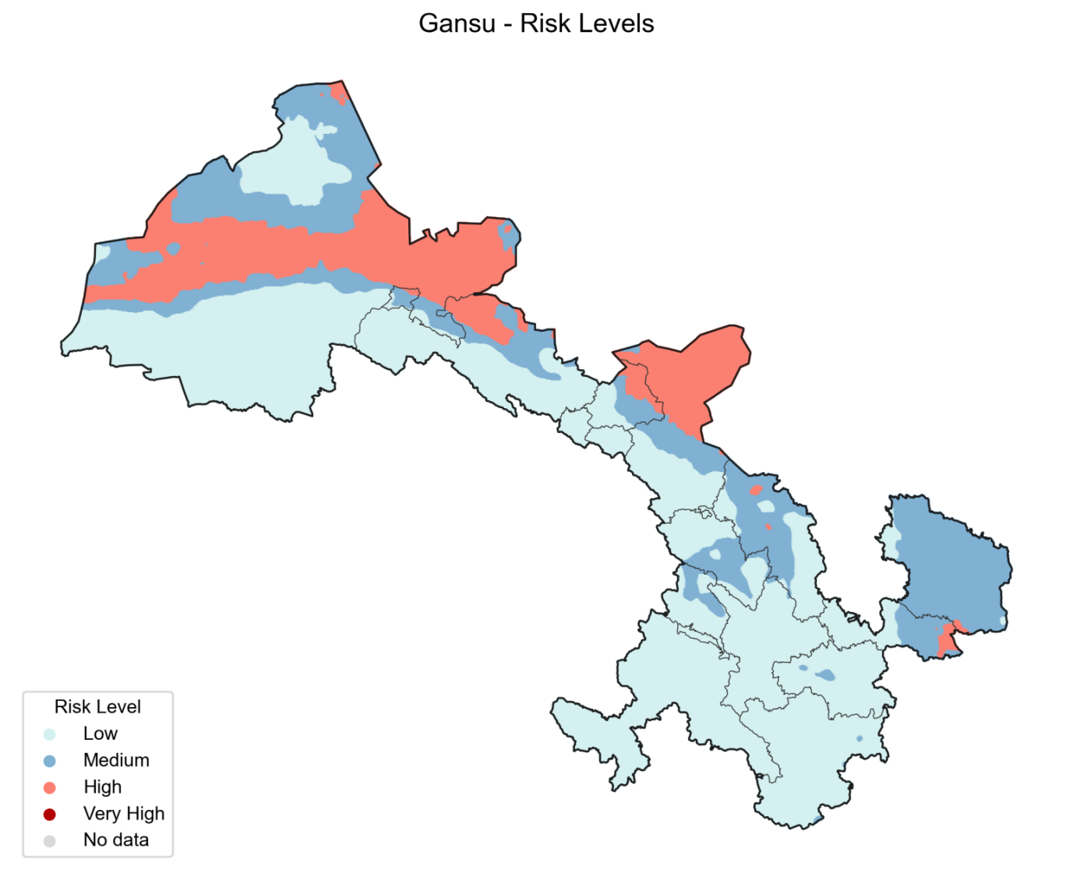
Figure S7. Gansu

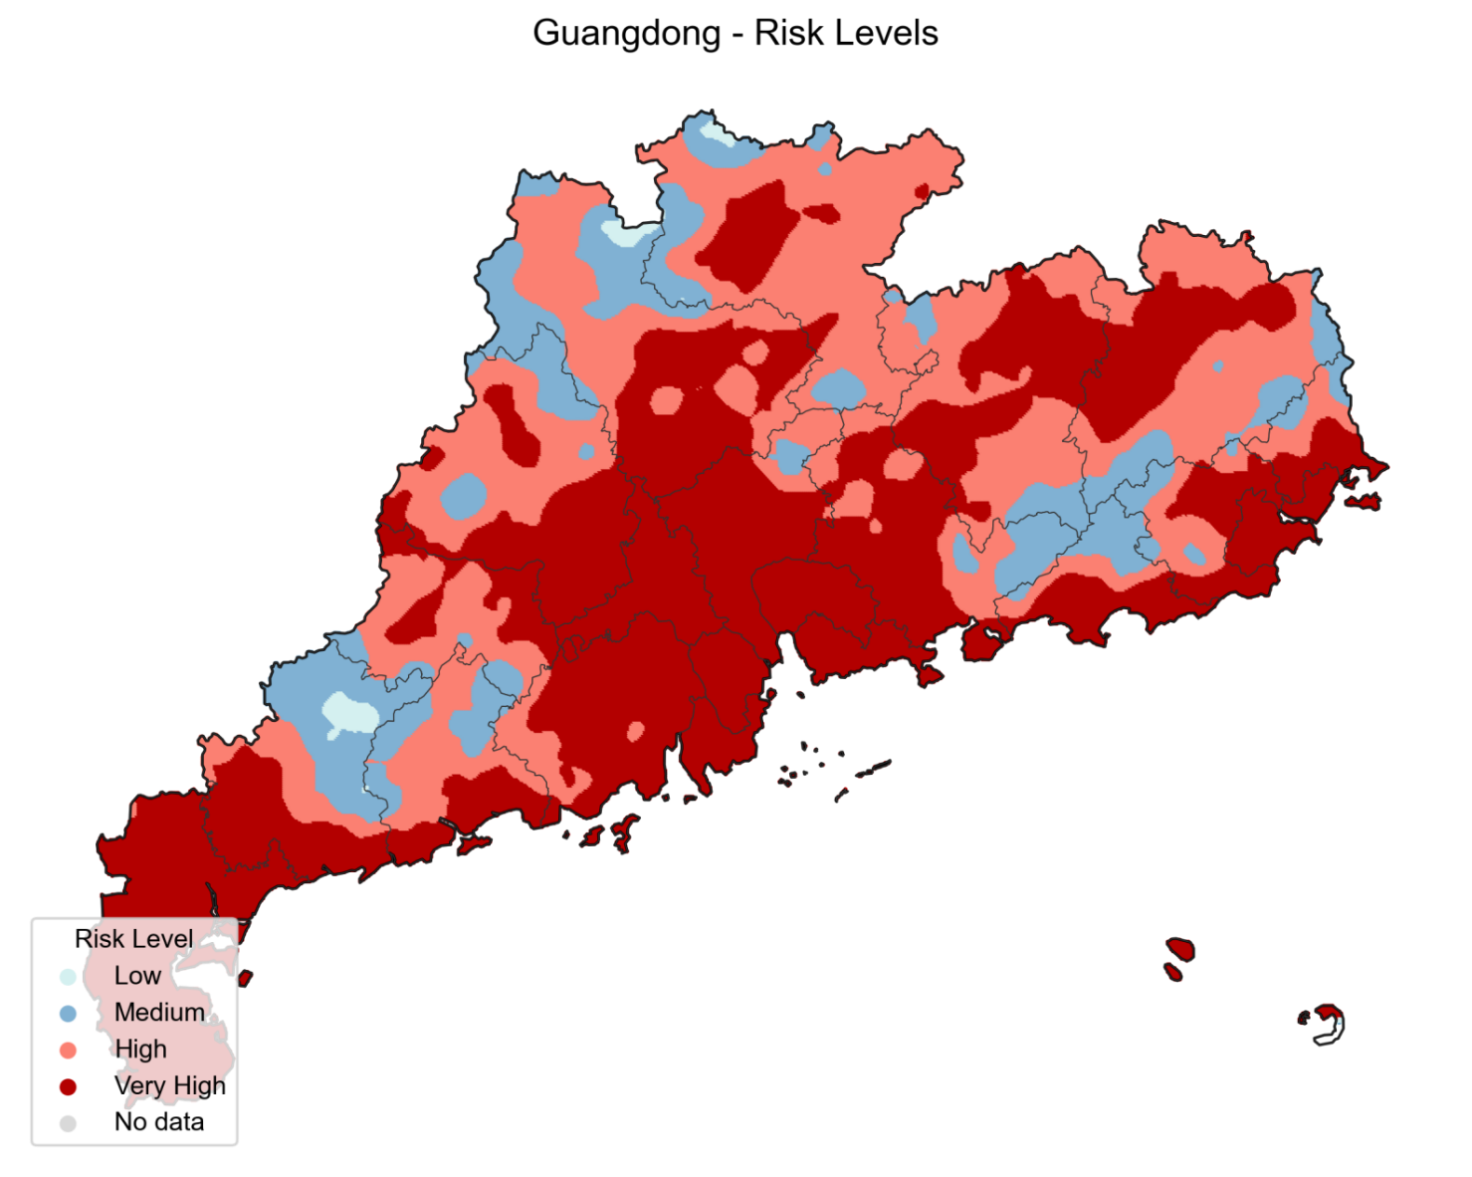
Figure S8. Guangdong
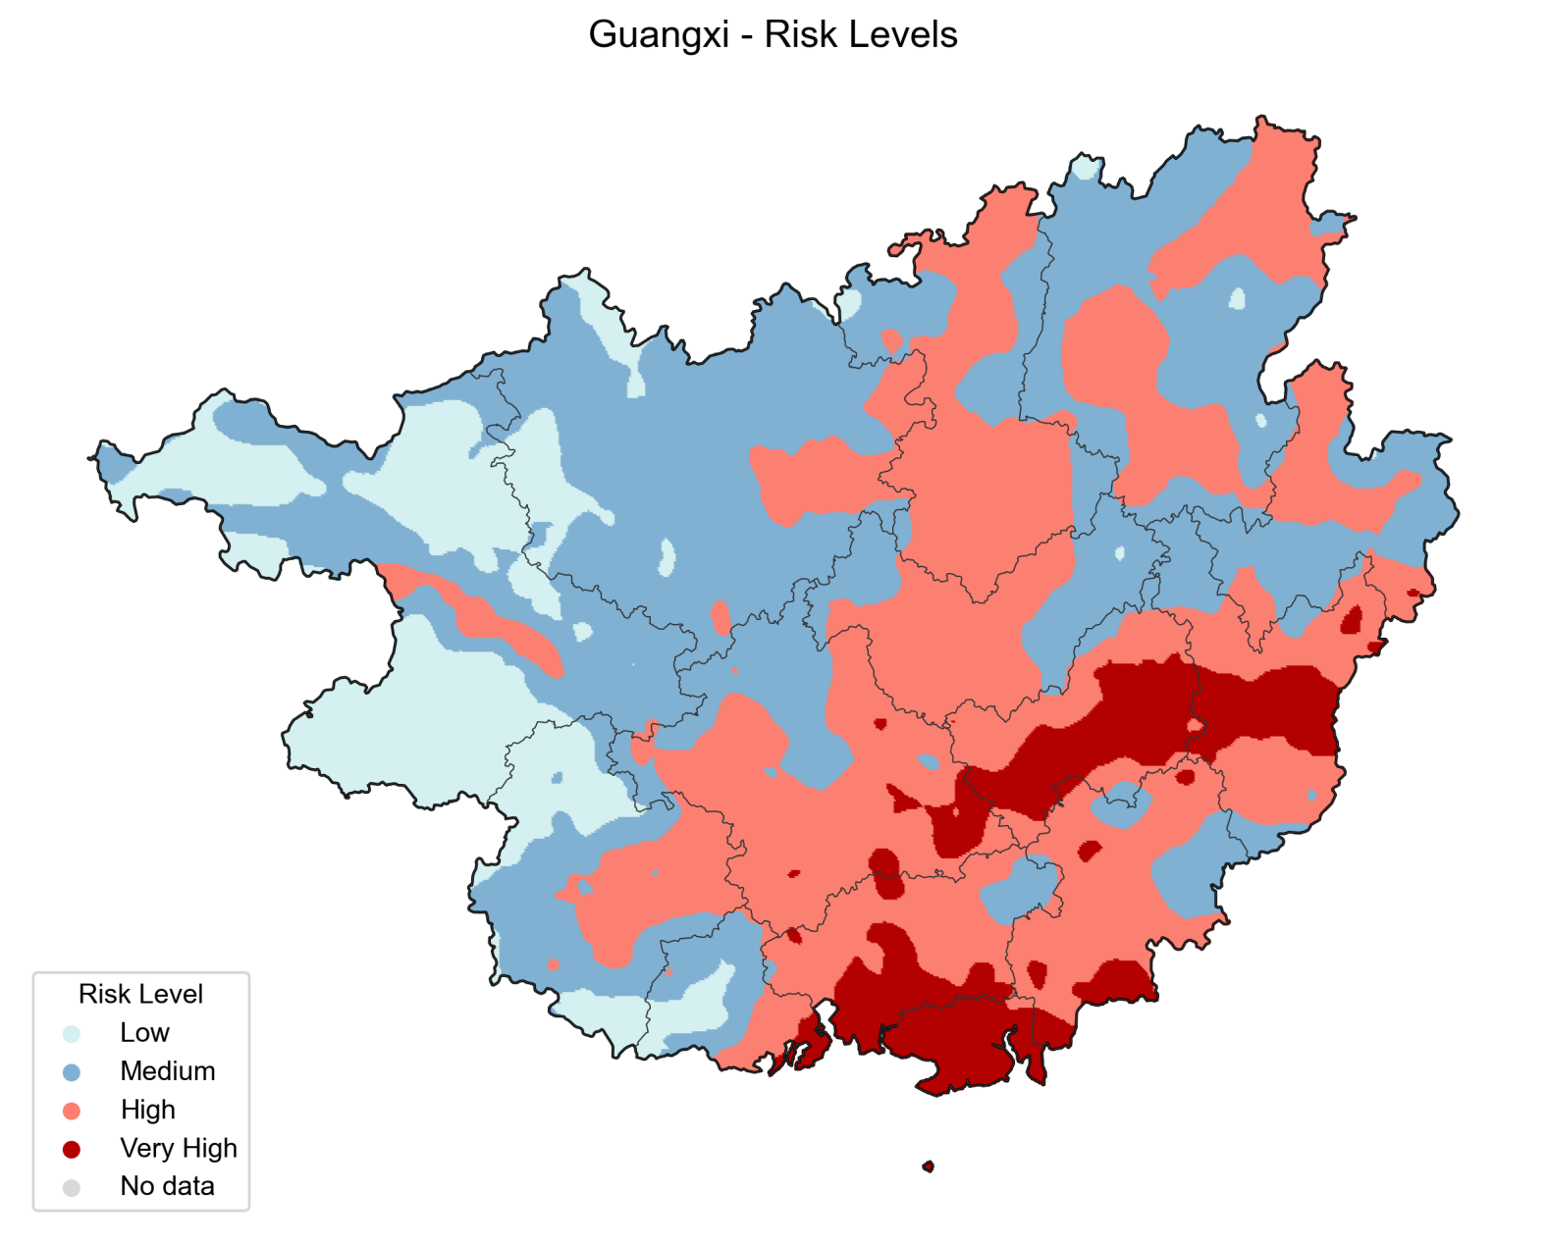
Figure S9. Guangxi
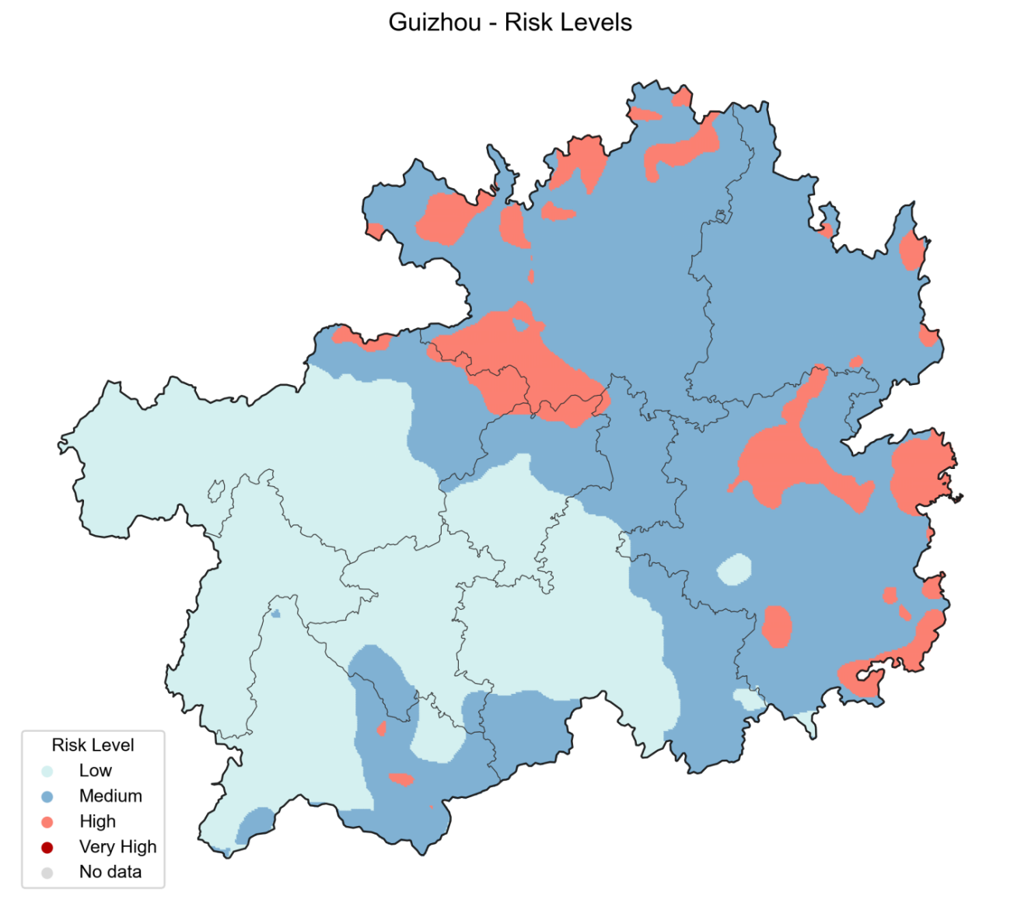
Figure S10. Guizhou
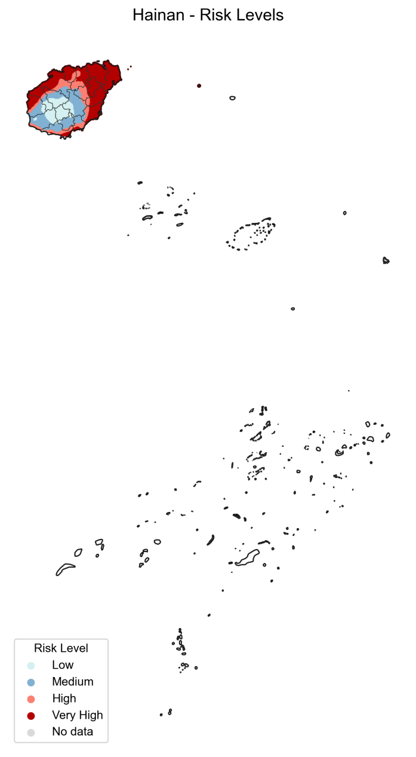
Figure S11.Hainan

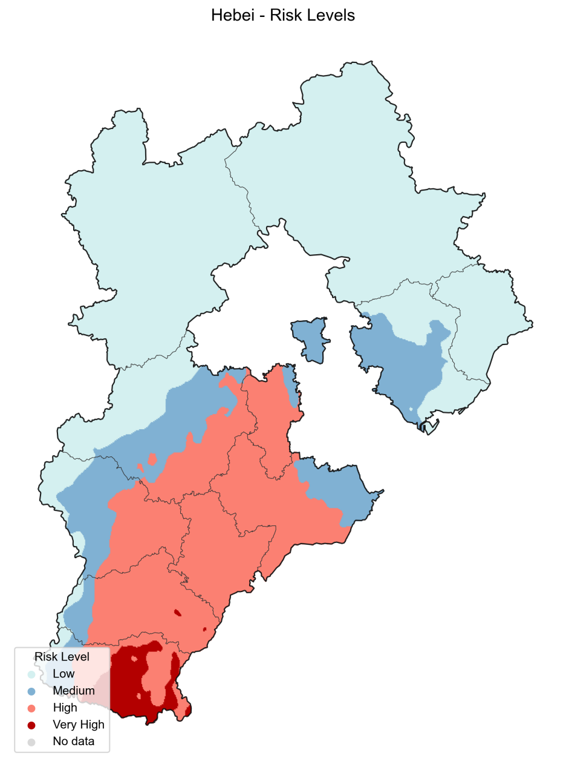
Figure S12. Heibei

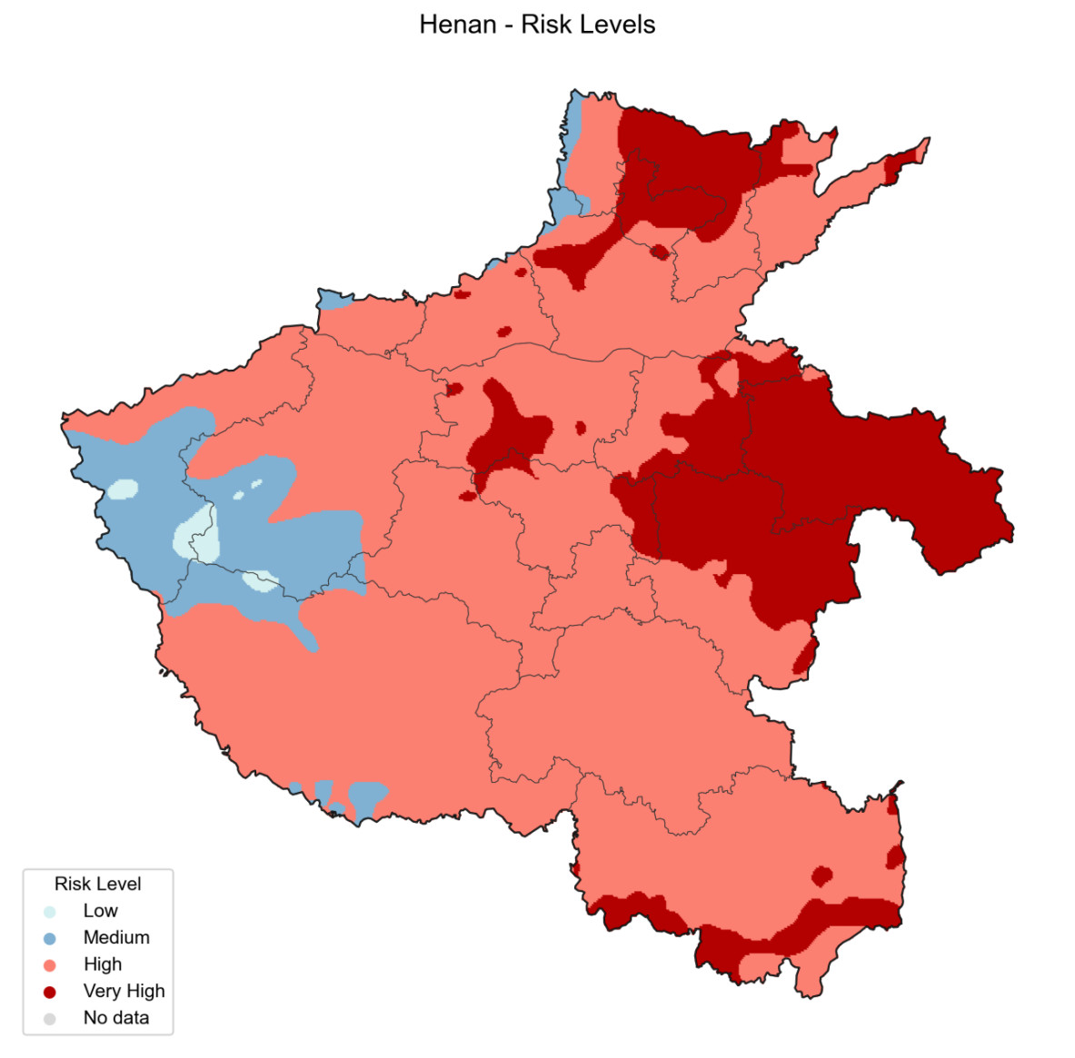
Figure S13. Henan

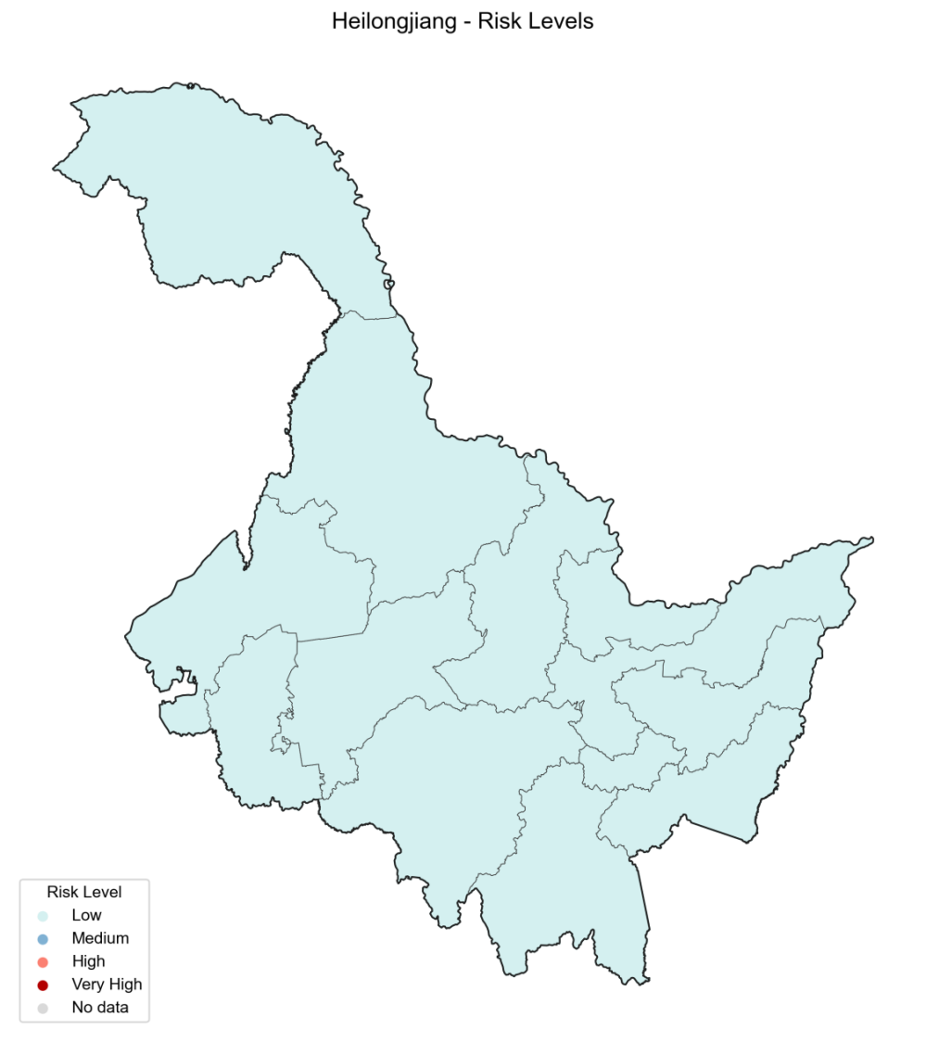
Figure S14. Helongjiang
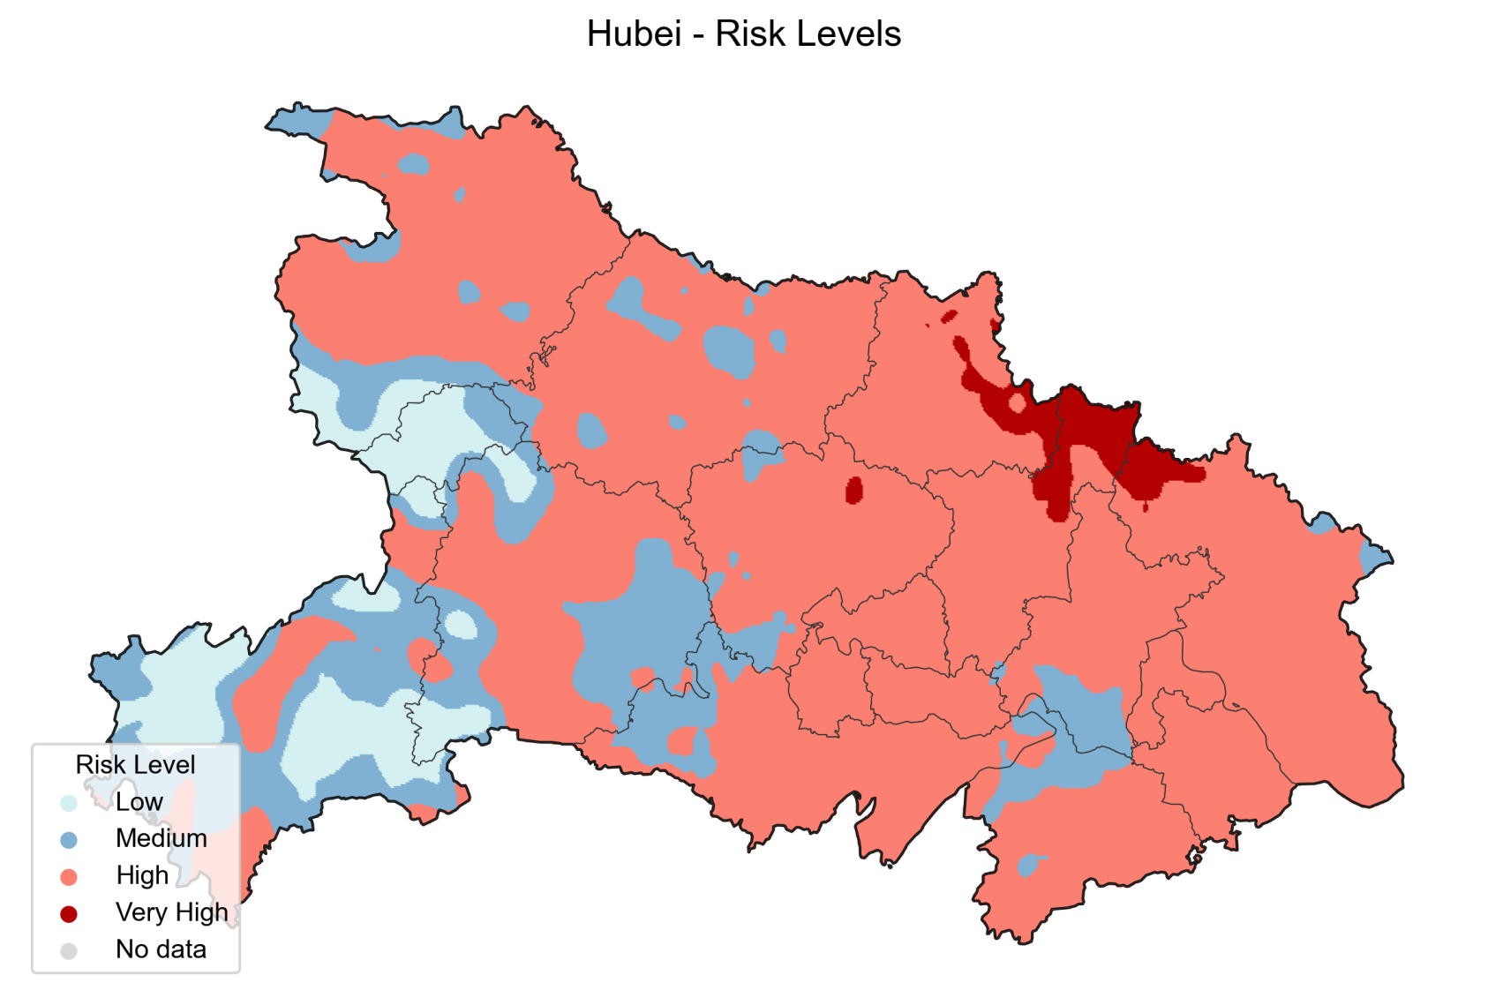
Figure S15. Hubei

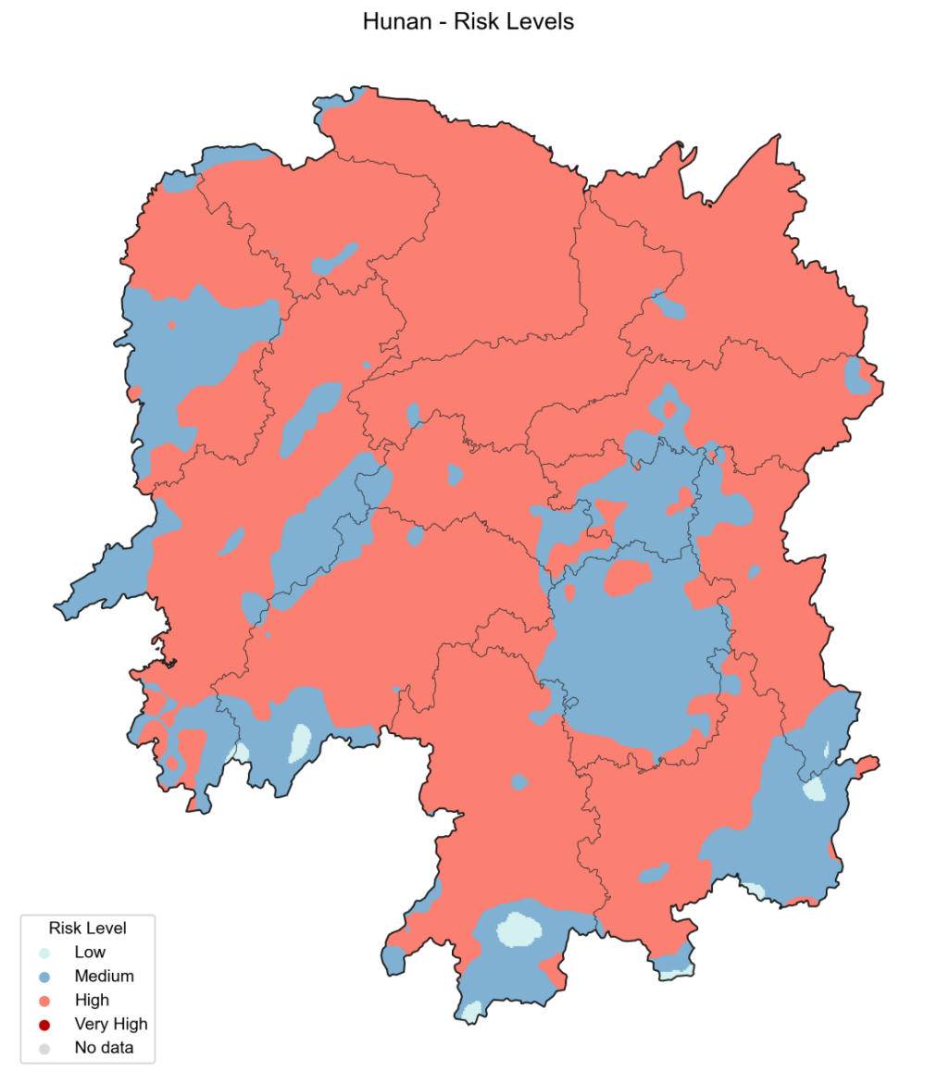
Figure S16. Hunan
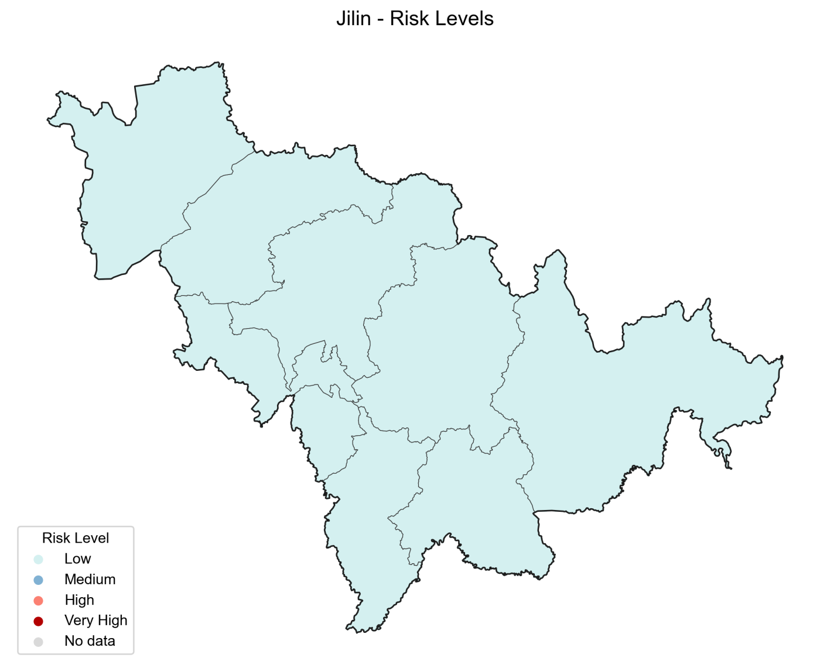
Figure S17. Jilin

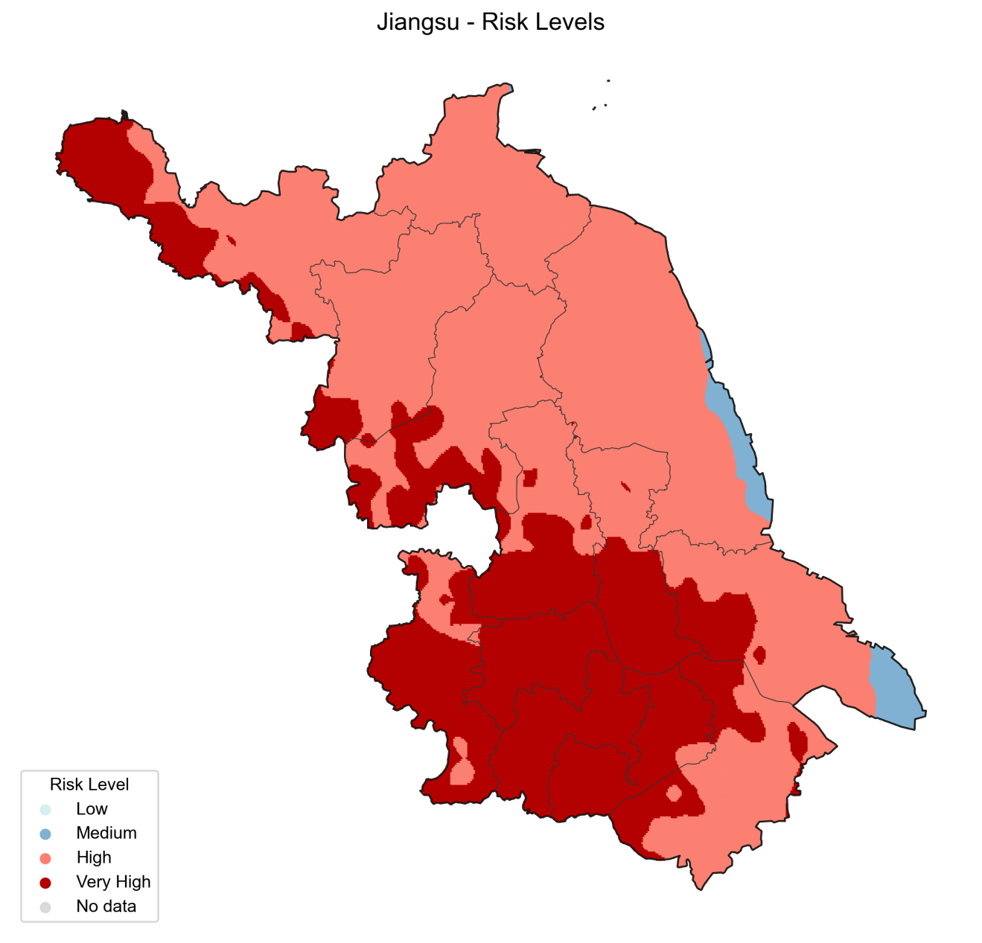
Figure S18. Jiangsu

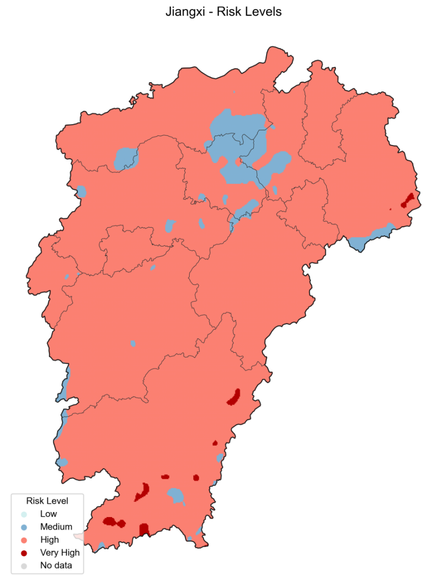
Figure S19. Jiangxi
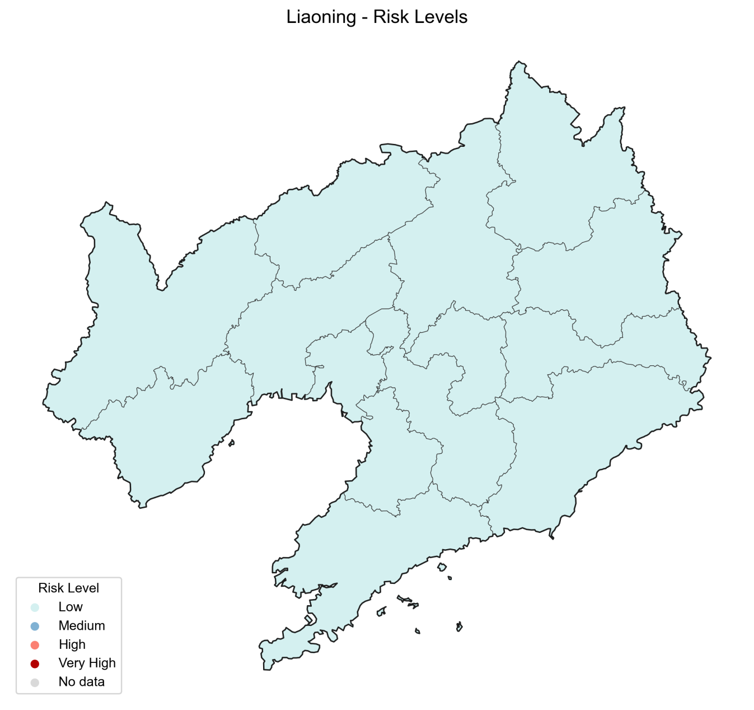
Figure S20. Liaoning
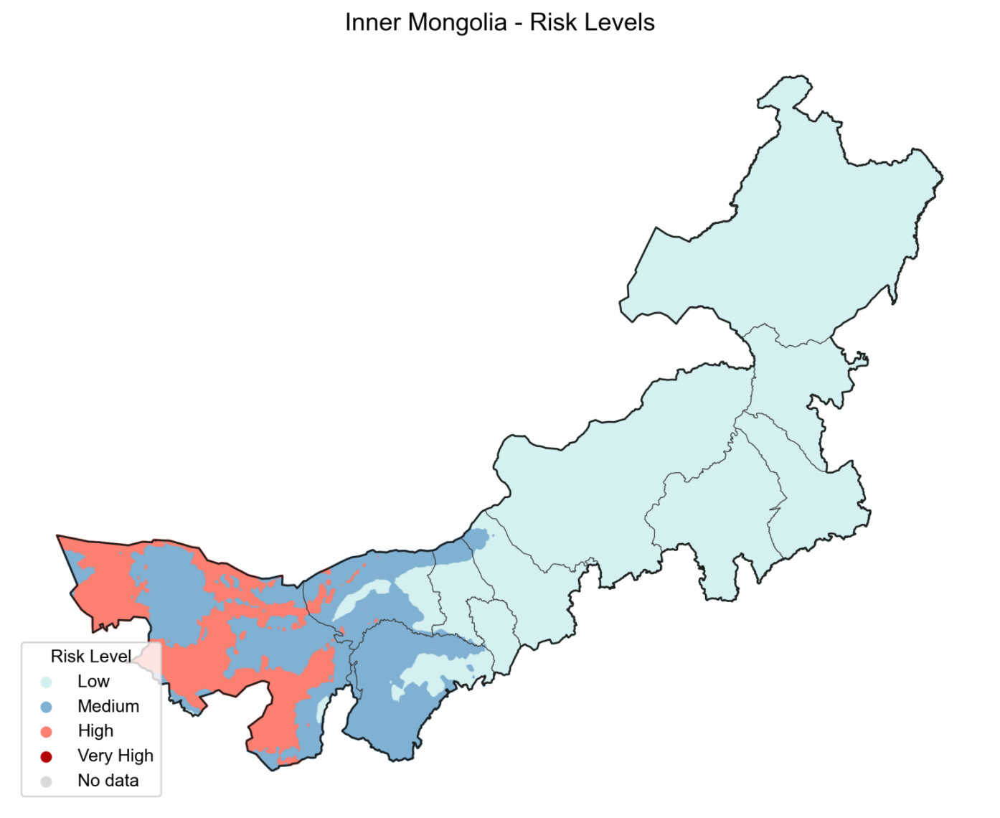
Figure S21. Inner Mongolia
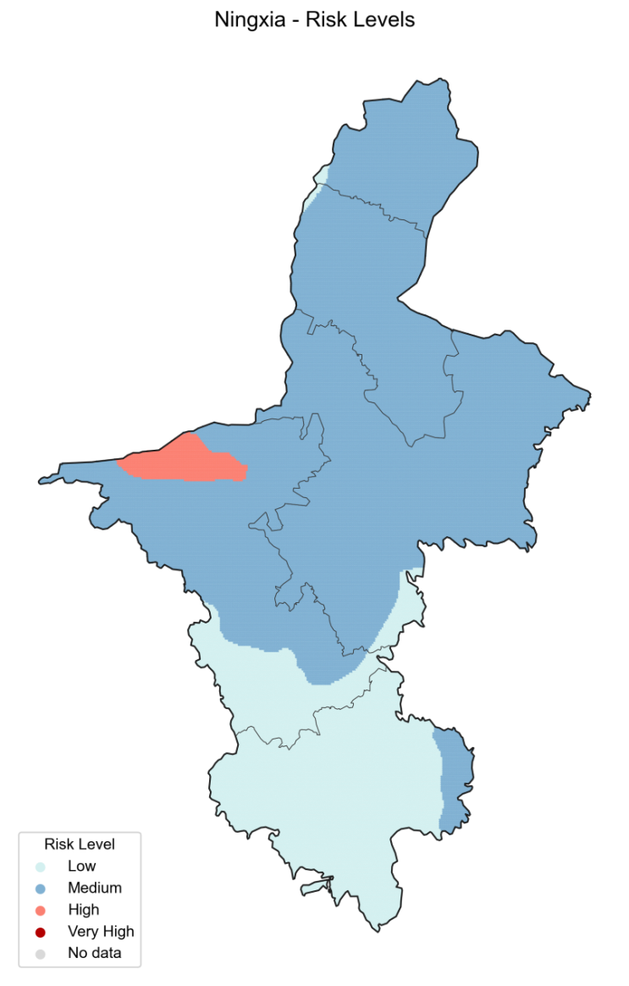
Figure S22. Ningxia

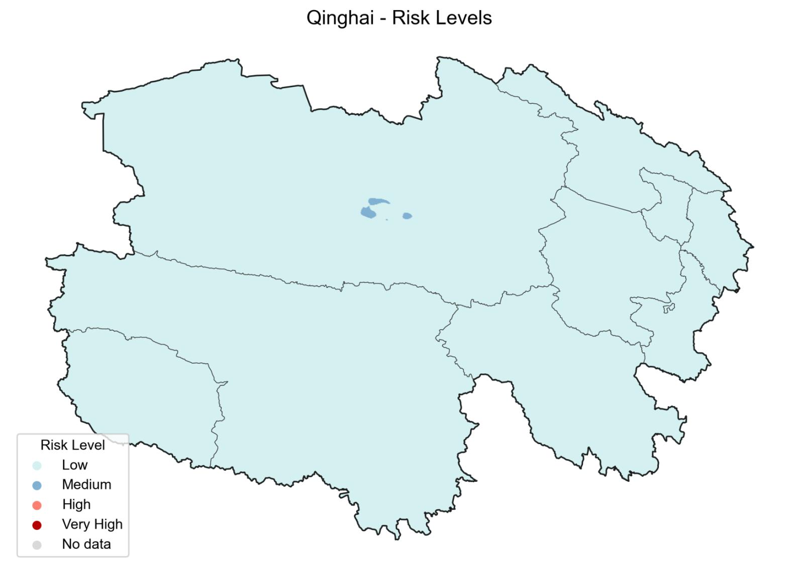
Figure S23. Qinghai

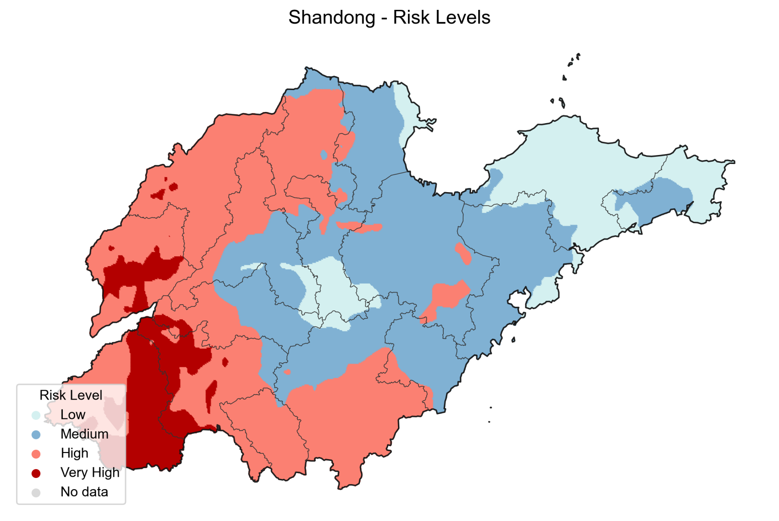
Figure S24. Shandong

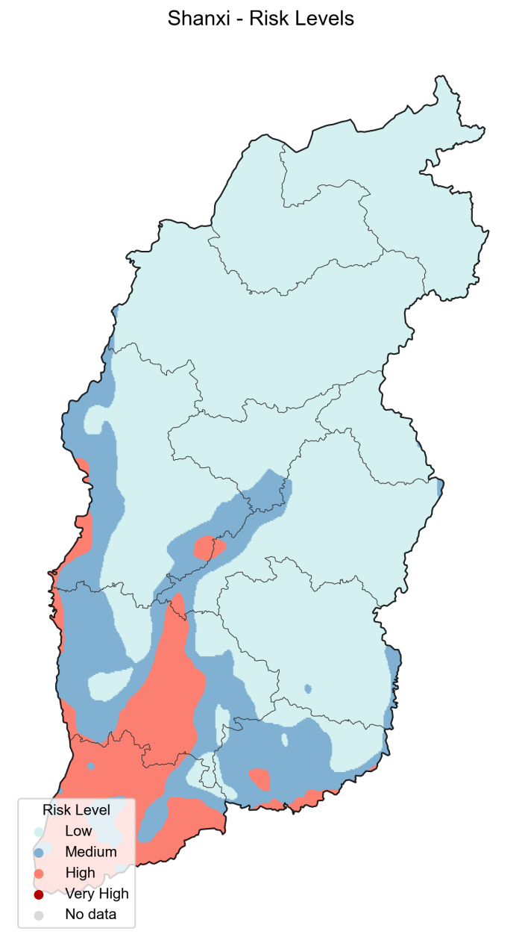
Figure S25. Shanxi

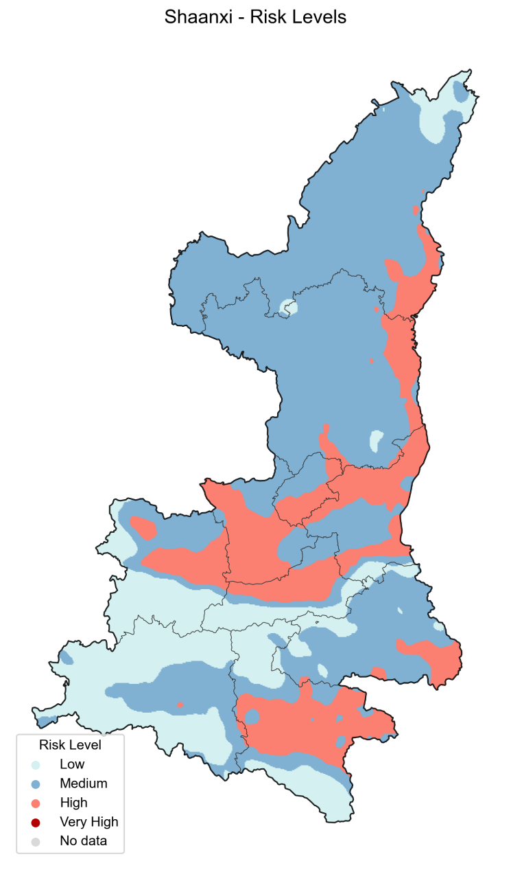
Figure S26. Shannxi
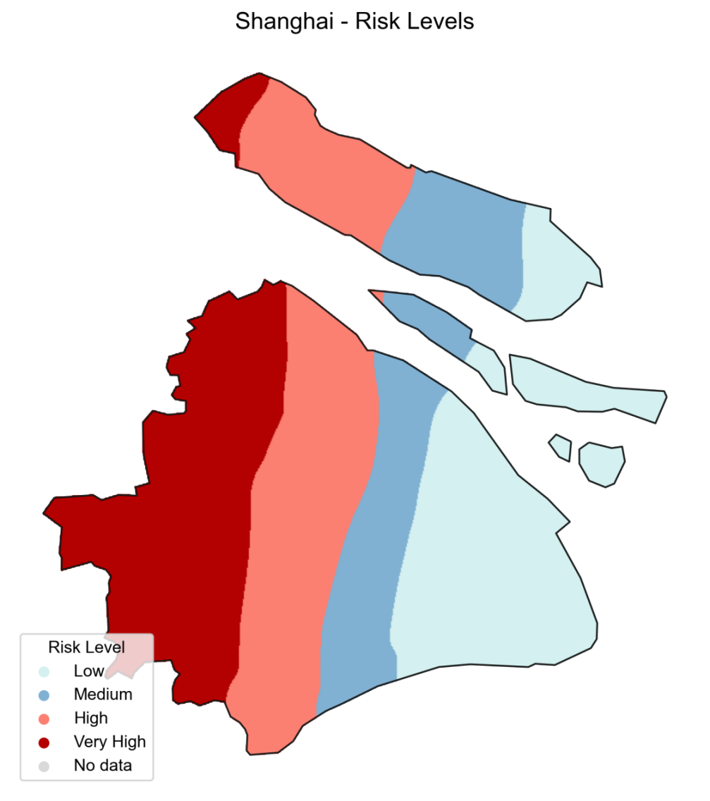
Figure S27. Shanghai
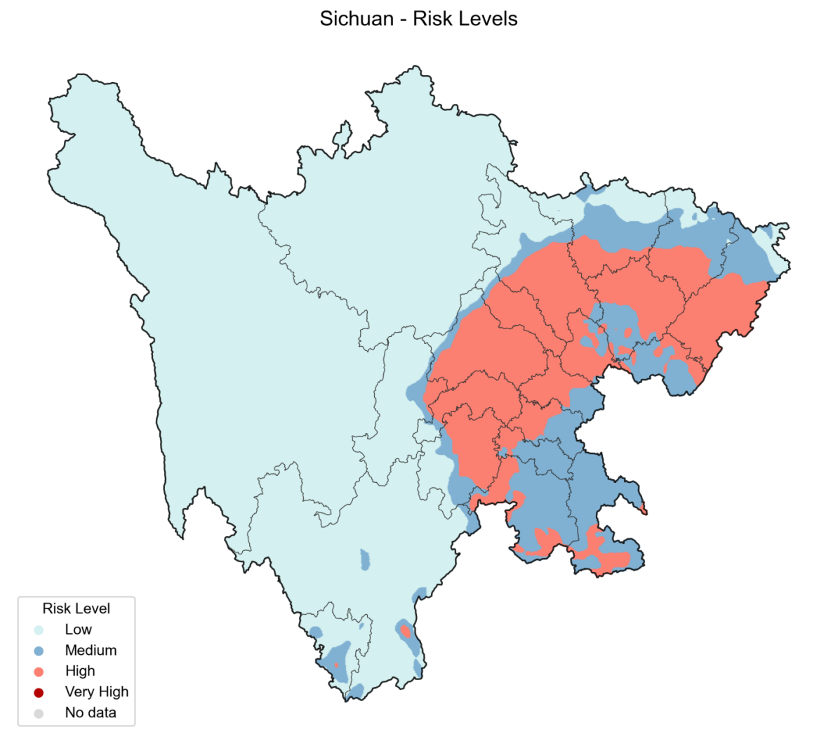
Figure S28. Sichuan
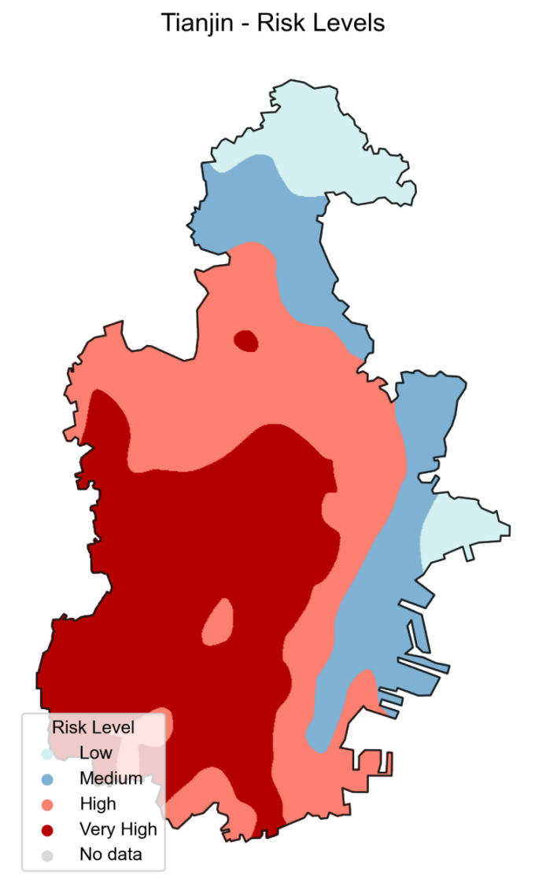
Figure S29. Tianjin

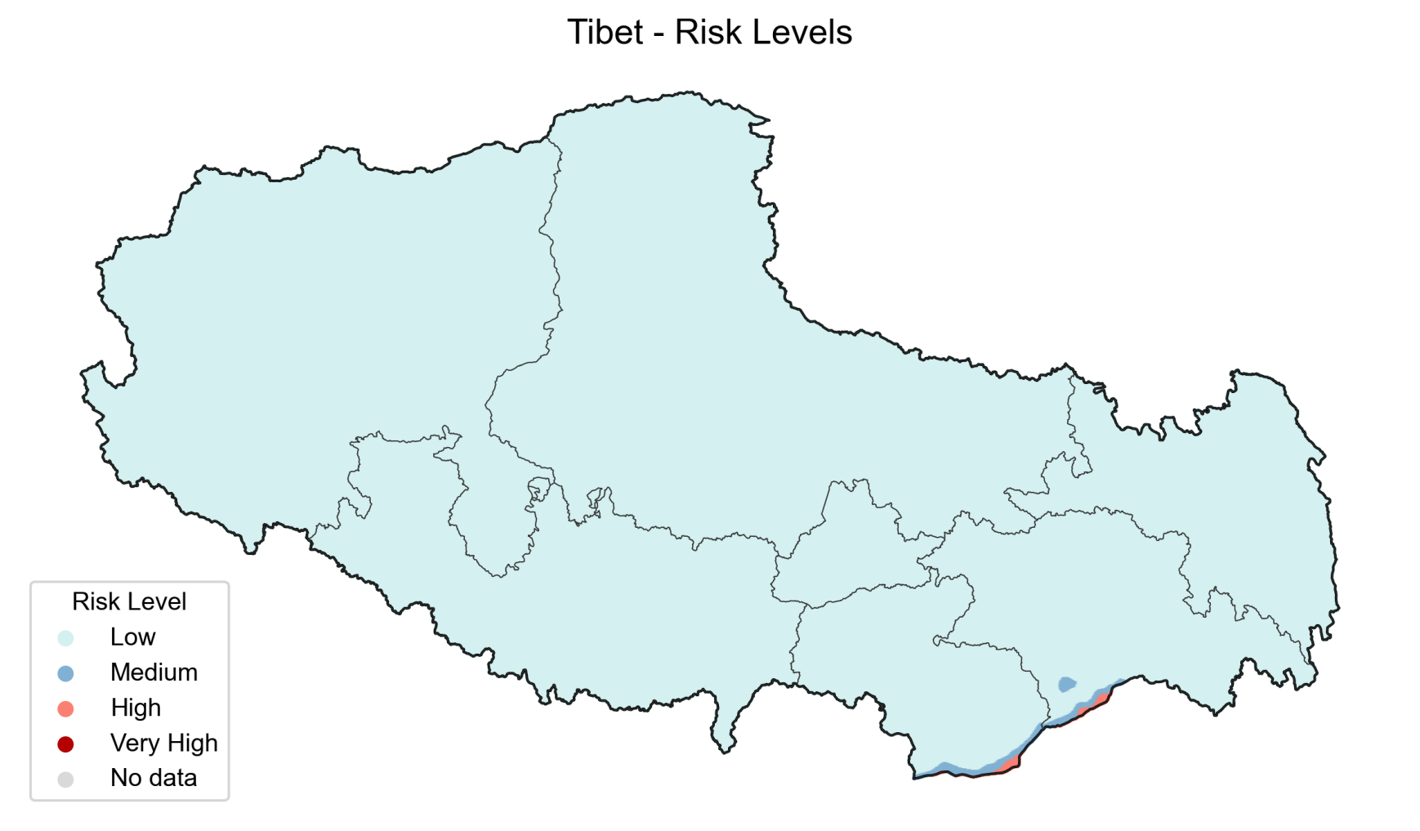
Figure S30. Tibet (Xizang)
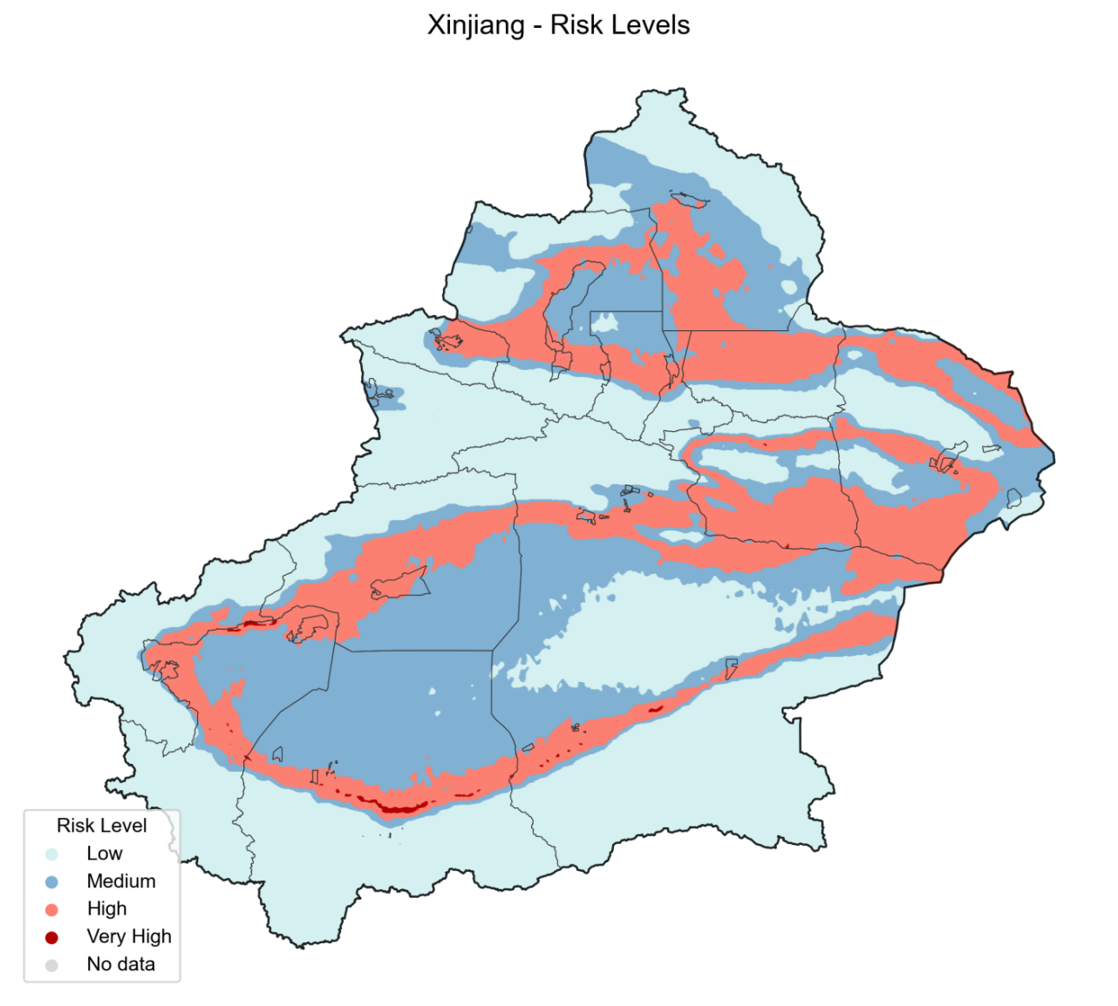
Figure S31. Xinjang

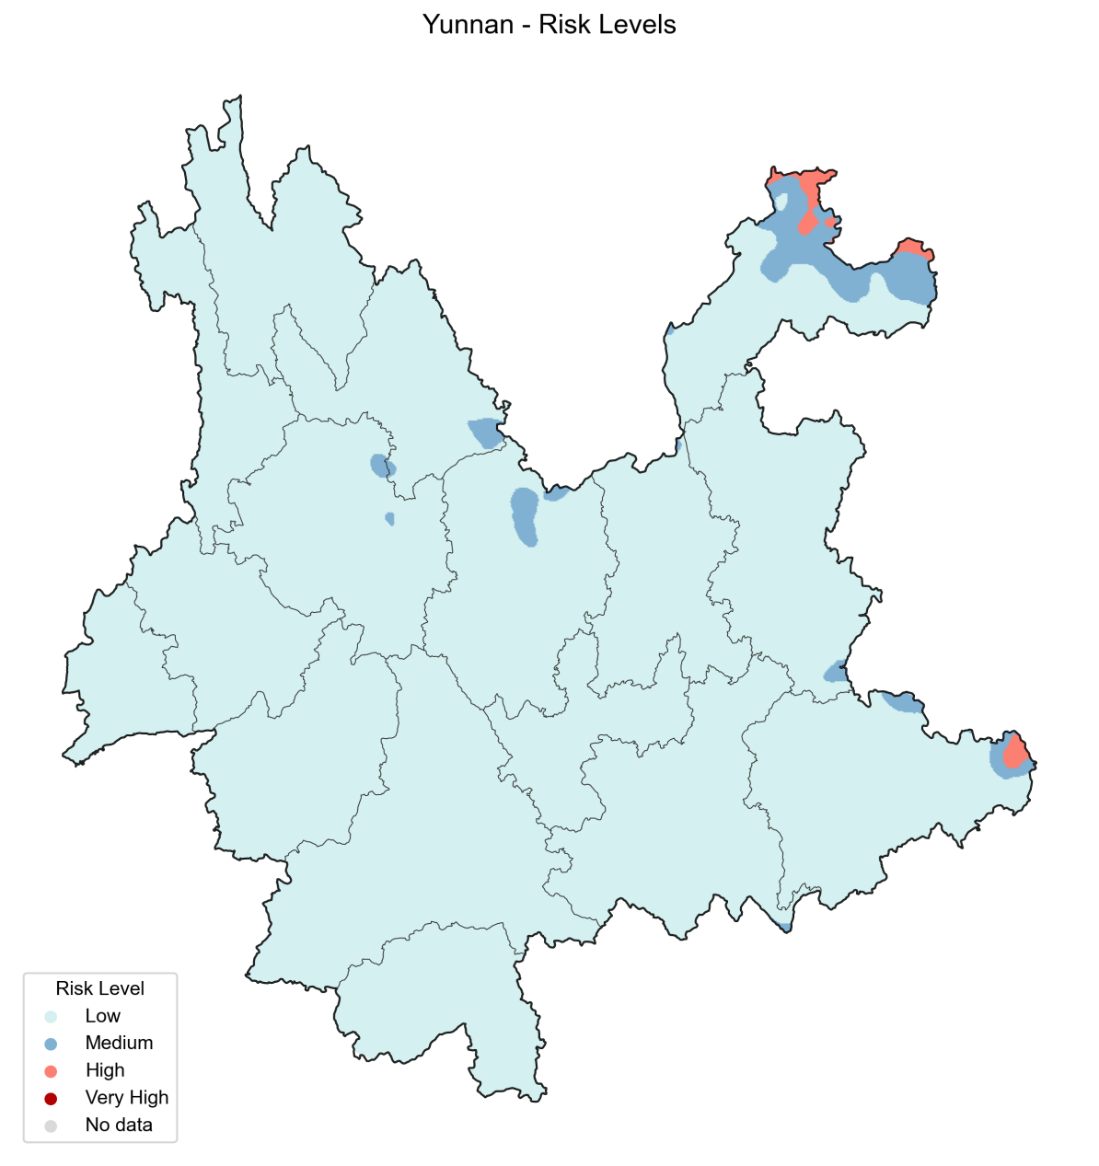
Figure S32. Yunan
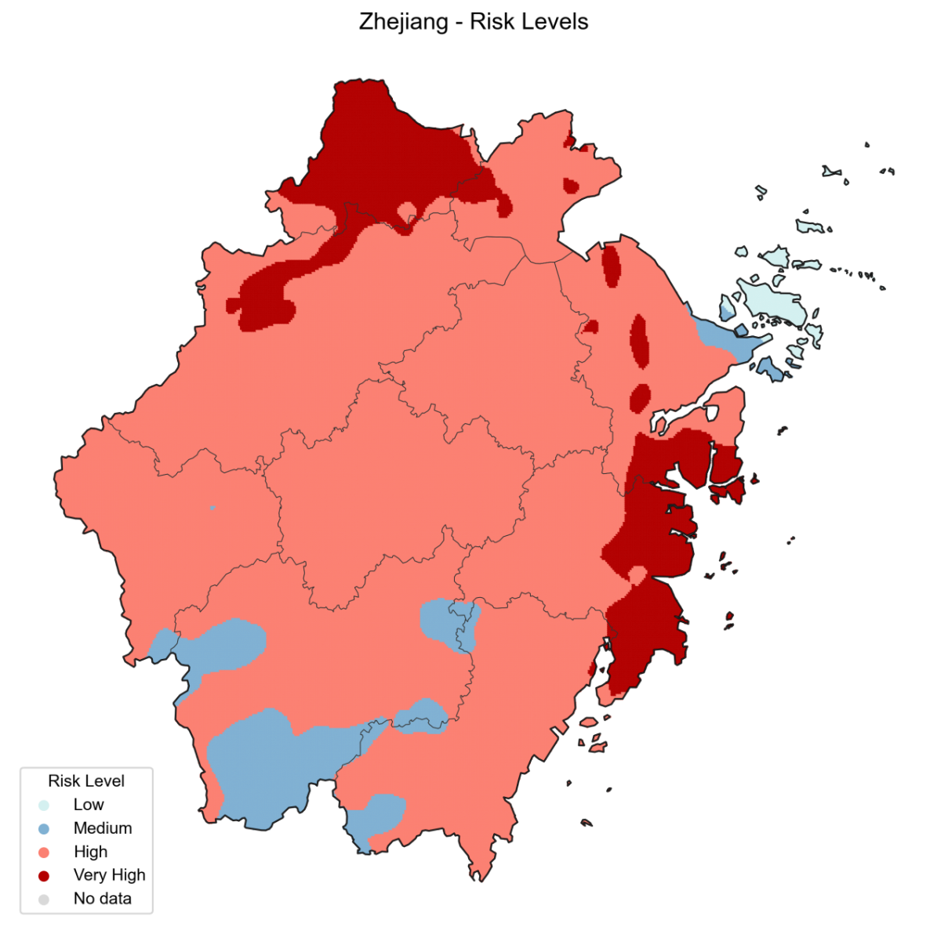
Figure S33. Zhejiang

Reference
1. Andraud M, Hens N, Marais C, Beutels P. Dynamic epidemiological models for dengue transmission: a systematic review of structural approaches. PLoS One. 2012;7(11):e49085.
2. Tang B, Xiao Y, Tang S, Wu J. Modelling weekly vector control against Dengue in the Guangdong Province of China. J Theor Biol. 2016;410:65-76.
3. Grunnill M, Boots M. How Important is Vertical Transmission of Dengue Viruses by Mosquitoes (Diptera: Culicidae)? J Med Entomol. 2016;53(1):1-19.
4. Delatte H, Gimonneau G, Triboire A, Fontenille D. Influence of temperature on immature development, survival, longevity, fecundity, and gonotrophic cycles of Aedes albopictus, vector of chikungunya and dengue in the Indian Ocean. J Med Entomol. 2009;46(1):33-41.
5. Liu X, Zhang M, Cheng Q, Zhang Y, Ye G, Huang X, et al. Dengue fever transmission between a construction site and its surrounding communities in China. Parasit Vectors. 2021;14(1):22.
6. Staples JE, Breiman RF, Powers AM. Chikungunya fever: an epidemiological review of a re-emerging infectious disease. Clin Infect Dis. 2009;49(6):942-8.
7. Wang T, Wang M, Shu B, Chen XQ, Luo L, Wang JY, et al. Evaluation of inapparent dengue infections during an outbreak in Southern China. PLoS Negl Trop Dis. 2015;9(3):e0003677.
8. Yasuno M, Tonn RJ. A study of biting habits of Aedes aegypti in Bangkok, Thailand. Bull World Health Organ. 1970;43(2):319-25.
9. Trpis M, Hausermann W. Dispersal and other population parameters of Aedes aegypti in an African village and their possible significance in epidemiology of vector-borne diseases. Am J Trop Med Hyg. 1986;35(6):1263-79.
10. Brady OJ, Johansson MA, Guerra CA, Bhatt S, Golding N, Pigott DM, et al. Modelling adult Aedes aegypti and Aedes albopictus survival at different temperatures in laboratory and field settings. Parasit Vectors. 2013;6:351.
11. Maciel-de-Freitas R, Codeço CT, Lourenço-de-Oliveira R. Daily survival rates and dispersal of Aedes aegypti females in Rio de Janeiro, Brazil. Am J Trop Med Hyg. 2007;76(4):659-65.
12. Chan M, Johansson MA. The incubation periods of Dengue viruses. PLoS One. 2012;7(11):e50972.
13. Duong V, Lambrechts L, Paul RE, Ly S, Lay RS, Long KC, et al. Asymptomatic humans transmit dengue virus to mosquitoes. Proc Natl Acad Sci U S A. 2015;112(47):14688-93.
14. Nguyet MN, Duong TH, Trung VT, Nguyen TH, Tran CN, Long VT, et al. Host and viral features of human dengue cases shape the population of infected and infectious Aedes aegypti mosquitoes. Proc Natl Acad Sci U S A. 2013;110(22):9072-7.
15. Nishiura H, Halstead SB. Natural history of dengue virus (DENV)-1 and DENV-4 infections: reanalysis of classic studies. J Infect Dis. 2007;195(7):1007-13.

