SUPPLEMENTARY MATERIAL

Title
Glyceryl trinitrate for treating hyperacute stroke: the Efficacy of Nitric Oxide in Stroke-2 (ENOS-2) feasibility randomised controlled trial

Journal
Neurological Sciences

Authors
Lisa J Woodhouse, PhD; Iris Mhlanga, MSc; Amanda Buck, BSc; Amanda Hedstrom, BSc; Camille Hutchinson, BSc; Lucy Gray, BSc; Tiffany Hamilton, PhD; Diane Havard, RGN; Kailash Krishnan, FRCP; Timothy England, FRCP PhD; Nikola Sprigg, FRCP PhD; Philip M W Bath, FRCP FMedSci

Correspondence to
Professor Philip Bath
Stroke Trials Unit
Mental Health & Clinical Neuroscience
University of Nottingham
Nottingham NG7 2UH UK

Tel: +44 115 823 1765
Fax: +44 115 823 1767
E-mail: philip.bath@nottingham.ac.uk

Contents

References

Supplemental Tables
- Substantial and minor protocol amendments and major events
- Reasons for exclusion from recruitment ordered by frequency.
- Sources of consent in 39 participants.
- Baseline CT neuroimaging findings.
- Adherence by randomised groups
- In-hospital procedures on days zero to two.
- Blood pressure and heart rate profile before and during treatment.

Supplemental Figures
- Recruitment curve.
- Histogram of recruitment by trial staff.
- Meta-analysis of the effect of GTN on modified Rankin scale (mRS) in randomised controlled trials where treatment vs control was given between 3-5 hours.

CONSORT 2010 checklist of information to include when reporting a pilot or feasibility trial

References

1 IST-3 collaborative group. Association between brain imaging signs, early and late outcomes, and response to intravenous alteplase after acute ischaemic stroke in the third International Stroke Trial (IST-3): secondary analysis of a randomised controlled trial. The Lancet Neurology. 2015;14(5):485-96. DOI: 10.1016/S1474-4422(15)00012-5.
2 Enos Trial Investigators. Efficacy of nitric oxide, with or without continuing antihypertensive treatment, for management of high blood pressure in acute stroke (ENOS): a partial-factorial randomised controlled trial. The Lancet. 2015;385(9968):617-28. DOI: 10.1016/s0140-6736(14)61121-1
3 Woodhouse L, Scutt P, Krishnan K, Berge E, Gommans J, Ntaios G, et al. Effect of hyperacute administration (within 6 hours) of transdermal glyceryl trinitrate, a nitric oxide donor, on outcome after stroke: subgroup analysis of the Efficacy of Nitric Oxide in Stroke (ENOS) trial. Stroke. 2015;46:3194-201. DOI:
4 Bath PM, Scutt P, Anderson CS, Appleton JP, Berge E, Cala L, et al. Prehospital transdermal glyceryl trinitrate in patients with ultra-acute presumed stroke (RIGHT-2): an ambulance-based, randomised, sham-controlled, blinded, phase 3 trial. The Lancet. 2019;393(10175):1009-20. DOI: 10.1016/s0140-6736(19)30194-1
5 van den Berg SA, Uniken Venema SM, Reinink H, Hofmeijer J, Schonewille WJ, Miedema I, et al. Prehospital transdermal glyceryl trinitrate in patients with presumed acute stroke (MR ASAP): an ambulance-based, multicentre, randomised, open-label, blinded endpoint, phase 3 trial. The Lancet Neurology. 2022;21(11):971-81. DOI: 10.1016/s1474-4422(22)00333-7
6 Bath PMW, Pathansali R, Iddenden R, Bath FJ. The Effect of Transdermal Glyceryl Trinitrate, a Nitric Oxide Donor, on Blood Pressure and Platelet Function in Acute Stroke. Cerebrovascular Diseases. 2001;11(3):265-72. DOI: 10.1159/000047649
7 Rashid P, Weaver C, Leonardi-Bee J, Bath F, Fletcher S, Bath P. The effects of transdermal glyceryl trinitrate, a nitric oxide donor, on blood pressure, cerebral and cardiac hemodynamics, and plasma nitric oxide levels in acute stroke. Journal of Stroke and Cerebrovascular Diseases. 2003;12(3):143-51. DOI: 10.1016/s1052-3057(03)00037-5
8 Willmot M, Ghadami A, Whysall B, Clarke W, Wardlaw J, Bath PMW. Transdermal Glyceryl Trinitrate Lowers Blood Pressure and Maintains Cerebral Blood Flow in Recent Stroke. Hypertension. 2006;47(6):1209-15. DOI: 10.1161/01.HYP.0000223024.02939.1e

Supplemental Table 1. Substantial and minor protocol amendments and major events
Change  MA / SA | Date | Summary of changes | Documents changed and new version numbers  (list) | Approvals:  codes and dates |  | Date implemented
 |  |  |  | REC | MHRA | Date implemented
MA/01/21 | 07/05/2021 | Pregnancy removed from exclusion criteria in trial synopsis. Trial registration numbers added. | Protocol (V1.2, 07 May 2021) | 10/05/2021 | N/A | 10/05/2021  (before site opened to recruitment)
SA/01/21 | 20/05/2021 | Multiple changes. | Protocol (V1.3, 14 May 2021)  PIS Full (V1.2, 14 May 2021)  RIS Full (V1.2, 14 May 2021)  PIS Short/Consent (V1.2, 14 May 2021)  RIS Short/Consent (V1.2, 14 May 2021) | 07/06/2021 | 23/06/2021 | 24/06/2021  (before site opened to recruitment)
SA/02/21 | 16/08/2021 | Multiple changes. | Protocol (V1.4, 02 Jul 2021)  RIS Short/Consent (V1.3, 02 Jul 2021)  PIS Short/Consent (V1.3, 02 Jul 2021)  Patient Postal Cover Letter (V1.0, 21 Jul 2021)  Day 90 Follow-Up Postal (V1.0, 16 Sep 2020)  Day 365 Follow-Up Postal (V1.0, 16 Sep 2020) | 25/08/2021 | N/A | 05/10/2021
SA/03/22 | 12/04/2022 | Multiple changes. | Protocol (V2.0, 12 April 2022)  RIS Short/Consent (V1.4, 12 April 2022)  PIS Short/Consent (V1.4, 12 April 2022)  PIS Full (V1.3, 12 April 2022)  RIS Full (V1.3, 12 April 2022)  GP Letter (V1.1, 12 April 2022)  Day 90 Follow-Up Postal (V1.1, 10 Feb 2022) | 04/05/2022  (HRA: 18/05/2022) | 13/05/2022 | 19/05/2022
SA/04/22 | 14/09/22 | Multiple changes. | Protocol (V3.0, 14 Sep 2022)  GP Letter (V1.2, 14 Sep 2022)  Practice Manager Letter (V1.0, 01 Jul 2022)  Day 90 Postal GP Letter (V1.0 01 Jul 2022) | 30/09/2022  HRA:  03/02/2023 | 02/02/2023 | 03/02/2023
MA/02/23 | 22/03/2023 | Clarification of the timeframe added to the day 90 participant-facing postal CRF regarding COVID-19 and infectious flu/cold-type illness. | Day 90 Follow-Up Postal (V1.2, 15 Mar 2023 DRAFT)  (V1.2, 19 May 2023 once live) | 24/03/2023 | N/A | 19/05/2023
MA/03/23 | 07/06/2023 | Non-commercial agreement updated to UoN version based on mNCA2022.  OID template submitted to reflect the current IRAS template (V1.6). | NCA (V5.0 01/02/2023)  OID (V2.0 08/06/2023) (template V1.6) | REC:  14/06/2023  HRA:  11/07/2023 | N/A | 11/07/2023
MA/04/24 | 15/03/24 | End of recruitment date amended from 29/02/24 to 29/06/24. IMP unavailable between 1/3/24 and 26/3/24 until protocol amendment approved. | Protocol v 3.1 20250315 | HRA:  26/03/2024 | N/A | 26/03/2024
HRA: Health Research Agency; MA: minor amendment; SA: substantive amendment

Supplementary Table 2. Reasons for exclusion from recruitment ordered by frequency.
Note exclusions are not mutually exclusive.
Explanation | N
Over 5 hours at presentation | 1398
Out-of-hours with no research staff present | 989
No eligible symptoms | 139
Unknown/unclear onset | 137
Palliative care/EOL | 87
mRS ≥4 | 69
Systolic BP < 120 mmHg | 62
Repatriated/Out of Area/Country | 54
GTN given clinically | 52
Doctor not available or not on trial log | 43
Wake-up stroke | 33
No limb weakness | 27
MT admission, doctor unwilling to randomise | 26
Seizure at presentation | 22
GCS ≤ 8 | 21
<5 hrs paused | 20
< 5 hours but out-of-hours | 19
Non-stroke | 16
Patient declined | 16
Doctor unwilling to randomise | 15
No IMP available | 12
Too unwell | 9
Recruited to another trial | 8
Patient died | 7
Prisoner | 7
Within 5 hours but insufficient time | 7
No capacity due to strike/ no capacity | 6
Not appropriate | 3
Self-discharges/ absconded | 3
Transferred to ICU | 1
Contraindication to GTN | 1
Incorrect onset time | 1
No fixed abode | 1
Nobody to consent | 1
Previously recruited | 1
Red flag | 1

Supplementary Table 3. Sources of consent in 39 participants.
Data are number (%).
Consent type | All | GTN | Sham
Patients with data at randomisation | 39 | 21 | 18
Initial Consent
Written consent by participant | 17 (43.6) | 9 (42.9) | 8 (44.4)
Written consent by relative/close friend | 8 (20.5) | 4 (19.0) | 4 (22.2)
Witnessed verbal consent by participant | 7 (17.9) | 5 (23.8) | 2 (11.1)
Witnessed verbal consent by relative/close friend | 5 (12.8) | 2 (9.5) | 3 (16.7)
Emergency waiver of consent | 2 (5.1) | 1 (4.8) | 1 (5.6)
Re-consent after regaining capacity
Patients with data at discharge | 39 | 21 | 18
Written consent by participant | 23 (59.0) | 13 (61.9) | 10 (55.6)
Written consent by relative/close friend | 15 (38.5) | 8 (38.1) | 7 (38.9)
Witnessed verbal consent by participant | 0 (0.0) | 0 (0.0) | 0 (0.0)
Witnessed verbal consent by relative/close friend | 0 (0.0) | 0 (0.0) | 0 (0.0)
Emergency waiver of consent | 1 (2.6) | 0 (0.0) | 1 (5.6)

Supplemental Table 4. Baseline CT neuroimaging findings.
Data are number (%) or median [interquartile range].

Characteristic | N | All | GTN | Sham
Onset to scan (minutes) | 39 | 136.0 [104.0, 178.0] | 150.0 [116.0, 178.0] | 112.5 [101.0, 142.0]
Diagnosis (%)
Normal | 39 | 21 (53.8) | 11 (52.4) | 10 (55.6)
Ischaemic stroke | 39 | 16 (41.0) | 8 (38.1) | 8 (44.4)
ICH | 39 | 1 (2.6) | 1 (4.8) | 0 (0.0)
Other | 39 | 1 (2.6) | 1 (4.8) † | 0 (0.0)
Findings (%)
Compatible lesion | 39 | 18 (46.2) | 10 (47.6) | 8 (44.4)
Mass effect | 39 | 3 (7.7) | 2 (9.5) | 1 (5.6)
Cerebral atrophy | 39 | 13 (33.3) | 5 (23.8) | 8 (44.4)
White matter disease | 39 | 8 (20.5) | 4 (19.0) | 4 (22.2)
Hyperdense artery | 39 | 5 (12.8) | 2 (9.5) | 3 (16.7)
Previous strokes | 39 | 11 (28.2) | 7 (33.3) | 4 (22.2)
Brain frailty score (/3) ‡ | 39 | 1.0 [0.0, 2.0] | 1.0 [0.0, 1.0] | 0.5 [0.0, 2.0]
CT angiography (CTA) | 39 | 26 (66.7) | 14 (66.7) | 12 (66.7)
Large vessel occlusion | 26 | 11 (42.3) | 4 (28.6) | 7 (58.3)
No patients had a baseline MRI scan.
ICH: intracerebral haemorrhage
† Functional stroke syndrome
‡ Brain frailty score = sum of (white matter disease + cerebral atrophy + old stroke lesions)[1]

Supplementary Table 5. Adherence by randomised groups
Data are number (%). Comparisons by Fisher’s exact test or unadjusted binary logistic regression.
Measure | All | GTN | Sham | p
Randomised | 39 | 21 | 18
Received first treatment | 37 (94.9) | 21 (100.0) | 16 (88.9) | 0.21
Received both treatments | 33 (84.6) | 19 (90.5) | 14 (77.8) | 0.29
Received no randomised treatment | 1 (2.6) | 0 (0.0) | 1 (5.6) | 1.00
Doctor did not want patch administered | 1 (2.6) | 0 (0.0) | 1 (5.6) | 1.00

Supplemental Table 6. In-hospital procedures on days zero to two.
Data are number (%). Complete data are present for all variables.
Characteristic | All | GTN | Sham
Reperfusion
Alteplase (%) | 22 (56.4) | 11 (52.4) | 11 (61.1)
Thrombectomy (%) | 5 (12.8) | 3 (14.3) | 2 (11.1)
Blood pressure, IV
Labetalol, intravenous | 1 (2.6) | 0 (0.0) | 1 (5.6)
Blood pressure, transdermal
Glyceryl trinitrate (open-label) | 3 (7.7) | 1 (4.8) | 2 (11.1)
Blood pressure, oral
Alpha-blocker | 2 (5.1) | 1 (4.8) | 1 (5.6)
Angiotensin-converting enzyme inhibitor | 11 (28.2) | 5 (23.8) | 6 (33.3)
Angiotensin-II receptor antagonist | 3 (7.7) | 2 (9.5) | 1 (5.6)
Beta-receptor antagonist | 6 (15.4) | 3 (14.3) | 3 (16.7)
Calcium channel blocker | 6 (15.4) | 3 (14.3) | 3 (16.7)
Diuretic | 4 (10.3) | 3 (14.3) | 1 (5.6)
Centrally acting agent | 1 (2.6) | 0 (0.0) | 1 (5.6)
Other agent | 2 (5.1) | 1 (4.8) | 1 (5.6)
Any BP drug | 21 (53.8) | 10 (47.6) | 11 (61.1)
Other interventions
Acute stroke unit | 38 (97.4) | 20 (95.2) | 18 (100.0)
Stroke rehabilitation unit | 11 (28.2) | 7 (33.3) | 4 (22.2)
Physiotherapy | 31 (79.5) | 20 (95.2) | 11 (61.1)
Occupational therapy | 31 (79.5) | 20 (95.2) | 11 (61.1)
Speech and language therapy | 18 (46.2) | 9 (42.9) | 9 (50.0)
Dietician | 8 (20.5) | 6 (28.6) | 2 (11.1)
Intermittent pneumatic stockings | 19 (48.7) | 12 (57.1) | 7 (38.9)
No participants required hemicraniectomy, mannitol or intensive care unit admission

Supplementary Table 7. Blood pressure and heart rate profile before and during treatment.
Date are mean (standard deviation). Analyses performed using repeated measures ANOVA.
Measure | N | All | GTN | Sham | P
Participants | 39 |  | 21 | 18 | -
Systolic blood pressure |  |  |  |  | 0.46
Baseline/day 0 | 39 | 161.8 (18.4) | 157.2 (12.5) | 167.1 (22.8) | -
2 hours post randomisation | 37 | 146.6 (25.5) | 144.1 (25.2) | 149.9 (26.4) | -
Day 1 | 35 | 136.0 (17.8) | 139.3 (16.1) | 132.1 (19.4) | -
Diastolic blood pressure |  |  |  |  | 0.35
Baseline/day 0 | 39 | 80.8 (14.9) | 80.4 (18.4) | 81.4 (10.1) | -
2 hours post randomisation | 37 | 78.1 (14.7) | 80.1 (16.6) | 75.6 (11.8) | -
Day 1 | 35 | 72.1 (12.9) | 75.1 (14.6) | 68.5 (9.9) | -
Heart rate |  |  |  |  | 0.052
Baseline/day 0 | 39 | 81.9 (17.9) | 83.3 (19.1) | 80.3 (16.7) | -
2 hours post randomisation | 37 | 76.9 (18.6) | 81.5 (19.9) | 70.8 (15.3) | -
Day 1 | 35 | 80.2 (17.1) | 85.3 (13.0) | 74.1 (19.6) | -

Supplemental Figure 1. Recruitment curve.

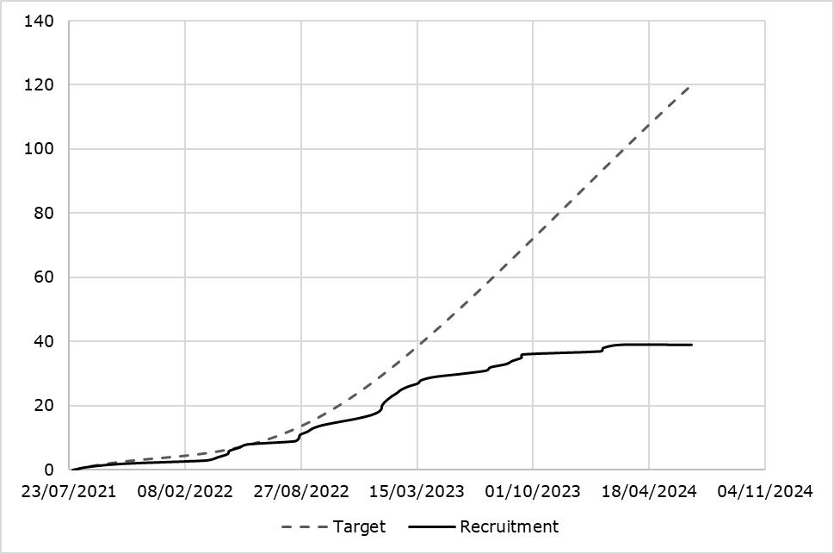
No drug available

Supplemental Figure 2. Histogram of recruitment by trial staff.

Supplemental Figure 3. Meta-analysis of the effect of GTN on modified Rankin scale (mRS) in randomised controlled trials where treatment vs control was given between 3-5 hours: ENOS-2 (this manuscript), ENOS early, RIGHT-2.[2-4]
Comparison of mRS. (mean, standard deviation) using Cochrane Review Manager software, version 5.4.1. Other trials of GTN are excluded because they only administered drug before 3 hours (MR ASAP [5]) or after 5 hours (GTN-1,[6] GTN-2,[7] GTN-3 [8]).

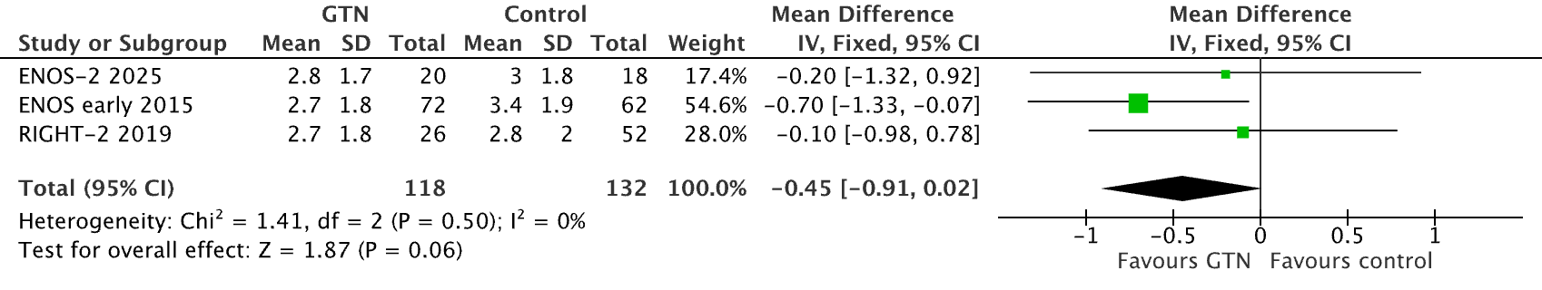


CONSORT 2010 checklist of information to include when reporting a pilot or feasibility trial

Section/Topic | Item No | Checklist item | Reported on page No
Title and abstract
 | 1a | Identification as a pilot or feasibility randomised trial in the title | 1
 | 1b | Structured summary of pilot trial design, methods, results, and conclusions (for specific guidance see CONSORT abstract extension for pilot trials) | 3
Introduction
Background and objectives | 2a | Scientific background and explanation of rationale for future definitive trial, and reasons for randomised pilot trial | 4-5
Background and objectives | 2b | Specific objectives or research questions for pilot trial | 4-5s
Methods
Trial design | 3a | Description of pilot trial design (such as parallel, factorial) including allocation ratio | 6
Trial design | 3b | Important changes to methods after pilot trial commencement (such as eligibility criteria), with reasons | 9-10
Participants | 4a | Eligibility criteria for participants | 6
Participants | 4b | Settings and locations where the data were collected | 6
 | 4c | How participants were identified and consented | 6
Interventions | 5 | The interventions for each group with sufficient details to allow replication, including how and when they were actually administered | 7
Outcomes | 6a | Completely defined prespecified assessments or measurements to address each pilot trial objective specified in 2b, including how and when they were assessed | 7-8
Outcomes | 6b | Any changes to pilot trial assessments or measurements after the pilot trial commenced, with reasons | N/A
 | 6c | If applicable, prespecified criteria used to judge whether, or how, to proceed with future definitive trial | N/A
Sample size | 7a | Rationale for numbers in the pilot trial | 9
Sample size | 7b | When applicable, explanation of any interim analyses and stopping guidelines | 9
Randomisation:
Sequence  generation | 8a | Method used to generate the random allocation sequence | 6-7
Sequence  generation | 8b | Type of randomisation(s); details of any restriction (such as blocking and block size) | 6-7
Allocation  concealment  mechanism | 9 | Mechanism used to implement the random allocation sequence (such as sequentially numbered containers), describing any steps taken to conceal the sequence until interventions were assigned | 6-7
Implementation | 10 | Who generated the random allocation sequence, who enrolled participants, and who assigned participants to interventions | 6
Blinding | 11a | If done, who was blinded after assignment to interventions (for example, participants, care providers, those assessing outcomes) and how | 8
Blinding | 11b | If relevant, description of the similarity of interventions | 7
Statistical methods | 12 | Methods used to address each pilot trial objective whether qualitative or quantitative | 8
Results
Participant flow (a diagram is strongly recommended) | 13a | For each group, the numbers of participants who were approached and/or assessed for eligibility, randomly assigned, received intended treatment, and were assessed for each objective | 28
Participant flow (a diagram is strongly recommended) | 13b | For each group, losses and exclusions after randomisation, together with reasons | 28
Recruitment | 14a | Dates defining the periods of recruitment and follow-up | 11
Recruitment | 14b | Why the pilot trial ended or was stopped | 11
Baseline data | 15 | A table showing baseline demographic and clinical characteristics for each group | 20-21
Numbers analysed | 16 | For each objective, number of participants (denominator) included in each analysis. If relevant, these numbers  should be by randomised group | 20-21
Outcomes and estimation | 17 | For each objective, results including expressions of uncertainty (such as 95% confidence interval) for any  estimates. If relevant, these results should be by randomised group | 22-25
Ancillary analyses | 18 | Results of any other analyses performed that could be used to inform the future definitive trial | 29, 32-40
Harms | 19 | All important harms or unintended effects in each group (for specific guidance see CONSORT for harms) | 26-27
 | 19a | If relevant, other important unintended consequences | N/A
Discussion
Limitations | 20 | Pilot trial limitations, addressing sources of potential bias and remaining uncertainty about feasibility | 14-15
Generalisability | 21 | Generalisability (applicability) of pilot trial methods and findings to future definitive trial and other studies | 14
Interpretation | 22 | Interpretation consistent with pilot trial objectives and findings, balancing potential benefits and harms, and  considering other relevant evidence | 14-15
 | 22a | Implications for progression from pilot to future definitive trial, including any proposed amendments | 15
Other information
Registration | 23 | Registration number for pilot trial and name of trial registry | 6
Protocol | 24 | Where the pilot trial protocol can be accessed, if available | 8
Funding | 25 | Sources of funding and other support (such as supply of drugs), role of funders | 8-9
 | 26 | Ethical approval or approval by research review committee, confirmed with reference number | 8
Citation: Eldridge SM, Chan CL, Campbell MJ, Bond CM, Hopewell S, Thabane L, et al. CONSORT 2010 statement: extension to randomised pilot and feasibility trials. BMJ. 2016;355. This is an Open Access article distributed in accordance with the terms of the Creative Commons Attribution (CC BY 3.0) license (http://creativecommons.org/licenses/by/3.0/), which permits others to distribute, remix, adapt and build upon this work, for commercial use, provided the original work is properly cited.
We strongly recommend reading this statement in conjunction with the CONSORT 2010, extension to randomised pilot and feasibility trials, Explanation and Elaboration for important clarifications on all the items. If relevant, we also recommend reading CONSORT extensions for cluster randomised trials, non-inferiority and equivalence trials, non-pharmacological treatments, herbal interventions, and pragmatic trials. Additional extensions are forthcoming: for those and for up-to-date references relevant to this checklist, see www.consort-statement.org.

