Content
1. Potato procurement 2
2. Supplementary Figure (S1-S4) 3
3. Strain preservation number 5
4. Article Experimental Data Table(1-10) 6

1. Potato procurement
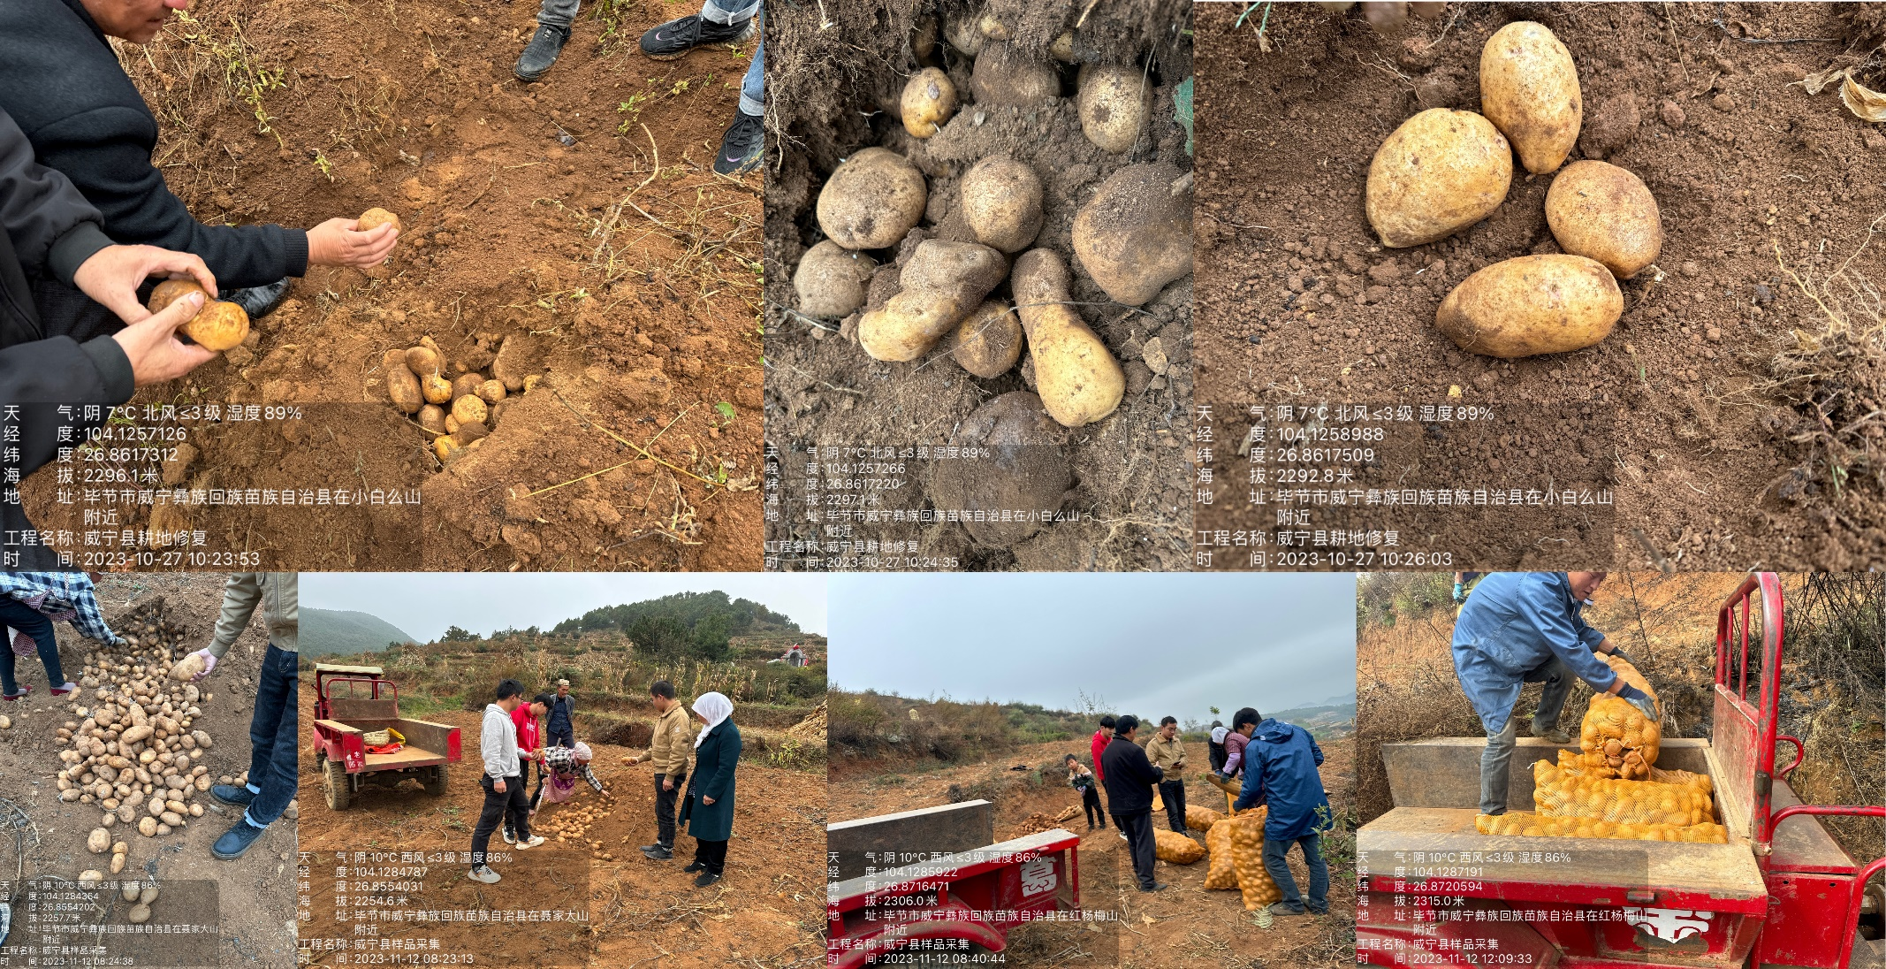

2. Supplementary Figure (S1-S4)
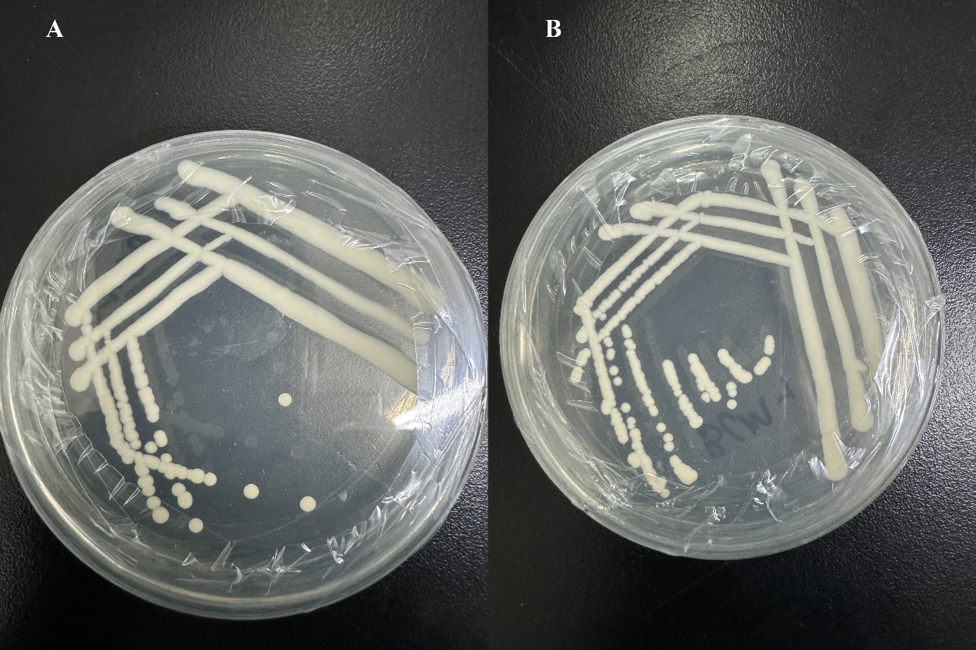
Figure S1. Fermentation inoculum (A: Saccharomyces cerevisiae;B: Pichia stipitis)
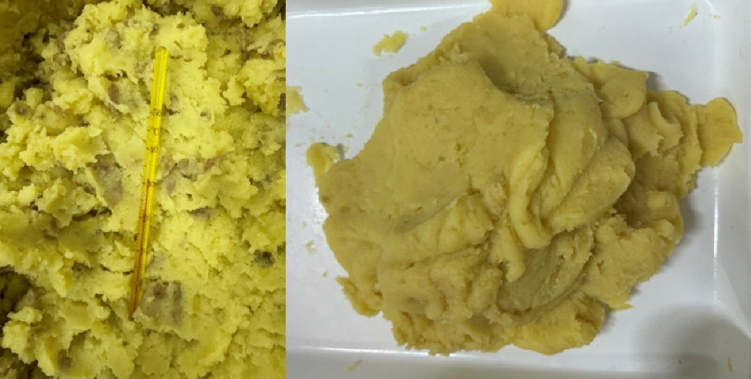
Figure S2. Mashed potatoes
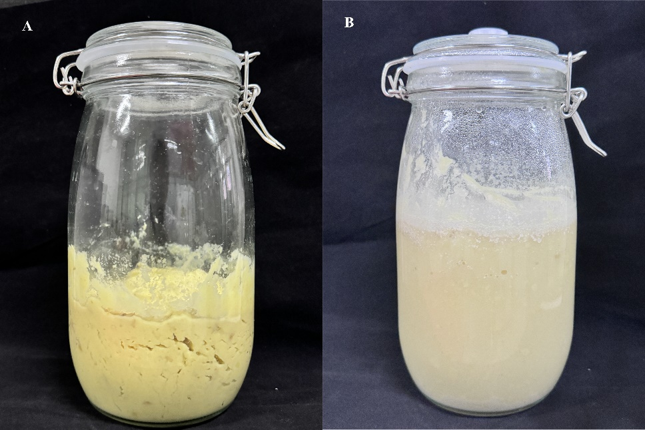
Figure S3. Photo of fermented mashed potatoes. (A: solid state fermentation; B: liquid fermentation)
Figure S4. Potato wine.(A:potato wine; B:Alcohol content of potato wine)

3. Strain preservation number
Pichia stipitis: BMZ017296; Saccharomyces cerevisiae: BZW2314T

4. Article Experimental Data Table(1-10)
Table 1. Cadmium content (mg/kg) in distillers’ grains under different fermentation treatments.
Treatment | Cd content
PCK | 0.545
PLS | 0.401
PSS | 0.795
PLP | 0.397
PSP | 0.894
SP | 1.31
LP | 0.801
SS | 1.447
LS | 1.063
CK | 0.643

Table 2. Cadmium chelation amount and chelation rate in potato distillers’ grains for selected treatments.
Treatment | Chelation content(mg/kg) | chelation rate(%)
PLP | 0.260 | 16.25
PLS | 0.252 | 17.34
PSS | 0.291 | 15.21
PSP | 0.248 | 31.68

Table 3 Amino acid content (ng/mg) in fermented potato samples under different treatments.
Compound | PSS | PSP |  | PLP | PLS | SS | LS | LP | SP
L-Alanine | 130.36 | 80.11 |  | 24.08 | 42.52 | 84.94 | 35.11 | 25.53 | 76.29
L-(+)-Arginine | 16.25 | 15.61 |  | 13.14 | 4.00 | 12.75 | 3.28 | 21.58 | 7.20
L-Glutamine | 893.09 | 179.98 |  | 204.35 | 223.42 | 348.86 | 94.42 | 144.87 | 423.37
L-GlutamicAcid | 121.90 | 554.53 |  | 137.54 | 61.47 | 428.83 | 88.42 | 50.74 | 577.49
Glycine | 40.85 | 28.04 |  | 17.58 | 24.92 | 29.90 | 19.01 | 20.41 | 22.97
L-Histidine | 369.14 | 434.75 |  | 160.07 | 45.71 | 361.05 | 131.15 | 177.62 | 349.05
L-Isoleucine | 53.31 | 42.57 |  | 13.41 | 19.48 | 26.64 | 14.68 | 12.95 | 29.79
L-Leucine | 149.66 | 45.00 |  | 36.19 | 56.35 | 58.45 | 43.8 | 28.09 | 52.94
L-Tryptophan | 133.90 | 75.27 |  | 30.66 | 23.72 | 15.52 | 13.6 | 15.54 | 86.88
L-(+)-Lysine | 236.34 | 113.13 |  | 66.94 | 96.86 | 125.92 | 75.25 | 56.88 | 220.29
L-Methionine | 60.07 | 89.31 |  | 18.65 | 15.77 | 48.62 | 9.87 | 9.00 | 56.93
L-Phenylalanine | 63.13 | 63.05 |  | 16.83 | 25.54 | 37.85 | 17.74 | 13.29 | 46.88
L-Proline | 236.11 | 275.31 |  | 105.27 | 95.13 | 179.39 | 98.06 | 92.62 | 183.17
L-Serine | 51.53 | 27.41 |  | 4.45 | 3.38 | 5.97 | 5.85 | 6.35 | 6.58
L-(-)-Threonine | 41.52 | 21.13 |  | 8.26 | 10.98 | 14.63 | 6.62 | 5.87 | 19.87
L-(-)-Tyrosine | 51.45 | 26.97 |  | 11.83 | 0.41 | 18.84 | 14.49 | 13.56 | 16.52
L-Valine | 134.49 | 162.91 |  | 43.67 | 47.75 | 84.20 | 27.39 | 19.89 | 104.72
L-Cysteine | 0.21 | 1.12 |  | 0.81 | 0.65 | 0.68 | 0.61 | 0.91 | 0.66

Table 4. Genus-level bacterial abundance in fermented samples under various treatments.
ASV ID | LS | LP | SS | SP | PLS | PLP | PSS | PSP
g__Lactobacillus | 49121.67 | 47353.67 | 32206.33 | 23193.5 | 41368 | 49414.5 | 2400.33 | 17690
g__Weissella | 2449.67 | 683 | 3754 | 8604 | 1304 | 1436.5 | 19632.33 | 209
g__Enterococcus | 681.67 | 407 | 1167.67 | 1079 | 478 | 1336.5 | 15105.67 | 9368
g__Bacillus | 1206 | 424 | 692.33 | 1379 | 373.67 | 1250 | 2003.33 | 2805
g__Pediococcus | 115.67 | 136.33 | 454.33 | 749.5 | 476.33 | 2102.5 | 1266.33 | 4817
g__Klebsiella | 420 | 91.33333 | 400 | 719 | 121.33 | 318.5 | 1041.67 | 2304.5
g__Enterobacter | 258 | 67.67 | 1399.67 | 280.5 | 90.67 | 389.5 | 1353.33 | 123
g__unclassified_f__Enterobacteriaceae | 158.33 | 31 | 41.67 | 523.5 | 69.67 | 66.5 | 358.33 | 125.5
g__Pantoea | 105.33 | 34 | 41 | 713 | 7.67 | 4 | 113 | 15.5
g__Cronobacter | 68.67 | 13.67 | 18.33 | 57.5 | 69.33 | 89 | 211.6667 | 199
g__Raoultella | 6.33 | 0 | 0 | 0 | 4.67 | 0 | 308 | 91
g__unclassified_o__Lactobacillales | 15 | 46 | 30.33 | 31 | 26.33 | 53 | 81.67 | 82
g__Lactococcus | 8 | 5.33 | 6.67 | 4.5 | 133 | 2.5 | 147.33 | 5.5
g__Citrobacter | 9.67 | 1.67 | 38.67 | 1.5 | 23 | 4 | 136.33 | 46
g__unclassified_o__Enterobacterales | 5.67 | 1.67 | 7.33 | 36.5 | 22.33 | 0 | 71 | 18.5
g__unclassified_c__Bacilli | 8.33 | 9.67 | 14 | 27.5 | 5.33 | 12 | 33.67 | 27.5
g__unclassified_f__Lactobacillaceae | 8.33 | 7 | 5 | 38.5 | 3 | 17.5 | 13 | 38.5
g__unclassified_k__norank_d__Bacteria | 2 | 3.67 | 26.33 | 35.5 | 12.33 | 9 | 22.67 | 15.5
g__Leuconostoc | 0 | 15.33 | 2 | 0 | 26.67 | 8.5 | 1.67 | 26
g__Escherichia-Shigella | 6 | 4.33 | 2.67 | 0 | 39 | 0 | 8.67 | 0
g__Serratia | 0 | 0 | 0 | 0 | 0 | 0 | 55 | 3.5
g__Streptococcus | 2.33 | 3.33 | 4.67 | 7.5 | 1.33 | 4 | 8.67 | 2
g__unclassified_c__Gammaproteobacteria | 0 | 0 | 5.67 | 8.5 | 2.33 | 4.5 | 5 | 0
g__Kluyvera | 0 | 0 | 0 | 0 | 0 | 0 | 26 | 0
g__unclassified_p__Proteobacteria | 2.33 | 2.67 | 4.67 | 3 | 0 | 0 | 0 | 0
g__unclassified_o__Bacillales | 0 | 0 | 0 | 5.5 | 0 | 0 | 0 | 5.5
g__unclassified_f__Erwiniaceae | 0 | 0 | 0 | 10 | 0 | 0 | 0 | 0
g__Pseudomonas | 0 | 4.67 | 3 | 0 | 0 | 1 | 0.67 | 0
g__Rummeliibacillus | 1.67 | 0 | 1.67 | 4.5 | 0 | 0 | 1.33 | 0
g__Pelomonas | 0 | 3.33 | 2.33 | 0 | 0 | 0 | 0 | 1
g__Acinetobacter | 0 | 0 | 0 | 4.5 | 0 | 0 | 0.67 | 1
g__Staphylococcus | 0 | 0 | 0 | 0 | 0 | 0 | 6 | 0
g__Bosea | 0.67 | 1.33 | 2.33 | 0 | 0 | 1 | 0.67 | 0
g__Mangrovibacter | 0 | 0 | 0 | 0 | 0 | 0 | 0 | 5
g__Bradyrhizobium | 1.33 | 0 | 0 | 1 | 2 | 0 | 0.67 | 0
g__Brevundimonas | 1 | 0 | 1.33 | 0 | 0.67 | 0 | 0.67 | 0
g__Sphingomonas | 0 | 1 | 0.67 | 0 | 1.33 | 0 | 0 | 0
g__Lysinibacillus | 0 | 0 | 0 | 0 | 0 | 3 | 0 | 0
g__unclassified_f__Streptococcaceae | 0 | 0 | 0 | 0 | 0 | 0 | 3 | 0
g__Neisseria | 0 | 1 | 0 | 0 | 0 | 0 | 1.67 | 0
g__Aquabacterium | 0 | 0 | 0 | 0 | 2.67 | 0 | 0 | 0
g__Allorhizobium-Neorhizobium-Pararhizobium-Rhizobium | 1 | 1 | 0 | 0 | 0 | 0 | 0 | 0
g__Paenibacillus | 0 | 1 | 0 | 1 | 0 | 0 | 0 | 0
g__norank_f__P5D1-392 | 0 | 0 | 1.67 | 0 | 0 | 0 | 0 | 0
g__unclassified_f__Staphylococcaceae | 0 | 0 | 0 | 0 | 1.67 | 0 | 0 | 0
g__Exiguobacterium | 0 | 0 | 0 | 1.5 | 0 | 0 | 0 | 0
g__Burkholderia-Caballeronia-Paraburkholderia | 0 | 0 | 1.33 | 0 | 0 | 0 | 0 | 0
g__unclassified_f__Leuconostocaceae | 0 | 0 | 0 | 0 | 1.33 | 0 | 0 | 0
g__norank_f__norank_o__mle1-27 | 0 | 0 | 1.33 | 0 | 0 | 0 | 0 | 0
g__Actinomyces | 0 | 1.33 | 0 | 0 | 0 | 0 | 0 | 0
g__Perlucidibaca | 0 | 1 | 0 | 0 | 0 | 0 | 0 | 0
g__Brevibacillus | 0 | 0 | 0 | 0 | 0 | 0 | 1 | 0
g__Acidovorax | 0 | 1 | 0 | 0 | 0 | 0 | 0 | 0
g__unclassified_f__Microbacteriaceae | 0 | 0 | 0 | 0 | 0 | 1 | 0 | 0
g__Ralstonia | 0 | 1 | 0 | 0 | 0 | 0 | 0 | 0
g__Thiomonas | 0 | 0 | 1 | 0 | 0 | 0 | 0 | 0
g__unclassified_o__Bacteroidales | 0 | 0 | 0 | 0 | 0 | 1 | 0 | 0
g__Quadrisphaera | 0 | 0.67 | 0 | 0 | 0 | 0 | 0 | 0
g__Mycobacterium | 0.67 | 0 | 0 | 0 | 0 | 0 | 0 | 0
g__Fusobacterium | 0 | 0.67 | 0 | 0 | 0 | 0 | 0 | 0
g__Methyloversatilis | 0 | 0 | 0 | 0 | 0.67 | 0 | 0 | 0
g__Afipia | 0.67 | 0 | 0 | 0 | 0 | 0 | 0 | 0
g__unclassified_f__Xanthobacteraceae | 0 | 0 | 0.67 | 0 | 0 | 0 | 0 | 0
g__Zoogloea | 0 | 0.67 | 0 | 0 | 0 | 0 | 0 | 0

Table 5. Two-group statistical comparison (mean, SD, p-value) of dominant bacterial genera.
 | L-mean | L-sd | S-mean | S-sd | statistic | pvalue | corrected_pvalue | fc | z_score
g__Lactobacillus | 91.7 | 4.708 | 47.09 | 31.56 | 108 | 0.000218 | 0.01047 | 0.513522 | 0.273406
g__Weissella | 2.858 | 1.808 | 20.97 | 23.94 | 21 | 0.01832 | 0.1466 | 7.337299 | 2.861649
g__Enterococcus | 1.295 | 0.8545 | 16.48 | 19.3 | 10 | 0.001727 | 0.04144 | 12.72587 | 3.262645
g__Bacillus | 1.455 | 0.9361 | 4.081 | 2.832 | 13 | 0.003474 | 0.05559 | 2.804811 | 3.153282
g__Pediococcus | 1.239 | 2.439 | 4.184 | 4.893 | 25 | 0.03777 | 0.259 | 3.376917 | 2.715833
g__Klebsiella | 0.4425 | 0.5203 | 2.554 | 3.367 | 18 | 0.01014 | 0.1217 | 5.771751 | 2.971012
g__Enterobacter | 0.3307 | 0.3913 | 2.185 | 2.172 | 21 | 0.01832 | 0.1466 | 6.607197 | 2.861649
g__Pantoea | 0.07513 | 0.1166 | 0.5122 | 0.9873 | 32 | 0.109 | 0.5007 | 6.817516 | 2.460654
g__Cronobacter | 0.1154 | 0.1415 | 0.2867 | 0.3974 | 40 | 0.3071 | 0.5007 | 2.484402 | 2.169021
g__Raoultella | 0.006562 | 0.01461 | 0.2492 | 0.6259 | 45.5 | 0.3964 | 0.5007 | 37.97623 | 1.968523
g__Lactococcus | 0.0832 | 0.1813 | 0.1069 | 0.3016 | 55 | 1 | 1 | 1.284856 | 1.622209
g__Citrobacter | 0.02273 | 0.05232 | 0.1416 | 0.2774 | 34.5 | 0.1361 | 0.5007 | 6.229652 | 2.369519
g__Leuconostoc | 0.02806 | 0.03048 | 0.01623 | 0.0421 | 75 | 0.138 | 0.5007 | 0.578403 | 0.893126
g__Escherichia-Shigella | 0.03203 | 0.07933 | 0.007829 | 0.01848 | 71 | 0.2117 | 0.5007 | 0.244427 | 1.038943
g__Serratia | 0 | 0 | 0.03784 | 0.1134 | 44 | 0.1468 | 0.5007 | 1 | 2.023204
g__Streptococcus | 0.005062 | 0.006462 | 0.01411 | 0.02175 | 52 | 0.8492 | 0.9264 | 2.787436 | 1.731571
g__Kluyvera | 0 | 0 | 0.01818 | 0.05748 | 49.5 | 0.3404 | 0.5007 | 1 | 1.822707
g__Pseudomonas | 0.003006 | 0.004597 | 0.002618 | 0.005402 | 58.5 | 0.8013 | 0.8945 | 0.870925 | 1.494619
g__Rummeliibacillus | 0.000791 | 0.002623 | 0.004538 | 0.005915 | 36 | 0.08129 | 0.4335 | 5.739218 | 2.314837
g__Staphylococcus | 0 | 0 | 0.004135 | 0.009025 | 44 | 0.1468 | 0.5007 | 1 | 2.023204
g__Pelomonas | 0.00192 | 0.004874 | 0.002193 | 0.003691 | 49.5 | 0.6375 | 0.765 | 1.142188 | 1.822707
g__Acinetobacter | 0 | 0 | 0.00355 | 0.008083 | 38.5 | 0.06427 | 0.3856 | 1 | 2.223702
g__Bosea | 0.001248 | 0.002352 | 0.002132 | 0.003609 | 50 | 0.6912 | 0.7899 | 1.708333 | 1.804479
g__Bradyrhizobium | 0.001918 | 0.003547 | 0.001011 | 0.002155 | 60 | 0.6715 | 0.7862 | 0.527112 | 1.439938
g__Mangrovibacter | 0 | 0 | 0.002594 | 0.008203 | 49.5 | 0.3404 | 0.5007 | 1 | 1.822707
g__Brevundimonas | 0.000865 | 0.001949 | 0.001403 | 0.00316 | 53 | 0.8776 | 0.9361 | 1.622153 | 1.695117
g__Sphingomonas | 0.001356 | 0.003032 | 0.000469 | 0.001482 | 60.5 | 0.5631 | 0.6931 | 0.345649 | 1.421711
g__Neisseria | 0.000616 | 0.002043 | 0.001165 | 0.003685 | 54 | 0.9449 | 0.986 | 1.891541 | 1.658663
g__Aquabacterium | 0.001655 | 0.003707 | 0 | 0 | 65 | 0.1893 | 0.5007 | 0 | 1.257668
g__norank_f__P5D1-392 | 0 | 0 | 0.001345 | 0.004253 | 49.5 | 0.3404 | 0.5007 | 1 | 1.822707
g__Paenibacillus | 0.000576 | 0.001911 | 0.000574 | 0.001815 | 55 | 1 | 1 | 0.996008 | 1.622209
g__norank_f__norank_o__mle1-27 | 0 | 0 | 0.001076 | 0.003403 | 49.5 | 0.3404 | 0.5007 | 1 | 1.822707
g__Allorhizobium-Neorhizobium-Pararhizobium-Rhizobium | 0.001013 | 0.002258 | 0 | 0 | 65 | 0.1893 | 0.5007 | 0 | 1.257668
g__Burkholderia-Caballeronia-Paraburkholderia | 0 | 0 | 0.000972 | 0.003072 | 49.5 | 0.3404 | 0.5007 | 1 | 1.822707
g__Exiguobacterium | 0 | 0 | 0.000861 | 0.002722 | 49.5 | 0.3404 | 0.5007 | 1 | 1.822707
g__Lysinibacillus | 0.000823 | 0.002728 | 0 | 0 | 60 | 0.3908 | 0.5007 | 0 | 1.439938
g__Actinomyces | 0.000821 | 0.002723 | 0 | 0 | 60 | 0.3908 | 0.5007 | 0 | 1.439938
g__Thiomonas | 0 | 0 | 0.000807 | 0.002552 | 49.5 | 0.3404 | 0.5007 | 1 | 1.822707
g__Brevibacillus | 0 | 0 | 0.000699 | 0.002211 | 49.5 | 0.3404 | 0.5007 | 1 | 1.822707
g__Ralstonia | 0.000576 | 0.001911 | 0 | 0 | 60 | 0.3908 | 0.5007 | 0 | 1.439938
g__Acidovorax | 0.000483 | 0.001602 | 0 | 0 | 60 | 0.3908 | 0.5007 | 0 | 1.439938
g__Perlucidibaca | 0.000483 | 0.001602 | 0 | 0 | 60 | 0.3908 | 0.5007 | 0 | 1.439938
g__Fusobacterium | 0.000411 | 0.001362 | 0 | 0 | 60 | 0.3908 | 0.5007 | 0 | 1.439938
g__Zoogloea | 0.000411 | 0.001362 | 0 | 0 | 60 | 0.3908 | 0.5007 | 0 | 1.439938
g__Quadrisphaera | 0.000411 | 0.001362 | 0 | 0 | 60 | 0.3908 | 0.5007 | 0 | 1.439938
g__Methyloversatilis | 0.000403 | 0.001337 | 0 | 0 | 60 | 0.3908 | 0.5007 | 0 | 1.439938
g__Afipia | 0.00033 | 0.001094 | 0 | 0 | 60 | 0.3908 | 0.5007 | 0 | 1.439938
g__Mycobacterium | 0.00033 | 0.001094 | 0 | 0 | 60 | 0.3908 | 0.5007 | 0 | 1.439938

Table 6. Phylum-level bacterial abundance in samples derived from Circos analysis.
ASV ID | LS | LP | SS | SP | PLS | PLP | PSS | PSP
d__Bacteria; k__norank_d__Bacteria; p__Firmicutes | 34207.67 | 34654.33 | 33117.67 | 32675 | 34487.33 | 34316 | 31947.67 | 32187.5
d__Bacteria; k__norank_d__Bacteria; p__Proteobacteria | 640.67 | 191.33 | 1708.67 | 2145 | 354 | 526.5 | 2882.67 | 2647.5
d__Bacteria; k__norank_d__Bacteria; p__unclassified_k__norank_d__Bacteria | 1.33 | 2.33 | 22.33 | 30 | 8.67 | 6 | 19.67 | 15
d__Bacteria; k__norank_d__Bacteria; p__Actinobacteriota | 0.33 | 1.33 | 0 | 0 | 0 | 0.5 | 0 | 0
d__Bacteria; k__norank_d__Bacteria; p__Myxococcota | 0 | 0 | 1.33 | 0 | 0 | 0 | 0 | 0
d__Bacteria; k__norank_d__Bacteria; p__Bacteroidota | 0 | 0 | 0 | 0 | 0 | 1 | 0 | 0
d__Bacteria; k__norank_d__Bacteria; p__Fusobacteriota | 0 | 0.67 | 0 | 0 | 0 | 0 | 0 | 0

Table 7. Relative abundance (%) of major bacterial phyla in samples based on Circos data.
ASV ID | LS | LP | SS | SP | PLS | PLP | PSS | PSP
p__Firmicutes | 0.981569 | 0.994385 | 0.950292 | 0.93759 | 0.989593 | 0.984677 | 0.916719 | 0.923601
p__Proteobacteria | 0.018384 | 0.00549 | 0.049029 | 0.061549 | 0.010158 | 0.015108 | 0.082716 | 0.075968
p__unclassified_k__norank_d__Bacteria | 3.82592061215e-05 | 6.69536107126e-05 | 0.000641 | 0.000861 | 0.000249 | 0.000172 | 0.000564 | 0.00043
p__Actinobacteriota | 9.56480153037e-06 | 3.82592061215e-05 | 0 | 0 | 0 | 1.43472022956e-05 | 0 | 0
p__Myxococcota | 0 | 0 | 3.82592061215e-05 | 0 | 0 | 0 | 0 | 0
p__Bacteroidota | 0 | 0 | 0 | 0 | 0 | 2.86944045911e-05 | 0 | 0
p__Fusobacteriota | 0 | 1.91296030607e-05 | 0 | 0 | 0 | 0 | 0 | 0

Table 8. Mantel test correlation values and p-values between selected amino acid pairs.
factor1 | factor2 | r | p_value
L-GlutamicAcid | L-(+)-Arginine | 0.019468 | 0.933247
L-Methionine | L-Leucine | 0.458857 | 0.036413
L-Histidine | L-Glutamine | 0.065403 | 0.778202
L-GlutamicAcid | L-Alanine | 0.123782 | 0.592946
L-Leucine | L-GlutamicAcid | 0.010921 | 0.962528
L-Histidine | L-Alanine | 0.027651 | 0.905294
L-(+)-Arginine | L-Alanine | 0.062729 | 0.787063
L-Tryptophan | L-GlutamicAcid | 0.3541 | 0.115291
Glycine | L-GlutamicAcid | 0.183724 | 0.425338
L-Methionine | L-Alanine | 0.198286 | 0.388896
L-Proline | L-Isoleucine | 0.778378 | 3.25E-05
L-(-)-Tyrosine | Glycine | 0.202055 | 0.379756
L-Cysteine | L-Leucine | -0.32329 | 0.152853
L-Cysteine | L-(+)-Lysine | -0.24885 | 0.276701
L-Isoleucine | L-Histidine | 0.50092 | 0.020719
L-Tryptophan | L-Glutamine | 0.195779 | 0.39504
L-Tryptophan | L-Isoleucine | 0.837215 | 2.22E-06
Glycine | L-Alanine | 0.615791 | 0.002959
L-Glutamine | L-(+)-Arginine | 0.301492 | 0.184123
L-Glutamine | L-Alanine | 0.738373 | 0.000132
Glycine | L-(+)-Arginine | 0.115115 | 0.619273
L-GlutamicAcid | L-Glutamine | 0.084577 | 0.715483
L-Isoleucine | Glycine | 0.321333 | 0.155502
L-Tryptophan | L-Histidine | 0.39994 | 0.072437
L-Methionine | L-GlutamicAcid | 0.707694 | 0.000332
L-Phenylalanine | L-GlutamicAcid | 0.575896 | 0.006294
L-Serine | L-Leucine | 0.528458 | 0.013787
L-Serine | L-Tryptophan | 0.57133 | 0.006822
L-Serine | L-(+)-Lysine | 0.395474 | 0.075984
L-Serine | L-Proline | 0.635223 | 0.001974
L-(-)-Threonine | L-Leucine | 0.779439 | 3.12E-05
L-(-)-Threonine | L-Phenylalanine | 0.574191 | 0.006487
L-(-)-Tyrosine | L-(+)-Arginine | 0.199876 | 0.385024
L-(-)-Tyrosine | L-Proline | 0.510095 | 0.018154
L-(-)-Tyrosine | L-(-)-Threonine | 0.612892 | 0.003137
L-Cysteine | L-Methionine | -0.07126 | 0.758875
Glycine | L-Glutamine | 0.529397 | 0.013589
L-Leucine | L-(+)-Arginine | 0.155657 | 0.500466
L-(+)-Lysine | L-(+)-Arginine | -0.0189 | 0.9352
L-Methionine | L-Glutamine | 0.122051 | 0.598168
L-Phenylalanine | L-(+)-Arginine | 0.187316 | 0.416182
L-Phenylalanine | L-Tryptophan | 0.831461 | 3.01E-06
L-(-)-Threonine | Glycine | 0.184179 | 0.424171
L-(-)-Tyrosine | L-(+)-Lysine | 0.230838 | 0.314061
L-(-)-Tyrosine | L-Methionine | 0.44436 | 0.043576
L-Valine | L-(+)-Lysine | 0.37263 | 0.096196
L-Valine | L-Serine | 0.440346 | 0.045741
L-Valine | L-(-)-Tyrosine | 0.577138 | 0.006157
L-Proline | Glycine | 0.438455 | 0.046789
L-Serine | L-Alanine | 0.311181 | 0.169731
L-Valine | L-GlutamicAcid | 0.598212 | 0.004176
L-Cysteine | L-Alanine | -0.30613 | 0.177141
L-Cysteine | L-Histidine | 0.030184 | 0.896662
L-Histidine | L-GlutamicAcid | 0.742428 | 0.000116
L-Isoleucine | L-Glutamine | 0.150636 | 0.514551
L-Leucine | Glycine | 0.060853 | 0.793299
L-(+)-Lysine | L-GlutamicAcid | 0.298002 | 0.189505
L-(+)-Lysine | Glycine | 0.600639 | 0.003987
L-Methionine | L-Tryptophan | 0.772958 | 3.99E-05
L-Cysteine | L-(+)-Arginine | 0.444919 | 0.043281
L-Cysteine | L-Valine | -0.10396 | 0.653832
L-Isoleucine | L-GlutamicAcid | 0.374003 | 0.09488
L-Phenylalanine | L-Isoleucine | 0.93937 | 2.82E-10
L-Serine | L-Glutamine | 0.52276 | 0.01504
L-(-)-Threonine | L-(+)-Lysine | 0.456411 | 0.037552
L-(-)-Tyrosine | L-Histidine | 0.189679 | 0.410218
L-Valine | L-(+)-Arginine | 0.163902 | 0.477751
L-Valine | L-Glutamine | 0.145807 | 0.528276
L-Histidine | L-(+)-Arginine | 0.129689 | 0.57528
L-Proline | L-(+)-Lysine | 0.553754 | 0.009203
L-Serine | L-Isoleucine | 0.569247 | 0.007074
L-Serine | L-Phenylalanine | 0.436494 | 0.047895
L-(-)-Threonine | L-Isoleucine | 0.615054 | 0.003004
L-Tryptophan | Glycine | 0.133103 | 0.565173
L-(+)-Lysine | L-Leucine | 0.281271 | 0.216777
L-(+)-Lysine | L-Tryptophan | 0.324483 | 0.151262
L-Proline | L-Tryptophan | 0.648401 | 0.001477
L-Serine | L-GlutamicAcid | -0.12056 | 0.602673
L-Serine | L-Histidine | 0.275442 | 0.226858
L-Valine | L-(-)-Threonine | 0.500748 | 0.02077
L-Cysteine | L-(-)-Tyrosine | -0.10038 | 0.665073
L-Isoleucine | L-Alanine | 0.158855 | 0.491594
L-Isoleucine | L-(+)-Arginine | 0.163723 | 0.478238
L-Leucine | L-Histidine | 0.105745 | 0.64825
L-Leucine | L-Isoleucine | 0.744347 | 0.000109
L-Tryptophan | L-Leucine | 0.720485 | 0.00023
L-(+)-Lysine | L-Isoleucine | 0.300753 | 0.185254
L-Serine | Glycine | 0.312734 | 0.167499
L-(-)-Threonine | L-Methionine | 0.427256 | 0.053381
L-(-)-Tyrosine | L-Glutamine | 0.250633 | 0.273156
L-Cysteine | L-Glutamine | -0.26001 | 0.255006
L-Cysteine | L-Serine | -0.28995 | 0.202321
L-Phenylalanine | L-Alanine | 0.264811 | 0.246022
L-Phenylalanine | Glycine | 0.327154 | 0.147731
L-Phenylalanine | L-Methionine | 0.935293 | 5.14E-10
L-Proline | L-Alanine | 0.362169 | 0.106666
L-Proline | L-Methionine | 0.79758 | 1.49E-05
L-(-)-Threonine | L-Tryptophan | 0.732605 | 0.000159
L-(-)-Tyrosine | L-Tryptophan | 0.632289 | 0.002102
L-Cysteine | L-Phenylalanine | -0.15604 | 0.499392
L-Histidine | Glycine | 0.182311 | 0.428969
L-Leucine | L-Alanine | 0.276318 | 0.225323
L-Methionine | Glycine | 0.295351 | 0.193663
L-Methionine | L-Histidine | 0.665323 | 0.000997
L-Proline | L-Histidine | 0.671591 | 0.000857
L-(-)-Threonine | L-Alanine | 0.519396 | 0.015821
L-(-)-Threonine | L-Histidine | 0.344442 | 0.126262
L-(-)-Tyrosine | L-Leucine | 0.753057 | 8.15E-05
L-Cysteine | Glycine | -0.04612 | 0.84265
L-Cysteine | L-Isoleucine | -0.14374 | 0.534199
L-Cysteine | L-Tryptophan | -0.25619 | 0.262301
L-Leucine | L-Glutamine | 0.294042 | 0.195739
L-Tryptophan | L-Alanine | 0.300087 | 0.186277
L-Tryptophan | L-(+)-Arginine | 0.152665 | 0.508838
L-Phenylalanine | L-Histidine | 0.546638 | 0.010343
L-Phenylalanine | L-(+)-Lysine | 0.411906 | 0.063545
L-Proline | L-Leucine | 0.506596 | 0.019101
L-(-)-Threonine | L-GlutamicAcid | 0.165042 | 0.47465
L-Valine | Glycine | 0.352454 | 0.11711
L-Valine | L-Histidine | 0.623291 | 0.002539
L-Valine | L-Methionine | 0.973997 | 1.04E-13
L-(+)-Lysine | L-Glutamine | 0.677926 | 0.000732
L-Methionine | L-(+)-Lysine | 0.318191 | 0.159813
L-Phenylalanine | L-Glutamine | 0.206966 | 0.368034
L-Proline | L-(+)-Arginine | 0.417708 | 0.059544
L-Proline | L-GlutamicAcid | 0.563788 | 0.007772
L-(-)-Tyrosine | L-Serine | 0.716526 | 0.000258
L-Valine | L-Alanine | 0.227829 | 0.320584
L-(+)-Lysine | L-Histidine | 0.250717 | 0.27299
L-Methionine | L-(+)-Arginine | 0.146087 | 0.527475
L-Methionine | L-Isoleucine | 0.84631 | 1.33E-06
L-Serine | L-(+)-Arginine | 0.394266 | 0.076966
L-(-)-Threonine | L-Glutamine | 0.633986 | 0.002027
L-Proline | L-Phenylalanine | 0.842741 | 1.63E-06
L-(-)-Tyrosine | L-Alanine | 0.121976 | 0.598394
L-(-)-Tyrosine | L-GlutamicAcid | -0.1399 | 0.545302
L-(-)-Threonine | L-(+)-Arginine | 0.256578 | 0.261558
L-(-)-Tyrosine | L-Isoleucine | 0.783876 | 2.62E-05
L-(-)-Threonine | L-Serine | 0.755846 | 7.4E-05
L-(-)-Tyrosine | L-Phenylalanine | 0.617085 | 0.002883
L-Valine | L-Isoleucine | 0.92507 | 1.99E-09
L-Valine | L-Tryptophan | 0.809719 | 8.71E-06
L-Valine | L-Proline | 0.840067 | 1.89E-06
L-Valine | L-Phenylalanine | 0.977023 | 3.24E-14
L-Cysteine | L-Proline | -0.12609 | 0.586004
L-(+)-Lysine | L-Alanine | 0.678614 | 0.00072
L-Phenylalanine | L-Leucine | 0.683327 | 0.000639
L-Proline | L-Glutamine | 0.440941 | 0.045415
L-Serine | L-Methionine | 0.327527 | 0.147241
L-(-)-Threonine | L-Proline | 0.622857 | 0.002562
L-Valine | L-Leucine | 0.572025 | 0.006739
L-Cysteine | L-GlutamicAcid | -0.08479 | 0.714794
L-Cysteine | L-(-)-Threonine | -0.44798 | 0.041693

Table 9. Mantel test results between microbial communities and amino acid profiles across samples.
DIM 1 | DIM2 | Mantel r statistic | p_value | Number of permutations
LS | L-Isoleucine | -0.6792 | 0.833333 | 999
LS | L-Alanine | -0.82374 | 1 | 999
LP | L-Cysteine | -0.35171 | 0.666667 | 999
LS | L-Histidine | -0.75562 | 1 | 999
SS | L-Histidine | 0.98754 | 0.333333 | 999
LS | L-Leucine | -0.74553 | 1 | 999
LP | L-Isoleucine | 0.93459 | 0.333333 | 999
LP | L-(+)-Lysine | 0.86257 | 0.333333 | 999
SS | L-Phenylalanine | 0.9983 | 0.166667 | 999
SP | L-(+)-Arginine | 0 | 0 | 999
PLS | L-Phenylalanine | 0.99267 | 0.166667 | 999
PLP | L-Isoleucine | 0 | 0 | 999
PLP | L-Serine | 0 | 0 | 999
PSS | L-Isoleucine | -0.29747 | 0.5 | 999
PSS | L-Tryptophan | -0.3615 | 0.666667 | 999
PSS | L-Proline | -0.94462 | 0.833333 | 999
PSP | L-Alanine | 0 | 0 | 999
PSP | L-Glutamine | 0 | 0 | 999
PSP | Glycine | 0 | 0 | 999
all | all | 0.65612 | 0.001 | 999
LS | L-Phenylalanine | -0.73278 | 1 | 999
LS | L-Methionine | -0.97876 | 1 | 999
LP | L-Glutamine | 0.99362 | 0.166667 | 999
LS | Glycine | -0.84689 | 1 | 999
LS | L-GlutamicAcid | -0.26302 | 0.5 | 999
LS | L-Proline | -0.74095 | 1 | 999
LS | L-Tryptophan | 0.99577 | 0.166667 | 999
LS | L-(-)-Threonine | 0.36042 | 0.5 | 999
LS | L-(+)-Arginine | 0.83992 | 0.166667 | 999
LS | L-Glutamine | -0.18402 | 0.5 | 999
SP | L-Phenylalanine | 0 | 0 | 999
PLP | L-Glutamine | 0 | 0 | 999
PSS | L-Cysteine | 0.99501 | 0.166667 | 999
PSP | L-Leucine | 0 | 0 | 999
SS | L-Isoleucine | 0.99642 | 0.166667 | 999
LS | L-(+)-Lysine | -0.92282 | 1 | 999
SS | L-Serine | 0.91964 | 0.333333 | 999
SP | L-Tryptophan | 0 | 0 | 999
LP | L-Histidine | -0.50519 | 0.833333 | 999
SP | L-(-)-Threonine | 0 | 0 | 999
PLP | L-(-)-Tyrosine | 0 | 0 | 999
SS | Glycine | 0.54889 | 0.333333 | 999
PSS | Glycine | 0.76633 | 0.333333 | 999
SS | L-Proline | 0.99243 | 0.333333 | 999
PSP | L-Valine | 0 | 0 | 999
SP | L-Alanine | 0 | 0 | 999
SP | L-Leucine | 0 | 0 | 999
PLS | L-(+)-Arginine | -0.64726 | 0.833333 | 999
PLS | L-Proline | 0.90014 | 0.333333 | 999
PLS | L-Valine | 0.96688 | 0.166667 | 999
PLP | L-Alanine | 0 | 0 | 999
PSS | L-Alanine | 0.86638 | 0.333333 | 999
PSS | L-Valine | -0.41012 | 0.666667 | 999
LP | Glycine | 0.88215 | 0.333333 | 999
LP | L-(-)-Tyrosine | 0.49027 | 0.5 | 999
SS | L-GlutamicAcid | 0.66696 | 0.333333 | 999
SS | L-(+)-Lysine | 0.89503 | 0.166667 | 999
SS | L-Cysteine | 0.97245 | 0.166667 | 999
SP | L-Histidine | 0 | 0 | 999
PLP | L-GlutamicAcid | 0 | 0 | 999
PLP | L-Tryptophan | 0 | 0 | 999
PSS | L-GlutamicAcid | -0.8393 | 0.833333 | 999
PSP | L-(+)-Arginine | 0 | 0 | 999
PSP | L-Serine | 0 | 0 | 999
PSP | L-(-)-Tyrosine | 0 | 0 | 999
LP | L-Proline | 0.9941 | 0.166667 | 999
SP | L-GlutamicAcid | 0 | 0 | 999
PLS | L-Isoleucine | 0.95455 | 0.166667 | 999
PSS | L-(+)-Lysine | 0.92012 | 0.333333 | 999
PSP | L-Histidine | 0 | 0 | 999
LS | L-Cysteine | -0.20633 | 0.666667 | 999
LP | L-Phenylalanine | 0.94877 | 0.333333 | 999
LP | L-Alanine | 0.99851 | 0.166667 | 999
LP | L-(+)-Arginine | 0.59654 | 0.333333 | 999
SS | L-Tryptophan | 0.98895 | 0.166667 | 999
LP | L-Leucine | 0.92086 | 0.333333 | 999
SS | L-(-)-Threonine | 0.99987 | 0.166667 | 999
SP | L-Cysteine | 0 | 0 | 999
LP | L-(-)-Threonine | 0.80957 | 0.333333 | 999
PLS | L-Alanine | 0.97723 | 0.166667 | 999
SS | L-Alanine | -0.56667 | 0.833333 | 999
PLS | L-(-)-Threonine | 0.97511 | 0.166667 | 999
SP | L-Serine | 0 | 0 | 999
PSP | L-Tryptophan | 0 | 0 | 999
PLS | L-Histidine | 0.05632 | 0.5 | 999
PLS | L-Leucine | 0.92346 | 0.333333 | 999
PLS | L-Serine | 0.94191 | 0.166667 | 999
PLP | L-Valine | 0 | 0 | 999
PSS | L-Methionine | -0.48834 | 0.666667 | 999
PSP | L-Methionine | 0 | 0 | 999
PSP | L-(-)-Threonine | 0 | 0 | 999
LS | L-Serine | 0.42877 | 0.5 | 999
LS | L-Valine | -0.70831 | 1 | 999
LP | L-Tryptophan | -0.72917 | 0.833333 | 999
PLS | L-(-)-Tyrosine | 0.98188 | 0.166667 | 999
PLP | Glycine | 0 | 0 | 999
PLP | L-Leucine | 0 | 0 | 999
PSP | L-Isoleucine | 0 | 0 | 999
LP | L-Methionine | 0.63904 | 0.333333 | 999
SS | L-(-)-Tyrosine | 0.22514 | 0.5 | 999
PLS | L-GlutamicAcid | -0.87302 | 0.833333 | 999
PLS | L-Methionine | -0.94057 | 1 | 999
PSS | L-Serine | -0.67624 | 0.833333 | 999
SP | L-Methionine | 0 | 0 | 999
SP | L-Proline | 0 | 0 | 999
SP | L-Valine | 0 | 0 | 999
PLS | L-Cysteine | 0.78575 | 0.333333 | 999
PLP | L-Histidine | 0 | 0 | 999
PLP | L-Proline | 0 | 0 | 999
LP | L-GlutamicAcid | -0.17363 | 0.5 | 999
SS | L-Glutamine | 0.99982 | 0.166667 | 999
SS | L-Valine | 0.99707 | 0.166667 | 999
LP | L-Valine | 0.97645 | 0.166667 | 999
PLS | L-Tryptophan | -0.35173 | 0.666667 | 999
PLS | L-(+)-Lysine | 0.96578 | 0.166667 | 999
SP | L-Glutamine | 0 | 0 | 999
PLP | L-Phenylalanine | 0 | 0 | 999
SP | Glycine | 0 | 0 | 999
PSS | L-(+)-Arginine | -0.6237 | 0.833333 | 999
SP | L-(-)-Tyrosine | 0 | 0 | 999
PSS | L-(-)-Tyrosine | -0.27014 | 0.5 | 999
PLP | L-(+)-Arginine | 0 | 0 | 999
PSP | L-(+)-Lysine | 0 | 0 | 999
PLP | L-(+)-Lysine | 0 | 0 | 999
PSS | L-(-)-Threonine | -0.25202 | 0.5 | 999
PSP | L-Phenylalanine | 0 | 0 | 999
SS | L-(+)-Arginine | -0.83175 | 0.833333 | 999
SS | L-Methionine | 0.99862 | 0.166667 | 999
PLP | L-(-)-Threonine | 0 | 0 | 999
PSS | L-Glutamine | 0.97244 | 0.333333 | 999
PSS | L-Leucine | -0.25462 | 0.5 | 999
PSP | L-Proline | 0 | 0 | 999
PSP | L-Cysteine | 0 | 0 | 999
LS | L-(-)-Tyrosine | -0.54501 | 0.833333 | 999
LP | L-Serine | 0.97174 | 0.166667 | 999
SP | L-Isoleucine | 0 | 0 | 999
SP | L-(+)-Lysine | 0 | 0 | 999
PLS | L-Glutamine | 0.96787 | 0.166667 | 999
PLS | Glycine | 0.85944 | 0.333333 | 999
PSS | L-Histidine | -0.6444 | 1 | 999
PSS | L-Phenylalanine | -0.42367 | 0.666667 | 999
SS | L-Leucine | 0.99808 | 0.166667 | 999
PLP | L-Methionine | 0 | 0 | 999
PLP | L-Cysteine | 0 | 0 | 999
PSP | L-GlutamicAcid | 0 | 0 | 999

Table 10. Concentration of flavor metabolites (μg/kg) in potato wine samples from PLS and PLP fermentation treatments.
Metabolite | PLS | PLP
Decamethylcyclopentasiloxane | 139.72 | 233.92
Dodecamethylcyclohexasiloxane | 189.48 | 173.42
3-Methyl-1-butanol | 484.88 | 356.07
Acetaldehyde | 48.21 | 54.39
Cystine | 0.00 | 56.91
Octanal | 123.57 | 108.06
Octanoic acid | 85.97 | 113.85
Ethyl caprylate | 138.19 | 61.70
Decanal | 122.43 | 138.80
Ethyl phenylacetate | 112.05 | 126.38
Phenethyl acetate | 129.97 | 65.01
trans-2-Decenal | 120.90 | 110.01
Decanoic acid | 94.27 | 107.81
Damascenone | 124.10 | 64.23
Ethyl caprate | 115.78 | 59.67
Undecanol | 130.28 | 84.81
(-)-Cubenol | 0.00 | 89.10
3-Hexadecanol | 147.68 | 71.80
Palmitic acid ethyl ester | 125.40 | 124.61
Ethyl lactate | 0.00 | 129.62
4-aminopentan-1-ol | 0.00 | 95.79
Isoamyl acetate | 159.72 | 133.00
Heptanal | 87.53 | 97.76
Cyclobutanol | 0.00 | 124.79
9-Octadecen-12-ynoic acid methyl ester | 0.00 | 163.60
Ethyl 3-methylvalerate | 0.00 | 92.53
Phenylacetaldehyde | 104.28 | 95.68
Isoamyl lactate | 0.00 | 88.66
Octanol | 0.00 | 109.35
2-Nonanol | 199.37 | 59.44
β-Pinene | 119.46 | 212.78
Undecanal | 111.77 | 138.70
trans-2-Undecenal | 94.41 | 99.47
Dodecanal | 85.17 | 104.97
Isopropyl myristate | 0.00 | 136.01
Palmitic acid | 157.67 | 99.44
DL-Alanine | 0.00 | 54.71
L-Alaninol | 0.00 | 166.20
2-Ethylhexanol | 0.00 | 126.10
Ethyl heptanoate | 0.00 | 145.18
Linalyl acetate | 127.55 | 140.71
2-Nonenal | 163.14 | 127.73
Citronellyl formate | 0.00 | 157.64
3-Decyn-2-ol | 0.00 | 110.85
1-Hexadecanol | 135.73 | 147.87
5-Methyl-2-hexanol | 0.00 | 155.61
1-Pentanol | 251.36 | 175.98
Isovaleraldehyde | 0.00 | 183.52
Benzaldehyde | 123.84 | 104.94
Linalool | 115.96 | 131.63
Phenethyl alcohol | 219.92 | 125.18
Citronellol | 136.78 | 110.52
Ethyl laurate | 0.00 | 92.55
Ethyl acetate | 0.00 | 101.67
2-Methylbutyl acetate | 0.00 | 135.44
Ethyl hexanoate | 185.49 | 140.06
DL-Leucic acid | 0.00 | 93.49
(E)-2-Octenal | 112.46 | 96.79
Nonanal | 111.48 | 151.99
Nerolidol | 0.00 | 174.09
Pyruvic acid | 0.00 | 128.89
3-Methyl-2-butanol | 0.00 | 118.87
1-Hexanol | 0.00 | 166.62
3-Methyl-1-pentanol | 0.00 | 178.76
Isopentyl acetate | 0.00 | 147.32
3-Methylhexan-2-ol | 0.00 | 96.86
Cyclooctanol | 0.00 | 123.03
Ethyl Oleate | 0.00 | 184.16
Ethyl undecanoate | 0.00 | 163.26
Hexamethylcyclotrisiloxane | 174.70 | 0.00
Hexanoic acid | 100.75 | 0.00
Octyl formate | 133.04 | 0.00
Methyl salicylate | 159.07 | 0.00
3-Butyn-1-ol | 105.54 | 0.00
5-Methyl-1-hexanol | 51.65 | 0.00
3,4-Dimethylbenzaldehyde | 156.22 | 0.00
Nonanoic acid | 57.47 | 0.00
2-Undecenal | 124.28 | 0.00
9-Hexadecenoic acid | 95.14 | 0.00
14-Octadecenal | 88.75 | 0.00
cis-13-Octadecenoic acid | 85.06 | 0.00
3-Octanol | 65.56 | 0.00
2,4-Dimethylbenzaldehyde | 107.80 | 0.00
Ethyl stearate | 89.02 | 0.00
Valeric acid | 112.34 | 0.00
Butanoic acid | 126.83 | 0.00
γ-Octalactone | 112.56 | 0.00
Heptanoic acid | 98.68 | 0.00
Decyl acetate | 142.42 | 0.00
Ethyl 3-phenylpropionate | 91.83 | 0.00
cis-6-Nonen-1-ol | 136.84 | 0.00
3-Carene | 87.31 | 0.00
trans-2-Dodecenal | 94.58 | 0.00
γ-Dodecalactone | 93.10 | 0.00
α-Bergamotene | 171.53 | 0.00
Myristic acid | 162.45 | 0.00

