CONVENTIONAL HCV PCR RESULT
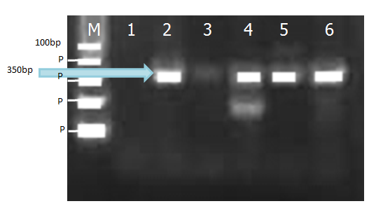

RESULTAT PCR CONVENTIONNEL DE HTLV-1

CONVENTIONAL HTLV-1 PCR RESULT

