IFN-λ4 genetic variants influence clinical malaria episodes in a cohort of Kenyan children
Additional file 1

Gabriela Samayoa Reyes¹, Conner Jackson¹, Sidney Ogolla², Katherine Sabourin¹, Adeola Obajemu³, Arlene E. Dent⁴, Ludmilla Prokunina-Olsson³, Rosemary Rochford^{1*}
¹University of Colorado Anschutz Medical Campus, Aurora, CO, United States, ²Center for Global Health Research, Kenya Medical Research Institute, Kisumu, Kenya, ³Laboratory of Translational Genomics, Division of Cancer Epidemiology and Genetics, National Cancer Institute, National Institutes of Health, Bethesda, MD, United States, ⁴Center for Global Health and Diseases, Case Western Reserve University, Cleveland, OH, United States
* corresponding author
Email: rosemary.rochford@cuanschutz.edu
Address: 12800 East 19th Avenue P18-9403D Aurora, CO 80045
Phone number: (303) 724-9960

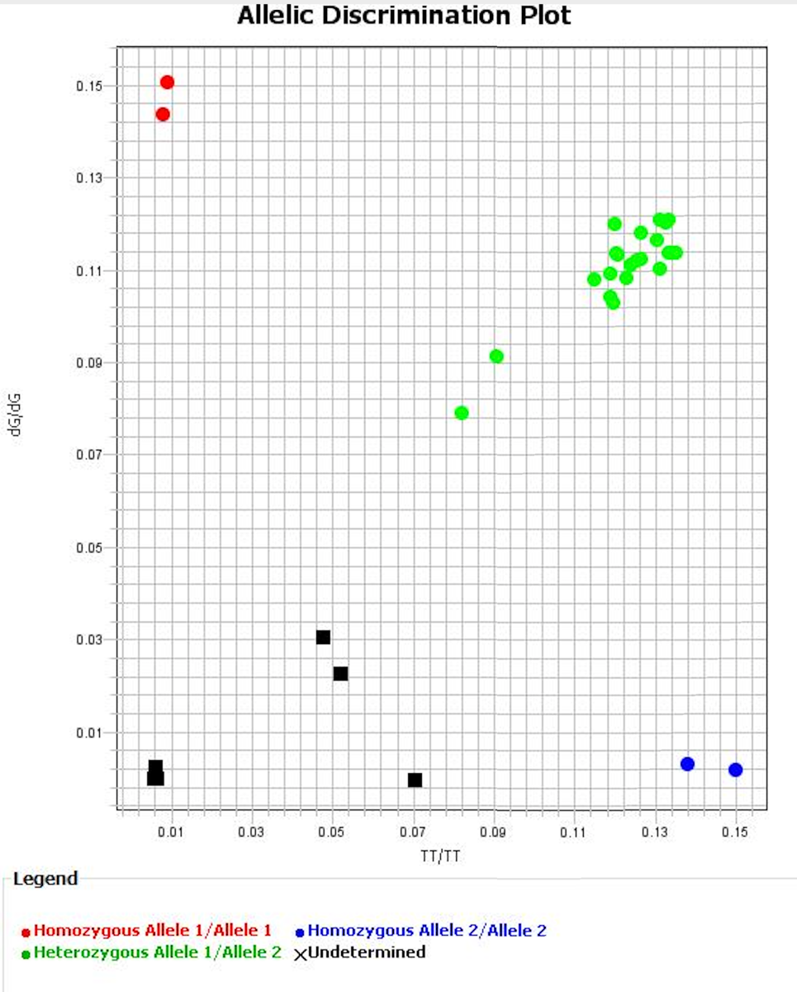
Supplementary Figure

dG/dG dG/TT
TT/TT Negative control

Supplementary Figure 1 Allelic Discrimination plot for IFNL4-rs368234815 polymorphism genotyping using a Custom TaqMan genotyping Assay. We show a clear separation of both homozygotes, were they do not show the presence of the other allele. Heterozygotes on the other hand show presence of both alleles, with different expression levels between samples. Here we present HapMan controls in duplicate, inside boxes, and five randomly selected study subjects gDNA samples.

