Extended Data Figures

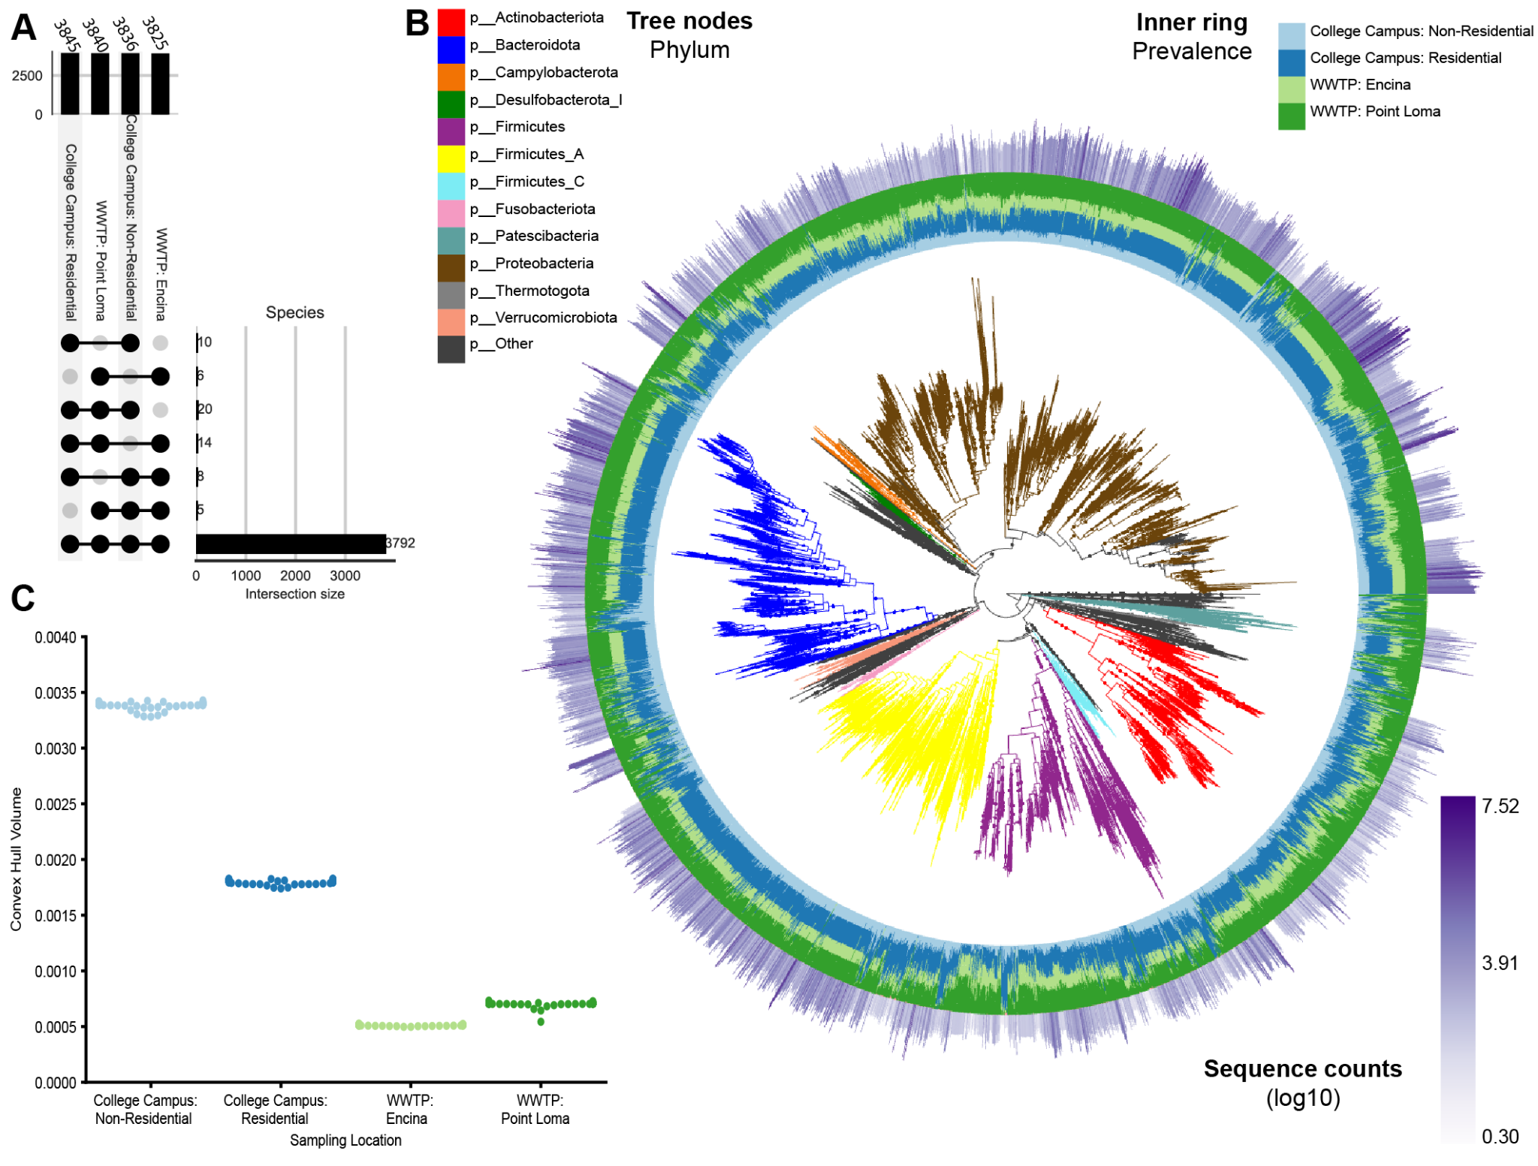

Extended Data Figure 1. Microbial feature space and community composition comparison, aggregating samples by wastewater sampling source. A) UpSet plot showing intersections of microbial species across wastewater sources. Aggregated NSS and WWTP samples exhibit comparable overall species diversity. B) Phylogenetic tree of metagenomic features aligned to the Web of Life (release 2). Tree nodes are colored by phylum-level taxonomy. The inner ring indicates feature prevalence across sources (blues, NSS; greens, WWTP), and the outer ring shows the total sequence counts per feature. C) Swarmplot of convex hull volumes estimated by a leave-one-out approach for each wastewater source.

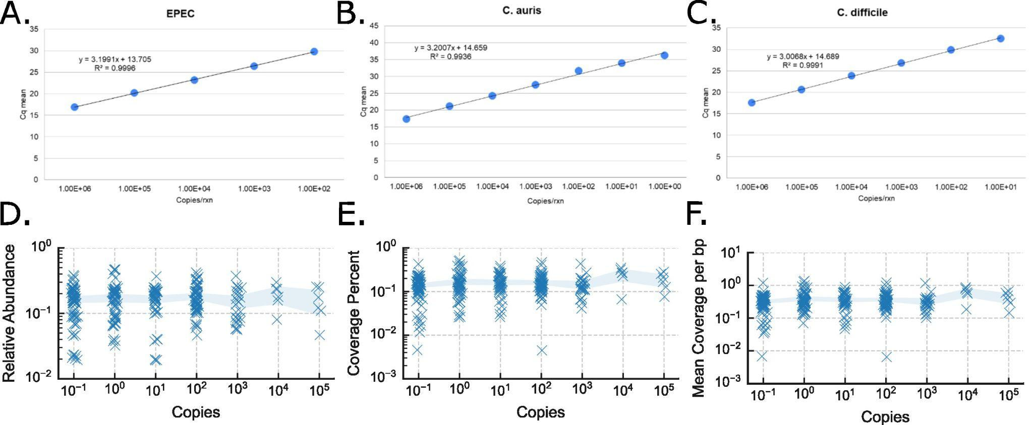

Extended Data Figure 2: qPCR quantification curve for pathogens and EPEC genome mapping analysis
Quantification curves generated by qPCR on various copies of genetic loci from A) Enteropathogenic E. coli (EPEC), B) C. auris, C) C. difficile. These loci were generated as gBlock fragments with primers unique to the respective sequences for each genome. Quantification estimation for each stock was performed as outlined in the Methods. Analysis for mapping directly to the genome of EPEC to determine the effect of EPEC genome copies on D) relative abundance, E) genome coverage percent, and F) mean coverage per bp as calculated by CoverM. Shaded band represents 95% CI around the mean.

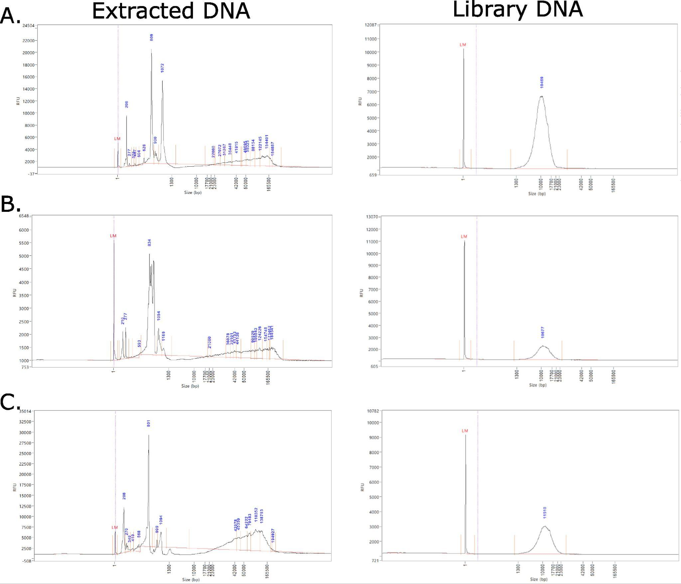

Extended Data Figure 3: Characterization of DNA extracts and libraries for long-read sequencing
Femto pulse (Agilent) results of raw extracted DNA (right) and library DNA (left) from samples taken from three different near-source wastewater samplers: A) AS002, B) AS016, and C) AS018. Extracted DNA was size-selected during the prep protocol using the PacBio SRE kit to remove short fragments. Fragment sizes (in bp) are denoted in blue above the Femto Pulse traces, where the peak fragment size is shown for the library trace, indicative of the final library fragment length distribution and expected average read length.

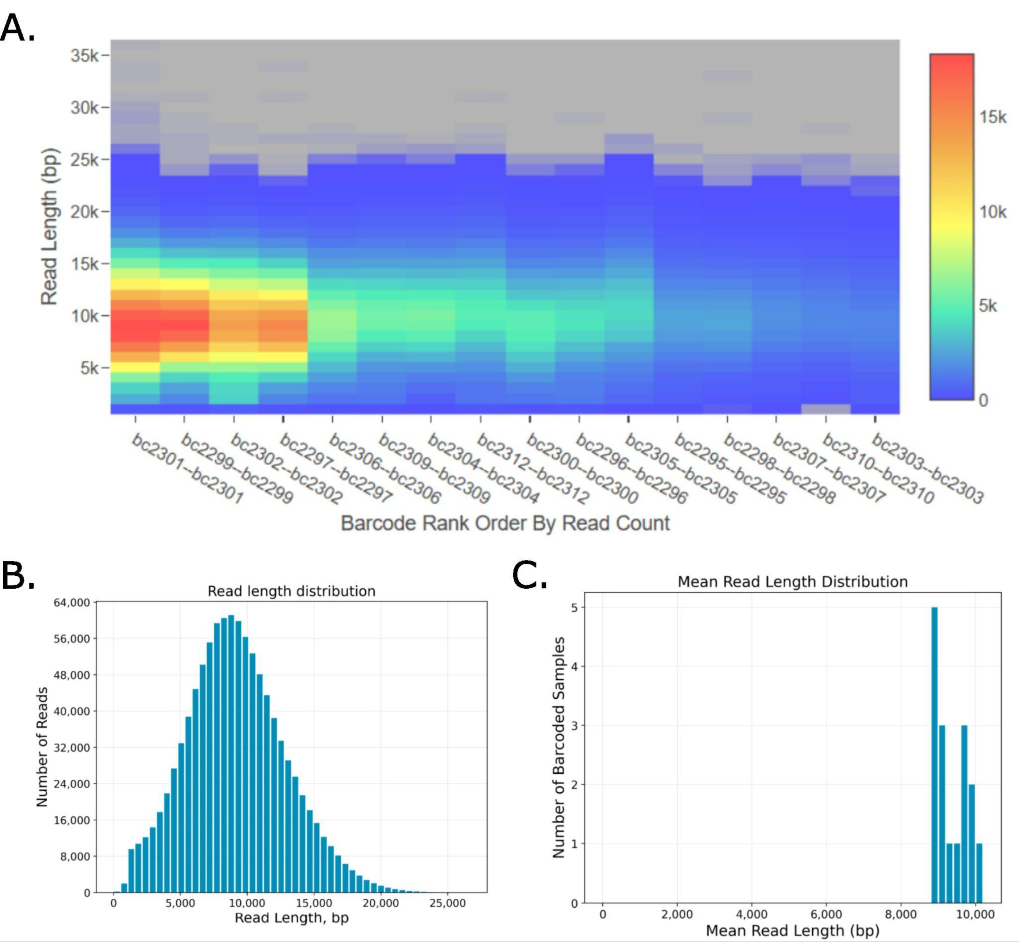

Extended Data Figure 4: PacBio long-read sequencing metrics on wastewater libraries
A) Plot denoting the sequencing read lengths across the wastewater libraries sequenced on the PacBio Revio. The heatmap denoted the count of various read lengths in each library, where the heatmap legend (left) defines the read counts across the gradient. Samples are ordered by total read count, from left to right. The samples that were run on the Femto Pulse from Extended Data Figure 3 can be identified as follows: bc2297=AS002, bc2298=AS016, and bc2300=AS0018. These three samples span various relative read counts across the set (high to low). B) Histogram showing the distribution of read lengths across all sequenced samples. C) Histogram showing the mean read length across all samples. All samples possess mean read lengths between 8-10kb.

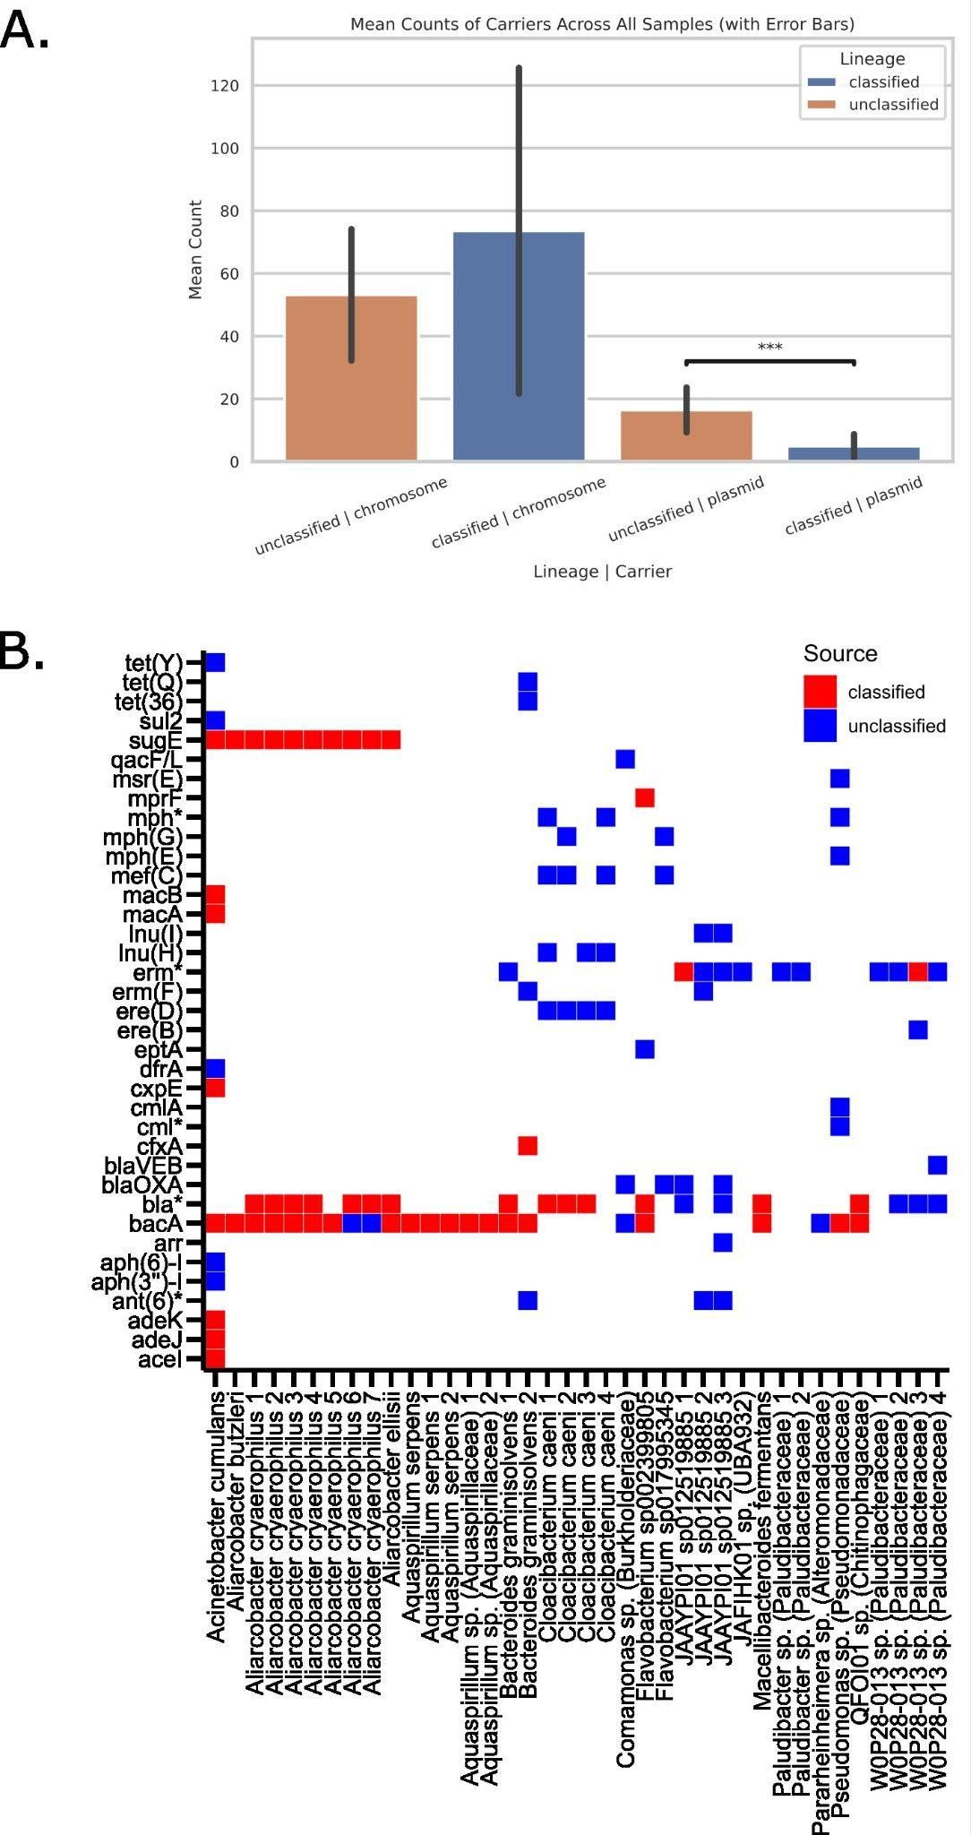

Extended Data Figure 5: Investigating AMR with long-read metagenomics
A) Barplot showing the mean count of ARGs for hits identified to chromosomal and plasmid context using Argo across all long-read sequenced samples. These counts are further divided between classified and unclassified taxonomic context. Error bars represent standard deviation for each of the four groups, and statistical comparisons were performed via t-test, where ***p < 0.001. B) Heat-map of antimicrobial-resistance (AMR) gene presence/absence across all MAGs generated from the HiFi MAG Pipeline generated via read mapping of the ARG-containing reads obtained from Argo. Rows are individual antibiotic resistance genes and columns are individual MAGs. MAGs are clustered by taxonomic classification. Gene which are present and originating from initially unclassified reads are colored blue, while the ones originating from classified reads are colored red.

