Supplemental Tables

Group 1 | Group 2 | Sample size | Permutations | pseudo-F | p-value | q-value
College Campus: Non-Residential | College Campus: Residential | 282 | 999 | 15.91 | 0.001 | 0.001
College Campus: Non-Residential | WWTP: Encina | 201 | 999 | 62.57 | 0.001 | 0.001
College Campus: Non-Residential | WWTP: Point Loma | 275 | 999 | 110.02 | 0.001 | 0.001
College Campus: Residential | WWTP: Encina | 293 | 999 | 74.70 | 0.001 | 0.001
College Campus: Residential | WWTP: Point Loma | 367 | 999 | 133.55 | 0.001 | 0.001
WWTP: Encina | WWTP: Point Loma | 286 | 999 | 41.79 | 0.001 | 0.001
Supplementary Table 1
PERMANOVA Group comparisons for unweighted unifrac distances between samples grouped by wastewater source. Near-source samples included Campus residential and non-residential sources. Wastewater treatment plant sources included the Encina and Point Loma plants.

Group 1 | Group 2 | Sample size | pseudo-F | p-value
College Campus: Non-Residential | College Campus: Residential | 282 | 17765 | 7.47E-43
College Campus: Non-Residential | WWTP: Encina | 201 | 10070 | 2.20E-34
College Campus: Non-Residential | WWTP: Point Loma | 275 | 17100 | 2.56E-42
College Campus: Residential | WWTP: Encina | 293 | 19822 | 6.76E-46
College Campus: Residential | WWTP: Point Loma | 367 | 33660 | 1.26E-61
WWTP: Encina | WWTP: Point Loma | 286 | 0 | 2.79E-45
Supplementary Table 2
Mann Whitney U Test comparisons for convex hull volumes calculated per wastewater source with a leave-one-out strategy. Near-source samples included Campus residential and non-residential sources. Wastewater treatment plant sources included the Encina and Point Loma plants.
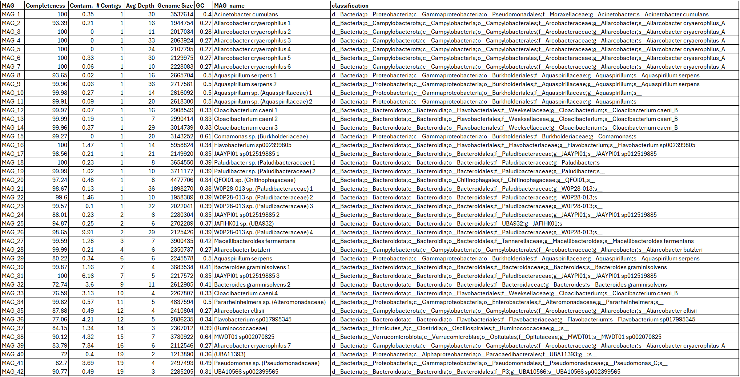
Supplementary Table 3
Table containing information on all of the MAGs generated from long-read sequencing, including completeness, contamination, number of contigs per MAG, cumulative genome size, average depth of coverage per MAG, GC content, and classification based on GTDB-Tk. MAGs are ordered by the number of contigs they contain, from the lowest to the highest number.

