The clinical and angiographic outcomes of post-dilation after percutaneous coronary intervention in patients with acute coronary syndrome: a systematic review and meta-analysis
Yan Li^{1#}, MD; Xiying Liang^{1#}, MD; Wenjiao Zhang^{1#}, MD; Xuan Qiao^{1#}, MD; Zhilu Wang^{2*}, MD
¹ The First Medical Clinical College of Lanzhou University, Lanzhou, Gansu, China;
² Department of Cardiology, The First Hospital of Lanzhou University, Lanzhou, Gansu, China.
#These authors contributed equally to this work.
*Corresponding author: Zhilu Wang, Department of Cardiology, The First Hospital of Lanzhou University, No. 1, Donggang West Road, Cheng guan District, Lanzhou, Gansu 730000, China. E-mail: wangzhl@lzu.edu.cn

Supplemental Tab S1. The definition of MACE in studies included.
Study | The definition of MACE
Saadat et al. 2019 | cardiac death + nonfatal myocardial infarction + repeat revascularization
Wang et al. 2019 | cardiac death + myocardial infarction+ revascularization + stent thrombsis
Gao et al. 2018 | hospitalization caused by angina pectoris, dyspnea, ventricular thrombus
Karjalainen et  al. 2017 | cardiac death + nonfatal myocardial infarction + target lesion revascularization，
Imori et al. 2016 | all-cause death + myocardial infarction + target lesion revascularization
Tasal et al. 2013 | death + target vessel revascularization + stent thrombsis
Biswas et al. 2012 | cardiac death + myocardial infarction + target vessel revascularization

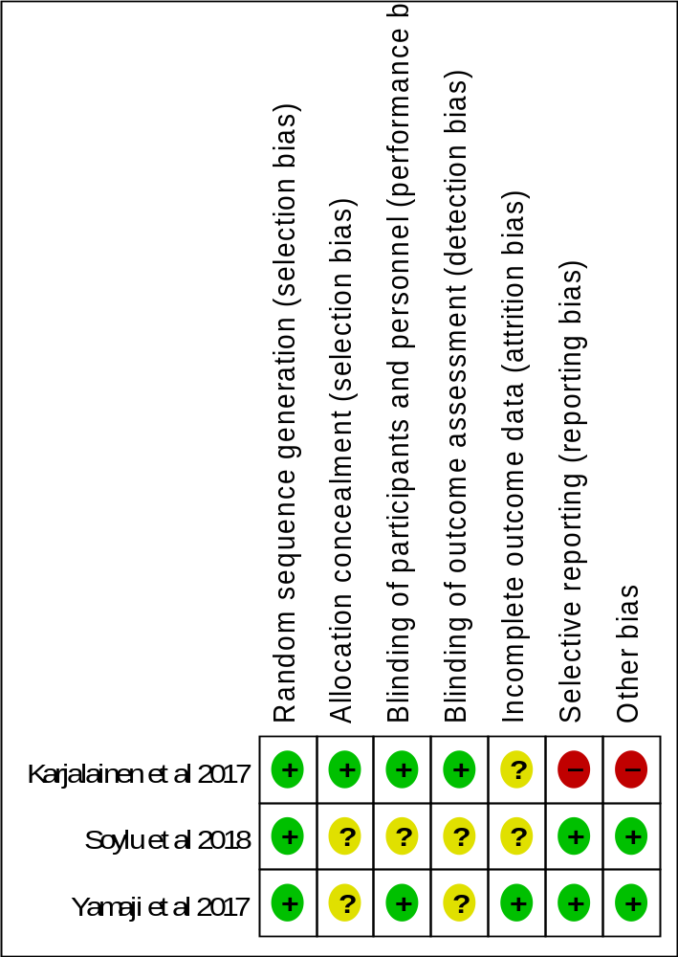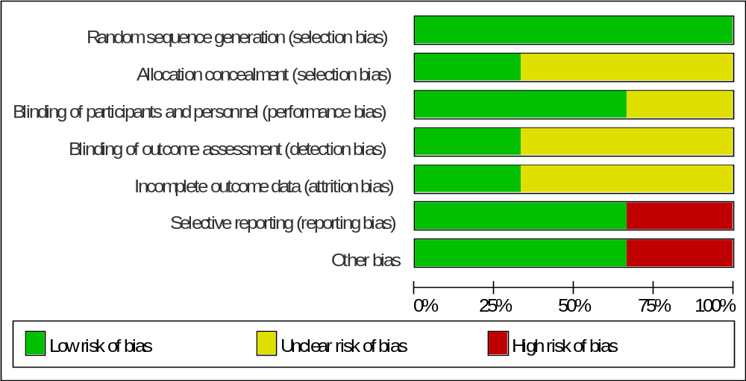
Supplementary Fig S1. Risk of bias of the studies included by Cochrane risk assessment tool.

Supplementary Tab S2. Quality assessment scale of Newcastle-Ottawa Scale (NOS) for non-randomized studies.
Study | Saadat et al. 2019 | Wang et al. 2019 | Qin et al. 2019 | Gao et al. 2018 | Imori et al. 2016 | Tasal et al. 2013 | Biswas et al. 2012 | Zhang et al. 2010
Representativeness of the exposed cohort (1) | A | A | A | A | A | A | A | A
Selection of the non-exposed  cohort (1) | A | A | A | A | A | A | A | A
Ascertainment of exposure (1) | A | A | A | A | A | A | A | A
Outcome of interest not present at start (1) | B | B | B | B | B | B | B | B
Comparability (2) | A | A | A | A | A | A | A | A
Assessment of outcome (1) | B | B | B | B | B | B | B | B
Follow-up duration (1) | A | A | B | A | A | B | B | A
Adequacy follow up (1) | A | A | A | A | A | A | A | A
Notes: (1) Representative-ness of the exposed cohort: A, truly representative of the average patient with post-dilation after stent implantion; B, somewhat representative of the average patient with post-dilation after stent implantation; C, selected special group; D, no description of the derivation of the hort. (2) Selection of the non-exposed cohort: A, drawn from the same community as the exposed cohort; B, drawn from a different source; C, no description of the derivation of the non-exposed cohort. (3) Ascertainment of exposure: A, secure record (e.g., surgical records); B, structured interview; C, written self-report; D, no description. (4) Demonstration that outcome of interest was not present at start of study: A, yes; B, no. (5) Comparability of cohorts on the basis of the design or analysis: A, study controls for comorbidities. B, study controls for additional risk factors; C, not done. (1) Assessment of outcome: A, independent blind assessment; B, record linkage; C, self-report; and D, no description. (2) Was follow-up long enough for outcomes to occur: A, yes; B, no. (3) Adequacy of follow-up of cohort: A, complete follow-up all subjects accounted for; B, subjects lost to follow-up unlikely to introduce bias (small number lost), follow-up rate higher than 90%, or description provided of those lost; C, follow-up rate 90% or lower(select an adequate percentage) and no description of those lost; and D, no statement.

a. MACE 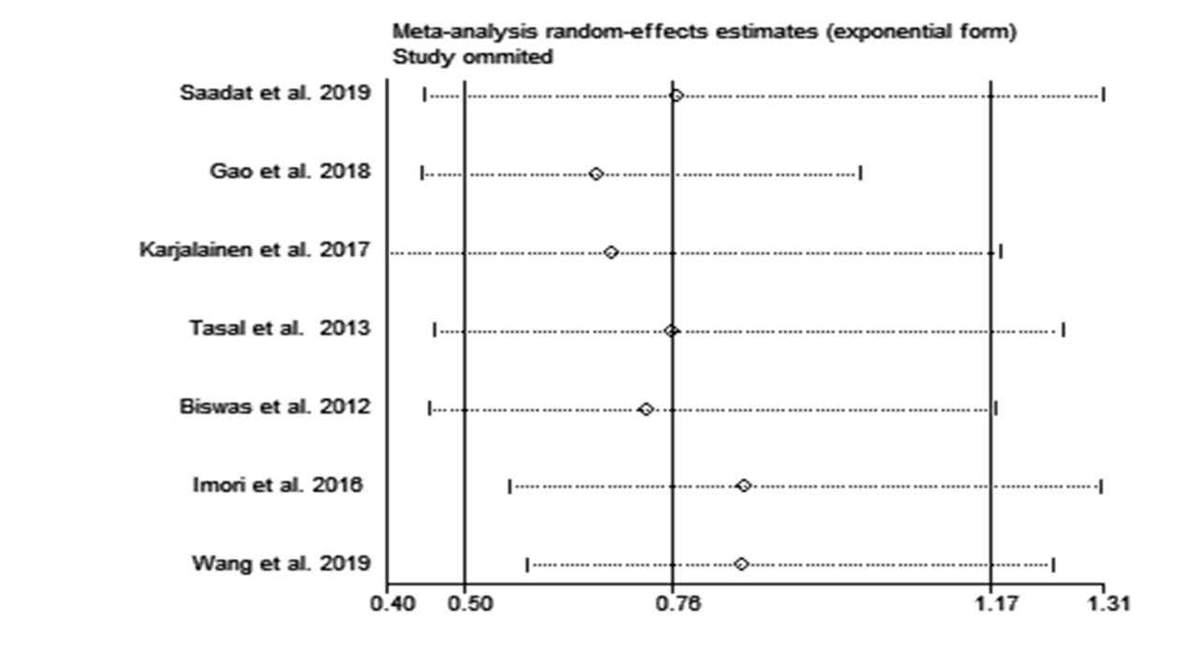
b. Myocardial infarction
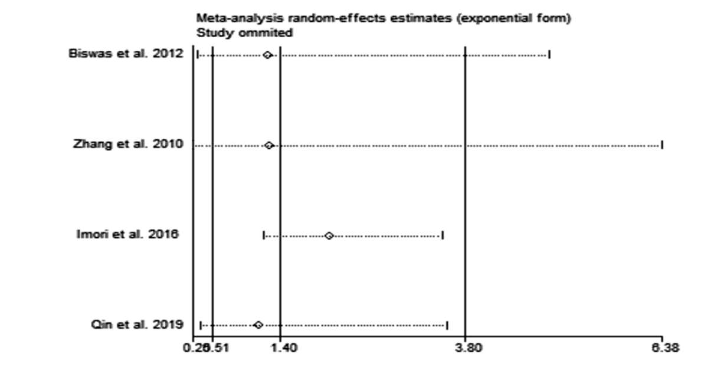
c. Target vessel revascularization .
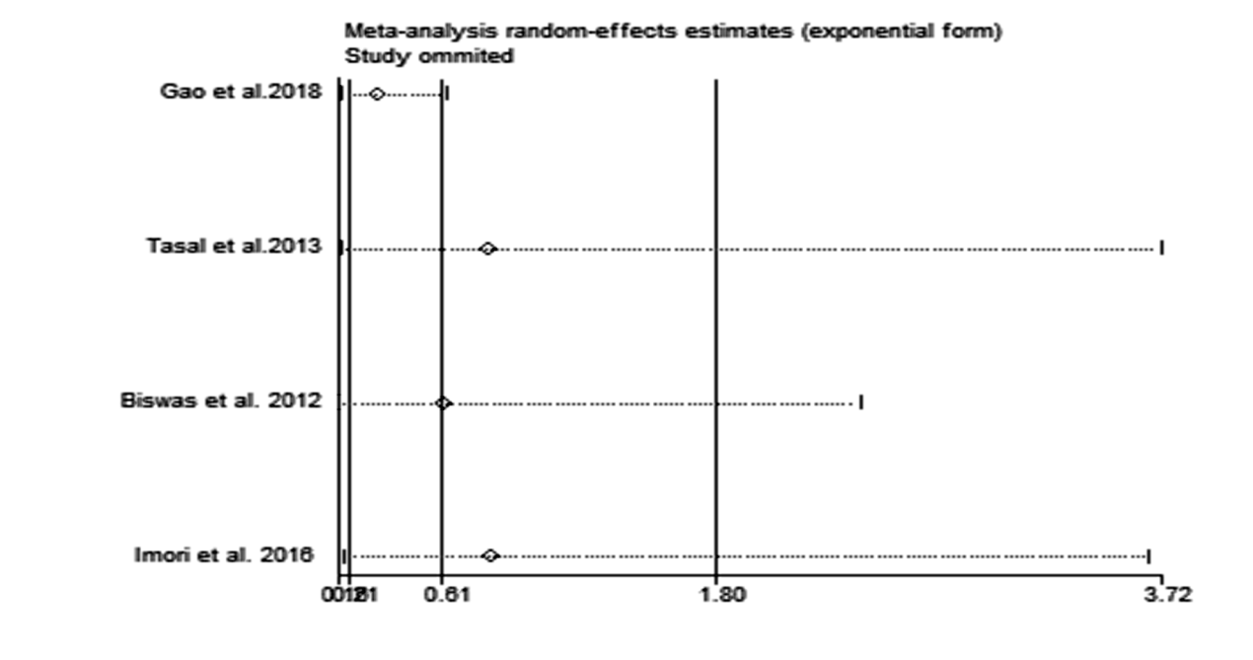
Supplemental Fig S2. Sensitivity analysis of MACE, myocardial infarction, and target vessel revascularization between post-dilation and non-post-dilation groups.

a. Myocardial Infarction
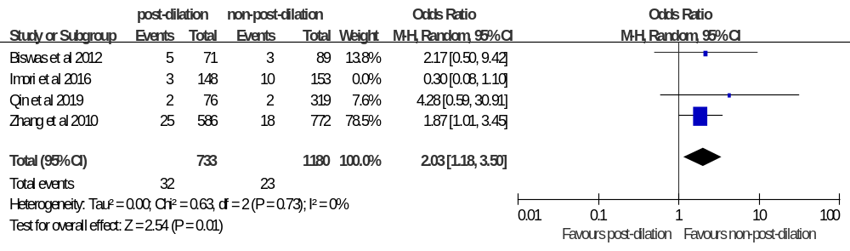
b. Target Vessel Revascularization
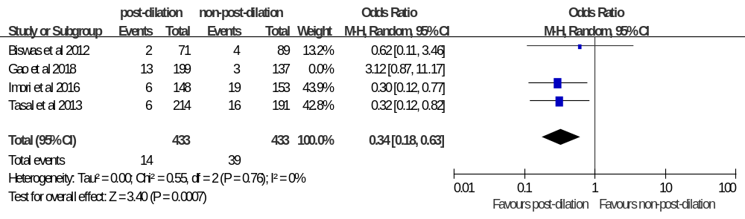
Supplemental Fig S3. Sensitivity analysis of myocardial infarction and target vessel revascularization between post-dilation and non-post-dilation groups after removing the studies of Imori et al. and Gao et al.

a. MACE
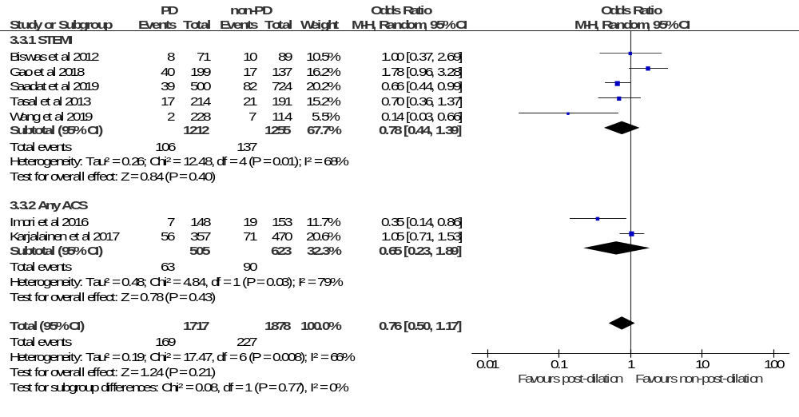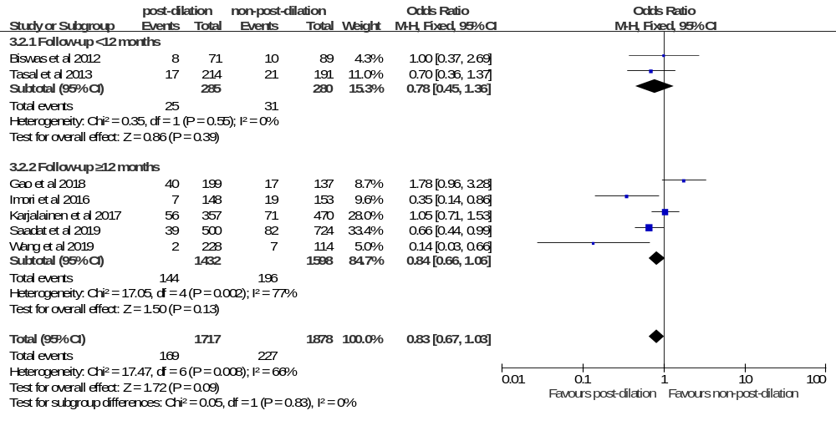
b. All-cause death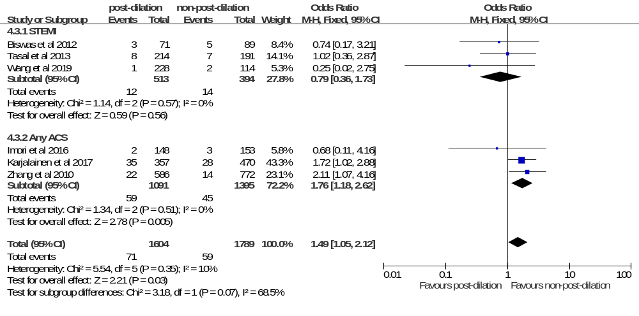

Stent thrombosis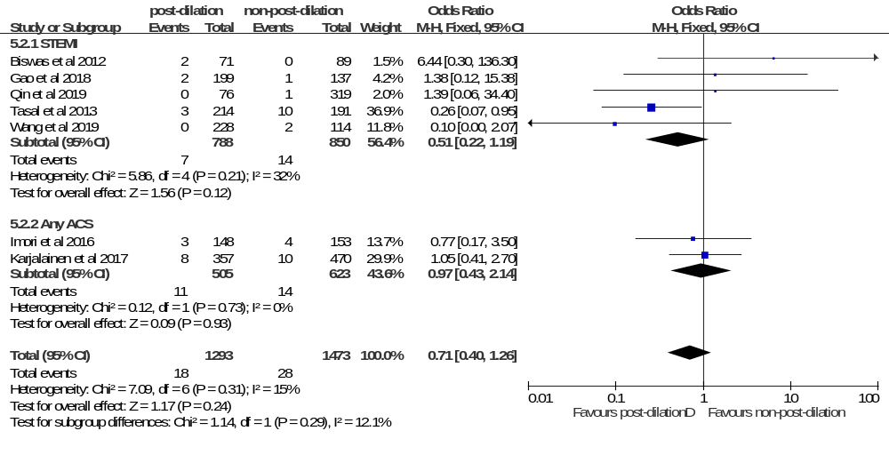
Myocardial infarction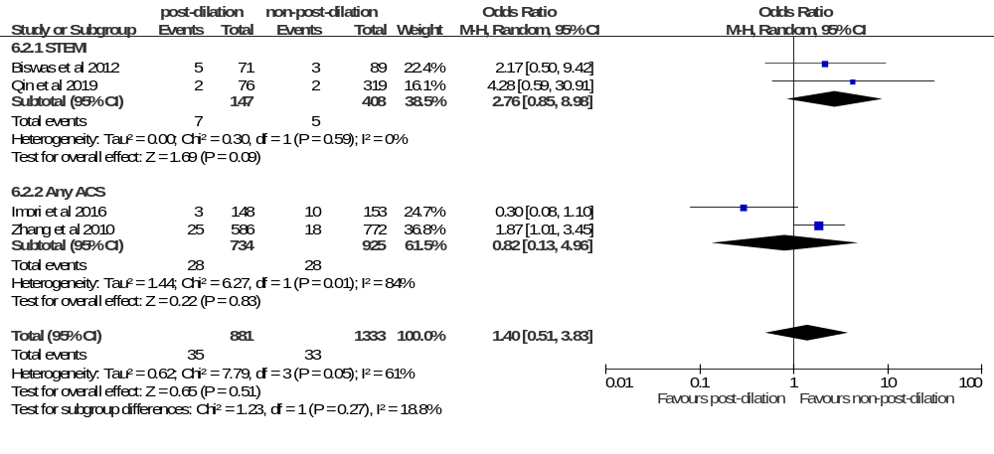
Target vessel revascularization
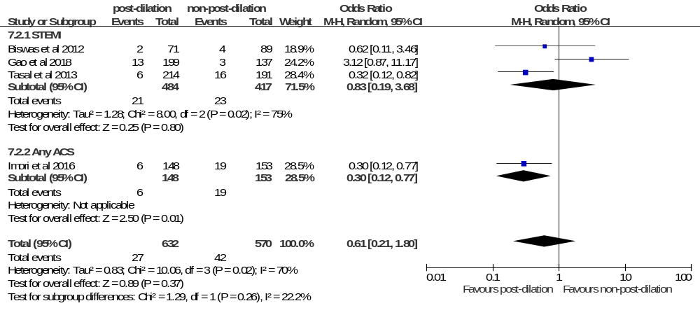c. All-cause death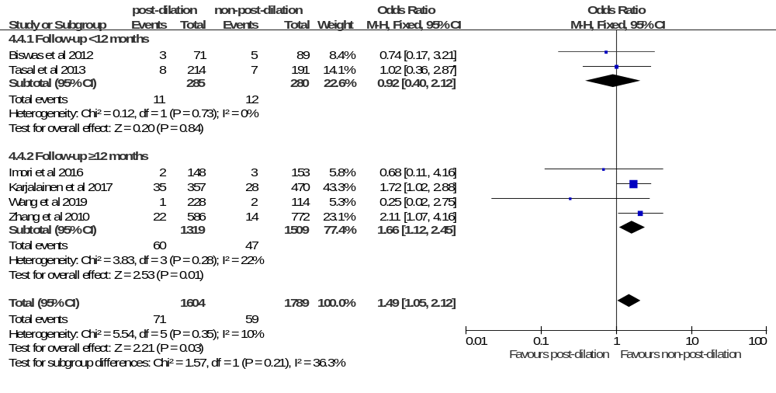
Stent thrombosis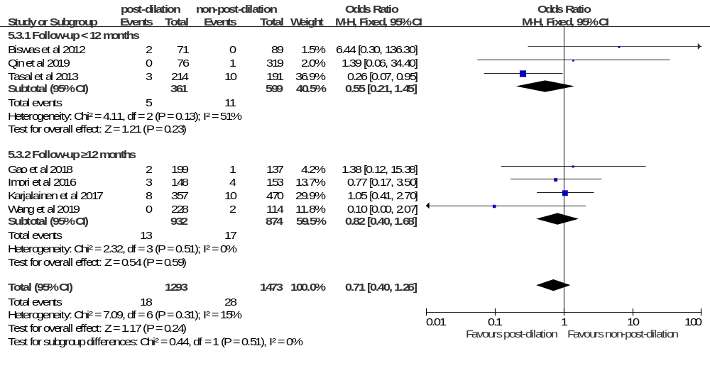
Myocardial infarction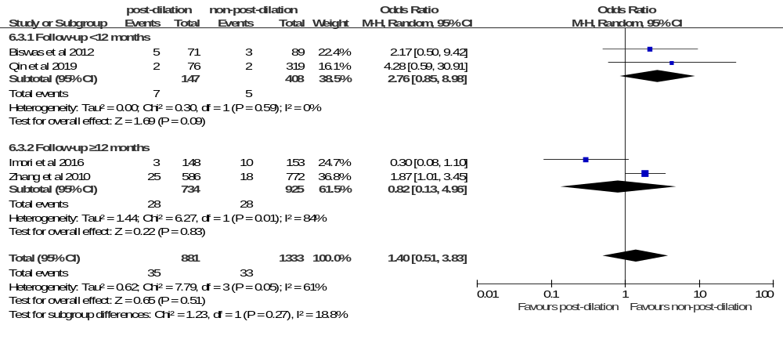
Target vessel revascularization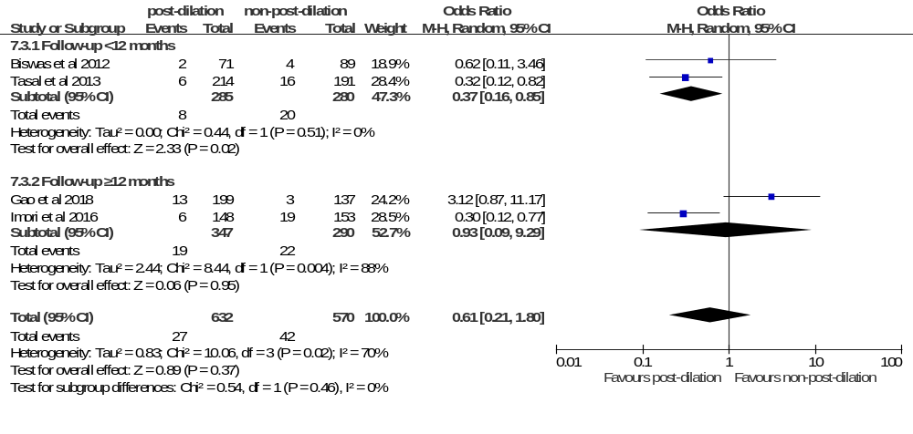
Supplemental Fig S4. Subgroup analyses of MACE, all-cause death, stent thrombsis, myocardial infarction, and target vessel revascularization according to classification of diseases (STEMI or any ACS) and duration of follow-up (<12 months or≥12 months).
Search strategy (Take the PubMed database for an example)
#1 "Acute Coronary Syndrome"[MeSH Terms] OR "Acute Coronary Syndromes"[Title/Abstract] OR "Acute Coronary Syndrome"[Title/Abstract] OR "coronary syndrome acute"[Title/Abstract] OR "coronary syndromes acute"[Title/Abstract] OR "syndrome acute coronary"[Title/Abstract] OR "syndromes acute coronary"[Title/Abstract] OR "ACS"[Title/Abstract]
#2 "Myocardial Infarction"[MeSH Terms] OR "Myocardial Infarction"[Title/Abstract] OR "Myocardial Infarctions"[Title/Abstract] OR "infarction myocardial"[Title/Abstract] OR "infarctions myocardial"[Title/Abstract] OR "Cardiovascular Stroke"[Title/Abstract] OR "stroke cardiovascular"[Title/Abstract] OR "strokes cardiovascular"[Title/Abstract] OR "Heart Attack"[Title/Abstract] OR "Heart Attacks"[Title/Abstract] OR "Myocardial Infarct"[Title/Abstract] OR "Myocardial Infarcts"[Title/Abstract] OR "infarct myocardial"[Title/Abstract] OR "infarcts myocardial"[Title/Abstract] OR "heart infarction"[Title/Abstract] OR "MI"[Title/Abstract] OR "acute myocardial infarction"[Title/Abstract] OR "AMI"[Title/Abstract]
#3 "Percutaneous Coronary Intervention"[MeSH Terms] OR "Percutaneous Coronary Intervention"[Title/Abstract] OR "Percutaneous Coronary Interventions"[Title/Abstract] OR "coronary intervention percutaneous"[Title/Abstract] OR "coronary interventions percutaneous"[Title/Abstract] OR "intervention percutaneous coronary"[Title/Abstract] OR "interventions percutaneous coronary"[Title/Abstract] OR "Percutaneous Coronary Revascularization"[Title/Abstract] OR "Percutaneous Coronary Revascularizations"[Title/Abstract] OR "coronary revascularization percutaneous"[Title/Abstract] OR "revascularization percutaneous coronary"[Title/Abstract] OR "revascularizations percutaneous coronary"[Title/Abstract] OR "PCI"[Title/Abstract]
#4 "Stents"[MeSH Terms] OR "stent"[Title/Abstract] OR "Stents"[Title/Abstract] OR "stenting"[Title/Abstract]
#5 "Angioplasty"[MeSH Terms] OR "Angioplasty"[Title/Abstract] OR "Angioplasties"[Title/Abstract] OR "Endoluminal Repair"[Title/Abstract] OR "Endoluminal Repairs"[Title/Abstract] OR "repair endoluminal"[Title/Abstract] OR "Percutaneous Transluminal Angioplasty"[Title/Abstract] OR "angioplasty percutaneous transluminal"[Title/Abstract] OR "transluminal angioplasty percutaneous"[Title/Abstract] OR "angioplasty transluminal"[Title/Abstract] OR "Transluminal Angioplasty"[Title/Abstract]
#6 "postdilation"[Title/Abstract] OR "post-dilation"[Title/Abstract] OR "Postdilatation"[Title/Abstract] OR "Post-dilatation"[Title/Abstract]
#7 (#1 OR #2) AND (#3 OR #4 OR #5) AND #6

