Microfluidic continuous flow production of noble bimetallic nanoparticles stabilized on evolvable polymer microspheres for confined synergistic catalysis
Li Maª, Junsheng Houª, Zijuan Luoª, Xiong Zhaoª, Yilong Yaoª, Yaxuan Xiao^{b}, Zihan Dingª, Zhenzhen Chen^{c}, Jinjia Wei^{a,d}, and Nanjing Hao^{a,d}*

ªSchool of Chemical Engineering and Technology, Xi'an Jiaotong University, 28 Xianning West Road, Xi'an, Shaanxi, 710049, P.R. China
^{b}Key Laboratory of Education Ministry for Modern Design and Rotor-Bearing System, School of Mechanical Engineering, Xi’an Jiaotong University, 28 Xianning West Road, Xi’an, Shaanxi, 710049, P.R. China
^{c}Nanofluids Technologies Co. Ltd, Xi’an, Shaanxi, 712000, P.R. China
^{d}State Key Laboratory of Fluorine & Nitrogen Chemicals, School of Chemical Engineering and Technology, Xi’an Jiaotong University, Xi’an, Shaanxi, 710049, P.R. China
*Corresponding author, email address: nanjing.hao@xjtu.edu.cn

Note S1: The preparation of polystyrene microsphere seeds 3
Note S2: Ag-loaded polystyrene microsphere in batch reactor 5
Figure S1 The fabrication of PS microspheres with dispersion polymerization. 3
Figure S2 The fabrication procedures of the spiral microreactor 4
Figure S3 The fabrication of Ag-loaded PS microspheres in a water-ethanol mixture. 4
Figure S4 The morphology evolution behaviour of PS microsphere in water-ethanol mixture 5
Figure S5 The characterization results of Ag-PS 6
Figure S6 The fabricated Ag nanocrystals in the spiral microchannel 6
Figure S7 The fabricated bimetallic (Ag and Pt) hollow PS microsphere 7
Figure S8 The HRTEM of the Ag and Pt nanoparticles on the hollow PS microspheres 7
Figure S9 Continuous flow synthesis of Ag@OHPS in a spiral microreactor. 8
Figure S10 Continuous flow synthesis of Ag-Au@OHPS in a spiral microreactor. 9
Figure S11 Continuous flow synthesis of Ag-Pt@OHPS in a spiral microreactor. 10
Table S1 Comparison of synthetic strategy between previously published work and this study 11
Table S 2 The reaction rate constant and activity parameters of various functional catalysts 12
Table S3 Comparison of catalytic performance of previously published work with this study 15

Note S1: The preparation of polystyrene microsphere seeds
The polystyrene microsphere seed utilized in the experiment was synthesized by one-pot dispersion polymerization at 70 °C with 400 rpm on a magnetic stirrer. In detail, 0.2 g of APS served as the initiator, and 0.02 g of PVP was used as a steric stabilizer; they were added into the reactor, which consisted of 3 ml of DI water and 25 ml of ethanol. Subsequently, the APS and PVP were completely dissolved in the water-ethanol mixture by sonication at ambient conditions. Following this, 4.4 ml of styrene monomer was added to the reactor and sonicated to form a homogenous emulsion. Then, the mixtures in the flask were stirred at 400 rpm for 10 minutes at 20 ℃ and heated to 70 ℃. The reaction ran for 6 h and was quenched by placing the flask reactor in an ice bath. Finally, the PS seed microsphere was washed with ethanol three times, collected by centrifugation at 6000 rpm, and then placed in a 45 ℃ oven for 6 h to collect the PS seed microsphere powder. The preparation process of the polystyrene microsphere was depicted in Figure S1.
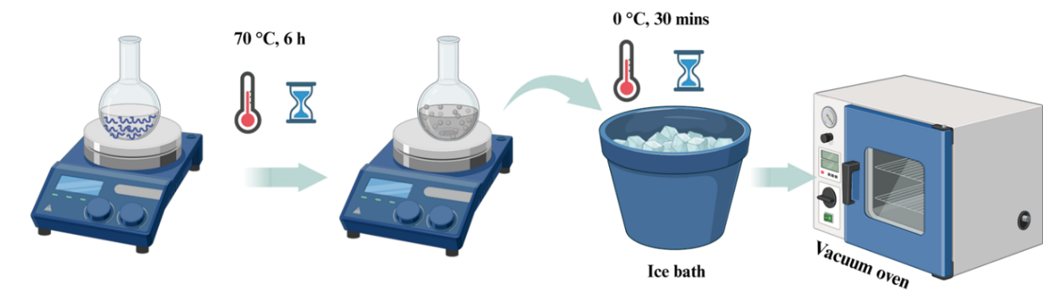
Figure S1 The fabrication of PS microspheres with dispersion polymerization.
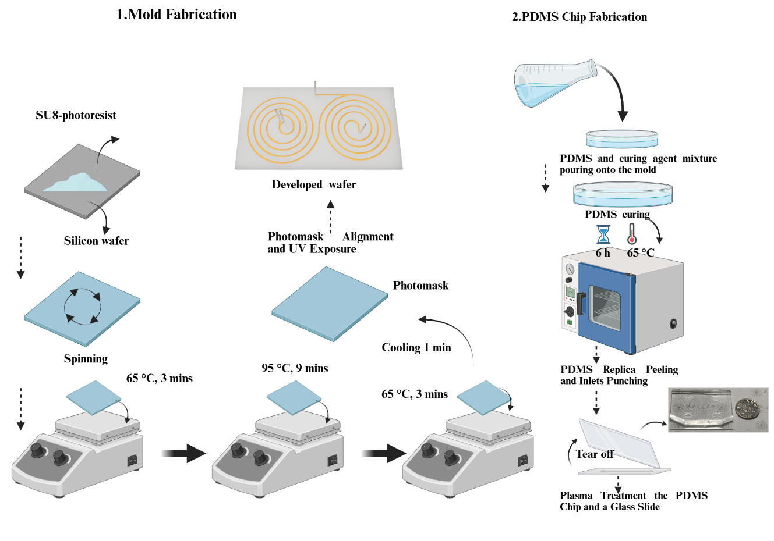
Figure S2 The fabrication procedures of the spiral microreactor.
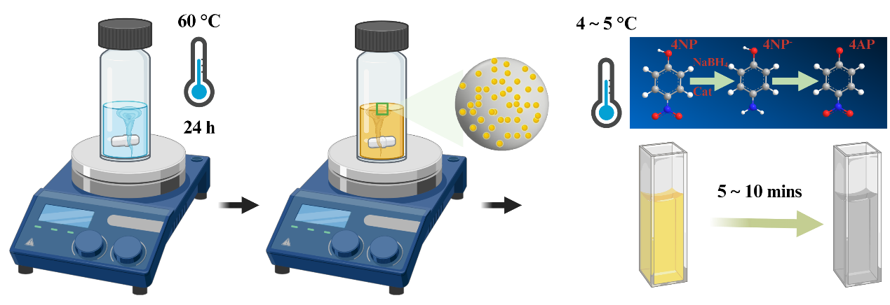
Figure S3 The fabrication of Ag-loaded PS microspheres in a water-ethanol mixture.
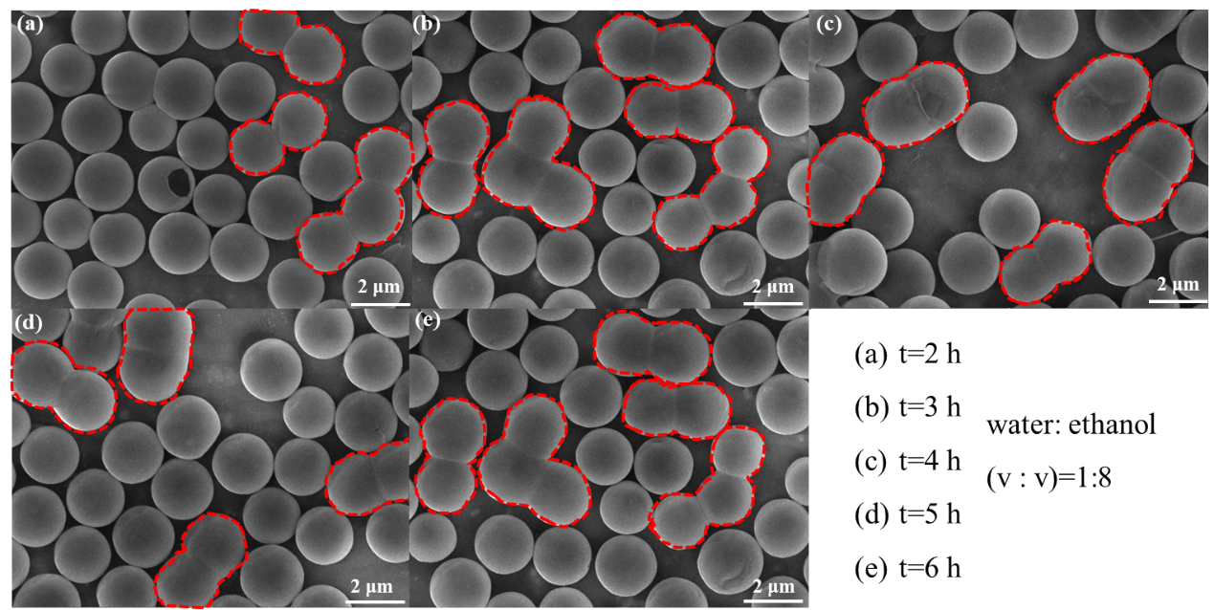
Figure S4 The morphology evolution behaviour of PS microsphere in water-ethanol mixture (v/v=1:8).

Note S2: Ag-loaded polystyrene microsphere in batch reactor
In traditional loading process, AgNO₃ served as the metal precursor to functionalize the PS microsphere; specifically, the PS seeds were dispersed in the water-ethanol mixture containing metal precursor AgNO₃ and steric stabilizer PVP at 70 °C, the fabricated Ag-loaded PS microspheres went through a noticeable change, and the suspension solution color changed from light yellow to dark yellow (Figure S5g). The SEM characterization results indicated that the Ag nanoparticles were successfully loaded on the surface of the PS microspheres (Figure S5b). At the initial stage, only a small amount of Ag nanocrystals was embedded on the PS microsphere, and the loading capacity steadily increased as the reaction time continued to increase. The TEM images demonstrated that the PS microsphere kept a solid core even after 12 hours of dispersion reaction. The ICP-OES measurement results demonstrated that the Ag loading capacity can reach 2.0 wt% when the reaction time reaches up to 24 h.
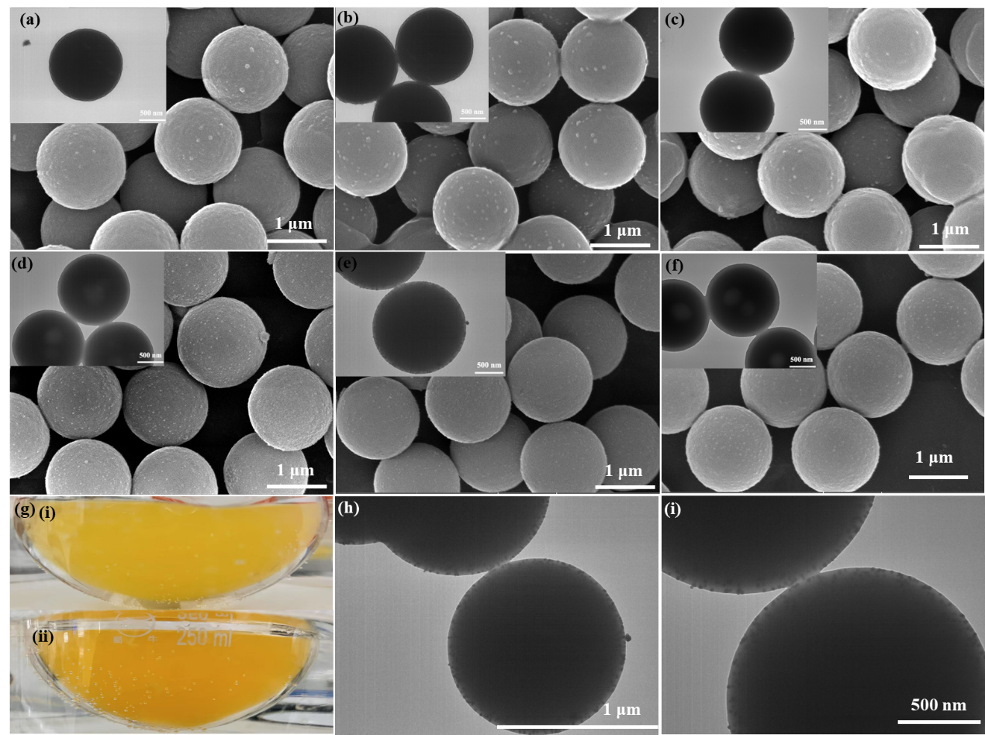
Figure S5 The characterization results of Ag-PS.
(a. t=30 mins; b. t=1 h; c. t=2 h; d. t=4 h; e. t=6 h; f. t=12 h; g. the color change of the Ag-PS suspension; h~i. the TEM characterization of the Ag-PS).
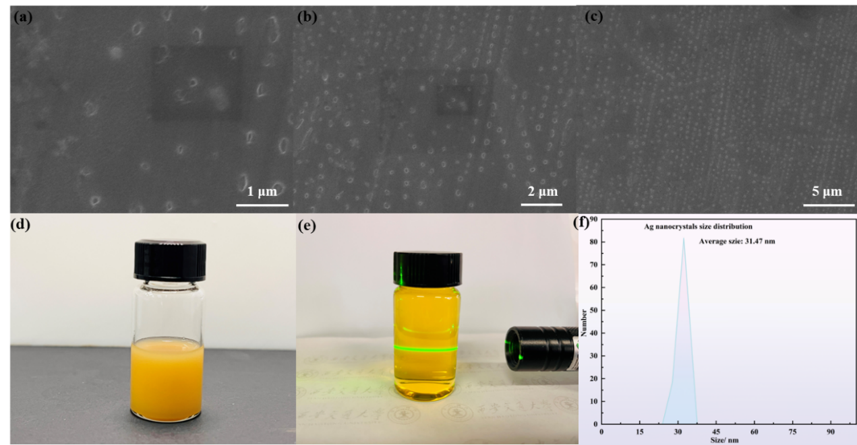
Figure S6 The fabricated Ag nanocrystals in the spiral microchannel.
(a. the SEM image of the Ag nanocrystals with 1 μm scale bar; b. the SEM image of the Ag nanocrystals with 2 μm scale bar; c. the SEM image of the Ag nanocrystals with 5 μm scale bar; d. the figure of Ag-Ps product; e. the picture of the generated Ag nanoparticles; f. the size distribution of the Ag nanoparticles).
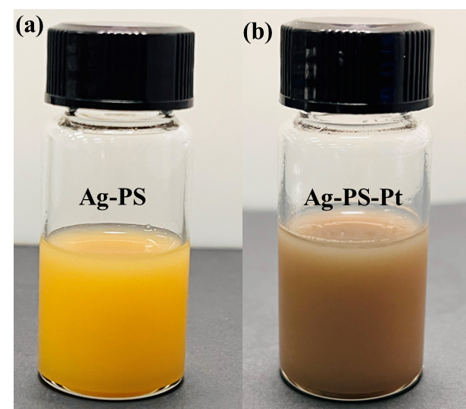
Figure S7 The fabricated bimetallic (Ag and Pt) hollow PS microsphere.
(a. before introducing the Pt nanoparticle, b. after introducing the Pt nanoparticle)
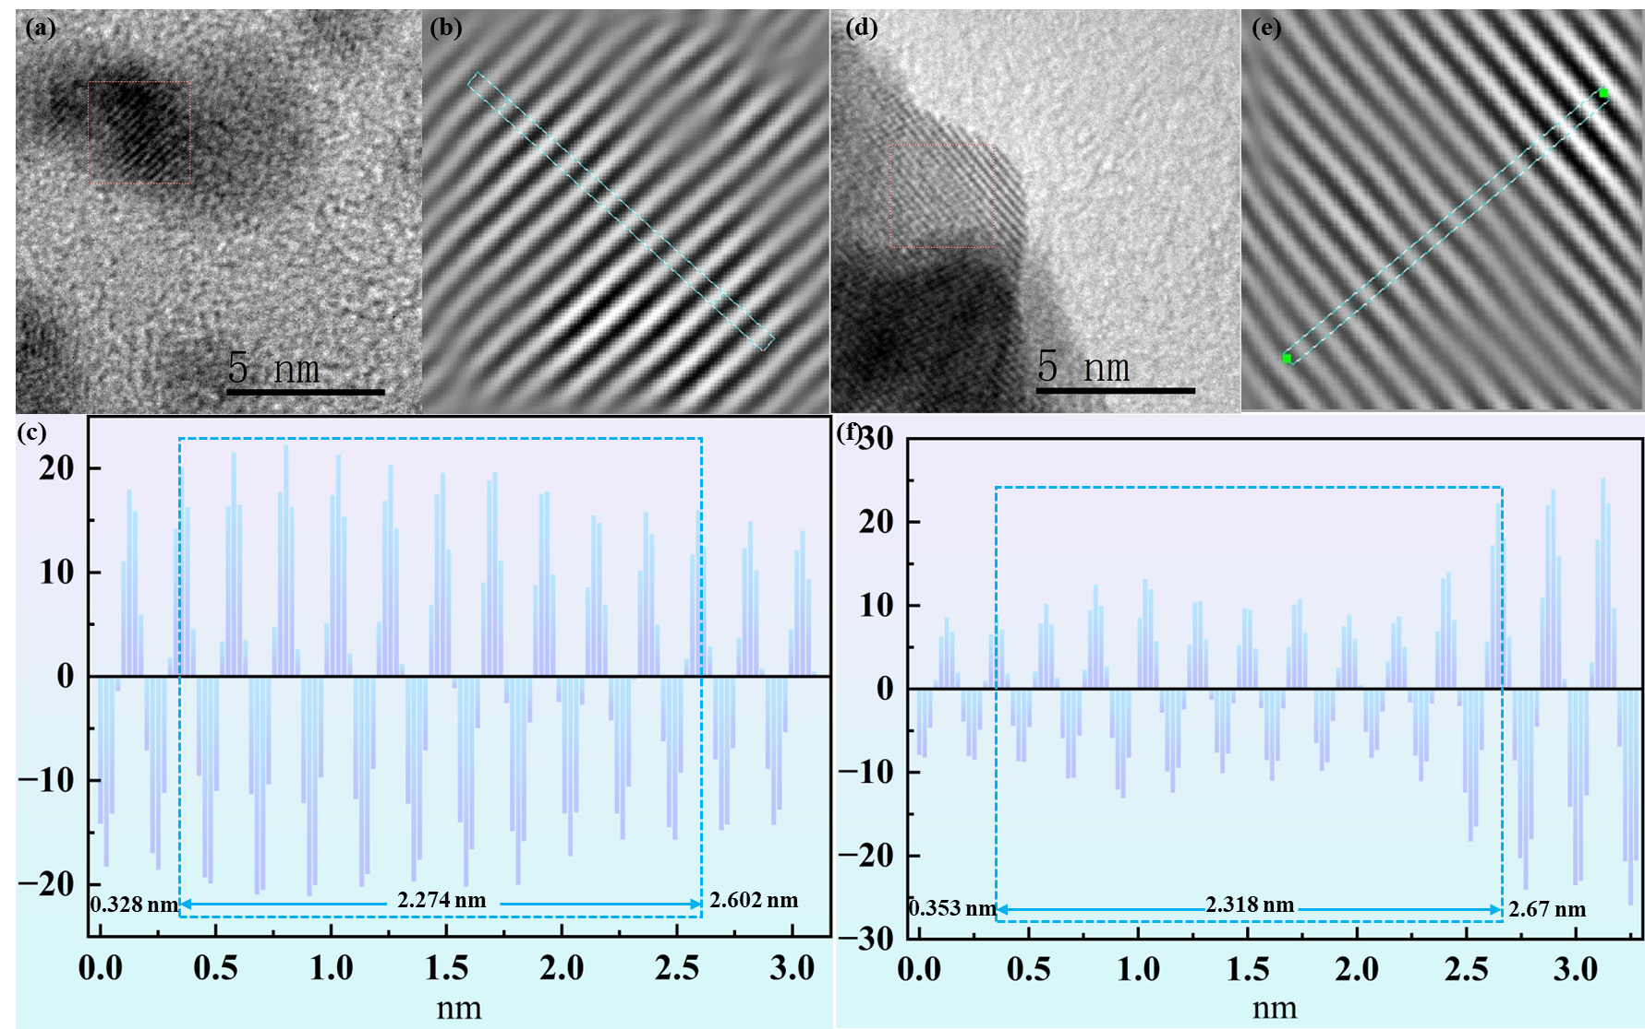
Figure S8 The HRTEM of the Ag and Pt nanoparticles on the hollow PS microspheres.
(a. HRTEM image of Pt nanoparticle, b. the lattice fringe of the Pt nanoparticles c. the average lattice fringe measurements of Pt nanoparticles; d. HRTEM image of Ag nanoparticle; e. the lattice fringe of the Ag nanoparticles; e. the average lattice fringe measurements of Ag nanoparticles)
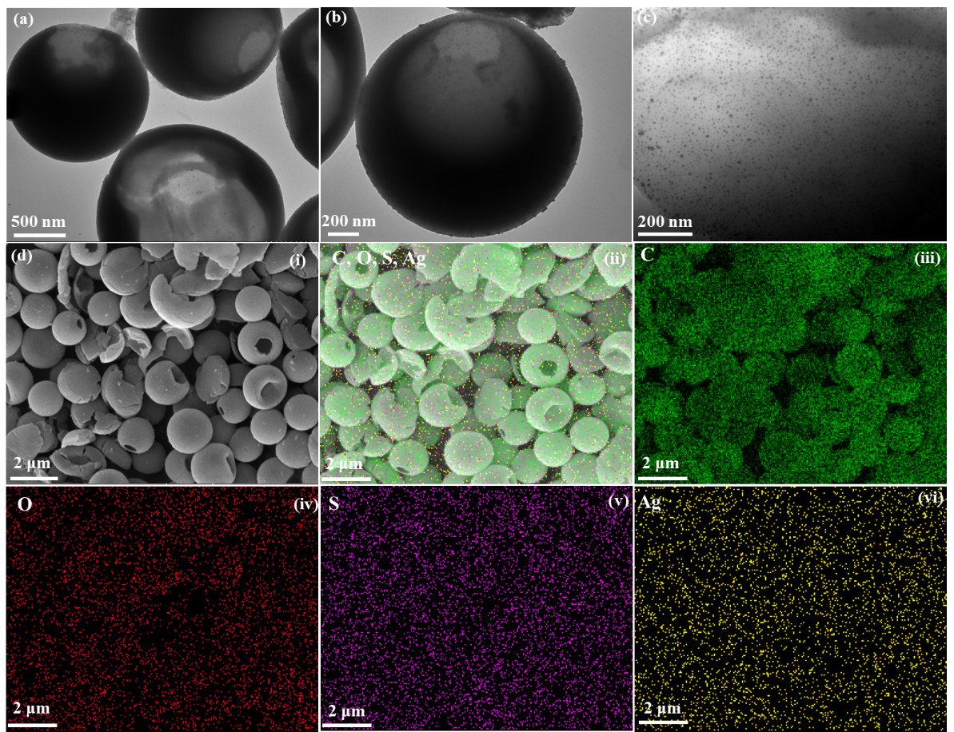
Figure S9 Continuous flow synthesis of Ag@OHPS in a spiral microreactor.
(a~c. TEM images at different magnifications, d. SEM image of the Ag@OHPS (i), and EDS mapping results of the Ag@OHPS microspheres).
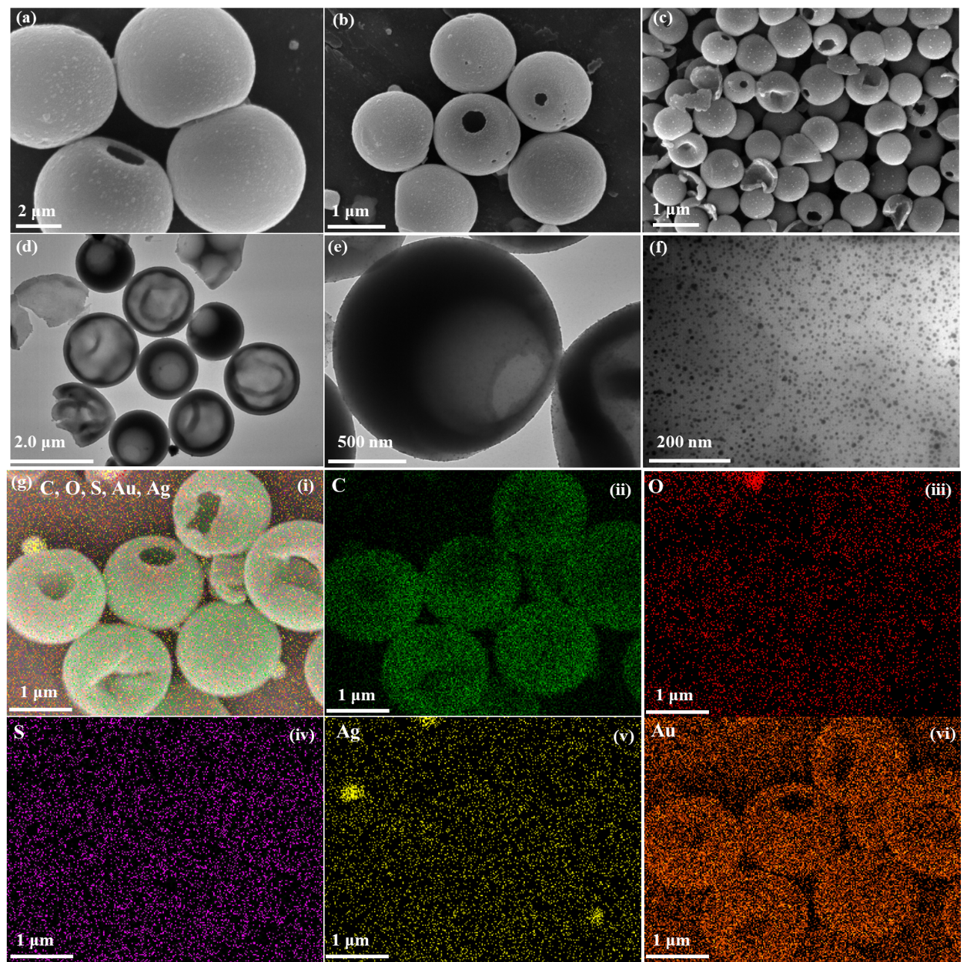
Figure S10 Continuous flow synthesis of Ag-Au@OHPS in a spiral microreactor.
(a~c. SEM images at different magnifications, d~F. TEM image of the Ag-Au@OHPS microspheres, and (g) EDS mapping characterization results of the Ag-Au@OHPS microspheres).

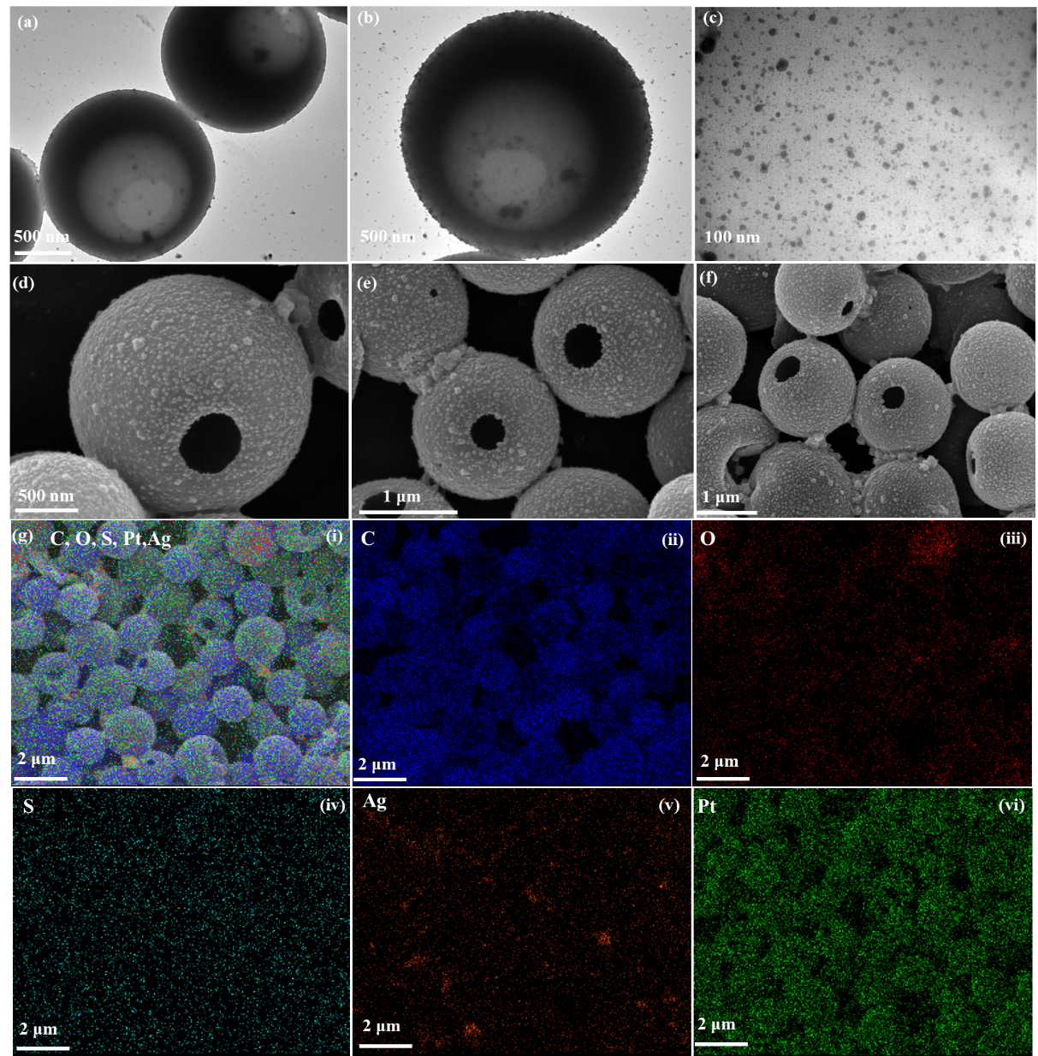
Figure S11 Continuous flow synthesis of Ag-Pt@OHPS in a spiral microreactor.
(a~c. SEM images at different magnifications, d~F. TEM image of the Ag@OHPS microspheres, and (g) EDS mapping characterization results of the Ag@OHPS microspheres).

Table S1 Comparison of synthetic strategy between previously published work and this study
Microparticles | Seeds | Reaction medium | Surfactant | Additive reagent | Reaction condition | Technology | Refs
Hollow PS | PS | Water-ethanol | N/A | N/A | 70 ℃, 2 h | Swelling | This work
Hollow dimple PS | PS | Water-ethanol | N/A | N/A | 70 ℃, 30 mins | Swelling | This work
Bowl-like PS | PS | Water-ethanol | N/A | N/A | 70 ℃, 1h | Swelling | This work
Open hole PS | HDPS | Water-ethanol | N/A | Toluene | RT, 10 mins | Swelling | This work
Porous PS | PS | N/A | N/A | fluorinated solvent | -20 ℃ | UV irradiation | [1]
Sticky dimple PS | PS | Water-ethanol | N/A | Decane | 60 ℃ | Swelling | [2]
Concave polystyrene-Carbon | PS | Water-alcohol | N/A | Methanol, propanol, butanol, pentanol | ~180 ℃ | Swelling | [3]
Porous PS | PS | Water-ethanol | N/A | Toluene | RT, 1h | N/A | [4]
PS  “Walnut-like” PS | PS | N/A | SDS | Divinylbenzene  1-chlordecone  4-vinylbenzyl chloride | 70 °C | Interfacial polymerization | [5]
Pathy poly (St-NaSS) sphere | PS | Water-Methanol | PVP, K-30 | Decane/EHMA monomer | 60 °C | Phase separation | [6]
Microparticles | Seeds | Reaction medium | Surfactant | Additive reagent | Reaction condition | Technology | Refs
Multi-hollow PS | Emulsion droplets | Water | SDS | N/A | 70 °C | N/A | [7]
Porous PMMA | Emulsion droplets | Water | Sulfonated PS | Toluene | 65°C | Pickering emulsion | [8]
PMMA/PS | PMMA particle | Water-Methanol | Decalin | Styrene | 60 °C | Phase separation | [9]
Note: SDS: sodium dodecyl sulfate, RT: room temperature, PS: Polystyrene; PVP: poly(vinylpyrrolidone)

Table S2 The reaction rate constant and activity parameters of various functional catalysts
Support | Noble metal nanoparticles | Loading content  wt% | Catalyst amount mg | Reaction rate constant 10⁻³ s⁻¹ | Activity parameters 10³ s⁻¹·g⁻¹
PS | Ag | 1.99% | 0.005 | 0.6 | 120
HPS | Ag | 3.0% | 0.005 | 0.9 | 180
OHPS | Ag | 4~5% | 0.005 | 1.4 | 280
PS | Ag-Pt | 2.1%-6% | 0.005 | 2.9 | 580
HPS | Ag-Pt | 6%-8% | 0.005 | 3.6 | 720
OHPS | Ag-Pt | 7%-10% | 0.005 | 3.8 | 760
Support | Noble metal nanoparticles | Loading content  wt% | Catalyst amount mg | Reaction rate constant 10⁻³ s⁻¹ | Activity parameters 10³ s⁻¹·g⁻¹
PS | Ag-Au | 2.03%-24% | 0.005 | 1.09 | 218
HPS | Ag-Au | 3%-34% | 0.005 | 1.97 | 394
OHPS | Ag-Au | 7%-33% | 0.005 | 2.43 | 486
PS | Ag | N/A | 0.01 | 0.5 | 50
PS | Ag | N/A | 0.015 | 0.5 | 33
PS | Ag | N/A | 0.02 | 0.5 | 25
HPS | Ag | N/A | 0.01 | 1.1 | 110
HPS | Ag | N/A | 0.03 | 1.7 | 57
HPS | Ag | N/A | 0.04 | 2.2 | 55
HPS | Ag | N/A | 0.05 | 2.3 | 46
OHPS | Ag-Au | N/A | 0.005 | 2.4 | 480
OHPS | Ag-Au | N/A | 0.01 | 5.5 | 550
OHPS | Ag-Au | N/A | 0.015 | 5.4 | 360
Support | Noble metal nanoparticles | Loading content  wt% | Catalyst amount mg | Reaction rate constant 10⁻³ s⁻¹ | Activity parameters 10³ s⁻¹·g⁻¹
OHPS | Ag-Au | N/A | 0.02 | 5.7 | 285
OHPS | Ag-Au | N/A | 0.025 | 6.9 | 276
OHPS | Ag-Pt | N/A | 0.005 | 3.8 | 760
OHPS | Ag-Pt | N/A | 0.01 | 4.2 | 420
OHPS | Ag-Pt | N/A | 0.015 | 5 | 330
OHPS | Ag-Pt | N/A | 0.025 | 17.3 | 692
OHPS | Ag-Pt | N/A | 0.05 | 1.4 | 28
PS | Ag-Au | N/A | 0.005 | 1.09 | 218
PS | Ag-Au | N/A | 0.015 | 2.69 | 179
PS | Ag-Au | N/A | 0.025 | 3.95 | 158

Table S3 Comparison of catalytic performance of previously published work with this study
Catalyst | Reaction model | Catalyst amount mg | Noble metal content (wt%) | Initial 4NP concentration | Reaction condition | Reaction rate constant ×10⁻³ s⁻ ¹ | Time/ mins | Catalytic activity/ s⁻¹·g⁻¹ | Refs
Ag-PS | 4NP-4AP | 0.005 | 1.99 % | 0.10 mM | RT | 0.6 | 54 | 120 | This work
Ag-HPS | 4NP-4AP | 0.005 | 3.0 % | 0.10 mM | RT | 0.9 | 48 | 180 | This work
Ag-OHPS | 4NP-4AP | 0.005 | 4~5 % | 0.10 mM | RT | 1.4 | 36 | 280 | This work
Ag-Pt@PS | 4NP-4AP | 0.005 | 2.1%-6% | 0.10 mM | RT | 2.9 | 14 | 580 | This work
Ag-Pt@HPS | 4NP-4AP | 0.005 | 6%-8% | 0.10 mM | RT | 3.6 | 12 | 720 | This work
Ag-Pt@OHPS | 4NP-4AP | 0.005 | 7%-10% | 0.10 mM | RT | 3.8 | 12 | 760 | This work
Ag-Au@PS | 4NP-4AP | 0.005 | 2.03%-24% | 0.10 mM | RT | 1.09 | 22 | 218 | This work
Ag-Au@HPS | 4NP-4AP | 0.005 | 3%-34% | 0.10 mM | RT | 1.97 | 20 | 394 | This work
Ag-Au@OHPS | 4NP-4AP | 0.005 | 7%-33% | 0.10 mM | RT | 2.4 | 20 | 480 | This work
SiO₂-Au | 4NP-4AP | 0.139 | 1.33 ~1.97% | 0.12 mM | N/A | N/A | 30 | N/A | [6]
Porous PS-Ag | 4NP-4AP | 0.15 | N/A | N/A | RT | 5.79 | 10 | 38.6 | [4]
Porous PS-Ag-Pt | 4NP-4AP | 0.15 | N/A | N/A | RT | 7.14 | 10 | 47.6 | [4]
Hollow PS-Au-Ag | 4NP-4AP | 0.0004 | 31.5% | N/A | RT | 2.14 | 20 | 5350 | [10]
Catalyst | Reaction model | Catalyst amount mg | Noble metal content (wt%) | Initial 4NP concentration | Reaction condition | Reaction rate constant 10⁻³ s⁻ ¹ | Time | Catalytic activity s⁻¹·g⁻¹ | Refs
Hollow PS-Pt-Ag | 4NP-4AP | 0.0004 | 68.5% | N/A | RT | 4.57 | 20 | 11425 | [10]
Hollow PS with a hole | 4NP-4AP | 0.12 | 3.18% | N/A | RT | 1.74 | 20 | 14.5 | [11]
Cross-linked Au-PS NPs | 4NP-4AP | 100 | N/A | N/A | RT | 0.12 | N/A | 0.12 | [12]
Pd@Polyurethane | 4NP-4AP | 30 | 0.33% | 0.10 mM | RT | 82.67 | N/A | 2.76 | [13]
Porous Pu/Pd NPs 1.0 mg | 4NP-4AP | 1.0 | N/A | 0.10 mM | RT | 8.00 | N/A | 8 | [14]
Porous Cu-MOF | 4NP-4AP | N/A | N/A | 0.10 mM | RT | 2.7 | 16 | N/A | [15]
Note: RT: room temperature; PS: Polystyrene
References
1. Hosaka, M., et al., Uniform, convex structuring of polymeric colloids via site-selected swelling. Journal of Colloid and Interface Science. 2024, 659, 542-549.
2. Kim, S.-H., et al., Synthesis and Assembly of Colloidal Particles with Sticky Dimples. Journal of the American Chemical Society. 2012, 134, (39), 16115-16118.
3. Liu, D., et al., Uniform Concave Polystyrene-Carbon Core-Shell Nanospheres by a Swelling Induced Buckling Process. J Am Chem Soc. 2015, 137, (31), 9772-5.
4. Kim, D.H., et al., Synthesis of highly porous polymer microspheres with interconnected open pores for catalytic microreactors. Chemical Engineering Journal. 2021, 420, 127628.
5. Sun, H., et al., Synthesis of Shape-Controllable Anisotropic Microparticles and “Walnut-like” Microparticles via Emulsion Interfacial Polymerization. Langmuir. 2021, 37, (19), 6007-6015.
6. Liu, N., et al., Patchy Templated Synthesis of Macroporous Colloidal Hollow Spheres and Their Application as Catalytic Microreactors. ACS Applied Materials & Interfaces. 2019, 11, (50), 47008-47014.
7. Yang, S., H. Liu, and Z. Zhang, Fabrication of Novel Multihollow Superparamagnetic Magnetite/Polystyrene Nanocomposite Microspheres via Water-in-Oil-in-Water Double Emulsions. Langmuir. 2008, 24, (18), 10395-10401.
8. Zeng, J., et al., Convenient synthesis of micron-sized macroporous polymers with dents on their surfaces and excellent adsorption performance for λ-cyhalothrin. Chemical Engineering Journal. 2015, 266, 1-11.
9. Okubo, M., R. Takekoh, and A. Suzuki, Preparation of micron-sized, monodisperse poly(methyl methacrylate)/polystyrene composite particles having a large number of dents on their surfaces by seeded dispersion polymerization in the presence of decalin. Colloid and Polymer Science. 2002, 280, (11), 1057-1061.
10. Park, S.H., et al., Heterophase polymer dispersion: A green approach to the synthesis of functional hollow polymer microparticles. Chemical Engineering Journal. 2018, 348, 46-56.
11. Kim, D.H., H.-C. Woo, and M.H. Kim, Room-Temperature Synthesis of Hollow Polymer Microparticles with an Open Hole on the Surface and Their Application. Langmuir. 2019, 35, (42), 13700-13710.
12. Mallikarjuna, K., et al., Au-Pd bimetallic nanoparticles embedded highly porous Fenugreek polysaccharide-based micro networks for catalytic applications. International Journal of Biological Macromolecules. 2019, 126, 352-358.
13. Yang, X., et al., Preparation of Highly Uniform Polyurethane Microspheres by Precipitation Polymerization and Pd Immobilization on Their Surface and Their Catalytic Activity in 4-Nitrophenol Reduction and Dye Degradation. Industrial & Engineering Chemistry Research. 2020, 59, (7), 2998-3007.
14. Arora, N., et al., 4-Nitrophenol reduction catalysed by Au-Ag bimetallic nanoparticles supported on LDH: Homogeneous vs. heterogeneous catalysis. Applied Clay Science. 2018, 151, 1-9.
15. Zhang, J., et al., Emerging porous materials in confined spaces: from chromatographic applications to flow chemistry. Chem Soc Rev. 2019, 48, (9), 2566-2595.

