SUPPLEMENTARY INFORMATION FOR

EXPERIMENTal DISsolution of ROAD DUST IN simulated Environmental and biological FLUIDS

Ahmad Kamal Mubarok^{1*} and Reto Gieré^{1,2}

* Corresponding author: kamalmu@sas.upenn.edu / +1 267 4669075 (mobile)
¹ Department of Earth and Environmental Science, University of Pennsylvania, Philadelphia, PA 19104, United States
² Center of Excellence of Environmental Toxicology, University of Pennsylvania, Philadelphia 19104, PA, United States

Table S1. Sample locations and mineral phases (identified by XRD) at each site.
Name | Location & site description | Latitude | Longitude | Mineral phases
Site 1 | 5th & Market St, near Liberty Park | 39.950459 | -75.148089 | Quartz, dolomite, calcite, andesine, albite, mica/ clay minerals
Site 4 | 37th St & Locust Walk, university/city road | 39.952216 | -75.199178 | Quartz, dolomite, anorthoclase, calcite, mica/ clay minerals
Site 5 | Between Hayden Hall & Shoemaker Green, university road | 39.951284 | -75.190590 | Quartz, dolomite, calcite, albite, mica/ clay minerals
Site 6 | 30th & Arch St (in front of Cira Center), near main transport station - off highway | 39.957017 | -75.181871 | Quartz, dolomite, albite, mica/ clay minerals
Site 12 | 15th & Arch St, Central Philadelphia Road | 39.954645 | -75.165146 | Quartz, dolomite, albite, mica/ clay minerals
Site 21 | Walnut Bridge (over Schuylkill River) | 39.951538 | -75.181789 | Quartz, dolomite, calcite, anorthoclase, mica/ clay minerals

Table S2. Mean elemental concentrations (n = 5) in road dust measured with XRF, reported in parts per million (ppm). Values below detection limit are marked as “-”. The first eight entries are the elements of interest in this study.
Element | Site 1 |  |  | Site 4 |  |  | Site 5 |  |  | Site 6 |  |  | Site 12 |  |  | Site 21
Element | Mean | SD |  | Mean | SD |  | Mean | SD |  | Mean | SD |  | Mean | SD |  | Mean | SD
Al | 25,555 | 821 |  | 23,113 | 1,007 |  | 22,544 | 426 |  | 25,644 | 804 |  | 20,119 | 6,372 |  | 27,380 | 7,265
Fe | 36,922 | 884 |  | 47,584 | 3,712 |  | 34,220 | 2,759 |  | 46,619 | 2,303 |  | 34,793 | 1,562 |  | 44,130 | 1,884
V | 251 | 29 |  | 160 | 28 |  | 124 | 21 |  | - | - |  | 110 | 13 |  | 119 | 25
Cr | 53 | 9 |  | 214 | 35 |  | 134 | 44 |  | 183 | 53 |  | 171 | 45 |  | 274 | 18
Ni | 31 | 3 |  | 44 | 13 |  | 30 | 6 |  | 34 | 3 |  | 44 | 10 |  | 44 | 13
Cu | 126 | 36 |  | 245 | 83 |  | 164 | 106 |  | 218 | 62 |  | 195 | 128 |  | 174 | 77
Zn | 308 | 15 |  | 989 | 168 |  | 528 | 98 |  | 1278 | 190 |  | 945 | 171 |  | 964 | 314
Pb | 21 | 2 |  | 63 | 11 |  | 47 | 14 |  | 123 | 20 |  | 79 | 18 |  | 84 | 16
As | 3.3 | 0.6 |  | 7 | 2 |  | 4.8 | 0.8 |  | 9.0 | 0.8 |  | 6 | 1 |  | 14 | -
Cd | 15 | 3 |  | - | - |  | 22 | - |  | - | - |  | - | - |  | - | -
Ca | 80,330 | 2,417 |  | 51,573 | 3,798 |  | 48,550 | 3,040 |  | 51,282 | 1,358 |  | 63,409 | 2,776 |  | 56,807 | 3,069
Mg | 13,791 | 495 |  | 13,950 | 720 |  | 10,681 | 530 |  | 11,876 | 431 |  | 13,782 | 1,522 |  | 12,836 | 1,124
K | 5,389 | 165 |  | 6,128 | 390 |  | 6,232 | 354 |  | 8,074 | 392 |  | 5,256 | 549 |  | 5,994 | 478
P | 1,546 | 54 |  | 1,889 | 49 |  | 2,087 | 35 |  | 1,939 | 32 |  | 2,148 | 62.80 |  | 1,978 | 41
Mn | 568 | 23 |  | 606.4 | 44 |  | 491 | 47 |  | 510 | 27 |  | 423 | 36 |  | 622 | 118
Sn | 23 | - |  | 21 | 3 |  | 24 | - |  | 22 | 3 |  | 19 | 4 |  | 33 | 22
Co | 62 | - |  | - | - |  | - | - |  | - | - |  | - | - |  | - | -
Si | 131,372 | 2,683 |  | 133,943 | 6,581 |  | 154,082 | 11,973 |  | 147,046 | 5,479 |  | 111,247 | 7,740 |  | 159,298 | 12,248
S | 5,790 | 133 |  | 3,355 | 470 |  | 3,039 | 210 |  | 3,396 | 245 |  | 4,478 | 392 |  | 1,622 | 287
Ti | 6,090 | 465 |  | 6,934 | 660 |  | 6,044 | 523 |  | 4,509 | 686.4 |  | 6,050 | 769 |  | 6,491 | 711
Rb | 27 | 1 |  | 29 | 2 |  | 27.2 | 0.8 |  | 32.4 | 0.9 |  | 20 | 3 |  | 24 | 3
Sr | 216 | 5 |  | 134 | 5 |  | 125 | 6 |  | 133 | 5 |  | 165 | 77 |  | 158 | 61
Y | 12 | 1 |  | 14 | 2 |  | 11 | 2 |  | 11 | 1 |  | 8 | 2 |  | 11 | 1
Zr | 110 | 15 |  | 233 | 71 |  | 145 | 36 |  | 230 | 55 |  | 169 | 34 |  | 255 | 46
Nb | 3.0 | - |  | 4.2 | 0.8 |  | 3.6 | 0.5 |  | 3.00 | - |  | - | - |  | 4 | 1
Mo | 5 | 1 |  | 10 | 2 |  | 4.8 | 0.5 |  | 9.6 | 0.9 |  | 8 | 1 |  | 8 | 3
Sb | 28 | - |  | - | - |  | 24 | - |  | 31 | 7 |  | - | - |  | 24.00 | -
Ba | 244 | 6 |  | 294 | 25 |  | 244 | 14 |  | 331 | 32 |  | 291 | 17 |  | 285 | 16

Table S3. EPA 3050B extraction results for the two size fractions studied at each site. Data reported in ppm, as determined by ICP-OES.
Site | Fraction | Al | V | Cr | Fe | Ni | Cu | Zn | Pb | As | Cd
1 | C | 4,800 | 42 | 14 | 8,100 | 7.5 | 51 | 93 | 9.2 | 0.5 | 1.3
4 | C | 3,600 | 34 | 44 | 14,000 | 15 | 230 | 270 | 40 | 0.6 | 2.2
5 | C | 3,000 | 15 | 15 | 8,800 | 6.3 | 79 | 150 | 17 | 0.2 | 1.3
6 | C | 3,000 | 14 | 52 | 18,000 | 14 | 120 | 390 | 68 | - | 2.4
12 | C | 2,800 | 19 | 37 | 10,000 | 15 | 130 | 260 | 28 | 0.8 | 1.5
21 | C | 2,400 | 14 | 73 | 15,000 | 13 | 92 | 180 | 27 | 0.1 | 1.9
1 | F | 6,700 | 61 | 16 | 10,000 | 8.4 | 90 | 150 | 19 | 0.3 | 1.6
4 | F | 5,000 | 46 | 66 | 17,000 | 23 | 200 | 460 | 59 | 0.4 | 2.8
5 | F | 5,700 | 34 | 44 | 13,000 | 18 | 210 | 520 | 67 | - | 2.4
6 | F | 5,300 | 20 | 51 | 15,000 | 18 | 180 | 690 | 140 | 1.5 | 2.3
12 | F | 4,100 | 31 | 66 | 13,000 | 25 | 190 | 570 | 72 | 1.3 | 2.0
21 | F | 4,600 | 25 | 60 | 14,000 | 29 | 180 | 560 | 82 | 0.8 | 2.2
C: coarse (<841 µm); F: fine (<75 µm). Values below detection limit are marked with “-“.

Table S4. Comparison of descriptive statistics of XRF results from selected elements studied in O’Shea et. al. (2020) and this study derived from the same six sampling locations. Under detection limit is marked with “-“.
 | O'Shea et al (2020) |  |  |  |  | This study
Element | Min. | Median | Max. | Mean | SD¹ | Min. | Median | Max. | Mean | SD¹
Al | 18,000 | 20,000 | 29,000 | 22,000 | 4,400 | 20,000 | 24,000 | 27,000 | 24,000 | 2,600
Fe | 40,000 | 54,000 | 104,000 | 65,000 | 28,000 | 34,000 | 41,000 | 48,000 | 41,000 | 6,100
V | 90 | 190 | 320 | 190 | 84 | 110 | 120 | 250 | 150 | 58
Cr | 51 | 140 | 270 | 160 | 87 | 53 | 180 | 270 | 170 | 75
Cu | 130 | 310 | 1,200 | 460 | 420 | 130 | 180 | 250 | 190 | 42
Zn | 200 | 660 | 2,900 | 1,000 | 1,000 | 310 | 950 | 1,300 | 830 | 350
Pb | 34 | 200 | 690 | 290 | 240 | 21 | 71 | 120 | 69 | 35
Ni | - | - | - | - | - | 30 | 39 | 44 | 38 | 7
As | - | - | - | - | - | 3.3 | 6.9 | 14 | 7.5 | 3.8
Cd | - | - | - | - | - | 15 | 19 | 22 | 19 | 5
¹SD = Standard Deviation

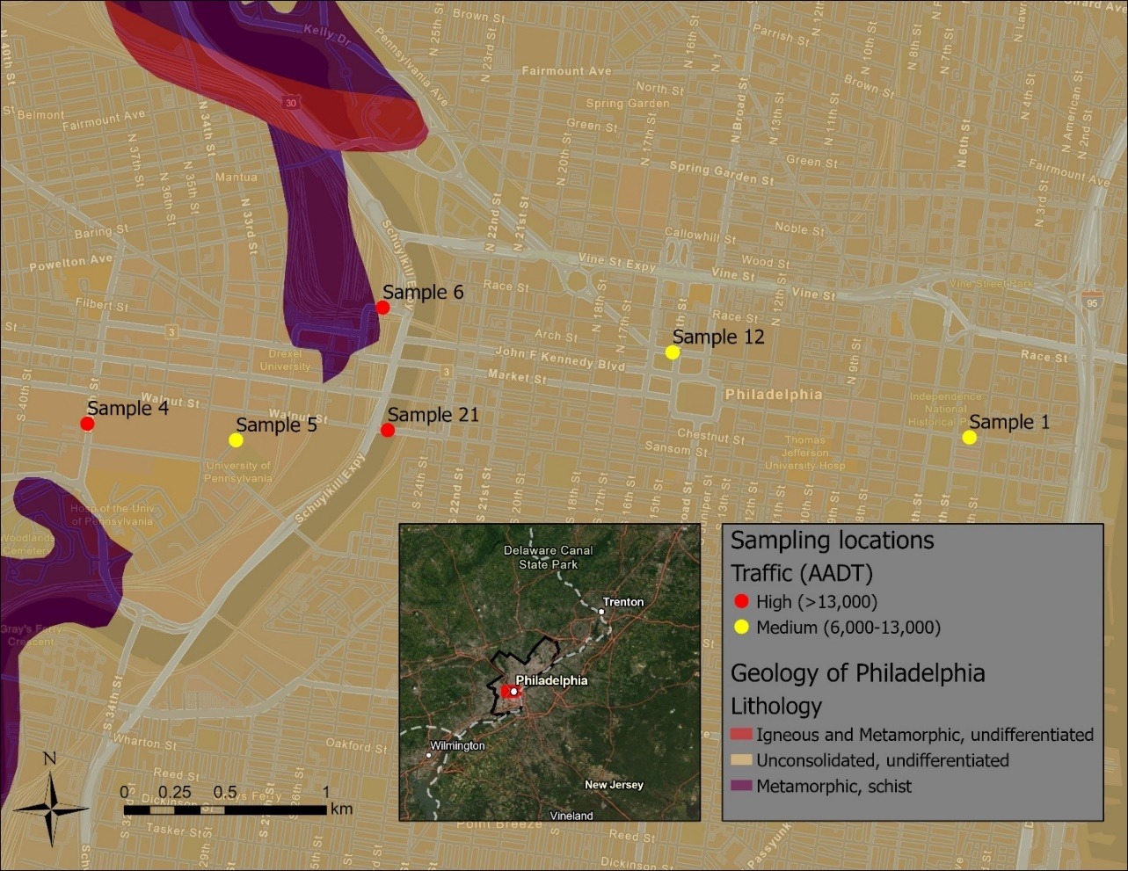
Igneous & Metamorphic, undifferentiated
Unconsolidated, undifferentiated
Metamorphic, Wissahickon schist

Figure S1. Locations of the road dust sampling sites in Philadelphia. The sample (or “sites” referred in the text) names are identical to those used in O’Shea et al. (2020), as the material was collected at the same sites. Lithologic characteristic is based on USGS (2022). AADT = average annual daily traffic.

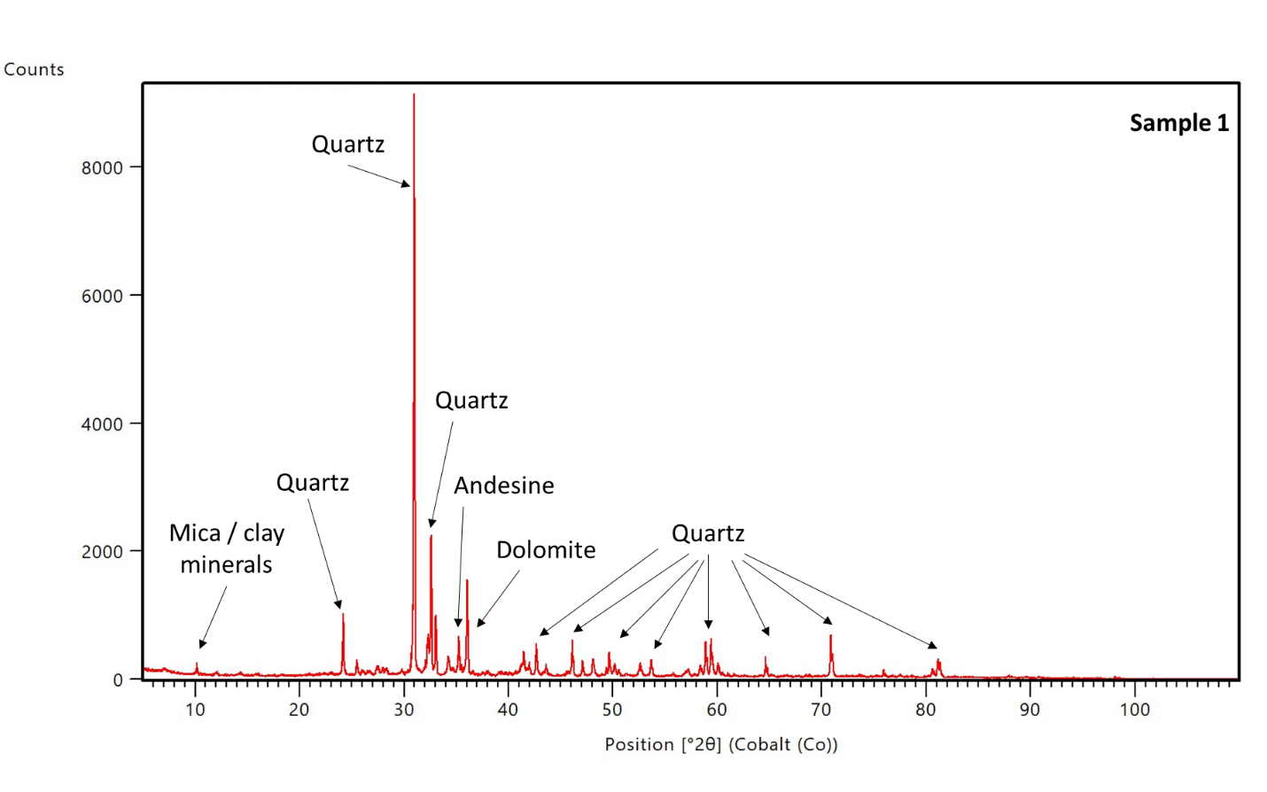Figure S2. Site 1: XRD pattern and mineralogical interpretation.
Site 1

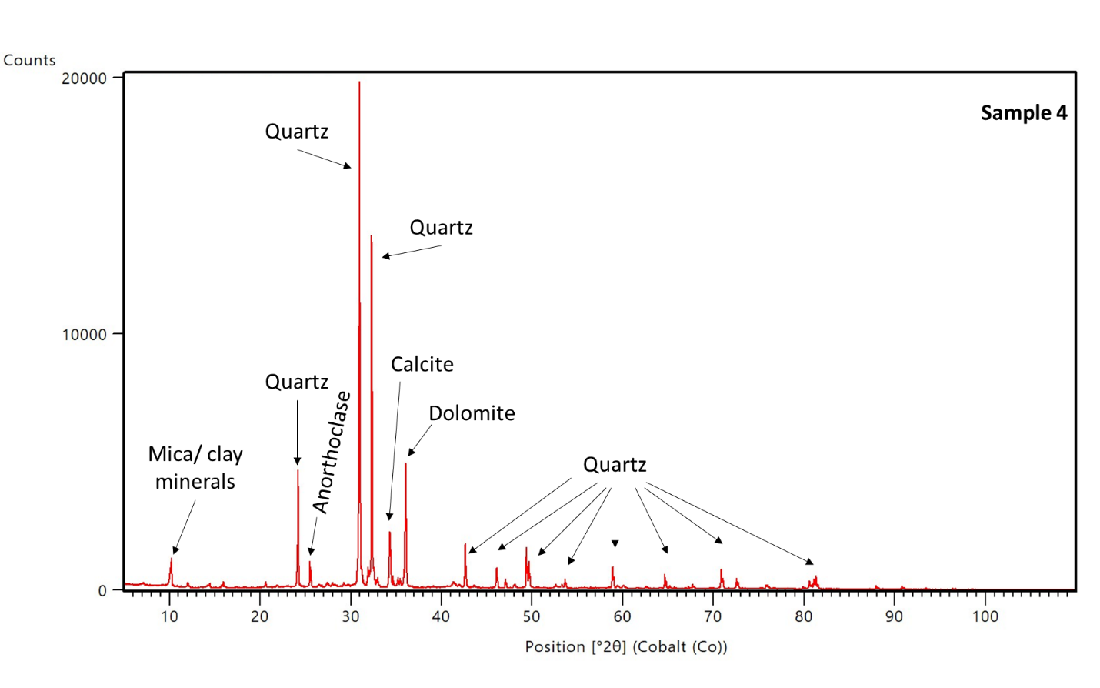Figure S3. Site 4: XRD pattern and mineralogical interpretation.
Site 4
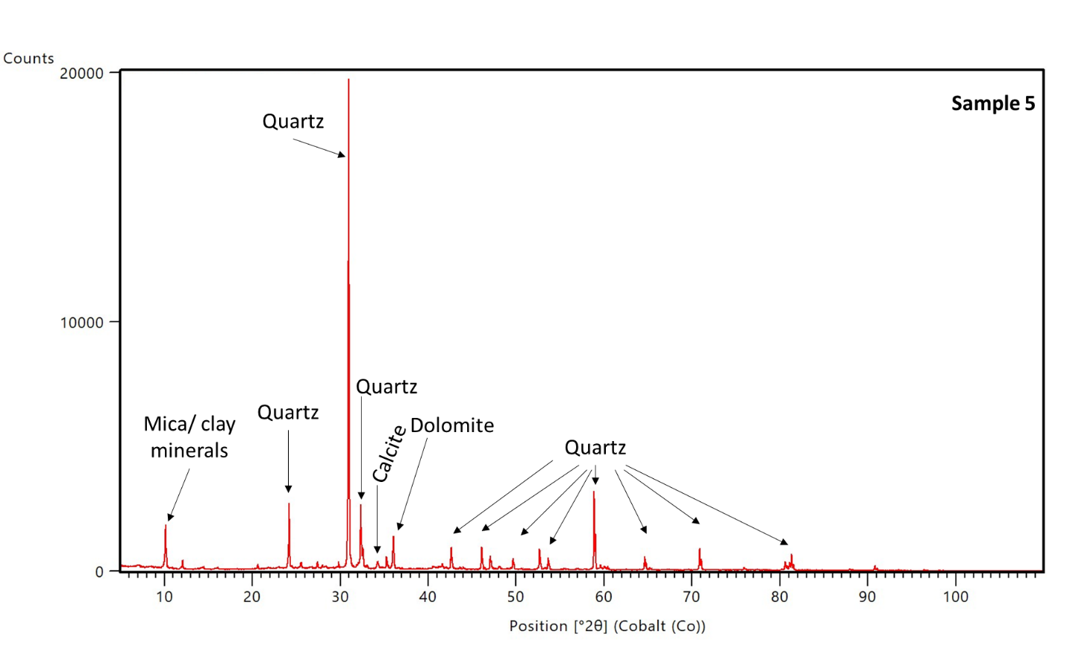Figure S4. Site 5: XRD pattern and mineralogical interpretation.
Site 5
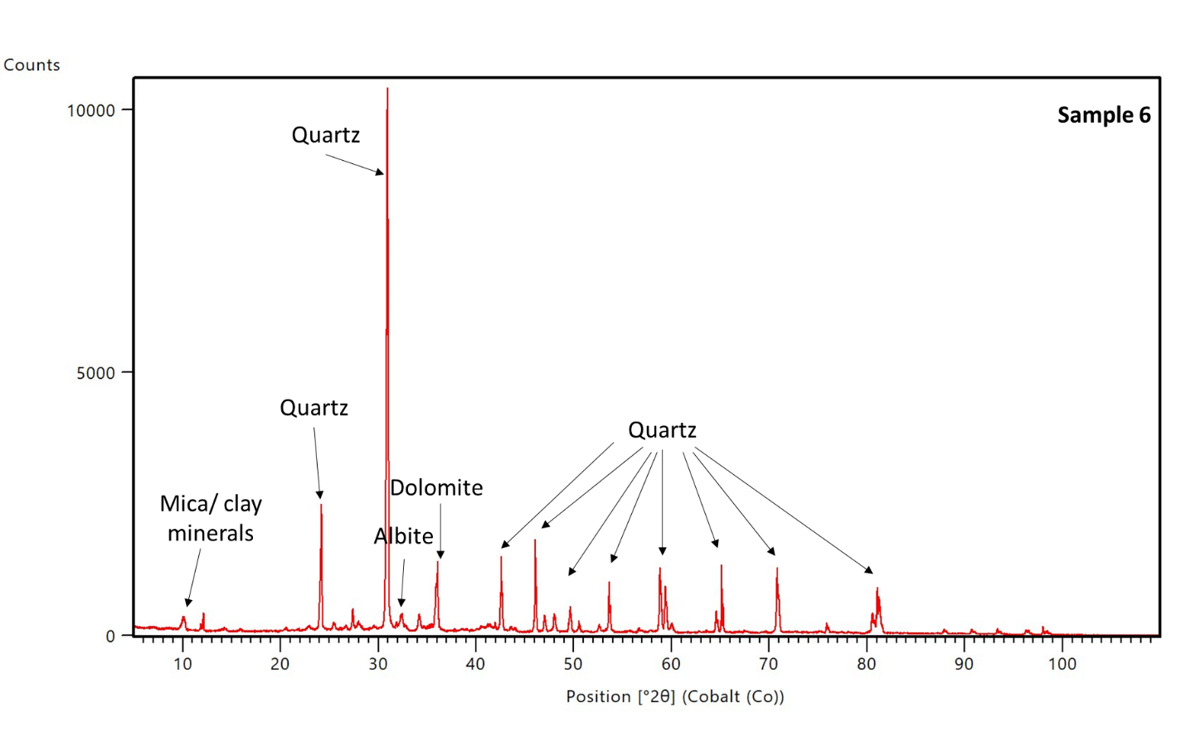Figure S5. Site 6: XRD pattern and mineralogical interpretation.
Site 6
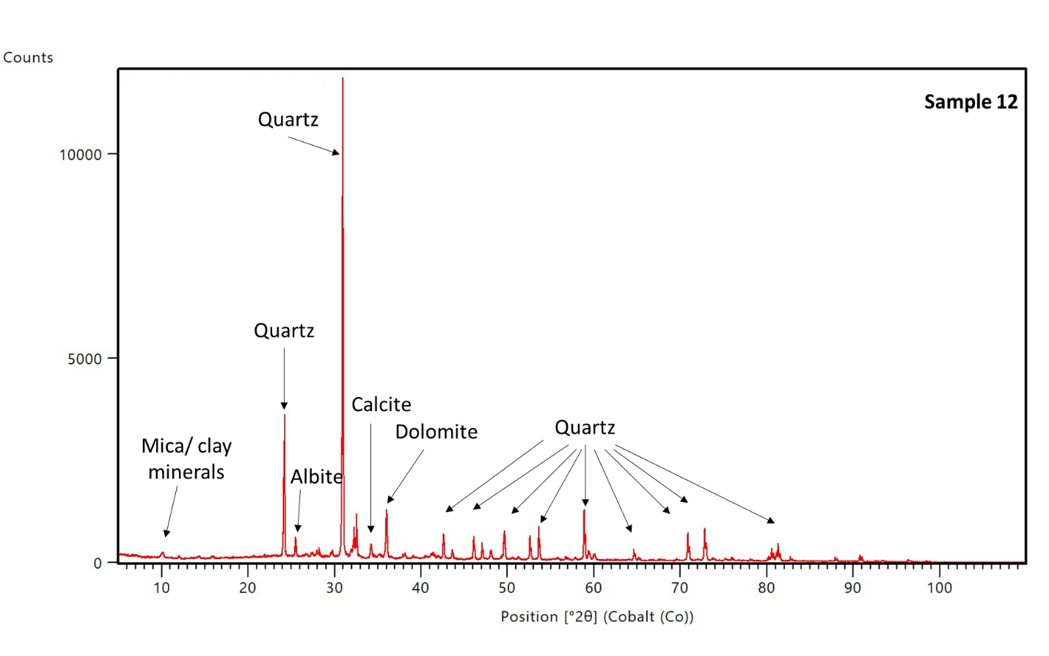Figure S6. Site 12: XRD pattern and mineralogical interpretation.
Site 12
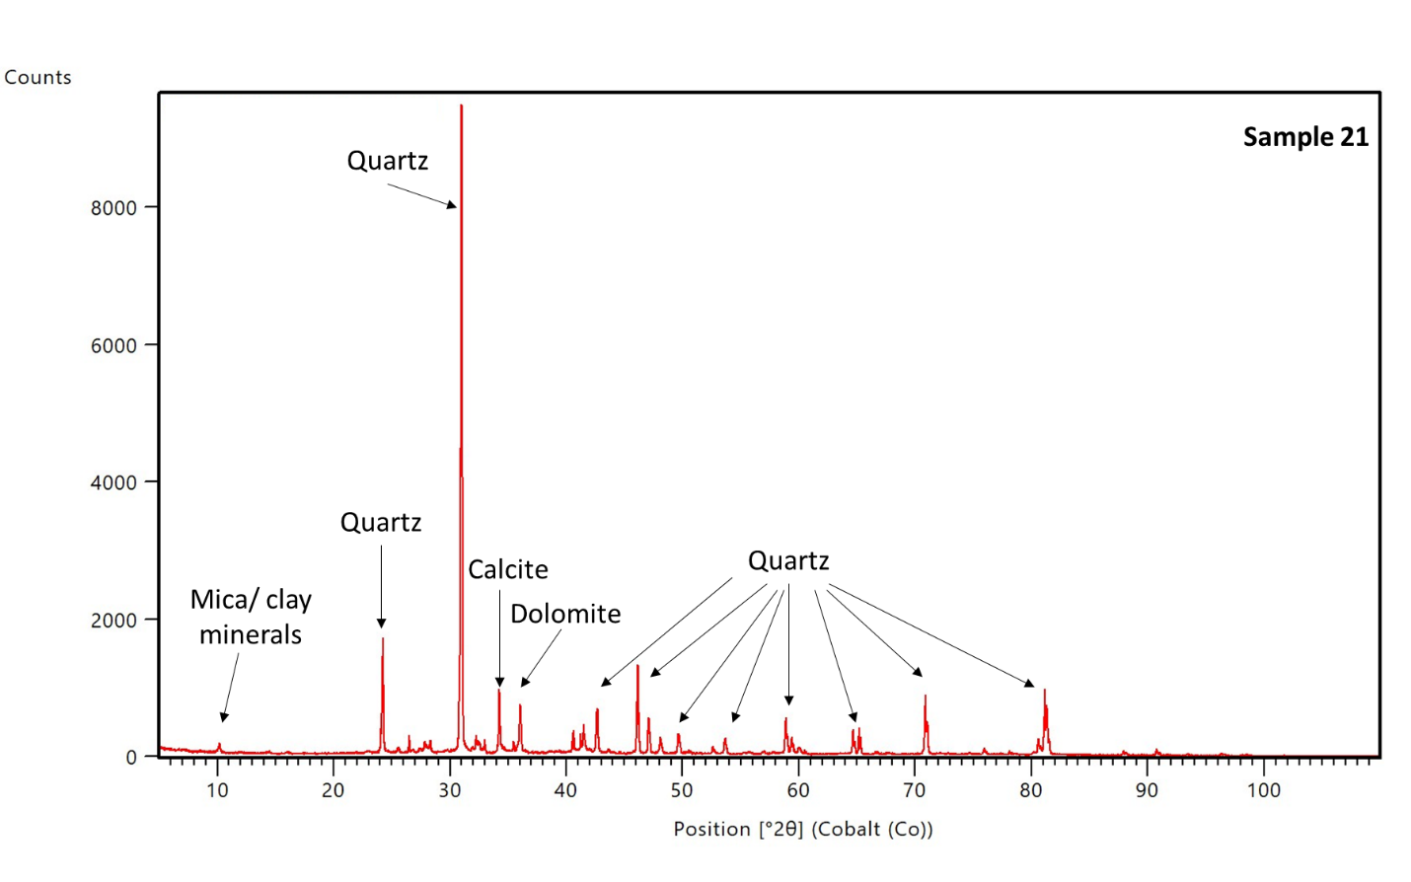Figure S7. Site 21: XRD pattern and mineralogical interpretation.
Site 21

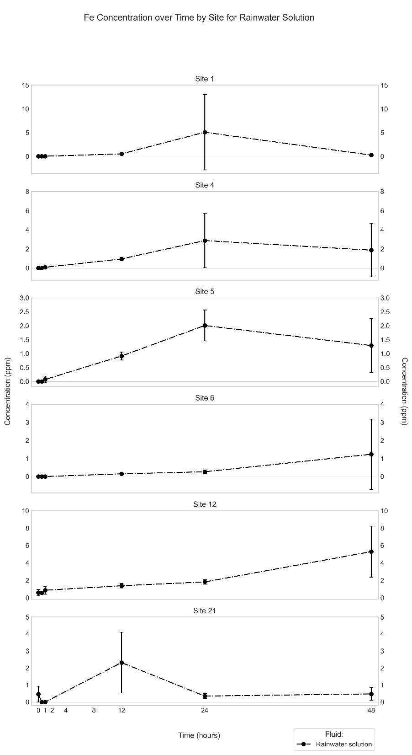
Figure S8. Mean (n = 3) Fe concentration in synthetic rainwater extract (in ppm) through time (in hours) for the different sites.
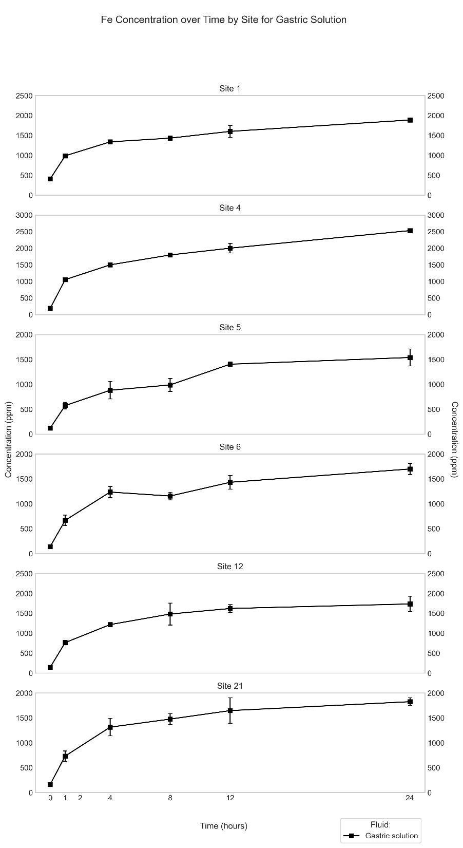
Figure S9. Mean (n = 3) Fe concentration in simulated gastric fluid extract (in ppm) through time (in hours) for the different sites.

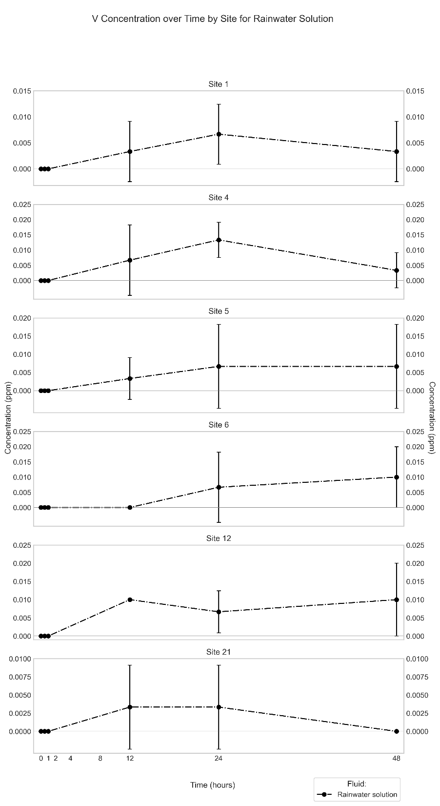
Figure S10. Mean (n = 3) V concentration in synthetic rainwater extract (in ppm) through time (in hours) for the different sites.
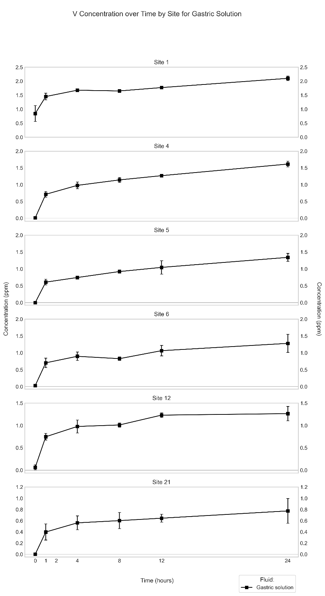
Figure S11. Mean (n = 3) V concentration in simulated gastric fluid extract (in ppm) through time (in hours) for the different sites.
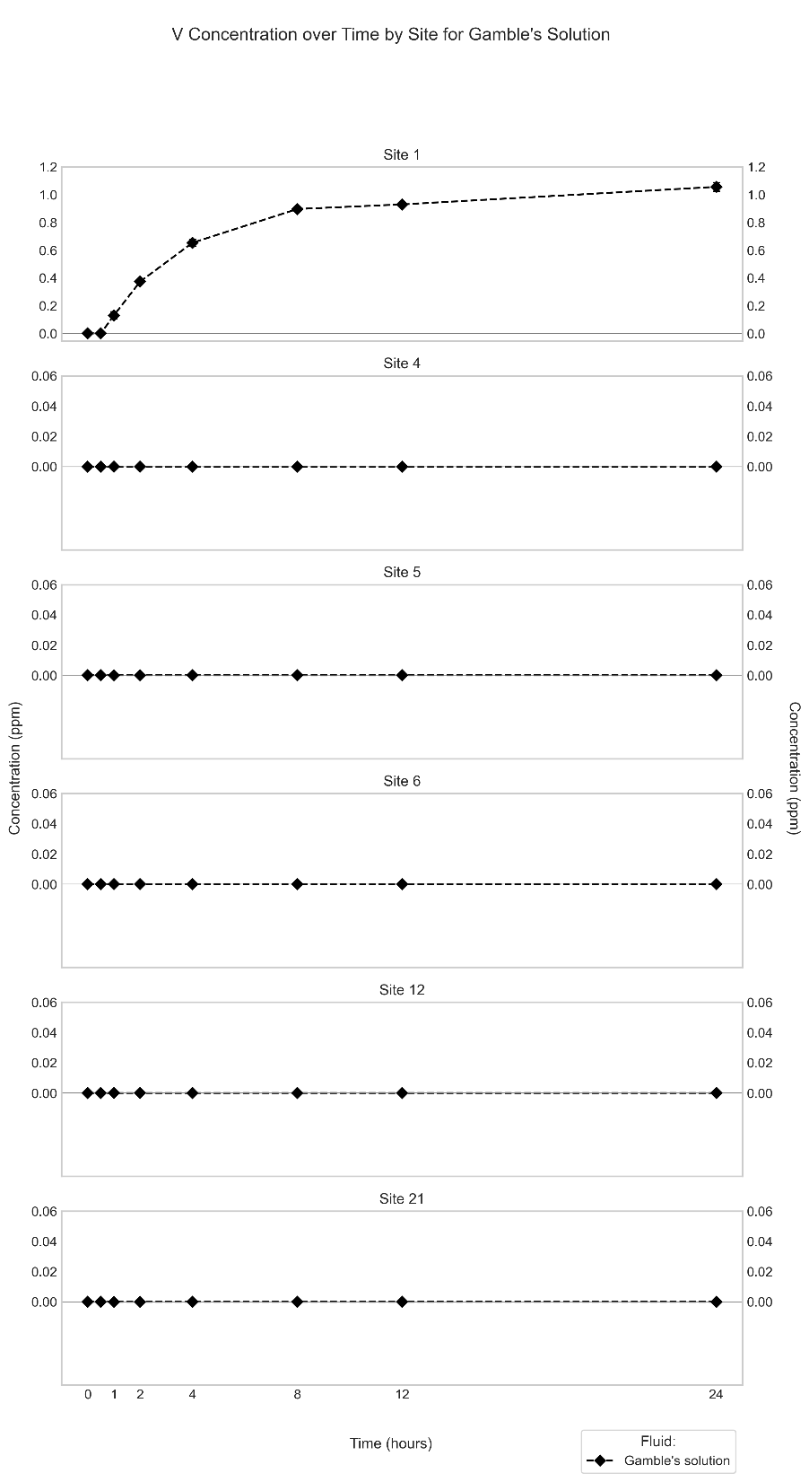
Figure S12. Mean (n = 3) V concentration in Gamble’s solution extract (in ppm) through time (in hours) for the different sites.
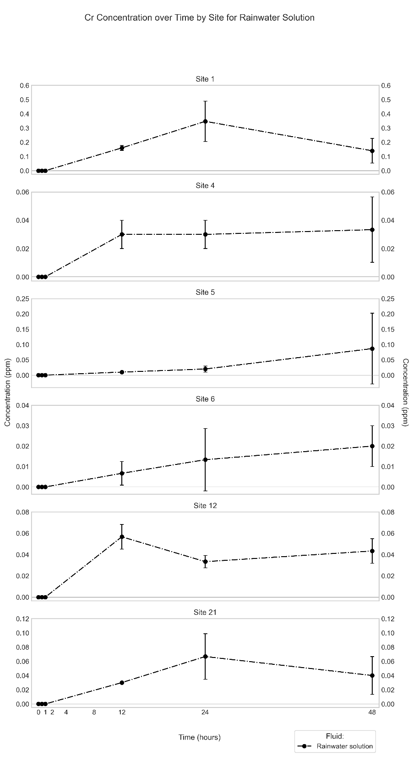
Figure S13. Mean (n = 3) Cr concentration in synthetic rainwater extract (in ppm) through time (in hours) for the different sites.
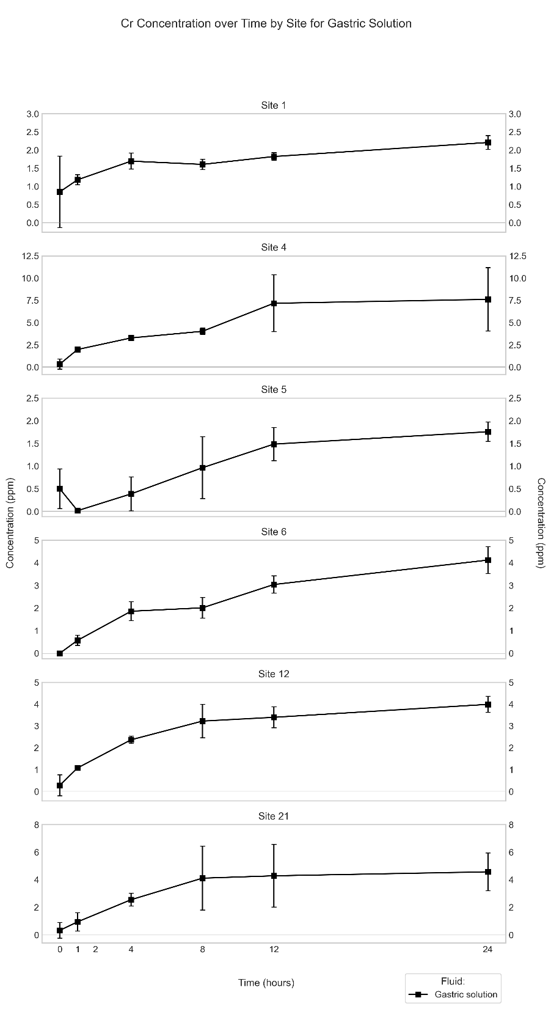
Figure S14. Mean (n = 3) Cr concentration in simulated gastric fluid extract (in ppm) through time (in hours) for the different sites.
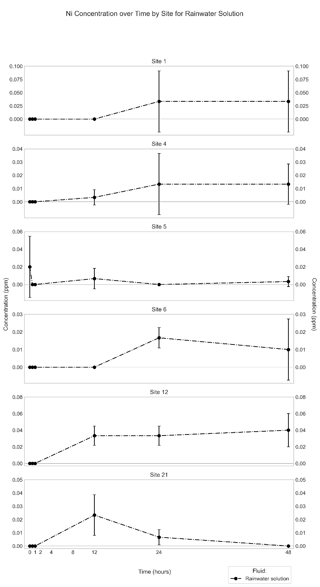
Figure S15. Mean (n = 3) Ni concentration in synthetic rainwater extract (in ppm) through time (in hours) for the different sites.
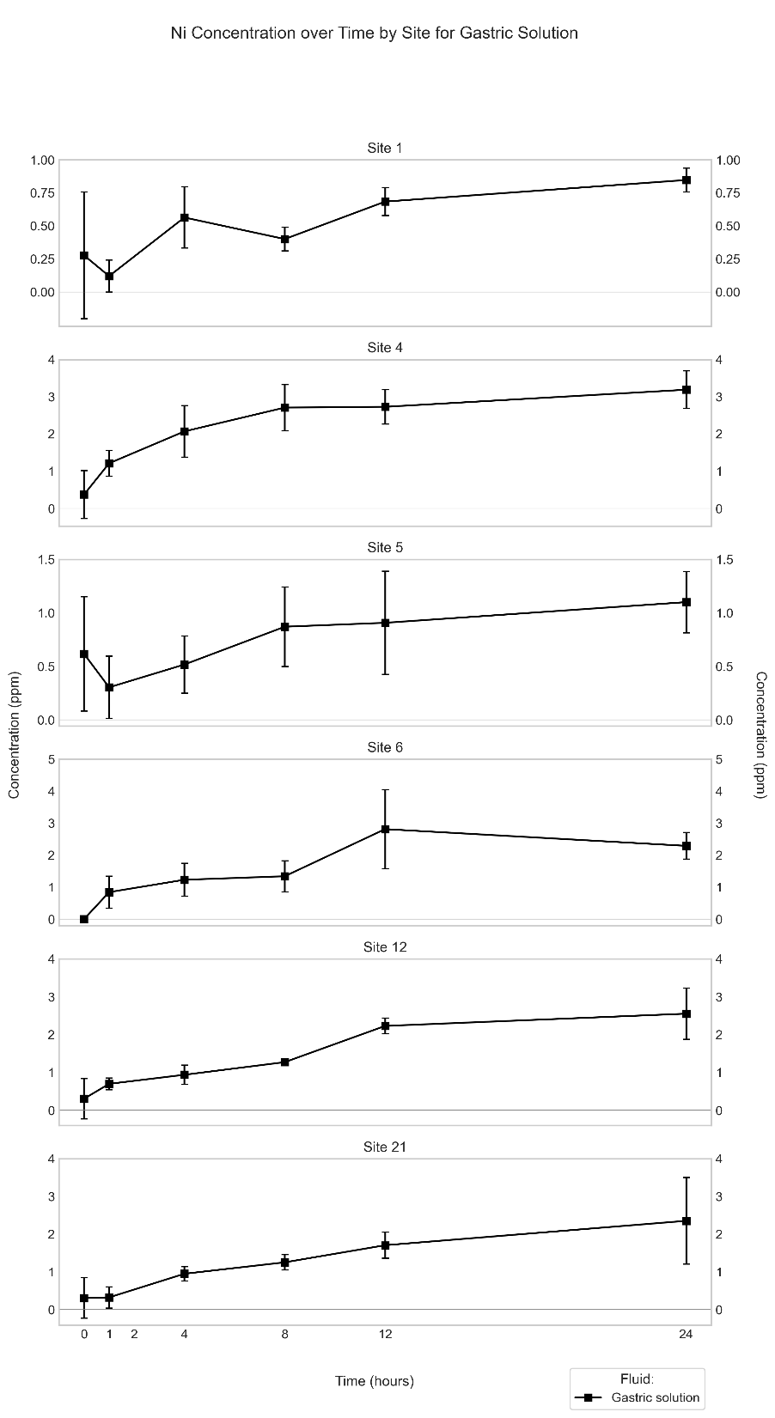
Figure S16. Mean (n = 3) Ni concentration in simulated gastric fluid extract (in ppm) through time (in hours) for the different sites.
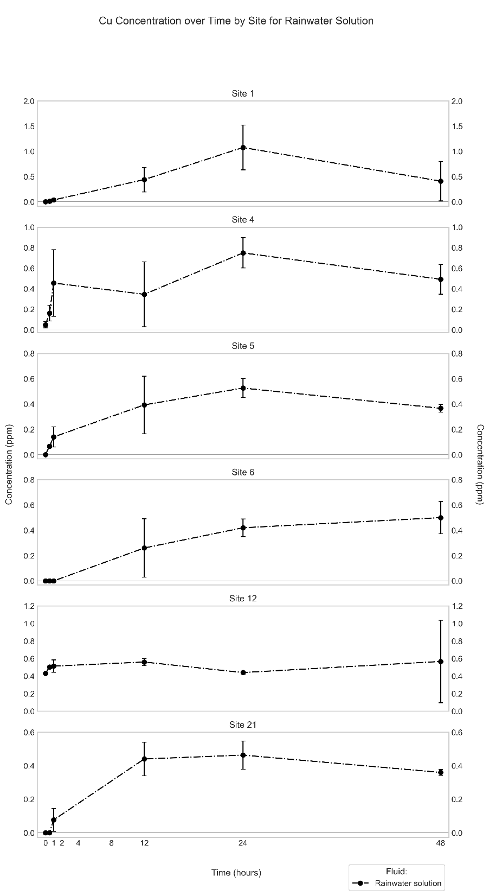
Figure S17. Mean (n = 3) Cu concentration in synthetic rainwater extract (in ppm) through time (in hours) for the different sites.

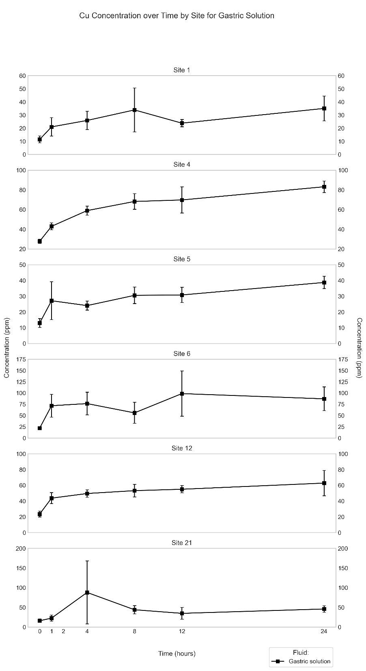
Figure S18. Mean (n = 3) Cu concentration in simulated gastric fluid extract (in ppm) through time (in hours) for the different sites.
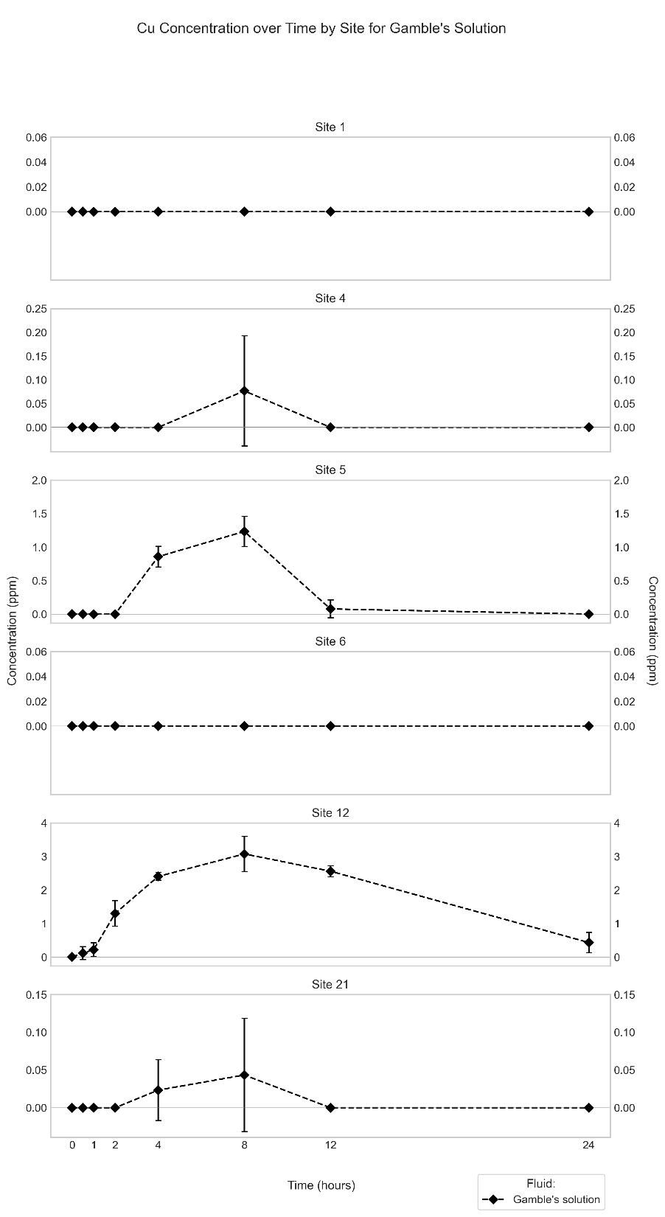
Figure S19. Mean (n = 3) Cu concentration in Gamble’s solution extract (in ppm) through time (in hours) for the different sites.
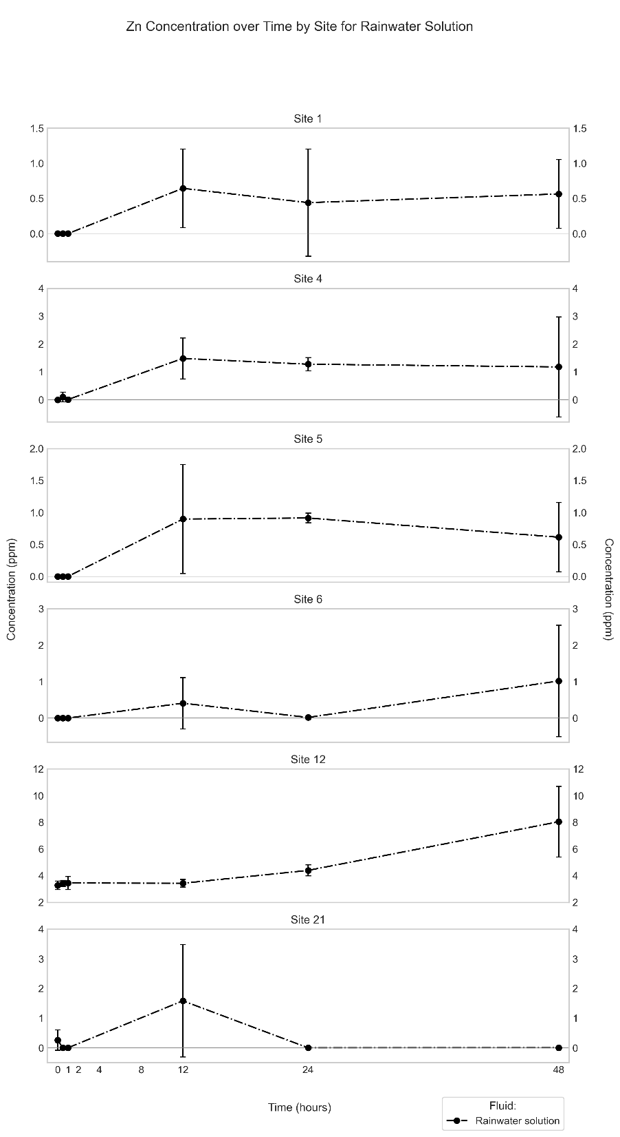
Figure S20. Mean (n = 3) Zn concentration in synthetic rainwater extract (in ppm) through time (in hours) for the different sites.
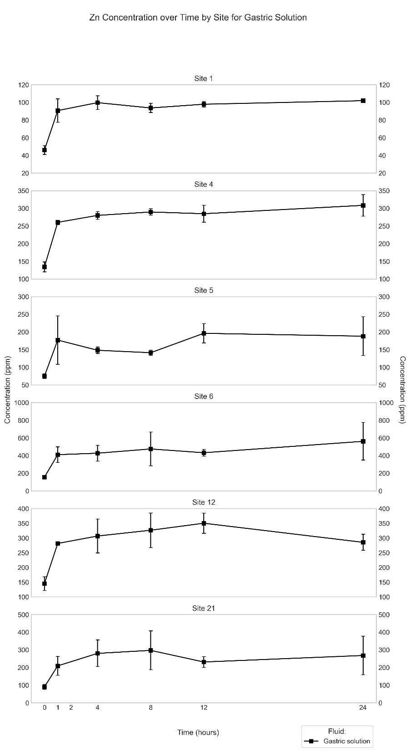
Figure S21. Mean (n = 3) Zn concentration in simulated gastric fluid experiment (in ppm) through time (in hours) for the different sites.
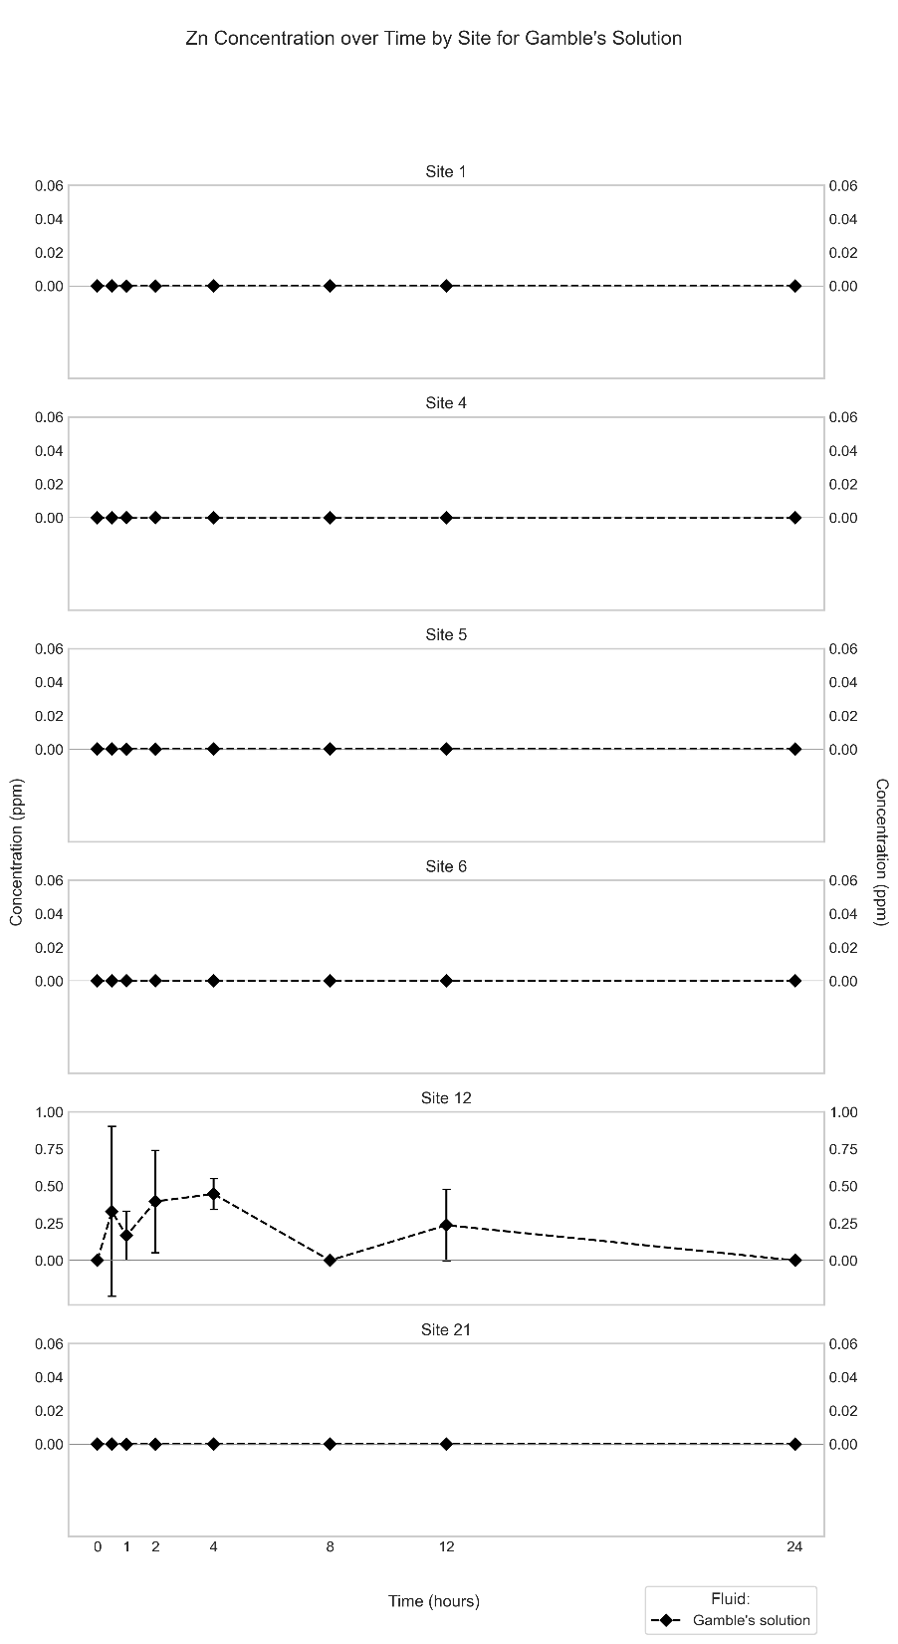
Figure S22. Mean (n = 3) Zn concentration in Gamble’s solution extract (in ppm) through time (in hours) for the different sites.

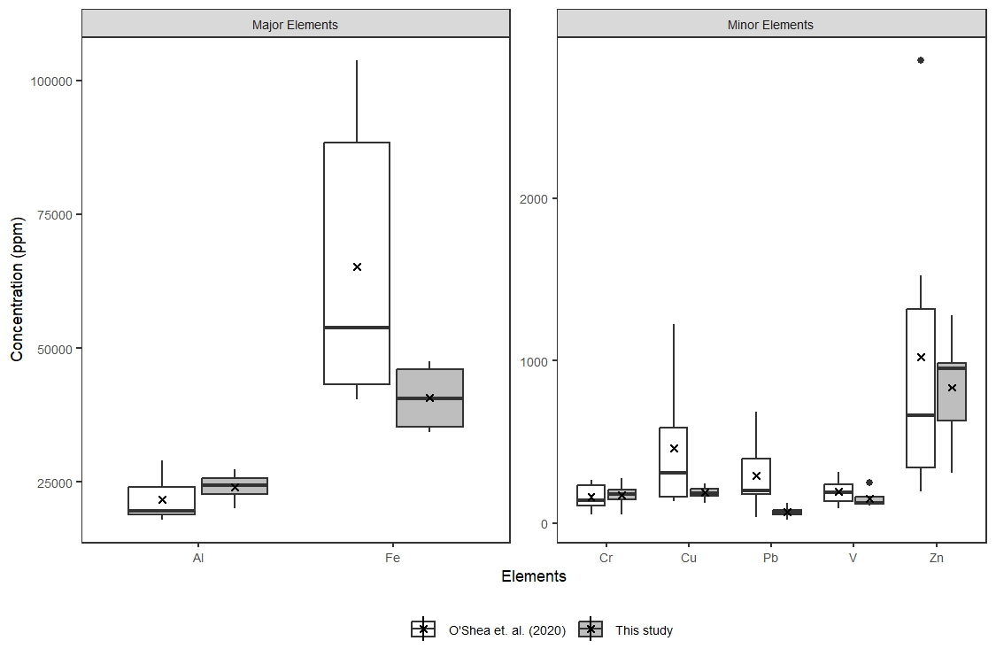
Figure S23. Comparison of selected elements studied in O’Shea et al. (2020) and this study from the same six sampling locations. Cross (“x”) symbol inside the box refers to the mean concentration of each element from all six sites, horizontal line represents the median.

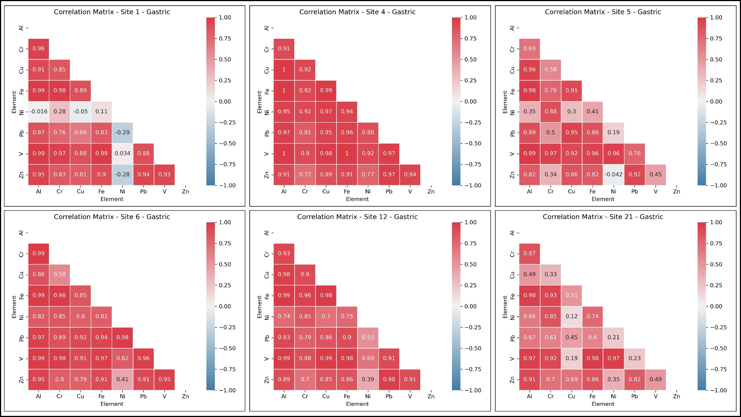
Figure S24. Pearson correlation matrices for the concentrations of the studied elements in the simulated gastric-fluid extracts from all six sites. Data points with element concentrations below their respective detection limits were not considered.

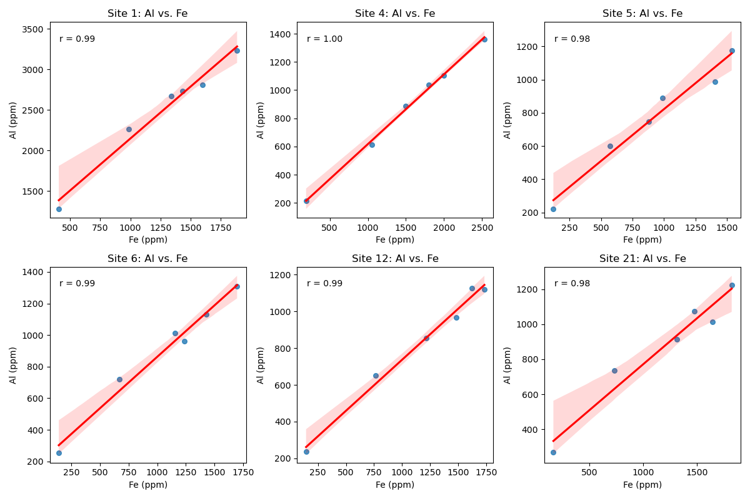
Figure S25. Diagrams showing the (Pearson) correlation between the concentrations of Al and Fe (in ppm) in the simulated gastric-fluid extracts for each site. Regression lines shown in red, confidence intervals are shaded in red). The correlated increases in the concentrations of Al and Fe from lower left to upper right, seen in each diagram, reflect the compositional evolution of the gastric fluid from the beginning to the end of the experiments (see Figs. 3, S9).
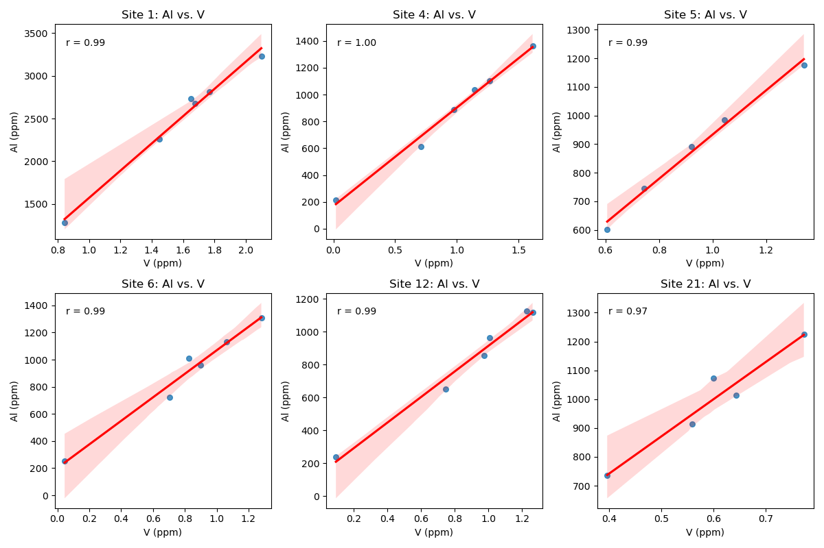
Figure S26. Diagrams showing the (Pearson) correlation between the concentrations of Al and V (in ppm) in the simulated gastric-fluid extracts for each site. Regression lines shown in red, confidence intervals are shaded in red. The correlated increases in the concentrations of Al and V from lower left to upper right, seen in each diagram, reflect the compositional evolution of the gastric fluid from the beginning to the end of the experiments (see Figs. 3, S11).
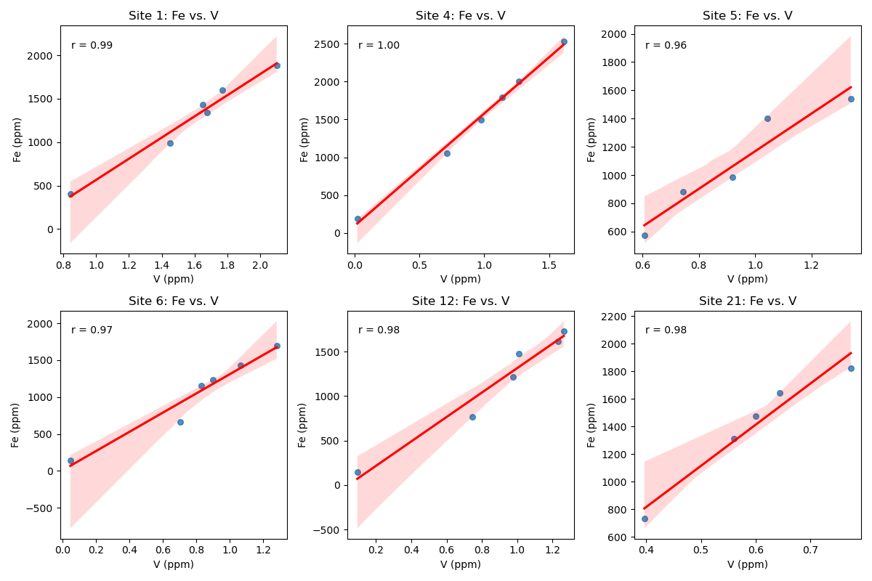
Figure S27. Diagrams showing the (Pearson) correlation between the concentrations Fe and V (in ppm) in the simulated gastric-fluid extracts for each site. Regression lines shown in red, confidence intervals are shaded in red. The correlated increases in the concentrations of Fe and V from lower left to upper right, seen in each diagram, reflect the compositional evolution of the gastric fluid from the beginning to the end of the experiments (see Figs. S9, S11).

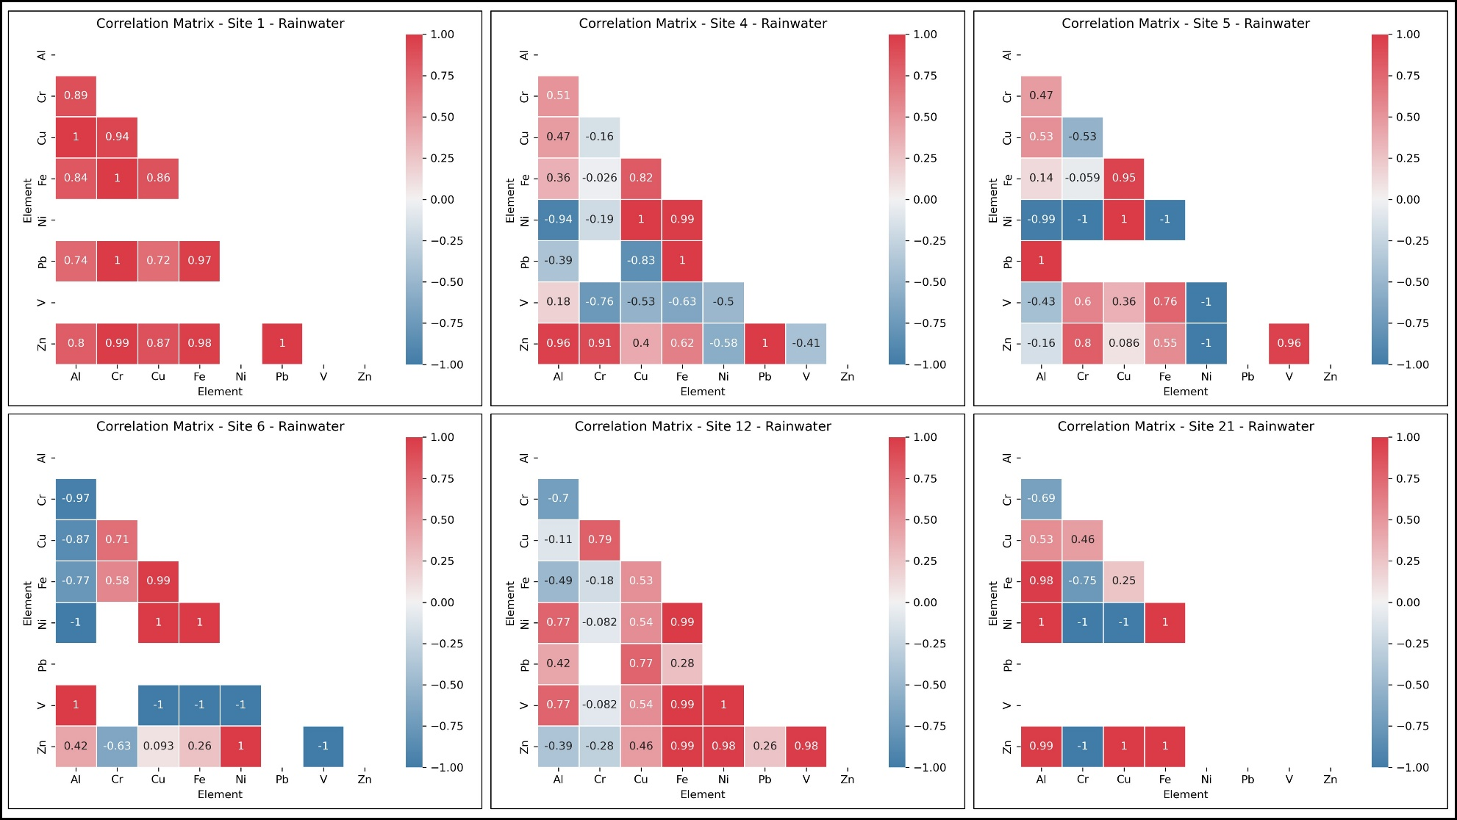
Figure S28. Pearson correlation matrices for the concentrations of the studied elements in the synthetic rainwater extracts from all six sites. Data points with element concentrations below their respective detection limits were not considered.

