SUPPLEMENTARY MATERIAL of :

“Loading ratio is key for biodegradation PHBV-based materials in home-composting conditions”
Héloïse BAZART¹, Valérie GUILLARD¹, Nathalie GONTARD², Lucile CHATELLARD¹
¹UMR IATE, Université de Montpellier, 163 rue Auguste Broussonnet, F-34090 Montpellier, France
²UMR IATE, INRAE, 2 place Pierre Viala, F-34060 Montpellier, France

Journal of Polymers and the Environment

Overview:
In the supplementary material, additional details that are not included in the main paper due to space limits are provided as follows:
- Details of the kinetic biodegradation curve for each tested material (see Section 1).
- Details of the comprehensive Gompertz model application (see Section 2).
- Details on the modelling process to estimate the number of days of biodegradation to reach the standardized rate and associated graphics for 1/3 condition (see Section 3).
- Details on the material to inoculum ratio calculation (see Section 4)

- Complete kinetic biodegradation profiles for the tested material
1.a. Shredded film

Figure S1: Cellulose microfibers ultimate biodegradation percentage based on 3 replicates in days.

Figure S2: PHBV shredded film ultimate biodegradation percentage based on 3 replicates in days.

Figure S3: PHBV cellulose shredded film ultimate biodegradation percentage based on 3 replicates in days.

1.b. Film shape

Figure S4: Kraft paper ultimate biodegradation percentage based on 3 replicates in days.

Figure S5: PHBV film ultimate biodegradation percentage based on 3 replicates in days. Only exception is PHBV_30, where one reactor produced inconsistent results, consequently, data from this reactor were excluded from day 242.

Figure S6: PHBV cellulose film ultimate biodegradation percentage based on 3 replicates in days

1.c. PET control kinetic biodegradation curves

A
Figure S7: PET control, shredded film form (A) and film form (B) ultimate biodegradation percentage based on 3 replicates in days.
B

- Comprehensive Gompertz model application

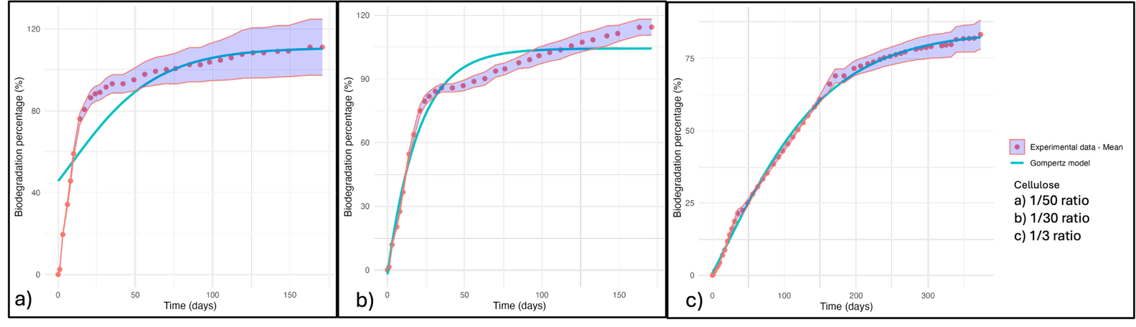
Figure S8: Cellulose microfibers
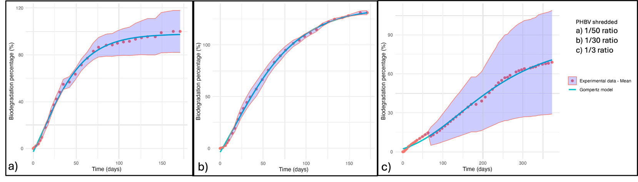
Figure S9: PHBV shredded
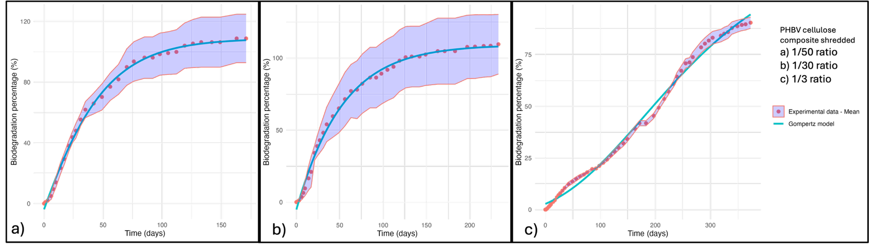
Figure S10: PHBV 20% cellulose shredded
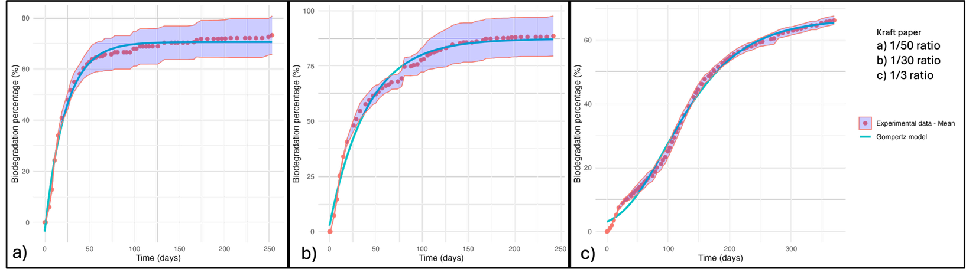
Figure S11: Kraft paper film
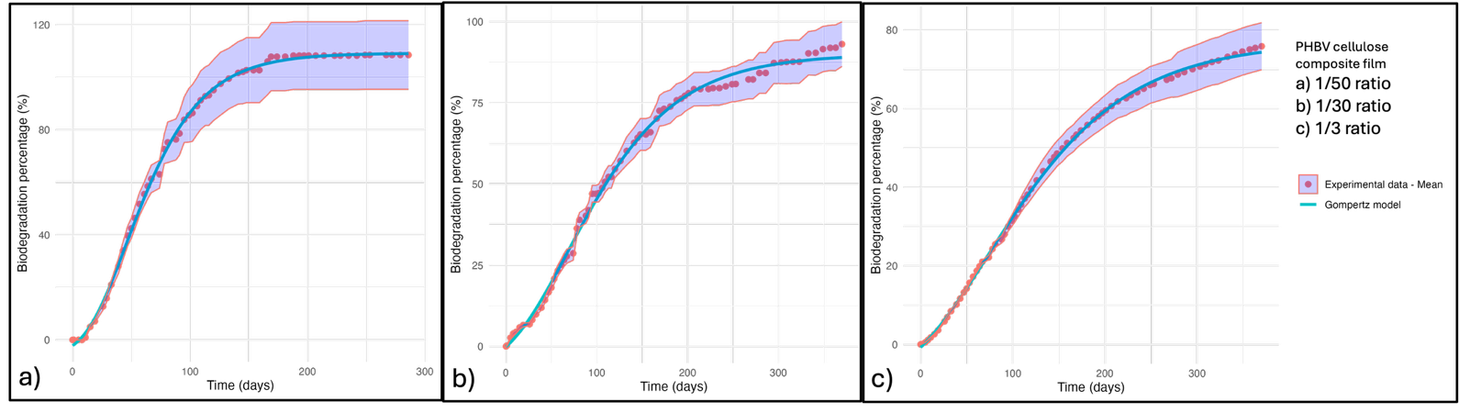
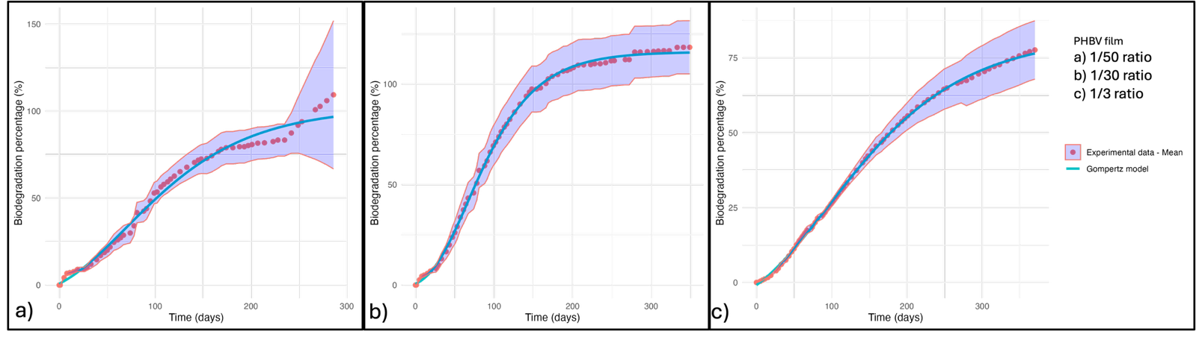
Figure S12: PHBV film
Figure S13: PHBV cellulose film

- Linear regression model for biodegradation time prediction
  - Method

Our experimental biodegradation data did not reach the standardized threshold of 90% of biodegradation within the 12 months testing period. To predict the time required to achieve 90% and 100% of biodegradation we applied a logarithmic regression model which is widely used for interpreting biodegradation data.

Data selection method: For each reactor, only data point representing biodegradation model from 50% were included in the analysis. This approach allowed us to capture the linear phase of the experimental data, providing a more accurate representation of the biodegradation trend during the latest stage of the process.

We used a regression model using Software RStudio (version xxx) to fit the following equation:

Model equation:
$Biodegradation(\%) = a + k × ln(Time)$ (Equation 2)
Where:
- a = intercept coefficient
- k = slope coefficient for ln(Time)
- ln(Time) = natural logarithm of time
Then to find the day when the biodegradation reaches 90%:
$t90\%​=exp(k-a​)$ (Equation 3)
  - Obtained modelling curves
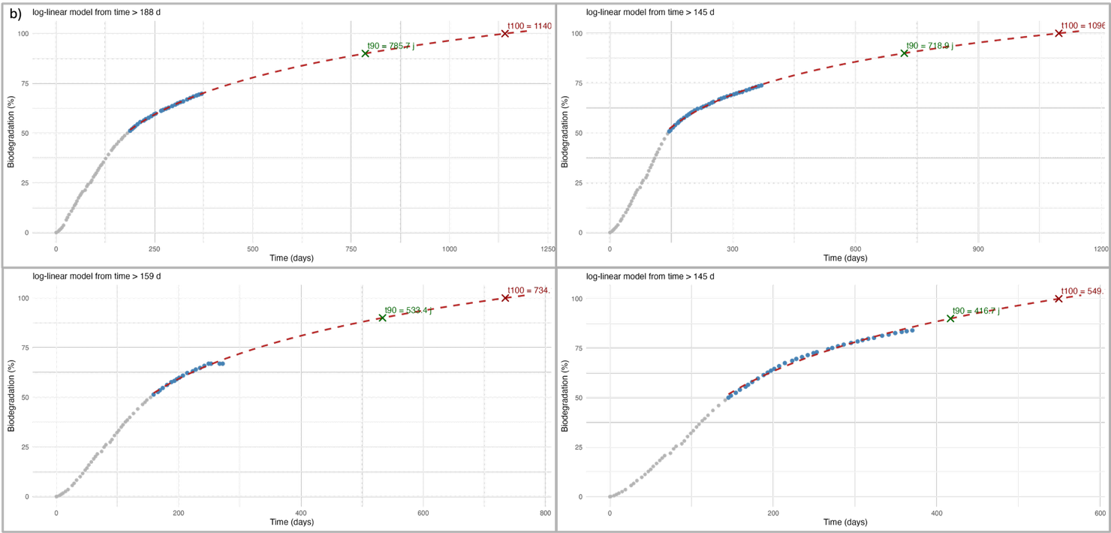
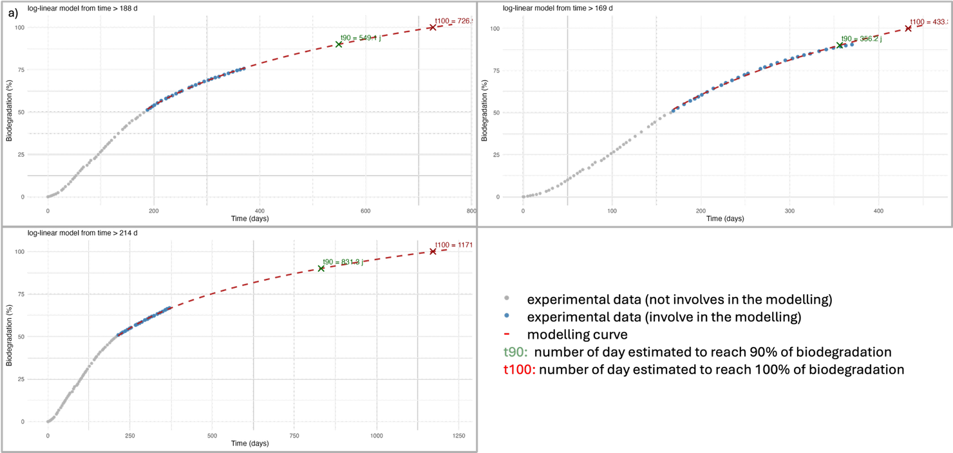
Figure S14: Biodegradation curves completed with modelling curve to estimate the time in days needed to reach 90% and 100% of biodegradation for each PHBV reactor (a) and PHBV with 20% cellulose (b) at 1/3 material to inoculum ratio. • represent the experimental data that are not involves in the modelling. • are the experimental data involving in the modelling. - - corresponds to the modelling curve. T90 and T100 correspond to the number of days when the model estimates 90% or 100% of biodegradation.

- Justification for material-to-inoculum ratio used in the present study
To defines the selected ratio in this study we estimated the total of organic waste produce in France and the total plastic packaging related to the food industry based on online available data (Table S1). The detailed data and calculation are described below.
According to the European Compost Network (ECN, 2019), France produced approximately 4.6 millions of tons of biowaste in 2019. For composting application, the balance between biowaste and green waste requires to mix equivalently at 50/50 ratio. This mix is typically containing between 65% and 55% water content, corresponding to 35-45% dry matter (DM).
The European Environment Agency reported that France produced 12.6 million tons of packaging waste in 2019 with plastic representing approximately 2.3 millions of tons according to Eurostat data for the same year.
Research from INRAE indicates that the food industry represents approximately 20% of France’s total plastic consumption (from 6.4 Mt). Since the food and beverage represents 91% of the food industry plastic use, the estimated amount of plastic packaging specifically for the food industry is 1.17 million tons.
Based on a 50:50 biowaste-to-green waste ratio at 65% water content, the following quantities were established for France in 2019 (Table S1). To calculate the representative ratio of a scenario were all the food packaging are composted after use (2):
Table S1: Organic and plastic waste data in France in 2019^{(a)} and 2022^{(b)} respectively and calculation of the food industry plastic packaging production.
Waste type | Quantity (Mt)
Biowaste^{(a)} | 4.6 Mt
Green waste | 4.6 Mt
Total organic waste | 9.2 Mt
Dry matter (total organic waste) | 3.2
Total plastic consumption^{(b)} | 6.4
Plastic packaging waste | 2.4
Food industry plastic packaging waste | 1.2 see calculation below (1)

$\left(1\right) Food industry plastic packaging:\left(total plastic*0.20\right)*0.91≈1.2$ Mt
$$\left(2\right) Representative ratio: \frac{food industry plastic packaging}{total organic waste (dry matter)}= \frac{1.2}{3.2}≈ \frac{1}{3}$$

Based on the 2019 and 2022 data, if all food plastic waste packaging were hypothetically incorporated into compost systems, the material ratio would be approximately 1:3 (plastic to organic waste), based on the dry matter content of the organic waste stream. This material-to-inoculum ratio was chosen consequently into the study. It represents a worst-case scenario for the maximum amount of plastic waste that could be hypothetically be added to a home composting process.

- ECN (2019): https://www.compostnetwork.info/policy/biowaste-in-europe/separate-collection/
- European Environment Agency: https://www.eea.europa.eu/publications/many-eu-member-states/france (choose filters: plastic, tonne and France, 2019)
- Eurostat: https://ec.europa.eu/eurostat/databrowser/view/env_waspac__custom_17499406/default/table?lang=en
- INRAE: https://www.inrae.fr/en/news/plastics-agriculture-and-food-production-state-affairs

