Extended Data Table 1 | CMIP5 models used for the detection and attribution of RSL and ESL changes over the period 1900 to 2005. Check marks indicate availability of historical and single-forcing experiments in different models, while Xs mark unavailability, in which case the respective experiment is derived from the difference of the other two experiments.
Model | Historical | Natural | Anthropogenic
CNRM-CM5 | ✔ | ✔ | ✔
CSIRO-Mk3.6.0 | ✔ | ✔ | ✔
CanESM2 | ✔ | ✔ | ✘
GISS-E2-R | ✔ | ✔ | ✔
IPSL-CM5A-LR | ✔ | ✔ | ✔
IPSL-CM5A-MR | ✔ | ✔ | ✘
MIROC-ESM | ✔ | ✔ | ✘
MIROC-ESM-CHEM | ✔ | ✔ | ✘
MRI-CGCM3 | ✔ | ✔ | ✘
NorESM1-M | ✔ | ✔ | ✘

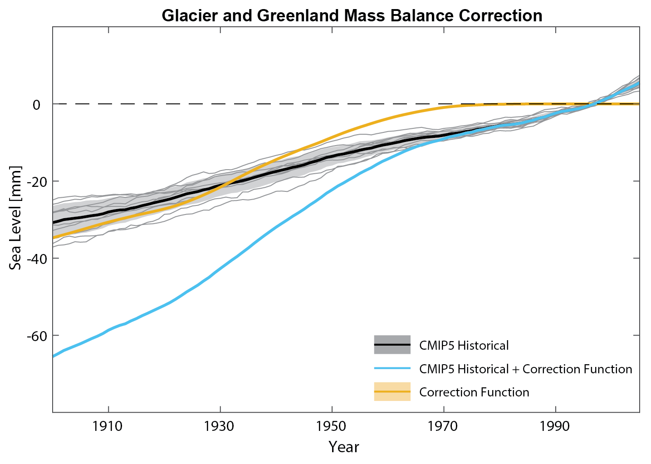
Extended Data Figure 2 | Correction Function for barystatic mass contributions simulated by CMIP5. The correction function is calculated from the ensemble mean difference between glacier and Greenland ice sheet mass balance from observations²⁷ and 10 CMIP5 model historical simulations^{18,19}.
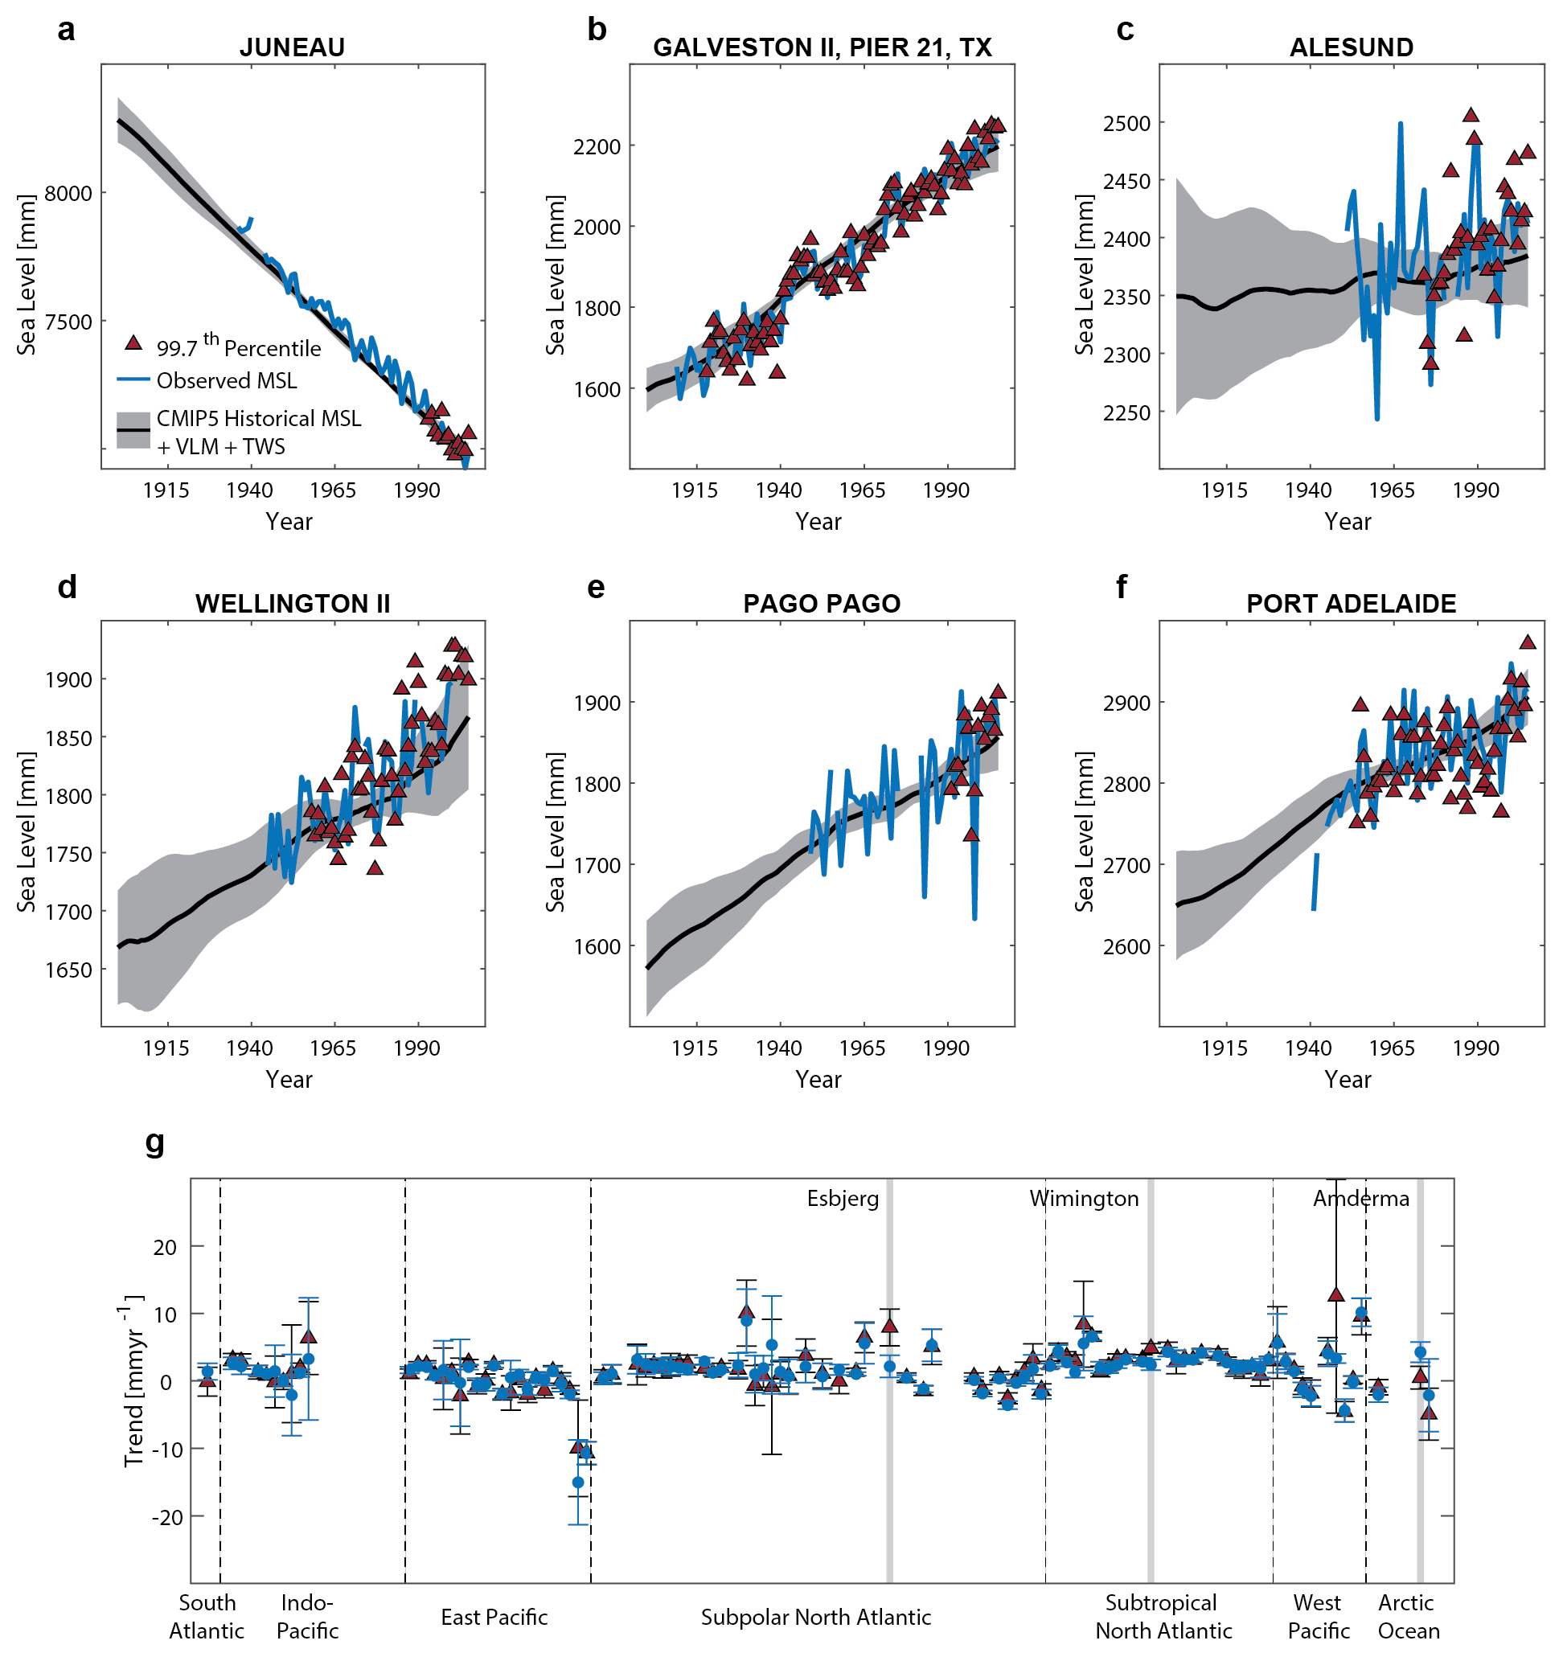
Extended Data Figure 3 | Comparison of trends in ESLs and RSLs. Shown are the time series of the 15-year moving 99.7th percentile of hourly sea-level records and the associated changes in observed and historically simulated CMIP5 RSL (adjusted by a vertical offset to match the mean of the 99.7th percentile over their overlapping period) at six selected sites: (a) Juneau, Alaska, (b) Galveston, Texas, (c), Alesund, Norway, (d) Wellington, New Zealand, (e) Pago Pago, American Samoa, (f) and Port Adelaide, Australia. (g) shows the linear trends in the 99.7th percentile vs RSL at all sites. Grey shadings mark three sites Esbjerg, Wilmington, and Amderma, where significant differences between the trends exist.
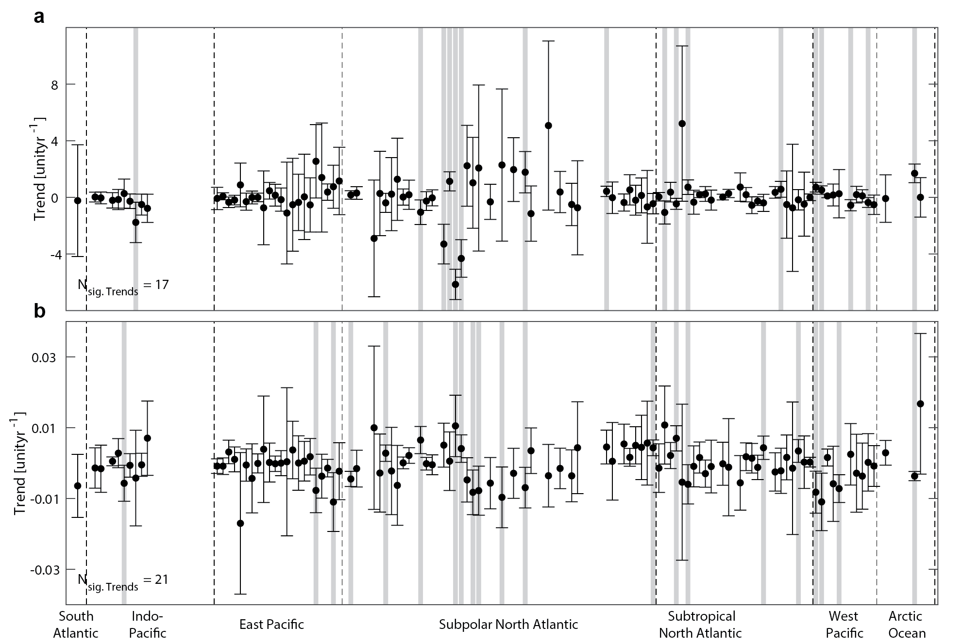
Extended Data Figure 4 | Trends in non-stationary GPD parameters. Shown are the trends in the two GPD parameters: shape (a), and scale (b). Error bars mark 95% confidence intervals. Grey shadings mark sites with statistically significant trends. Dashed lines mark the seven ocean basins with gauges used in this study.

