Supplemental material

1,465 aa
PfGCN5
1134 1284 1373 1443
yGCN5
NNN
HAT
BrD
tGCN5
hGCN5L
hGCN5S
mGCN5
PCAF-h
TgGCN5-A
TgGCN5-B
Length
1,032 aa
1,186 aa
830 aa
837 aa
467 aa
439 aa
418 aa
69 174 292 375
124 226 347 360
93 246 335 405
86 336 503 656 745 815
81 331 496 649 738 808
850 996 1118 1166
631 784 901 971
143 240

Supplemental figure 1. Conservation of functional domains in GCN5. Comparative diagram of GCN5 homologs from Tetrahymena thermophila (tGCN5), Saccharomyces cerevisiae (yGCN5), Homo sapiens (hGCN5S: short isoform; hGCN5L: long isoform), Mus musculus (mGCN5), Toxoplasma gondii (TgGCN5A/B), and Plasmodium falciparum (PfGCN5). The P300/CBP-associated factor (PCAF)-homology domain is shown in orange, the histone acetyltransferase (HAT) domain in blue, the bromodomain (BrD) in green, and the poly-N repeat in pink. Numbers above each domain/motif indicate the start and the end of these regions according to data collected from UniProt using the PROSITE database. Not drawn to scale.

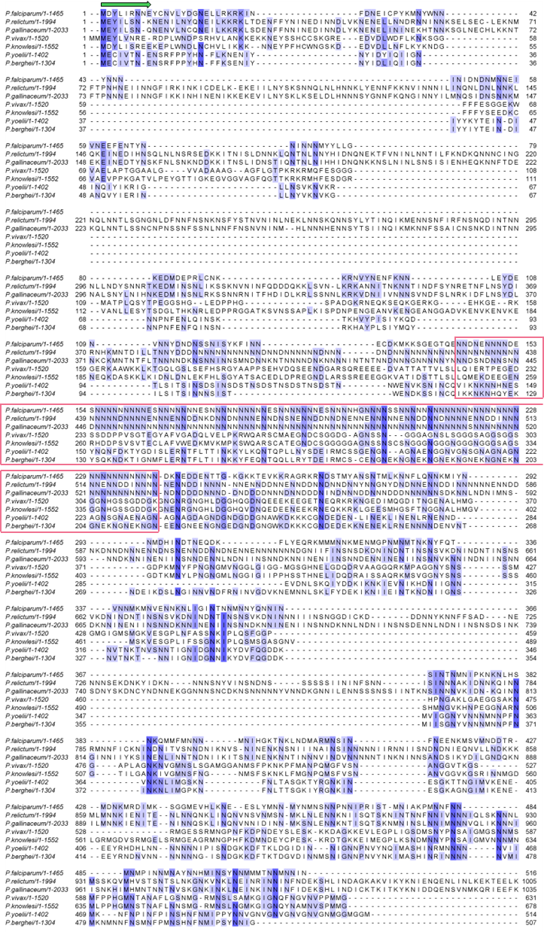

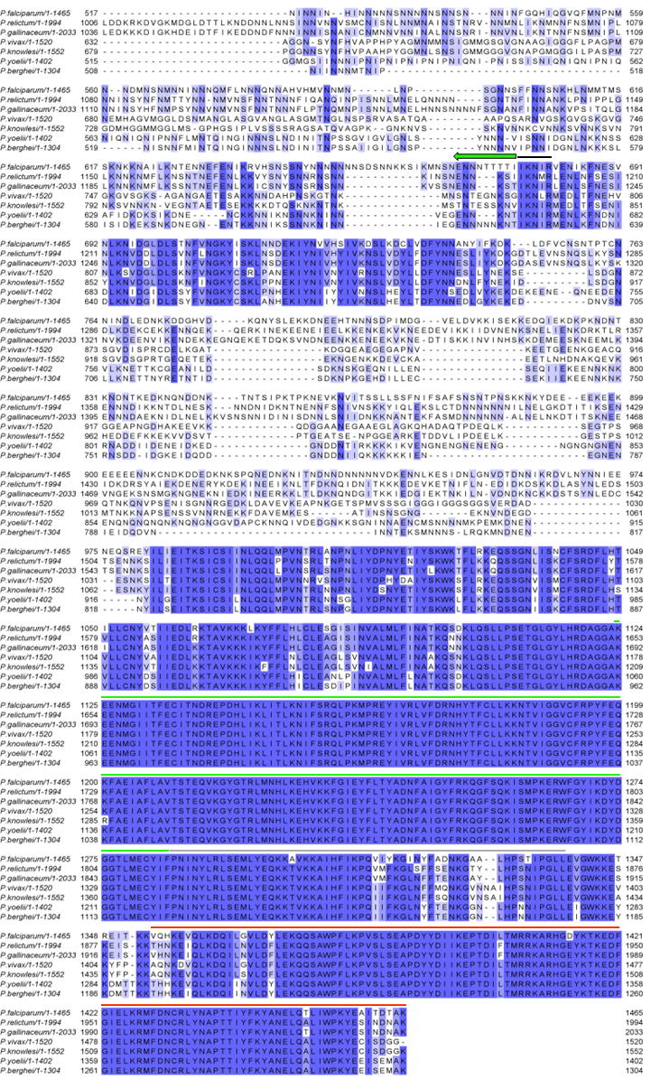
Supplemental figure 2. Multiple sequence alignment analysis across plasmodial GCN5 homologs. Alignment performed using Clustal Omega and visualized in Jalview. The region flanked by the two green arrows depicts the PfGCN5 N terminus region used to make the PyGCN5 chimeric construct. Portion in pink box encompasses the N/GS-repeat. Black line highlights the conserved motif used to define the PfGCN5 N terminus in the chimeric construct. Green, gray, and red lines indicate the HAT, putative ADA2-binding, and BrD domains.
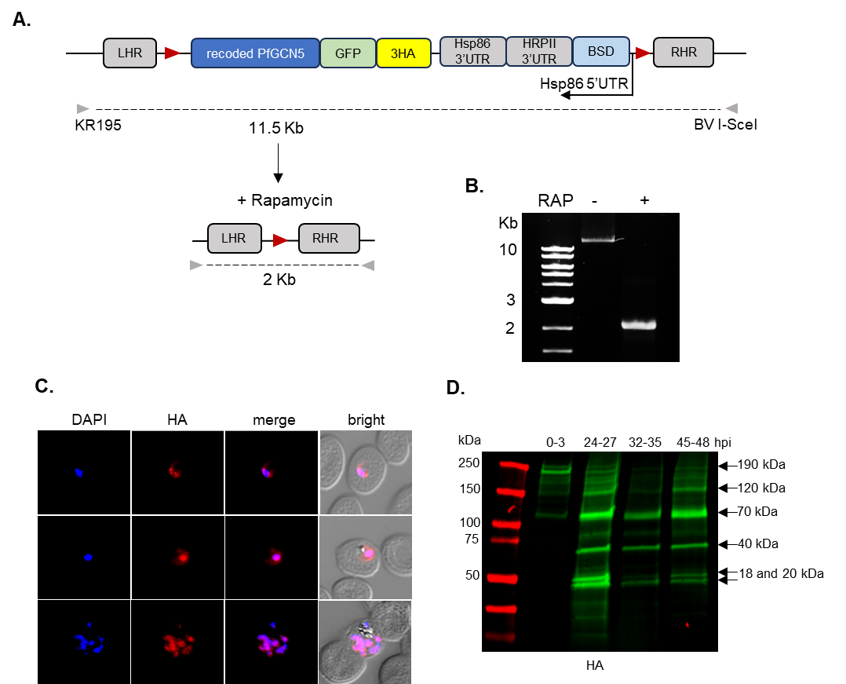

Supplemental figure 3. Generation and characterization of the PfGCN5^{LoxP} line. A) edited pfgcn5 locus showing LoxP sites (red triangles) and regulatory elements: the native promoter embedded in the left homologous region (LHR), Hsp86 3’UTR stabilizing the pfgcn5 transcript, Hsp86 5’UTR driving the expression of the resistance cassette, blastocidin (BSD), and HRPII 3’ UTR stabilizing the bsd transcript. A Saccharomyces cerevisiae recoded PfGCN5 coding sequence was C-terminally tagged with GFP (light green) and 3xHA (yellow). Both the LHR and the right homologous region (RHR) were used for homologous recombination using CRISPR/Cas9. Gray arrowheads indicate primers KR195 and BV I-SceI used to check integration and rapamycin excision. B) Ethidium bromide-stained agarose gel showing excision of the entire pfgcn5 locus 30 hours after adding RAP. Expected bands at 11.5 kb (-RAP) and 2 kb (+RAP) are observed C) Immunofluorescence analysis of PfGCN5 localization using anti-HA antibodies. DAPI stain was used for nuclear visualization. Shown is one biological replicate from three. D) Representative western blot from three biological replicates showing the processing of PfGCN5 throughout the intraerythrocytic cycle. Parasites were synchronized by magnet purification of late schizonts followed by sorbitol treatment 3 hours later. Arrows indicate the molecular mass after subtracting the mass of the GFP tag.

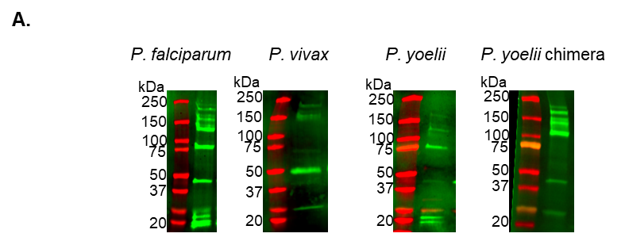

Supplemental figure 4. Identification of second copies (WT, homologs, and chimeric protein) in asynchronous rescue lines. FLAG-tagged GCN5 under the control of the native PfGCN5’s promoter was identified through western blot analysis using an anti-FLAG antibody.

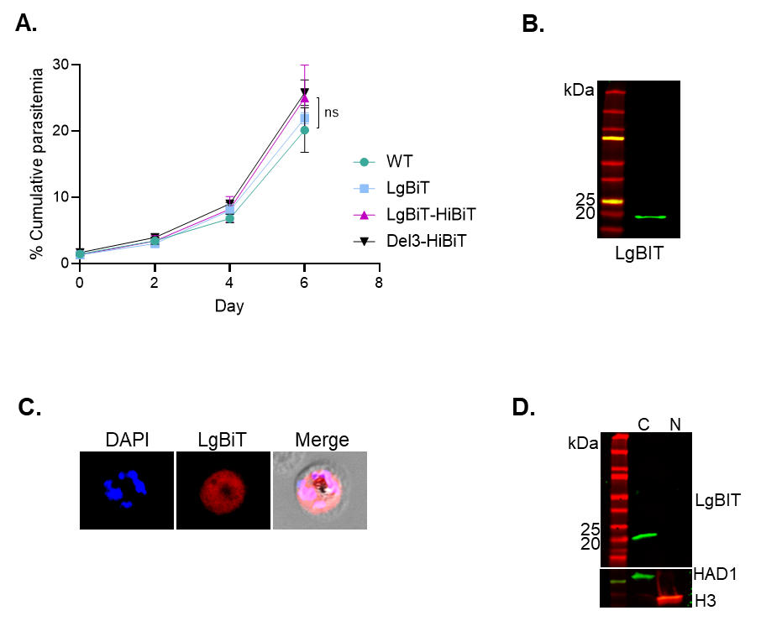

Supplemental figure 5. Characterization of the LgBiT-HiBiT line. A) Growth phenotype of LgBiT, LgBiT-HiBiT, and Del3-HiBiT lines assessed by flow cytometry every cycle for 6 days. Mean values from three independent experiments are shown, and error bars represent standard deviations. Data were analyzed statistically by a two-tailed Student’s test. B) Representative western blot showing the expression of LgBiT in the LgBiT line using an anti-LgBiT specific antibody. C) Inspection of the cellular localization of the LgBiT protein using immunofluorescence analysis. D) Cellular fractionation of the LgBiT-HiBiT line. LgBiT was identified using an anti-LgBiT antibody. Anti-HAD1 and anti-Histone 3 antibodies were used as markers of the cytosolic “C” or nuclear “N” fraction, respectively.

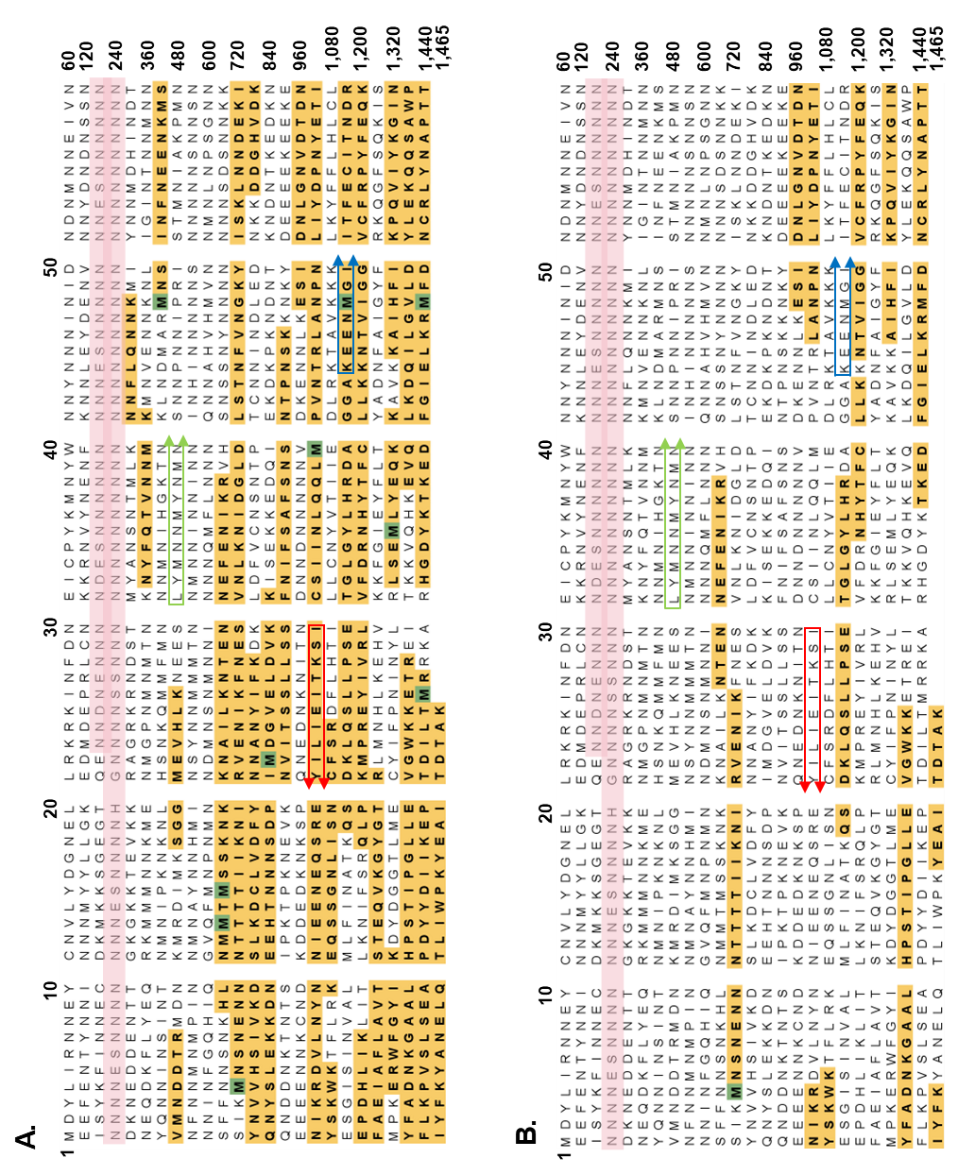
1,200
1,465
1,080
10 20 30 40 50
60
120
360
1,320
480
600
720
840
960
240
1,440
1

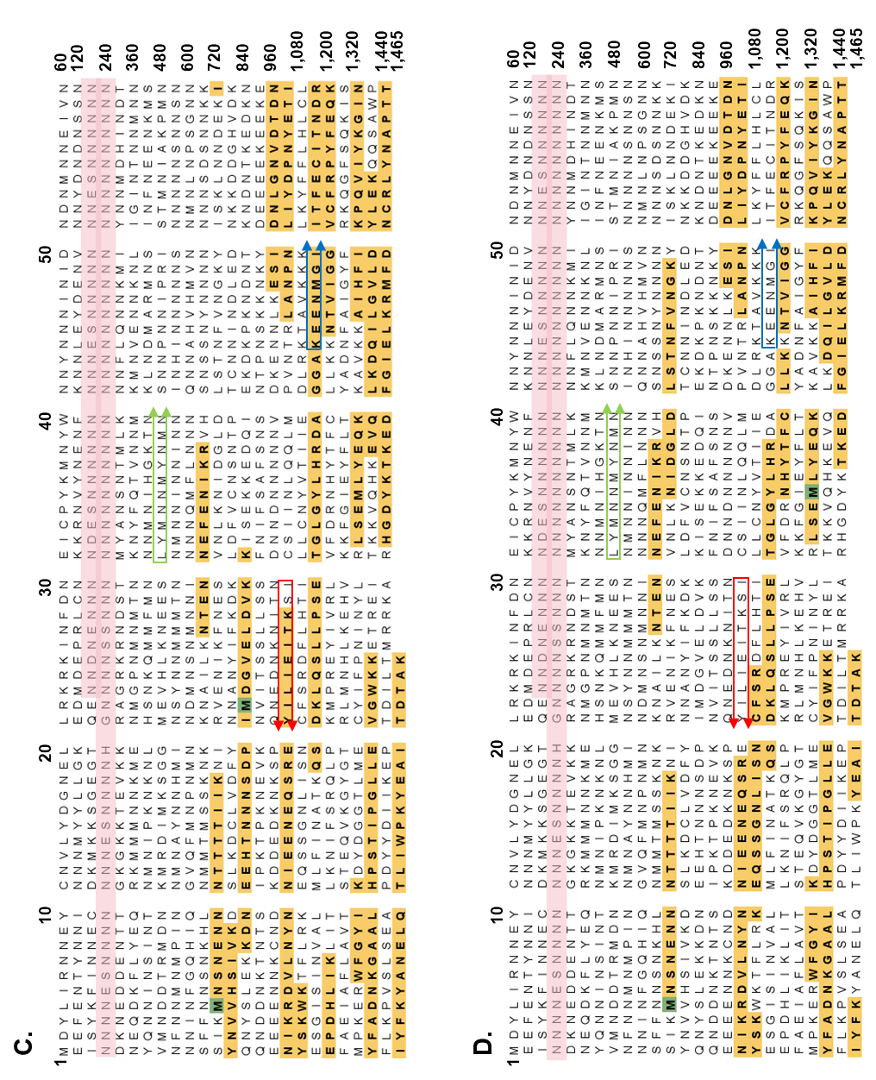

Supplemental figure 6. Sequence coverage from C-terminal pull-downs in the A) WT, B) Del1, C) Del2, and D) Del3 rescue lines. Peptides identified by mass spectrometry are shown in yellow, methionine residues susceptible to oxidation are shown in green, and the poly-N repeat is shown in light pink. The largest N-terminal polypeptide (~120 kDa) is predicted to end at the sequence enclosed with red arrows, and the largest C-terminal polypeptide (~120 kDa) is predicted to end at the sequence enclosed with green arrows. The predicted start site for the HAT domain is enclosed with blue arrows. Numbers indicate the amino acid position. Sequence coverage was visualized using the proteome software, Scaffold 5.

Supplemental table 1. PfGCN5 C-terminal pull-downs couple with mass spectrometry. Spectral counts were normalized to that of GCN5 for each line. Fold change corresponds to the ratio between the average of normalized values across the deletion lines over that of the WT rescue line. std: standard deviation. Values shown correspond to one biological replicate.

Supplemental table 2. Primers used in this study
Name | Sequence
KR195 | CATGGAAAATTAAAAATATAACAATAACTTATTTTTAAACCTAGG
BV into I-SceI rev (BV I-SceI) | CGCGGCCGCTTACAACTGGACCTTGCTGG
KR24 GFP AsiSI In-fusion Fw | AGGTCCAGCGATGCGATCGCAGTAAAGGAGAAGAACTTTTCACTG  GAGTTG
KR25 GFP In-fusion Rv | ACGTCATAAGGGTAGGCCGATTTGTACAGTTCATCCATGCC  ATGTGTAATC
KR137 PfGCN5 recod Fw | GAACATCCGCCGCTCATGGATTATCTTATTCGAAATAACGAATACT  GCAACG
KR138 PfGCN5 recod Rv | AGTTCTTCTCCTTTACTGCGTCCTCCACTTCCGAGCGGTTTAGCAGT  ATCAGTAATAGCTTCATATTTTGGCC
KR135 PfGCN5 5'utr Fw | TCATTGACTGTGCCGGCCGGCAGTTTTCTAATAATATAAGATTTCAAG  AAGAAATGC
KR136 PfGCN5 5'utr Rv | GCTCCGGCAAATGACAAGGGACTTTTCTATTTCAATGATTTTTCACA  AGGAAAATATTTT
KR47 PfGCN5 RHR Fw | AGCTCGGATTACCCTGTTATGATCCAATTAATAATACACTCCTTTTTTA  TTTTTGGGAAAATAAAAAAGATGTATATATATTTTTTTATAT  TTGTATACCAGATAAGCATATCCTTTTATTATACAG
KR21 PfCGN5 RHR In-fusion Rv | GTATTAGACCTAGGGCATTAACAGTTCATATAAATGAAACATATTC  TTCAAACATTTG
KR104 GCN5 Pf 5'utr Infusion Fw | CGAAAAGTGCCACCTGACGTCGGAAAATTAAAAATATAA  CAATAACTTATTTTTAAACC
KR105 PfGCN5 5'utr Infusion Rv | ACGAGGTATTCCATCATCATGGCGCGCCACTTTTCTATTTCAA  TGATTTTTCACAAGGAAAATATTTT
KR333 PfGCN5 Del1 | GATGAAAGCAACAATAATAACAATAACAACAACAATGAG  AGCAACAATAACAACAACAATAATGAGTCAAATAACAAC  AATAACAATAACAACAATAACGAGTCTAACAACAACAAC  AACAACAATGAGAGTAACAATAATAATCACGGTAACAACA  ATAACGATAAGAATGAAGACGATGAGAATACGACTGGTAA  AGG
KR334 PfGCN5 Del2 | AAGATGAAAAAGTCTGGTGAGGGAACTCAAGAAAATAA  CGATAACGAAAACAACAACAACGATGAAAGCAACAATA  ATAACAATAACAACAACAATGAGAGCAACAATAACAAC  AACAATAATGATAAGAATGAAGACGATGAGAATACGAC  TGGTAAAGGTAAAAAAACTGAAGTGAAAAAAAGAGC
KR335 PfGCN5 Del3 | ATAAGATGAAAAAGTCTGGTGAGGGAACTCAAGAAAAT  AACGATAACGAAAACAACAACAACGATAAGAATGAAGA  CGATGAGAATACGACTGGTAAAGGTAAAAAAACTGAAGT  GAAAAAAAGAGCTGGTAGAAAAAGG
KR300 PfGCN5 N-hibit-N | TAACAACAATAATAATAACAATAATAATAACGTGAGCGG  CTGGCGGCTGTTCAAGAAGATTAGCAACAATGATAAGA  ATGAAGACGATGAGAATACGACTGGTAAAGG
KR256 LgBiT into yTEOE Fw | TCGAATAAACACGATTTTTTCTCGAGATGGTCTTCACACTC  GAAGATTTCG
KR258 Flag into yTEOE-LgBiT | TAAATATATTATATAACTCGACGCGGCCCCTAGGTCATTTATCAT  CATCATCTTTATAATCTTTATCATCATCATCTTTATAATCCTTGTCGTCGTCGTCCTTGTAGTCGCT  AGCACTGTTGATGGTTACTCGGAACAGC
KR60 PfGCN5 gRNA1 | TAAGTATATAATATTTTTTTTCTCTTTTTTCGTAAGTTTT  AGAGCTAGAA
KR61 PfGCN5 gRNA2 | TAAGTATATAATATTTTGTATACCAGATAAGCATAGTTTT  AGAGCTAGAA
KR139 PfGCN5 guide#3 Fw | TAAGTATATAATATTGTATTATCTTCTTGGAAAAGGTTTT  AGAGCTAGAA
KR140 PfGCN5 guide#3 Rv | TTCTAGCTCTAAAACCTTTTCCAAGAAGATAATACAATA  TTATATACTTA
KR141 PfGCN5 guide#4 Fw | TAAGTATATAATATTAAGATGATGAAAATACTACAGTTTT  AGAGCTAGAA
KR142 PfGCN5 guide#4 Rv | TTCTAGCTCTAAAACTGTAGTATTTTCATCATCTTAATATT  ATATACTTA
KR143 PfGCN5 guide#5 Fw | TAAGTATATAATATTTATTTGCACAGAGATGCGGGGTTTT  AGAGCTAGAA
KR144 PfGCN5 guide#5 Rv | TTCTAGCTCTAAAACCCCGCATCTCTGTGCAAATAAATA  TTATATACTTA

