Supplementary Information

TiO₂-facet-dependent reconstruction of Pt nanoparticles during CO oxidation
Jihun Kim†¹, Yunkyung Kim†², Daewon Oh¹, Seokhyun Choung², Hyeongeon Lee¹, Hogyun Lee¹, Eonu Nam¹, Shinjae Lee¹, Jeongjin Kim³, Sinmyung Yoon^{1,4*}, Jeong Woo Han^{2*}, and Kwangjin An^{1*}
¹School of Energy and Chemical Engineering, Ulsan National Institute of Science and Technology (UNIST), Ulsan 44919, Republic of Korea
²Department of Materials Science and Engineering, Research Institute of Advanced Materials, Seoul National University, Seoul 08826, Republic of Korea.
³Pohang Light Source II, Pohang University of Science and Technology (POSTECH), Pohang, Gyeongbuk 37673, Republic of Korea
⁴Current Address: Delaware Energy Institute, University of Delaware, 221 Academy St., Newark, DE 19716, United States

*These authors contributed equally to this work. Correspondence and requests for materials should be addressed to S.Y. (smyoon@udel.edu), J.H. (email: jwhan98@snu.ac.kr) and K.A. (email: kjan@unist.ac.kr).

This file includes:
Supplementary Fig. 1 to 33
Supplementary Table 1 to 5
Supplementary Note
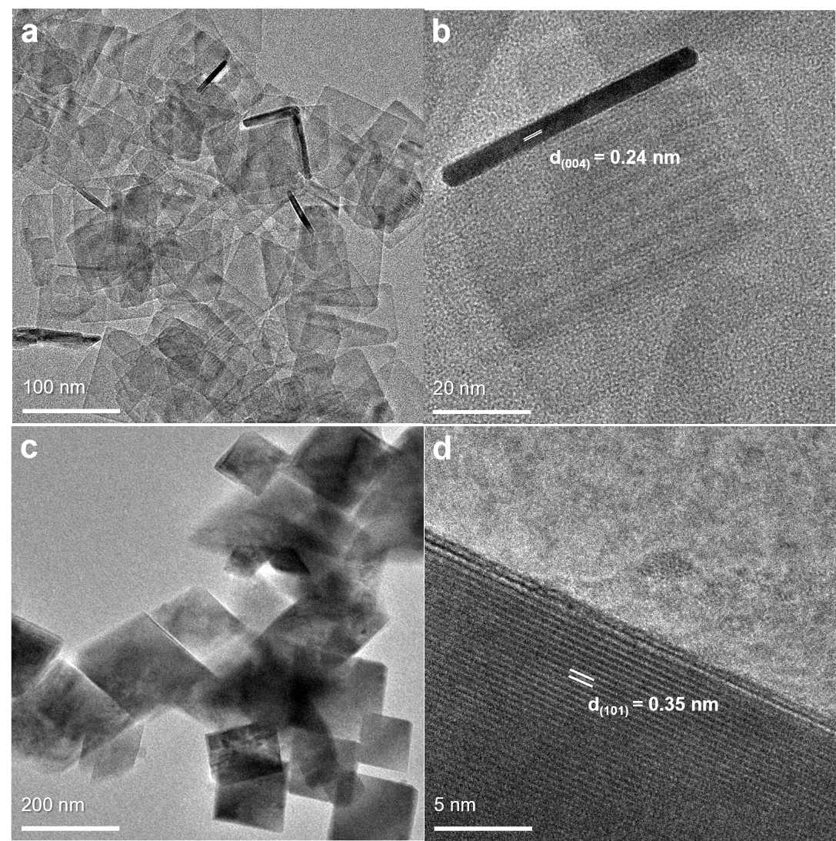
Supplementary Figure 1. (a–d) TEM images of as-synthesized TiO₂ crystals with controlled morphologies: (a–b) nanosheets predominantly exposing the (001) facet and (c–d) rhombic-shaped crystals primarily exposing the (101) facet.

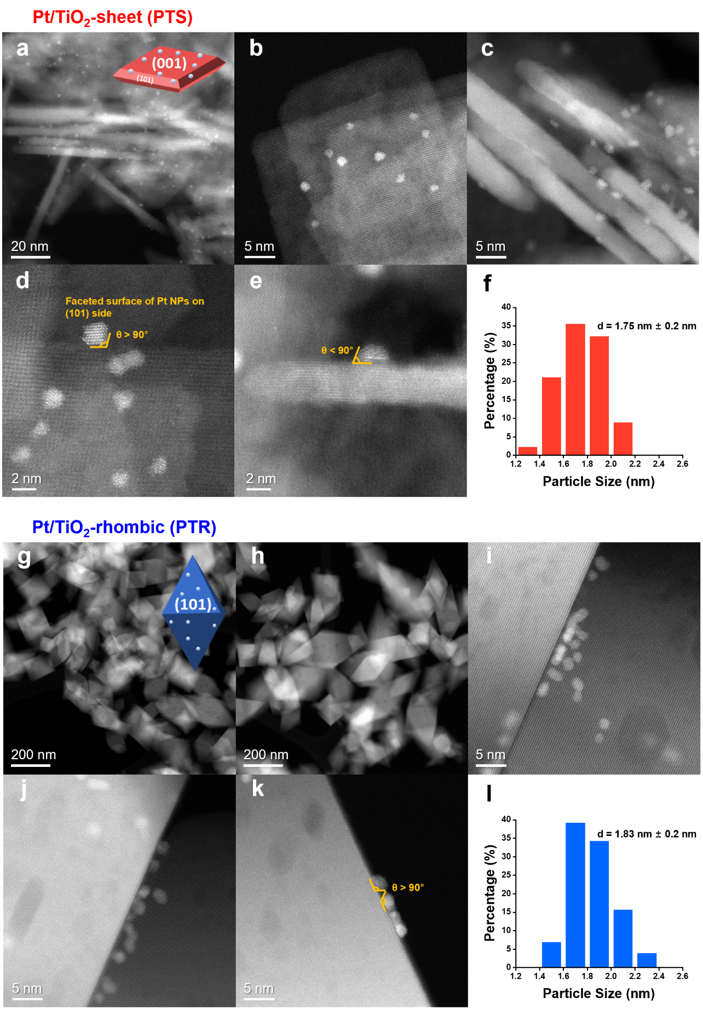
Supplementary Figure 2. (a–e, g–k) HAADF-STEM images of the as-prepared Pt/TiO₂ catalysts: (a–e) PTS with exposed (001) facets and (g–k) PTR with exposed (101) facets. (f, l) Corresponding histograms showing the Pt NP size distributions for (f) PTS and (l) PTR.
Supplementary Table 1. Physicochemical properties of Pt/TiO₂ catalysts, including average Pt particle size, Pt loading, CO chemisorption capacity, and dispersion.

Catalysts | Pt size by TEM  (nm)ª | Pt  (wt %)^{b} | Chemisorbed CO  (mmol·g⁻¹)^{c} | D_{Pt}  (%)^{d}
PTS | 1.75 $±$0.2 | 0.32 | 0.00897 | 51.5
PTR | 1.83 $±$0.2 | 0.45 | 0.01038 | 49.1

ªAverage Pt particle size determined from HAADF-STEM analysis.
^{b}Pt content measured by ICP-OES
^{c} Chemisorbed CO amount estimated by single-pulse injection of 2% CO/He (30 sccm, 5 s).
^{d}Pt dispersion (D_{Pt}) calculated using CO chemisorption and ICP-OES data according to D_{Pt} (%) = X_{M} N_{s} / N_{T} × 100, assuming a Pt/CO stoichiometry (X_{M}) of 1:1. N_{T} is the total number of Pt atoms per unit weight and Ns is the number of exposed Pt atoms.

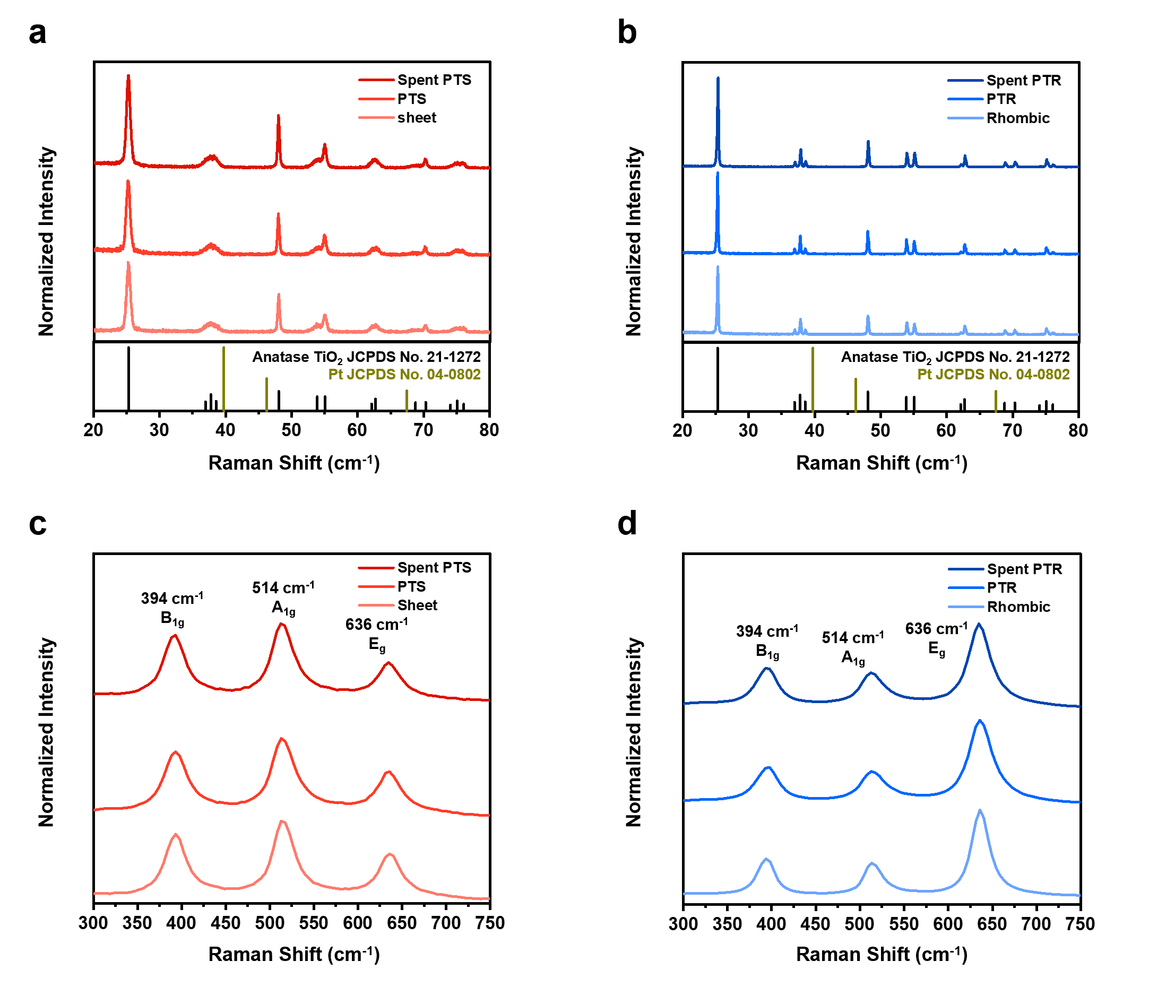
Supplementary Figure 3. (a–b) XRD patterns and (c–d) Raman spectra of TiO₂ supports and Pt/TiO₂ catalysts before and after CO oxidation. (a, c) Sheet-shaped TiO₂ with predominantly exposed (001) facets, fresh PTS, and spent PTS; (b, d) Rhombic TiO₂ with predominantly exposed (101) facets, fresh PTR, and spent PTR. Spent catalysts were obtained after catalytic treatment under 1% CO and 1% O₂/Ar flow (50 mL·min⁻¹) at 300 °C for 2 h.

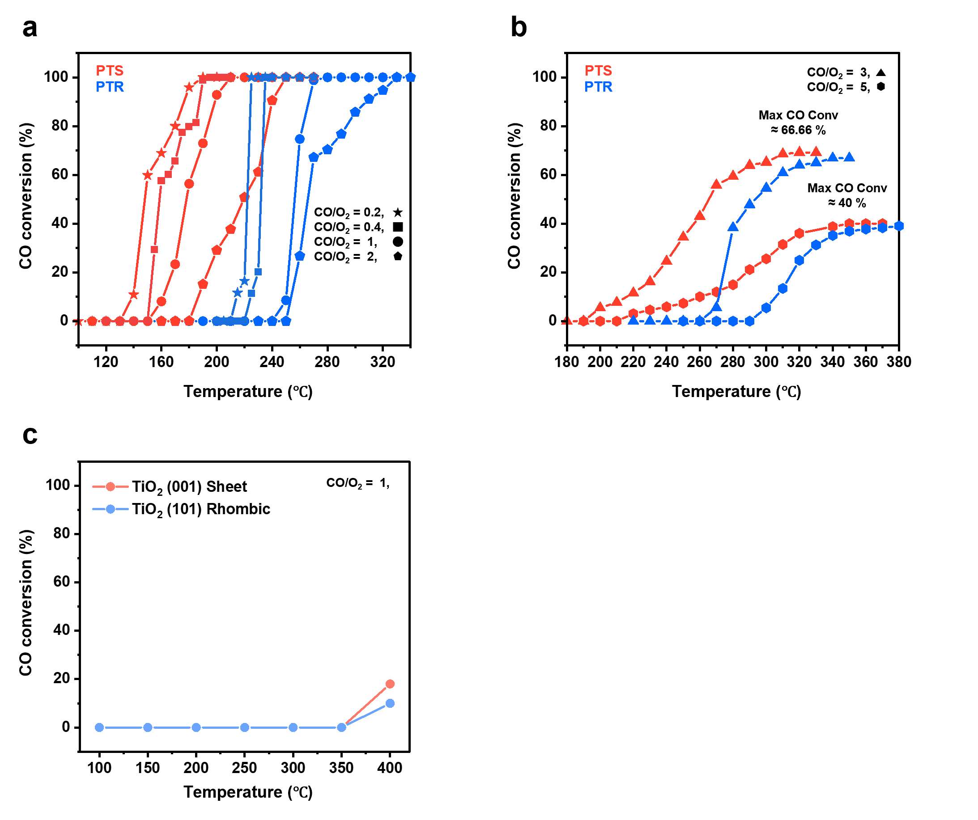
Supplementary Figure 4. Temperature-dependent CO conversion profiles of PTS and PTR catalysts under varying CO/O₂ ratios. (a) Conversion curves under O₂-rich to stoichiometric conditions: CO/ O₂ = 0.2 (1% CO / 5% O₂, ★), 0.4 (1% CO / 2.5% O₂, ■), 1 (1% CO / 1% O₂, ●), and 2 (1% CO / 0.5% O₂, ⬟). (b) Conversion curves under CO-rich conditions: CO/O₂ = 3 (3% CO / 1% O₂, ▲) and 5 (5% CO / 1% O₂, ⬢). (c) CO conversion curves of pristine TiO₂ under stoichiometric conditions (CO/O₂ = 1). The total gas flow rate was maintained at 50 mL·min⁻¹ for all measurements.

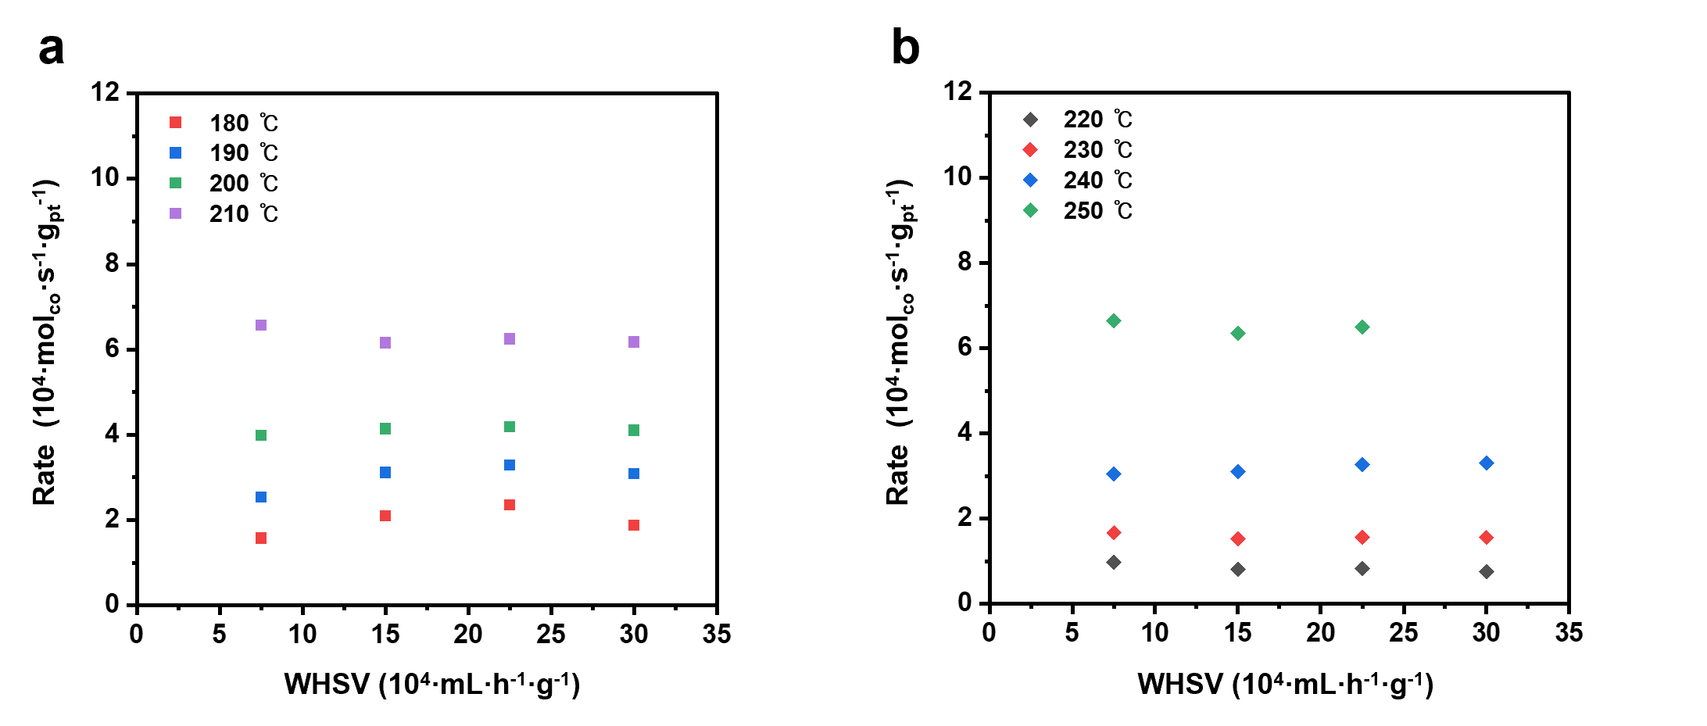
Supplementary Figure 5. CO oxidation rates over a range of total gas flow rates for (a) PTS and (b) PTR catalysts. The constant reaction rates across varying flow rates confirm that the CO oxidation is controlled by surface kinetics rather than mass transfer limitations. The apparent activation energy (E_{a}) was calculated under a total flow rate of 100 mL·min⁻¹ with a CO/O₂ ratio of 1, specifically within the kinetically relevant regime (15% CO conversion).

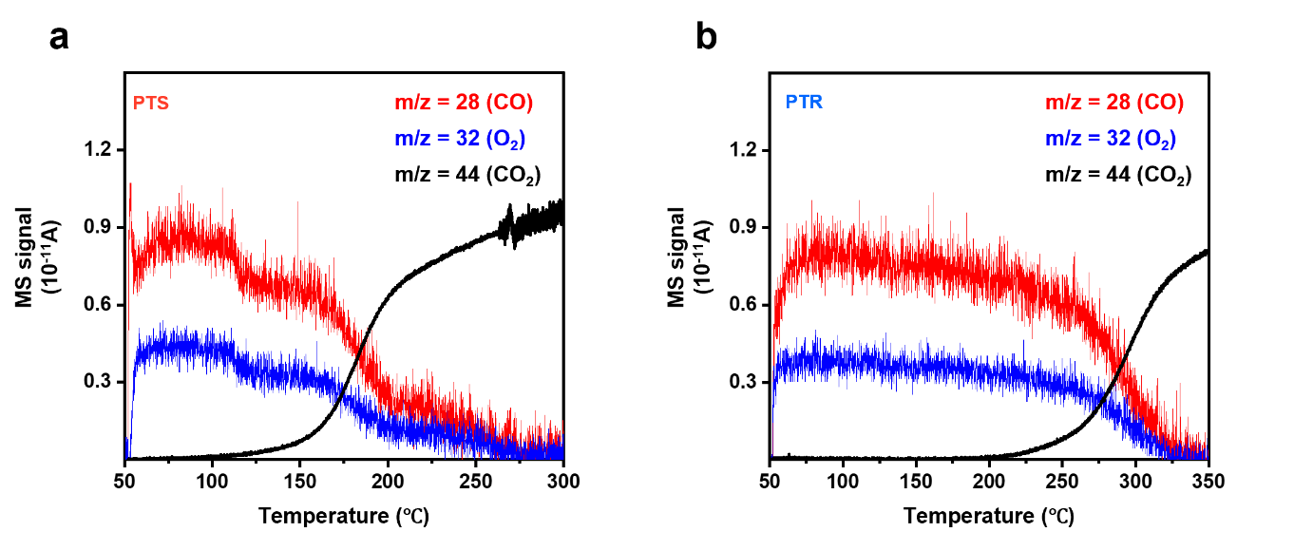
Supplementary Figure 6. CO-TPR profiles and corresponding CO₂ mass spectrometry (MS) signals for (a) PTS and (b) PTR catalysts. The CO₂ MS signal intensities reflect the reducibility and surface oxygen availability of the Pt/TiO₂ catalysts under CO-rich conditions, providing insights into the MvK reaction pathway.

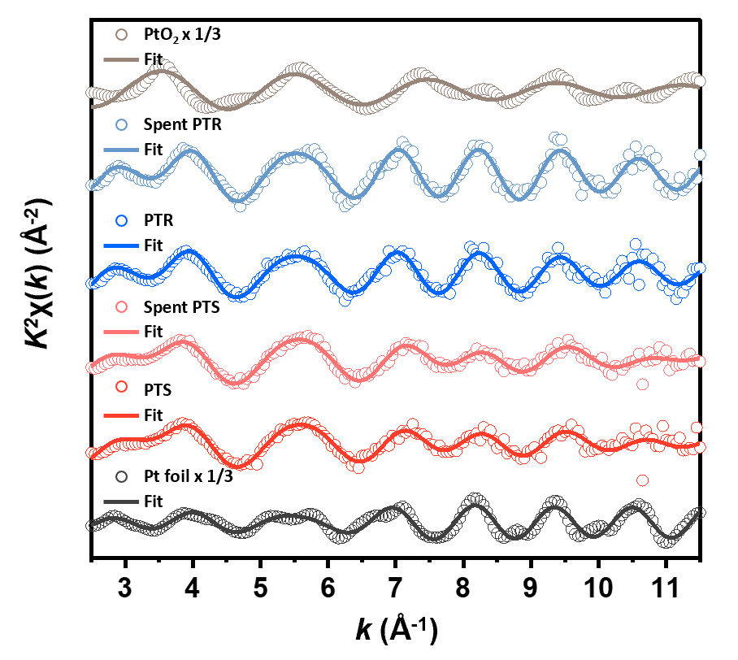
Supplementary Figure 7. Pt L₃-edge EXAFS k²-weighted χ(k) spectra of fresh and spent Pt/TiO₂ catalysts, compared with Pt foil and PtO₂ reference samples. These data provide insight into the coordination environment and oxidation state of Pt species before and after CO oxidation.

Supplementary Table 2. Fitting results of the Pt L₃-edge EXAFS spectra for fresh and spent Pt/TiO₂ catalysts under different CO/O₂ ratios (0.2, 1, and 5), compared with Pt foil and PtO₂ references.
Catalysts | shell | CN | d (Å) | σ² | E₀ shift | R factor
Pt foil | Pt−Pt | 12.0 | 2.762 | 0.004 | 7.13 | 0.0095
PtO₂ | Pt−O | 6.0 | 2.012 | 0.004 | 7.29 | 0.0022
Fresh PTS | Pt−Pt | 6.4 | 2.713 | 0.010 | 5.56 | 0.0123
Fresh PTS | Pt−O | 1.6 | 1.970 | 0.005 | 5.56 | 0.0123
Spent PTS,  O₂-rich  (CO/O₂=0.2) | Pt−Pt | 7.2 | 2.713 | 0.014 | 6.36 | 0.0102
Spent PTS,  O₂-rich  (CO/O₂=0.2) | Pt−O | 2.1 | 1.990 | 0.004 | 6.36 | 0.0102
Spent PTS  (CO/O₂=1) | Pt−Pt | 7.7 | 2.694 | 0.012 | 2.89 | 0.0130
Spent PTS  (CO/O₂=1) | Pt−O | 1.5 | 1.965 | 0.002 | 2.89 | 0.0130
Spent PTS,  CO-rich  (CO/O₂=5) | Pt−Pt | 8.8 | 2.700 | 0.010 | 3.46 | 0.0198
Spent PTS,  CO-rich  (CO/O₂=5) | Pt−O | 1.6 | 2.003 | 0.020 | 3.46 | 0.0198
Fresh PTR | Pt−Pt | 8.6 | 2.735 | 0.009 | 5.71 | 0.0080
Fresh PTR | Pt−O | 1.2 | 1.980 | 0.011 | 5.71 | 0.0080
Spent PTR,  O₂-rich  (CO/O₂=0.2) | Pt−Pt | 8.2 | 2.746 | 0.006 | 6.66 | 0.0212
Spent PTR,  O₂-rich  (CO/O₂=0.2) | Pt−O | 1.0 | 1.990 | 0.005 | 6.66 | 0.0212
Spent PTR  (CO/O₂=1) | Pt−Pt | 8.7 | 2.740 | 0.007 | 6.87 | 0.0127
Spent PTR  (CO/O₂=1) | Pt−O | 1.0 | 1.981 | 0.003 | 6.87 | 0.0127
Spent PTR,  CO-rich  (CO/O₂=5) | Pt−Pt | 10.3 | 2.744 | 0.008 | 5.88 | 0.0110
Spent PTR,  CO-rich  (CO/O₂=5) | Pt−O | 0.5 | 1.991 | 0.003 | 5.88 | 0.0110
CN represents the average coordination number around the Pt absorber atom, σ² is the Debye–Waller factor, d is the bond distance, and R-factor indicates the quality of the fit. The amplitude reduction factor (S₀²) was fixed at 0.77, as determined from Pt foil fitting. EXAFS fitting was performed using k²-weighted spectra over the ranges: 2.8(3.0) < k < 10.8(11) Å^{–1} and 1(1.3) < r < 3.3(3.5) Å.
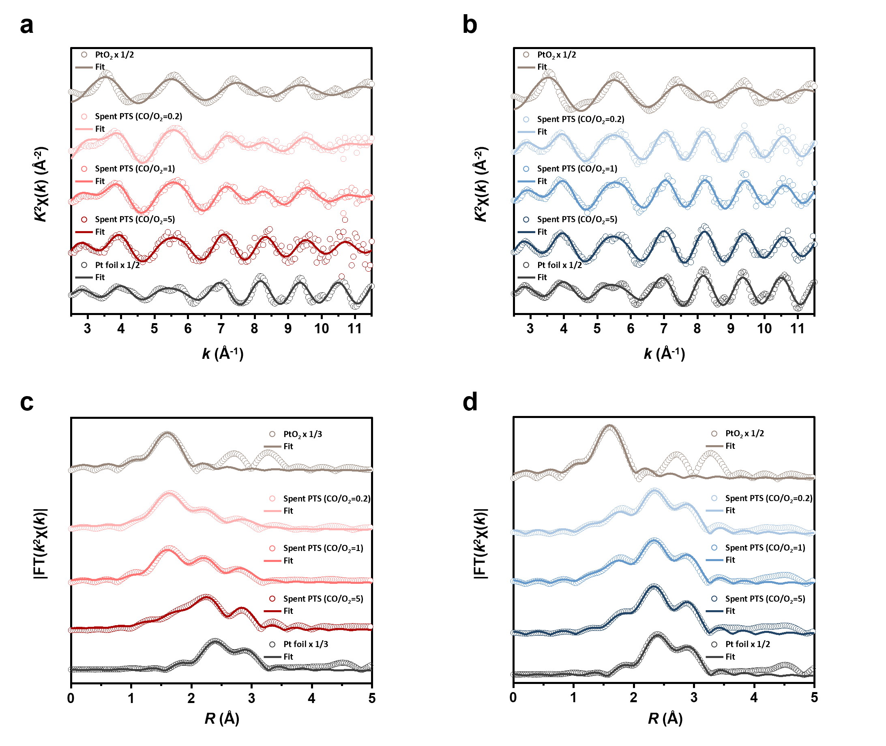
Supplementary Figure 8. (a, b) k²-weighted χ(k) functions of Pt L₃-edge EXAFS spectra for spent Pt/TiO₂ catalysts after CO oxidation under different CO/O₂ ratios (0.2, 1, and 5). (c, d) Corresponding FT-EXAFS spectra and fitting results, showing the local coordination environment of Pt after catalytic reaction.

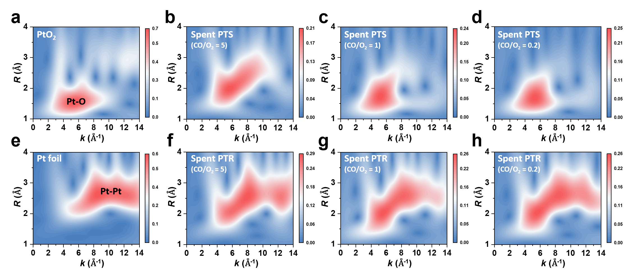
Supplementary Figure 9. WT contour maps of k²χ(k) functions from Pt L₃-edge EXAFS for spent Pt/TiO₂ catalysts after CO oxidation under various CO/O₂ ratios, compared with reference materials: (a) PtO₂, (b–d) spent PTS at CO/O₂ = 5, 1, and 0.2, respectively, (e) Pt foil, and (f–h) spent PTR at CO/O₂ = 5, 1, and 0.2, respectively. These maps visualize changes in Pt coordination and bonding environments induced by different reaction conditions.

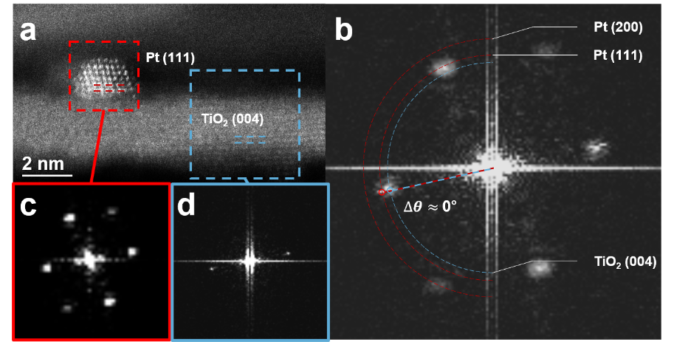
Supplementary Figure 10. (a) HAADF-STEM image of the spent PTS catalyst after CO oxidation. (b) Corresponding fast Fourier transform (FFT) pattern of the selected region in (a). Insets show magnified FFT patterns for (c) Pt NPs and (d) the TiO₂ nanosheet, respectively, indicating lattice alignment and potential epitaxial relationship between Pt and the TiO₂ (001) facet.

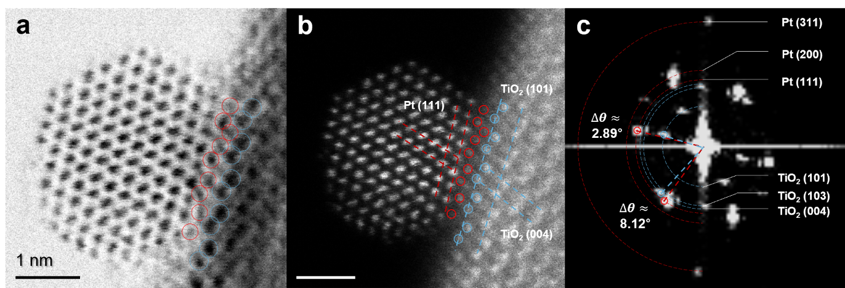
Supplementary Figure 11. (a) Bright-field and (b) dark-field STEM images of the spent PTR catalyst after CO oxidation. (c) Corresponding FFT pattern of image (b). The positions of Pt and Ti atoms in (b) are indicated by red and blue circles, respectively, based on contrast differences observed in (a), highlighting the interface structure between Pt and the TiO₂ (101) facet.
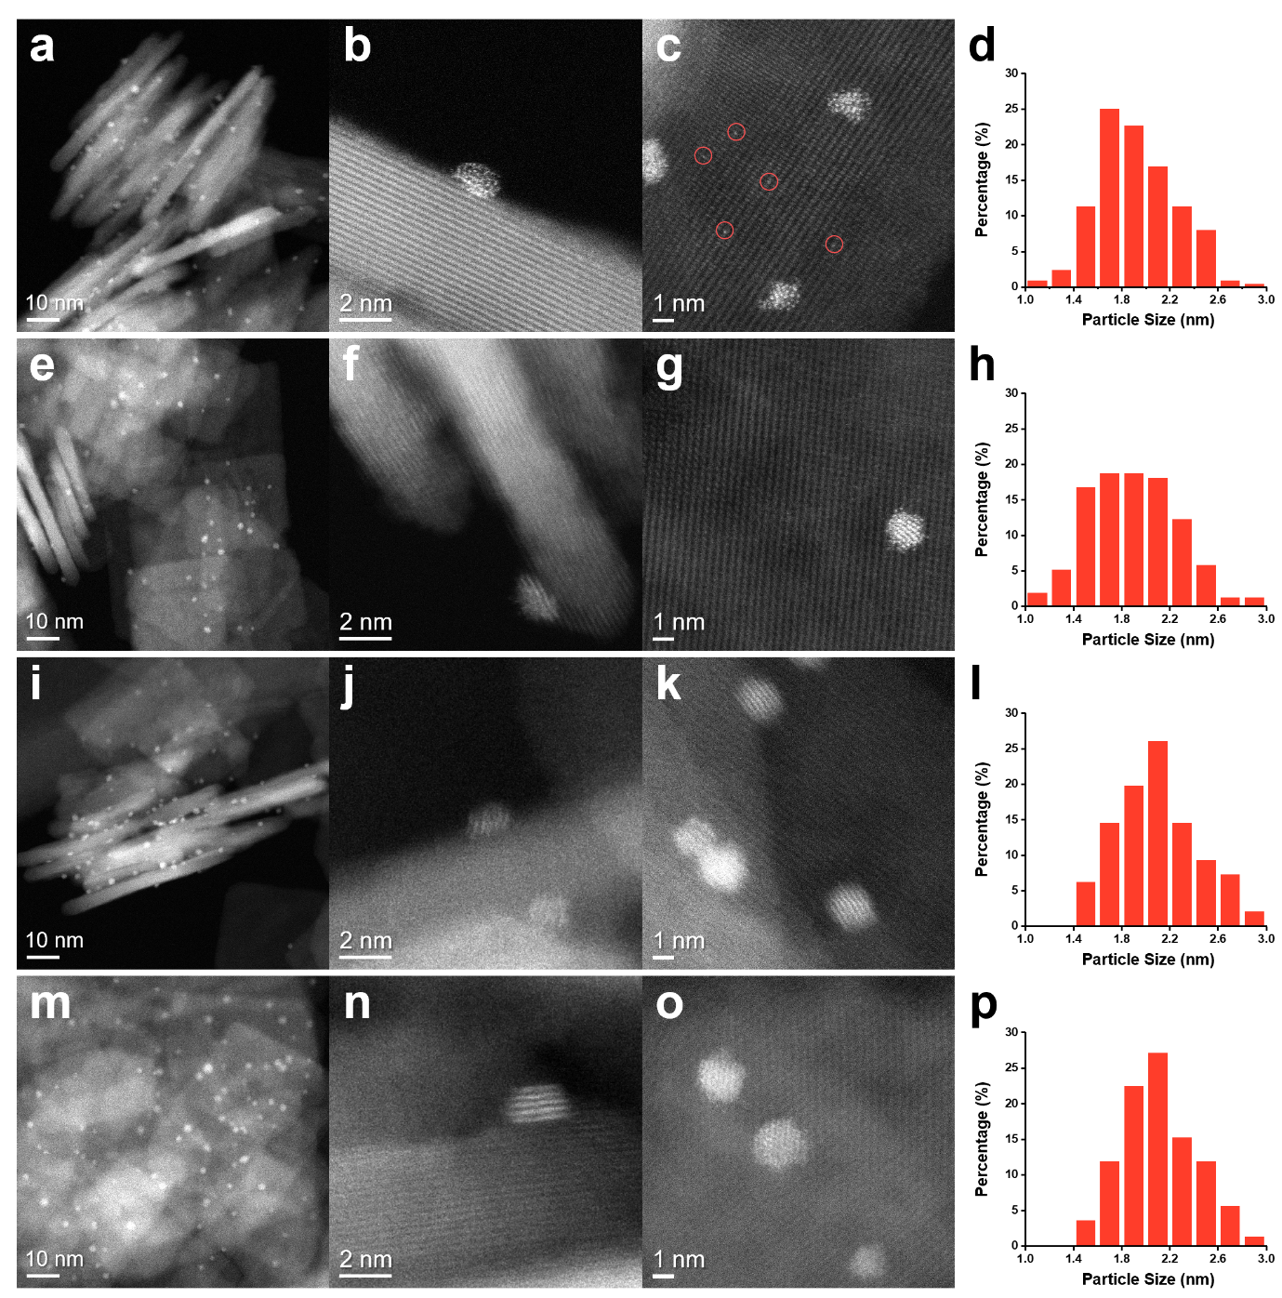
Supplementary Figure 12. HAADF−STEM images and corresponding Pt particle size distributions of the spent PTS catalyst after CO oxidation under varying CO/O₂ ratios: (a–d) CO/O₂ = 0.2, (e–h) CO/O₂ = 1, (i–l) CO/O₂ = 3, and (m–p) CO/O₂ = 5. Each set shows representative NP morphology and size histogram, indicating facet-dependent reconstruction behavior of Pt on TiO₂ (001).

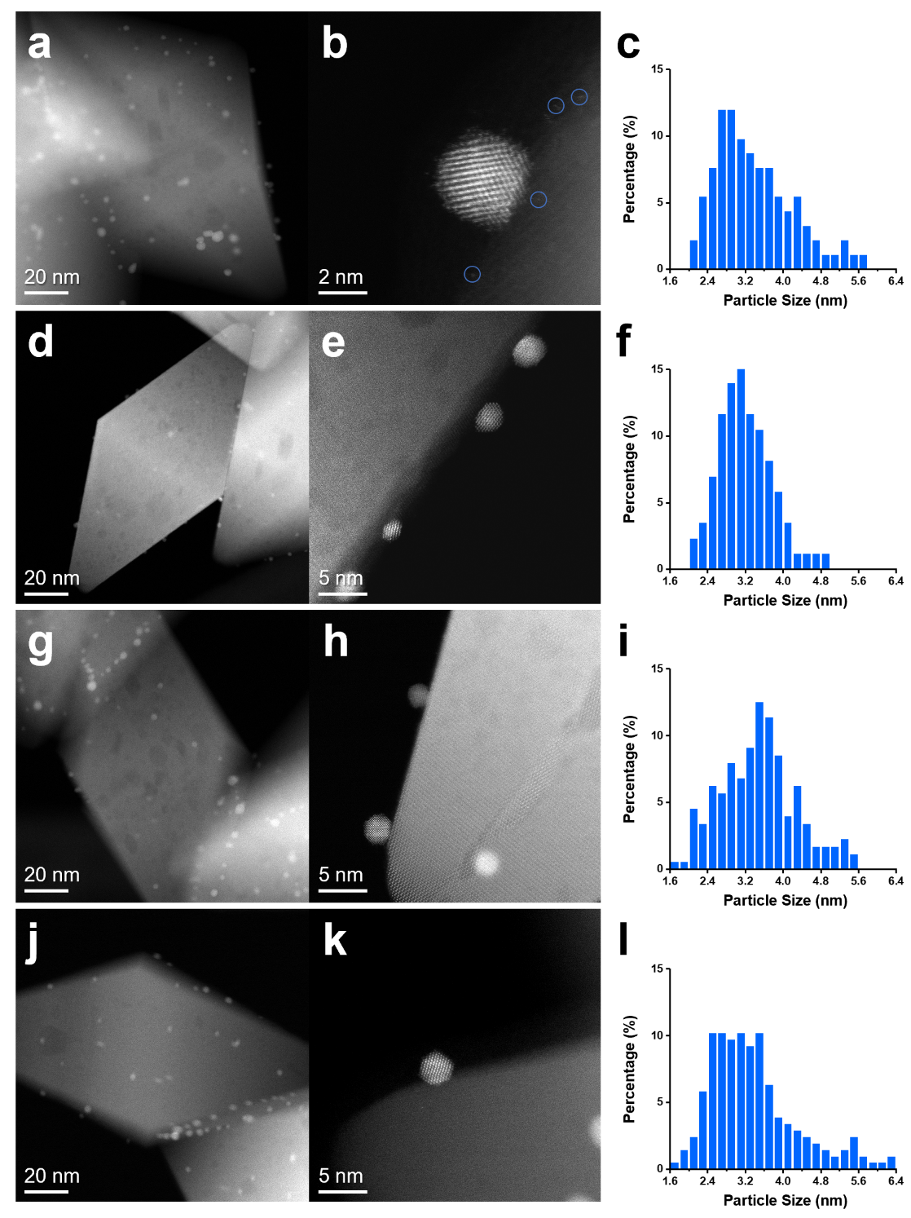
Supplementary Figure 13. HAADF−STEM images and corresponding Pt particle size distributions of the spent PTR catalyst after CO oxidation under various CO/O₂ ratios: (a–c) CO/O₂ = 0.2, (d–f) CO/O₂ = 1, (g–i) CO/O₂ = 3, and (j–l) CO/O₂ = 5. Each set shows representative NP morphology and size histogram, indicating facet-dependent reconstruction behavior of Pt on TiO₂ (101).

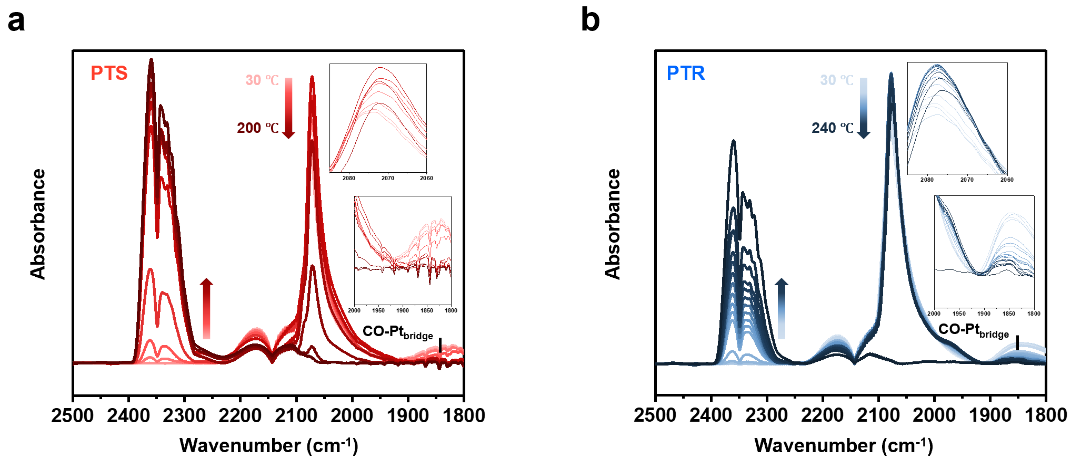
Supplementary Figure 14. Full in situ DRIFTS spectra of (a) PTS and (b) PTR catalysts recorded under CO oxidation conditions (CO/O₂ = 1) at various temperatures. The spectra capture the temperature-dependent evolution of surface species, including CO adsorption and CO₂ formation.

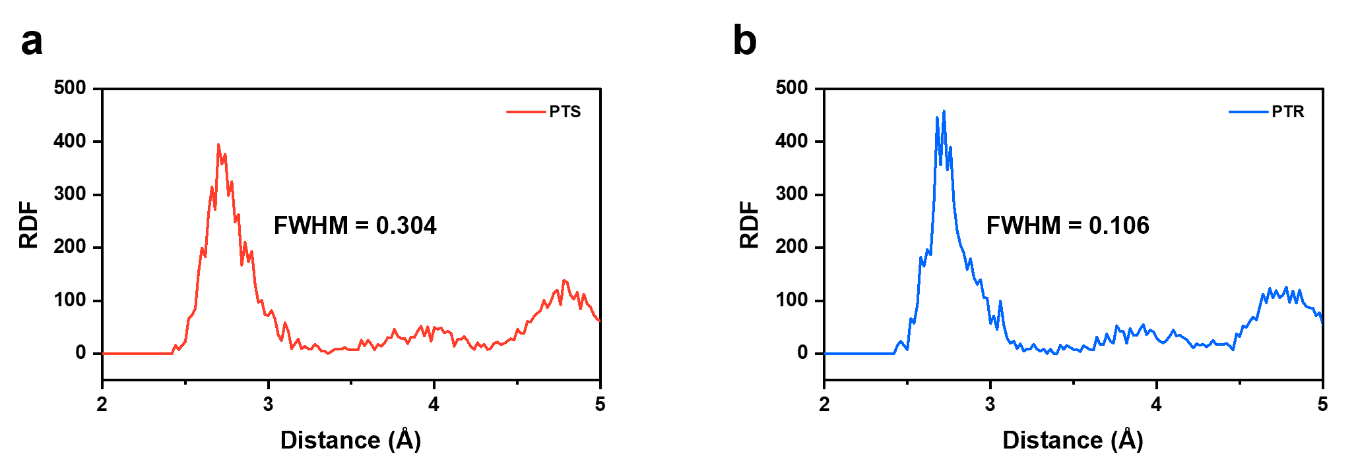
Supplementary Figure 15. Radial distribution functions (RDF) of (a) Pt₂₀₁/TiO₂ (001) and (b) Pt₂₀₁/TiO₂ (101) after 100 ps GNN-based MD simulation.

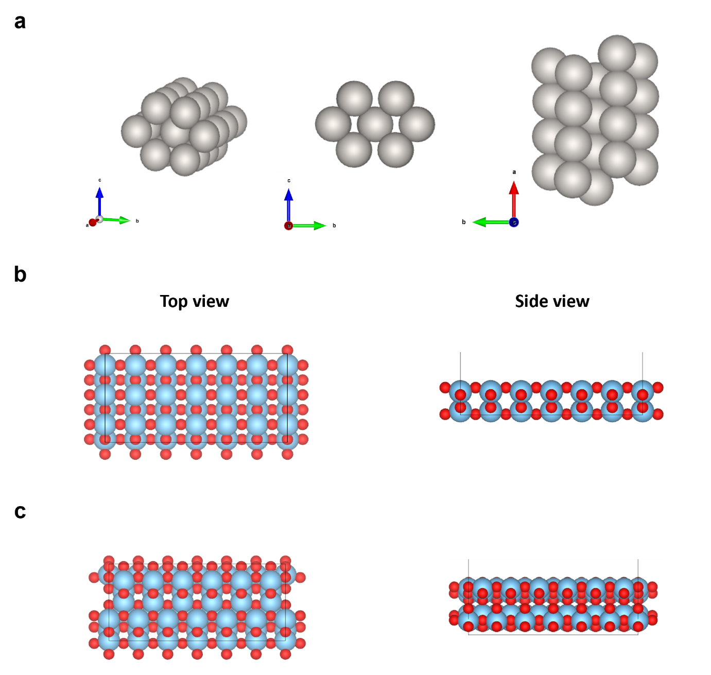
Supplementary Figure 16. Initial structural models used for DFT calculations: (a) rod-shaped Pt₂₈ cluster, (b) TiO₂ sheet exposing the (001) facet, and (c) TiO₂ rhombic crystal exposing the (101) facet. Multiple viewing angles are shown to illustrate the atomic arrangement and surface orientations of each model.

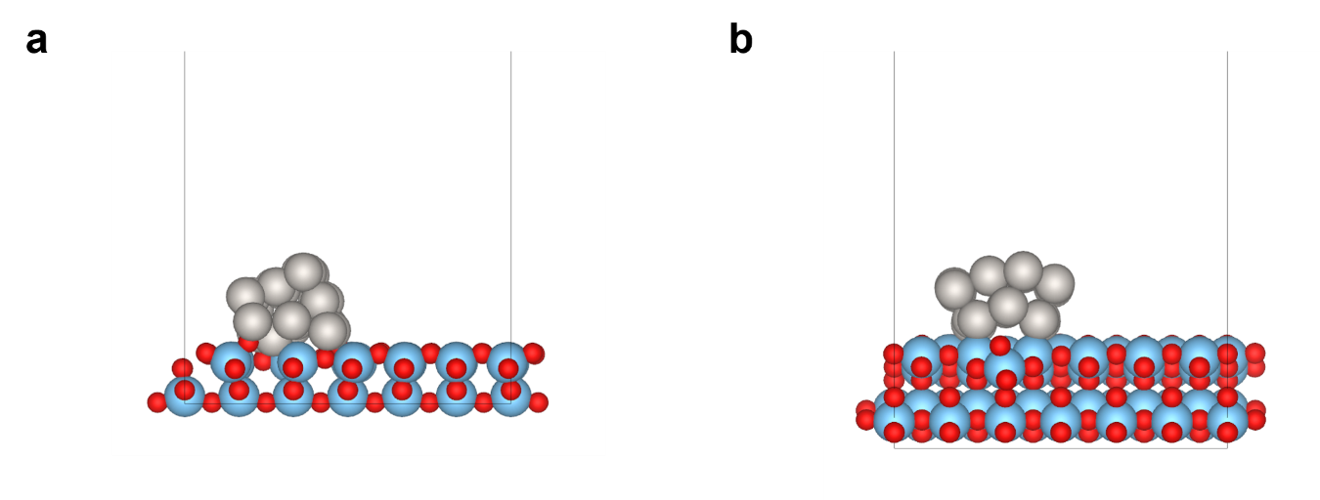
Supplementary Figure 17. Side-view representations of DFT-optimized models: (a) Pt₂₈ rod on TiO₂ (001) facet and (b) Pt₂₈ rod on TiO₂ (101) facet.

Supplementary Table 3. Average Pt–Pt coordination number (CN) and corresponding bond distance (Å) with standard deviations in the DFT-optimized Pt₂₈ rod models supported on TiO₂ (001) and (101) facets.
 | Pt/TiO₂ (001)  (PTS) | Pt/TiO₂ (101)  PTR
Average Pt–Pt coordination number | 4.79 | 5.00
Average Pt–Pt distance [Å] | 5.55 | 5.31
Standard deviation of Pt–Pt distances [Å] | 2.23 | 2.01

Supplementary Table 4. Surface energies of TiO₂ (001) and (101) facets and the corresponding normalized Pt binding energies (per Pt atom) in the DFT-optimized Pt₂₈ rod on TiO₂ models.
 | PTS | PTR
Surface energy of TiO₂ surface [eV· Å^{–2}] | 0.084 | 0.067
Normalized Pt binding E [eV·atom^{–1}] | -0.78 | -0.68

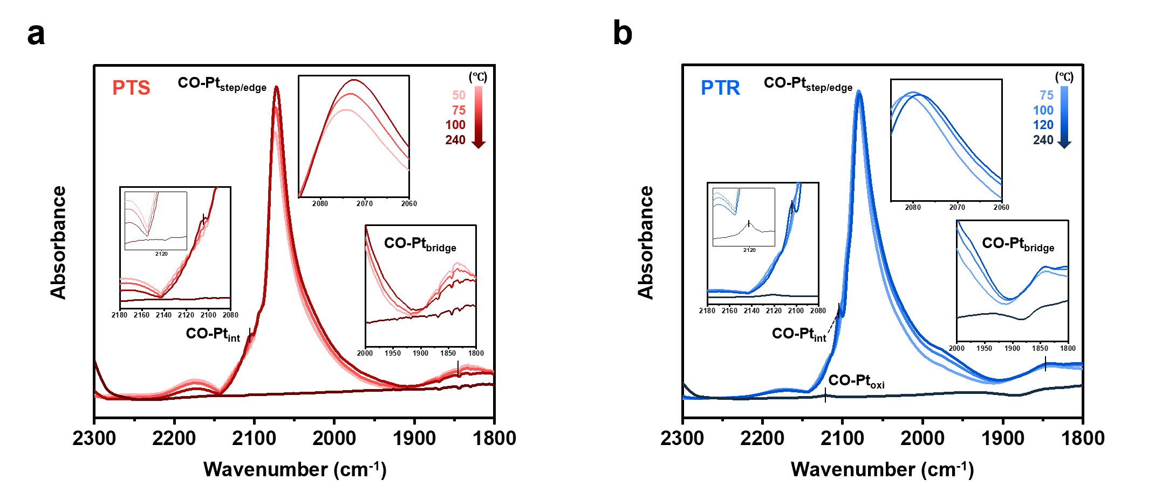
Supplementary Figure 18. In situ DRIFT spectra of (a) the spent PTS and (b) PTR catalysts under CO oxidation condition (CO/O₂ = 1) at increasing temperatures. Characteristic bands corresponding to CO adsorbed on interfacial and oxidized Pt sites, along with the evolution of surface species, highlight facet-dependent reconstruction and CO adsorption behavior after catalytic operation.

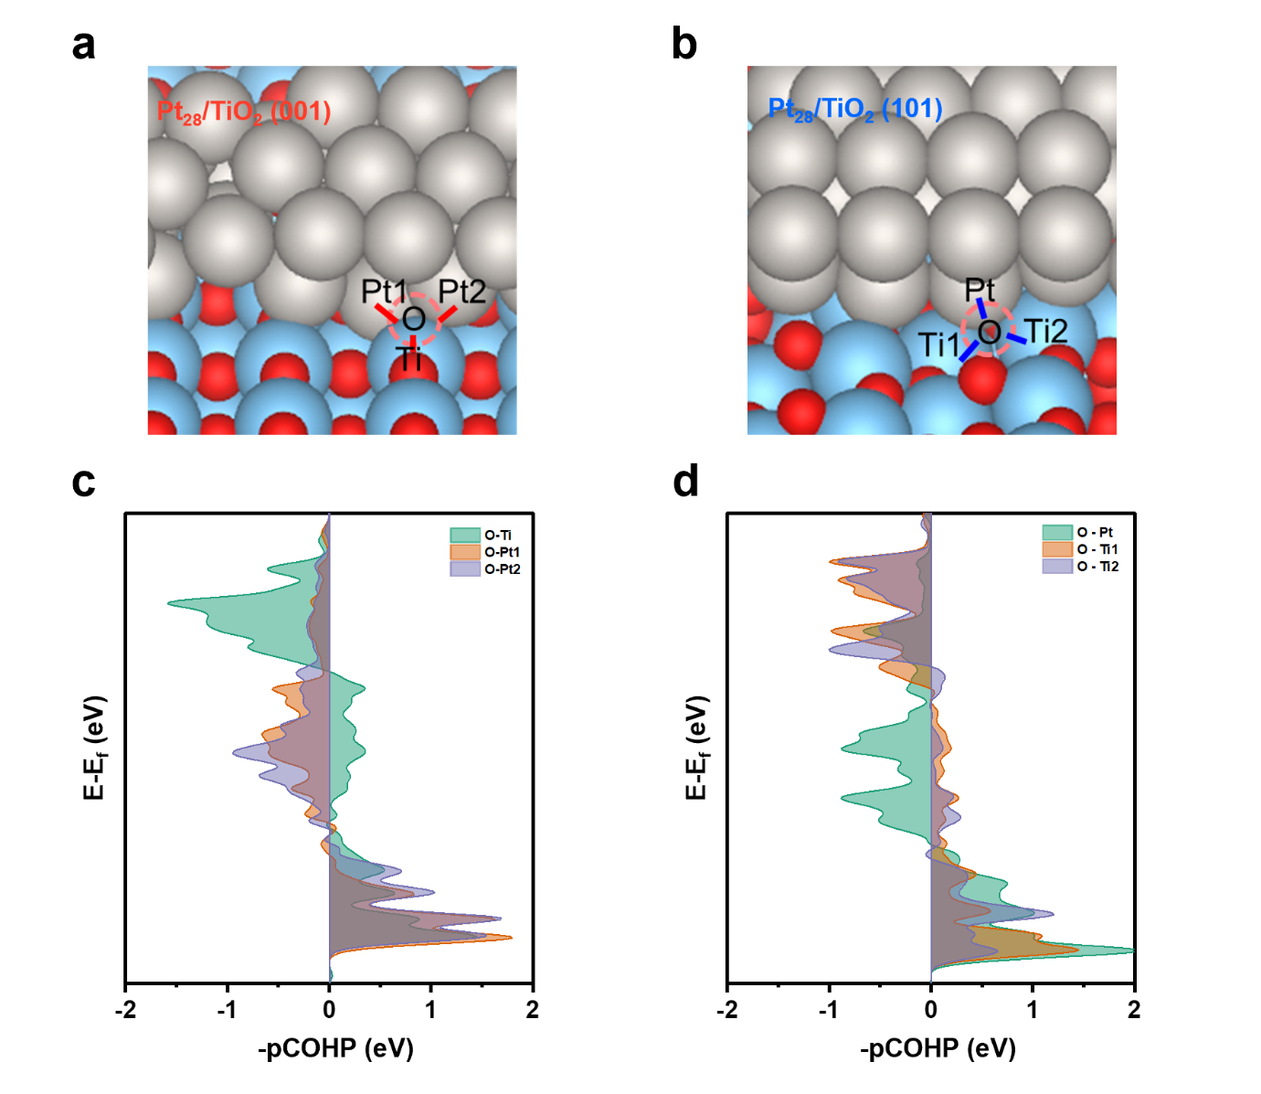
Supplementary Figure 19. The active oxygen vacancy site and its neighboring bonds for (a) Pt₂₈/TiO₂ (001) and (b) Pt₂₈/TiO₂ (101), along with the corresponding −pCOHP analysis results for oxygen vacancy formation at the Pt–TiO₂ interface: (c) Pt₂₈/TiO₂ (001) and (d) Pt₂₈/TiO₂ (101). Colored curves indicate the −pCOHP for individual bonds between the selected oxygen vacancy site and its neighboring Pt/Ti atoms, as shown in (a) and (b).

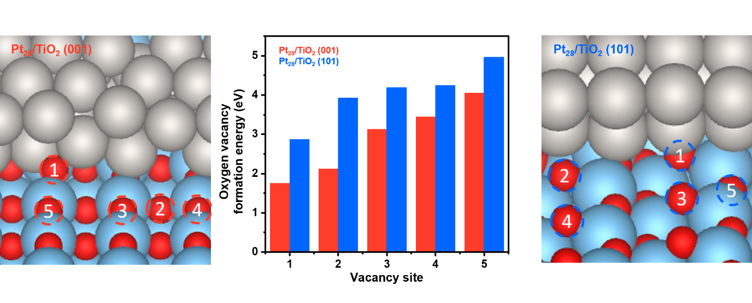
Supplementary Figure 20. Possible oxygen vacancy formation sites at the Pt–TiO₂ interface for both (001) and (101) surfaces in the Pt₂₈/TiO₂ models, along with the corresponding calculated formation energies for each site.

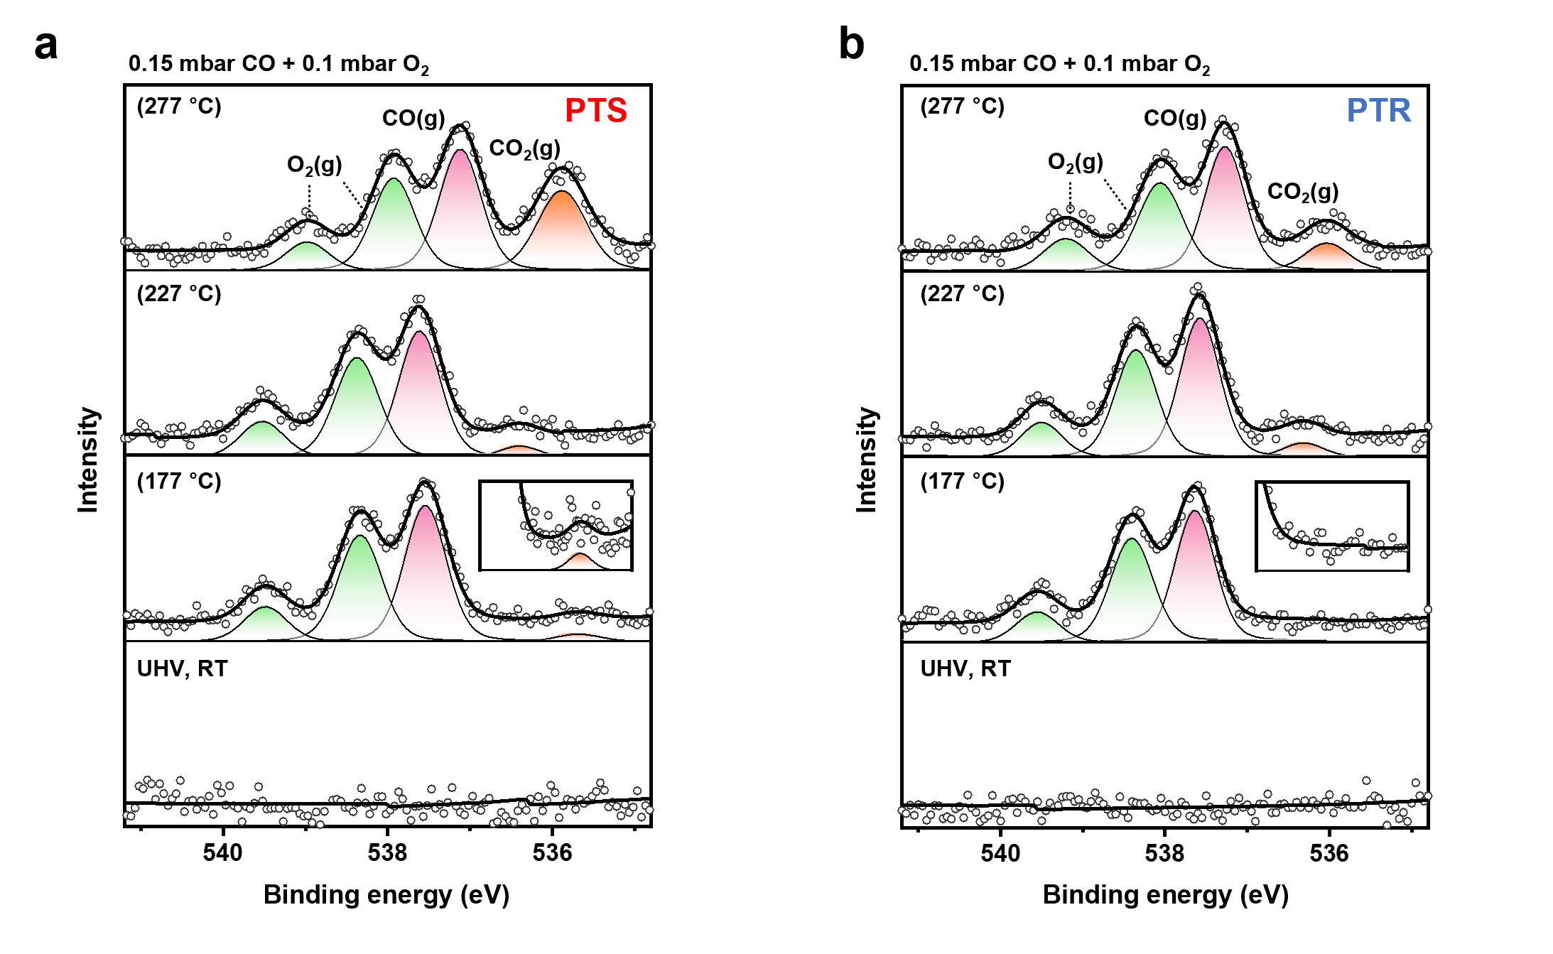
Supplementary Figure 21. Enlarged view of the gas-phase region in the O 1s AP-XP spectra (hv = 640 eV) for (a) PTS and (b) PTR under UHV and CO oxidation conditions (0.15 mbar of CO and 0.1 mbar of O₂) at various temperatures (RT, 177, 227, and 277 °C).

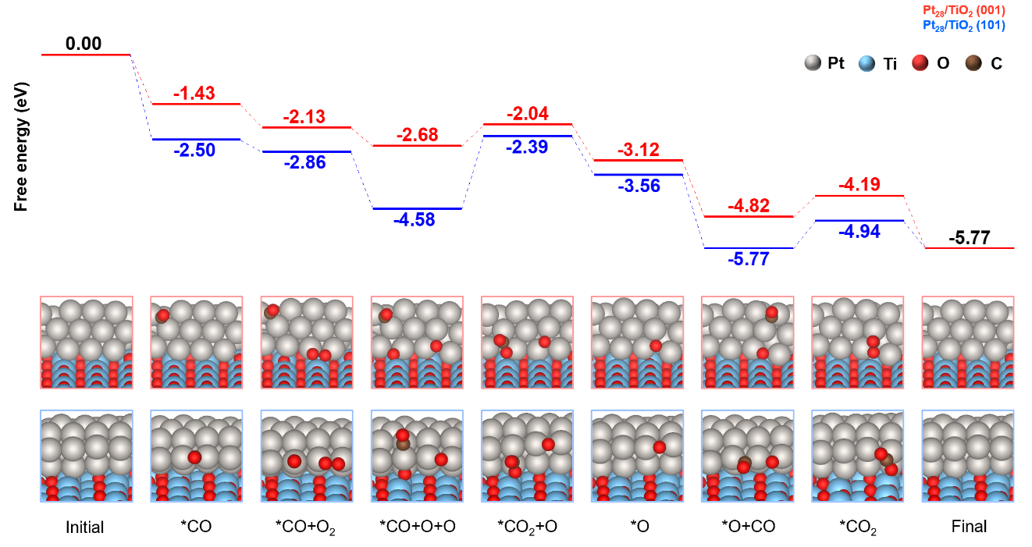
Supplementary Figure 22. Reaction energy profiles for CO oxidation via the L–H mechanism on Pt₂₈/TiO₂ (001) and Pt₂₈/TiO₂ (101) models. The energy barriers associated with the co-adsorbed *CO and *O reaction step highlight the facet-dependent differences in activation energy and rate-determining steps.

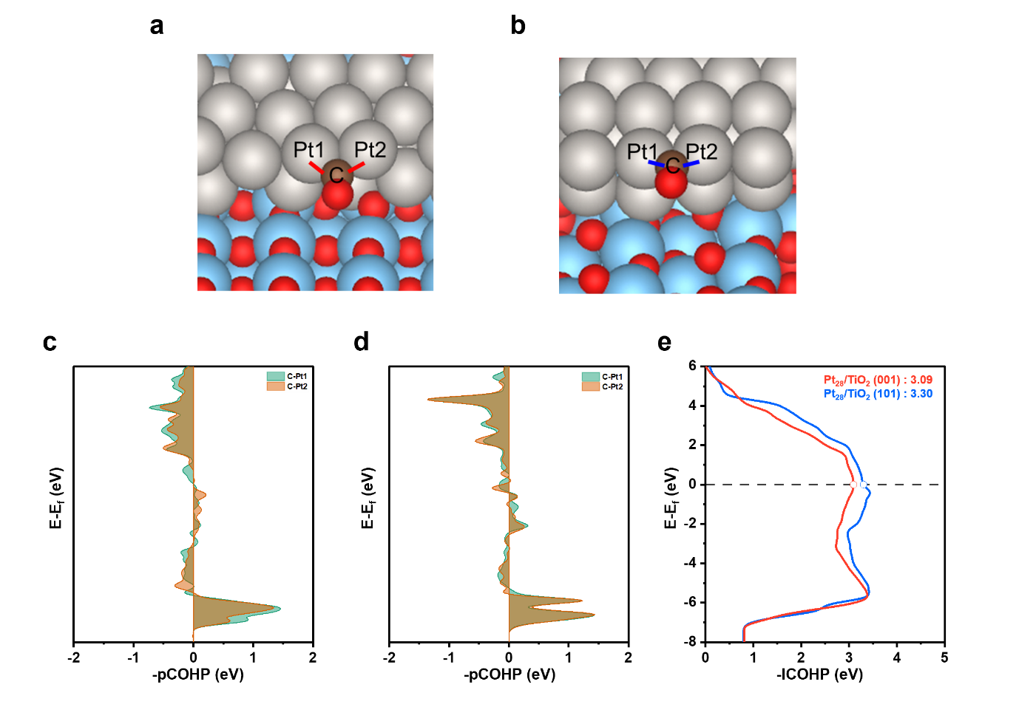
Supplementary Figure 23. The active CO adsorption site and corresponding Pt–C bonds for (a) Pt₂₈/TiO₂ (001) and (b) Pt₂₈/TiO₂ (101), along with the −pCOHP analysis of CO adsorption at the Pt site: (c) Pt₂₈/TiO₂ (001) and (d) Pt₂₈/TiO₂ (101) models. Colored curves represent the −pCOHP for individual Pt–C bonds between the adsorbed CO molecule (C atom) and the neighboring Pt atoms indicated in (a) and (b).

Catalysts | O_{50-600 °C} (μmol·m^{–2})
TiO₂ sheet (001), (TiO₂-S) | 1.70
TiO₂ rhombic (101), (TiO₂-R) | 2.06
PTS | 3.13
PTR | 2.85
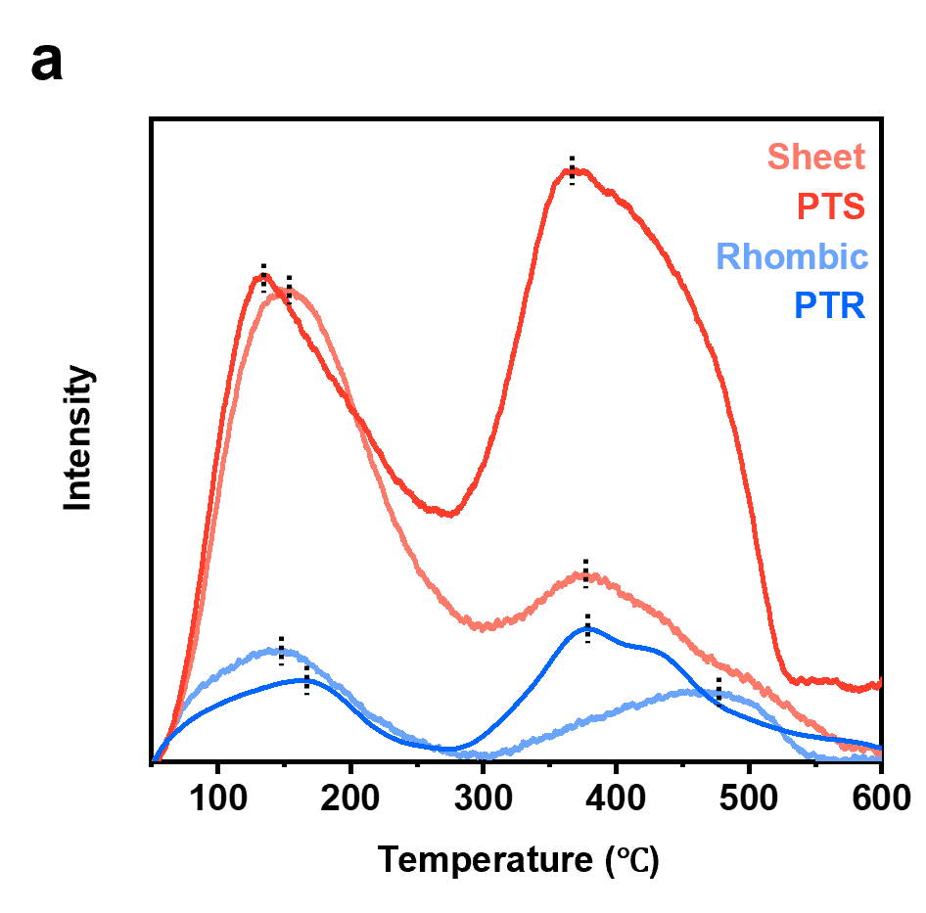
Supplementary Figure S24. (a) O₂-TPD profiles of pristine TiO₂ and Pt/TiO₂ catalysts, showing distinct desorption features attributed to superoxide (O₂–, 100–300 °C) and peroxide (O–, 300–600 °C) species. (b) Corresponding oxygen storage capacity values integrated from 50 to 600 °C and normalized by the specific surface area, highlighting enhanced oxygen mobility and activation upon Pt loading, particularly on the TiO₂ (001) facet.

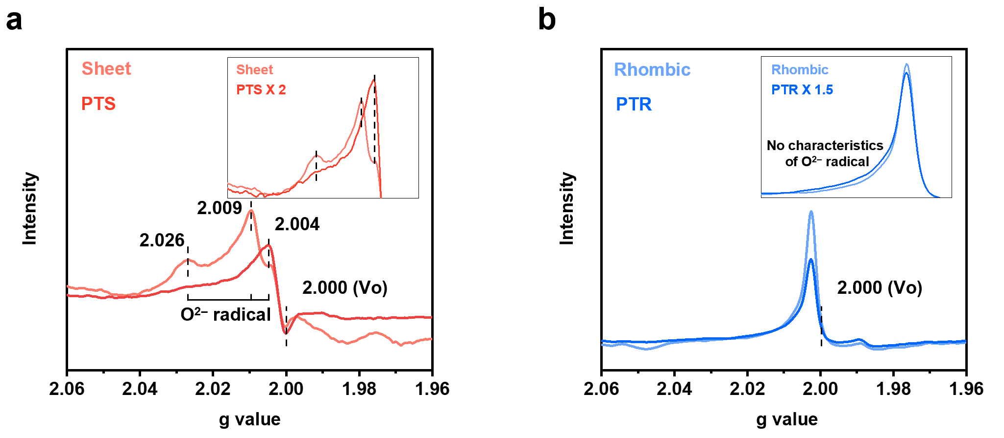
Supplementary Figure 25. EPR spectra of (a) pristine TiO₂ sheet with predominantly exposed (001) the corresponding Pt-loaded catalyst (PTS), and (b) pristine TiO₂ rhombic with exposed (101) facets and the corresponding Pt-loaded catalyst (PTR). The inset figures in both panels highlight that the EPR signals exhibit facet-dependent characteristics of TiO₂ upon Pt loading.

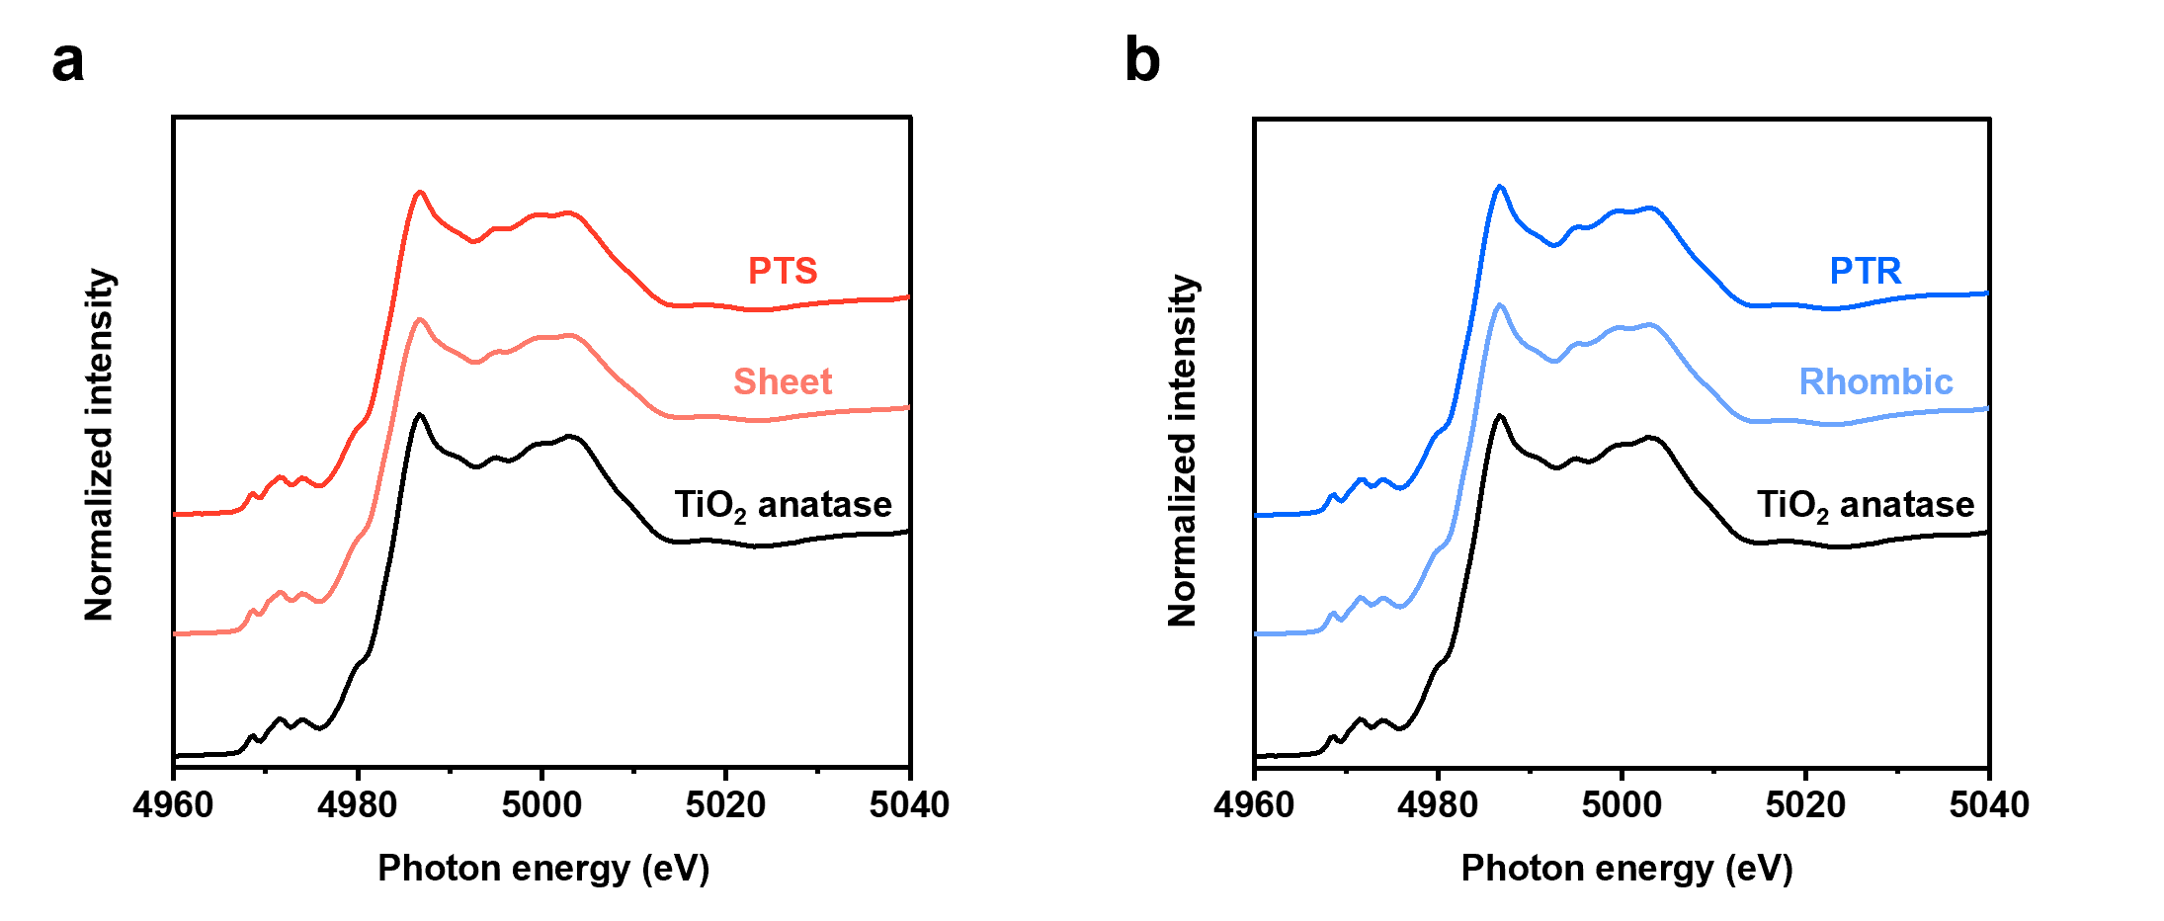
Supplementary Figure 26. Ti K-edge XANES spectra of (a) pristine TiO₂ sheet and Pt-loaded PTS catalyst and (b) pristine TiO₂ rhombic and Pt-loaded PTR catalyst.

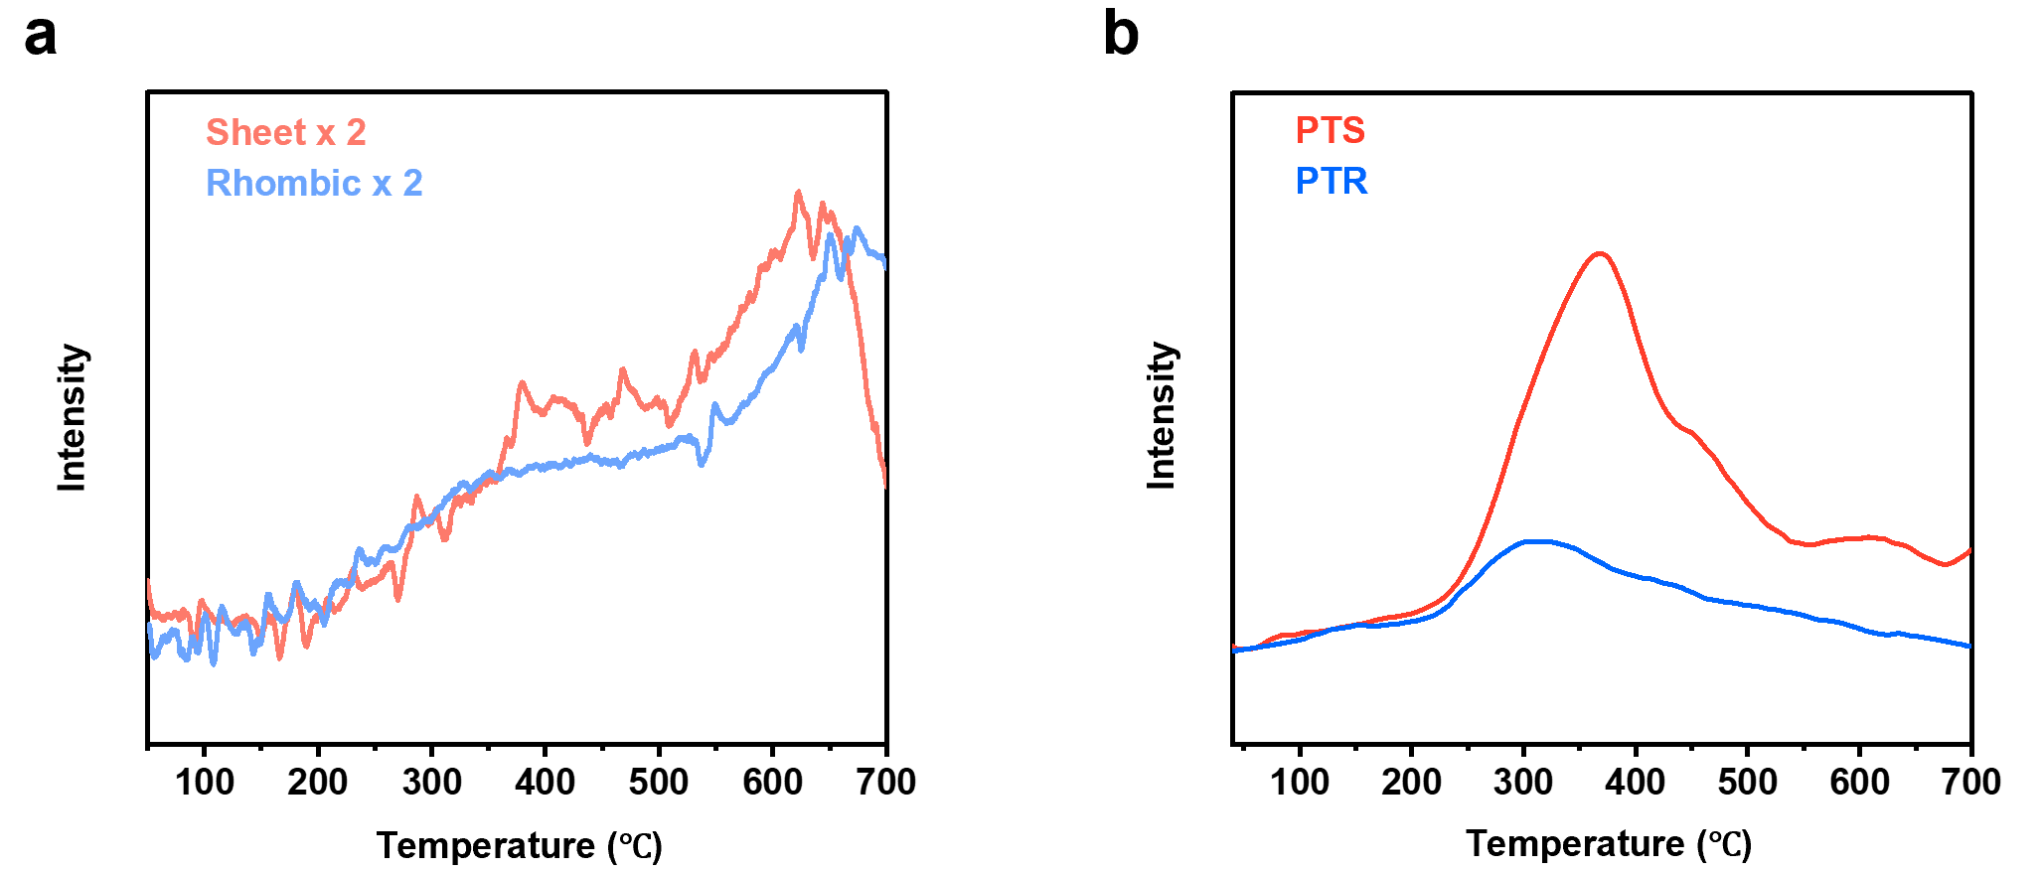
Supplementary Figure 27. H₂-TPR profiles of (a) pristine TiO₂ supports and (b) Pt-loaded TiO₂ catalysts.

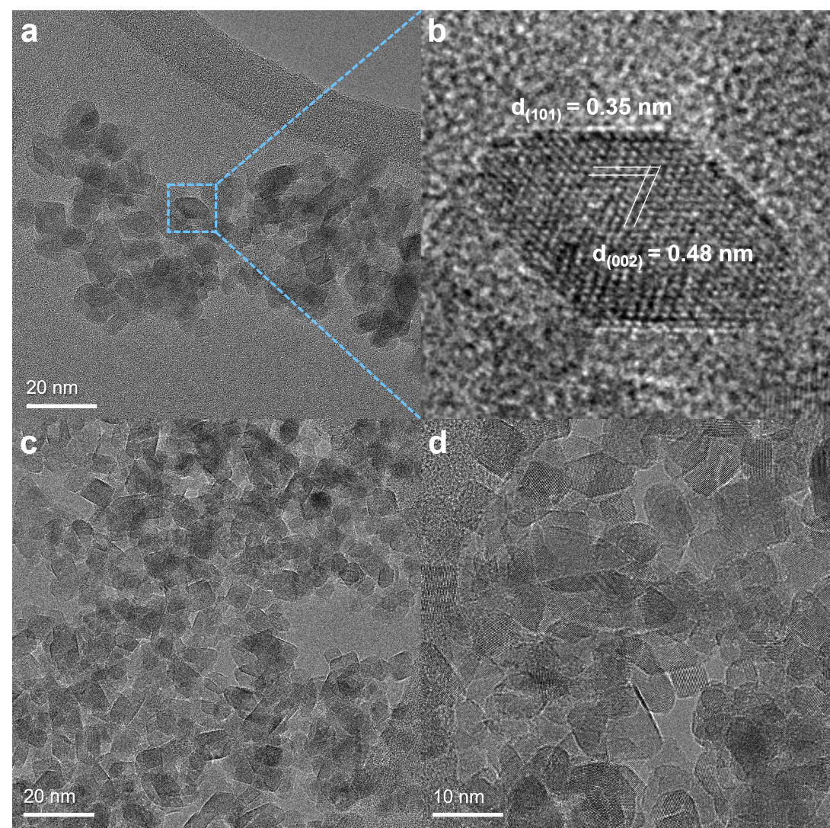
Supplementary Figure 28. TEM images of pristine TiO₂-r samples predominantly exposing the (101) facet, showing rhombic morphology.

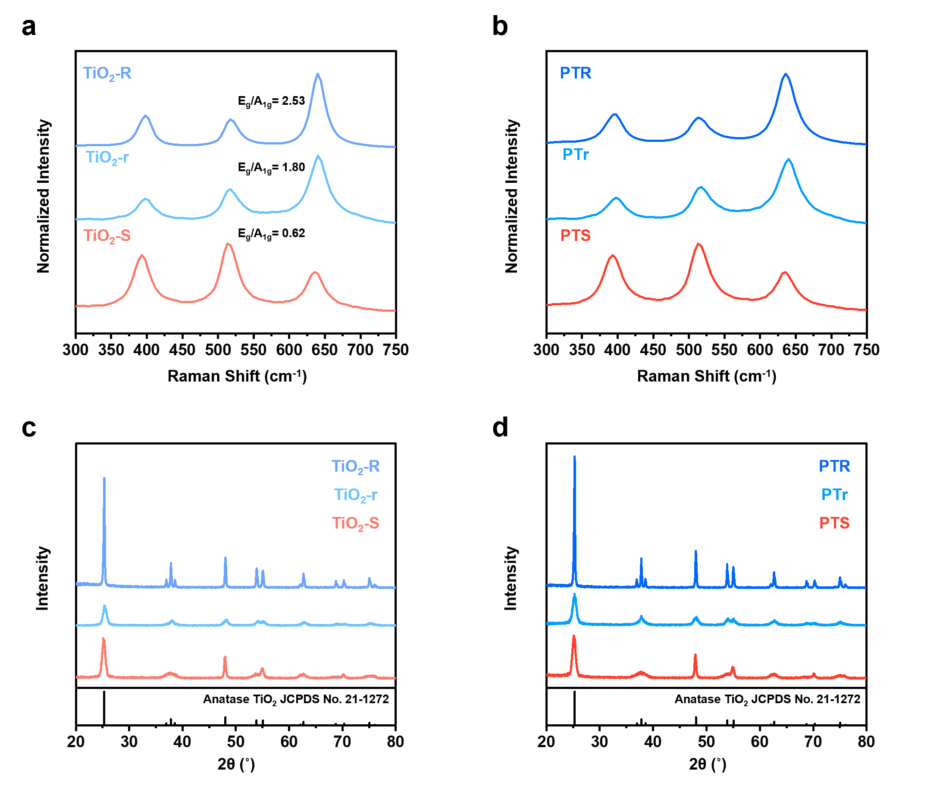
Supplementary Figure 29. (a, b) Raman spectra of (a) pristine TiO₂ supports and (b) fresh Pt/TiO₂ catalysts. (c, d) XRD patterns of (c) pristine TiO₂ and (d) fresh Pt/TiO₂ catalysts.

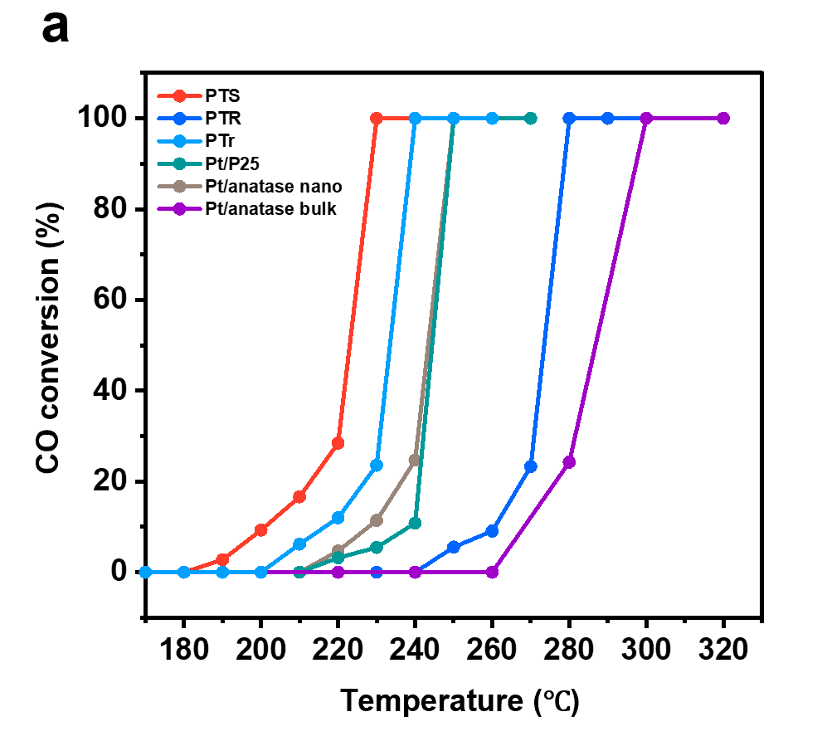
Supplementary Figure 30. CO conversion curves of Pt/TiO₂ catalysts prepared using synthesized TiO₂ supports (TiO₂-S, TiO₂-r, and TiO₂-R) and commercial TiO₂ powders (P25, anatase nanopowder, and bulk powder). Catalytic tests were conducted under a 2% CO + 2% O₂/Ar flow (Total 50 mL·min⁻¹).

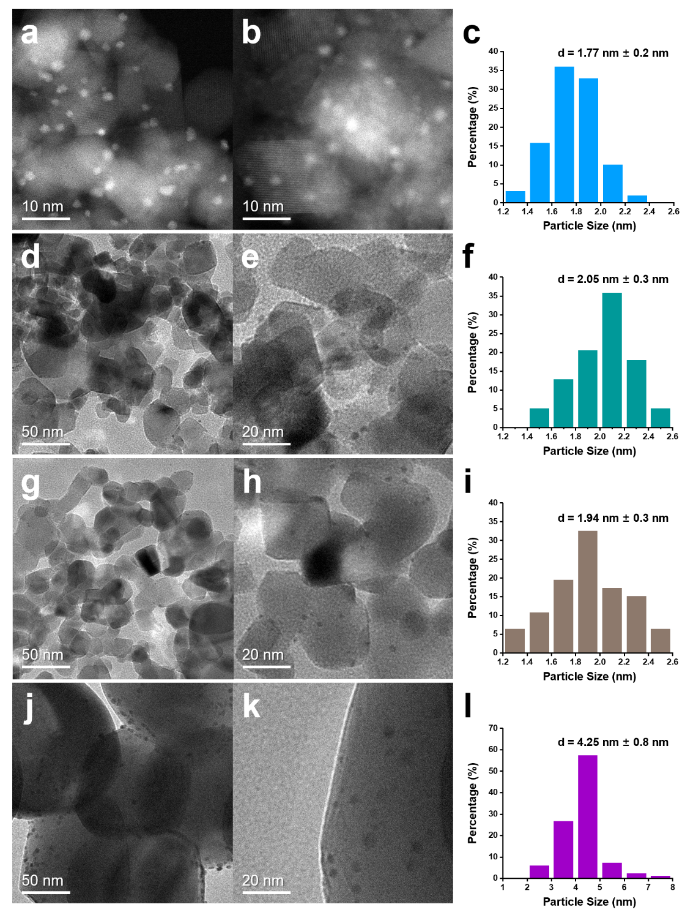
Supplementary Figure 31. HAADF–STEM images and corresponding Pt NP size distributions of Pt catalysts supported on (a–c) TiO₂-r (PTr), (d–f) commercial P25, (g–i) anatase nanopowder, and (j–l) anatase bulk powder.

Supplementary Table S5. Specific surface areas of pristine TiO₂ samples measured by the BET method.
Catalysts | Specific surface area  (m²g^{–1})
TiO₂ nanosheet (001), (TiO₂-S) | 70.3
PTS | 69.1
TiO₂ large rhombic (101), (TiO₂-R) | 14.4
PTR | 13.0
TiO₂ small rhombic (101), (TiO₂-r) | 119.5
P25 | 51.8
Anatase nanopowder | 52.2
Anatase bulk powder | 8.9

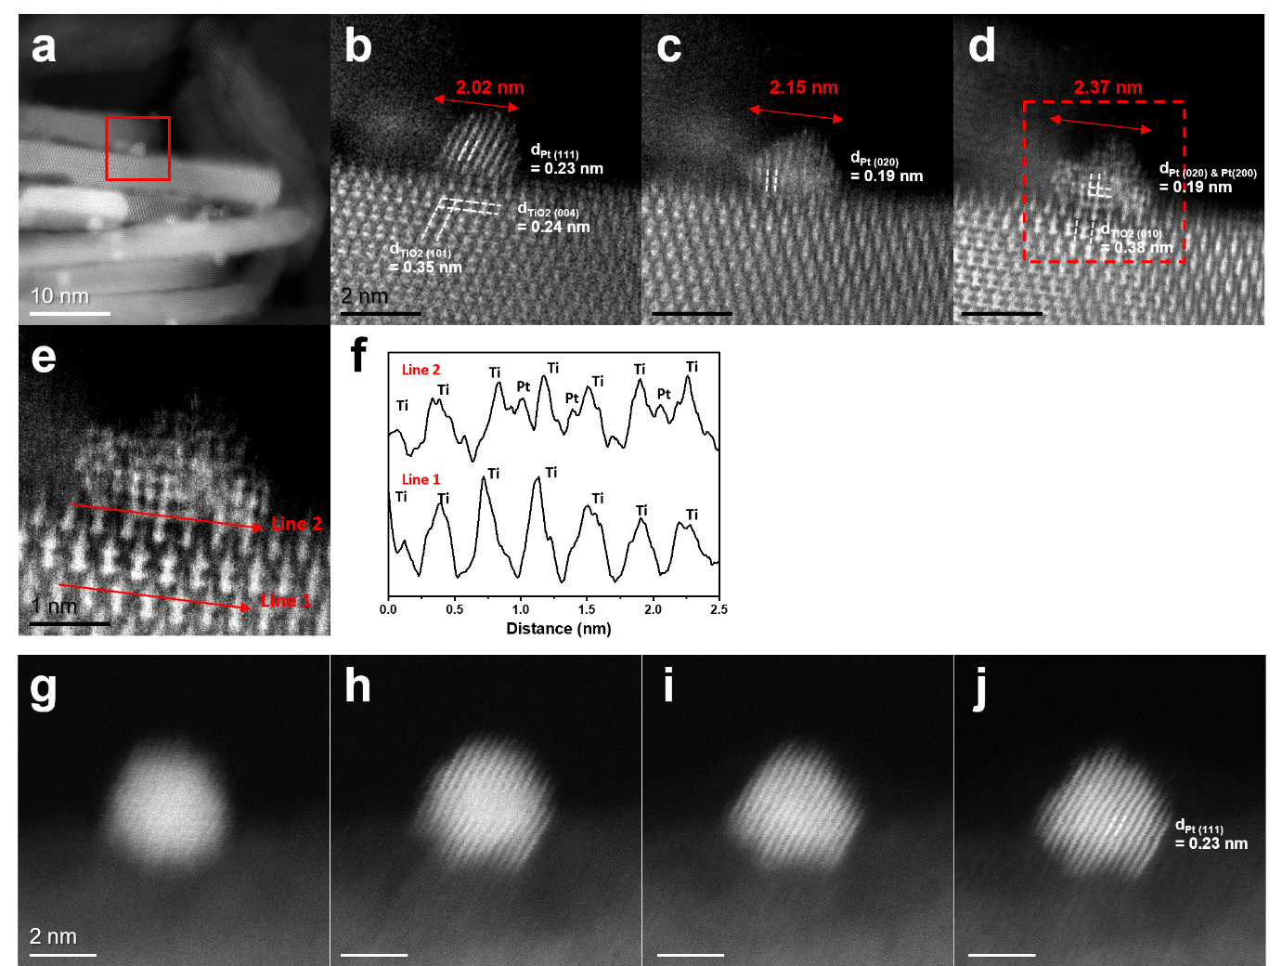
Supplementary Figure 32. (a) HAADF–STEM image of fresh PTS catalyst. (b–d) Electron beam-induced reconstruction of Pt NPs within the red rectangular region in (a) under magnifications of (b) 5 M, (c) 8 M, and (d) 20 M. (e) Enlarged view of the red dashed rectangle in (d). (f) Intensity profiles extracted along the line in (e), showing changes in lattice spacings during reconstruction. (g–j) HAADF–STEM images of fresh PTR catalyst at magnifications of (g–i) 10 M and (j) 12 M, illustrating beam-induced morphological evolution of Pt NPs.

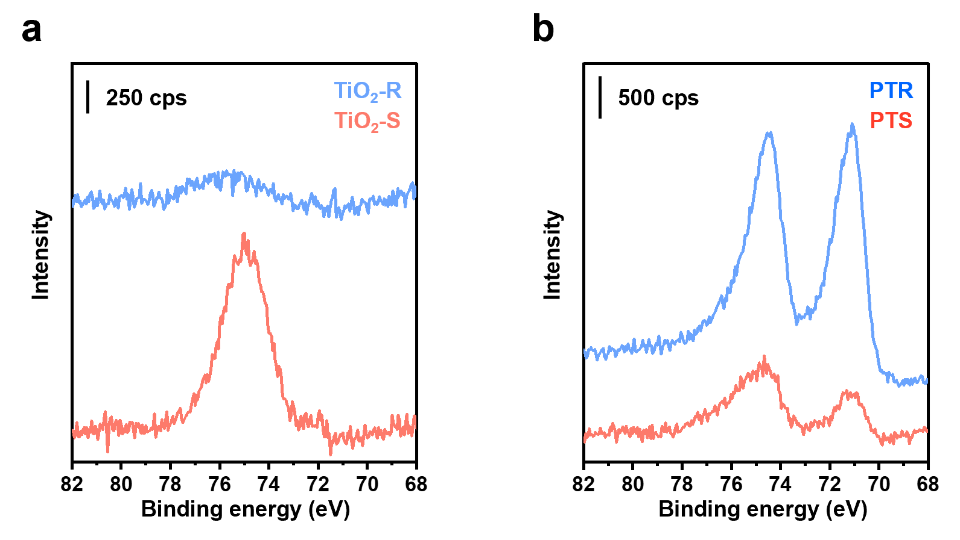
Supplementary Figure 33. (a) Ti 3s satellite spectra of TiO₂-S and TiO₂-R supports. (b) Pt 4f XPS spectra of PTS and PTR catalysts measured under UHV conditions.

Supplementary Note 1. Methods for Synthesizing Rhombic TiO₂ with Predominantly Exposed (101) Facets
In this study, we compared two anatase TiO₂ morphologies with predominantly exposed (001) and (101) facets. The synthesis of TiO₂ with predominantly exposed (001) facets typically involves the use of hydrofluoric acid (HF) during the hydrothermal stage, as F– ions inhibit crystal growth along the [001] direction, leading to sheet-like morphologies with extensive (001) exposure. In contrast, anatase TiO₂ with predominantly exposed (101) facets can be obtained via three main strategies: (1) reducing the amount of HF during synthesis,^{1, 2} (2) employing Ti(OH)₄ precursors derived from TiCl₄ hydrolysis,³ and and (3) using Na-titanate precursors formed by alkali treatment of commercial P25 TiO₂.⁴ Among these, method (1) tends to result in relatively low (101) facet exposure, so we focused on methods (2) and (3), which are consistent with previous reports on facet-controlled catalysis.^{3, 5, 6, 7}
As shown in Supplementary Fig. 28, TiO₂ synthesized via method (2) exhibited small crystals with rhombic morphology. However, a considerable portion of the sample lacked well-defined shapes. Although this observation is not explicitly discussed in prior studies, similar morphology appears in published TEM images, likely due to the small crystallite sizes (<10 nm edge length). Because this work aims to investigate how exposed TiO₂ facets affect Pt NP reconstruction and catalytic CO oxidation, well-defined TiO₂ morphologies are essential to isolate the facet effects. Therefore, method (3) was adopted to produce larger rhombic TiO₂ crystals with a high percentage of exposed (101) facets. As shown in Fig. 1, the TiO₂ product from method (3) exhibits a well-defined rhombic shape, although the surface area is reduced due to the increased crystallite size
Accordingly, we designated the TiO₂ synthesized by method (2) as TiO₂-r (small rhombic) and that by method (3) as TiO₂-R (large rhombic). The corresponding Pt-supported catalysts are referred to as PTr and PTR, respectively. Supplementary Fig. 29 compares their surface and crystal structures using Raman spectroscopy and XRD. Raman spectra show that TiO₂-r exhibits a higher E_{g}/A_{1g} intensity ratio (1.80) than TiO₂-R (2.53), while XRD confirms that all samples retain the anatase phase. This suggests that although TiO₂-r maintains the anatase structure, it does not expose the (101) facets as fully as TiO₂-R. Thus, TiO₂-R was selected for subsequent studies due to its more complete (101) facet exposure, which enables clearer identification of Pt reconstruction on well-defined (101) terrace surfaces.
To further assess the facet-dependent catalytic activity, we compared Pt/TiO₂ catalysts synthesized using these TiO₂ supports with those made from commercial TiO₂ (P25, anatase nano powder, and bulk powder) (Supplementary Fig. 30). TEM images and Pt particle size distributions are provided in Supplementary Fig. 31. While the catalytic activity generally increased with increasing surface area (Supplementary Table 5), PTS (Pt supported on TiO₂ with exposed (001) facets) showed superior activity compared to all other samples, including PTr, despite TiO₂-r having 1.7 times larger surface area than TiO₂-S. This indicates that the (001) facet of TiO₂-S provides a more catalytically active environment for CO oxidation than the (101) facets of TiO₂-R or any commercial TiO₂ sample.
Taken together, these findings confirm that although surface area is an important factor in catalytic performance, the enhanced activity of PTS originates primarily from the intrinsic reactivity of the exposed (001) facet, not from surface area effects. Therefore, TiO₂-R synthesized via method (3) was used in the main study to reliably investigate the influence of the (101) facet on Pt structural evolution and CO oxidation catalysis.

Supplementary Note 2 Indirect Evidence of Facet-Dependent Pt Reconstruction on TiO₂ Nanosheets with Exposed (001) Facets
During TEM analysis of the PTS catalyst, it was difficult to manually align the Kikuchi patterns (i.e., zone axis) due to the small crystal size (~3–5 nm) of the TiO₂ nanosheets along the [001] direction. Therefore, observations were focused on the side view of the TiO₂ nanosheets, which were perpendicularly loaded onto the Cu grid, particularly targeting Pt particles located near the edges of the (001) surface to minimize contrast differences between TiO₂ and Pt. As shown in Fig. 2i, our analysis concentrated on the parallel lattice alignment between the Pt (111) and TiO₂ (004) planes, in contrast to the atomic-level interfacial structure of PTR discussed in Fig. 3m. We attempted to obtain similar atomic-resolution images of the PTS interface after the reaction; however, resolving the interfacial atomic structure with sufficient clarity remained challenging.
Interestingly, electron beam-induced reconstruction of Pt NPs was observed during STEM imaging of fresh PTS samples. As shown in Supplementary Fig. 32a, a well-aligned fresh PTS specimen exhibited parallel alignment of the Pt (111) plane with the TiO₂ (101) plane. Upon increasing magnification to better examine the interfacial structure (Supplementary Figs. 32b–d), we observed beam-induced Pt reconstruction, where the lateral size of a Pt particle increased from 2.02 nm to 2.37 nm, indicating particle spreading. This reconstruction was accompanied by a reduction in the d-spacing from 0.23 nm, characteristic of the Pt (111) plane, to 0.19 nm, corresponding to Pt (200) and (020) planes. During this transformation, the TiO₂ (001) surface facilitated partial embedding of Pt into the Ti lattice (Supplementary Figs. 32e, f), resulting in an epitaxial and parallel orientation with the TiO₂ (010) and (004) planes. Similar Pt incorporation behavior was previously reported in single-atom Pt/TiO₂ nanosheet systems.² This suggests that the structural characteristics of the TiO₂ (001) sheet enable enhanced interaction and epitaxial alignment with Pt NPs, promoting a spread morphology and increased interfacial contact area.
We also observed electron beam-induced reconstruction behavior in the fresh PTR sample (Supplementary Figs. 32g–j), albeit with slightly lower image quality. In this case, Pt particles gradually transformed into sharper cuboctahedral shapes, consistent with the reconstruction behavior observed in the spent PTR sample (Fig. 2l). These transformations are likely driven by oxygen loss from TiO₂ under prolonged high-energy beam exposure. Nonetheless, the observations provide indirect yet supportive evidence for the facet-dependent Pt reconstruction behaviors described in the main text for spent Pt/TiO₂ catalysts.

Supplementary Note 3. Challenges in Interpreting AP-XPS Spectra
To gain a comprehensive understanding of the surface chemical states and valence behavior of the catalysts, we analyzed the in situ AP-XPS spectra of the Pt 4f region for each sample. As shown in Supplementary Fig. 33, it is important to note that interpretation of the Pt 4f region is complicated by the overlap with the Ti 3s energy loss feature located near ~75 eV.^{2, 8} This spectral interference poses a significant challenge to accurate quantification of the Pt 4f signals.
The issue is particularly pronounced for TiO₂-S and its corresponding Pt/TiO₂ catalyst, compared to TiO₂-R, due to the relatively low surface density of Pt NPs. Despite similar Pt loading and particle size, the larger surface area of the TiO₂ nanosheets in TiO₂-S results in a more dilute distribution of Pt, further complicating the detection and deconvolution of Pt 4f signals.
Moreover, variations in the Ti 2p and O 1s core-level spectra were minimal, likely due to the small contribution of interfacial Pt–TiO₂ interactions relative to the overwhelming signal from bulk TiO₂. Given these challenges—including spectral overlap, weak Pt signal intensity, and the low proportion of reactive interfacial zones relative to the support bulk—we focused our attention on the O 1s region.
Specifically, we examined the behavior of the carbonate-related C=O peak and the corresponding evolution of the CO₂(g) signal under CO oxidation conditions. These features provided more interpretable and reliable insights into the dynamic changes occurring at the catalyst surface during reaction, particularly at the Pt–TiO₂ interface.

Reference
1. Yu, J. et al. Enhanced photocatalytic CO₂-reduction activity of anatase TiO₂ by coexposed {001} and {101} facets. J. Am. Chem. Soc. 136, 8839-8842 (2014).
2. Zang, W. et al. Distribution of Pt single atom coordination environments on anatase TiO₂ supports controls reactivity. Nat. Commun. 15, 998 (2024).
3. Liu, L. et al. Crystal-plane effects on the catalytic properties of Au/TiO₂. ACS Catal. 3, 2768-2775 (2013).
4. Yang, M.H. et al. Alkali metal ion assisted synthesis of faceted anatase TiO₂. CrystEngComm 15, 2966-2971 (2013).
5. Jia, A. et al. Selective hydrogenation of crotonaldehyde over Ir/TiO₂ catalysts: unraveling the metal-support interface related reaction mechanism. J. Catal. 425, 57-69 (2023).
6. Tang, M. et al. Facet-Dependent Oxidative Strong Metal-Support Interactions of Palladium-TiO₂ Determined by In Situ Transmission Electron Microscopy. Angew. Chem. Int. Ed. 60, 22339-22344 (2021).
7. Yuan, W. et al. Direct In Situ TEM Visualization and Insight into the Facet-Dependent Sintering Behaviors of Gold on TiO₂. Angew. Chem. Int. Ed. 57, 16827-16831 (2018).
8. Chen, J.J. et al. Reverse oxygen spillover triggered by CO adsorption on Sn-doped Pt/TiO₂ for low temperature CO oxidation. Nat. Commun. 14, 3477 (2023).

