Supporting Information
Benzimidazolyl-Phenylpropenones Synthesized and Evaluated for Selective Anticancer Activity in Prostate Colon and Breast Tumor Models
Aboudramane Koné,^{1,2*} Adingra Francesco Kouassi,^{2,3} Souleymane Coulibaly,^{2*} Drissa Sissouma,² and Sylvain Collet⁴
¹Laboratoire des Sciences et Technologies de l’Environnement, UFR Environnement, Université Jean Lorougnon Guédé, Daloa, BP 150 Daloa, Côte d’Ivoire
²Laboratoire de Constitution et Réaction de la Matière, UFR Sciences des Structures de la Matière et Technologie, Université Félix Houphouët Boigny Abidjan-Cocody, 22 BP 582 Abidjan 22, Abidjan, Côte d’Ivoire
³Département de Physique-Chimie, UFR Sciences et Technologies Université Alassane Ouattara, Bouaké, BPv 18 Bouaké 01, Côte d’Ivoire
⁴Chimie Et Interdisciplinarité : Synthèse, Analyse, Modélisation (CEISAM), Université de Nantes, BP 92208, 44322 Nantes Cedex 3, France
*Corresponding authors: kone.aboudraman@gmail.com, https://orcid.org/0000-0001-7464-8553 and souleymane.coulibaly87@ufhb.edu.ci, http://orcid.org/0000-0003-4573-5978

Chemistry
For all compounds, the ¹H and ¹³C NMR spectra were recorded at room temperature on a Bruker Avance AC300 (300 MHz for ¹H and 75 MHz for ¹³C) or on a Bruker Avance AC300 (400 MHz for ¹H and 100 MHz for ¹³C) in deuterated dimethylsulfoxide (DMSO-d₆). Tetramethylsilane (TMS) was used as a reference and chemical shifts are expressed in parts per million (ppm) while coupling constants (J) are expressed in Hertz (Hz). NMR spectra are described using the following symbols: s (singlet), d (doublet), t (triplet), q (quadruplet), m (massive), dd (doublet of doublet). Mass spectra were recorded using a ThermoScientific DSQII quadrupole instrument by electron impact (EI, 70 eV) or chemical ionization (CI, 500 eV). High-resolution mass spectroscopy (HRMS) was performed on a ThermoScientific LTQ-Orbitrap mass spectrometer in positive electrospray ionization mode. The progress of the reaction and the purity of the compounds were monitored by TLC on aluminum plates coated with silica gel (Kieselgel 60 F₂₅₄, MERCK). After elution in the appropriate solvent or solvent mixture, the plates were revealed by UV fluorescence (λ = 254 nm) or by potassium permanganate (KMnO₄) solution followed by heating. The melting points of solid compounds were determined using a Köfler bench and are uncorrected. Solvents and reagents were purchased from Acros Organics (France) or Sigma-Aldrich (France).
Synthesis
Compounds 1a (1H-benzimidazol-2-yl)methanol), 2a (1H-benzimidazole-2-carbaldehyde), 3a ((E)-3-(1H-Benzimidazol-2-yl)-1-phenylprop-2-en-1-one), 3b ((E)-3-(1H-Benzimidazol-2-yl)-1-(2-hydroxyphenyl)prop-2-en-1-one) and ((E)-3-(1H-Benzimidazol-2-yl)-1-(2-hydroxy phenyl)prop-2-en-1-one) have already been reported.
Synthesis of (5-substituted-1H-benzimidazol-2-yl)methanol (1b-d)
To a solution of 1 eq orthophenylenediamine derivatives 1 (5 g, 46.23 mmol) in 50 mL of HCl 4N, was added 3 eq glycolic acid (10.5 g, 138.71 mmol). The reaction mixture was refluxed for 6 h then cooled to room temperature and quenched with ammonia solution 25% at 0 °C. The product was collected pure by filtration and dried at room temperatura in open air to yielded (5-substitued-1H-benzimidazol-2-yl)methanol (2b-d).
(5-Chloro-1H-benzimidazol-2-yl)methanol (1b)
Brown solid, yield = 97%, ¹H NMR : (300 MHz, DMSO-d₆, δ ppm) 12.46 (br s, 1H, NH), 7.56-7.47 (m, 2H, H₄ and H₇) 7.15 (dd, J₆₋₇ = 8.8, J₆₋₄ = 2.1 Hz, 1H, H₆), 5.76 (br s, 1H, OH), 4.69 (s, 2H, H₁). ¹³C NMR: (75 MHz, DMSO-d₆, δ ppm) 156.9 (C_{Ar}), 133.0 (C_{Ar}), 121.6 (C_{Ar}), 119.6 (C_{Ar}), 117.8 (C_{Ar}), 112.5 (C_{Ar}), 110.9 (C_{Ar}), 57.6 (CH₂). MS: [EI, 70 eV, m/z (rel. Int)]: 184 (29), 183 (24), 182 (100), 181 (40), 165 (29).
(5-Nitro-1H-benzimidazol-2-yl)methanol (1c)
Brown solid, yield = 97%, ¹H NMR : (300 MHz, DMSO-d₆, δ ppm) 12.71 (br s, 1H, NH), 8.68-8.15 (m, 1H, H₄), 8.08 (dd, J₆₋₇ = 8.9 Hz, J₆₋₄ = 2.3 Hz, 1H, H₆), 7.67 (d, J₇₋₆ = 8.8 Hz, 1H, H₇), 5.93 (s, 1H, OH), 4.77 (s, 2H, H₁). ¹³C NMR: (75 MHz, DMSO-d₆, δ ppm) 159.8 (C_{Ar}), 142.3 (C_{Ar}), 118.5 (C_{Ar}), 117.6 (C_{Ar}), 114.5 (C_{Ar}), 111.5 (C_{Ar}), 107.9 (C_{Ar}), 57.7 (CH₂). MS: [EI, 70 eV, m/z (rel. Int)]: 194 (16), 193 (100), 192 (28), 147 (18).
(5-Benzoyl-1H-benzimidazol-2-yl)metanol (1d)
Beige solide, yield = 97%, ¹H NMR : (300 MHz, DMSO-d₆, δ ppm) 12.72 (br s, 1H, NH), 7.88 (t, J = 1.2 Hz, 1H, H₄), 7.76-7.70 (m, 2H, H₆ and H₇), 7.70-7.52 (m, 5H, H_{Ar}), 5.83 (br s, 1H, OH), 4.74 (s, 2H, H₁). ¹³C NMR: (75 MHz, DMSO-d₆, δ ppm) 195.7 (C=O), 138.2 (2C_{Ar}), 132.0 (C_{Ar}), 130.3 (2C_{Ar}), 129.3 (2C_{Ar}), 128.3 (4C_{Ar}), 123.6 (2C_{Ar}), 57.7 (CH₂). MS:[EI, 70 eV, m/z (rel. Int)]: 253 (20), 252 (100), 251 (14), 175 (76).

Synthesis of 5-substituted-1H-benzimidazole-2-carbaldehyde (2b-d)
To a solution of benzimidazol-2-ylmethanol derivatives 2b-d (1 eq, 1 g) in 10 mL of EtOH, was added activated manganese dioxide (8.5 eq). The reaction mixture was stirred at room temperature overnight and concentrated. 20 mL of boiling DMF was added, filtered over a pad of celite and concentrated under reduced pressure. The crude product was purified by silica gel chromatography (elution: DCM/MeOH 98 :2) to yielded compound 2 as yellow crystals.
5-Chloro-1H-benzimidazole-2-carbaldehyde (2b)
Yellow solid, yield = 52%, ¹H NMR: (300 MHz, DMSO-d₆, δ ppm) 13.82 (br s, 1H, NH), 9.95 (s, 1H, CHO), 7.79-7.35 (m, 3 H, H₄, H₆ and H₇). ¹³C NMR: (75 MHz, DMSO-d₆, δ ppm) 183.4 (CH=O), 141.7 (C_{Ar}), 140.6 (C_{Ar}), 136.9 (C_{Ar}), 129.5 (C_{Ar}), 123.8 (C_{Ar}), 116.3 (C_{Ar}), 115.5 (C_{Ar}). MS: [EI, 70 eV, m/z (rel. Int)] : 180 (12), 154 (28), 152 (100), 151 (11).
5-Nitro-1H-benzimidazole-2-carbaldehyde (2c)
Yellow solid, yield = 55%, ¹H NMR: (300 MHz, DMSO-d₆, δ ppm) 14.04 (br s, 1H, NH), 9.97 (s, 1H, CHO), 8.50-7.73 (m, 3H, H₄, H₆ and H₇). ¹³C NMR: (75 MHz, DMSO-d₆, δ ppm)
183.1 (CH=O), 145.1 (C_{Ar}), 144.4 (C_{Ar}), 141.5 (C_{Ar}), 139.8 (C_{Ar}), 118.3 (C_{Ar}), 116.6 (C_{Ar}), 113.0 (C_{Ar}). MS: [EI, 70 eV, m/z (rel. Int)]: 192 (16), 191 (100), 190 (28), 145 (18).
5-Benzoyl-1H-benzimidazole-2-carbaldehyde (2d)
Yellow solid, yield = 57%, ¹H NMR: (400 MHz, DMSO-d₆, δ ppm) 13.83 (s, 1H, NH), 10.01 (s, 1H, CHO), 7.80-7.75 (m, 3H, H_{Ar}), 7.72-7.68 (m, 2H, H_{Ar}), 7.61-7.57 (m, 3H, H_{Ar}). ¹³C NMR: (75 MHz, DMSO-d₆, δ ppm) 194.0 (C=O), 183.6 (CH=O), 142.6 (C_{Ar}), 141.5 (C_{Ar}), 138.6 (C_{Ar}), 138.4 (C_{Ar}), 132.4 (C_{Ar}), 131.2 (C_{Ar}), 130.3 (2C_{Ar}), 128.4 (2C_{Ar}), 124.1 (C_{Ar}), 119.0 (C_{Ar}), 114.9 (C_{Ar}). MS: [EI, 70 eV, m/z (rel. Int)] : 251 (19), 250 (100), 249 (14), 173 (82), 145 (17).
Synthesis of (E)-3-(1H-benzimidazol-2-yl)-1-arylprop-2-en-1-one 3d-h
To a solution of NaOH (7.5 eq) in EtOH (10 mL), were added benzimidazole-2-cardaldehyde 2b-d (1 eq, 500 mg) and appropriate acetophenone (1 eq). The mixture was stirred at room temperature overnight then quenched with acetic acid 20% at 0 °C. The crude was collected by filtration, dried and purified by flash-chromatography on silica gel (DCM/MeOH 95 :5) to yielded compounds 3f-h as yellow crystals (63-77%).
(E)-3-(5-Chloro-1H-benzimidazol-2-yl)-1-phenylprop-2-en-1-one (3d)
Yellow solid, yield = 71%, M.p = 158-160 °C, ¹H NMR : (400 MHz, DMSO-d₆, δ ppm) 12.04 (br s, 1H, NH), 8.50 (d, J₃₋₂ = 15.8 Hz, 1H, H₃), 8.16 (d, J = 7.3 Hz, 2H, H_{Ar}), 7.80-7.72 (m, 3H, H₂ and 2H_{Ar}), 7.65-7.59 (m, 3H, H_{Ar}), 7.40 (dd, J = 1.6 Hz, J = 8.7 Hz, 1H, H_{Ar}). ¹³C NMR: (100 MHz, DMSO-d₆, δ ppm) 188.2 (C=O), 149.0 (C_{Ar}), 137.6 (C_{Ar}), 136.7 (C_{Ar}), 135.5 (C_{Ar}), 133.9 (C_{Ar}), 129.5 (2C_{Ar}), 129.0 (2C_{Ar}), 128.8 (C_{Ar}), 128.7 (C_{Ar}), 128.6 (C_{Ar}), 124.7 (C_{Ar}), 116.5 (C_{Ar}), 114.8 (C_{Ar}). HRMS: (ES+) Calculated for C₁₆H₁₂N₂OCl [M + H]⁺ : 283.0638, found : 283.0634. IR: (ATR, υ cm⁻¹) 3453.2 (N-H), 2919.1 (=C-H), 1673.1 (C=O), 1441.9 (C=C), 710.9 (C-Cl).
(E)-3-(5-Chloro-1H-benzimidazol-2-yl)-1-(2-hydroxyphenyl)prop-2-en-1-one (3e)
Yellow solid, yield = 69%, M.p = 116-118 °C, ¹H NMR : (400 MHz, DMSO-d₆, δ ppm) 11.94 (s, 1H, NH), 8.26 (d, J₃₋₂ = 15.2 Hz, 1H, H₃), 8.00 (dd, J = 1.2 Hz, J = 8.1 Hz, 1H, H_{Ar}), 7.72-7.52 (m, 5H, 4H_{Ar} and H₂), 7.29 (d, J = 8.3 Hz, 1H, H_{Ar}), 7.06-702 (m, 2H, H_{Ar}). ¹³C NMR : (100 MHz, DMSO-d₆, δ ppm) 192.2 (C=O), 170.2 (C_{Ar}), 161.0 (C_{Ar}), 138.3 (C_{Ar}), 136.3 (C_{Ar}), 131.2 (C_{Ar}), 130.4 (2C_{Ar}), 127.8 (C_{Ar}), 123.9 (C_{Ar}), 123.6 (C_{Ar}), 121.4 (C_{Ar}), 119.4 (2C_{Ar}), 117.7 (C_{Ar}), 113.5 (C_{Ar}). MS : [EI, 70 eV, m/z (rel. Int)] : 299 (23), 298 (100) [CI, NH_{3,} m/z] : 299 [M+H]⁺. HRMS: (ES+) Calculated for C₁₆H₁₂N₂O₂³⁵Cl [M + H]⁺ : 299.0587, found : 299.0579. IR: (ATR, υ cm⁻¹) 3425.4 (O-H), 2922.7 (=C-H), 1647.4 (C=O), 1583.0 (C=N), 748.7 (C-Cl).
(E)-3-(5-Chloro-1H-benzimidazol-2-yl)-1-(3-hydroxyphenyl)prop-2-en-1-one (3f)
Yellow solid, yield = 63%, M.p = 210-212 °C, ¹H NMR : (400 MHz, DMSO-d₆, δ ppm) 12.01 (br s, 1H, NH), 8.52 (d, J₃₋₂ = 15.7 Hz, 1H, H₃), 7.84 (s, 1H, H_{Ar}), 7.77 (d, J = 8.6 Hz, 1H, H_{Ar}), 7.68-7.55 (m, 3H, H₂ and 2H_{Ar}), 7.53-7.38 (m, 3H, H_{Ar}), 7.15 (dd, J = 2.1 Hz, J = 7.9 Hz, 1H, H_{Ar}). ¹³C NMR : (100 MHz, DMSO-d₆, δ ppm) 187.9 (C=O), 158.0 (C_{Ar}), 138.0 (C_{Ar}), 130.7 (C_{Ar}), 130.1 (C_{Ar}), 129.3 (2C_{Ar}), 127.4 (C_{Ar}), 125.3 (C_{Ar}), 121.2 (2C_{Ar}), 119.8 (2C_{Ar}), 116.4 (C_{Ar}), 114.6 (2C_{Ar}). HRMS: (ES+) Calculated for C₁₆H₁₂N₂O₂³⁵Cl [M + H]⁺ : 299.0587, found : 299.0583. IR: (ATR, υ cm⁻¹) 3321.4 (O-H), 2920.6 (=C-H), 1653.6 (C=O), 1585.0 (C=N), 778.4 (C-Cl).
(E)-3-(5-Nitro-1H-benzimidazol-2-yl)-1-(2-hydroxyphenyl)prop-2-en-1-one (3g)
Yellow solid, yield = 77%, M.p = 225-226 °C, ¹H NMR : (400 MHz, DMSO-d₆, δ ppm) 11.90 (br s, 1H, NH), 8.47 (d, J₃₋₂ = 15.2 Hz, 1H, H₃), 8.21 (dd, J = 1.2 Hz, J = 8.1 Hz, 1H, H_{Ar}), 7.95-7.77 (m, 5H, 4H_{Ar} and H₂), 7.65 (d, J = 8.3 Hz, 1H, H_{Ar}), 7.52-7.40 (m, 2H, H_{Ar}). ¹³C NMR : (100 MHz, DMSO-d₆, δ ppm) 195.5 (C=O), 184.7 (C_{Ar}), 158.9 (C_{Ar}), 150.3 (C_{Ar}), 144.1 (C_{Ar}), 137.7 (C_{Ar}), 137.6 (C_{Ar}), 132.4 (C_{Ar}), 132.3 (C_{Ar}), 129.5 (2C_{Ar}), 128.5 (C_{Ar}), 125.0 (2C_{Ar}), 119.5 (C_{Ar}), 115.7 (C_{Ar}). MS: [CI, NH_{3,} m/z] : 309 [M]⁺, 310 [M + H]⁺. HRMS: (ES+) Calculated for C₁₆H₁₂N₃O₄ [M + H]⁺ : 310.0828, found : 310.0824. IR: (ATR, υ cm⁻¹) 3102.1 (O-H), 1670.2 (C=O), 1587.5 (C=N), 1340.1 (-NO₂).
(E)-3-(5-Benzoyl-1H-benzimidazol-2-yl)-1-(2-hydroxyphenyl)prop-2-en-1-one (3h)
Yellow solid, yield = 65%, M.p = 195-196 °C, ¹H NMR : (400 MHz, DMSO-d₆, δ ppm) 11.91 (s, 1H, NH), 8.52 (d, J₃₋₂ = 15.8 Hz, 1H, H₃), 8.08-8.05 (m, 1H, H_{Ar}), 8.03 (s, 1H, H_{Ar}), 7.90-7.57 (m, 9H, H_{Ar}), 7.69 (d, J₂₋₃ = 15.8 Hz, 1H, H₂), 7.08-7.03 (m, 2H, H_{Ar}). ¹³C NMR: (100 MHz, DMSO-d₆, δ ppm) 195.3 (C=O), 192.0 (C=O), 161.0 (C_{Ar}), 150.4 (C_{Ar}), 137.6 (C_{Ar}), 136.5 (C_{Ar}), 132.6 (C_{Ar}), 132.4 (C_{Ar}), 130.6 (2C_{Ar}), 130.3 (C_{Ar}), 129.6 (2C_{Ar}), 128.5 (C_{Ar}), 125.6 (C_{Ar}), 121.5 (C_{Ar}), 119.5 (C_{Ar}), 118.3 (2C_{Ar}), 117.8 (C_{Ar}), 115.1 (2C_{Ar}), 114.3 (C_{Ar}). MS : [EI, 70 eV, m/z (rel. Int)] : 369 (35), 368 (100), 367(16) [CI, NH_{3,} m/z] : 368 [M]⁺, 369 [M + H]⁺. HRMS: (ES+) Calculated for C₂₃H₁₇N₂O₃ [M + H]⁺ : 369.1239, found : 369.1241. IR: (ATR, υ cm⁻¹) 3287.4 (O-H), 3171.2 (N-H), 1682.6 (C=O), 1564.7 (C=N), 1478.1 (C=C).

Cell culture

Normal human skin fibroblasts were purchased from Gibco (Thermo Fisher Scientific). The cancer cell lines Caco-2, MDA-MB-231, HCT-116, PC3, and MCF-7 were obtained from the European Collection of Authenticated Cell Cultures (ECACC, Porton, UK). Cells were maintained under the recommended conditions: Caco-2, MDA-MB-231, and MCF-7 in Dulbecco’s Modified Eagle Medium (DMEM); HCT-116 in McCoy’s medium; and PC3 in RPMI medium. All culture media were supplemented with 10% fetal bovine serum (FBS), 1% penicillin–streptomycin, and 2 mM glutamine. Cultures were incubated at 37 °C in a humidified atmosphere containing 5% CO₂. All cell lines are maintained in liquid nitrogen as both master and working banks. Routine mycoplasma testing was performed to confirm the absence of contamination throughout the study.

Cytotoxic assay

Test compounds were dissolved in DMSO to create 10 mM stock solutions, which were then diluted with culture medium to the desired concentrations. To determine the IC₅₀ values, dose-response cytotoxicity assays were performed by treating the cells with increasing concentrations of each compound (final well concentrations: 0.1 μM, 0.3 μM, 0.9 μM, 3 μM, 9 μM, and 25 μM). Cells were seeded into 96-well plates (4,000 cells/well), and after 24 hours, they were exposed to the compounds.
Following 48 hours of treatment, cells were washed with PBS and fixed in 90% ethanol/5% acetic acid at 4°C for 20 minutes. The nuclei were stained with Hoechst 33342 (Sigma B2261), and image acquisition and analysis were conducted using a Cellomics ArrayScan VTI/HCS Reader (ThermoScientific). Cell survival was expressed as the percentage of surviving cells after compound treatment relative to DMSO-treated control cells. The activity of the synthesized chalcones was compared to two reference anticancer agents, Roscovitine (Rosco) and Paclitaxel (Taxol®), under the same assay conditions.

¹H NMR, ¹³C NMR, IR, MS and HRMS of compounds

Compound 1b
¹H NMR in DMSO-d₆
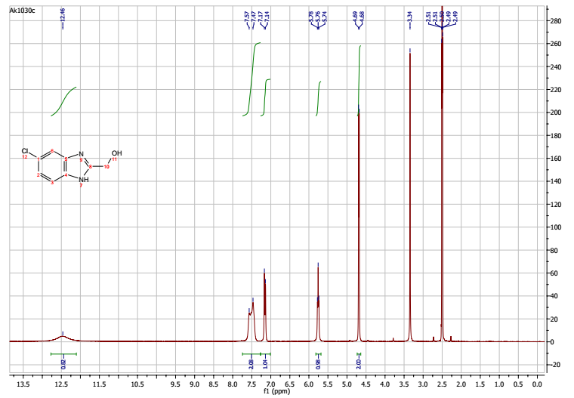

COSY
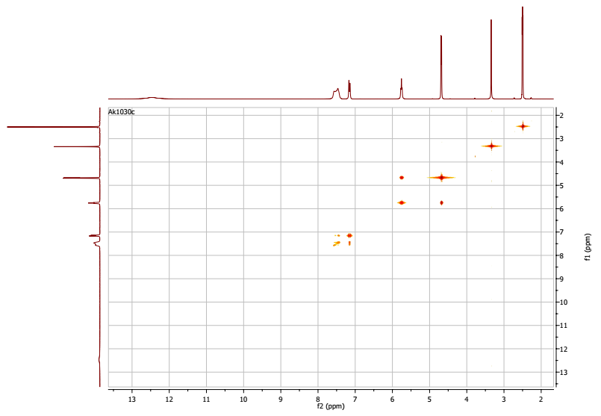
MS Spectrum
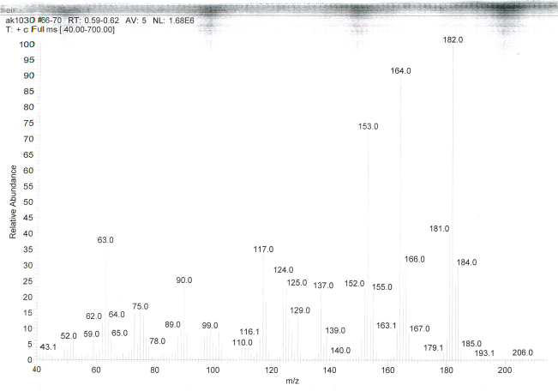

Compound 1c
¹H NMR in DMSO-d₆
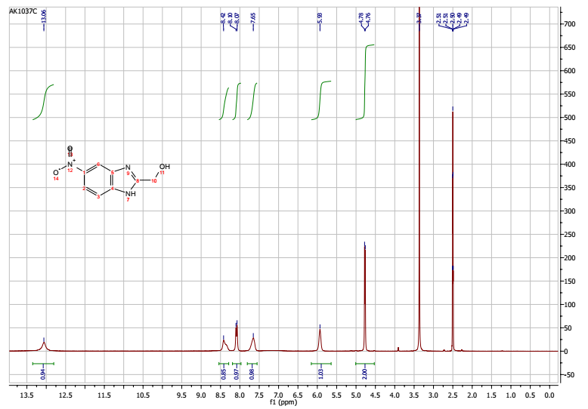
COSY
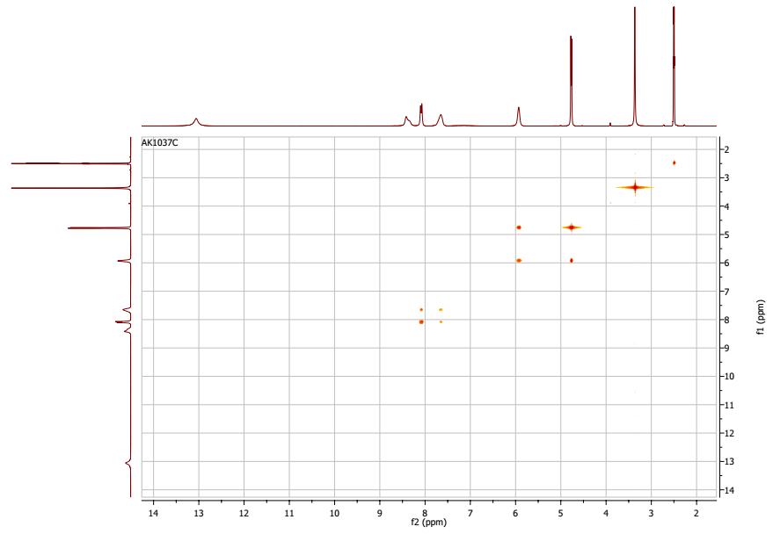

MS Spectrum
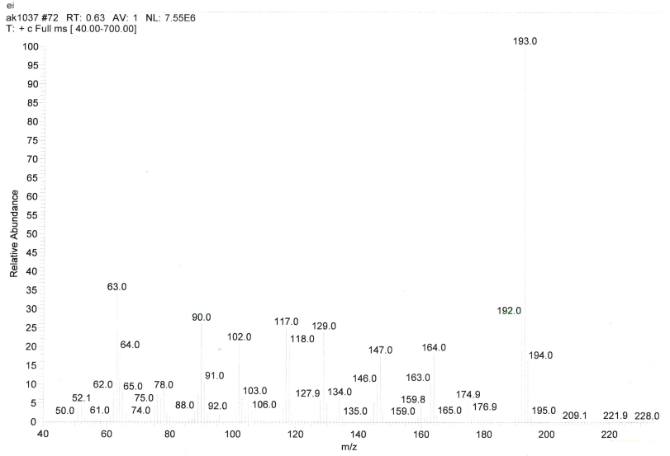

Compound 1d
¹H NMR in DMSO-d₆
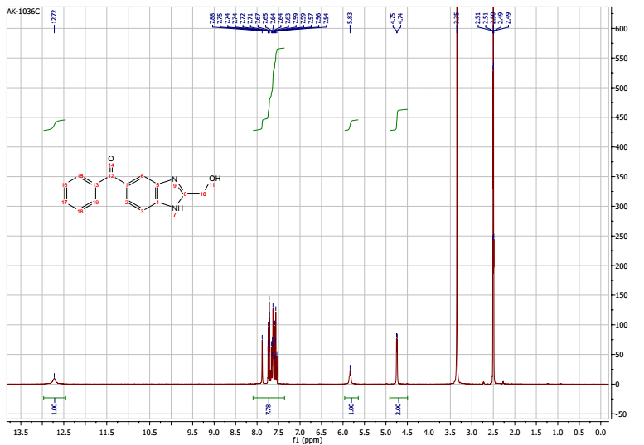

COSY
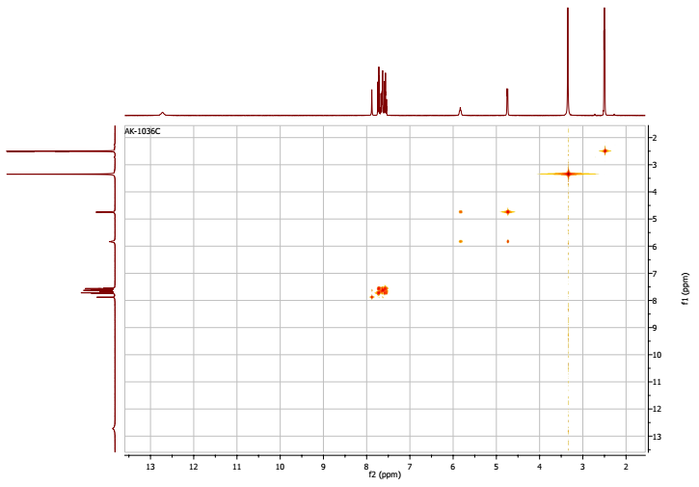

Compound 2b
MS
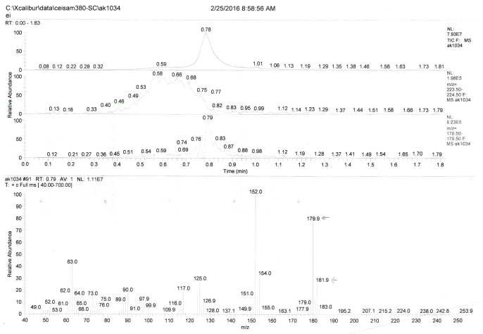

Compound 2d
¹H NMR in DMSO-d₆
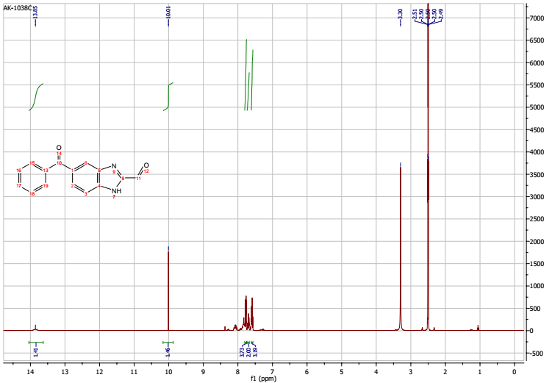
MS
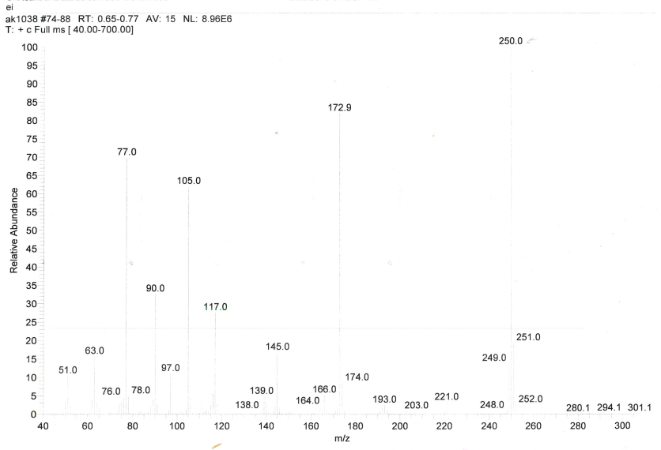

Compound 3d
¹H NMR in DMSO-d₆
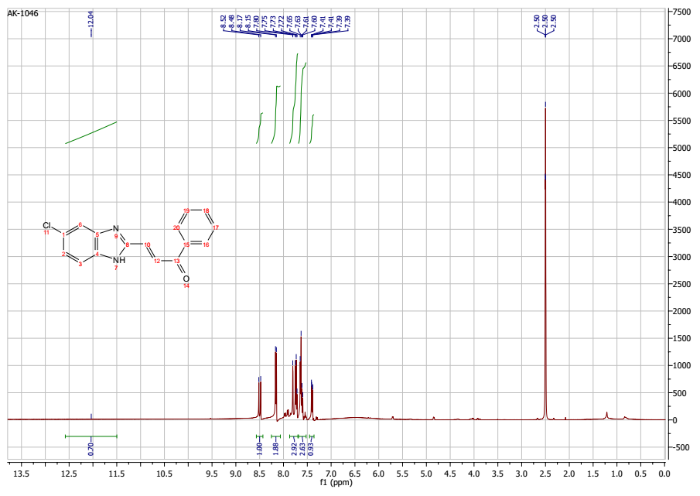
¹³C NMR in DMSO-d₆
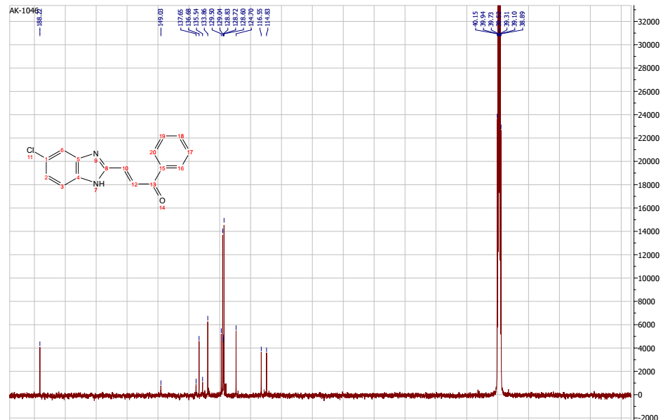

FTIR
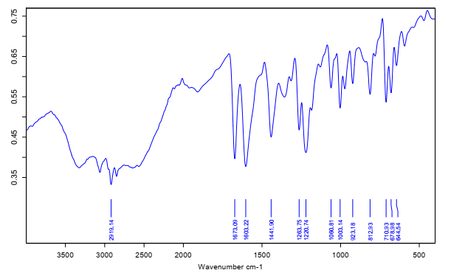
HRMS
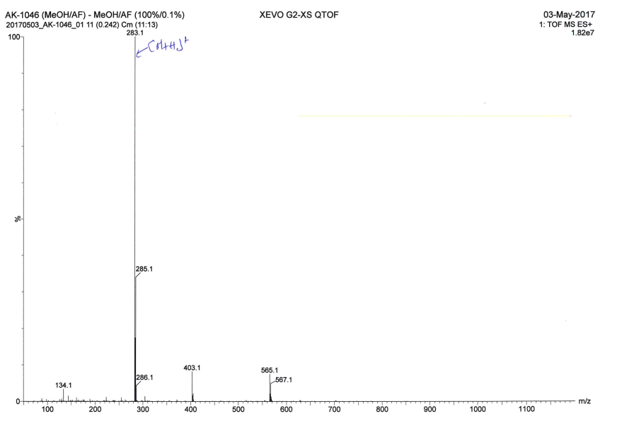
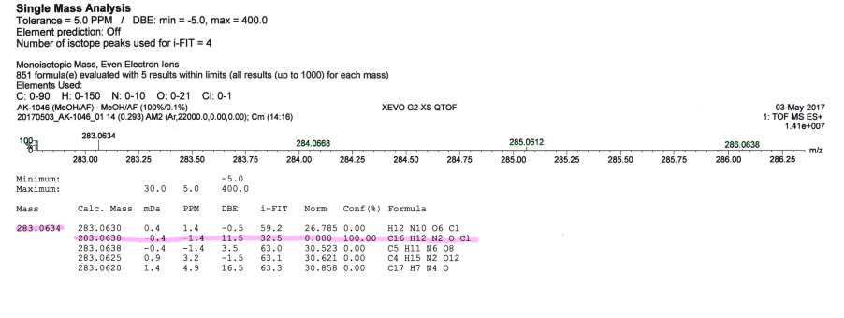

Compound 3e
¹H NMR in DMSO-d₆
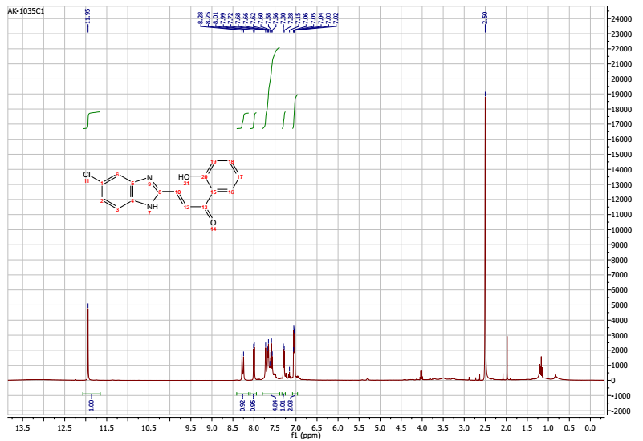

¹³C NMR in DMSO-d₆
e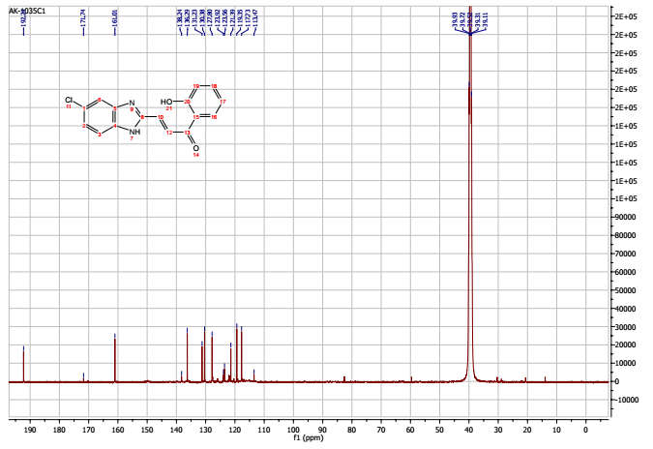
FTIR
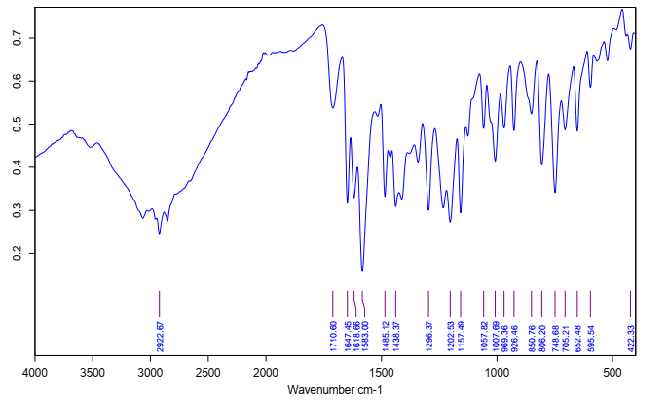

MS
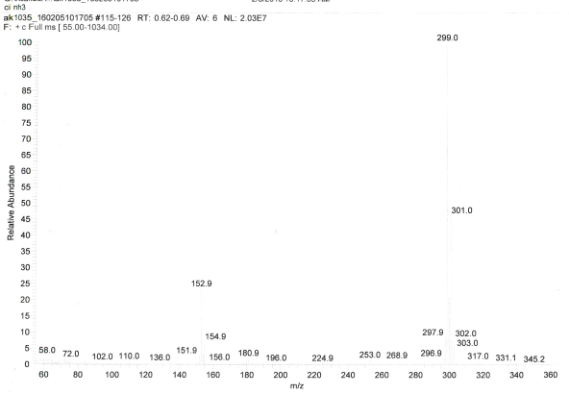
HRMS
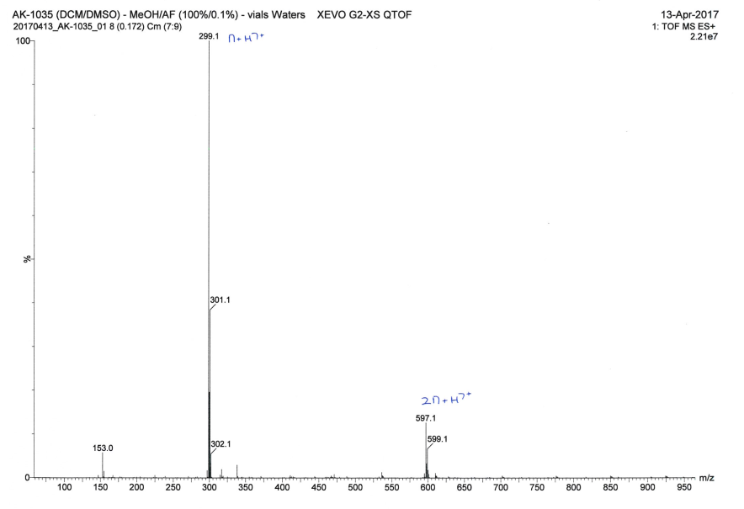
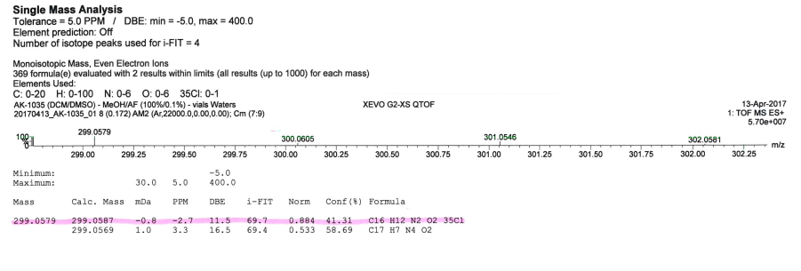

Compound 3f
¹H NMR in DMSO-d₆
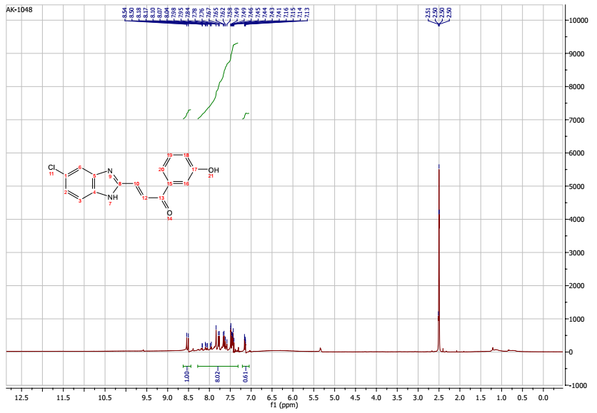

¹³C NMR in DMSO-d₆
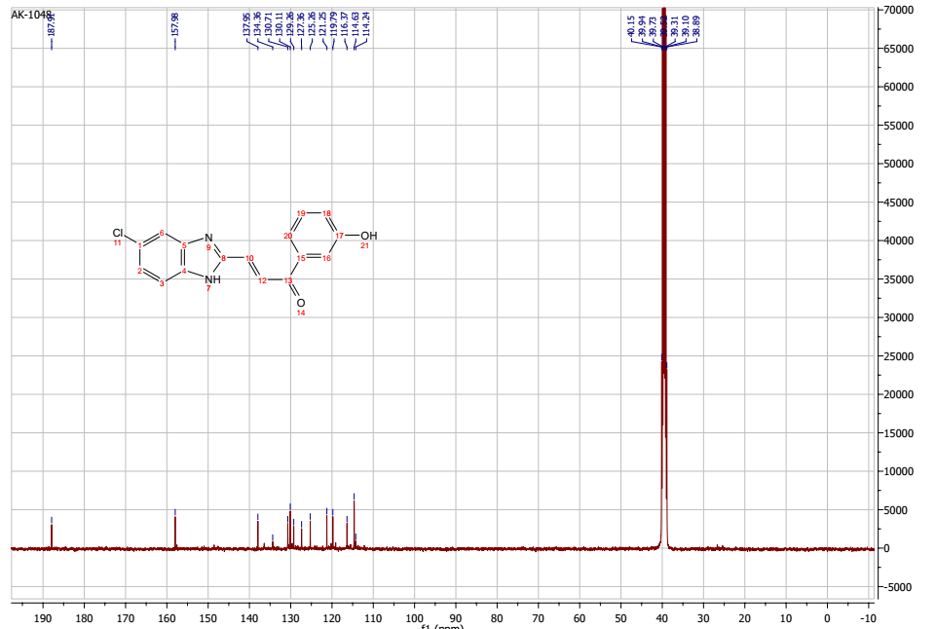
HRMS
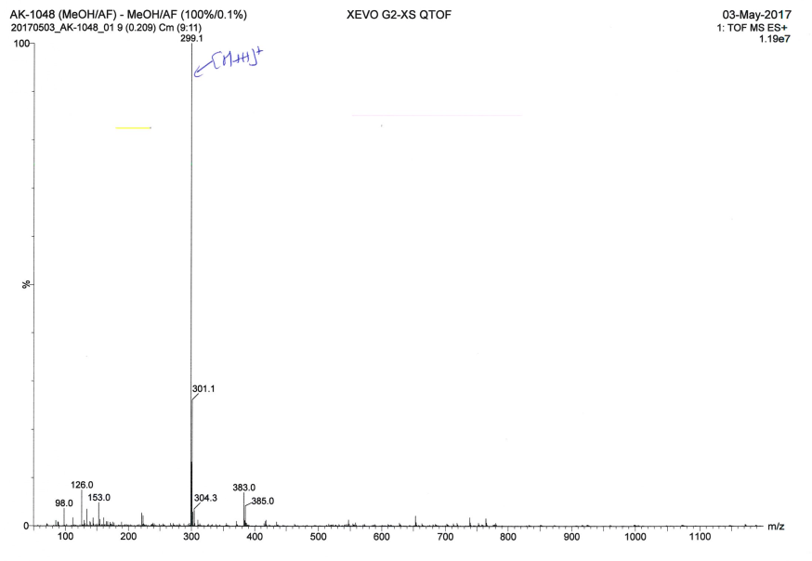
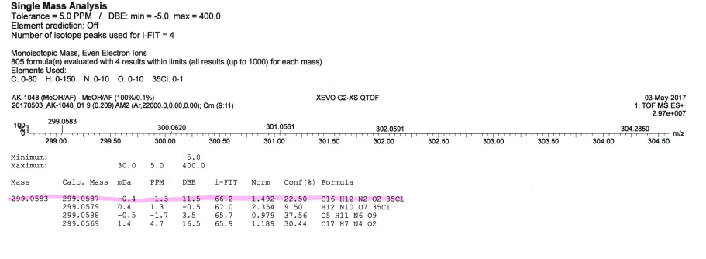

Compound 3g
FTIR
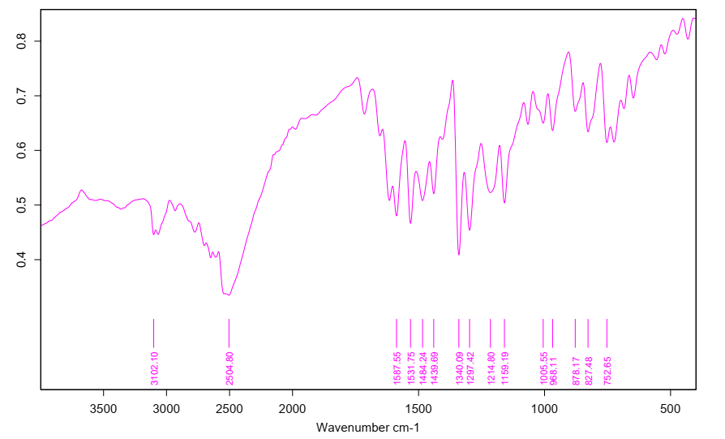

MS
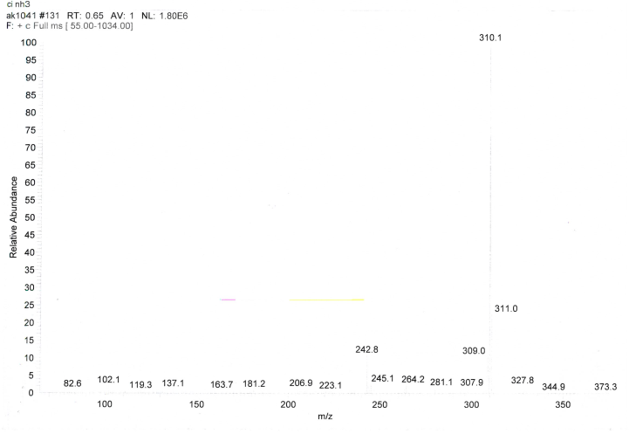
HRMS
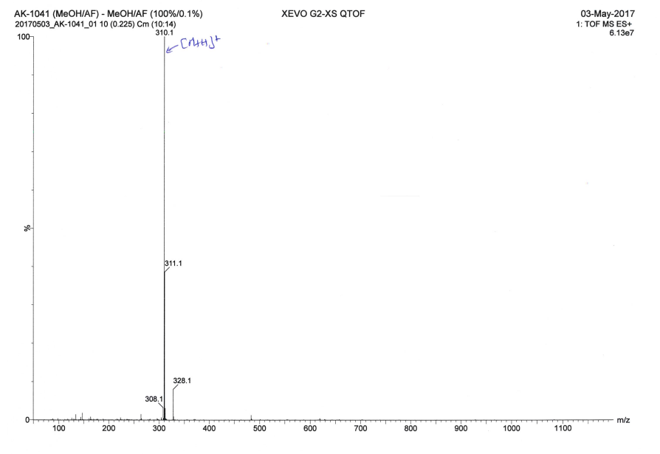
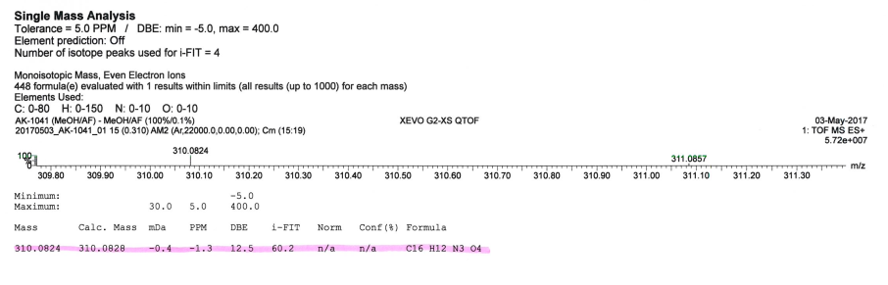

Compound 3h
¹H NMR in DMSO-d₆
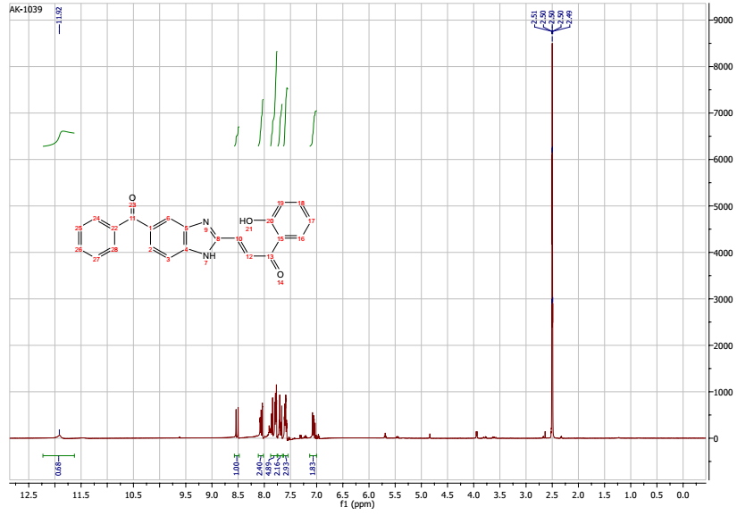

¹³C NMR in DMSO-d₆
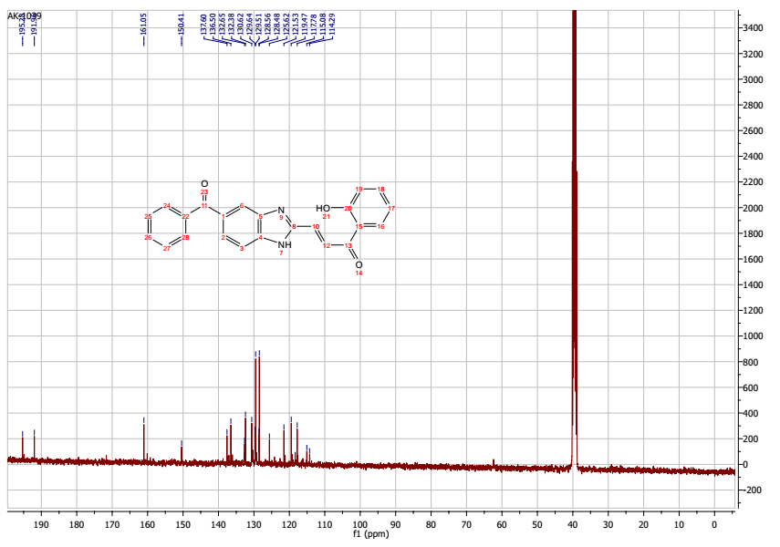
MS
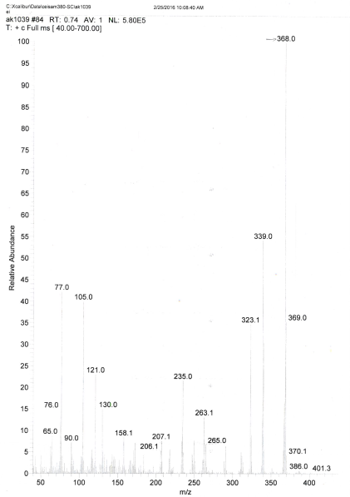
HRMS
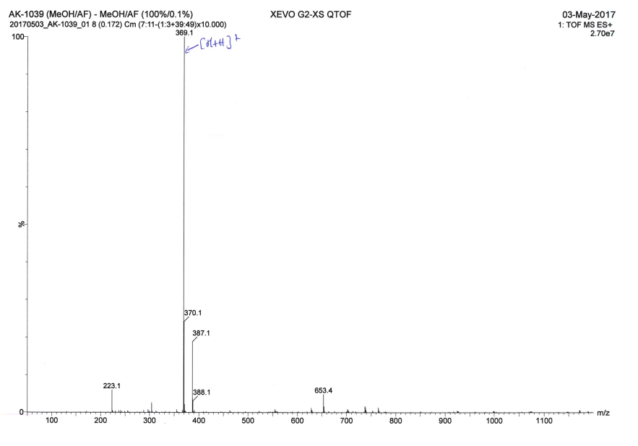
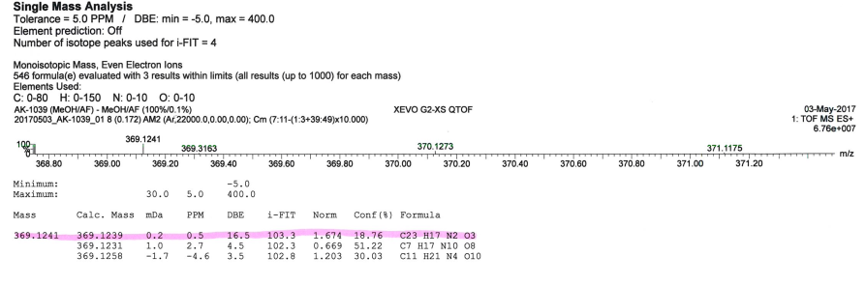

Koné, A., Souleymane, C., Kalo, M., Tchambaga Etienne, C., Collet, S., and Sissouma, D. Synthesis of novel benzimidazole-based retrochalcones and their anticancer activity against breast and colon cancer. Synth. Commun. 55, 175–182 (2025).

