Supplementary Section
TRACTION CURVES
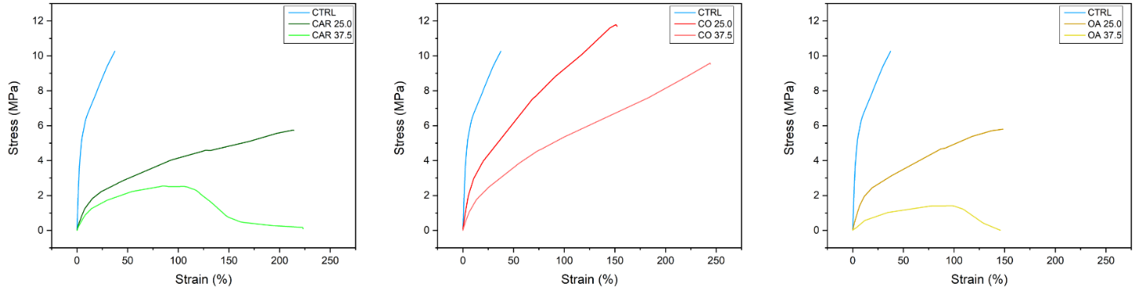
S.1 Traction curves by plasticizer.
CYCLICAL COMPRESSION
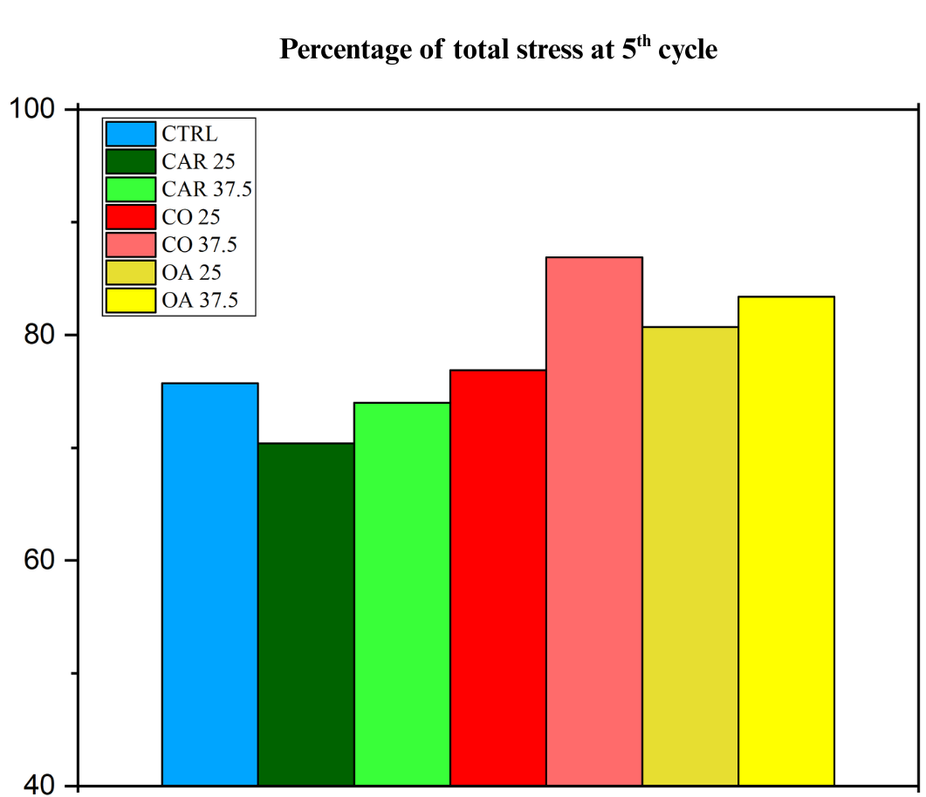
S.2 The histogram represents the percentage at 5th cycle of the final residual stress.
CONTACT ANGLE
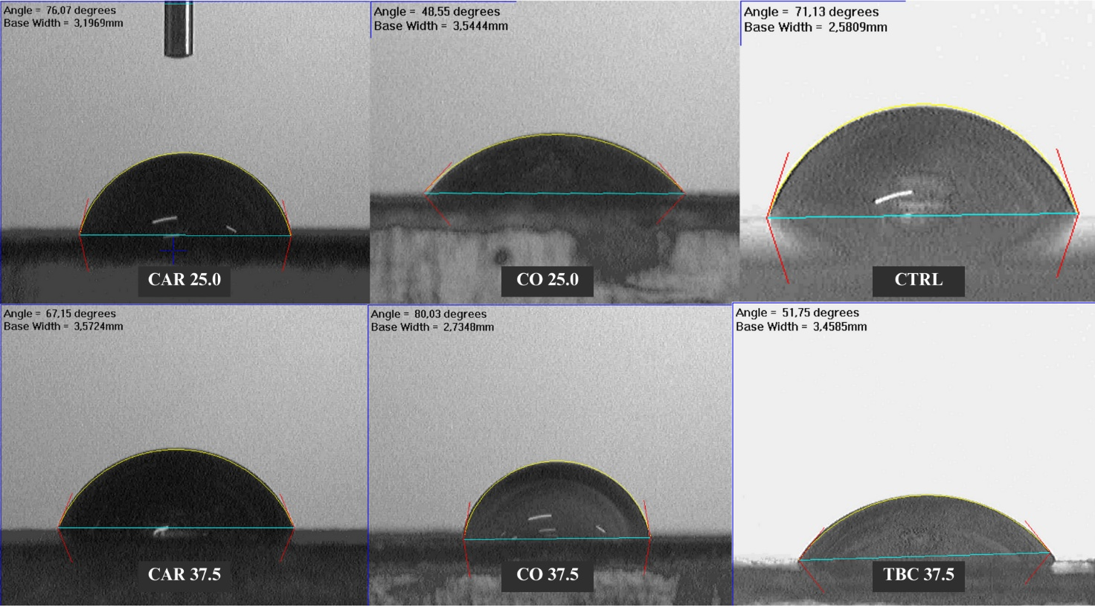
S.3. Sessile drop over plasticized Oleogel, from the left to the right and from up to bottom, respectively, Cardanol 25.0%, Casto Oil 25.0%, Control Oleogel, Cardanol 37.5%, Castor Oil 37.5% and Tributyl Citrate 37.5%.

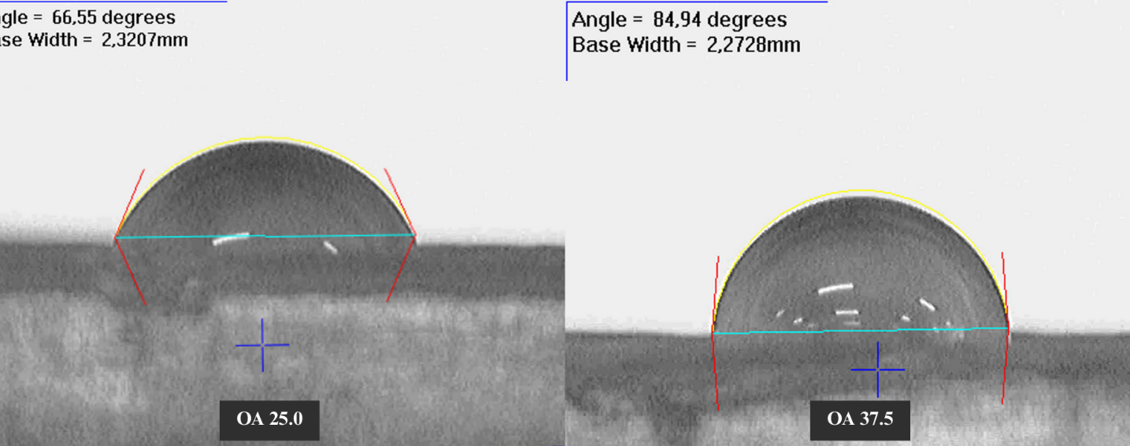
S.4 Sessile drop over plasticized Oleogel with Oleic Acid (25% on the left, 37.5% on the right).
FTIR- ATR
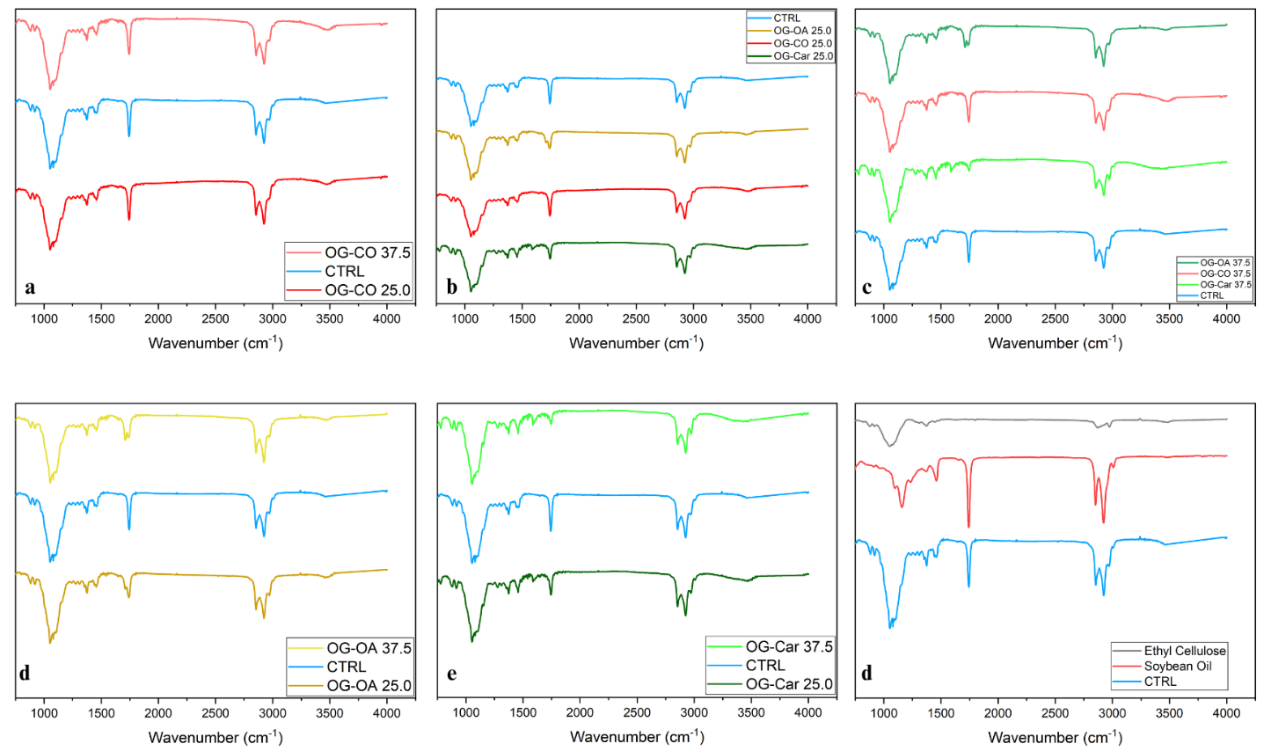
S.5 The base Oleogel and the Oleogels with plasticizers show FTIR spectra are the sum of the spectra of the individual components.
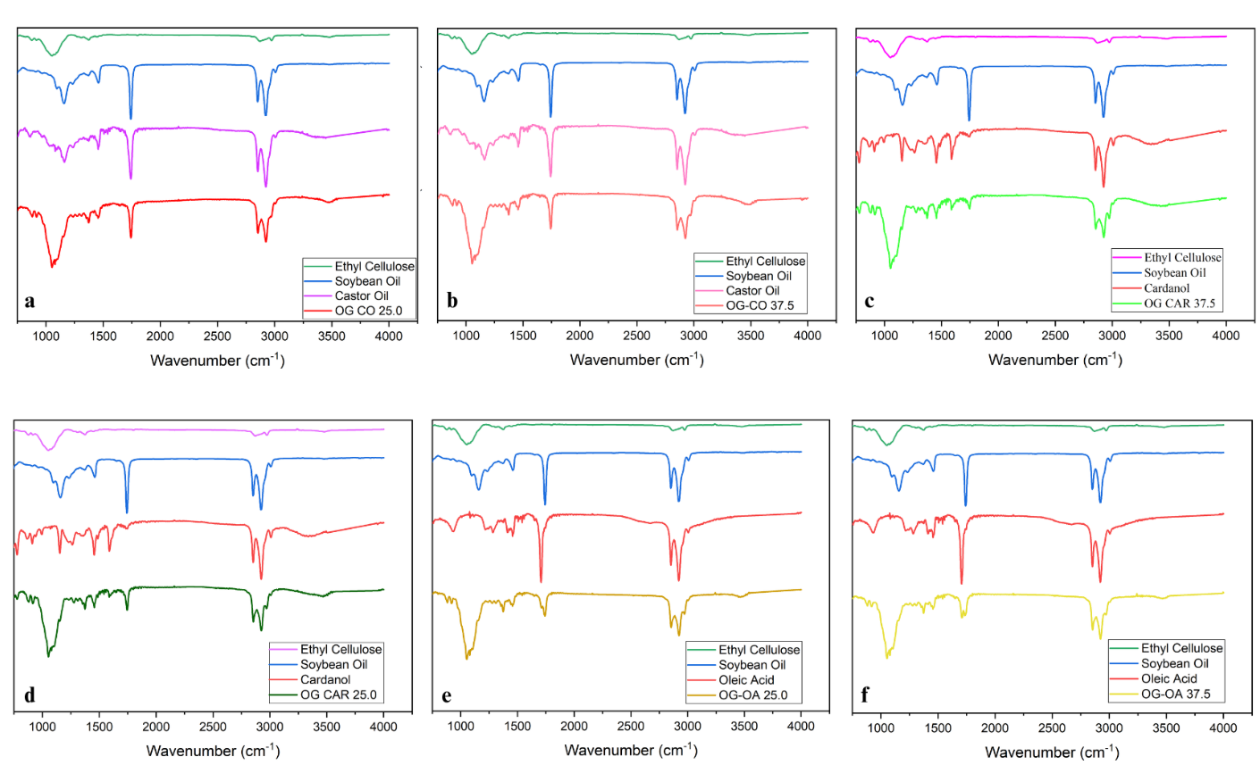
S.6 The base Oleogel and the Oleogels with plasticizers show FTIR spectra are the sum of the spectra of the individual components.
GELATION TEMPERATURE
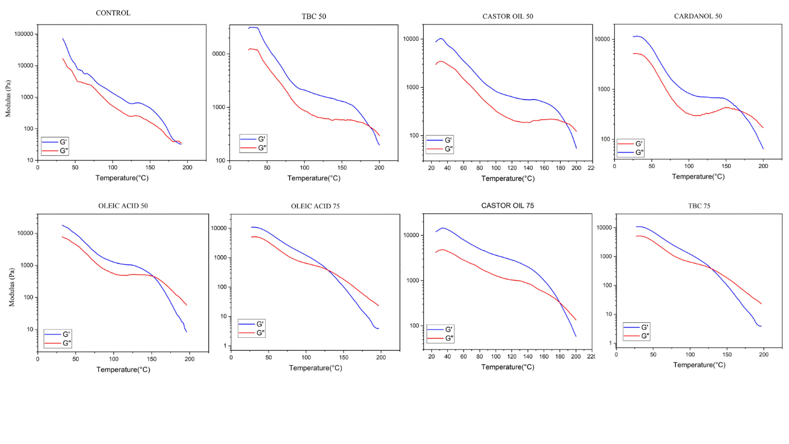
S.7 The gelation temperature decreases proportionally to the amount of plasticizers used in the Oleogel.
DSC-DTA
Differential scanning calorimetry – differential thermal analyses show the transition of Oleogel from a solid-like to a fluid-like starts around 150°C.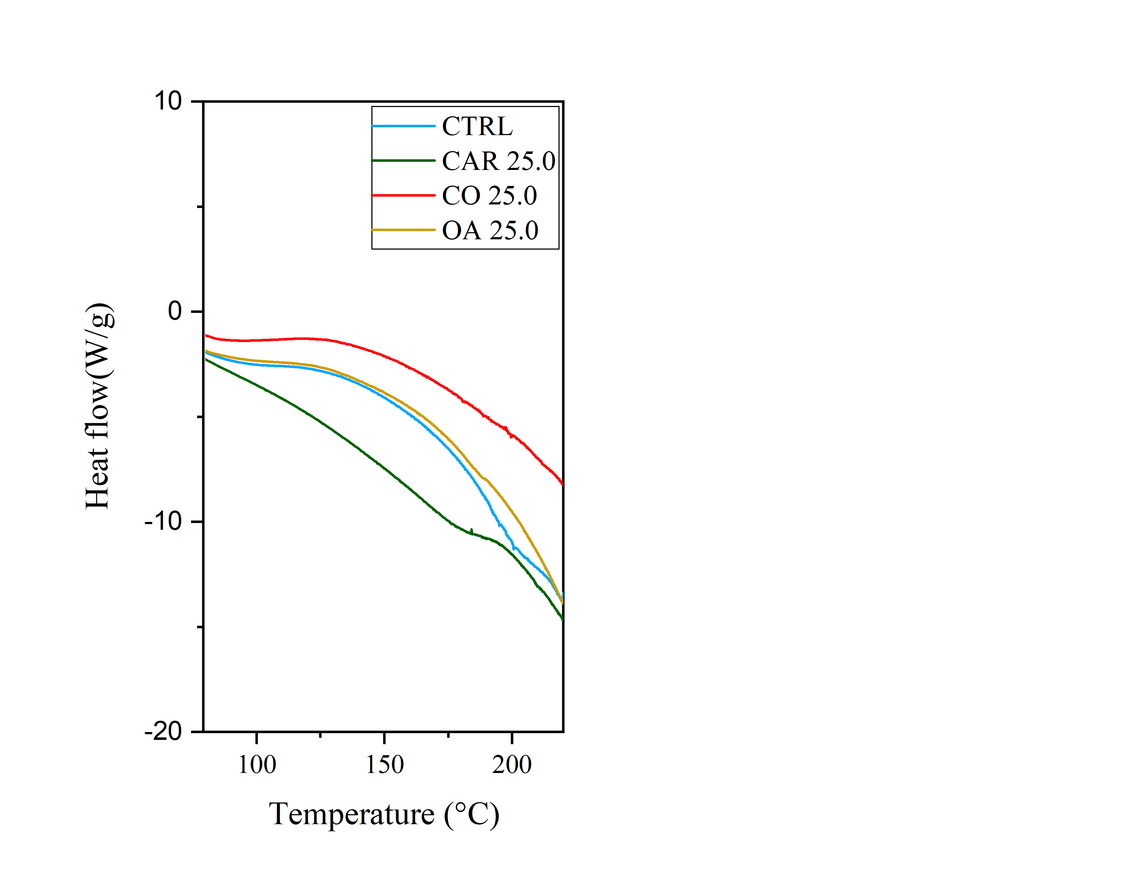
S.8 The thermal event which detects the transition between solid-like to liquid-like is centred around 150°C.

