Supplementary material

Table 1S: Principal Component Analysis (PCA) Results: Eigenvalues, Explained Variance, and Component Loadings for Meat and Dairy Consumption
 | Component 1 (PC1) | Component 2 (PC2)
Eigenvalue Analysis
Eigenvalue | 1.9076 | 0.0923
Proportion of Variance (%) | 95.38% | 4.62%
Cumulative Variance (%) | 95.38% | 100.0%
Principal Component Loadings
Meat Consumption | 0.7071 | -0.7071
Dairy Consumption | 0.7071 | 0.7071

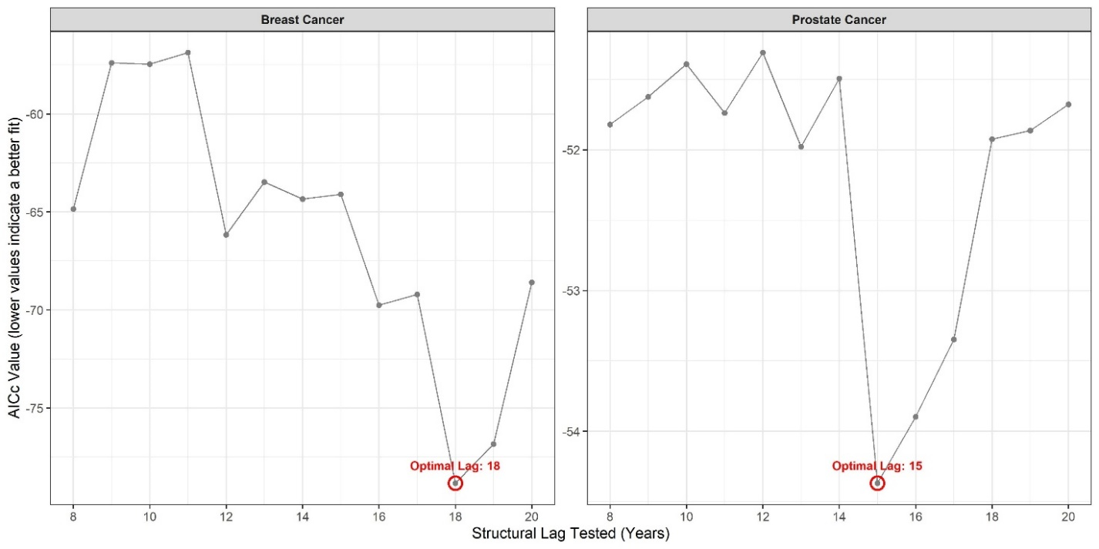

Figure 1S. Optimal Lag selection via Corrected Akaike information criterion (AICc)

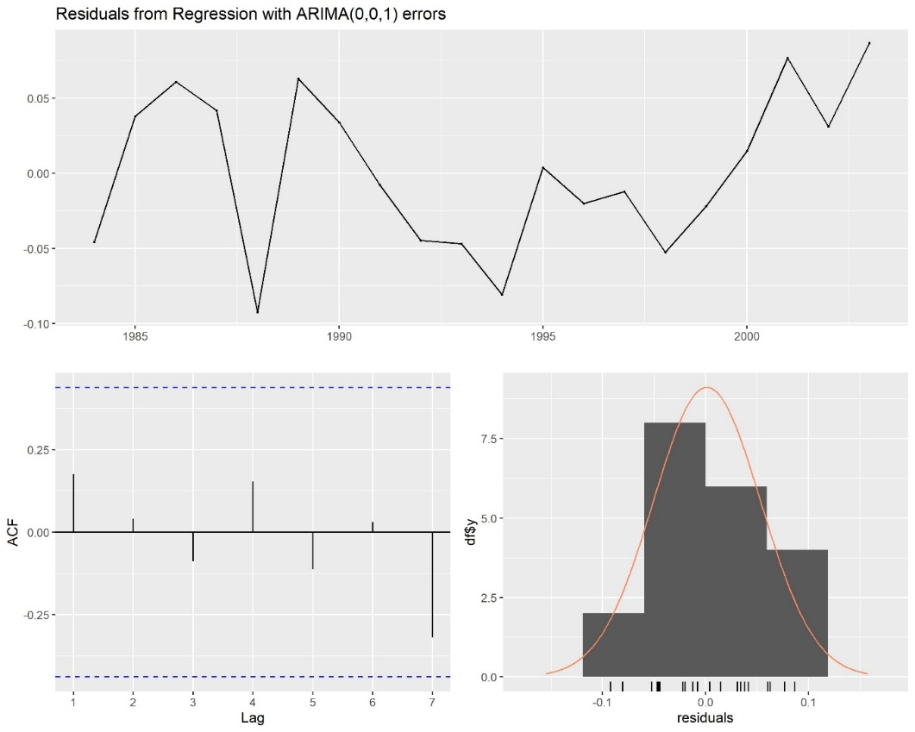

- Breast
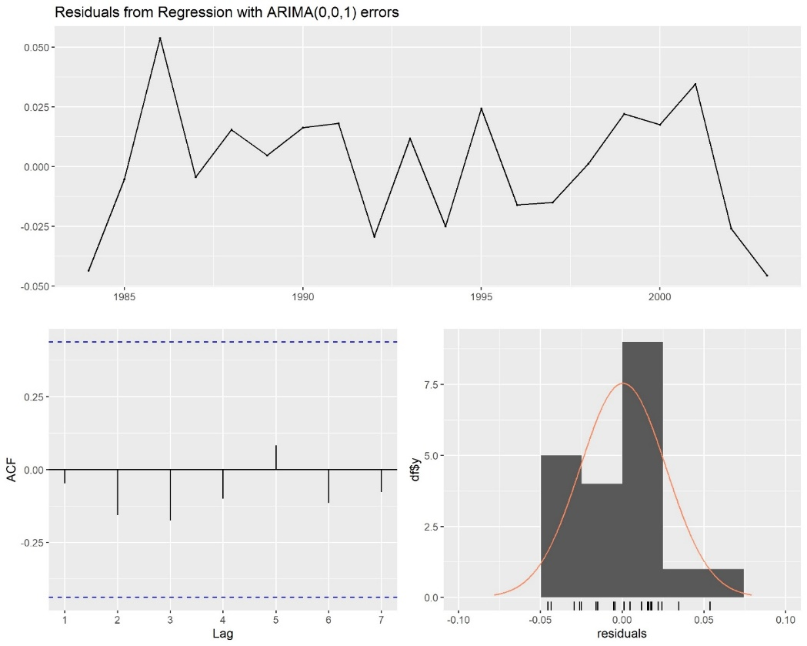

b (Prostate)

Figure 2S: Residual diagnostics plots. (a) Breast model ARIMAX (0,0,1) lag 18 and (b) Prostate model ARIMAX(0,0,1) lag 15

