Supplementary File
S1:
Table S1 – Oligonucleotides used to verify the gene expression of candidate sugar transporters
Oligonucleotides | Sequences (5’-3’)
F – 56684  R – 56684 | CACAACCCTCTCTATGCTGATG  GGGCACGATATTTGGGATATGA
F – 50894  R – 50894 | GGCGGTGTCTTGTATGGTTAC  ATCGTATTCTCCCATGTGCTG
F – 69563  R – 69563 | CGGTCACAGCACAGATAACA  TATCCAGAGTGTCCCAGATGTA
F – 56289  R – 56289 | CTGTAGCCCTCAACTTCATCTC  ACCCAAGATGGGTAGCAAAG
F – 59333  R – 59333 | GTTCCTCGTCGAAGGCTTAAT  CGATCTGTGAACCATCCCTAAG
F – 67541  R – 67541 | GCATTGGCTGCGTTCTTATC  GTTGCCAGAATGCCAATGAG
F – 80058  R – 80058 | CGGCTCGTGACACGTATTAT  CGGTTCCTCGGAATAGTAAACA
F – 54632  R – 54632 | TTTCTGCATGGGTTCTGGG  TCTACCTTGGTCGCAATTCTC
F – 69712  R – 69712 | GACTCAGTGAAGCCTGCATAG  AGTTGCCGATAGACCACATAAC
F – 121482  R – 121482 | CTGCTGAGAAACCGACCTTTA  AACAAGGGCAGGAACAATCT
F – 104816  R – 104816 | TTGGCGGATTCTTGGATTT  TCCGAGGAAGAGGATGAAGA
F – 3532  R – 3532 | GGCTTCTCTGCCGACATTAT  TCGCAGCAAAGGATATGTAAGA
F – 82309  R – 82309 | GCAGAGCTACTTCTCCATGTT  CGCAATACCGATCCACTCTT
F – 104320  R – 104320 | AACCTAGCCTCCCTACTCTTC  AAAGCGGCGATCCAAGTATAG
F – 78833  R – 78833 | GCTCCT ACG TCTTCTTCAACTT  GCATTGGTAATCTCGGGTATCT
F – 105260  R – 105260 | CAGCAGTTCTCCGGAATCAA  ACGAGTCCGAATCCCATAGA
F – 21595  R – 21595 | GGACAGCCACCAGAACTTT  GTACACGACGGAGAGGTAGAT
F – 22912  R – 22912 | TGGTCGGATGTATCATTTGGG  GGACCTGAGCAGATTCGATAC
F – 68812  R – 68812 | CTTCTTCGCTGCTCACTTCT  TTGGCACCCATACAAATACC
F – 76897  R – 76897 | TTGTCGTCCATCGGCTAAAG  CCAGACTTGCCAGTCAGTAAA
F – 70830  R – 70830 | CTCACTGTACATCCTGGGATT  CCGTGCCTATCGAGAACAAT
F – 5000  R – 5000 | ATTGCCGGTATGAGCAAAGA  CCAATCTTGCGGATGAGGAT
F – 65915  R – 65915 | GCTCTTTATGCTGCCGACTA  GACAAAGGAGGCTTGGTATGA
F – 69901  R – 69901 | TGACGAGCTCTTTGCTACTG  CTTCCCTTTGTCTGCCTCTT
F – 62380  R – 62380 | CGCCCTCATCATCTACTTCTTC  GGAACCCATTTGGAGCTCTT
F – 75165  R – 75165 | ATGAAGCAACCAGACCACTC  TGTAGGTCGCGCATTGTT
F – 111888  R – 111888 | ATGGCTTCCGTGGTATGTTC  GCTGAGTCAAGTTGGCTACTA
F – 6005  R – 6005 | GAGGAGAGGAGACTGGTTAGAA  AGATGGCACGGTTGATGTT
F – 106330  R – 106330 | CCTGTACATTGTGGGCATCT  CGACGCAGCCCATAGATAAA
F – 65583  R – 65583 | CTTCTTTGCGGGCTTCTTTG  GACTGGTCCCATTAATCCAGTAG

S2:
Table S2 – Oligonucleotides and sequences used for amplification of fragments with Tr62380 mutations, wild ORFs of Tr62380 and Tr82309, and ORFs for fusion of transporters with GFP
Oligonucleotides | Sequências (5’-3’)
FWD_Tr62380_p416GPD | TTAGTTTCGACGGATTCTAGAACTAGTATGACCGTTACCTTCGACCAGCATG
REV_Tr62380_p416GPD | CGAATTCCTGCAGCCCGGGGGATCCTTAGACATGCTCCTCGTGAGAAGGAG
FWD_62380_GGFIMG | GGGTGGATTTATCATGGGTTACGACACTGG
REV_62380_GGFIMG | CCAGTGTCGTAACCCATGATAAATCCACCC
FWD_62380_S119E | ATTGGTCGCAGGCCCGAAATCTCGTT
REV_62380_S119E | AACGAGATTTCGGGCCTGCGACCAAT
FWD_Tr62380_p416GPD_GFP | TCTAGAACTAGTGGATCCCCCAGGGCTGCAGGATGACCGTTACCTTCGACC
REV_Tr62380_GFP | TGGGACAACACCAGTGAATAATTCTTCACCTTTAGACATGACATGCTCCTCGTGAGAAG
FWD_Tr82309_p416GPD | TTAGTTTCGACGGATTCTAGAACTAGTATGACCGTCCTCACCTCACCTCT
REV_Tr82309_p416GPD | AATTCCTGCAGCCCGGGGGATCCCTACTCCTTTGGCTCGGCAACTT
FWD_Tr82309_p416GPD_GFP | TCTAGAACTAGTGGATCCCCCAGGGCTGCAGGATGACCGTCCTCACCTCAC’
REV_Tr82309_GFP | TGGGACAACACCAGTGAATAATTCTTCACCTTTAGACATCTCCTTTGGCTCGGCAAC
FWD_GFP_p416GPD | ATGTCTAAAGGTGAAGAATTATTCACTG
REV_GFP_p416GPD | TTATTTGTACAATTCATCCATACCATG

S3:
Table S3 – Oligonucleotides and sequences used to confirm the transformation of Tr62380_WT, and its mutants, and Tr82309_WT
Oligonucleotides | Sequences
FWD_Tr62380_p416GPD | GTCTTGGGCTTTGGCATCTT
REV_Tr62380_p416GPD | CGAATTCCTGCAGCCCGGGGGATCCTTAGACATGCTCCTCGTGAGAAGGAG
FWD_Tr82309_p416GPD | TTAGTTTCGACGGATTCTAGAACTAGTATGACCGTCCTCACCTCACCTCT
REV_Tr82309_p416GPD | AATTCCTGCAGCCCGGGGGATCCCTACTCCTTTGGCTCGGCAACTT

S4:

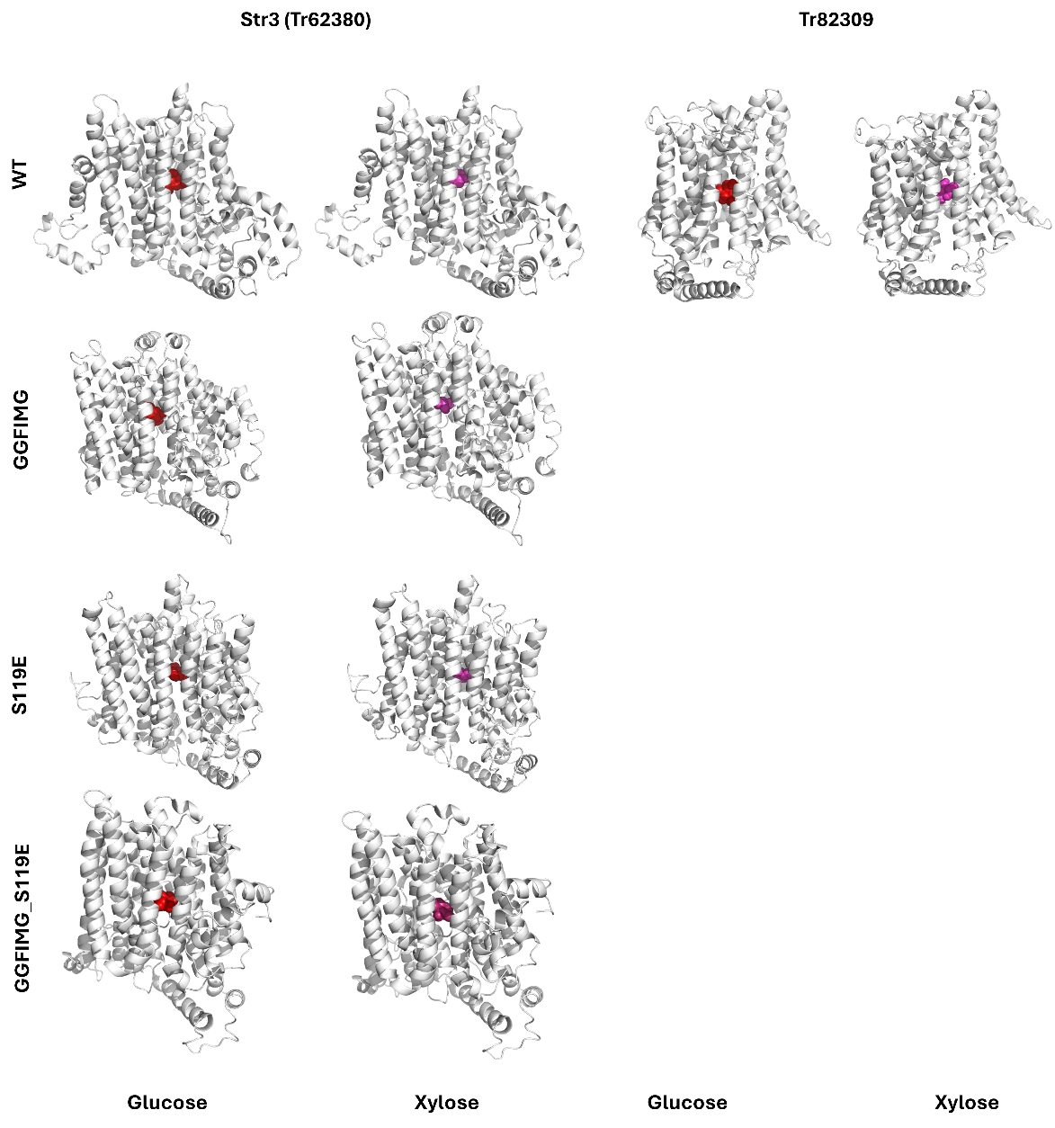
Figure S4 – Three-dimensional models of Str3 (Tr62380)_WT and its mutants, from Tr82309_WT, docked with glucose (red) and xylose (purple).

S5:
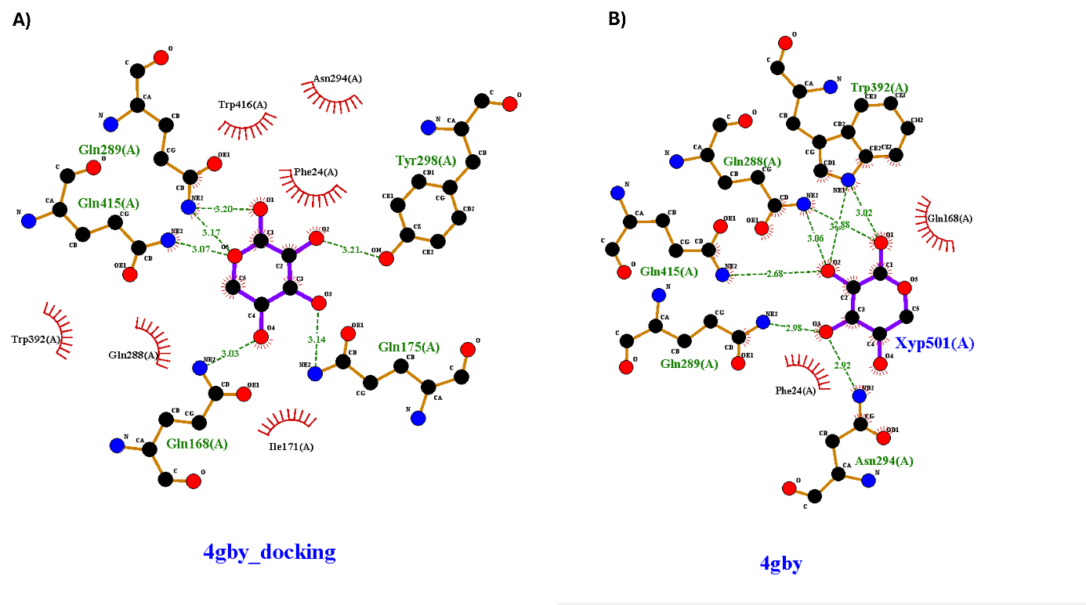
Figure S5 – Docking validation. A) Interactions between 4GBY and xylose from the mobile docking. B) Interactions between 4GBY and xylose from the file deposited in the PDB.

S6:
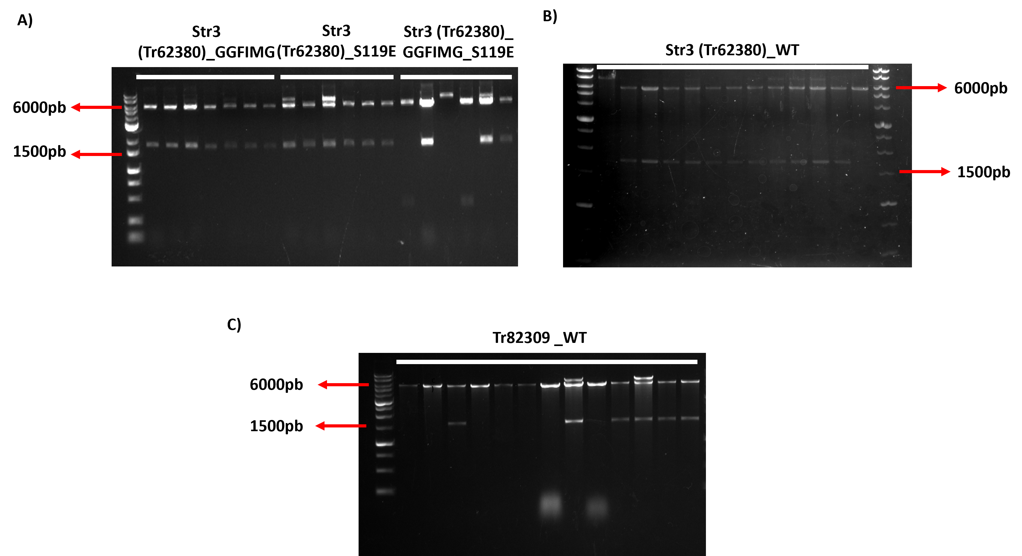
Figure S6 – Digestion of constructed expression cassettes. A) Expression cassettes digested with SmaI and BcuI of transporters with Str3 mutations (Tr62380). B) Expression cassettes digested with Str3 SmaI and BcuI (Tr62380). C) Expression cassettes digested with SmaI and BcuI of Tr82309.
S7:
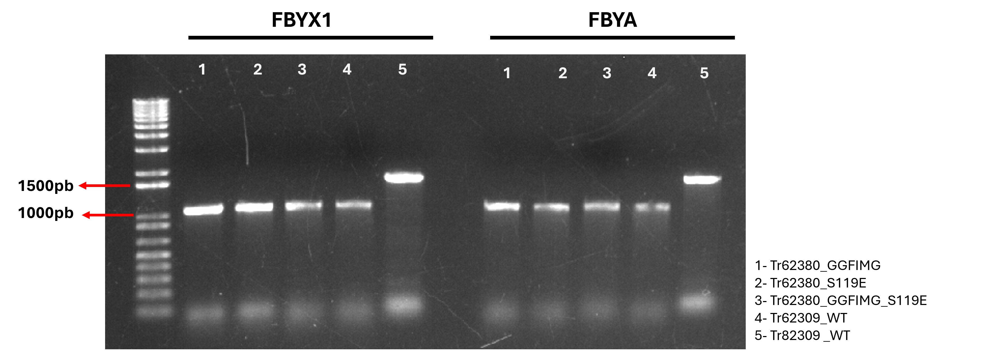
Figure S7 – PCR of expression cassettes after transformation into S. cerevisiae FBYX1 and FBYA strains.

S8:
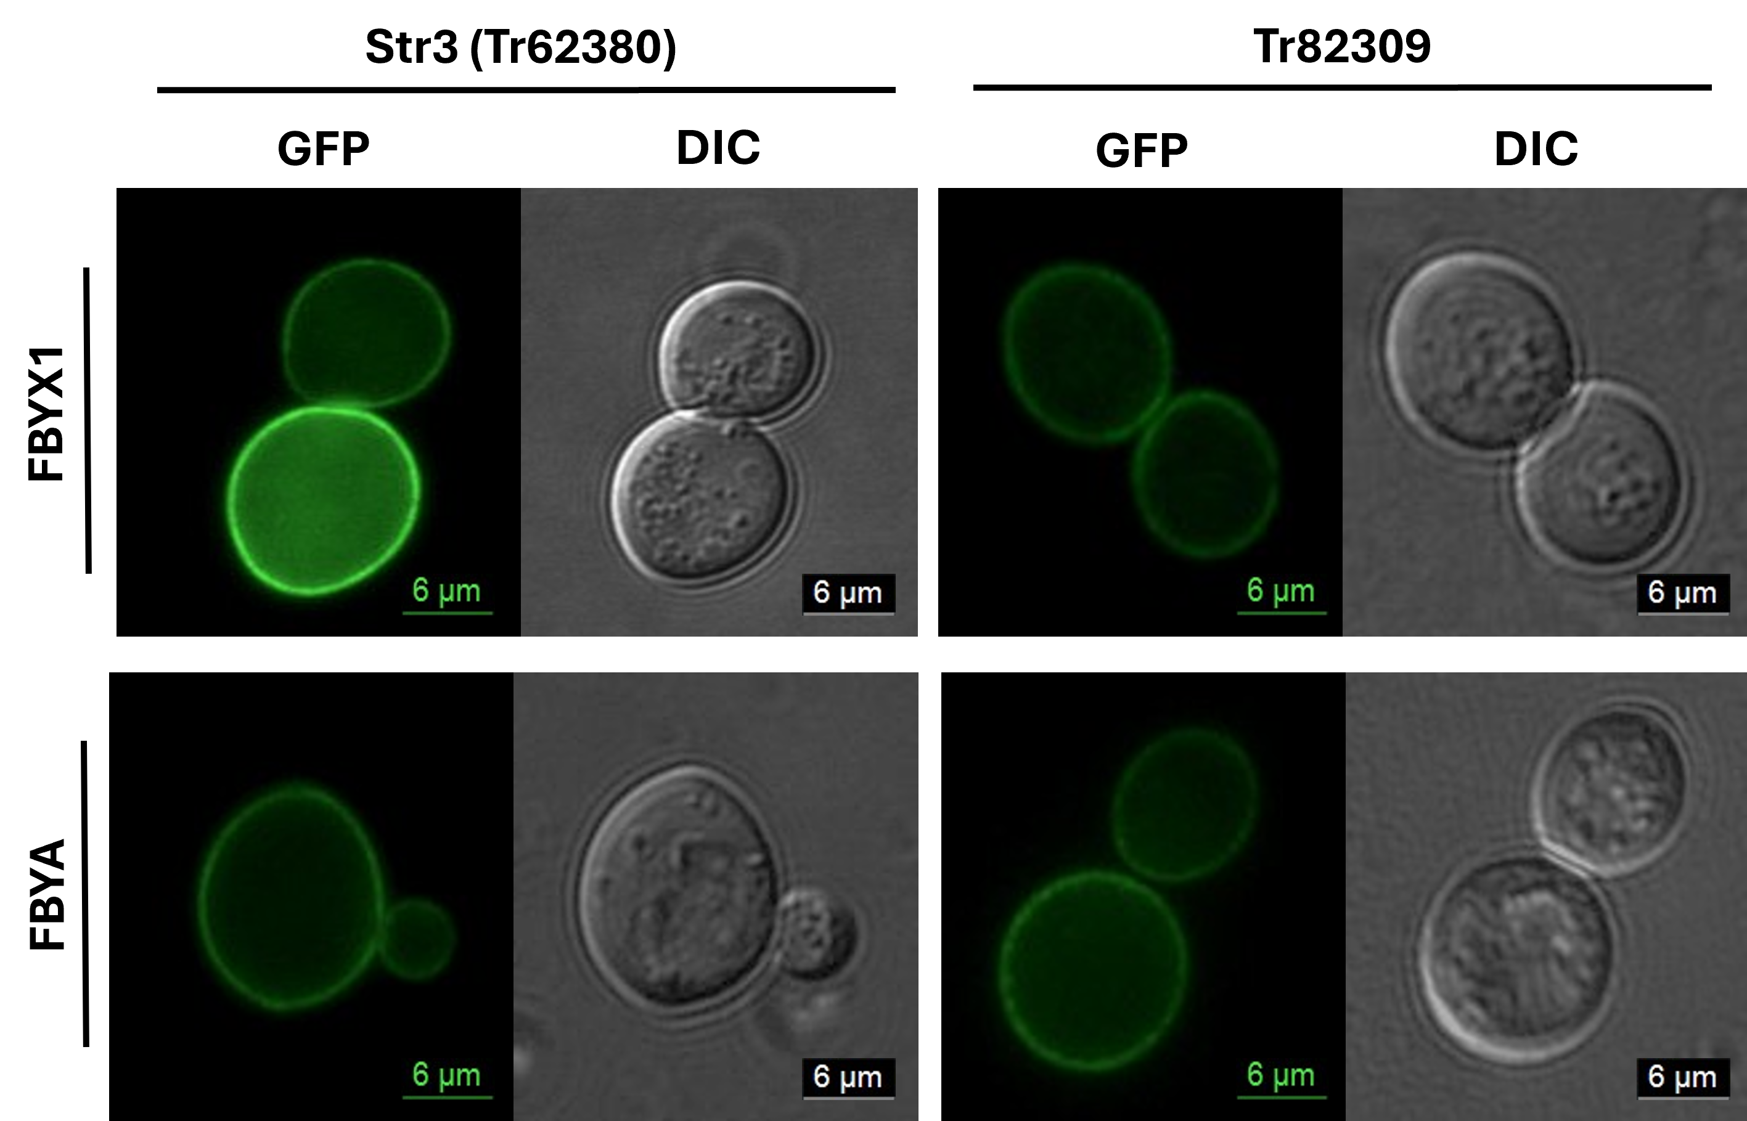
Figure S8 – Fluorescence microscopy of FBYX1 and FBYA cell lines expressing Str3 (Tr62380) and Tr82309 cassettes fused to GFP.

