Joint association of Body Roundness Index and Atherogenic Index of Plasma with new-onset stroke in middle-aged and older adults: first evidence from the China Health and Retirement Longitudinal Study

Supplementary Materials
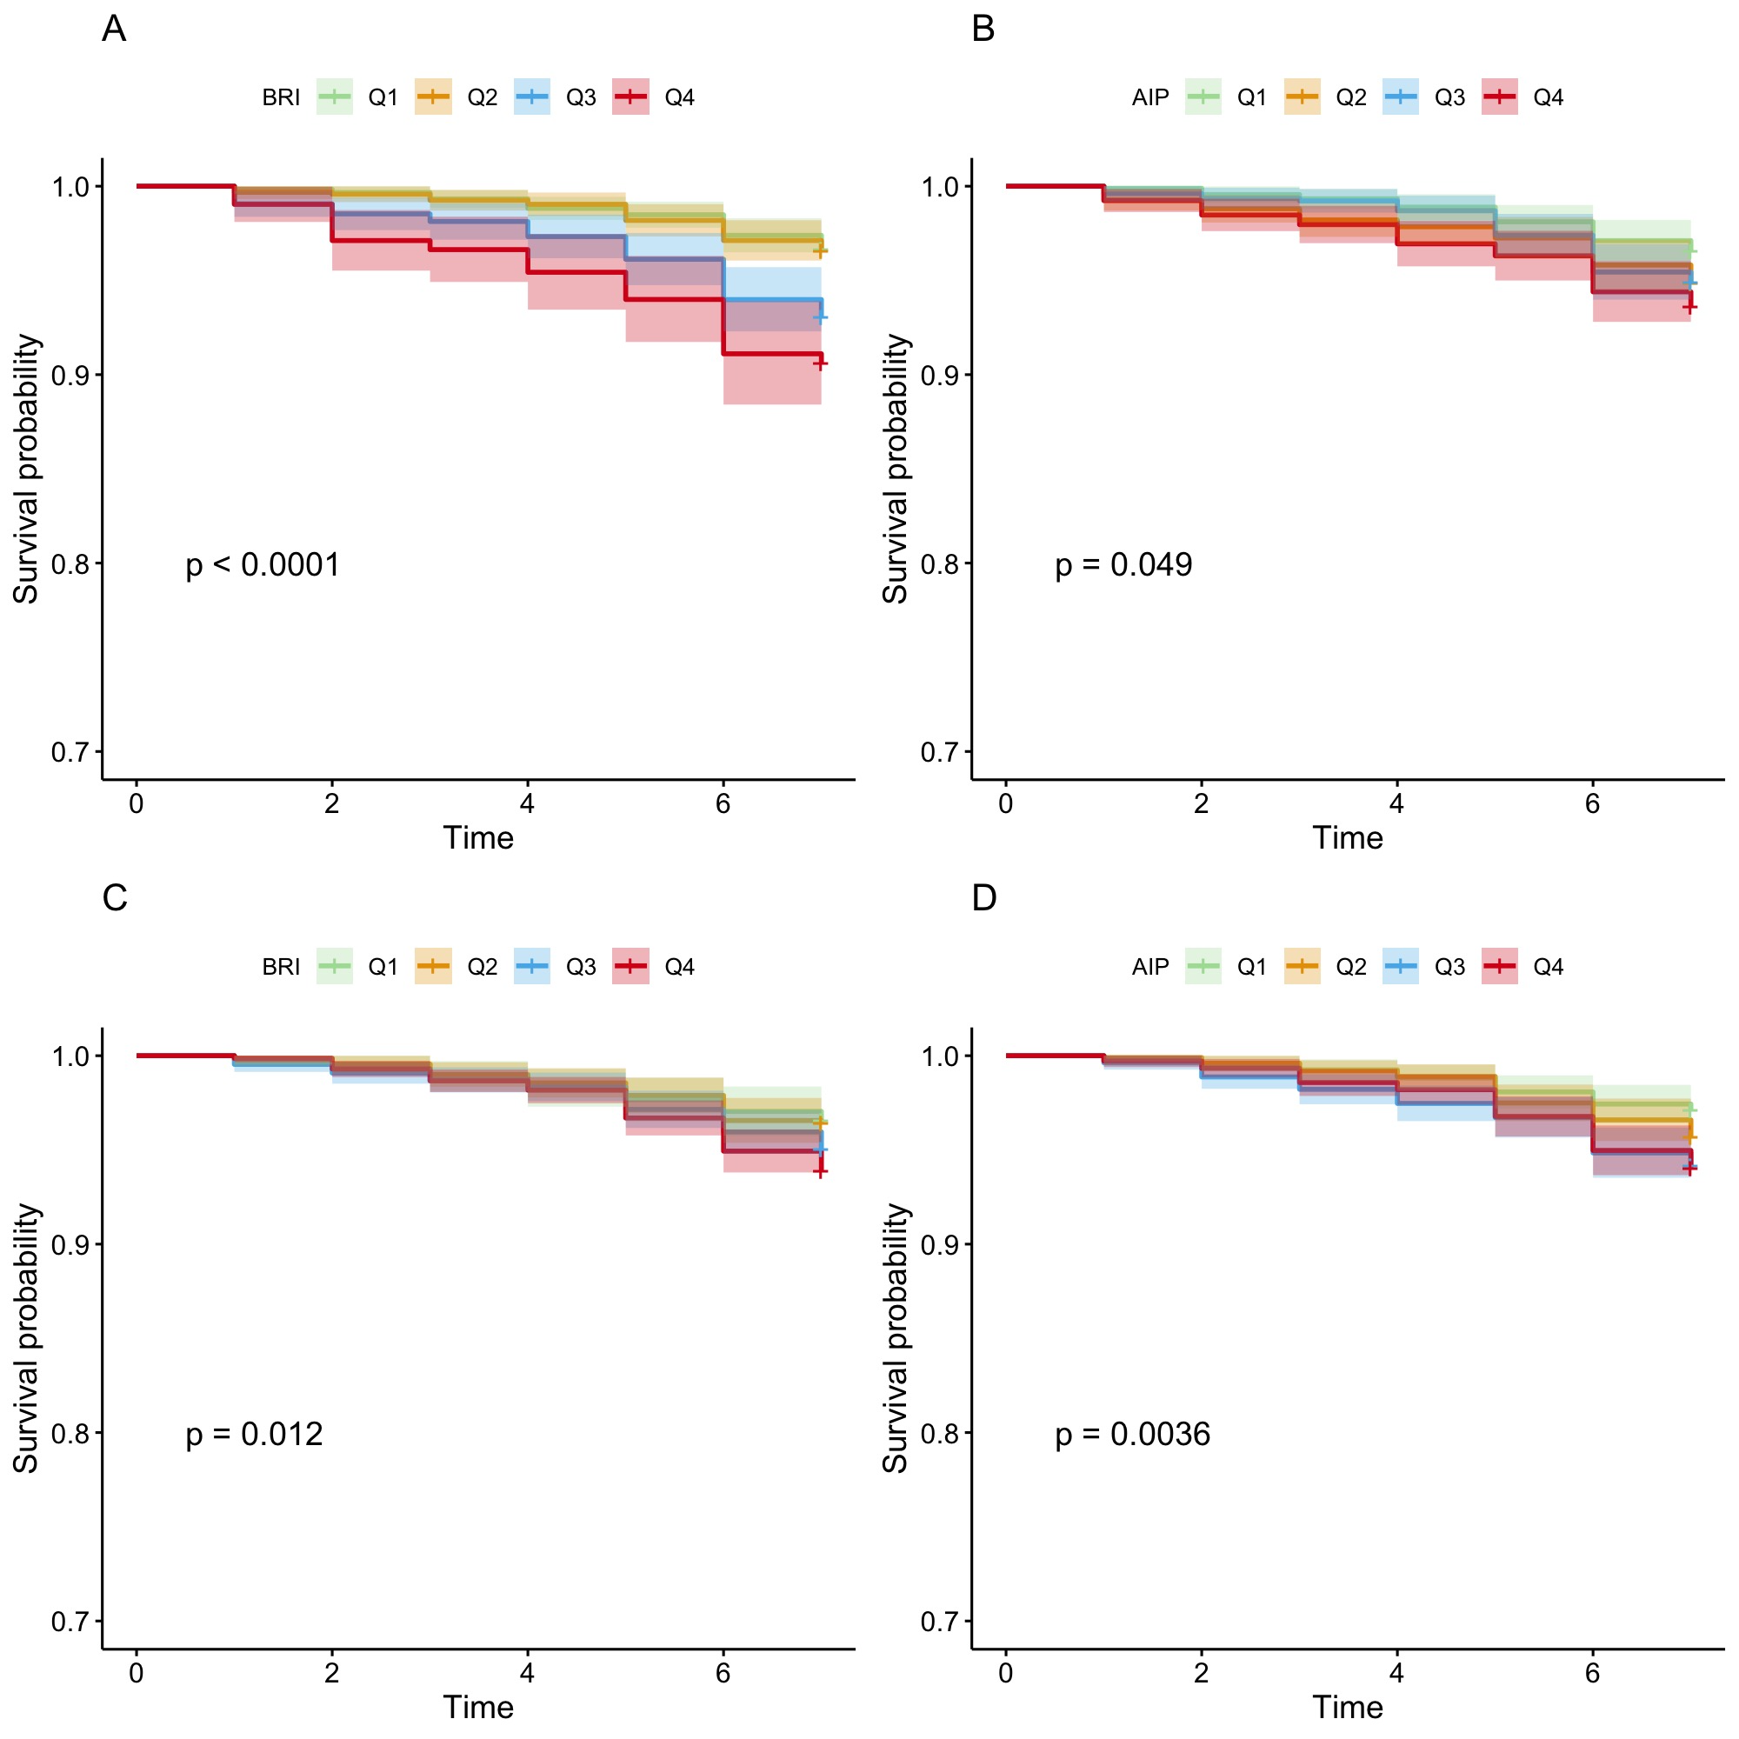
Supplementary Figure 1. Kaplan–Meier Curves for Stroke Incidence by BRI and AIP Stratification in Men and Women Aged ≥45 Years
Kaplan–Meier survival curves depicting stroke-free probability among individuals aged 45 years and older, stratified by Body Roundness Index (BRI) and Atherogenic Index of Plasma (AIP) quartiles, and separated by sex.
(A) BRI quartiles in men.
(B) AIP quartiles in men.
(C) BRI quartiles in women.
(D) AIP quartiles in women.
Participants were divided into quartiles (Q1–Q4) based on BRI or AIP levels. Shaded areas represent 95% confidence intervals. Log-rank test P values are shown in each panel.

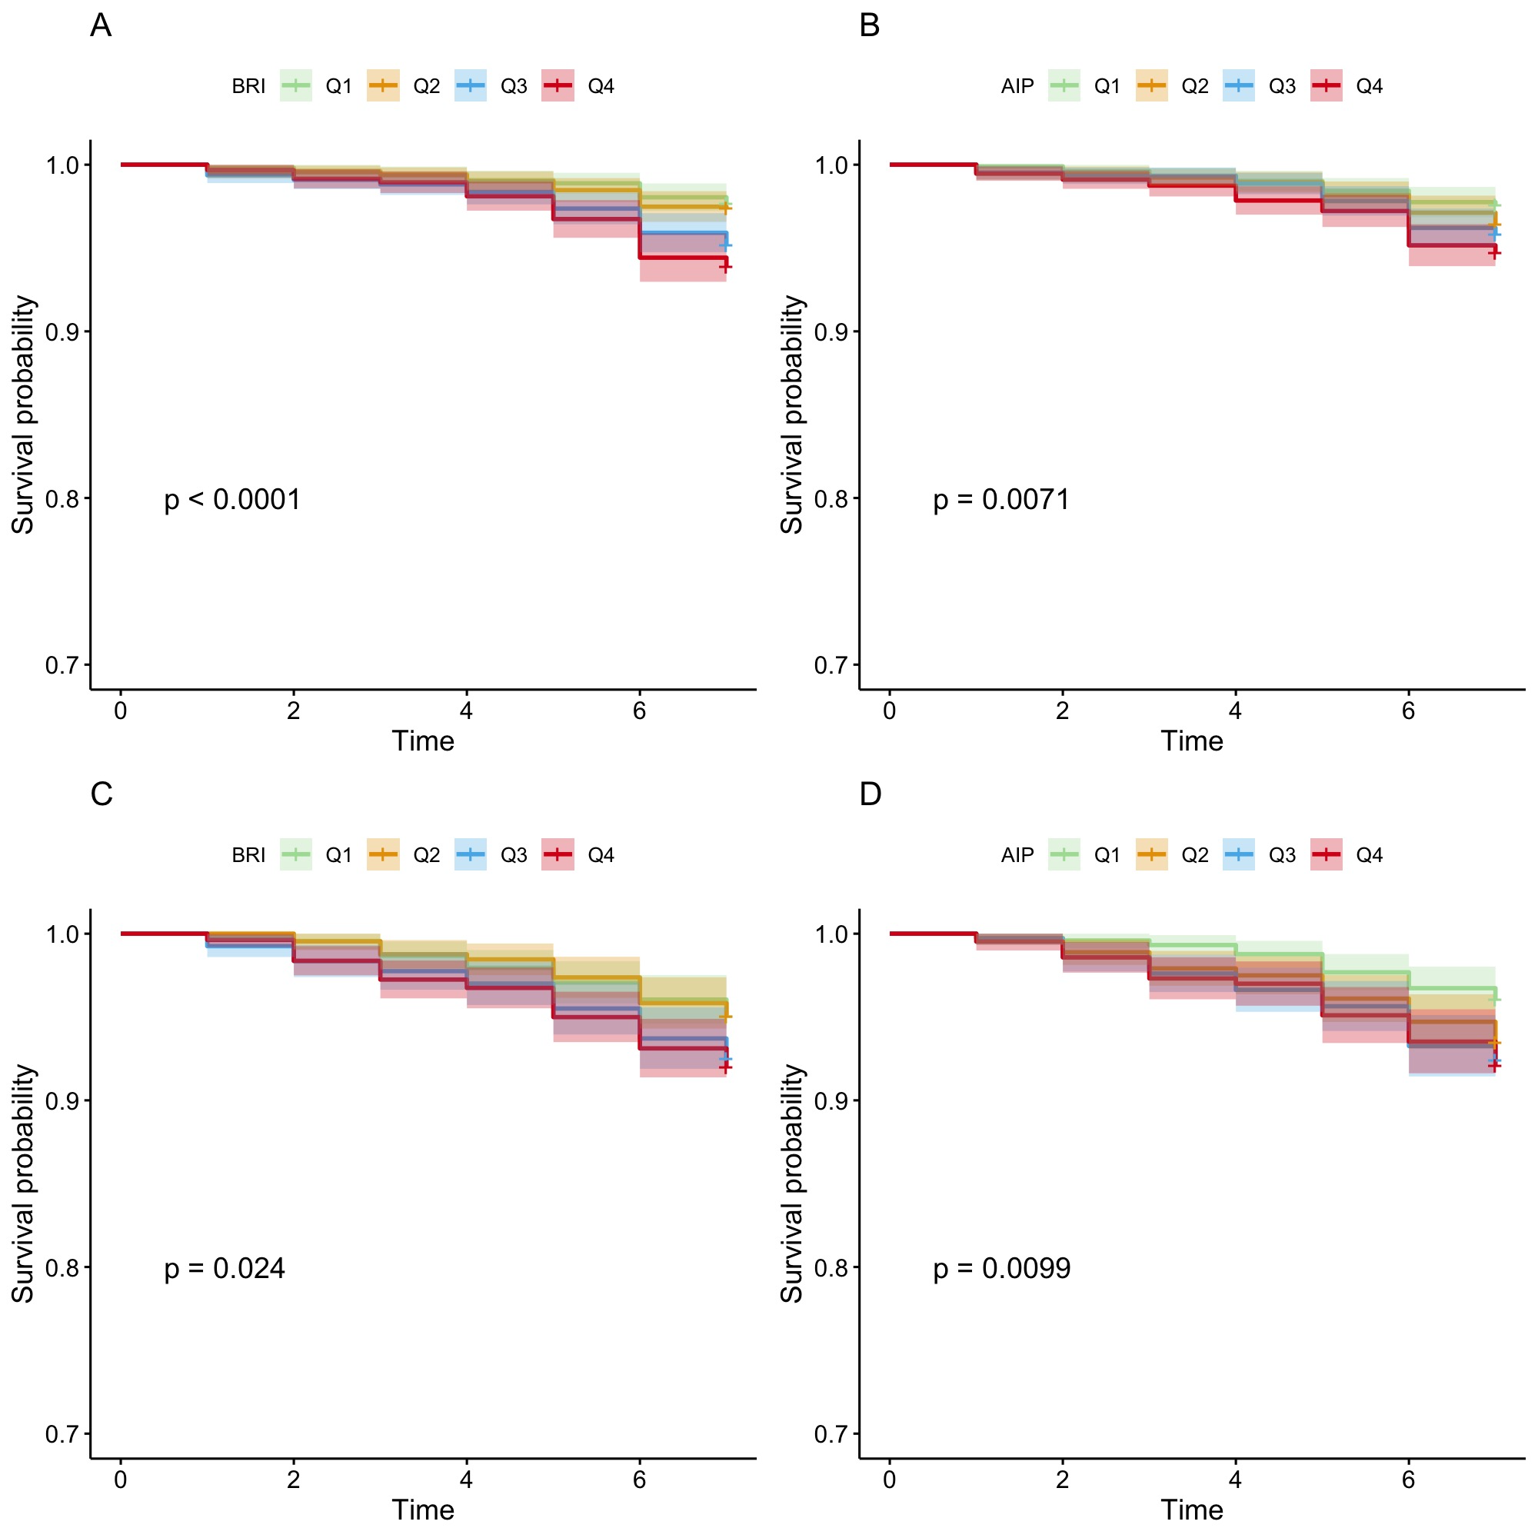Supplementary Figure 2. Kaplan–Meier Curves for Stroke Incidence Stratified by BRI and AIP in Middle-Aged and Older Adults.
Kaplan–Meier survival curves showing stroke-free probability among participants aged ≥45 years, stratified by quartiles of Body Roundness Index (BRI) and Atherogenic Index of Plasma (AIP), and grouped by age.
(A) BRI quartiles in middle-aged adults (45–59 years).
(B) AIP quartiles in middle-aged adults (45–59 years).
(C) BRI quartiles in older adults (≥60 years).
(D) AIP quartiles in older adults (≥60 years).
Participants were classified into quartiles (Q1–Q4) based on BRI or AIP values.
Supplementary Table 1. Independent associations of BRI and AIP with the risks of stroke among male adults ª.
 |  | Model A |  |  | Model B |  |  | Model C
 | HR | 95% CI | P value | HR | 95% CI | P value | HR | 95% CI | P value
BRI
Continuous | 1.39 | 1.24-1.56 | <0.001 | 1.40 | 1.25-1.57 | <0.001 | 1.27 | 1.12-1.45 | <0.001
Q1 | Reference |  |  | Reference |  |  | Reference
Q2 | 1.02 | 0.64-1.62 | 0.945 | 1.01 | 0.63-1.61 | 0.968 | 0.95 | 0.59-1.53 | 0.845
Q3 | 2.11 | 1.40-3.19 | <0.001 | 2.10 | 1.39 -3.17 | <0.001 | 1.76 | 1.14-2.72 | 0.011
Q4 | 2.90 | 1.87- 4.51 | <0.001 | 2.92 | 1.88-4.53 | <0.001 | 2.18 | 1.34 -3.54 | 0.002
P trend |  |  | <0.001 |  |  | <0.001 |  |  | <0.001
AIP
Continuous | 1.85 | 1.25-2.75 | 0.002 | 2.17 | 1.44-3.25 | <0.001 | 1.66 | 1.07- 2.56 | 0.023
Q1 | Reference |  |  | Reference |  |  | Reference
Q2 | 1.51 | 1.40-3.12 | 0.082 | 1.56 | 0.98- 2.47 | 0.061 | 1.41 | 0.88-2.27 | 0.156
Q3 | 1.49 | 1.56-3.31 | 0.100 | 1.58 | 0.99-2.54 | 0.058 | 1.51 | 0.93-2.45 | 0.093
Q4 | 1.88 | 1.20-2.95 | 0.0056 | 2.12 | 1.35-3.34 | 0.001 | 1.68 | 1.04-2.71 | 0.033
P trend |  |  | 0.009 |  |  | 0.002 |  |  | 0.036
Abbreviations: CI, confidence interval; HR, hazard ratio. The associations are presented as HRs (95% CI). Model A did not adjust for any covariates. Model B adjusted for age. Model C further adjusted for educational level, residence, marital status, smoking history, drinking history, hypertension, diabetes, heart disease, dyslipidemia, kidney disease, glycated hemoglobin level and CRP level based on Model B.

Supplementary Table 2. Independent associations of BRI and AIP with the risks of stroke among female adults ª.
 |  | Model A |  |  | Model B |  |  | Model C
 | HR | 95% CI | P value | HR | 95% CI | P value | HR | 95% CI | P value
BRI
Continuous | 1.19 | 1.10-1.29 | <0.001 | 1.16 | 1.07-1.26 | <0.001 | 1.06 | 0.97-1.17 | 0.845
Q1 | Reference |  |  | Reference |  |  | Reference
Q2 | 1.04 | 0.60-1.79 | 0.893 | 1.04 | 0.60-1.79 | 0.882 | 0.94 | 0.54-1.62 | 0.810
Q3 | 1.46 | 0.89-2.40 | 0.135 | 1.46 | 0.89 -2.40 | 0.134 | 1.22 | 0.74-2.03 | 0.434
Q4 | 1.81 | 1.13- 2.88 | 0.013 | 1.65 | 1.03-2.65 | 0.036 | 1.17 | 0.72 -1.90 | 0.537
P trend |  |  | 0.001 |  |  | 0.007 |  |  | 0.334
AIP
Continuous | 1.91 | 1.29-2.83 | 0.001 | 1.86 | 1.25-2.76 | 0.002 | 1.47 | 0.97- 2.25 | 0.071
Q1 | Reference |  |  | Reference |  |  | Reference
Q2 | 1.50 | 0.93-2.43 | 0.099 | 1.48 | 0.92- 2.40 | 0.110 | 1.38 | 0.84-2.24 | 0.200
Q3 | 2.05 | 1.30-3.22 | 0.002 | 2.03 | 1.29-3.18 | 0.002 | 1.73 | 1.09-2.75 | 0.021
Q4 | 2.10 | 1.34-3.30 | 0.001 | 2.06 | 1.31-3.23 | 0.002 | 1.67 | 1.04-2.65 | 0.031
P trend |  |  | <0.001 |  |  | <0.001 |  |  | 0.024
Abbreviations: CI, confidence interval; HR, hazard ratio. The associations are presented as HRs (95% CI). Model A did not adjust for any covariates. Model B adjusted for age. Model C further adjusted for educational level, residence, marital status, smoking history, drinking history, hypertension, diabetes, heart disease, dyslipidemia, kidney disease, glycated hemoglobin level and CRP level based on Model B.

Supplementary Table 3. Independent associations of BRI and AIP with the risks of stroke among middle-aged adults ª.
 |  | Model A |  |  | Model B |  |  | Model C
 | HR | 95% CI | P value | HR | 95% CI | P value | HR | 95% CI | P value
BRI
Continuous | 1.29 | 1.17-1.43 | <0.001 | 1.34 | 1.21-1.48 | <0.001 | 1.17 | 1.04-1.32 | 0.011
Q1 | Reference |  |  | Reference |  |  | Reference
Q2 | 1.12 | 0.66-1.91 | 0.669 | 1.19 | 0.69-2.03 | 0.530 | 1.06 | 0.61-1.84 | 0.842
Q3 | 2.10 | 1.30-3.37 | 0.002 | 2.30 | 1.42 -3.72 | <0.001 | 1.84 | 1.11-3.05 | 0.019
Q4 | 2.67 | 1.67- 4.27 | <0.001 | 3.11 | 1.91-5.05 | <0.001 | 2.01 | 1.18 -3.42 | 0.011
P trend |  |  | <0.001 |  |  | <0.001 |  |  | 0.001
AIP
Continuous | 2.25 | 1.53-3.33 | <0.001 | 2.24 | 1.52-3.31 | <0.001 | 1.53 | 1.00- 2.35 | 0.049
Q1 | Reference |  |  | Reference |  |  | Reference
Q2 | 1.46 | 0.88-2.42 | 0.144 | 1.46 | 0.88-2.43 | 0.141 | 1.42 | 0.84-2.40 | 0.185
Q3 | 1.72 | 1.05-2.81 | 0.030 | 1.73 | 1.06-2.83 | 0.029 | 1.44 | 0.86-2.41 | 0.165
Q4 | 2.20 | 1.38-3.51 | <0.001 | 2.20 | 1.38-3.51 | <0.001 | 1.64 | 1.00-2.69 | 0.052
P trend |  |  | <0.001 |  |  | <0.001 |  |  | 0.055
Abbreviations: CI, confidence interval; HR, hazard ratio. The associations are presented as HRs (95% CI). Model A did not adjust for any covariates. Model B adjusted for age. Model C further adjusted for educational level, residence, marital status, smoking history, drinking history, hypertension, diabetes, heart disease, dyslipidemia, kidney disease, glycated hemoglobin level and CRP level based on Model B.

Supplementary Table 4. Independent associations of BRI and AIP with the risks of stroke among older adults ª.
 |  | Model A |  |  | Model B |  |  | Model C
 | HR | 95% CI | P value | HR | 95% CI | P value | HR | 95% CI | P value
BRI
Continuous | 1.17 | 1.08-1.26 | <0.001 | 1.19 | 1.09-1.29 | <0.001 | 1.13 | 1.03-1.24 | 0.009
Q1 | Reference |  |  | Reference |  |  | Reference
Q2 | 0.99 | 0.61-1.61 | 0.970 | 1.01 | 0.62-1.64 | 0.975 | 0.94 | 0.58-1.53 | 0.801
Q3 | 1.53 | 0.99-2.36 | 0.057 | 1.58 | 1.02 -2.46 | 0.043 | 1.38 | 0.88-2.17 | 0.164
Q4 | 1.64 | 1.08- 2.49 | 0.020 | 1.76 | 1.13-2.74 | 0.013 | 1.39 | 0.88-2.21 | 0.166
P trend |  |  | 0.004 |  |  | 0.005 |  |  | 0.076
AIP
Continuous | 1.74 | 1.14-2.64 | 0.010 | 1.74 | 1.14-2.66 | 0.010 | 1.55 | 1.00- 2.41 | 0.053
Q1 | Reference |  |  | Reference |  |  | Reference
Q2 | 1.68 | 1.06-2.67 | 0.028 | 1.68 | 1.06-2.68 | 0.027 | 1.50 | 0.93-2.40 | 0.093
Q3 | 1.96 | 1.25-3.08 | 0.003 | 1.97 | 1.25-3.09 | 0.003 | 1.89 | 1.20-2.99 | 0.006
Q4 | 2.05 | 1.29-3.23 | 0.002 | 2.05 | 1.30-3.25 | 0.002 | 1.80 | 1.12-2.88 | 0.015
P trend |  |  | 0.002 |  |  | 0.002 |  |  | 0.009
Abbreviations: CI, confidence interval; HR, hazard ratio. The associations are presented as HRs (95% CI). Model A did not adjust for any covariates. Model B adjusted for age. Model C further adjusted for educational level, residence, marital status, smoking history, drinking history, hypertension, diabetes, heart disease, dyslipidemia, kidney disease, glycated hemoglobin level and CRP level based on Model B.

