Urbanization and Agriculture as Drivers of River Pollution: A Case Study from the Arkavathi River Basin
Brijesh C P¹, Gopal C M¹, Jayakrishna Kanhangad Shenoy¹, V N Amrish¹, K Balakrishna^{1,2*}
¹Department of Civil Engineering, Manipal Institute of Technology, Manipal, 576104, India
²Centre of Excellence for Smart Coastal Sustainability, Department of Civil Engineering, Manipal Institute of Technology, Manipal, 576104, India
*Email: k.balakrishna@manipal.edu
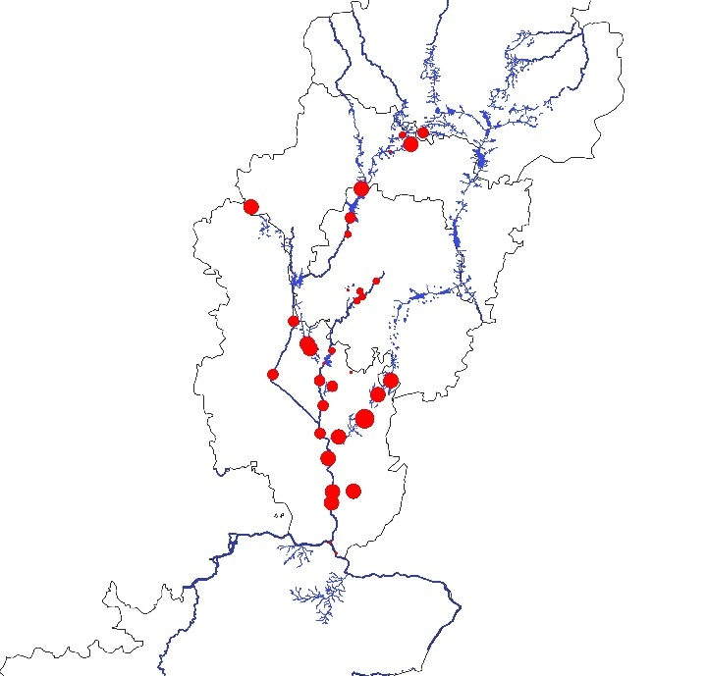  Fig.S1 Temperature (T°C)  ● Temperature varies from 20.2°C to 28.5°C | 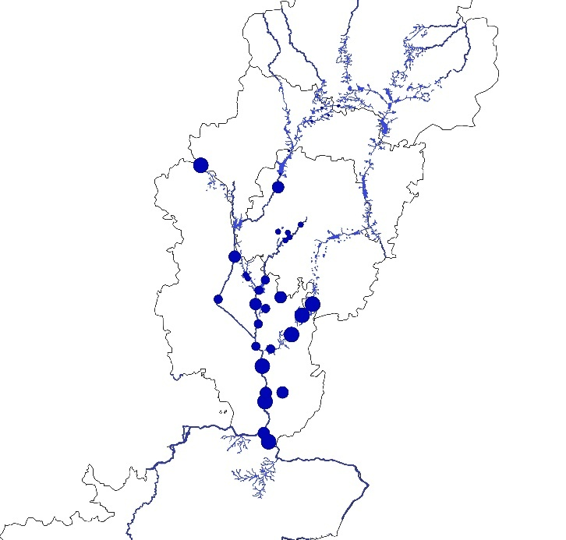  Fig.S2 pH  ● pH ranging from 5.80 to 8.79
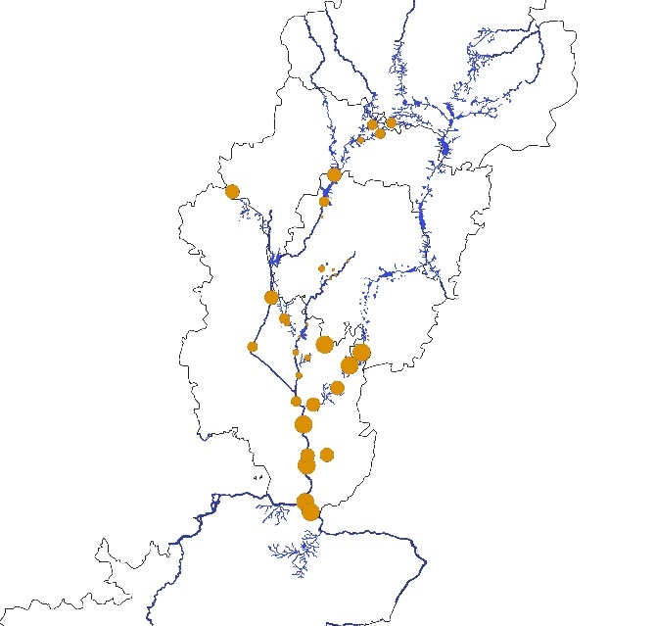  Fig.S3 Electrical Conductivity (EC μs/cm)  ● EC Minimum 15.8μs/cm to maximum of 691μs/cm | 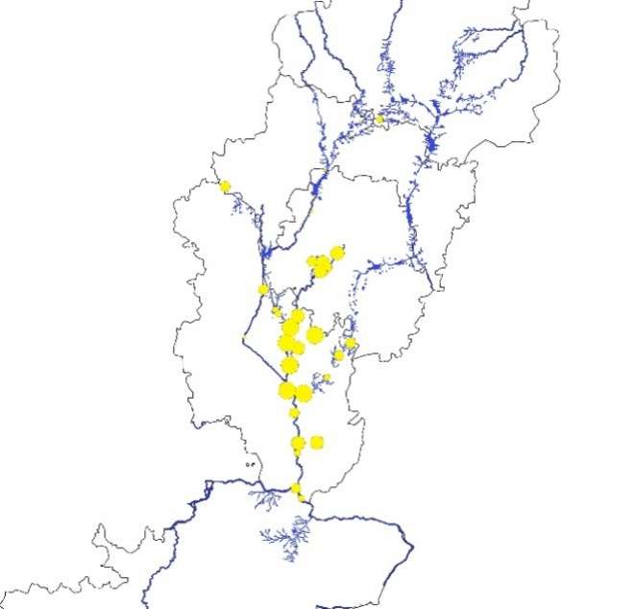  Fig.S4 Dissolved Oxygen  ● DO 1.01 mg/L to 9.16 mg/L
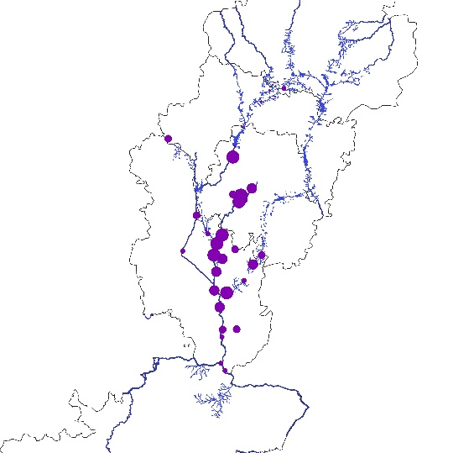
Fig.S5 Alkalinity (mg/L)
● Alkalinity Minimum of 23 mg/L and maximum of 837 mg/L
S.1-5 Water quality parameters in the Arkavathi River.

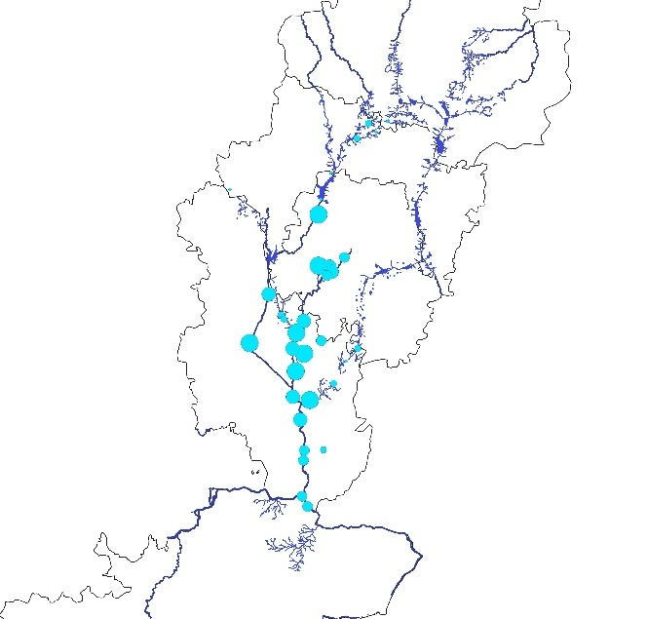  Fig.S6 Cl⁻  ● Cl⁻ minimum of 3.09mg/L to a maximum of 642mg/L | 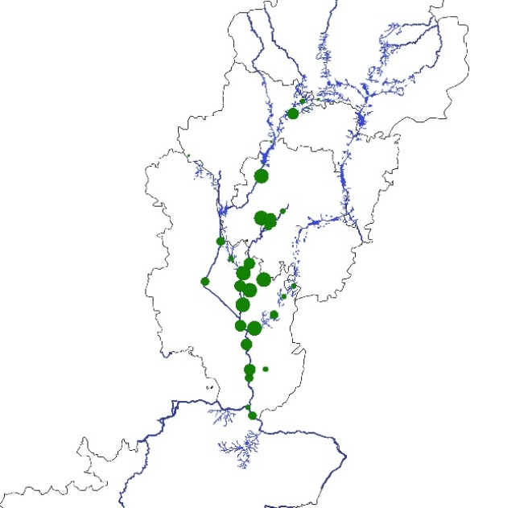  Fig.S7 SO₄²-  ● SO₄²- minimum of 0.76 mg/L to a maximum of 88mg/L
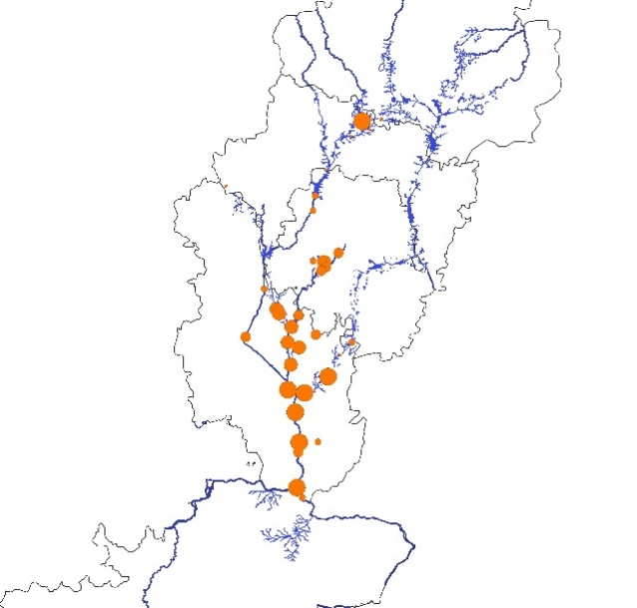  Fig.S8 F-  ● F- minimum of 0.03 mg/L to a maximum of 0.72mg/L | 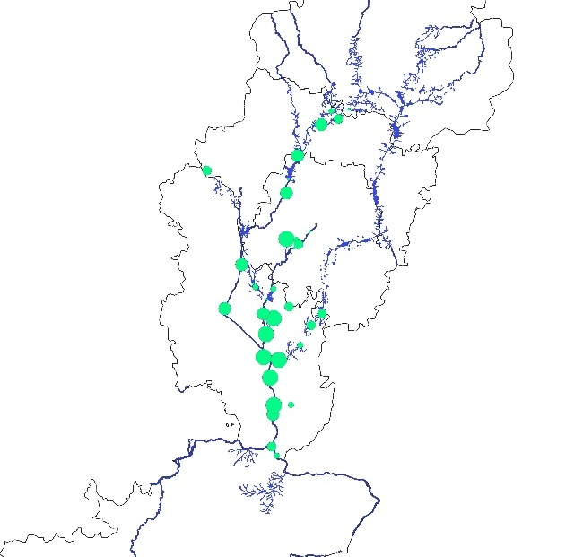  Fig.S9 NO₃⁻  ● NO₃⁻ minimum of 0.03mg/L to a maximum of 30mg/L

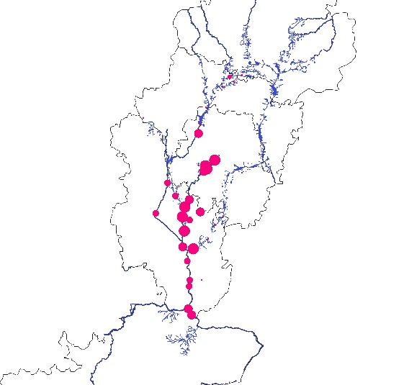
Fig.S10 PO₄³⁻
● PO₄³⁻ minimum of 0.5965mg/L of a maximum of 86.45mg/L

Fig.S6-10 Average concentration Inorganic anion contents of Arkavathi river water samples.

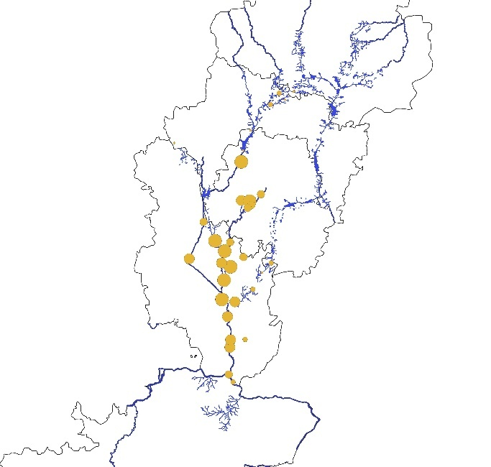  Fig.S11 Na⁺  ● Na⁺ minimum of 1.644 mg/L of a maximum of 563.03mg/L | 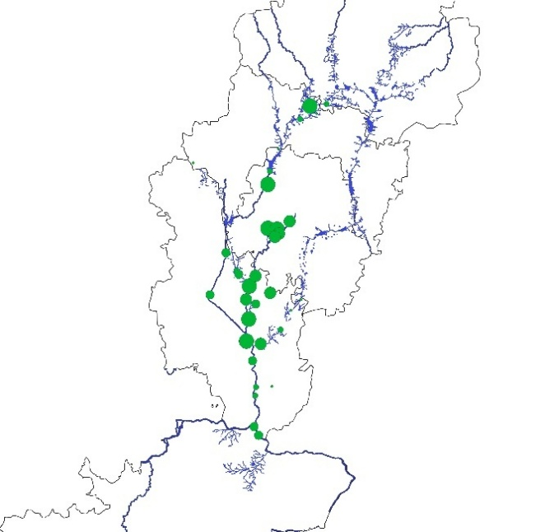  Fig.S12 K⁺  ● K⁺ minimum of 0.5965 mg/L of a maximum of 86.45mg/L
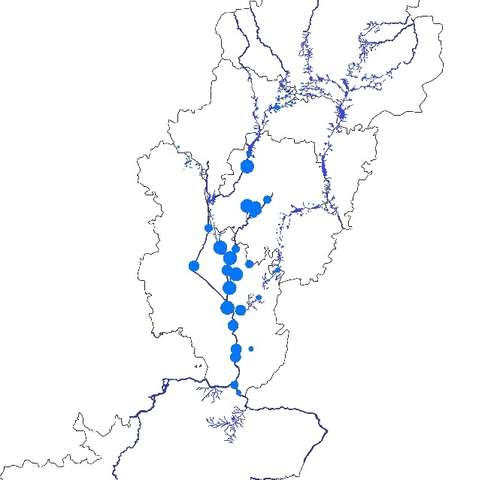  Fig.S13 Mg²⁺  ● Mg²⁺ minimum of 0.206 mg/L to a maximum of 129.36mg/L | 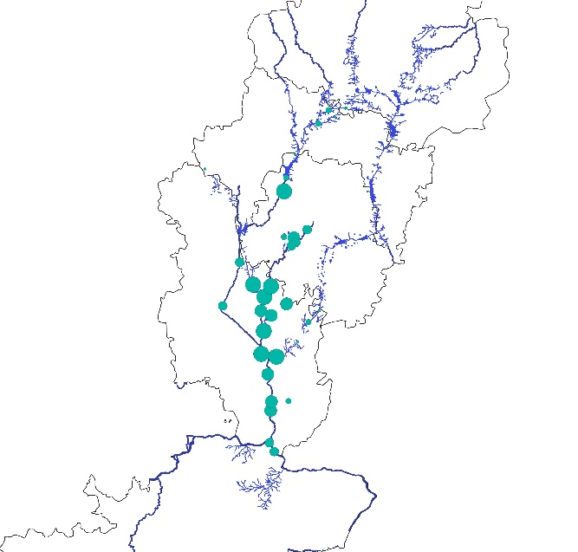  Fig.S14 Ca²⁺  ● Ca²⁺ minimum of 2.0925mg/L of a maximum of 406.9mg/L

Fig.S11-14 Average concentration Inorganic cation contents of Arkavathi river water samples.

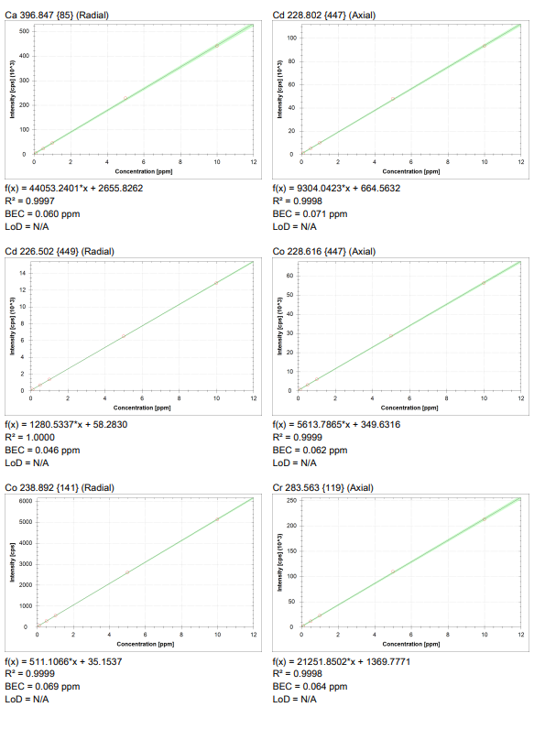
Fig.S15 Calibration curves for all metals detected and quantified using ICP-OES

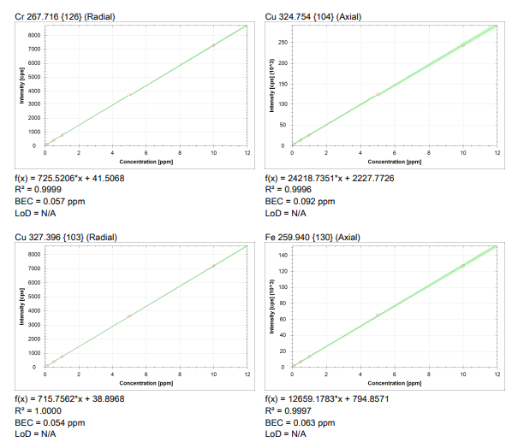
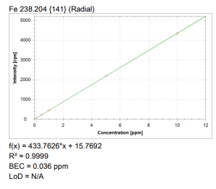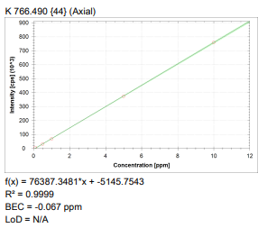
Fig.S15 Calibration curves for all metals detected and quantified using ICP-OES

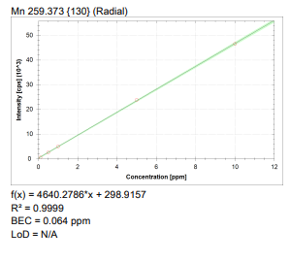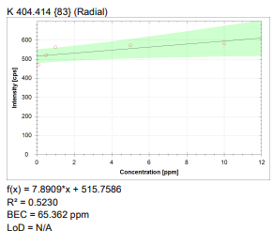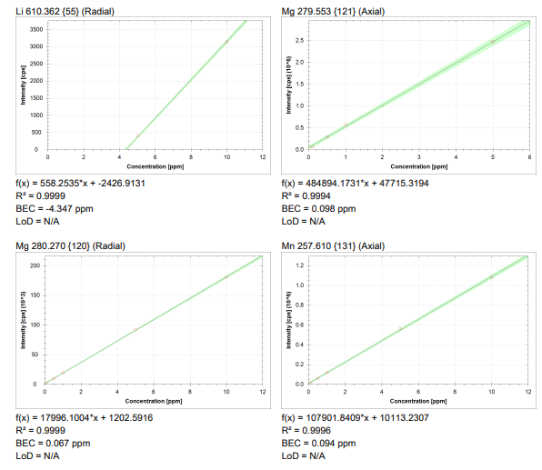Fig.S15 Calibration curves for all metals detected and quantified using ICP-OES

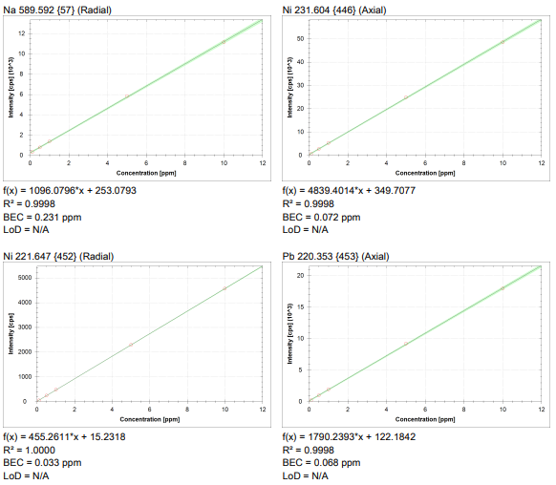
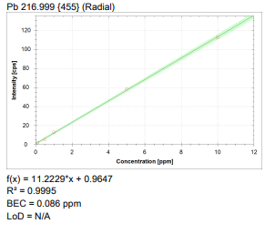
Fig.S15 Calibration curves for all metals detected and quantified using ICP-OES

