to be further analyzed.
Table S1. Primers used for gene expression analysis and vector construction.
Primer | Sequence (5’→3’)
MdCLE8+PRI101F | ttgatacatatgcccgtcgacATGCTCTGGAGATTTTGTG
MdCLE8+PRI101R | tttacccatgaattcggatccATGATGTCTAGGATCAGGA
RT-MdCLE1-F | TTTGATCGGCAGCAGCAAAC
RT-MdCLE1-R | AGTGGTGCTGAGGATCTGGT
RT-MdCLE3-F | ATGGCGCTCGACATCATAACA
RT-MdCLE3-R | TGCAGGCACAACATCTCCAGT
RT-MdCLE4/5-F | CACAATATTATGGCGGGCGC
RT-MdCLE4/5-R | TCCTGGTGAGACTCTGTCAGT
RT-MdCLE6-F | GCTCGTTCTCCAGTGCCATT
RT-MdCLE6-R | ATGTTGCGGATCAGGTCCTC
RT-MdCLE8-F | AAGAGGAACGTAACCGGGTC
RT-MdCLE8-R | ACTCAATCGCTTCGGGTTGT
RT-MdCLE10-F | AAGCTCGATTTCCAGTGCCA
RT-MdCLE10-R | TGGACTCGAAGGGTTTTCCG
RT-MdCLE21-F | TCAAGCTCGTTCTCCAGTGC
RT-MdCLE21-R | TGGACTCGAAAGGTTTTCCGA
RT-MdCLE23-F | AACATGTCGTATCGGGCGAT
RT-MdCLE23-R | CACCCTGACCACCATGATGT
RT-MdLAX-like1-F | GTCTGCTGTGTACTGGGCAT
RT-MdLAX-like1-R | AGTGCAAGCAAACCCAAACG
RT-MdLAX-like2-F | TTCGGGGGACATGCTGTTAC
RT-MdLAX-like2-R | AGCAAGTCTCCAAATGCCCA
RT-MdLAX-like3-F | ACCCGCCTTAGCTCATATGC
RT-MdLAX-like3-R | AGTTGGTCATGCTAGCCCAC
RT-MdLAX-like4-F | GGGCCCATAAACTCTGCAGT
RT-MdLAX-like4-R | CACAAAGTTGGTCACGCTGG
RT-MdLAX-like5-F | GTATTTCACCGGAGCCACCA
RT-MdLAX-like5-R | GGTTGAGAAGCTCGTCACCA
RT-MdXTH1-F | TACTGCACTGACCGAGCCCGAT
RT-MdXTH1-R | TCTCTGTCCCTCTGGCACTCTGGT
RT-MdXTH2-F | TCAGGCACTTCCCGTTGTCCTT
RT-MdXTH2-R | GCCCTGTGGAATCGAGTGACTGA
RT-MdXTH3-F | TCCCCAATGAGAAGCCGATGTACTT
RT-MdXTH3-R | GCCCATTCGTCTGCGTTCCATA
RT-MdXTH4-F | GTCCCATACCCAAAGCTCCAACCTA
RT-MdXTH4-R | CCACAACGTCGAAAACACTCCCA
RT-MdXTH5-F | CCACCAGAACCACCAGCTCGTT
RT-MdXTH5-R | GCGGAATCGGTGCAGTAGTCGTA
RT-MdXTH6-F | CCCTAAAAACCAGCCCATGAGGAT
RT-MdXTH6-R | CCACCTCTTGTTGCCCAGTCATCT
RT-MdXTH7-F | GACCCCACAAAAACCTTCCACACAT
RT-MdXTH7-R | AATATAATGCGCTGCGAGTTCCAAA
RT-MdXTH8-F | GCAAAGGCAACAGAGAGCAGCAA
RT-MdXTH8-R | GGAAGTCGGCAGTTGGGTCAAA
RT-MdXTH9-F | GACCCGACAGCAGTACAGGACCAT
RT-MdXTH9-R | TCTTGGGGTCCCTGCAATAGTCAT
RT-MdXTH10-F | CAATCCCCAAGAAGCTGAAAGACTG
RT-MdXTH10-R | TCTGCTCCGGTGGTGATGCTT
RT-MdXTH11-F | GCAGCCACAAACGACAGTCCAA
RT-MdXTH11-R | CTCGGTTGCGTTTGTGGGACTT
PGAZAT-RT-F1 | GGAGCTGTTAATCTCCTAGTTC
PGAZAT-RT-R1 | CGCCATCAAACATTATCCAGC
PGLR-RT-F1 | GCATAAGCATCCAAGTTTCTG
PGLR-RT-R1 | CGTGTATGTTGATATTCGAGC
XTR6-RT-F1 | GTGGTTGCTCTGCTTGCTTC
XTR6-RT-R1 | CCTGAGCCTGAAGCTTTGTC
EXP17-RT-F1 | GCTCAGTTTCTGCTGGTTGG
EXP17-RT-R1 | CATCCACCGCATGACTTG
LAX3-RT-F1 | CGCAAAAGTTCAAGGCGAT
LAX3-RT-R1 | GCGGTATCTCTAAAACCAGTC

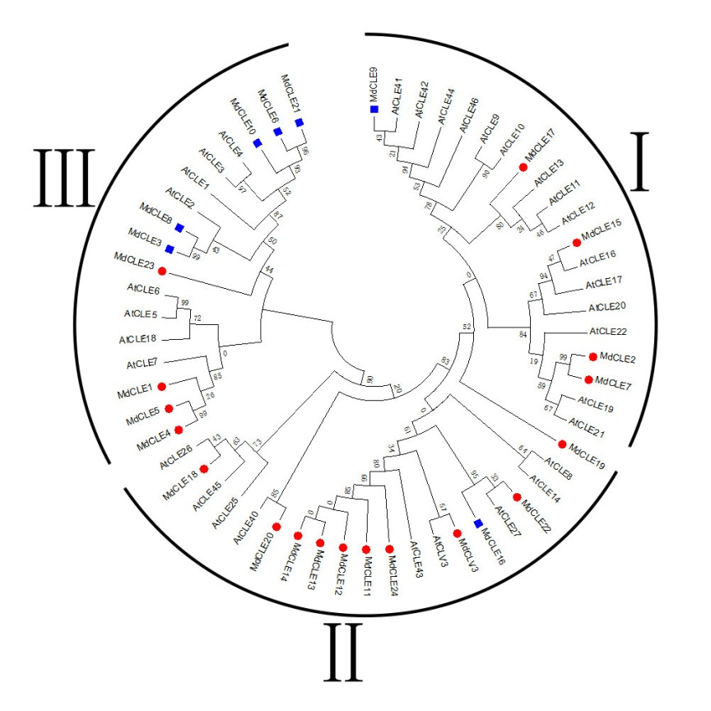
Fig. S1. Phylogenetic tree of CLE protein sequences in apple and Arabidopsis. The red symbol indicates the A-type MdCLE peptide and the blue indicates the B-type (Zhang et al.).
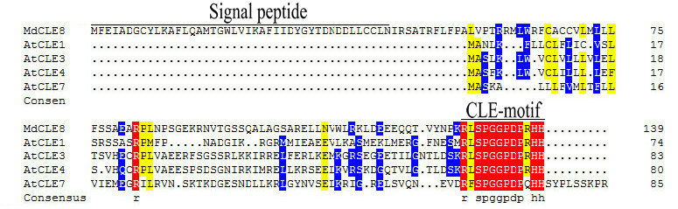
Fig. S2. Multiple alignment of the MdCLE8 and Arabidopsis CLE1/3/4/7 proteins. The CLE motif is indicated.
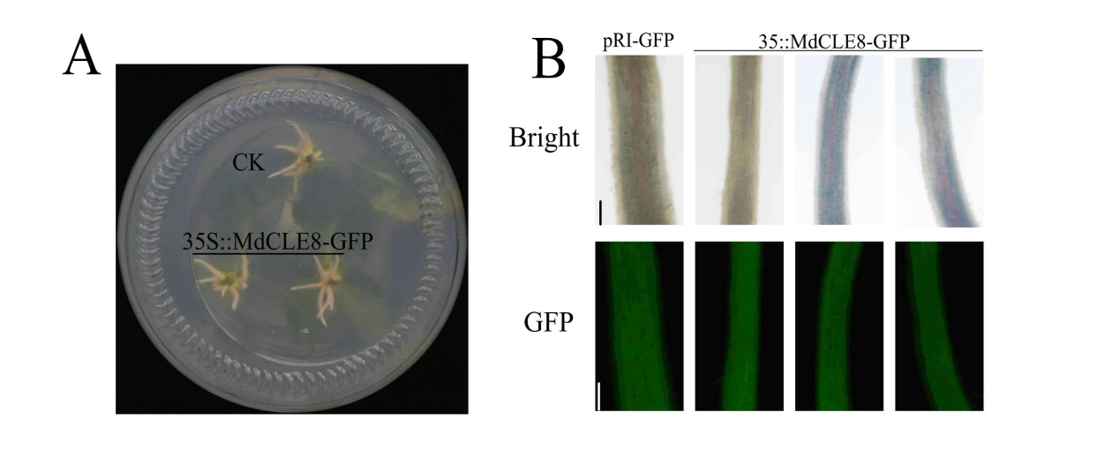
Fig. S3. A. Phenotype of apple seedlings adventitious roots after Agrobacterium rhizogenes infection for 25 days. B. Green fluorescence of transgenic roots was identified by fluorescence microscopy, and false positive roots without GFP fluorescence were removed. Bar=0.5 mm.
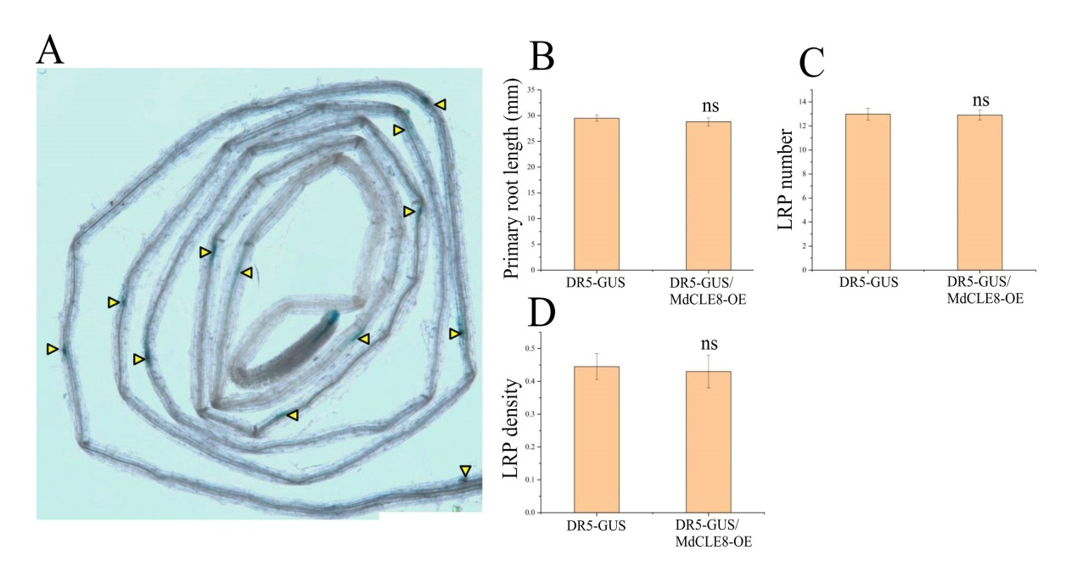
Fig. S4. A. GUS staining of 7-day-old DR5-GUS/MdCLE8-OE transgenic Arabidopsis. The DR5-GUS/MdCLE8-OE was obtained by hybridization of the DR5-GUS and MdCLE8-OE1 transgenic Arabidopsis. The triangle symbol indicates
the position of the lateral root primordia. B-D. Primary root length, lateral root primordia number and density of Arabidopsis in (A). Statistical significance was determined using Student’s t-test: ns, P > 0.05.

