Additional file 2
Tremor source locations of the 2011 unrest with ASL method

Here the ASL technique described in the text is applied to seismic records of an unrest event on 23 May 2011 at Kusatsu-Shirane (the 2011 unrest), consisting transient ground inflation-deflation and associated volcanic tremor. Terada et al. (2011) estimates deformation source beneath the Ainomine cone, not at Yugama. Instead, an ASL analysis by Fujiwara et al. (2011) obtained volcanic tremor locations beneath the Yugama. Now we re-examine source locations of volcanic tremor of the 2011 unrest with the same ASL technique that demonstrated in the text for the 2018 eruption.
Fig. S3 represents inferred tremor locations, corresponding the minimum $RES$ values, and source elevations. Our analysis yields almost the same (about 200 m north) tremor locations with the 2018 eruption. Borehole seismometer at KSJ was repaired in 2016. Hence, $S_{i}$ for vertical ground velocity records at KSJ in 2011 might be different from our estimates for the 2018 eruption. The difference between our result and that reported in Fujiwara et al. (2011) can be derived from methods of $S_{i}$evaluations and station configurations.

Reference
Fujiwara Y, Yamasato H, Ogiso M (2011) Sources of the volcanic tremor with tilt changes on 27 May 2011 at Kusatsu-Shiranesan estimated using seismic amplitudes. Abstracts of the Volcanological Society of Japan 2015 Fall Meeting: P24 (in Japanese).

Terada A, Aoyama H, Nogami K, Yamawaki T, Saito M (2011) A source model of the ground deformation observed during the volcanic tremor on 27 May 2011: An image of a volcanic fluid ascent process inferred from a tiltmeter net- work of Kusatsu-Shirane volcano. Abstracts of the Volcanological Society of Japan 2011 Fall Meeting: A3-01 (in Japanese).

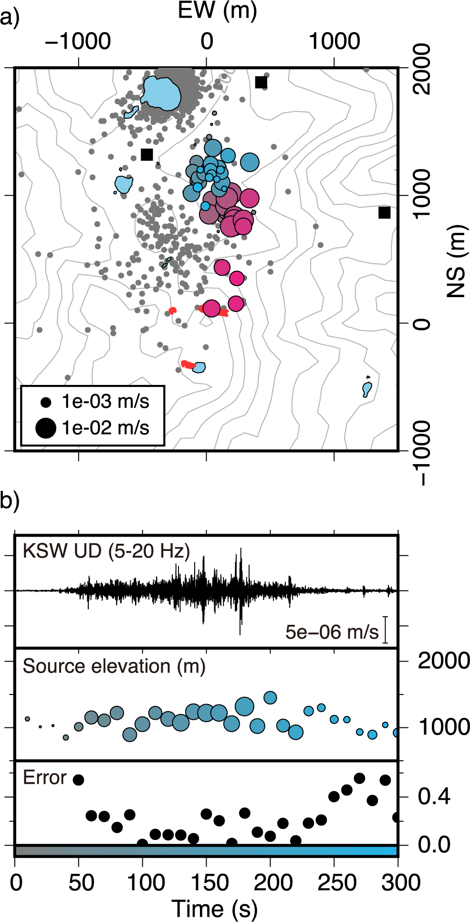

Fig. S3 a Horizontal locations of estimated tremor sources of the 2011 unrest (27 May, 2011 00:29). Color of each plot corresponds a contour bar in b. Epicenters of volcanic earthquakes (Fig. 2), and tremor locations of the 2018 eruption inferred in the text are also shown by gray dots and red plots. b Analyzed filtered (5–20 Hz) vertical ground velocity at KSW, estimated source elevations, and the minimum $RES$ values of each time window.

