Additional file 1
Site amplification factors by coda-normalization and corresponding ASL result

To validate our determination of site amplification factor $S_{i}$ in the text, another $S_{i}$ determination method is demonstrated here with the coda-normalization method (Mayeda et al., 1991). We choose 10 events of tectonic earthquakes occurred around Kusatsu-Shirane from the earthquake catalogue by NIED (2019). Hypocenter information of each event is described in Table S1, and corresponding epicenters are shown in Fig. S1.
Table S2 summarizes site amplification factors and standard deviations obtained by the coda-normalization method. Since seismic records at KSW show the lowest amplification among the network, here we define $S_{i}$ as an amplification ratio relative to KSW.
Figure S2 shows the ASL result adopting $S_{i}$ derived from the coda-normalization method. Here we adopt vertical ground velocity records at 10 stations that covering possible source regions at Motoshirane, because no fixed reference station is given. All time windows in Fig. S2 are the same with the ASL demonstrated in the text (Fig. 7). Although inferred source elevations are unstable in time, it is remarkable that obtained horizontal source locations are almost identical with the result in the text. Hence, we consider that our ASL result in the text is reasonable.

Reference
Mayeda K (1991) site amplification from s-wave coda in the long valley caldera region, california. Bull Seismol Soc Am 81:2194–2213.

National Research Institute for Earth Science and Disaster Resilience (2019), NIED Hi-net, National Research Institute for Earth Science and Disaster Resilience, doi:10.17598/NIED.0003.

Table S1. A list of tectonic earthquakes adopted for site amplification determinations.

Date (JST) | Latitude | Longitude | Depth (km) | Magnitude
Feb. 3, 2016 (21:28) | 36.4047 | 137.6371 | 2.27 | 4.2
June 3, 2016 (11:55) | 35.7184 | 138.0818 | 200.81 | 4.4
June 25, 2016 (13:51) | 36.8089 | 137.8308 | 1.93 | 4.6
June 27, 2016 (14:17) | 37.5663 | 138.0737 | 23.08 | 3.5
Sep. 11, 2017 (00:51) | 35.7199 | 139.1371 | 48.10 | 4.4
Nov. 2, 2017 (22:31) | 36.8097 | 140.7794 | 73.90 | 5.1
Nov. 19, 2017 (14:54) | 36.3085 | 139.0481 | 116.88 | 4.2
Dec. 15, 2017 (16:04) | 37.2629 | 139.2937 | 147.16 | 4.7
Jan. 6, 2018 (00:54) | 35.6453 | 140.0231 | 76.02 | 5.5
Jan. 23, 2018 (04:42) | 36.3694 | 139.2400 | 15.44 | 2.9

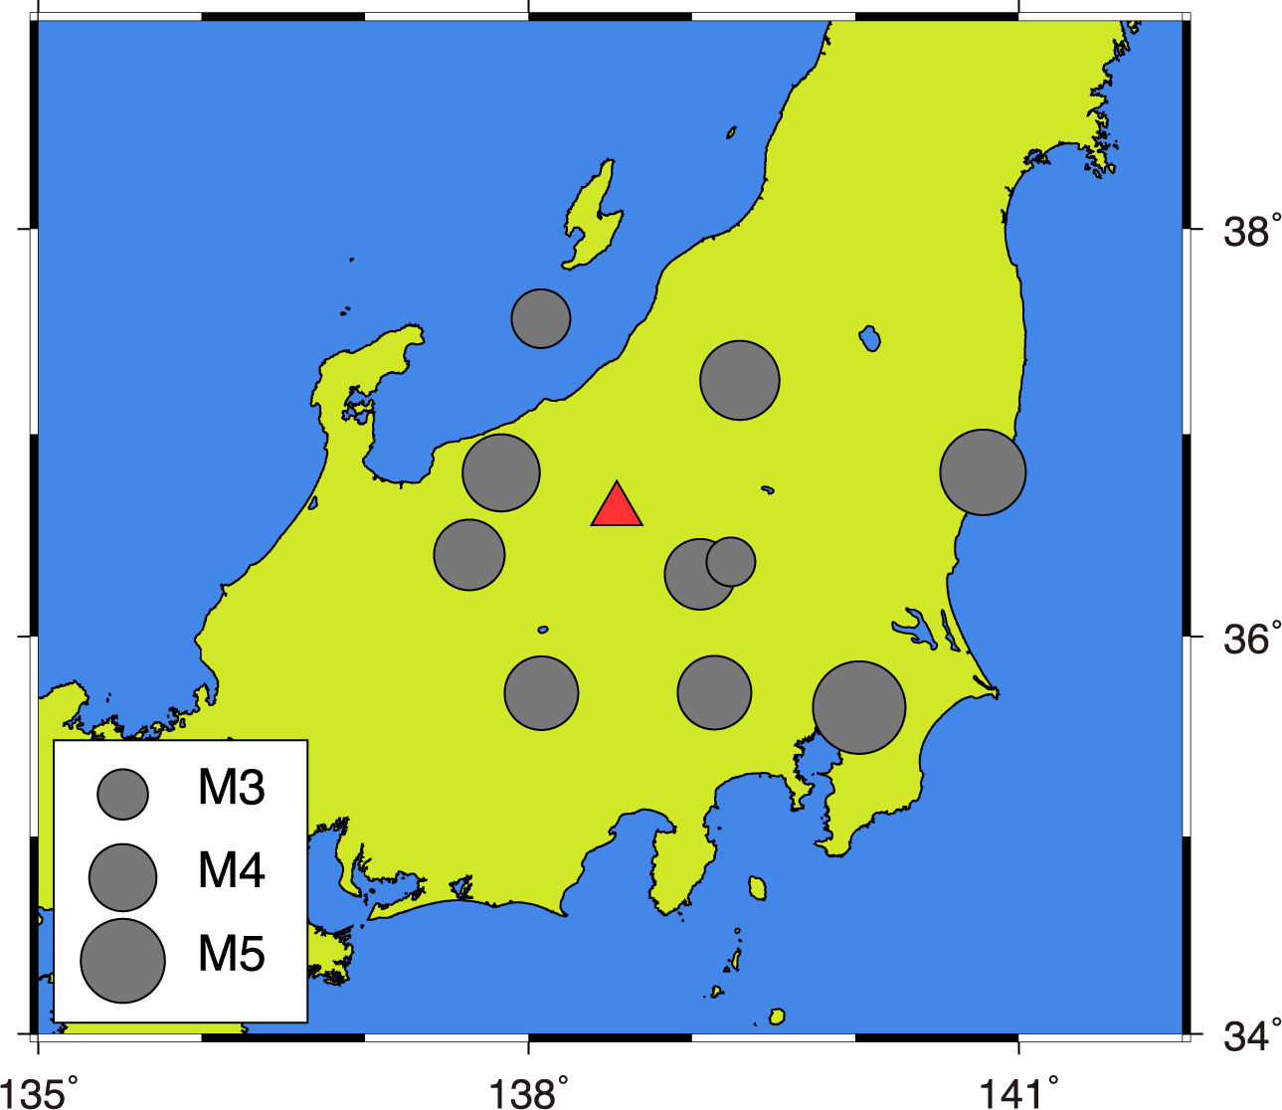
Fig. S1. Epicenters of tectonic earthquakes adopted for site amplification determination with the coda-normalization method. A red triangle shows the location of Kusatsu-Shirane volcano.

Table S2. Obtained amplification factors $S_{i}$relative to KSW and corresponding standard deviations.

Station | Amplification factor (relative to KSW) | Standard deviation
JIE | 2.97 | 0.36
KSE | 1.77 | 0.19
KSS | 1.81 | 0.20
KSYG | 5.98 | 1.51
KSHV | 1.80 | 0.42
KSYV | 2.73 | 0.44
KSNV | 2.76 | 0.55
KSAO | 1.69 | 0.22
KSHA | 4.42 | 0.75

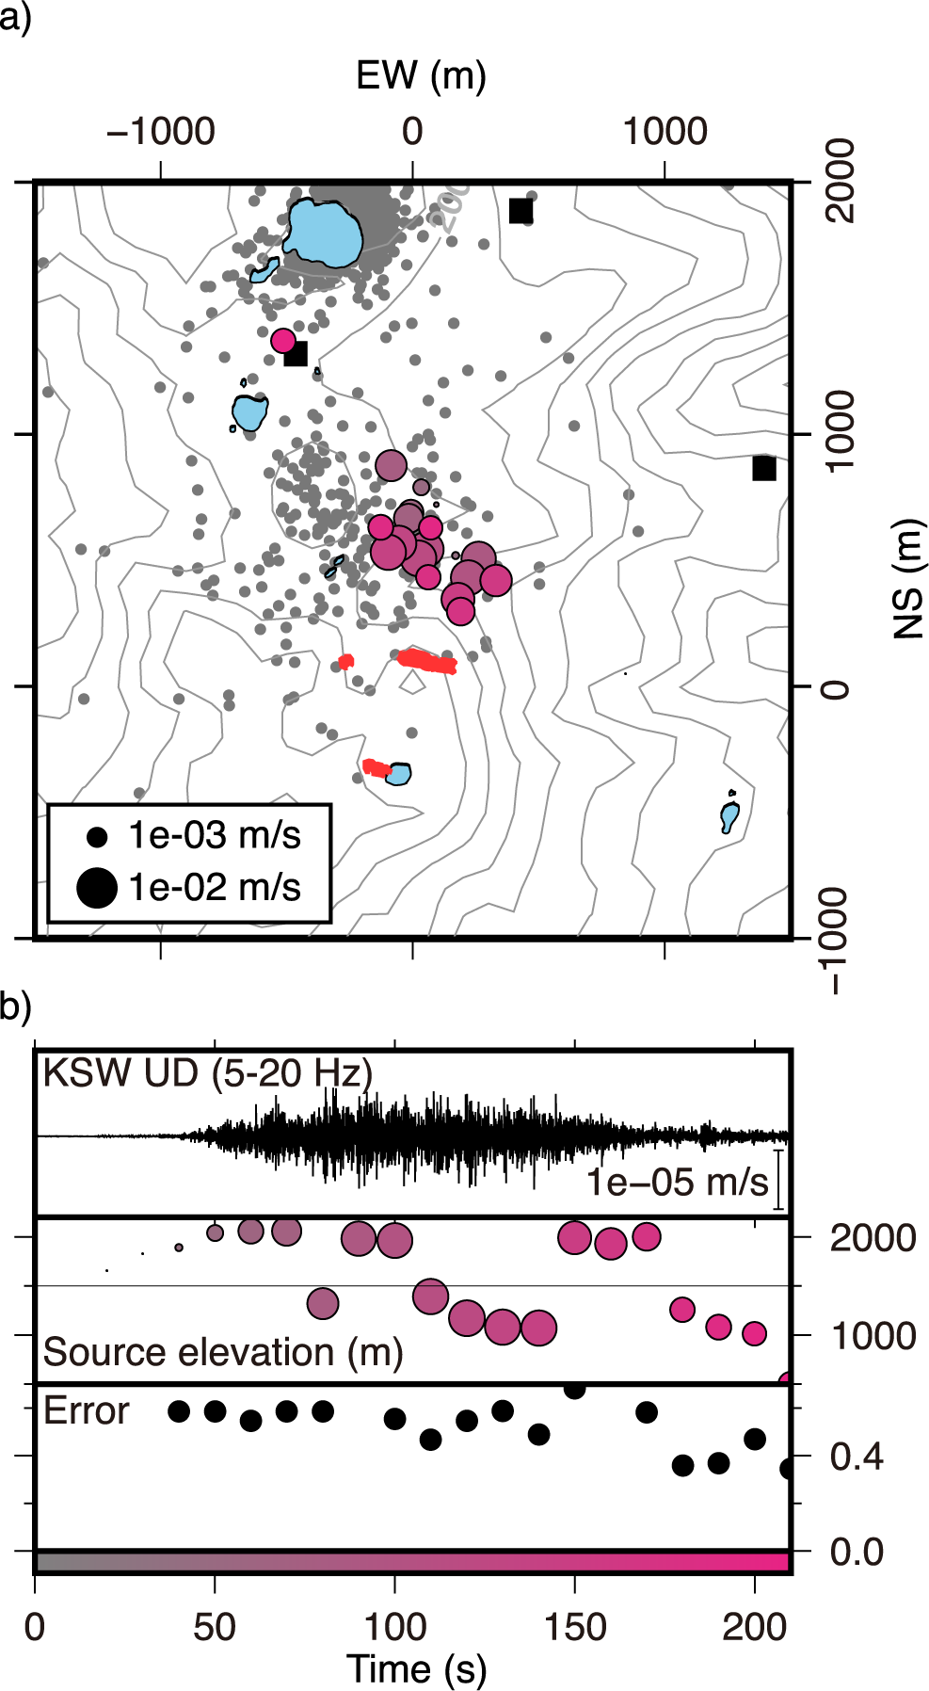

Fig. S2. a Horizontal locations of estimated tremor sources with $S_{i}$ evaluated from coda-normalization method. Color of each plot corresponds a contour bar in b. Epicenters of volcanic earthquakes (Fig. 2) are also shown by gray dots. A plot with a green square show corresponds fixed source location for the reference time window. b Analyzed filtered (5–20 Hz) vertical ground velocity at KSW, estimated source elevations, and the minimum $RES$ value of each time window.

