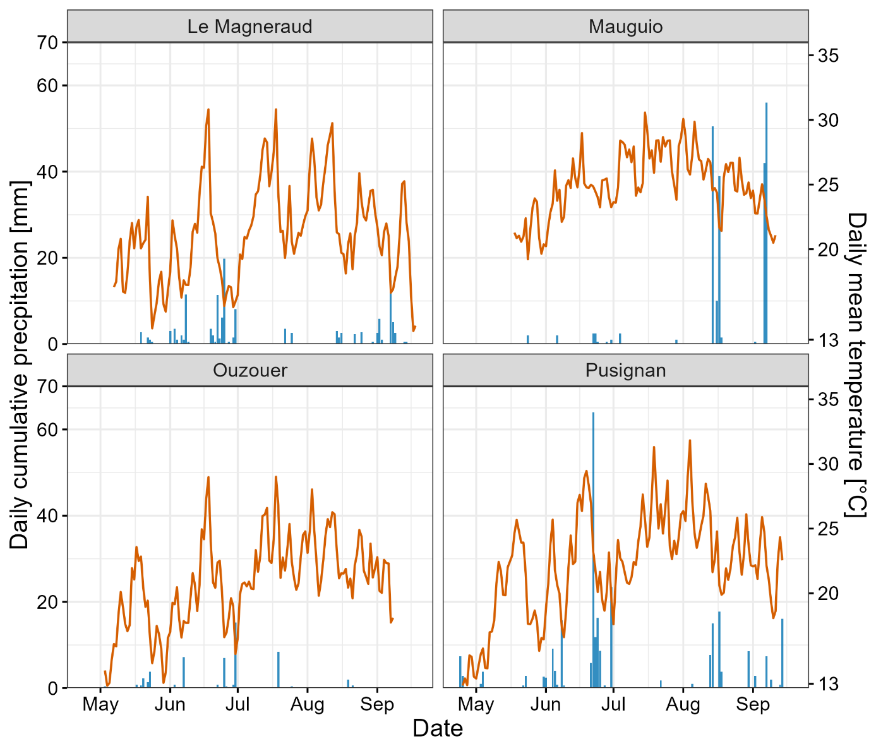
Supplementary Figure 1: Daily cumulative precipitation with blue bars [mm] and daily mean temperature in orange [°C] per site for the period between sowing and harvest.

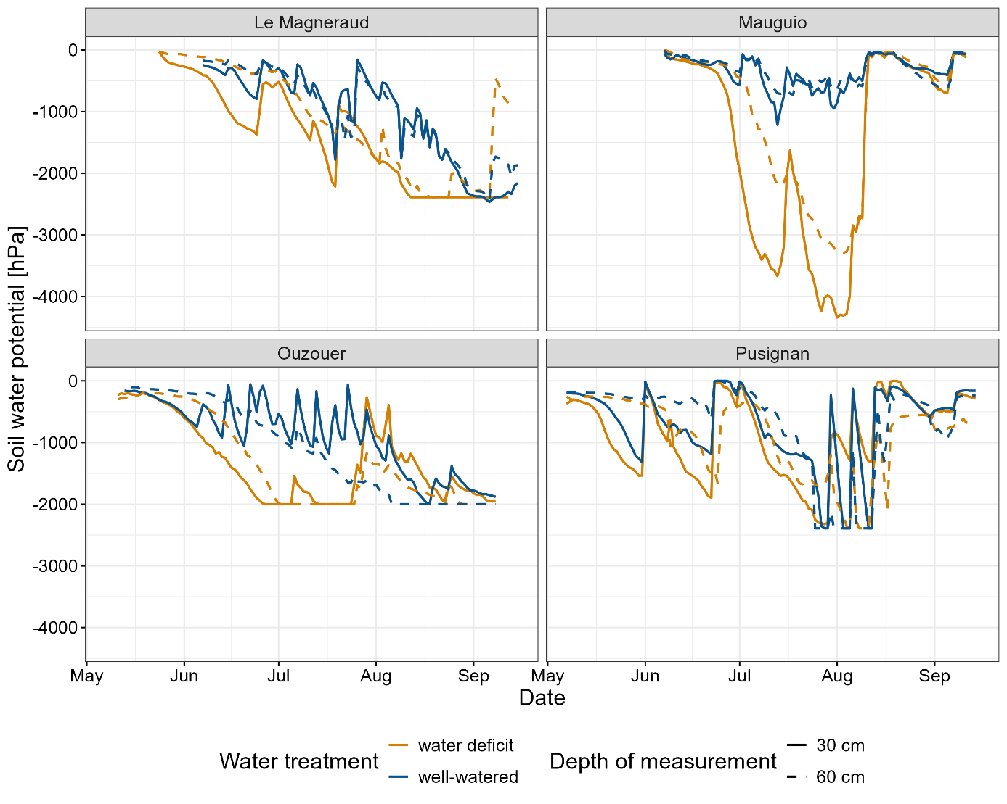
Supplementary Figure 2: Daily soil water potential [hPa] per site measured at two depths (solid line: 30 cm, dashed line: 60 cm) for both water treatments (water deficit: yellow, well-watered: blue).
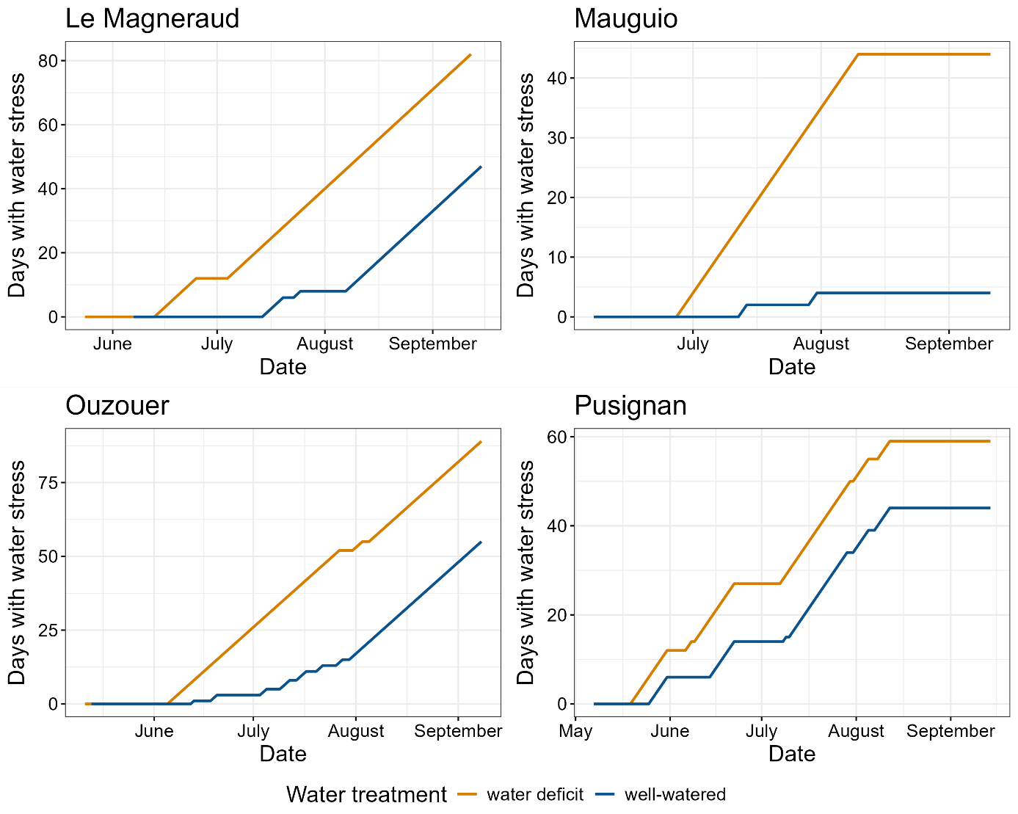
Supplementary Figure 3: Cumulative sum of days with stress due to low soil water potential per site for both water treatments.
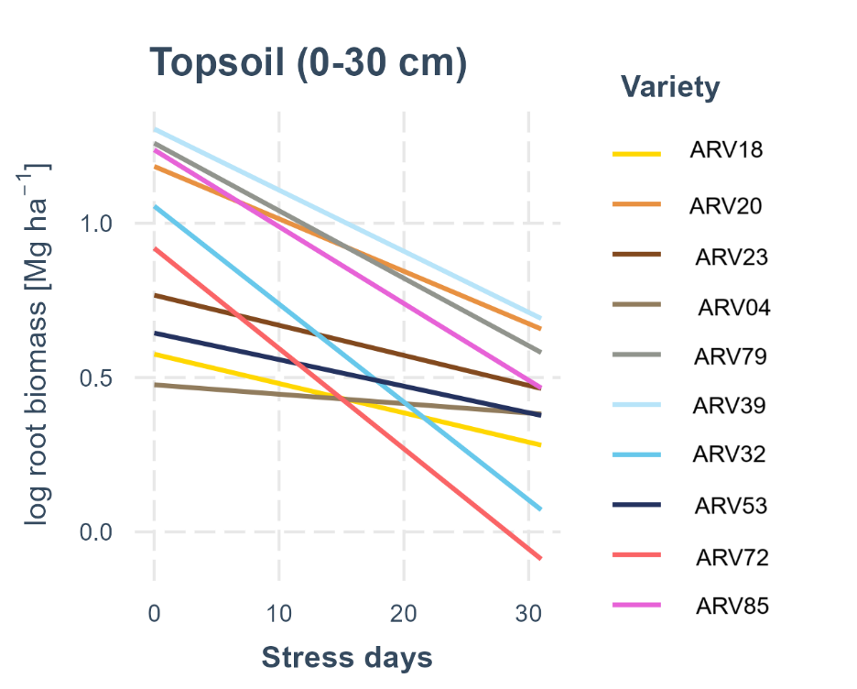
Supplementary Figure 4: Root biomass in the topsoil of ten maize varieties in response to the cumulative number of water stress days during the growing period.

Supplementary Table 1: C org, pH and soil texture per depth increment and site.
Site | Depth [cm] | C org  [%] | pH (CaCl₂) [-] | Sand [%] | Silt [%] | Clay [%] | Texture class
Pusignan | 0-15 | 1.2 | 6.3 | 42 | 38 | 20 | clay loam
Pusignan | 15-30 | 1.2 | 6.3 | 73 | 10 | 17 | sandy loam
Pusignan | 30-50 | 0.7 | 6.1 | 84 | 10 | 6 | loamy sand
Pusignan | 50-75 | 0.7 | 6.1 | 80 | 10 | 10 | loamy sand
Pusignan | 75-100 | NA | NA | NA | NA | NA | NA
Mauguio | 0-15 | 1.1 | 7.8 | 30 | 52 | 18 | silt loam
Mauguio | 15-30 | 0.9 | 7.9 | 25 | 55 | 20 | clay loam
Mauguio | 30-50 | 0.7 | 7.8 | 30 | 26 | 44 | clay
Mauguio | 50-75 | 0.6 | 7.5 | 30 | 26 | 44 | clay
Mauguio | 75-100 | 0.6 | 7.6 | 27 | 26 | 47 | clay
Ouzouer | 0-15 | 1.3 | 7.5 | 9 | 65 | 26 | silty clay loam
Ouzouer | 15-30 | 1.2 | 7.5 | 9 | 65 | 26 | silty clay loam
Ouzouer | 30-50 | 0.8 | 7.5 | 10 | 55 | 35 | silty clay loam
Ouzouer | 50-75 | 0.6 | 7.5 | 12 | 53 | 35 | silty clay loam
Ouzouer | 75-100 | 0.6 | 7.5 | 12 | 53 | 35 | silty clay loam
Le Magneraud | 0-15 | 2.5 | 7.7 | 15 | 53 | 32 | silty clay loam
Le Magneraud | 15-30 | 2.4 | 7.6 | 15 | 53 | 32 | silty clay loam
Le Magneraud | 30-50 | 1.9 | 7.6 | 12 | 37 | 45 | clay
Le Magneraud | 50-75 | 1.8 | 7.5 | 12 | 37 | 51 | clay
Le Magneraud | 75-100 | 1.7 | 7.5 | 12 | 37 | 51 | clay

Supplementary Table 2: Comparison of root biomass [Mg ha⁻¹] per variety across all sites and water treatments. Statistical grouping via a comparison of estimated marginal means per variety indicated by letters.
Variety | Median root biomass [Mg ha⁻¹]
ARV79 | 3.0ª ± 1.2
ARV39 | 2.8ª ± 1.1
ARV20 | 2.5ª ± 1.1
ARV85 | 2.4ª ± 1.3
ARV32 | 1.8^{b} ± 0.9
ARV52 | 1.7^{b} ± 0.6
ARV23 | 1.6^{b} ± 0.7
ARV04 | 1.6^{b} ± 0.5
ARV18 | 1.5^{b} ± 0.6
ARV72 | 1.4^{b} ± 0.7

Supplementary Table 3: Yield [Mg ha⁻¹] per variety across sites and water treatments. Statistical grouping via a comparison of estimated marginal means per variety is indicated by letters.
Variety | Median Yield [Mg ha⁻¹]
ARV18 | 13.3ª ± 2.5
ARV23 | 13.5ª ± 2.8
ARV72 | 12.7^{ab} ± 2.1
ARV32 | 12.6^{ab} ± 2.7
ARV20 | 12.6^{ab} ± 2.7
ARV04 | 12.5^{ab} ± 2.7
ARV52 | 12.4^{ab} ± 2.7
ARV39 | 12.2^{b} ± 2.7
ARV85 | 10.9^{c} ± 2.9
ARV79 | 9.54^{c} ± 3.2

Supplementary Table 4: Root to shoot ratios per variety across sites and water treatments. Statistical grouping via a comparison of estimated marginal means per variety.
Variety | Median
ARV79 | 0.18ª ± 0.02
ARV85 | 0.17ª ± 0.01
ARV39 | 0.16ª ± 0.01
ARV20 | 0.15^{ab} ± 0.01
ARV32 | 0.14^{abc} ± 0.01
ARV52 | 0.11^{bcd} ± 0.01
ARV23 | 0.10^{cd} ± 0.01
ARV04 | 0.10^{cd} ± 0.01
ARV72 | 0.09^{cd} ± 0.01
ARV18 | 0.09 ^{d} ± 0.01

