Table 2: Knockdown 50 (KT₅₀) and Knockdown 95 (KT₉₅) values using Probit analysis for Aedes aegypti from different countries after insecticide exposure.
Country | Locality |  | 5% malathion |  |  |  | 60mg/m² pirimiphos-methyl |  |  |  | 0.4% permethrin |  |  |  | 0.03% deltamethrin
Country |  |  | KT₅₀ (CI) |  | KT₉₅ (CI) |  | KT₅₀ (CI) |  | KT₉₅ (CI) |  | KT₅₀ (CI) |  | KT₉₅ (CI) |  | KT₅₀ (CI) |  | KT₉₅ (CI)
Malaysia | VCRU  (Susceptible) | - |  | - |  | - |  | - |  | 2.68  (1.871-3.576) |  | 0.59  (0.235-1.044) |  | 3.28  (2.337-4.152) |  | 0.77  (0.378-1.223)
Malaysia | Hamna | 69.88  (62.71-84.62) |  | 148.92  (112.72-253.67) |  | - |  | - |  | - |  | - |  | 103.91  (82.57-149.11) |  | 450.19  (272.68-1014.76)
Malaysia | Taman Bukit Jambul | 50.20  (47.14-54.05) |  | 143.68  (121.70-178.01) |  | - |  | - |  | - |  | - |  | - |  | -
Thailand | Songkhla | 0.87 |  | 0.008 |  | - |  | - |  | 0.000001 |  | 8.61E-14 |  | 568.14  (121.62-770908.25) |  | 39524.85  (1611.50-1.53E+11)
Thailand | Surat Thani | 4.05E+8 |  | 1.60E+22 |  | 70.94 |  | 108.57 |  | 876.61 |  | 70999.68 |  | 0.000278 |  | 1.29E-9
Indonesia | Depok | 22.51  (19.59-25.98) |  | 36.08  (29.92-58.10) |  | 38.51  (36.75-40.42) |  | 74.06  (67.30-77.57) |  | 13.67  (12.85-14.54) |  | 22.43  (20.72-25.94) |  | 15.30  (14.73-15.93) |  | 29.79  (27.35-33.16)
USA | Riverside | - |  | - |  | - |  | - |  | 4.51E+11 |  | 2.19E+17 |  | 114.66  (88.40-162.51) |  | 1222.97  (691.03-2677.31)
*KT₅₀ and KT₉₅ values cannot be computed due to no knockdown occurred at the 1-hour reading.
Table 4: Distribution of single and multiple loci of the genotypic combination in domains II and III of the VGSC gene in Ae. aegypti from Malaysia, Thailand, Indonesia, and the United States of America.
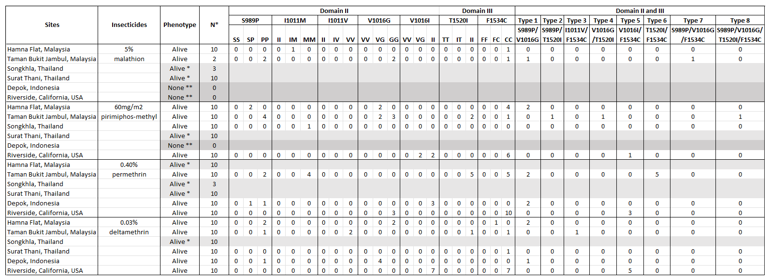
*No mutations were detected in alive-resistant mosquitoes.
** Mosquito strains were susceptible, and no individuals were alive for resistance analysis.

