Shared decision making code book: Based on Elwyn 2017 three step model
- Introducing choice 2. Describing options and 3. Helping patients explore preferences and make decisions.

SDM- recognizes the need to support autonomy by building good relationships, respecting both individual competence and interdependence on others.
SDM is supported by evidence from 86 randomized trials showing knowledge gain by patients, more confidence in decisions, more active patient involvement, and, in many situations, informed patients elect for more conservative treatment options Stacey D, Bennett C, Barry M, Col N, Eden K, Holmes-Rovner, M Llewellyn-Thomas, H Lyddiatt A, et al. Decision aids for people facing health treatment or screening decisions. Cochrane Database of Systematic Reviews. 2011;as well as(10):CD001431.
Deliberation | A process where patients become aware of choice, understand their options and have the time and support to consider “what matters most to them”: may require more than one clinical contact not necessarily face-to-face and may include the use of decision support and discussions with others
Choice talk | Conveys awareness that a choice exists – initiated by either a patient or a clinician. This may occur before the clinical encounter
Option talk | Patients are informed about treatment options in more detail
Decision talk | Patients are supported to explore “what matters most to them”, having become informed.
Decision support | Decision support as designed in two formats: 1) brief enough to be used by clinician and patient together and 2) more extensive, designed to be used by patients either before or after clinical encounters
Initial Preferences | Awareness of options leads to the development of initial preferences, based on existing knowledge. The goal is to arrive at informed preferences.
Informed Preferences | Personal preferences based on “what matters most to patients”, predicated on an understanding of the most relevant benefits and harms.

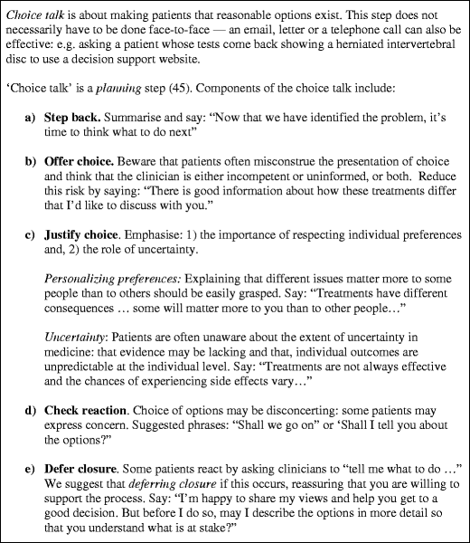

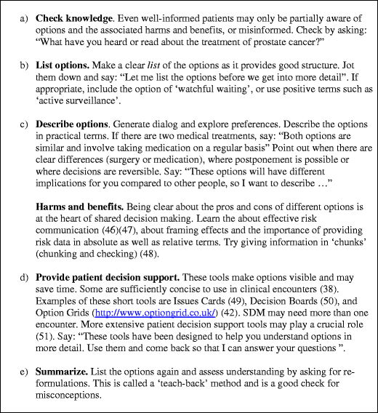

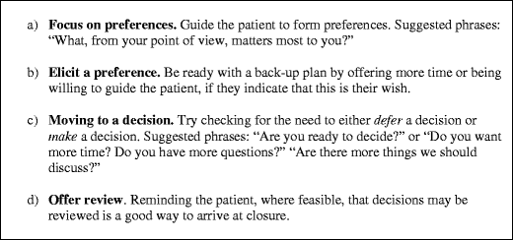
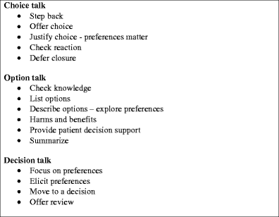

Codebook main
Choice awareness | Little code | Description of the code
Team talk  (Choice talk) | Indicate choice | To inform the patient that a choice exists. To become aware of options.
 | Provide support
 | Identify goals | Patient expressing their goals, concerns, fears (er dette et velprøvd product?), and preferences. Active listening-big part.
 | Lack of team talk | The patient insisting on giving the physician full responsibility. Additionally the physician not involving the patient to join the team as the expert in their body.

 | Little code | Description of the code
Option talk | Discuss harms and benefits | Explanation of harms and benefits  Side effects and so on
 | Compare alternatives | What are the different alternatives of treatment
 | Risk communication | Associated risks with the treatment

 | Little code | Description of the code
Decision talk | Get to informed preferences | The knowledge provided is considered good enough to understand the differences
 | Make preference-based decisions | “Tell me what matters most to you for this decision”
 | Get to not so informed preferences | Initially the patient believes they received enough information but it turned out to be not so when actually using the medication
 | Patients deciding more that the physician | The patient is lacking support from the physician when making a decision.
 | Physician making decisions without the patients notice

